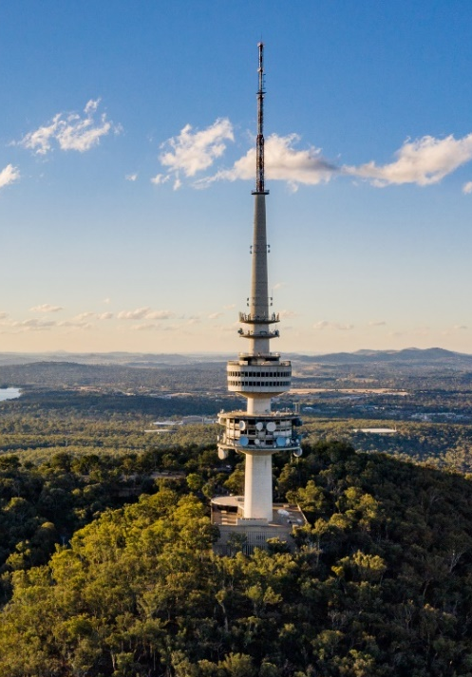
2022-23 ACT Budget Consultation
To help inform the 2022-23 Budget, we sought input from all Canberrans on the prioritisation of government resources, and how best to deliver services for the community.
The community’s input helped shape the 2022-23 Budget – through immediate investments in Canberra’s people and places, and through our longer-term plans for the delivery of services and infrastructure.
This Budget provides for a growing population – with the ACT having strongest population growth of any jurisdiction over the last 10 years, growing from 370,000 to 455,000 people.
It also builds on our response to the COVID-19 pandemic, paving the way for a stronger, more vibrant, and liveable Canberra – both now and in the future. The 2022-23 Budget invests in our city and in infrastructure that is built for Canberra.

The Conversation
The Budget consultation process allows all Canberrans to get involved in the development of Government policy, and to provide feedback on how we can do things differently. We welcome the community’s ideas in considering how the Government can best deliver for you and your community.
Between 10 March and 27 May 2022, we invited community members, businesses, and local organisations to share their ideas for the 2022-23 Budget, including via the completion of an online survey and by providing written submissions through the Budget Consultation project page on the YourSay webpage. The Government also met with a range of community and industry groups in early 2022 to seek input from these groups on their social, environmental and economic priorities.
We have published all submissions, except those provided in confidence, on our Input Received page.

Who Engaged
Written submissions were received from 84 ACT residents, community and business groups, unions and other stakeholders, and 145 people responded to our survey questions.
Submissions, survey responses and direct engagement covered a diverse range of issues, including issues in the economy, arts and culture, community services, housing, disability support, education, climate action and environmental sustainability, health, public infrastructure, and transport.

Key insights from the community
Health services
- Health services was identified as the single most important budget priority, while also receiving the highest level of commentary. Input highlighted the need for a broad range of services including preventative health, paediatric services, and continued access to COVID-19 testing.
- Feedback sought further support for vulnerable cohorts, including people with a disability and other complex needs, while highlighting the importance of non-government partners in delivering specialist services for people who may otherwise have difficultly accessing the public health system.
- The community identified the impact the COVID-19 pandemic has had on mental health, seeking more support for early intervention counselling and outreach programs, with a particular focus on services for children, young people, and the elderly.

Housing affordability and homelessness
- Consultation identified the importance of access to affordable housing, and the disproportionate effect housing affordability has on more vulnerable Canberrans.
- Feedback also highlighted the need for more homelessness support, including greater access to safe and secure public housing. The community also identified a need for short-term crisis accommodation – in particular, for those at risk of domestic and family violence.
- Feedback recognised the significance of housing on other all other wellbeing outcomes, notably health and safety.
Justice system reforms, human rights, and safety
- Survey results identified access to emergency services as one of the community’s top key priorities for the 2022­23 Budget.
- We received a large number of submissions identifying the importance of addressing the overrepresentation of Aboriginal and Torres Strait Islander people in the criminal justice system. Community input also supported raising the minimum age of criminal responsibility.
- Consultation identified an increase in sexual abuse and domestic and family violence, seeking more resources for the community-based organisations that provide support to those affected.
Environment and climate action
- Climate action and environmental sustainability were identified as some of the most important budget priorities. Canberrans recognised the significance of addressing climate change and emissions reductions and emphasised the importance of considering Canberra’s ecological footprint as we look to improve our region’s climate resilience.
- Several submissions identified the importance of encouraging and investing in active travel, including through maintaining Canberra’s footpaths and cycling infrastructure.
Education
- Feedback highlighted the need for new and expanded schools in our growing suburbs, with modern infrastructure that supports all students to engage in learning – particularly those with a disability or other complex needs.
- We received a range of feedback identifying the importance of accessible mental health and counselling services for Canberra’s students, as well as a desire for greater support for languages in public schools.
- Consultation also highlighted the importance of supporting our teachers and early childhood educators, including through opportunities for professional development.
Community services
- The community highlighted the importance of support services for people with a disability, the elderly, carers and those impacted by domestic and family violence.
- Consultation identified a need for more community-based advocacy, legal assistance, education, and health services – particularly for vulnerable cohorts including culturally and linguistically diverse communities.
- Input also highlighted the value of sharing the investment between the public service and the non-government sector when delivering programs and services for the community, and the valued role this sector plays.
Transport and city amenity
- Consultation highlighted the need for safe and efficient public transport services, with improved access for seniors. Input identified the ongoing need for road maintenance and upgrades, and the significance of the light-rail planning works.
- Canberrans also recognised the importance of investing in the amenity of our city, including through town centre upgrades and suburban revitalisation. Many submissions identified community consultation as a key component of all infrastructure and planning projects, both large and small.
Employment, cost of living, and government services
- The community identified the need to promote workforce skills development, and sought more support for local jobs, small businesses, and tourism recovery. This included being able to attract and retain skilled labour in the current environment, as well as deal with supply constraint issues.
- Consultation also identified the need for the Government to respond to rising cost of living pressures, with Canberra’s community sector organisations now supporting more clients in full-time employment who previously would not have sought the sector’s assistance.
- Feedback indicated the community’s preference for the simplification of regulation, early engagement on new projects, and to leveraging the expertise of community-based service providers in policy development and delivery.
Other topics
- Other topics raised included arts and culture, sport and recreation, land release and urban infill, expanded options to leverage the wellbeing framework (including forward planning for areas of need), as well as opportunities to further benefit from a range of varied programs delivered by community service providers.

What’s Next?
We have used your ideas to help inform the priorities for the ACT’s 2022-23 Budget.
Thank you to everyone who provided feedback. The 2022-23 Budget is available online and may be viewed at: https://www.treasury.act.gov.au/budget/budget-2022-23/home.
The written submission process remains open – written submissions can be provided at any time, and will help inform the development of the 2023-24 and future budgets. Additional consultation activities will also take place in coming months to inform the development of the 2023-24 Budget.
THANK YOU FOR YOUR FEEDBACK
84  written submissions  received | 145  responses to the  online survey | 2,395  unique visitors to our  Input Received page*
*From 28 June 2021 through to the preparation of this report. The Input Received page had received 933 unique page visits over the period 1 March 2022 to 30 June 2022.

