Sydney and Melbourne Buildings
CONSERVATION MANAGEMENT PLAN

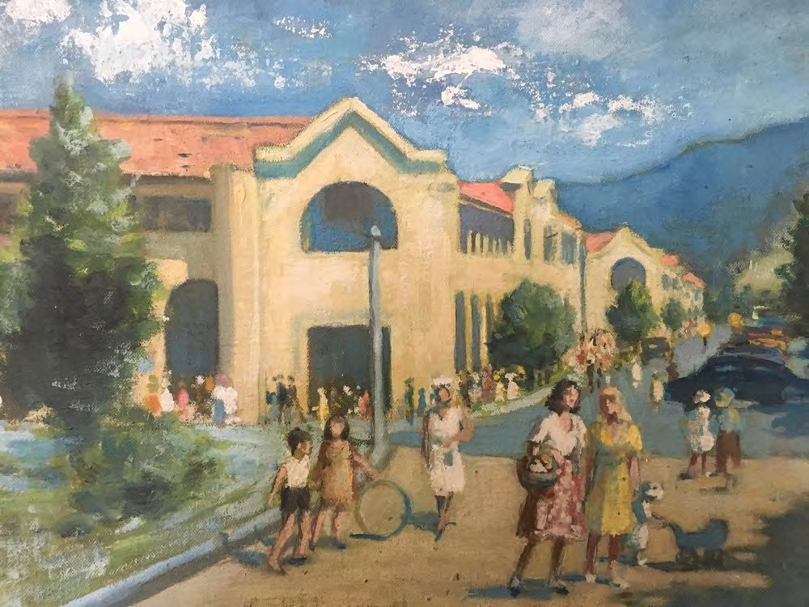

Prepared by
Philip Leeson Architects Pty Ltd
On behalf of
City Renewal Authority, ACT Government
ACT Heritage Council Approved
Amended 27 January 2022

Cover Image: Esther Paterson, ‘Civic Square Canberra’, 1947.
Source: Canberra Museum and Gallery (painting on loan from Dawn Waterhouse), http://www.cmag.com.au/events/in-conversation-with-dawn-waterhouse-reflections-on-1928-1951 accessed March 2020.



Notice of Approval of Conservation Management Plan under Sections 110 & 61K of the Heritage Act 2004

The ACT Heritage Council (the Council) has approved the “Sydney and Melbourne Buildings Conservation Management Plan” (Philip Leeson Architects, 27 January 2022) for the Sydney and Melbourne Buildings on 2 February 2022.

In approving this Conservation Management Plan, the Council is satisfied on reasonable grounds that the conservation policies and actions contained therein will ensure the conservation and responsible management of the Sydney and Melbourne Buildings.

Conditions of Approval
The Council’s approval of this Conservation Management Plan is conditional, and sets out:
- Remaining original interiors are significant fabric of the registered place, and in accordance with Conservation Policy 18 of the CMP, are to be conserved and responsibly managed. Specific Council advice and/or approval is required for any works proposing internal alterations.

- Within six months of the date of approval, a ‘Kit of Parts’ for signage is to be developed and submitted to the Council for approval. This should identify a range of supported forms and materials for signage elements, to ensure that future signage complements the heritage significance of the place.

- This ‘Notice of Approval’ is to be inserted in front of the CMP contents page; and the CMP finalised.

- The finalised CMP is to be provided to the Council, the ACT Heritage Library and any other interested party for the place.

- Implementation of conservation policies and actions described in this CMP are the responsibility of the owners/managers of the heritage place.

- This approval is current for a period of 10 years from the date of approval; unless the Council requires earlier review in response to substantial new information.

The Council advises that where proposed works comply with the policies and actions set out within this CMP, they will not contravene the Heritage Act 2004 and the Council supports those works being undertaken as exempt development.
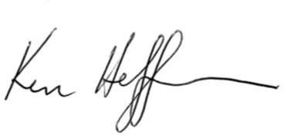

Dr Kenneth Heffernan Chair (as delegate for), ACT Heritage Council
2 February 2022

Executive Summary
Introduction
This Conservation Management Plan (CMP) Update has been prepared by Philip Leeson Architects Pty. Ltd. for City Renewal Authority, ACT Government. The City Renewal Authority has commissioned this CMP update on behalf of owners with the aim of assisting them with the continuing conservation and revitalisation of these important historical landmark buildings in Canberra City.

The subject place is Section 1 and Section 48, City. This includes Odgers and Verity Lanes (the inner courtyards). The place is ACT Heritage Register Place ID 120049, a statutory listing under the ACT Heritage Act 2004. The London Plane Trees located in the laneways are registered trees on the ACT Tree Register. Heritage and Tree Register entries are included in appendices D and E.

This CMP has been prepared in accordance with The Australia ICOMOS Burra Charter 2013 Principles and Practice Notes, J.S. Kerr’s ‘The Conservation Plan’, and with the ACT Heritage Council document, Conservation Management Plan – Guiding Principles, February 2015.
Heritage Significance
The Sydney and Melbourne Buildings have a range of heritage values related to their architectural style, large scale, as commercial buildings from the early years of development in the new national capital, unique form of development, and historical associations.
The Sydney and Melbourne Buildings are significant as good examples in Canberra of the Inter-War Mediterranean style and are of added interest as large-scale examples in this style. This Sydney and Melbourne Buildings are excellent examples of this style which was popular in Australia during the early years of the national capital.
The Sydney and Melbourne Buildings are rare as:
- large-scale commercial buildings dating from the early decades in the development of the national capital; and
- as large-scale examples of Inter-War Mediterranean style buildings.
The Sydney and Melbourne Buildings are also unique in Canberra in the form of development – as the block by block development was undertaken by individual leaseholders working to an overall design. The different approach in this case partly reflects the special circumstances of Canberra as a city built for and under the close control of government. The Melbourne and Sydney Buildings’ design and details exhibit particular aesthetic characteristics, which were inherent in the original design and are valued by the community today.
The Sydney and Melbourne Buildings are of historic value as commercial buildings associated with the early development of Canberra as the national capital. While there were other substantial developments in Canberra from the same period, the Sydney and Melbourne Buildings were the major development in Canberra City, which was intended at the time as the commercial centre for the new city.
The Sydney and Melbourne Buildings have played and continue to play an important role in defining Canberra City. They established the early character and scale of the city’s retail and development in Canberra City and provided its focus. While they continue as a landmark in Canberra City, other development since 1960 has diffused the focus of commercial activity and changed the character and scale of Canberra City. Accordingly, the role of the Sydney and Melbourne Buildings has been diminished.

The Sydney and Melbourne Buildings have a strong and special association with the architect Sir John Sulman. Sulman is an important historical figure in Australia, and part of this relates to his role with the Federal Capital Advisory Committee in the early development of Canberra in the 1920s. Sulman

prepared the concept design for the Sydney and Melbourne Buildings, and they are one of only two places in Canberra that perhaps best present substantial and tangible evidence of his influence in Canberra.
The ACT Heritage citation is included in an appendix, and an analysis against ACT Heritage Significance Criteria is in section 3.

Intrinsic Features
The Intrinsic Features of the Sydney and Melbourne Buildings should be conserved, managed and interpreted in accordance with the principles and practice notes of the Burra Charter and the ACT Heritage Act 2004. Features Intrinsic to the Significance of the Place comprise:
  - Exterior façade of the Melbourne and Sydney Buildings;
  - Remaining original interiors;
  - Central courtyards and remaining internal lightwells; and
  - London Plane trees (Platanus x acerfolia) in the interior courtyards of both buildings.
Additional guidance as to Significant, Neutral and Intrusive elements of the Sydney and Melbourne Buildings is provided in Section 3. Refer to the individual block inventories in Appendix B for specific details for any given block.
Historical information from the 2011 CMP is included in Appendix C.

Opportunities and Constraints
There are both opportunities and constraints arising from the need to conserve features intrinsic to the heritage significance of the place. The heritage significance of the place creates an opportunity for the Sydney and Melbourne Buildings to be coherent places of strong historic character, upon which they can trade commercially and upon which Canberra City can trade as a destination. The requirement for conservation of these features constrains flexibility in establishing character other than the historic character.
Section 4 outlines opportunities and constraints which impact on the development of conservation policy for the place such as -
- Condition and integrity: Façade Refurbishment Documentation was prepared by David Clarke Architects in 2008. This generally covered replacement of unsympathetic or damaged gutters and downpipes, cracked and damaged render repairs, removal of intrusive fabric etc. The 2020 site inspections revealed that very few of these recommendations have been actioned, suggesting that there are challenges in translating, coordinating and/or funding works. Individual block inventories in Appendix B provide specific information on works required to repair condition and restore integrity on a block by block basis to assist owners.
- Statutory obligations: Obligations arise out of the ACT Heritage Act 2004, the Tree Protection Act 2005, the City Renewal Authority and Suburban Land Agency Act 2017, Territory Plan 2008 and the Planning and Development Act 2007 including various codes relating to services, landscaping, lighting, access and signage. These are discussed in section 4, where there is also a discussion about compliance with the Commonwealth Disability Discrimination Act 1992 and other relevant aspects of the National Construction Code.
- Management Context and Stakeholders: There are a large number of owners of the 65 blocks that make up the Sydney and Melbourne Buildings without any centralized body corporate equivalent to coordinate actions. The views of owners and tenants have been recorded to the extent it is has been possible to reach them. The City Renewal Authority is highly interested in the presentation of the buildings, and the ACT Heritage Council is interested in the conservation of the buildings. The impact of COVID-19 on trading at the time of writing is also acknowledged.
Conservation Policies
There are 57 conservation policies pertaining to the place. These are recorded in section 5 and include:

- Policies relating to this CMP such as ownership, approval, guidance and advice.
- Policies relating to statutory requirements such as compliance, approvals and stakeholder consultation.
- Policies relating to building management such as coordination, decision making, integration, heritage awareness and liaison with ACT Heritage.
- Policies relating to use such as continuation of historic use, and information about heritage significance to be included in lease agreements.
- Policies relating to the conservation of the buildings including the treatment of intrinsic, intrusive and neutral features and carrying out repairs. There are specific policies for shopfronts, recessed doorways, upper verandahs, opening facing laneways, colonnade paving, access ramps, painting and colour schemes, which should be consulted at the time of any proposed changes.
- Policies relating to lighting and services.
- Policies relating to maintenance.
- Policies relating to new development including alterations to shopfronts, interiors, rear additions, location of service equipment, development in courtyards, tree management, keeping records of changes, Statements of heritage Effect.
- Policies relating to signage such as the need for development and heritage approvals, original and sympathetic signage types and locations, total number of signs and acceptable fixings.
- Policies relating to interpretation.

Design Guidance and Conservation Works
Practical guidance for conservation and making changes is included in section 6. It includes a table outlining when heritage approvals are required, and design guidelines such as:
  - colour schemes;
  - drawings illustrating permissible shopfront options;
  - original skirting detail;
  - colonnade pavement patterns.
Schedules of original building fabric are included in section 2.
Section 7 provides guidance on recommended conservation, repairs, restoration and reconstruction actions with suggested timeframes and a schedule of recommended cyclic maintenance actions.
Appendix A includes a copy of the Burra Charter which is the primary document that guides heritage conservation in Australia. Australia ICOMOS is developing a series of Practice Notes to supplement and provide practical advice on aspects of the Burra Charter and its application, which can be found on the Australia ICOMOS website.

Appendix B includes individual block inventories. They provide detailed information on a block by block basis indicating:
  - Surviving original features
  - Modified features
  - Physical condition
  - Intrusive elements
  - Recommended repairs, conservation and restoration / reconstruction works.
The most comprehensive drawings of the Sydney and Melbourne Buildings produced to date are included in Appendix F. General layout plans are included in section 2.

Table of Contents

EXECUTIVE SUMMARY 4
TABLE OF CONTENTS 7
- INTRODUCTION 9
- PHYSICAL ASSESSMENT 13
  - Description 13
  - Original Fabric 16
  - Original Colour Scheme 26
  - General Layout Plans 28
- ANALYSIS AND STATEMENT OF SIGNIFICANCE 31
  - Assessment Against ACT Heritage Significance Criteria 31
  - Statement of Heritage Significance 33
  - Features Intrinsic to the Significance of the Place 34
- OPPORTUNITIES AND CONSTRAINTS 37
  - Conservation of Intrinsic Features 37
  - Current Condition and Integrity 37
  - Interpretation 39
  - Statutory Obligations 40
  - Management Context and Stakeholders 59
- CONSERVATION POLICIES 62
  - Policies relating to this CMP 62
  - Policies relating to Statutory Requirements 62
  - Policies relating to Building Management 63
  - Policies relating to Use 63
  - Policies relating to Conservation 64
  - Policies relating to Lighting and Services 66
  - Policies relating to Maintenance 67
  - Policies relating to New Development 68
  - Policies relating to Signage 69
  - Policies relating to Interpretation 70
- IMPLEMENTATION 72
  - The Australia ICOMOS Burra Charter, 2013 72
  - Definitions 72
  - Heritage Best Practice 73
  - When is Heritage Approval Required 74
  - Design Guidelines 75
- CONSERVATION WORKS 87
  - Recommended Conservation, Repairs, Restoration and Reconstruction Actions 87
  - Recommend Recurring Maintenance Actions 91
- REFERENCES 92
- APPENDIX A: THE BURRA CHARTER 93
- APPENDIX B: BLOCK INVENTORIES 94
  - Sydney Building, Alinga Street 94
  - Sydney Building, East Row 105
  - Sydney Building, London Circuit 121
  - Sydney Building, Northbourne Avenue 130
  - Melbourne Building, West Row 140
  - Melbourne Building, London Circuit 149
  - Melbourne Building, Northbourne Avenue 160
  - Melbourne Building, Alinga Street 174
- APPENDIX C: HISTORICAL INFORMATION FROM THE 2011 CMP 180
- APPENDIX D: ACT HERITAGE CITATION 181
- APPENDIX E: ACT TREE REGISTER ENTRY 182
- APPENDIX F: DRAWINGS OF THE SYDNEY AND MELBOURNE BUILDINGS 183

Introduction
Project Brief
This Conservation Management Plan (CMP) Update has been prepared by Philip Leeson Architects Pty. Ltd. for City Renewal Authority, ACT Government. The City Renewal Authority has commissioned this CMP update on behalf of owners with the aim of assisting the latter with the continuing conservation and revitalisation of these important historical landmark buildings in Canberra City.

The City Renewal Authority’s brief for the CMP in December 2019 was as follows:

- As there is already a good understanding of the history and heritage significance of the Sydney and Melbourne Buildings, the CMP update will not need to review those aspects of the 2011 CMP.
- The CMP update should be informed by:
  - A detailed assessment of the physical condition of the Buildings notably the exterior;
  - Review and completion of actions that can be completed by the Consultant recommended by the 2011 CMP, such as paint scrapes to validate the exterior colour scheme;
  - A review of management constraints and opportunities, such as current legislation and policy, needs of owners, views of key stakeholders and the current statutory context;
  - A review of the conservation policy framework, to incorporate new and updated information. The policy framework should focus on heritage conservation, but it also allows for the consideration of (for example) compatible uses and changes that are consistent with heritage values;
  - Allowance for up to three Consultation and engagement sessions with stakeholders including the Heritage Council, Building Owners, Tenants, and Peak Bodies to draft and review the updated CMP;
  - A scope of works setting out the maintenance, repair and works that would be required to conserve heritage values;
  - A detailed specification for works including defining technical specifications for items such as paint colour, lighting, tiling and signage; and
  - Identification and assistance with material selection and sourcing for conservation works to ensure consistency;
  - Presentation to the City Renewal Authority Board or Design Committee.
- Coordinate the CMP application process under Section 61J of the Heritage Act 2004 and respond to any ACT Heritage Council advice requesting further information and amendments.
The City Renewal Authority’s consultation with building owners revealed that a clearer specification and guidance for works would add to the document’s meaning and function. A draft revitalisation plan has also been commissioned by the City Renewal Authority and prepared by Philip Leeson Architects. This document will be used to guide building owners on undertaking works to the exterior of the buildings once the updated CMP has been approved. The plan has been developed with building owners to provide straight forward and practical guidance on undertaking works that will assist with improving the presentation of the Sydney and Melbourne Buildings’.

Identification of the Place
The subject place is Section 1 and Section 48, City corresponding with the ACT Heritage Register Entry boundary for the place. This includes Odgers and Verity Lanes (the inner courtyards). Refer to the diagram from ACTmapi overleaf.

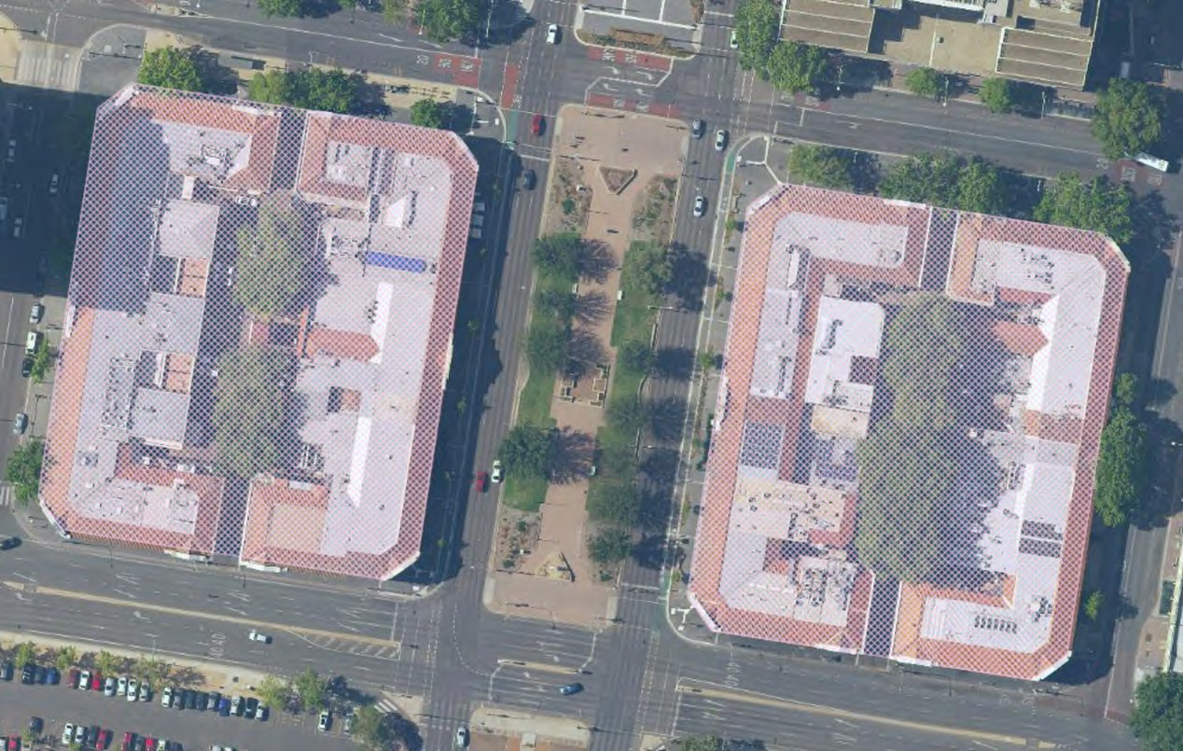
Image: Pink shaded areas indicating heritage registration. Source: ACTmapi, 2020.
The Melbourne Building is on Section 1 to the west of Northbourne Avenue and consists of blocks 4-20, 35 and 39 - 40. Odgers Lane dissects the block north to south and West Row bounds the site to the west.
The Sydney Building is on Section 48 to the east of Northbourne Avenue and consists of blocks 1-6, 9- 26 and 28-32. Verity Lane dissects the block north south and East Row bounds the site to the east.

Alinga Street bounds the sites to the north and London Circuit bounds the site to the south.
Authorship
This CMP update has been prepared by David Hobbes and Alanna King of Philip Leeson Architects Pty. Ltd. It is an update of the currently endorsed CMP prepared by Duncan Marshall et al in 2011. It incorporates much of the information contained in the earlier CMP but provides supplementary information as outlined below.

Methodology
This CMP has been prepared in accordance with, The Australia ICOMOS Burra Charter 2013 as well as
J.S. Kerr’s ‘The Conservation Plan’ and with the ACT Heritage Council document, Conservation Management Plan – Guiding Principles, February 2015.

Review of Existing Heritage Management Documents
The following existing documentation was reviewed during the preparation of this CMP:
- ACT Heritage Register listing
- Conservation Management Plan prepared by Duncan Marshall et al, 2011, including historical information, lighting and signage guidelines

Historical Assessment
The Historical Evidence provided in Appendix 1 is from the 2011 CMP.
Physical Assessment
Site inspections were undertaken by David Hobbes and Alanna King between February and October 2020 to assess the physical condition of the place. The physical assessment includes:

- a description including sketches and photographs
- condition statements
- individual block inventories, provided in Appendix B.

Unless noted otherwise photographs were taken by Philip Leeson Architects between February and October 2020. Unless noted otherwise sketches were produced by Philip Leeson Architects in October 2020.
Assessment of Significance
The ACT Heritage Register Entry includes a Significance Assessment and a Statement of Heritage Significance. The project team reviewed the historical and physical assessments provided in the 2011 CMP and has revised the assessment of significance where it deemed necessary.
Opportunities and Constraints
A review of opportunities and constraints around conservation, maintenance, management and development was prepared based on obligations arising from heritage significance and discussions with stakeholders as follows -

- Door knock of building tenants;
- Workshops with building owners;
- Meeting with ACT Heritage staff; and
- Presentation to ACT Heritage Council.

The following documentation was reviewed and pertinent issues summarised:
- ACT Heritage Act 2004;
- ACT Tree Protection Act 2005 and ACT Tree Register;
- Territory Plan 2008;
- National Capital Plan;
- City Renewal Authority and Suburban Land Agency Act 2017 (including 2020 Amendments);
- ACT Discrimination Act 1991 and Commonwealth Disability Discrimination Act 1992.

Conservation Policies
Conservation policies addressing conservation, maintenance, management and development are based on those provided in the 2011 CMP but have been amended where deemed appropriate following review of the assessment of significance, further historical research, the updated physical assessment and current opportunities and constraints.
Implementation
This section provides more detailed information on statutory obligations and heritage best practice. It also provides detailed lists of significant features for each item of heritage significance and recommends conservation and maintenance actions which are consistent with the conservation policies.
Heritage Status
Listing Type | Listing Body | Item | Status
Statutory | ACT Heritage Council | Sydney and Melbourne  Buildings | ACT Heritage Register Place  ID 120049
Non Statutory | National Trust ACT | Sydney and Melbourne Buildings | Classified
Non Statutory | Australian Institute of Architects | Sydney and Melbourne Buildings | Listed on the AIA Register of  Significant Twentieth Century Architecture (ACT)

Limitations
The building interiors were not investigated or considered in detail, although some general comments and guidance are offered.
The history of the individual blocks has not been updated and is not exhaustive.
The social values of the buildings have not been subject to detailed research, including aspects related to design and aesthetic qualities.
Acknowledgements
The authors gratefully acknowledge the assistance of the following people in the preparation of this CMP Update:

- John Pooley and Simon Landsdown, City Renewal Authority
- Daisy Chaston and Gabrielle Caddy, ACT Heritage
- Ellen Samuels, Helen Leahyr and Harley McNamara, Communication Link
- All building owners in attendance at workshops.
We also acknowledge the impact of the COVID-19 pandemic on all parties throughout 2020 and 2021.

Physical Assessment
This section provides a brief description of the buildings as part of developing a good understanding of the heritage place. Some text has been drawn from the 1993 conservation management plan (Philip Cox, Richardson, Taylor & Partners 1993).
  - Description Overview
The Sydney and Melbourne Buildings are broadly similar. They are two storeys above ground level and each is bisected, north-south, by a laneway and service courtyard with mature Plane trees. On street frontages, the ground floor is an arcade created by arched colonnades, with arched windows on the internal wall line, and the original first floor verandahs have either been retained or enclosed.

The Sydney and Melbourne Buildings are of painted rendered masonry (brick and concrete) with a Cordova terracotta tile roof to the street frontages (also called Roman or barrel tiles).
The Sydney and Melbourne Buildings are constructed to the same basic concept plan. Each Building is two storey and covers a city block. A number of blocks also have a basement level – in particular, part of the former government-owned section of the Melbourne Building, northwest, and Block 2 of the Sydney Building. A continuous 3.6 metre wide colonnade runs around the street frontages of the Buildings. Ground level shops face onto the colonnades and wrap around central service courtyards.
The courtyard elevations are stepped in and out, forming what has been referred to in the Register Entry as lightwells, enclosed on three sides. The service courtyards are accessed through a short laneway in the south and north elevations.

The Sydney and Melbourne Buildings were originally designed with a 2.4 metre wide verandah to the perimeter of the first floor. This has been retained or restored along West Row and parts of Alinga Street, but otherwise these verandahs have been glazed and the space incorporated into the interiors by demolishing the original external wall that originally separate the interior from the verandah. In some cases window-mounted air conditioners have been installed.
The Sydney and Melbourne Buildings’ is constructed of a mix of cavity brick and reinforced concrete. Walls on the street elevations and at the laneways are rendered and painted. Walls facing onto the courtyards are generally face brickwork. However, the courtyard walls of the western part of the Melbourne Building are also rendered and painted. Internal dividing walls between blocks were originally hard plastered.

The colonnade columns and arcaded outer walls are generally reinforced concrete cast on site. However, the columns for the northwest section of the Melbourne Building were pre-cast. The first floor verandah columns are reinforced concrete cast on site.
The Sydney and Melbourne Buildings are constructed around reinforced concrete post and beam frames, all cast on site. Floors are generally timber framed and with tongue and groove boards. Basement floors and floors to wet areas are reinforced concrete slabs, as are the floors and verandah floors in the northwest section of the Melbourne Building.
The roofs are timber truss structures clad in Cordova terracotta tiles to the street frontages. Flat roof areas are metal sheet. More recent new or replacement sections of roofing use profiled zincalume tray- decks. Some pitched roofs may be clad in corrugated asbestos cement sheet (this was noted in 1993 but no complete inspection was undertaken of the roof for this plan). In some cases air conditioning plant is mounted on roofs, and this is visible from the surrounding streets.

The colonnades are paved in quarry or other glazed tiles, and a few sections have been covered in bitumen. The original concrete finish is visible under some sections of bitumen. In four out of eight street

frontages there remains a step between the colonnade and the adjacent footpath, while to the other four street frontages there is no step, because the street level has been raised to meet the colonnade level. The junction between colonnade paving and footpath is marked by a concrete tread or paving stone where there is a step, and even in some cases where there is no step. There appear to be various types of treads used. The courtyards have bitumen paving.
While the interiors of the Sydney and Melbourne Buildings were not subject to detailed or systematic inspection during the preparation of this CMP, a number of observations were made. The interiors have been subject to a wide range of changes as part of various refurbishment projects. These have resulted in changes to layouts, ceiling heights and materials. The partial or complete lowering of ceilings on the ground floor is a common change, though often the new ceiling angles or steps up to allow the full height of the ground floor arched shopfront to be expressed.
The condition of different blocks in the Sydney and Melbourne Buildings varies from poor to good, and there are many deteriorated finishes and elements.

Building Elements
Facades
The facade is two storeys high and consists of an arched colonnade at ground level and rectangular openings to a first floor verandah, which are mostly now enclosed.

The street elevations feature parapeted bays at the splayed building corners, centrally along the east and west elevations, and as framing elements either side of the laneways to the service courtyards on the north and south sides. These bays have parapeted gables with a small pediment framed by scrolled modillion brackets, a double storey arch with an ancon at its crown acting as a visual keystone, and an intermediate panel and central shield separating the ground and first floors. The central parapeted bays and those that frame the entrances to the laneways incorporate rectangular openings, with some of those to the first floor having been infilled with glazing. Those to the central bay are capped by an arched pediment (ground floor) and stylized shield (first floor). There is a moulded roundel above each of the ground floor columns.

The decorative façade elements include rondels and shields which are precast elements. Other mouldings, including those to the pilasters, ceiling beams and arches, are rendered elements that have been ‘run’ in-situ.
The guttering is 125 mm ogee eaves gutters. Decorative timber ‘out-riggers’ at the end of each rafter extend to the back of the gutters.

Colonnades
A 3.6 metre wide pedestrian colonnade encircles the Sydney and Melbourne Buildings at ground level. The outer face of the colonnade is formed by the facade. The internal face of the colonnade is formed by the arcaded elevation of the shop fronts. The shopfronts installed into each arch display a wide variety of construction – including timber, steel and aluminium framed, or frameless glass windows or doors, and metal or paint finishes.
Some original metal shopfronts survive, such as at the southwest corner of the Sydney Building. An original narrow decorative frieze panel survives in many instances, which forms the transom which divides the lower shopfront from the highlight in the arch. Original highlights are metal framed and multi- paned, with a central openable hopper. Some highlights have been painted out. A variety of skirting materials are used, of varying height, which finishes the colonnade wall at ground level.

The ceiling of the colonnade is generally paint finished fibre cement sheet with timber cover-strips and timber cornices to the perimeter. In the northwest section of the Melbourne Building the ceiling is the painted soffit of the verandah slab above. Floor beams for the verandahs run across the colonnade

below ceiling level. A decorative and non-structural moulded corbel is fixed to the wall below each end of the beam.
There is a wide variety of signage suspended from the colonnade ceiling or from the walls. A few interpretive signs are wall mounted. Lighting is generally ball fittings mounted on the ceilings or ceiling beams. There are many surface mounted conduits.

Verandahs
At first floor level a 2.4 metre wide verandah, now mostly enclosed, encircles the Sydney and Melbourne Buidings. Brick or concrete walls divided the verandah at each block boundary. Except for the northwest section of the Melbourne Building, the verandah floor is constructed on reinforced concrete beams with timber joists spanning between them. The verandahs are finished in tongue and groove timber boards.

In the case of the northwest section of the Melbourne Building, the verandah floor and beams are both reinforced concrete. A topping slab was poured over the main slab and graded to a spoon drain at the perimeter of the verandah. The slab has been paved with tiles.
The external walls of the verandah are rendered brickwork to 1.2 metres high and were originally all open above to the lintel level of approximately 3 metres. The inside face of the verandah is rendered with a paint finish. Access to the open verandahs on West Row is provided by timber framed glazed French doors. A doorway is provided in the middle of each bay, with glazed sidelights and a highlight. These open verandahs are divided with multi-paned, timber framed (stained and varnished) glass screens.
Courtyards
Service and delivery access to the buildings is generally provided from the courtyards. These are generally surfaced in bitumen with concrete kerbs.

The walls of the various premises facing the courtyard are generally red face brickwork. Windows and doors facing onto the courtyard are timber or metal framed, some windows being double hung timber sashes, others being metal framed, and all paint or metal finished. Many windows have metal security bars. Some windows facing Verity Lane have been sheeted over in metal.

An exception to the courtyard finishes outlined above is the northwest section of the Melbourne Building. In this section, the courtyard walls are rendered and painted brickwork, with blind (originally actual) windows, painted timber framed windows, and doorways. This section of the building was constructed up to 4 metres from the rear boundary on the whole ground floor – there was originally a boundary wall, bicycle shelters and a courtyard in this space. The first floor extends to the rear in three wings, with enclosed light courts of equal width between.
There are numerous wall mounted services such as air conditioners, ductwork and conduits.
In the centre of each courtyard a row of Plane trees has been planted inside traffic islands. The mature trees dominate the courtyards. In some instances the tree roots have grown around the concrete kerbing.
An electrical substation is constructed in the centre of each courtyard, in the middle of the rows of trees. Construction of the Melbourne Building substation, which appears to be of an early, possibly original date, is rendered and paint finished brickwork with timber doors. The more modern Sydney Building substation is a metal clad structure.

Associated Places
The Sydney and Melbourne Buildings are associated with the street layout of Canberra City, notably the bounding streets for the buildings and especially with the landscape of Northbourne Avenue leading up

to City Hill. By occupying two whole city blocks, the Sydney and Melbourne Buildings give a strong expression to the original street layout, where they were the first commercial (shop) buildings in the city centre. In addition, the broad and formal character of Northbourne Avenue, and the paired placement either side of the avenue at the southern end of current development along the avenue, creates an urban composition of some value.
  - Original Fabric
The following information about the nature of original building fabric has been compiled following analysis of early photographs and surviving physical evidence assessed in 2020.

Item | Description | Comments and photos
EXTERIOR
Main Façade | Rendered and painted masonry  Moulded cornicing to parapets  Rendered and painted off form concrete moulded details including columns, moulded arches, sills, roundels, scrolls, shields | 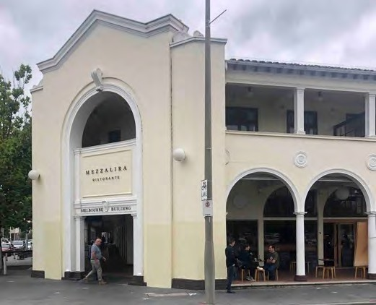  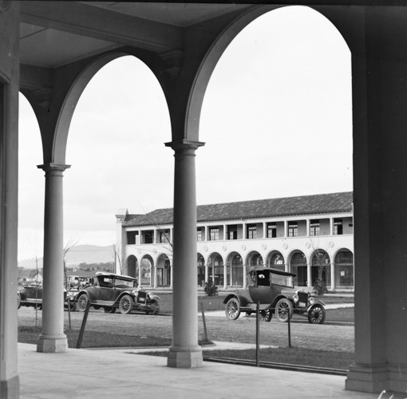  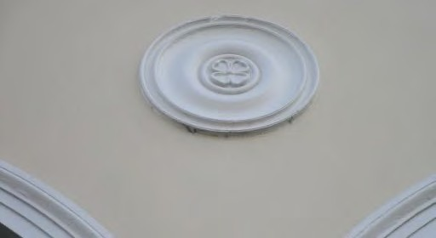  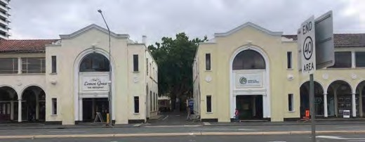

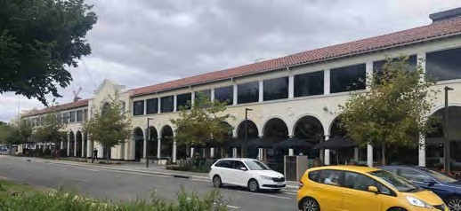

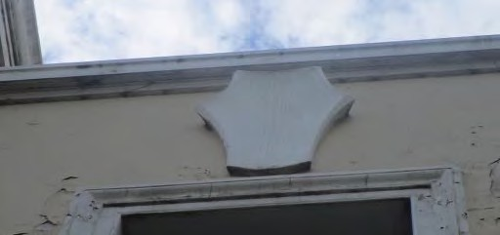

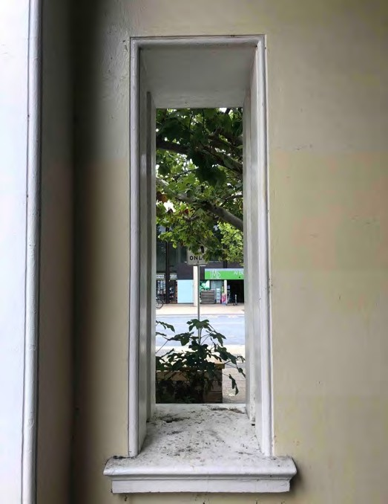

 |  | 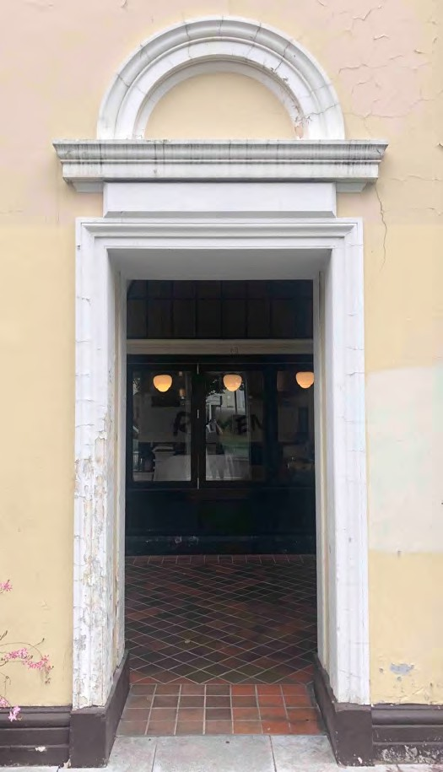
Rafters | 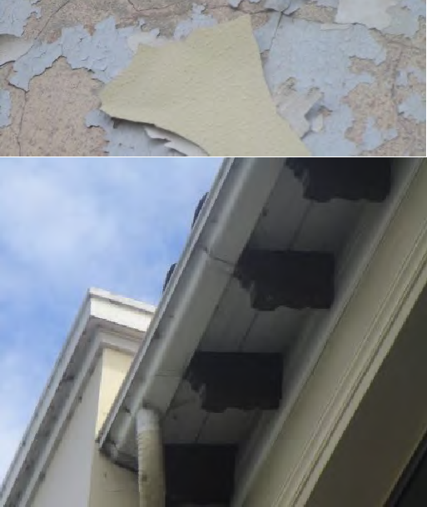  Painted timber, decorative moulding
Eaves | Painted V jointed timber boards | 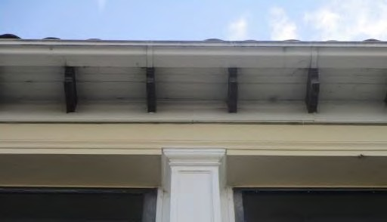
Front Roof Slope | Spanish (Cordoba) type terracotta tiles | 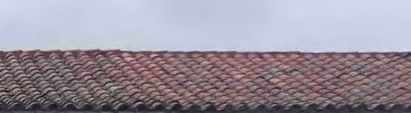

Fascia, gutters and downpipes | Painted timber fascia, OG profile painted galvanized steel gutter, painted galvanized steel round downpipes, on timber wall blocks. | 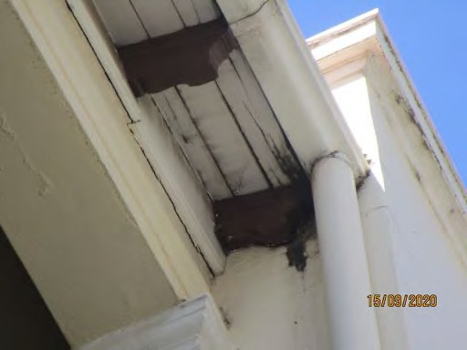
Rear Roof Slope | Spanish (Cordoba) type terracotta tiles | 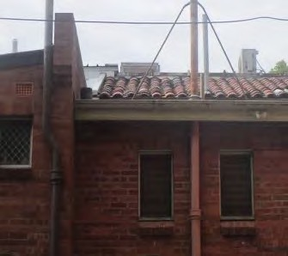
Rear Walls | Unpainted Canberra Red bricks
Windows to rear and facing laneways | Painted timber, various opening configurations | 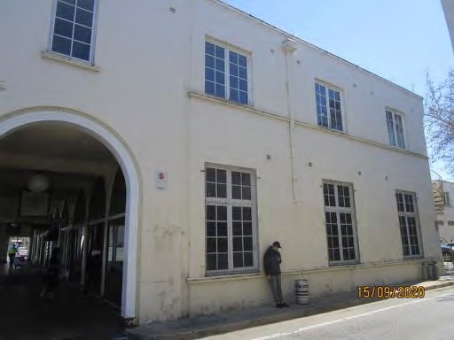  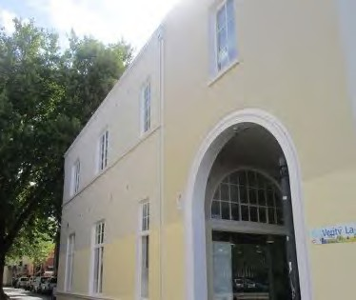

 |  | 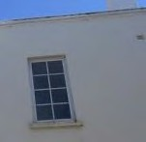
Doors to rear | Timber
Upper Verandah Floor | Hardwood boards on timber joists  Entire Sydney Building and part Melbourne Building.
Upper Verandah Floor | Painted, smooth trowelled off form concrete  Part Melbourne Building – West Row
Upper Verandah Walls | Rendered and painted masonry
Verandah Doors | Pairs of French doors (some with sidelights), painted timber frame, multi-paned | 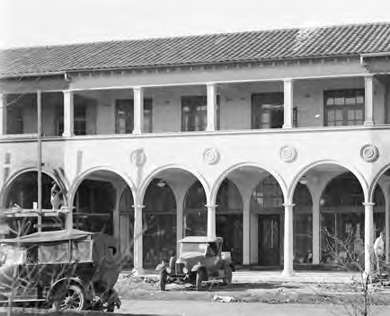  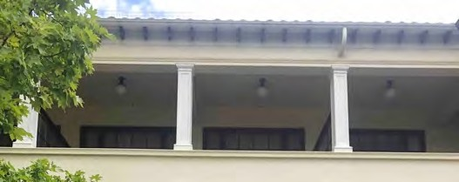
Verandah Beams | Rendered and painted concrete  beams, moulded edges, corbels at walls
Verandah Ceiling | Entire Sydney Building and part Melbourne Building - Painted asbestos cement sheeting, painted timber battens, painted  timber scotia mould at beams
Verandah Ceiling | Part Melbourne Building – West Row - Painted, smooth trowelled

 | off form concrete, small scotia cornice (in parts only)
Colonnade Floor | Smooth trowelled concrete with tooled joints forming a grid pattern | 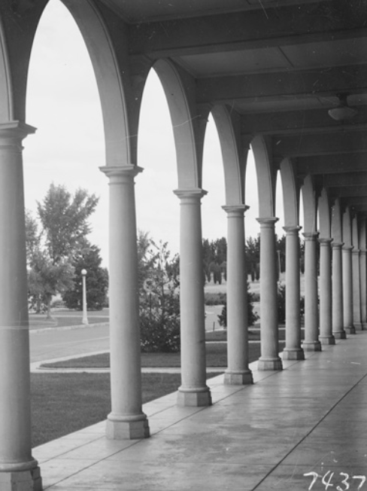  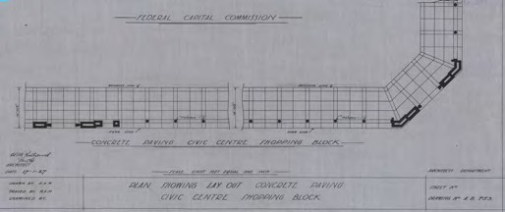
Colonnade Beams | Rendered and painted precast  concrete beams, moulded edges, corbels at walls | 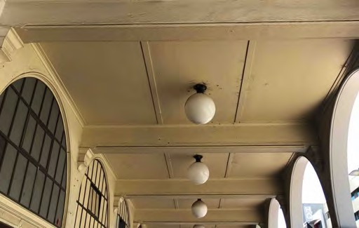
Colonnade Ceiling | Entire Sydney Building and Part Melbourne Building:  Painted asbestos cement sheeting, painted timber battens, painted timber scotia mould at beams
Colonnade Ceiling | Part Melbourne Building – West Row: Painted smooth off form concrete | 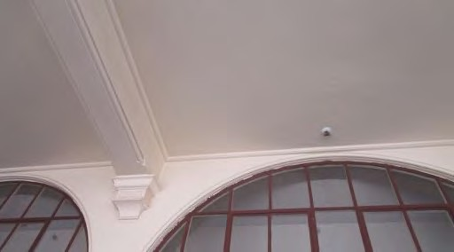
Downpipes | Painted galvanized steel across face of beams.  Somewhat random, not in every block | 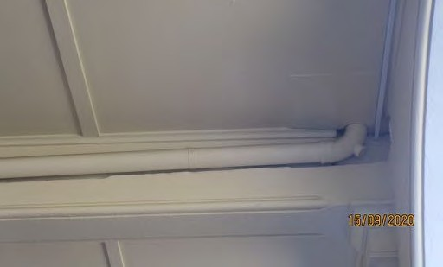

Skirtings | Polished black stone with subtle white veining, quarter splayed. Carrying across window bay and around pilasters in a continuous band. | 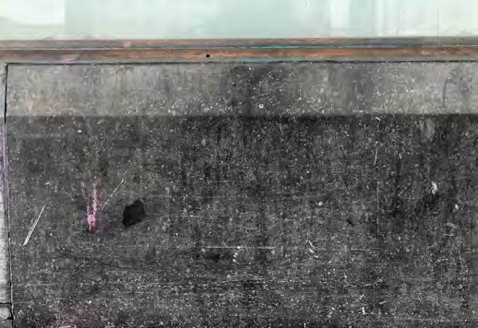  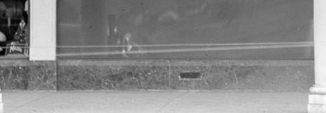
Ventilators | Brass with simple vertical slots, generally centred with one per arched bay | 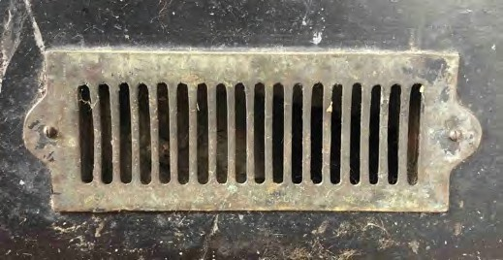
Door Thresholds | Polished black marble with white veining, bullnosed leading edge | 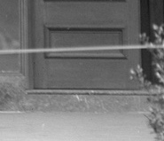
Inset Porches | Polished black marble with white veining, bullnosed leading edge
Walls | Rendered and painted masonry | 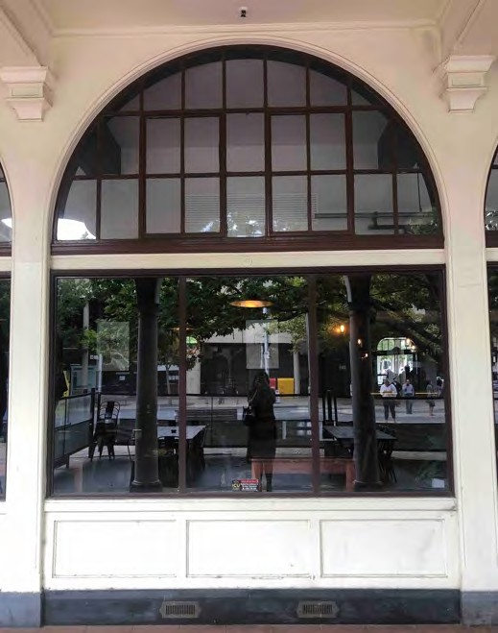
Walls | Painted precast concrete pilasters and arches, moulded edges

Shopfronts | Large plate glass windows with slender copper moulding | 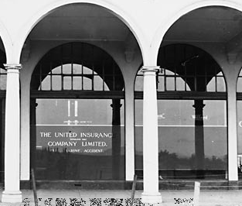  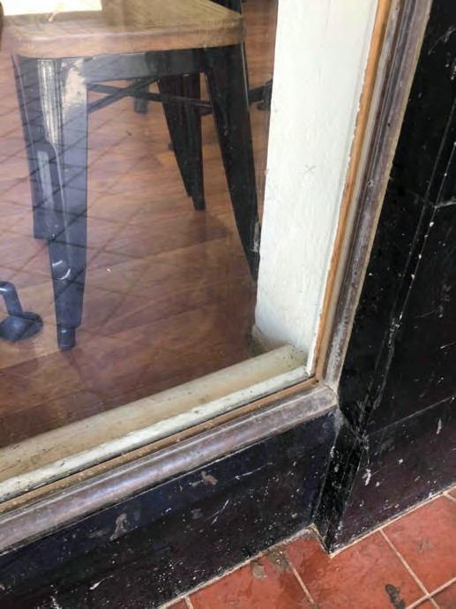  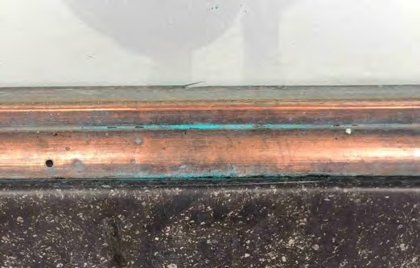

 |  | 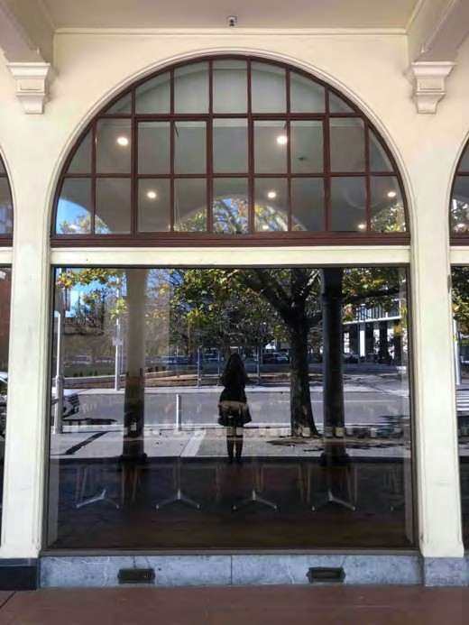
Doors | Painted timber frame, lower timber panel, upper glazed panel, timber mouldings.  Double doors and flanking sidelights to match plate glass windows in standard arched bays.  Single doors in recessed porches. | 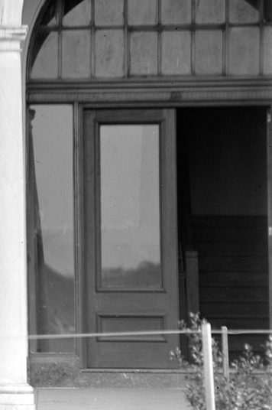
Decorative Frieze | Unpainted pressed copper with vertical fluting and centre bosses | 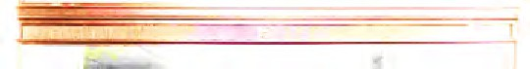
Highlight Windows | Unpainted copper frames, multi- paned, small hopper sashes | 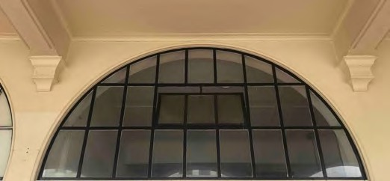

Lighting | On every second colonnade beam, ‘Schoolhouse’ type white glass fittings, metal collar. | 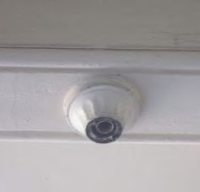  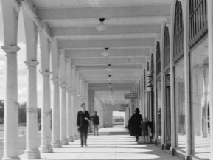
Lighting | To laneway arches and ceilings in centre portals, ‘Teardrop’ type white glass fittings, metal collar
Lighting | At mid-way interval on main façades, ‘Ball’ type fittings, white glass, metal collars fixed at centre of roundel. | 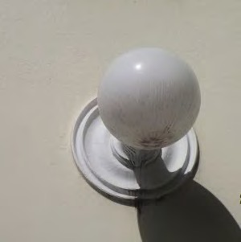  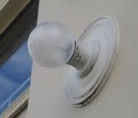

 | Flanking centre and corner portals, ‘Ball’ type fittings, white glass, metal collars fixed to flat wall. | 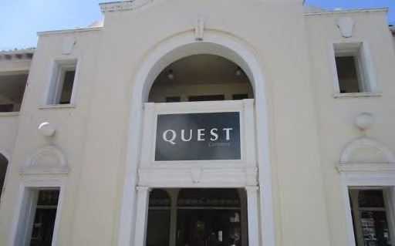  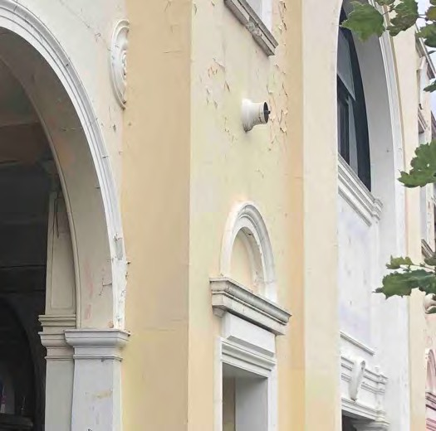
Signage |  | 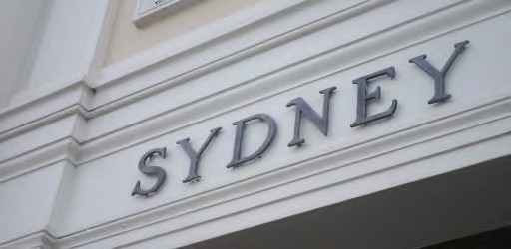
INTERIORS
Walls | Canberra red bricks, rendered and painted.
Main Floors | Hardwood boards on timber bearers and joists, brick piers | 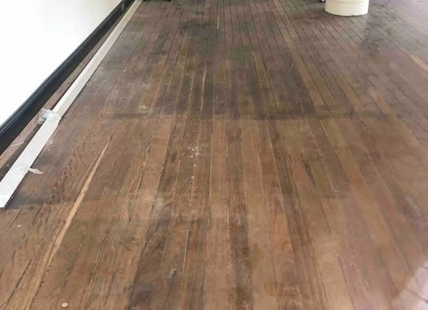
Ceilings | Painted plaster sheeting with decorative plaster cornice and  battens.

  - Original Colour Scheme
An historic paint finishes analysis was undertaken by Craftech Heritage Services on behalf of Philip Leeson Architects in 2020. This was an exercise specifically requested by ACT Heritage in the update of the CMP for the Sydney and Melbourne Buildings. Policy from the 2011 CMP stated that the exterior

colour scheme for the buildings should be validated by paint scrapes and once a scheme has been validated, no other colour or variation is to be used.
Methodology
Paint samples were collected on site by blade and small cold chisel, whereby a small crater or chip was made on a painted surface to reveal all the layers of paint back to the substrate. The crater was then viewed using a Light Lupe (illuminated magnifying lens) for a preliminary understanding of the colours below the outer most coat of paint. The samples were then set in resin, cut and polished to for detailed cross sectional analysis. The sectioned samples were analysed and photographed under magnification. Relevant samples were then colour matched and referenced to Australian Standards AS2700 -2011 Colour Standards for General Purposes.

The Australian Standard Colours AS 2700 – 2011 colour system is a selection of colours that were originally known as the British Standard colours and used to regulate the use of traditional colours. They represent a range with well-established usage in the industrial, architectural and decorative industries. Referencing to a standard paint colour system like AS2700 provides archival accuracy and ensures the reference colours will be accessible in the future as commercial brands remove colours and trends change. All Australian paint manufacturers and paint suppliers can produce the Australian Standards range or tint variations as required.
Information revealed about render
Sampling revealed that the façade was originally one uniform colour. Two consecutive applications of a cement based paint on the façade of the sampled shopfront was found, followed by conventional paint systems to the present-day including oil paints in some locations and modern acrylic emulsions. When the samples are compared with available historic documentation, they confirm that the Sydney and Melbourne Buildings were painted in a warm beige coloured cement paint with a stucco appearance (except for the inner skirting) until about 1960. The first cement-based paints were a colour slightly warmer than X42 Biscuit.

The first cement paint application typically would have included lime, Portland cement, water and powdered pigment, made to a paste and applied to a damp wall and cured. The second was a cement paint (probably Boncote) a new to the market product that satisfied the need for a permanent finish of the right look on exterior plaster / stucco / cement, fibro and brick fabric.

By the time opaque oil paints began to be applied, trim elements were being picked out to enhance the appearance. This started with turquoise on the column bases, then followed by black. The wall finishes were still showing as monotone / monochrome in the 1938 and 1942 photos in the CMP. The turquoise enhancement is a distinctly 1950-1960s colour.

The aberrant tones of turquoise, lime, orange, red etc. are probably related to the commercial activities and individual tenants’ preferences.
The current colour scheme does not reflect the traditional colouring or the architectural intent of the original colouring, which was to provide a Mediterranean influenced character in keeping with the architectural style. This was obtained with the choice of paint material and the colour of the paint. This paint was a soft, porous material with no gloss. It has visual characteristics and colouring that create subtle changes that occur with real stone, which absorbs water and darkens when damp and releases water and brightens when dry. The original paint material was cement paint composed of lime, pigment and a small portion of white cement. Modern versions of this traditional paint can contain a small portion on a polymer to prolong the life of the paint and allow it to adhere to imperfect substrates, including non- porous degraded paint layers.

The samples reveal later layers of thick oil-based and emulsion paints containing sand grains, which were probably applied in an attempt to ‘restore’ the original appearance of the original porous paint finishes.

Window frames and frieze detailing
The sample taken from the decorative copper frieze show a first layer of blue green (thin layer, patina). This is followed directly by a significant layer of soiling, indicating the frieze was unpainted for an extended period (approximately 30-40 years), the sample reveals and additional 5 layers of paint following the initial upainted period. It can be presumed that the original design intent is for the decorative copper freize to be unpainted.
The frame of the highlight windows was found to be copper channel with lead fill. The sample of copper has a layer of orange (patina) and micaceous mid grey (metal paint). The grey layer, as with the frieze, was applied a significant time after completion of the façade. It can be interpreted copper was intended to be the original outermost layer. The addition of the micaceous mid grey may have been to alter the copper appearance to a more bronze or pewter like look as times and trends changed.

Colour scheme
See also Colour Scheme 1 at section 6.5 Design Guidelines.The colour scheme detailed in the table below is based on a combination of the investigations undertaken by Craftech Heritage Services and an assessment undertaken by David Hobbes (where Craftech were unable to obtain samples).

Element | Colour / Specification
Rendered external walls | Cement-based paint with stucco appearance (see description above). AS2700 X42 Biscuit
Pilasters, mouldings, reveals, beams, lintels, corbels, beads, columns, capitals, spandrels, bulls-eye,
Colonnade Ceiling | AS 2700 X33 Warm White
Doors | AS2700 R63 Red Oxide
Rafters | AS2700 R63 Red Oxide
Eave Soffits | AS2700 Y35 Off White
Gutters | AS2700 R64 Deep Indian Red
Shopfront window frames | Copper (unpainted)
Frieze above doors | Copper (unpainted)
Highlight windows | Copper (unpainted)
Skirting and thresholds | Black marble (unpainted)

  - General Layout Plans
General layout plans for the Melbourne and Sydney Buildings are provided overleaf. For comprehensive architectural plans and elevations refer to the Appendix.

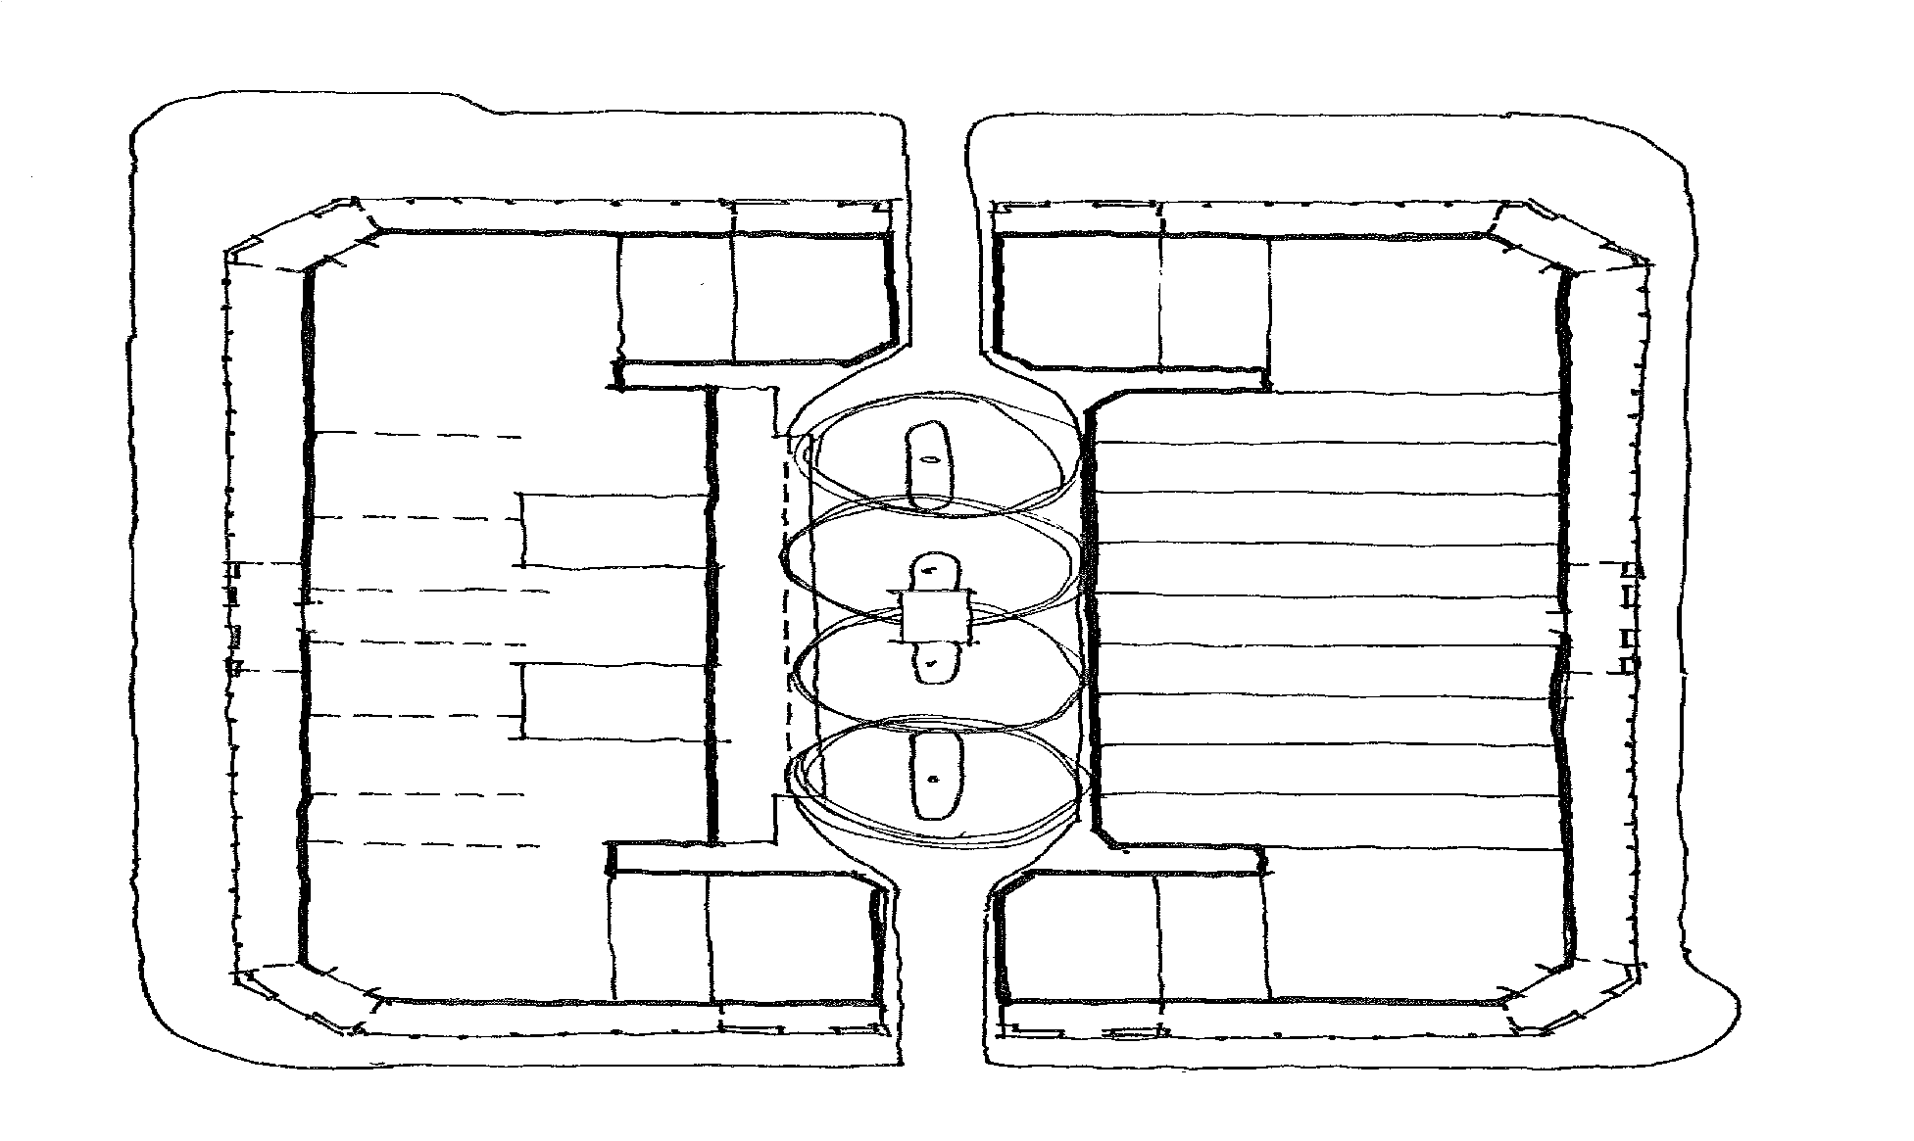
ALINGA STREET

verge

colonnade

B4 B5
ODGERS LANE
B6

facade line
B7 shopfront line

B8

first floor terrace
WEST ROW

B35

first floor terrace

sub- stn.
B9 B10 B11 B12 B13 B14
B15
NORTHBOURNE AVENUE

B20

B19

B18

B17
B16

Melbourne Building - General Layout Plan

LONDON CIRCUIT

Legend
 corner portal  laneway portal
centre portal

ALINGA STREET

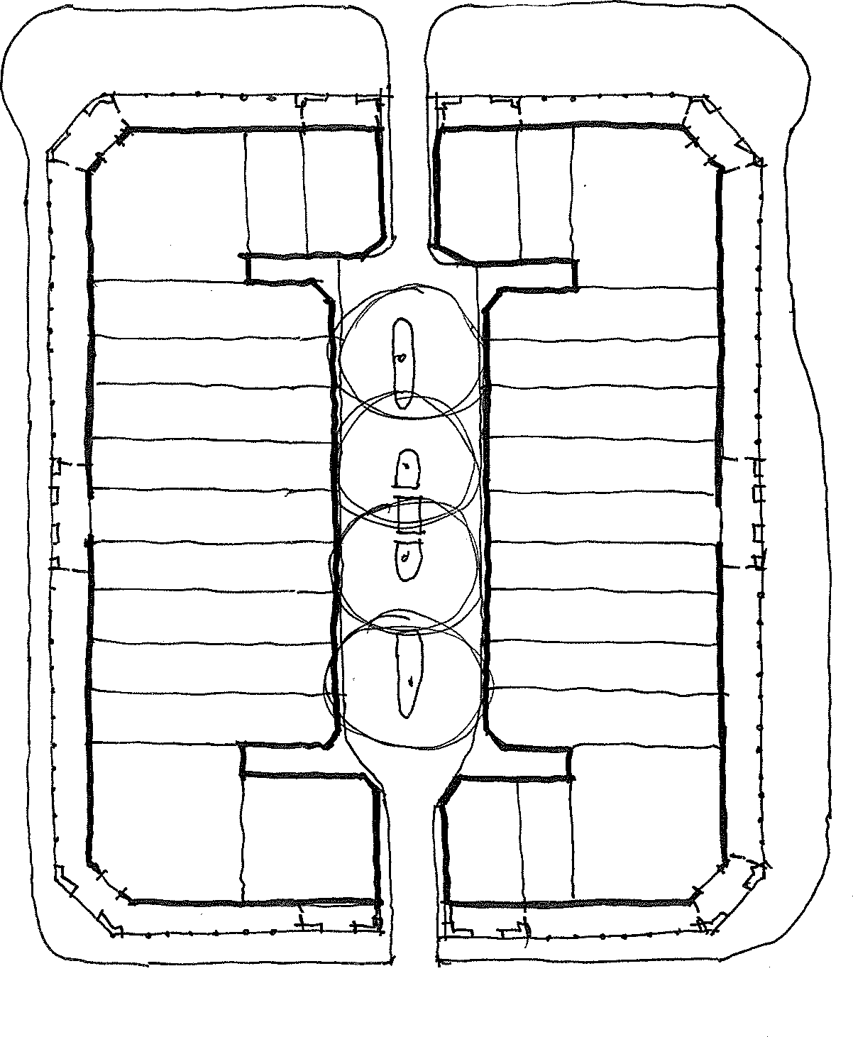
verge

colonnade
VERITY LANE

B1 B25 B5 B6 B26 B2

B9 B10 B11
NORTHBOURNE AVENUE
B12 B29 B13
B14

B15 B16

B17 B18 B19
B20

B30 B21
B22 B23 B24
facade line shopfront line

B3
B32

B31
B4
B28

Sydney Building - General Layout Plan
EAST ROW

LONDON CIRCUIT

Legend
corner portal laneway portal
centre portal

Analysis and Statement of Significance
  - Assessment Against ACT Heritage Significance Criteria
The following table presents the assessment of heritage significance HERCON Criteria as adapted for the ACT and effective from October 31, 2014.

    - importance to the course or pattern of the ACT’s cultural or natural history;
The Sydney and Melbourne Buildings are of some historic value as commercial buildings associated with the early development of Canberra as the national capital. This value is shared by commercial buildings in Braddon, Kingston and Manuka which were also developed in the 1920s. While these other developments were substantial, the Sydney and Melbourne Buildings were the major development in Canberra City which was intended at the time as the commercial centre for the new city.
The Sydney and Melbourne Buildings have played and continue to play an important role in defining Canberra City. They established the early character and scale of the city’s retail and business area. From the 1920s until at least the late 1950s the Sydney and Melbourne Buildings were the first major development in Canberra City and provided its focus. For some portion of this time, these were the only shops in the City Centre. While they continue as a landmark in Canberra City, other development since 1960 has diffused the focus of commercial activity and changed the character and scale of Canberra City. The role of the Sydney and Melbourne Buildings has been diminished by this other development.

The Sydney and Melbourne Buildings meet this criterion.
    - has uncommon, rare or endangered aspects of the ACT’s cultural or natural history; There are several possible values arising under this criterion. The Sydney and Melbourne Buildings are rare as large- scale commercial buildings dating from the early decades in the development of the national capital. They compare with developments in Kingston and Manuka also from the 1920s, such as the J B Young’s store and the Manuka Arcade.

The Sydney and Melbourne Buildings are rare in Canberra being large-scale examples of Inter-War Mediterranean style buildings. Most other buildings of this style are houses, and the Administration Building at Mount Stromlo is the only other large-scale example.
The Sydney and Melbourne Buildings are also unique in Canberra in the form of development – as the block by block development was undertaken by individual leaseholders working to an overall design. No other such example is known to exist in Canberra. Normally buildings would have been, and continue to be, substantially developed by one government or private owner. The different approach in this case partly reflects the special circumstances of Canberra as a city built for and under the close control of government.
The Sydney and Melbourne Buildings display a moderate degree of integrity but this does not seem a rare or unique quality.

The Sydney and Melbourne Buildings meet this criterion.
    - potential to yield information that will contribute to an understanding of the ACT’s cultural or natural history;
The Sydney and Melbourne Buildings have contributed to some degree to an understanding of the cultural history of the ACT, and they have the potential to make a greater contribution. However, it is not clear if this has been a significant contribution to a wider understanding. In addition, there is nothing to distinguish the Sydney and Melbourne Buildings from the potential of any other heritage place in the ACT to play such a role.

The Sydney and Melbourne Buildings do not meet this criterion.

    - importance in demonstrating the principal characteristics of a class of cultural or natural places or object
The Sydney and Melbourne Buildings are examples of the Inter-War Mediterranean style, and they display a large number of style indicators including:

- light-coloured smooth walling to all street facades and flanking laneway entries;
- medium pitch roof of Cordova pattern tiles to front roof slopes;
- exposed scrolled rafter ends;
- round arches;
- arcaded loggia (the colonnades);
- formal pedimented entrance portals with decorative crests; and
- arched highlight windows.
This style is displayed by a number of Canberra buildings, especially houses. These are:
- Administration Building and houses, Mount Stromlo Observatory Precinct (1926-29);
- Calthorpes’ House (1927);
- Murray Crescent Precinct (1933-34);
- Curator’s Cottage at Manuka Oval (1937); and
- Houses in Barton, Forrest, Griffith and Reid conservation areas.
Many of these buildings are good examples of the style. In this context, the Sydney and Melbourne Buildings are also good examples, and are of added interest for the larger scale of the composition compared to the other examples.

The Sydney and Melbourne Buildings might also be considered in the context of commercial buildings as a class of places. However, there is insufficient information about such a class and its characteristics to enable a meaningful assessment at this time.
The Sydney and Melbourne Buildings meet this criterion.
    - importance in exhibiting particular aesthetic characteristics valued by the ACT community or a cultural group in the ACT;
The Melbourne and Sydney Buildings’ design and details exhibit particular aesthetic characteristics, which were inherent in the original design and are valued by the community today.
The Sydney and Melbourne Buildings meet this criterion.
    - importance in demonstrating a high degree of creative or technical achievement for a particular period;
The Sydney and Melbourne Buildings display a degree of creative achievement through their planning and architectural style, and as important elements in a broader town planning composition. However, while this achievement is substantial, it does not appear to meet the high level required by this criterion.
The Sydney and Melbourne Buildings do not meet this criterion.

    - has a strong or special association with the ACT community, or a cultural group in the ACT for social, cultural or spiritual reasons;
The Sydney and Melbourne Buildings may have social values for the wider Canberra community related to their landmark qualities as well as strong and special associations because of the social, commercial and government uses over a long period of time. However, no research has been undertaken to substantiate such values.

There is currently insufficient information to assess the Sydney and Melbourne Buildings against this criterion
    - has a special association with the life or work of a person, or people, important to the history of the ACT.
The Sydney and Melbourne Buildings are associated with a range of individuals, notably Sir John Sulman, and other architects J H Kirkpatrick, J S Murdoch, H M Rolland and D E Limburg. All of these architects played a substantial role in the development of Canberra.
Sulman is an important historical figure in Australia, and part of this relates to his role with the Federal Capital Advisory Committee in the development of Canberra (see Apperly and Reynolds 1990). While the FCAC had limited success, it is an important phase in the story of the development of the national capital. Sulman is associated with the design of many buildings, however in the case of Canberra he arguably has a special association with two places – Old Parliament House, being a key advocate for the building, and the Sydney and Melbourne Buildings where he prepared the concept design. These two places perhaps best present substantial and tangible evidence of his influence in Canberra.

Kirkpatrick has an association with the Sydney and Melbourne Buildings as the design architect who realised Sulman’s concept. However, it is not clear this is a strong or special association with Kirkpatrick – mindful that every architect has an association with the buildings they design or contribute to. In addition, Kirkpatrick’s historical importance seems modest. His other notable associations are through the design, with others, of the former Australian Forestry School (1927) and Albert Hall (1928). On balance, the association with Kirkpatrick does not seem sufficient to meet this criterion.

The role of Murdoch, Rolland and Limburg in the design of the Sydney and Melbourne Buildings appears to have been much less substantial, and therefore not strong or special.

The Sydney and Melbourne Buildings meet this criterion.
  - Statement of Heritage Significance
The Sydney and Melbourne Buildings have a range of heritage values related to their architectural style, large scale as commercial buildings from the period, unique form of development, and historical associations.

The Sydney and Melbourne Buildings are significant as good examples in Canberra of the Inter-War Mediterranean style and are of added interest as large-scale examples in this style. This style was one the distinctive designs used in the early decades of the development of Canberra as the national capital and use of the style declined after the 1930s.

The Sydney and Melbourne Buildings are rare as:
- large-scale commercial buildings dating from the early decades in the development of the national capital; and
- as large-scale examples of Inter-War Mediterranean style buildings.
The Sydney and Melbourne Buildings are also unique in Canberra in the form of development – as the block by block development was undertaken by individual leaseholders working to an overall design. The different approach in this case partly reflects the special circumstances of Canberra as a city built for and under the close control of government.
The Sydney and Melbourne Buildings are of historic value as commercial buildings associated with the early development of Canberra as the national capital. While there were other substantial developments in Canberra from the same period, the Sydney and Melbourne Buildings were the major development in Canberra City, which was intended at the time as the commercial centre for the new city.

The Sydney and Melbourne Buildings have played and continue to play an important role in defining Canberra City. They established the early character and scale of the city’s retail and development in Canberra City and provided its focus. While they continue as a landmark in Canberra City, other development since 1960 has diffused the focus of commercial activity and changed the character and scale of Canberra City. Accordingly, the role of the Sydney and Melbourne Buildings has been diminished.
The Sydney and Melbourne Buildings have a strong and special association with the architect Sir John Sulman. Sulman is an important historical figure in Australia, and part of this relates to his role with the Federal Capital Advisory Committee in the early development of Canberra in the 1920s. Sulman prepared the concept design for the Sydney and Melbourne Buildings, and they are one of only two places in Canberra that perhaps best present substantial and tangible evidence of his influence in Canberra.

The Melbourne and Sydney Buildings’ design and details exhibit particular aesthetic characteristics, which were inherent in the original design and are valued by the community today.

  - Features Intrinsic to the Significance of the Place
According to the ACT Heritage Register Entry, Features Intrinsic to the Significance of the Place comprise:
    - Exterior façade of the Melbourne and Sydney Buildings;
    - Remaining original interiors;
    - Central courtyards and remaining internal lightwells; and
    - London Plane trees (Platanus x acerfolia) in the interior courtyards of both buildings.
For the purposes of additional guidance, the CMP authors consider the following features of the place to be Significant, Neutral and Intrusive respectively. For block specific detail relating to each shopfront refer to the Individual Block Inventories in Appendix B.

Significant Features
The prominent setting and landmark qualities of the Sydney and Melbourne Buildings, as well as their planned relationship to each other, Northbourne Avenue and City Hill.
The large scale and commercial character of the Sydney and Melbourne Buildings, evidenced by shopfronts and signage.
The overall form of the Sydney and Melbourne Buildings generally defined by the street façades, the recessed colonnades, the shopfront alignment, the eave line and front roof slope to the main ridge,
the rear block boundaries and the central courtyards.
Fabric related to the Inter-War Mediterranean style, including:
- light-coloured smooth walling to all street facades and flanking laneway entries
- medium pitch roof of Cordova pattern tiles to front roof slopes
- exposed scrolled rafter ends
- round arches
- arcaded loggia (the colonnades)
- formal pedimented entrance portals
- arched highlight windows and hopper sashes
Other classical references displayed by the Sydney and Melbourne Buildings including:
- the rhythmical arcade design with pavilions featuring pedimented parapets and central arches punctuating the arcades
- decorative moulded edges to arches, beams and pilasters
- cast roundels, shields, scrolls and corbels on the exterior walls within and above the colonnades
- painted rendered spandrel panels below windows in parts of Melbourne Building
- surviving original shopfront elements including black marble skirtings, bullnosed black marble thresholds, brass ventilators, metal framed plate glass windows

- surviving open first floor verandahs
- surviving pairs of French doors and painted rendered walls abutting first floor verandahs
Other planning attributes including:
- the evidence of original blocks demonstrated by party walls and shopfronts
- the central courtyards defined by the rear block boundaries
- the laneway openings to London Circuit and Alinga Street
- the original / early electrical substation in the Melbourne Building courtyard
- the London Plane trees in the courtyards
Other original details which contribute to the overall architectural design:
- lighting locations in the colonnades, façade and laneway arches
- board and batten ceilings to colonnades generally
- painted off form concrete ceilings to colonnades in West Row
- painted V jointed timber boarding to eave soffits
Surviving original interior elements including:
- the overall volumes of the main basement, ground and first floor spaces
- lobbies and stairs to basements and first floors
- plaster ceilings and decorative cornices
Neutral Features
Modern yellow terrazzo thresholds to parts of the Melbourne Building
Modern traditional style painted timber panelled doors and windows
Some modern frameless or minimally framed plate glass shopfronts
“Pill” type signage fixed to walls in various locations “Drop” type signage in parts of Melbourne Building
Unobtrusively framed tinted glazing to first floor verandah openings
Modern garbage enclosures to rear courtyards
Intrusive Features
Bitumen and quarry tiled colonnade paving
Unsympathetic services and fixtures including:
- security alarms
- CCTV Cameras
- air conditioners
- roof mounted plant visible above main ridge line
- sprinklers
- speakers
- heaters
- power and light switches
- light fittings
- surface conduits
- flagpoles and redundant fixings at corner portals
Redundant non original services and fixings including:
- power and light points and conduits
- former awning and signage fixings
Modern cladding including:
- tiles, clear or painted over
- plywood, custom wood and metal sheeting
- timber boards
- steel thresholds
Unsympathetic signage on entry portals, colonnades and shopfronts
Unsympathetic gutter materials and profiles
Unsympathetic downpipe materials, profiles, fixings and locations

Unsympathetic modern shopfronts – Refer to Individual Block Inventories
Painted over shopfronts and highlights
Poorly repaired intrinsic features including roughly rendered pilasters
Highlights blocked by lowered ceilings behind them
Unsympathetic changes to highlights
Unsympathetic windows to first floor verandahs and laneway entries
Concrete kerbs to rear courtyards which are affecting the roots of the Plane trees

Opportunities and Constraints
This section identifies other important factors to be considered in the formulation of suitable Conservation Policies for the conservation and management of the place.

  - Conservation of Intrinsic Features
There are both opportunities and constraints arising from the need to conserve features intrinsic to the heritage significance of the place.
The heritage significance of the place creates an opportunity for the Sydney and Melbourne Buildings to be coherent places of strong historic character, upon which they can trade commercially and upon which Canberra City can trade as a destination.

The requirement for conservation of these features constrains flexibility in establishing character other than the historic character. This suggests the need for compatible uses. There are also costs associated with restoration and repair where features intrinsic to the significance of the place are damaged or lost.

  - Current Condition and Integrity
Façade Refurbishment Documentation was prepared by David Clarke Architects in 2008. This generally covered replacement of unsympathetic or damaged gutters and downpipes, cracked and damaged render repairs, removal of intrusive fabric etc. The 2020 site inspections revealed that very few of these recommendations have been actioned, revealing challenges in translating, coordinating and/or funding works.

Below are general descriptions only. Refer to individual Block Inventories in Appendix B for specific façade, colonnade and shopfront information.

Element | Description | Condition Description | Condition P - Poor  F - Fair  G - Good | Integrity H – High M – Mod.  L - Low
Façade Walls | Rendered masonry | Many areas sound | F | H
Façade Walls | Rendered masonry | A number of fair to moderate  movement cracks | F | H
Façade Walls | Rendered masonry | Several areas of spalling render | P | H
Façade Walls | Rendered masonry | Many areas of peeling paint. | P | H
Mouldings | Painted off form concrete  corbels, roundels, scrolls | Several sections chipped | F | H
Verandah Openings | Some original open verandahs with pairs of French doors in  masonry wall | Most areas sound | G | H
Verandah Openings | Many instances of tinted glazing in unobtrusive frames – some rear walls and  doorways intact, most not intact | Most areas sound | G | L

 | Some 1950s style steel framed windows | Most areas reasonable | F | L
 | Some 1950s style steel framed windows | Some areas rusting, paint peeling | F/P | L
Eave soffits | Painted V jointed  timber boards | Some sections rotten, boards  missing, poorly patched | F | H
Rafters | Exposed, scrolled  detail, painted timber | Some peeling paint, several  rafters rotten | F | H
Eave Gutters | Painted galvanized “Ogee” profile | Many areas sound | G | H
Eave Gutters | Painted galvanized “Ogee” profile | Some areas rusted, deformed | P | H
Eave Gutters | Modern Colorbond | Most areas sound | G | L
Downpipes | Painted rectangular gal. steel | Most areas sound Some areas rusted  Some areas deformed, missing brackets | F | H
Downpipes | Modern Colorbond | Most areas sound | G | L
Downpipes | Modern round PVC | Most areas sound, some  missing brackets | F | L
Front roof | Original “Cordova” style terracotta tiles | Some chipped/broken tiles | F | H
Front roof | Modern reproduction “Cordova” style tiles, particularly SE corner  of Sydney Building. | Generally sound | G | L
Rear roofs | A few areas of original “Cordova” style  terracotta tiles. | Some chipped/broken tiles | F | H
Rear roofs | Various later roof  forms and materials | Various conditions | G/F/P | L
Colonnade inside walls | Painted rendered masonry | Several areas of spalling render many areas of peeling  paint. | F | H
Colonnade floor | Tiles or bitumen over original tooled  concrete | Bitumen worn, tiles chipped, cracked, missing grout | P | L
Colonnade floor |  | Lack of proper drainage behind walls at corner, centre  and laneway portals. | P | NA
Colonnade  Beams | Painted render,  moulded edges | Cobwebs, some chips | F | H
Verandah Drainage | Painted gal.steel downpipes on face of  Colonnade beams | Many sections loose, rusted, missing brackets | P | L
Colonnade Ceilings | Painted asbestos  cement sheet and timber battens | Some sections replaced  Some panels split or bowed Some battens rotted | F | H
Colonnade Ceilings | Painted off form concrete | Some peeling paint | G | H
Shopfront Glazing | A few sections of original oxidized brass  frames and plate glass windows | All sections sound | G | H
Shopfront Glazing | Various shopfronts | Various conditions | G/F/P | L/S

Doors | Various | Various conditions | G/F/P | L/S
Skirtings | Some sections of original black marble  skirting | Generally sound | G | H
Skirtings | Some sections of  reproduction black marble skirting | Generally sound | G | S
Skirtings | Various later skirting  types | Various conditions | G/F/P | L/S
Ventilators | Some sections of original brass  ventilators | Generally sound | G | H
Ventilators | Various later vent  types | Various conditions | G/F/P | L/S
Shopfront upper walls | Painted rendered masonry
Shopfront Pilasters | Painted render, moulded edge detail | Many areas sound. Several areas covered with tiles,  Some areas poorly patched | F | M
Frieze | Painted embossed copper | Most areas sound.  Several areas covered up with unsympathetic boards, signs etc.  Some areas replaced – some sympathetic, some not | F | H/M
Highlights | Painted metal frames,  multi-paned, hopper sashes
Rear walls | A few original  “Canberra Red” brick walls. | Generally sound | F | H
Rear walls | Later “Canberra Red” brick walls | Mostly sound. Some | F | L
Rear Openings | Some original double hung windows, glass louvred windows,  timber doors. | Mostly sound | F | H
Rear Openings | A variety of later timber and metal door  and window openings | Various conditions | G/F/P | L

  - Interpretation
A wealth of historical information has been collected about the Sydney and Melbourne Buildings and about individual blocks which is recorded within the history in Appendix C. There are also some wonderful photographs and drawings of various aspects of the Sydney and Melbourne Buildings held by the National Archives of Australia and the National Library. Owners are also able to access original drawings of their block through access to their Building File, a copy of which is usually included in a contract of sale.

There is an opportunity for owners, tenants and the other stakeholders to use this detailed information about the place to promote the unique character and history of the Sydney and Melbourne Buildings through interpretation. Opportunities might include for example:
- Sharing of stories and photographs through social media;
- Walking tours and staging of historical events such as part of the Heritage Festival;
- Inclusion of the Sydney and Melbourne Buildings in the Canberra Tracks program;
- Interpretation of lost or obscured design elements in development proposals;
- Identifying community connections with the place through a social media campaign;
- Continued use of the shopfronts and colonnades for uses connected with historical use.
In several instances historic photographs have been used successfully in shop windows at the Sydney and Melbourne Buildings. These photographs attract attention and interest from passersby, and there is an opportunity to expand this practice where there is a desire to partly obscure the view through shopfront windows.

There are only very few opportunities for signage plaques to be fixed to the walls of the Sydney and Melbourne Buildings, and there are existing historical signs in several locations already inside the colonnades. Interpretation in the form of signs fixed to walls is constrained by the need to conserve building fabric and should be avoided.
There is an opportunity for a comprehensive Interpretation Plan for the place to be developed as part of a wider scale promotion of the unique features of the Sydney and Melbourne Buildings.

  - Statutory Obligations
There are various pieces of legislation relevant to management and use of the Sydney and Melbourne Buildings. Their general content and relevance from an opportunities and constraints point of view has been outlined below.
Heritage Act 2004 (ACT)
The Sydney and Melbourne Buildings are registered under section 41 of the Heritage Act 2004 and the planning authority must therefore refer development applications to the ACT Heritage Council. This Conservation Management Plan has been prepared for approval under the Heritage Act 2004 and will be referred to in assessment of Development Applications.

The main objectives of the Act are:
- To establish a system for the recognition, registration and conservation of places and objects that have cultural heritage significance;
- To establish the heritage council;
- To provide for heritage agreements to encourage the conservation of heritage places and objects;
- To establish enforcement and offence provisions to provide greater protection for heritage places and objects; and
- To provide a system integrated with land planning and development to consider development applications having regard to the heritage significance of places and heritage guidelines.
A function under the Act must be exercised in a way that achieves the conservation of the place with heritage significance and the maximisation of the community’s ability to benefit from the place, without adversely affecting the ongoing conservation of the place. There is an opportunity to maximise the community’s ability to benefit from the place within the constraints of conservation.
The ACT Heritage Council is established by the Act. Council membership must include experts in fields including architecture, history, urban design etc. (6), at least one public representative of the community

- and of the property ownership, management and development sector (1), the conservator of flora and fauna, and the chief planning executive. The role of Council is:
  - To identify, assess, conserve and promote places in the ACT with natural and cultural heritage significance.;
  - …
  - …
  - To advise the Minister about issues affecting the management and promotion of heritage;
  - To encourage and assist in appropriate management of heritage places and objects;
  - To encourage public interest in, and understanding of, issues relevant to the conservation of heritage places and objects;
  - To encourage and provide public education about heritage places and objects;
  - To assist in the promotion of tourism in relation to heritage places and objects;
  - And j) etc.
There is an opportunity for stakeholders in the Sydney and Melbourne Buildings who are representative of the community or of the property ownership, management and development sector to join the ACT Heritage Council and advocate for positive outcomes for the place. There is also an opportunity for stakeholders to request that the ACT Heritage Council advocate on their behalf for promotion of tourism focused on the Sydney and Melbourne Buildings and to encourage public interest in and pride for the place.
The Act provides for establishment of the heritage register, and for corrections and changes to be made to the heritage register where Council is satisfied that the change is in the interests of maintaining up-to- date, comprehensive and accurate information in the register. While the heritage registration for the Sydney and Melbourne Buildings sets out the basis for heritage constraints for the place, there is an opportunity to apply to correct the register if it becomes apparent that the registration entry is not accurate.
There is an opportunity to engage with ACT Heritage to seek written advice on a development proposal prior to or independent of the submission of a formal Development Application. The Planning and Development Act 2007 provides that:
- the ACT Heritage Council be given a copy of certain development applications;
- the Council give advice to the planning and land authority about the effect of a development on the heritage significance of a place, and
- the Council’s advice must be considered by the planning and land authority in approving or refusing to approve a development application.
Advice may set out proposed conditions on any approval of the development including conditions requiring compliance with a conservation management plan approved by the Council.
If a tree or trees form an important part of a place with heritage significance, as is the case with the London Plane trees in the laneways, Council must provide advice on tree protection notices received from the conservator under the Tree Protection Act 2005. The London Plane trees are a feature intrinsic and as such need to be conserved under the Heritage Act 2004. The advice must include an outline of the effect of the proposed tree damaging activity or tree management plan and advice about ways of avoiding or minimising the harm of the activity, or risks associated with the plan, for the tree or place.
This poses a constraint on tree management, and evidence about impacts is likely to be requested from the applicant. Any proposal for tree removal will require a SHE approved by the Council1.

There are constraints on activities (development or otherwise) carried out at the Sydney and Melbourne Buildings. Development is as defined in the Planning and Development Act 2007 (PDA 2007). The Heritage Register entry lists the features of the place which are of heritage significance and are to be

1 Note that approval under the Tree Protection Act 2005 does not constitute a s75 defense against a s74 offence under the Heritage Act 2004.

conserved (Features Intrinsic). Works that may diminish the heritage significance of these features and the place, are where a Statement of Heritage Effect will be required.
The opportunity arises for the Council’s approval decision on a CMP to identify that anything explicitly supported in the CMP is consistent with the Heritage Act 2004 and in the Council’s opinion meets the exempt development criteria for heritage.

A Statement of Heritage Effect (SHE) application must be made to Council in writing where an activity that is likely to diminish the heritage significance of the place is proposed. The SHE must set out:
- a description of the place or object,
- details about the proposed activity, including the reason for the activity and the extent and duration of the activity;
- the likely effect of the proposed activity on the heritage site, including the effects that may diminish the heritage significance of, or damage, the heritage site;
- the measures the applicant will adopt during the activity to reduce the risk of diminishing the heritage significance of, or damage to, the heritage site; and
- whether other reasonably practicable ways of carrying out the activity at the heritage site are available.

Council may direct a person or entity to make an application for approval of a SHE, and the person or entity may only start the activity if the Council approves a SHE for the activity. The Council must approve the SHE if satisfied on reasonable grounds that the proposed activity is justifiable and that the applicant has identified reasonable steps to reduce the risk of diminishing the heritage significance, or damage to, the heritage site.
The Flowchart below has been developed for this CMP to assist proponents in understanding the
Heritage Act 2004 approvals process for development proposals.
Develop scope of works in keeping with heritage significance
↓
Review the proposed works against the approved CMP
↓ ↓ ↓

OR OR
Works do not comply with one or more CMP policy
Works comply with all of the CMP policies
Works are recommended Conservation Works in the CMP

↓ ↓ ↓
Prepare a Statement of Heritage Effect and lodge with the ACT Heritage Council for Approval
Document the location and extent of works and seek ACT Heritage Council Approval
Confirm with ACT Heritage that no further Approval is required under the Heritage Act 2004
↓ ↓
Not Approved
Approved
↓ ↓

Provide ACT Heritage Council Advice to ACT Planning or to Certifier as evidence of Approval
Reformulate scope of works in keeping with heritage significance
The Heritage Act 2004 requires that works at heritage places be carried out in accordance with the Register entry (including any ‘Specific Requirements’), and Guidelines published for the place, and general Council policies such as ‘General Conservation Policy 1 – External Solar, Water, Air conditioning and other Services in Heritage Places.’

The Act also contains provisions for heritage directions, heritage orders, repair damage directions, offences, penalties and heritage agreements. A person commits an offense if the person engages in conduct that diminishes the heritage significance of a place and is reckless or negligent about whether the conduct would diminish the heritage significance of the place. This is an obligation that constrains owners and managers of the Sydney and Melbourne Buildings to conserve the heritage significance of the place.
Tree Protection Act 2005 and ACT Tree Register
The London Plane trees in the interior courtyards of Odgers and Verity Lanes are registered trees on the ACT Tree Register and are thus protected trees under the Tree Protection Act 2005. Given the constraint that the trees must be conserved, there is an opportunity to reorient the central courtyards to celebrate their presence. The street trees are not included within the heritage registration boundary.
The objects of the Tree Protection Act 2005 are –
- to protect individual trees in the urban area that have exceptional qualities because of their natural and cultural heritage values or their contribution to the urban landscape; and
- to protect urban forest values that may be at risk because of unnecessary loss or degradation; and
- to protect urban forest values that contribute to the heritage significance of an area; and
- to ensure that trees of value are protected during periods of construction activity; and
- to promote the incorporation of the value of trees and their protection requirements into the design and planning of development; and
- to promote a broad appreciation of the role of trees in the urban environment and the benefits of good tree management and sound arboricultural practices.
Registered trees
The four plantings of London Plane tree in Odgers Lane behind the Melbourne Building on Section 1 City are Registered Trees number RT 256B on the ACT Tree Register. The four plantings of London Plane tree in Verity Lane behind the Sydney Building on Section 48 City are Registered Trees number RT0256A on the ACT Tree Register. Their height is approximately 16m and the broadest canopy diameter is 12m. Their species is recorded as Platanus x hispanica syn. Platanus x acerifolia (London Plane).
Two registration criteria apply:
- Natural or cultural heritage value. These trees are of particular importance to the community due to their intrinsic heritage values.
- Landscape and aesthetic value. These trees are of particular importance to the community due to their substantial contribution to the surrounding landscape.

The tree register must include the tree management plan (if any) for the tree. As none is available on the register, it is assumed that no tree management plan exists for these trees.
Regulated trees and tree protection
A regulated tree is a living tree that is not a pest plant under the Pest Plants and Animals Act 2005, and:
  - is 12m or more high, or
  - has a trunk with a circumference of 1.5m or more at 1m above natural ground level, or
  - has 2 or more trunks and the total circumference of all the trunks at 1m above natural ground level is 1.5m or more, or
  - has a canopy 12m or more in width.
Tree damaging activities
The major constraint for the London Plane trees in Odgers and Verity Lanes is that unless specific approval is granted by the conservator under the Act, a person commits an offence by:

- Damaging a protected tree, defined as killing, destroying, poisoning, ringbarking, felling or removing, cutting branches or stems between branch unions, removing branches to a previously pruned or lopped point, major pruning, or anything else that causes the tree to die or significantly reduces its expected life or significantly and adversely affects its health, stability or general appearance.
- Undertaking prohibited groundwork in the tree protection zone, defined as contaminating the soil with something that is poisonous to trees, or cutting any of the tree’s roots in the protection zone that have a diameter greater than 50mm, or either excavating to a depth greater than 10cm or raising the soil level by more than 10cm above the natural soil level over an area 4m2 or larger, or anything else prescribed by regulation.
The conservator may give anyone undertaking an activity that may affect a protected tree a written direction to do or not do something for the protection of the tree. There are provisions for approval in urgent circumstances or for minor works, as well as for cancellation of approval where the conservator is satisfied that the activity approved no longer satisfies the approval criteria.
Tree protection and tree management plans
Activities in the Odgers and Verity Lane courtyards are constrained by the requirement to protect the London Plane trees therein. A person may apply, in writing, to the conservator for approval for an activity that would or may damage a protected tree or be prohibited groundwork in the protection zone for a protected tree or a declared site.

A protection zone may be defined in a tree management plan for the protected tree. In the absence of a tree management plan, the protection zone for a protected tree is –
  - The area under the canopy of the tree; and
  - The 2m wide area surrounding the vertical projection of the canopy; and
  - The 4m wide area surrounding the trunk as measured at 1m above natural ground level.
A tree management plan may provide for activities to be undertaken in relation to a tree and may set out conditions about how the activities are to be undertaken. Anything done in relation to a protected tree in accordance with a tree management plan for the tree is an exception to the tree damaging and prohibited groundwork offences. A tree management plan would be required if work was proposed in and around the London Plane trees in the Verity and Odgers Lane courtyards.
Interaction with other legislation
An activity may be approved and undertaken in accordance with the conditions of approval. There are special provisions about interaction with the Plant Diseases Act 2002, the Utilities Act 2000, the Utilities (Technical Regulation) Act 2014, the Public Unleased Land Act 2013 and the Emergencies Act 2004. However, it must be noted that the London Plane trees are protected under the Heritage Act 2004.
Approvals under the Tree Protection Act 2005 do not authorize removal of the London Plane Trees, nor actions that may diminish their heritage significance. Separate Heritage Act 2004 approvals would be required for this outcome. Where an activity is proposed, specific requirements should be coordinated with ACT Heritage.
Where the trees form part of a place with heritage significance, as is the case for the London Plane Trees in Verity and Odgers Lanes, the conservator must give a copy of the application to undertake works to the ACT Heritage Council within 3 days of receiving the application. Council must give the conservator their advice within 10 working days. If the Heritage Council does not give advice within the prescribed period, support for the application is assumed. The conservator must take into account any entity advice and has 30 days from that date of application to make a determination. At the time of writing, this process is the fastest way of receiving advice from the ACT Heritage Council on tree management.

City Renewal Authority and Suburban Land Agency Act 2017

This Act established the City Renewal Authority, whose role it is to renew Canberra City. The objectives of the Act are to –
- Establish the city renewal authority; and
- Establish the suburban land agency; and
- Promote and facilitate the orderly and efficient delivery of residential, commercial and industrial development in the public interest, including urban renewal; and
- Promote development that is environmentally sustainable and applies innovative environmental building and public domain design; and
- Support, encourage and facilitate public and private sector investment and participation in the development of the Territory.
The objects of the City Renewal Authority are to encourage and promote a vibrant city through the delivery of design-led, people-focused urban renewal and to encourage and promote social and environmental sustainability. Some of the functions of the authority, in relation to an urban renewal precinct, are to –
  - Carry out urban renewal;
  - Make arrangements for the public service or another entity to carry out development or works;
  - Support public and private sector investment and participation in urban renewal;
  - Manage orderly urban renewal…;
  - Support cooperation between the authority, the community, and relevant entities.
The Act makes provision for the declaration of an urban renewal precinct. For each urban renewal precinct, the Minister must name the precinct, describe the precinct by reference to land, set out a map of the precinct, and set out the urban renewal priorities for the precinct in general terms.
The City Renewal Authority has a high level of interest in the Sydney and Melbourne Buildings. The City Renewal Authority and Suburban Land Agency Amendment Act 2020 has been drafted and was passed by the Legislative Assembly on 27 August 2020 specifically to achieve revitalisation of the Melbourne and Sydney Buildings. A summary of pertinent provisions follows:

  - The preparation of a draft revitalisation plan for the Melbourne and Sydney Buildings, which sets out the work required to revitalise leased public areas;
  - Consultation with building owners, the conservator of flora and fauna (if works involve protected trees) and the heritage council in relation to the proposed draft revitalisation plan;
  - Ministerial approval of the revitalisation plan, including a period in which the work must be completed by an owner of the building;
  - If an owner does not carry out the revitalisation work within the stated period, the City Renewal Authority may give an owner written direction requiring the specified revitalisation work to be completed within 6 months;
  - Authorisation for the City Renewal Authority to carry out incomplete revitalisation work on behalf of an owner and for the cost of carrying out the work to be a debt to the Territory by the person who is required to comply with the direction;
  - For an owner of the building who is required to comply with a direction for revitalisation work to pay to the Territory the reasonable cost of any revitalisation work carried out on their behalf.
In the definitions of the Act, Leased public area of the Melbourne Building or Sydney Building –
- Means the façade and other external parts of the building that are accessible by or visible to the public (e.g. colonnade, shopfront, verandah); and
- Includes –
  - A structure or thing attached to the building (e.g. sign, solar panel, antenna, light); and
  - A structure or thing on the land surrounding the building (e.g. footpath, garden or landscaping).

There is an enormous opportunity in this legislation for wholesale and holistic revitalisation of the large- scale complex that is the Melbourne and Sydney Buildings. The provisions for consultation also present an opportunity for the revitalisation visions of numerous stakeholders to be aligned. The revitalisation plan must be in keeping with conservation objectives for the place and the policies of the CMP. If the works in the revitalisation plan can be coordinated with approval from owners and from the ACT Heritage Council, there is a great opportunity for once in a generation renewal of the Sydney and Melbourne Buildings. Owners will then be constrained to carry out the works set out in the revitalisation plan.
Territory Plan 2008 and Planning and Development Act 2007
The Territory Plan 2008 is prepared and administered by the ACT Planning and Land Authority as required by the Planning and Development Act 2007. The Plan applies to land within the ACT and is a statutory document which is used to manage development and assess development applications. The Territory, the Executive, Ministers and Territory authorities must not do or give approval for anything that is inconsistent with the Plan, nor the National Capital Plan.
Zones and zone objectives
Zones apply different planning policies to different land areas and different types of land uses and provide a structure of land uses that can be applied to parcels of land. The land use zone for the Sydney and Melbourne Buildings is CZ1: Core Zone.
The objectives of CZ1 – Core zone are to:
- Encourage a mix of predominantly commercial land uses that contribute to a diverse and active character;
- Provide for a range of conveniently located retail and service outlets;
- Promote vibrant, interesting and lively street frontages including during events and weekends;
- Encourage an attractive, safe pedestrian environment with ready access to public transport;
- Maintain and enhance a high standard of urban design through use of sustainable design and materials and ensure that buildings retain a high level of design consistency and compatibility;
- Provide opportunities for business investment and employment;
- Maintain and enhance environmental amenity;
- Promote the establishment of cultural and community identity that is representative of, and appropriate to, the place.
These zone objectives are entirely in keeping with the heritage significance of the Sydney and Melbourne Buildings and outline the opportunities around use.

Approvals
The Act requires development to be assessed in accordance with the provisions of the Plan and the Act, unless it is defined as exempt development. Note that works at Heritage places cannot be exempt development unless they meet all criteria set out in the Planning and Development Regulation 2007, including that works do not contravene the Heritage Act and that advice is obtained from the ACT Heritage Council endorsing those works.

The Act defines development as:
- building, altering or demolishing a building or structure on the land;
- carrying out earthworks or other construction work on or under the land;
- carrying out work that would affect the landscape of the land;
- use of land, or a building or structure on the land including beginning continuing or changing a use of the land.
- Subdividing or consolidating land;
- Varying a lease relating to the land;
- Putting up, attaching or displaying a sign or advertising material otherwise in accordance with a license issued under the Act or permit under the Roads and Public Places Act 1937.

In CZ1 – Core zone, the following uses require a development application and will be assessed in the merit track. In the case of the Sydney and Melbourne Buildings, all development applications will be reviewed by ACT Heritage for compliance with this Conservation Management Plan.

Development
ancillary use | minor road
car park | minor use
civic administration | NON-RETAIL COMMERCIAL USE
club | outdoor recreation facility
COMMERCIAL ACCOMMODATION USE | parkland
communications facility | pedestrian plaza
COMMUNITY USE | place of assembly
consolidation | public transport facility
craft workshop | recyclable materials collection
demolition | RESIDENTIAL USE
development in a location and of a type identified in a precinct map as additional  merit track development | restaurant
drink establishment | service station*
emergency services facility | SHOP
home business | sign
indoor entertainment facility | subdivision
indoor recreation facility | temporary use
light industry | tourist facility
*prohibited at PD4 by City Precinct Code

Codes
Codes identify planning, design and environmental controls for differing land uses, development types, Zones, and precincts. A development application will be assessed against the rules or criteria within the applicable Code or Codes. The order of precedence is:

- Precinct Codes, which apply to geographical areas – The City Precinct Map and Code is applicable to the Sydney and Melbourne Buildings; then
- Development Codes, which apply to specific Zones or development types; and finally
- General Codes, which may apply to defined development types and/or planning and design issues throughout the ACT and to Territory authorities. Relevant codes may include:
  - Access and Mobility General Code
  - Bicycle Parking General Code
  - Crime Prevention through Environmental Design General Code
  - Lease Variation General Code
  - Parking and Vehicular Access General Code
  - Signs General Code.
City Precinct Code
Located within RC1, the Sydney and Melbourne Buildings are defined as PD4. The City Precinct Code sets out rules and criteria relating to Use, Buildings, Footpaths, etc. All street frontages around the Sydney and Melbourne Buildings are identified in the document as ‘Main Pedestrian Areas and Routes’. Only the following uses are allowed at ground floor level in buildings fronting main pedestrian areas and routes:
  - business agency
  - club
  - community activity centre
  - drink establishment
  - financial establishment

  - hotel
  - indoor entertainment facility
  - indoor recreation facility
  - public agency
  - restaurant
  - SHOP
Service station is prohibited development on the PD4 site.
Commercial Zones Development Code
The Commercial Zones Development Code sets out rules and/or criteria applicable to all development in commercial zones. Our commentary on opportunities and constraints relevant to Sydney and Melbourne Buildings in the CZ1 Core Zone is set out against some of the relevant rules and criteria below.

Rule or criteria | Opportunities and constraints commentary
3.2 Plant and structures  Plant installations and service structure are integrated with the building design, so they are set back from the building façade and screened from public areas. | Plant, equipment and services structures: Because the Sydney and Melbourne Buildings were designed without rooftop HVAC plant, and the rear has traditionally been the back of house screened location for plant and services, there is a challenge in making the internal courtyards increasingly public while continuing to screen plant and structures. New work at the rear should demonstrate adequate screened areas for plant and equipment.
4.1 Landscaping  Landscape associated with the development achieves the following  - Response to site attributes, including streetscapes and landscapes of documented heritage significance  - appropriate scale relative to the road reserve width and building bulk  - vegetation types and landscaping styles which complement the streetscape  - integration with parks, reserves and public transport corridors  - minimal adverse effect on the structure of the proposed buildings or adjoining buildings  - contribution to energy efficiency and amenity by providing substantial shade in summer, especially to west facing windows etc.  g-j) etc  - provides adequate sight lines for pedestrians, cyclists and vehicles, especially near street corners and intersections  - does not obscure or obstruct building entries, paths and driveways to reduce the actual or perceived personal safety and secuitry. | Verge landscaping:  There is an opportunity to widen verges and soften hard landscaped areas around the Sydney and Melbourne Buildings. When first constructed, the Sydney and Melbourne Buildings were surrounded by generous verges of grass, trees, pedestrian pathways and seating. See NAA: A3560,4978 and A360,5253 below.  Native grasses and rain gardens could be appropriate contemporary interpretations of the original planting scheme, with the hierarchical relationship of shade trees, horizontal underplanting and separate pedestrian pathways being key to a successful interpretation of the original scheme. This strategy would support retention of the step at the perimeter of the Sydney and Melbourne Buildings whilst providing for accessibility with ramping at portal entry points to the colonnade.  We note reports of London Plane trees causing damage to the Sydney and Melbourne Buildings. Future condition audits should be alert to this possibility. London Plane trees must be managed in accordance with the Tree Protection Act 2005 and the Heritage Act 2004, see above.

4.2 Lighting  External lighting is provided to building frontages, to all pathways, roads, laneways and car-parking areas in accordance with Australian Standard AS1158.3.1 pedestrian Lighting.  All external lighting provided is in accordance with Australian Standard AS4282 – Control of the Obtrusive Effects of Outdoor Lighting. Light spill is minimised. | External lighting:  Webb Australia prepared a report on the Sydney and Melbourne Buildings’ colonnade lighting in 2011 with the aim of achieving aesthetic consistency within the existing colonnade lighting scheme and meeting the requirements of the Australian Standards for lighting of public spaces. The report:  - Identified operational and maintenance problems and a range of inconsistencies resulting in a failure to meet public lighting code requirements;  - Identified P7 as the AS/NZS 1158.3.1:2005 Lighting for Roads and Public Spaces category of lighting applicable to the colonnades;  - Noted that vandalism appears to be an ongoing problem in the colonnades and light fittings in some instances had been broken and not replaced. There was also variation in the size and colour of light fittings from opal white to yellow to green;  - Observed that despite being necessary to light a public space, colonnade lighting is connected to leaseholders’ electricity, and there is no consistency in operation of the lighting, nor compensation for the electricity cost. Alternative scenarios were set out;  - Proposed Colonnade Lighting Guidelines for individual leaseholders to implement to achieve a cohesive lighting strategy; and  - Recommended that all cabling be inspected by a registered electrician.  Lamp specifications proposed in the report were:  - All luminaires in colonnades to remain ON from dusk to dawn every night. This is consistent with the street light network and can be achieved with a PE cell;  - Colour rendering Ra 85 (minimum);  - Colour temperature 3000K in colonnades and 4000K on façade;  - Control gear must be integral.  In 2011 a long life, amalgam compact fluorescent bulb was recommended. Since that time there has been a widescale transition to LEDs, and the same properties can be achieved with a LED lamp.  Colonnade fixture specifications proposed in the report were:

- 350mm diameter opalescent sphere to obscure image of lamp;
- Pendant mounting with 150mm length of 25mm conduit;
- Ingress protection IP55 to prevent ingress by insects and to prevent damage from condensation and water spray;
- Impact resistant polyethylene to IK10 for protection against vandalism (as defined by IEC 60529);
- UV resistant to prevent discolouration of the diffuser over time;
- Use of microprism material or equivalent with high transmittance but also provides good veiling of the lamp.

Colonial Lighting were identified as a supplier of this type of light fixture. See coloniallighting.com.au.
The above specification reflects an objective for consistency in the current lighting scheme. If the objective was to restore the original lighting scheme, decorative Schoolhouse type reproduction light fittings would have to be sourced and/or manufactured specifically. Given the number required, the challenges of sourcing and coordination of multiple property owners, this remains a future opportunity.
There has not been the same analysis of the
existing situation, opportunities and constraints for lighting of Odgers and Verity Lanes.
5.1 Access  (for pedestrians and cyclists)  …  b) pedestrian and cycle access is provided through the site to increase permeability  …  d) priority is provided for pedestrian and cycle access.  (vehicular entries)  Loading docks and vehicular entries do not dominate the street frontage or conflict with parking and pedestrian movements on front of the building. | Pedestrian and cycle access:  There is an opportunity to make Odgers and Verity Lanes safer and more accessible to pedestrians and cyclists. Ideas include nominating a time of use or other restricted access for vehicles and improving external lighting.  The lanes were designed to provide back of house and servicing access for the Sydney and Melbourne Buildings, and this is both historically important, and likely to continue.  Vehicular entrances to Lanes:  Where vehicles currently have right of way over foot traffic at Verity and Odgers Lanes, there is an opportunity to change this with pavement treatments and/or bollards to give pedestrians right of way in this important pedestrian precinct.

5.3 Service access and delivery  Goods loading and unloading facilities are located within the site and allow for service vehicles to enter and leave the site in a forward direction.  Facilities for the loading and unloading of goods achieve all of the following:  - Safe and efficient manoeuvering of service vehicles  - Does not unreasonably compromise the safety of pedestrains or cyclists  - Does not unreasonably compromise traffic movement or the operation of any adjoining road, cycleway or pedestrian pathway  - Does not unreasonably affect on-street or off-street car parking  - Adequate provision for the manoeuvering of vehicles. | Service loading and unloading:  It must be recognised in any ambition for new uses for the Laneways that these spaces are critical for loading and unloading, which is not appropriate at the street frontages of the Sydney and Melbourne Buildings.  The recent construction of garbage enclosures in Laneways has demonstrated some of the challenges and competing access requirements. It is not clear at this stage whether all usage requirements can reasonably be accommodated.  A civil engineering design report could be commissioned to demonstrate how all of the desired uses can be achieved within the criteria (i.e. safely accommodating service vehicles, pedestrians, cyclists, traffic movement, parking and vehicle manoeuvring).
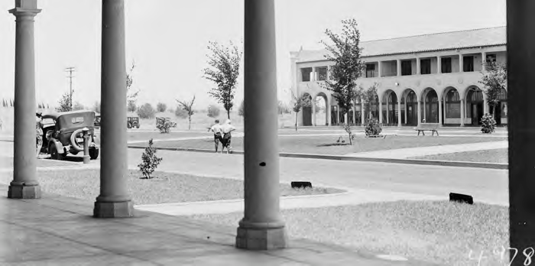
Opportunities for soft landscaping around the Sydney and Melbourne Buildings. Source: NAA A3560, 4978 Melbourne Building from Sydney Building across Northbourne Avenue, Civic Centre.

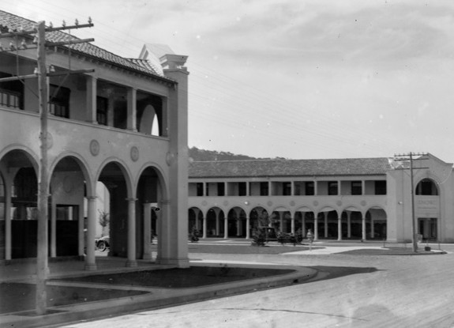
Opportunities for widening the landscaped verge along London Circuit. Source: NAA A3560, 5232 Intersection of Northbourne Avenue and London Circuit. Sydney Building and Snows corner on the right, Melbourne Building on the left.

Residential Zones Development Code / Multi Unit Housing Development Code
Where residential uses are permitted at the upper level of the Sydney and Melbourne Buildings, the applicable residential development code applies.
Signs General Code
The Signs General Code defines many different types of sign all of which are permissible within Commercial Zone C1. Signage requires development approval unless exemption criteria are met. The Signs General Code contains provisions to limit the amount of signage. Not all sign types are relevant or appropriate to the heritage significance of the Sydney and Melbourne Building. The following table is provided as guidance:

Sign type  (See signs General Code for definitions) | Appropriate for the Sydney and Melbourne  Buildings? | Heritage opportunities and constraints
Awning fascia sign | Not applicable
Blind sign | Not applicable
Business plates | Not appropriate | Several existing which should be removed
Canopy signs | Not applicable
Changeable message sign | Not appropriate | Several existing which should be removed
Construction site fence sign (Temporary) | Yes | Subject to appropriate size etc.
Display/development site sales sign  (Temporary) | Not applicable

An advertisement to facilitate the sale, auction or leasing of a group
of houses or building sites
Event sign (Temporary) | Not appropriate
Fence sign | Not applicable
Flag pole sign | Not appropriate | Remove existing flagpoles  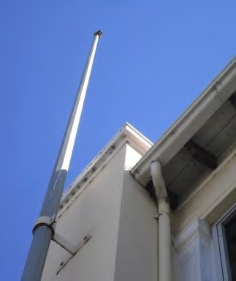
Ground sign | Not appropriate
Hamper sign | Not appropriate | Several existing which should be removed
High rise building sign | Not applicable
Inflatable sign (Temporary) | Not appropriate
Information sign  An advertisement providing information related to the use of facilities or features of the site, such as entry, exit, parking etc. details | Yes | If absolutely necessary for wayfinding etc. Only in entrances to laneway  Minimal in size and number  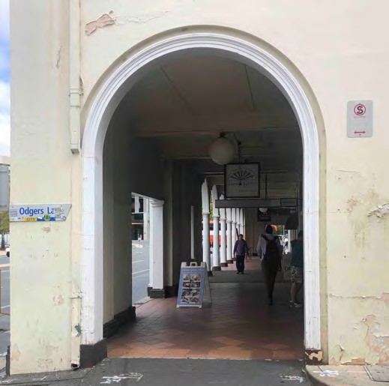
Lantern sign | Not appropriate
Mobile sign  A portable freestanding light weight sign, or a sign mounted on wheels to facilitate easy movement about a  site. | Yes | If part of street furniture, limit to one per premises. Ensure accessible path of travel through colonnades
Pole sign | Not appropriate
Projecting sign  A sign projecting at right angles to a wall and fixed to the wall. Not an  under awning sign. | Yes | Recommended signage type.  Match existing illuminated pill shaped sign with brass surround. For colonnades only.

 |  | 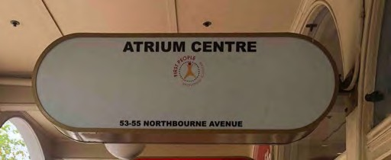
Pylon/column sign | Not appropriate
Roof sign | Not appropriate
Stallboard sign | Not appropriate
Territory signs | Not applicable
Under awning sign  An advertisement suspended under an awning or verandah | Yes | Recommended signage type  Match existing suspended sign type.  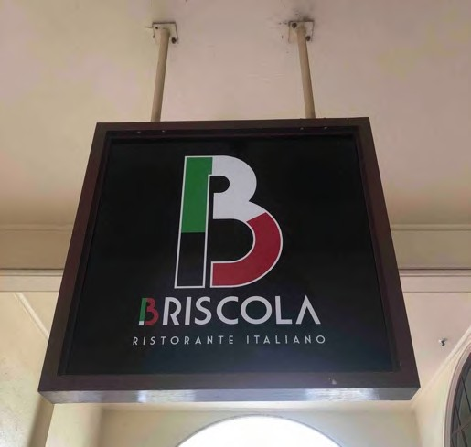
Vertical banner building sign | Not appropriate
Vertical banner freestanding sign | Not appropriate
Wall sign  An advertisement, painted or otherwise affixed, flat to a wall | Not appropriate | 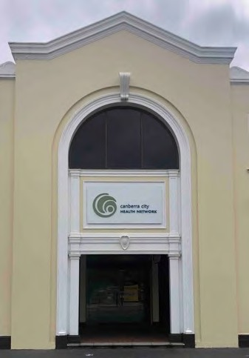
Window sign  An advertisement painted or  otherwise affixed, on the outside of the glass of a display window | Yes | Recommended signage type. Limited area

Access and Mobility General Code
This Code applies only to new developments and major alterations and extensions to existing buildings which affect more than 50% of the volume of the whole building. For this reason it is unlikely to be applicable to the Sydney and Melbourne Buildings. However, other human rights legislation at Federal and Territory levels makes it unlawful to discriminate against individuals with a disability. These laws include the Disability Discrimination Act 1992 (Cwth) (DDA), the Discrimination Act 1991 (ACT) (ACTDA), and the Human Rights Commission ACT 2005 (ACT). See below.
Discrimination Act 1991 (ACT) and Commonwealth Disability Discrimination Act 1992

The Discrimination Act (ACTDA) aims to protect the rights of people in the ACT. It makes it unlawful for a person to be treated unfavourably because of specified personal attributes, including disability, in a range of areas of public life, including access to premises.
Section 19 of the Act deals specifically with access and states that it is unlawful for a person to discriminate against another person –
- By refusing to allow the other person access to, or the use of, any premises that the public or a section of the public is entitled or allowed to enter or use (whether for payment or not); or
- In the terms or conditions on which the discriminator is prepared to allow the other person access to, or the use of, any such premises; or
- In relation to the provision of means of access to such premises; or
- By refusing to allow the other person use of any facilities in such premises that the public or a section of the public is entitled or allowed to use (whether for payment or not); or
- In the terms or conditions on which the discriminator is prepared to allow the other person the use of any such facilities; or
- By requiring the other person to leave such premises of cease to use such facilities.

The Act covers places that can be used by the public, or a section of the public. The definition includes schools, universities, shopping centres, public buildings, shops, car parks, parks and recreational facilities, theatres, museums and more.
The Commonwealth Disability Discrimination Act 1992 (DDA) is administered by the Human Rights and Equal Opportunities Commission. The Act aims to eliminate bias against people with disabilities and protect their rights to equality a community member. The Act says that it is unlawful to discriminate against another person on the grounds of the other person’s disability or a disability of any other person’s associates –

- By refusing to allow the other person access to, or the use of, any premises that the public or a section of the public is entitled or allowed to enter or use (whether with payment or not); or
- In relation to the provision of means of access to such premises.
Essentially, premises in the Sydney and Melbourne Buildings should be accessible to ensure compliance with this legislation. Some guidance is outlined below.

Original building condition | Guidance on achieving universal access
Step between edge of colonnade and street verge | There was originally a step around the perimeter of the Sydney and Melbourne Buildings from the streetscape to the colonnade. The nature of the verge has changed over time, as have standards around accessibility. There are several different conditions around the Sydney and Melbourne Buildings today.  There is also an opportunity to maintain the step around the perimeter of Sydney and Melbourne Buildings and provide access ramps at certain limited entry points. Soft landscaping could be used at the verge along the length of the Sydney and Melbourne Buildings where the step is maintained. This would reflect some of the original intent for soft landscaping at the verge.  On Northbourne Avenue and Alinga Street a solution has been developed which provides level access along the entire length of the colonnade.  Notwithstanding approval for this change through a SHE process this is not the preferred approach of the ACT Heritage Council.

Step between colonnade and ground floor premises | There are several different existing conditions. In some cases the whole floor level inside has been reduced (with a new concrete slab) to match the level of the colonnade, in some cases there is a ramp inside, and in some cases there is a step ramp at the doorway in the colonnade.  The option least likely to cause obstruction from a disability access point of view is to ramp inside (due to the risk of trips and falls along the length of the colonnade). However, this involves building work to cut out the floor and reduce the threshold sill of the door. It also has an impact on overall floor area.  The option that is simplest to achieve is to provide a step ramp or similar immediately outside the door. The design should provide sufficient luminance contrast to alert people with vision impairments to navigate the  colonnade safely and meet all other requirements of AS1428.1.
Stairs between ground floor level and upper floor level | Where they exist, original stairs should be conserved. Universal access should be provided to the upper level within proximity to but without making modifications to original stairs. Options include:  - a small lift accommodated outside of the original building envelope; or  - a chair lift in proximity to the original stair without impacting original balusters.
Narrow width of entrance doors | In some instances original doors consist of a narrow pair of French doors. The width of these doors does not meet disability access standards. Options are:  - to introduce a solution whereby there is some automated or push- button control of the original doors, or  - to replace the narrow doors with a single wider door or with two wider leaves. The style of all doors should be consistent with the original design – timber panel doors with glazed upper, and the alignment of the door within the shopfront should remain consistent. i.e. if paired doors are centred, a new single door should also be centred. If the original door is aligned to the right or left under a section of frieze, the new door suite should be of  similar width, with a sidelight and door leaf adjacent if necessary.
Entrance door of similar colour to surrounding shopfront | Luminance contrast is required to enable people of limited sight to identify a door leaf within a shopfront or wall. The colour of door leaves within  shopfronts should be consistent throughout the Sydney and Melbourne Buildings complex.
Tactile indicators | If necessary to meet standards, tactile indicators should be specified to complement the material palette of the original architecture (black, brass). Black carborundum insert brass are recommended for the colonnades. A single product should be used consistently throughout.  
The relevant standards are:

- AS1158.3.1 Road lighting – Pedestrian area (Category P) lighting – Performance and installation design requirements
- AS1428.1 Design for Access and Mobility – General Requirements for Access – New Building Work

- AS1428.2 Design for Access and Mobility – Enhanced and Additional Requirements – Buildings and Facilities
- AS1428.3 Design for Access and Mobility – Requirements for Children and Adolescents with Physical Disabilities
- AS1428.4 Design for Access and Mobility – Tactile Indicators
- AS 1735.7 Lifts, Escalators and Moving Walkways – Stairway Lifts
- AS1735.12 Lifts, Escalators and Moving Walkways – Facilities for Persons with Disabilities
- AS1735.14 Lifts for people with limited mobility – restricted use – low rise platforms
- AS2890.1 Parking facilities: Part 1 – Off Street Car Parking
- AS2899 Public Information Symbol Signs – Part 1 General Information Signs
- AS4586 Slip Resistance Classification of New Pedestrian Surface materials

National Capital Plan
The National Capital Plan is the strategic plan for Canberra and the Territory, prepared and administered by the National Capital Authority. It ensures that Canberra and Territory are planned and developed in accordance with their national significance. In accordance with the Australian Capital Territory (Planning and Land Management) Act 1988, the plan sets out the broad planning principles and policies for Canberra and the Territory, and detailed conditions of planning, design and development for the ‘Designated Areas’ because of their particular importance to the special character of the national capital.
Northbourne Avenue (as one of the main avenues and approach routes between the Act border and the central national area) is a Designated Area in the National Capital Plan. Within Designated Areas the National Capital Authority has sole responsibility for determining detailed conditions of planning, design and development, and for Works Approval. The Sydney and Melbourne Buildings are not located within the Designated Area and are not constrained by the National Capital Plan.

Main Avenues (Northbourne Avenue)
Land within boundaries of the reservations of Northbourne Avenue is specified as one of the Main Avenues in the National Capital Plan. The main opportunity here is for a high quality and complementary streetscape along Northbourne Avenue, which has largely been achieved, whilst the main constraint is the volume of traffic dividing the twin sites of the Melbourne and Sydney Buildings on each side of the arterial road. The streetscape could be further enhanced to complement the Sydney and Melbourne Buildings through sympathetic architectural lighting to light the facades, by improving the quality of space at the Northbourne Avenue median strip, and by reducing the waiting time for pedestrians crossing Northbourne Avenue.
Objectives for Main Avenues and Approach Routes are to:
- Establish and enhance the identity of the approaches to the Central National Area as roads of national significance and, where relevant, as frontage roads for buildings which enhance the National Capital function and as corridors for a possible future inter-town public transport system.
- Ensure that works within the road reservations are carried out to the highest standards, by maintaining and enhancing landscaping, and by facilitating the flow of traffic as far as possible.
- Reinforce and, where possible, express the integrity of the Griffin Plan’s visual structure by strengthening the geometry and form of main avenues, vistas and public spaces.
- Improve the urban design and streetscape qualities of the Main Avenues as approaches to the Central National Area.
Pertinent conditions of planning, design and development include:
  - Landscaping: In built-up areas, the established design theme of verges and medians and formal tree plantings will be maintained. In areas of intensive pedestrian use, high quality paving is to be used.

  - Streetscape design: A streetscape hierarchy, that complements the road hierarchy, should be established. This hierarchy should give primacy to main avenues, emphasise continuity along their length through avenues of appropriately scaled trees, consistent pedestrian pavement materials, street furniture and lighting. A limited palette of high-quality pedestrian pavement materials, street furniture and lighting will be used. Pavement and landscape design should have an elegant, simple and bold design emphasising the geometry and formality of the main avenues. Streetscapes are to be well lit for pedestrians and optimise security and safety for nighttime use.
These conditions generally support desirable outcomes for the Sydney and Melbourne Buildings. Streetscape lighting design should be complementary to the architecture in scale, spacing, pattern of light-shed and colour temperature.
Special Requirements for the City Centre
There are special requirements for some parcels of Territory Land in the National Capital Plan including City Centre, within which the Sydney and Melbourne Buildings are located. The Commonwealth’s interest in the City Centre is related to geometry, the organising framework of the Griffin Plan for Canberra, its location at the apex of the National Triangle and as a convergence of main avenues. City Hill is of interest as the visual and symbolic centre of City Centre, and as an identifiable element within the Amphitheatre of central basin. The National Capital Plan seeks to achieve harmonious and high quality architectural and environmental qualities through consideration of height, colour and materiality. It also has a specific interest in London Circuit.
Policies include:
  - Measures for discouraging through traffic from using City Centre road network in peak periods must be considered;
  - Future demand for car parking should be met by the construction of structured car parks in locations that service needs throughout the City Centre while aiming to minimise congestion, and/or by on-site provision of parking spaces;
  - Vehicle access and traffic management throughout the area should seek to maintain the ease and comfort of moving around the city, catering to a diversity of pedestrian, cycle, vehicular and public transport modes.
  - The importance of Main Avenues radiating from City Hill (e.g. Northbourne Avenue) and their role as the main public transport corridors should be complemented through the landscape and architectural treatment on abutting blocks.
  - The massing, height, colours and materials used for buildings in City Centre should result in a harmonious and high quality urban design outcome with a recognizable city edge.

It is clear from the National Capital Plan that there is significant opportunity for the Sydney and Melbourne Buildings to trade on their landmark qualities and strengthen their recognition as a landmark within this protected setting.

City Hill Precinct
The City Hill Precinct Code also sets out how the land on the opposite side of London Circuit is intended to become the pre-eminent heart of the City - a vibrant, interesting and lively centre with high levels of human activity. Development on these sites must complement, actively relate to and integrate with the rest of the city. As the setting around the Sydney and Melbourne Buildings changes, their landmark and pedestrian qualities must be conserved and enhanced, particularly along London Circuit.

Signs General Code
According to the National Capital Plan, carefully designed and positioned signs, in addition to fulfilling their roles of informing, directing and advertising, may positively enhance and enliven Canberra’s major commercial and tourist areas and aid in giving imageability and form to the city. Insensitive or poorly

designed and constructed signs may detract from the architectural appearance of buildings and adversely affect the pleasantness and general amenity of an area.
Whilst the Sydney and Melbourne Buildings are not constrained by Signs General Code of the National Capital Plan, there is an opportunity to achieve a higher standard of signage by adhering to some of the National Capital Plan guidelines such as:

  - The type, position, size, appearance, illumination, animation, content or other characteristic of the sign must not adversely affect the architectural character or appearance of the buildings.
  - Signs must not be animated or flashing or illuminated by exposed lamps or neon tubes.
  - The clearance between the pavement level and any signs projecting from a building must not be less than 2.5m.
  - Signs above the ground floor level will be restricted in content to the name of the building and the name, insignia and type of activity of the principal occupant, and must not project from the building.
National Construction Code
The National Construction Code (NCC) provides the minimum necessary requirements for the safety and health; amenity and accessibility, and sustainability on the design, construction, performance and liveability of new buildings (and new building work in existing buildings) throughout Australia. NCC Volume One primarily applies to Class 2 to 9 (multi-residential, commercial, industrial and public) buildings and structures. NCC Volume Two primarily applies to Class 1 (residential) and 10 (non- habitable) buildings and structures.

The NCC is a performance-based code containing all Performance Requirements for the construction of buildings. It is built around a hierarchy of guidance and code compliance levels, with the Performance Requirements being the minimum level that buildings, building elements, and plumbing and drainage systems must meet. A building, plumbing or drainage solution will comply with the NCC if it satisfies the Performance Requirements, which are the mandatory requirements of the NCC.
There are no exemptions for compliance with the NCC for heritage listed buildings, and all new building work must comply with the current NCC (which is 2019 at the time of writing).

  - Management Context and Stakeholders City Renewal Authority
The City Renewal Authority (the Authority) is committed to the comprehensive revitalisation of the Sydney and Melbourne Buildings, as outlined above (see City Renewal Authority and Suburban Land Agency Amendment Act 2020 above). This CMP and the accompanying Revitalisation Plan have been funded by the Authority (a statutory authority of the ACT Government) and are aimed at significantly improving the presentation and commercial success of both Buildings in the near term.

A 2020-2023, a Revitalisation Plan was drafted by Philip Leeson Architects on behalf of the Authority in consultation with building owners and the ACT Heritage Council. Building fabric in leased public areas identified in the plan include:
- Rendered façade and paint finishes,
- Friezes and highlight windows,
- Lighting,
- Signage,
- Colonnade pavement,
- Black marble skirting, and
- Shop front windows and doors.

The unique qualities of the Sydney and Melbourne Buildings are highlighted in the Revitalisation Plan and the recommended works are aligned with conservation objectives.

The Authority has regularly consulted with owners about the revitalisation process since 2019 and has sought to achieve consensus with all owners who have participated in the consultation process. At the time of writing this CMP, an implementation process for the Revitalisation Plan is being finalised but continues to be the subject of active engagement with all interested parties.
The Authority also continues to advocate for the rationalisation of the City bus interchange to improve public realm use, particularly on East Row adjoining the Sydney Building frontage. It is working with TCCS to upgrade the services and condition of both Verity and Odgers Lanes. These works will help protect the Buildings and support the greater use of the lanes as accessible public spaces through new traffic management arrangements.

Building Owners / Leaseholders and Tenants
There are a large number of owners of the 65 blocks that make up the Sydney and Melbourne Buildings, and there is no body corporate. An attempt has been made by and on behalf of the City Renewal Authority to gather contact details for all owners, resulting in a City Renewal Authority consultation database. Of the owners contacted, approximately a dozen chose to participate in the consultation process regarding revitalisation of the Sydney and Melbourne Buildings. Participating owners shared the following thoughts about opportunities and constraints.

- Service access: The rear courtyards are necessary for deliveries and services, and there is only very limited space for other activities. The courtyards often become congested with deliveries in the early hours of the morning.

- Colonnade pavement: Quarry tiles used to pave the colonnade surface in the 1980s are no longer available, presenting a major hurdle for repairs.
- Level access: Owners would like to see level access provided at the boundary. Some owners have been required to provide ramp access inside the premises, and this has a negative impact on the usable floor space. There are also concerns with providing ramp access outside shopfront doors, as this could be a trip hazard and/or attract vandalism.
- Indoor/outdoor connection: Food and beverage businesses would like to have an opportunity to open up shopfronts to provide indoor/outdoor connection during trading hours.
- Dust: The colonnades collect leaves and dust at various times throughout the year, and dust settles in particular on the top of ball lights
- Parking: The Sydney and Melbourne Buildings do not have dedicated parking. Large public car parks on the opposite side of London Circuit regularly fill up on weekend evenings when Canberrans expect to be able to find parking close to their destination, and this is sometimes a limitation to peak period restaurant trading in the Sydney and Melbourne Buildings. Increased public parking infrastructure in the immediate vicinity would support trading.
- Bus interchange: Noise pollution, fumes and the visual barrier of buses idling in the bus interchange have a negative impact on the atmosphere in East Row and on Alinga Street
- Vandalism: Owners of the Sydney and Melbourne Buildings regularly experience vandalism in the colonnades. Anything not securely fixed in place is subject to vandalism.
- Lease conditions: The leases for blocks in the Sydney and Melbourne Buildings are unusual in that there are many unique and specific conditions related to use. This leaves some owners unable to benefit from CZ1 opportunities unless expensive and complex lease variations are pursued on a case-by-case basis

- COVID-19: Enforced lockdowns have had a negative impact on trading in 2020 and 2021, making funds constrained.
- Trees: The roots, leaves and seeds of the London Plane trees get into the pipework and gutters of the Sydney and Melbourne Buildings and cause damage
In addition to this, when Communication Link door knocked tenants they asked whether tenants were aware of the existence of the CMP. None of the tenants were aware of the CMP for the Sydney and Melbourne Buildings.

ACT Heritage Council
Alanna King and Ellen Samuels met with staff of ACT Heritage in February 2020 to discuss any issues the Council may have come across with the Sydney and Melbourne Buildings or the existing CMP. ACT Heritage staff shared the following thoughts for consideration:

- CMP: The existing document is comprehensive, but not useful on a day to day basis. There is no need for the CMP to revisit the history, which should be included as an Appendix. The condition assessment and a scope of works is of great interest.

- Interiors: Original interiors are a feature intrinsic to the significance of the place, but relatively little is documented about what remains. An interior condition assessment has never been done to a high standard. This lack of information makes it challenging to respond to requests for change, and there is a risk that interior features could be lost.
- Public understanding: There is a strong misconception that only the facades are significant, which must be countered.
- Pressures for change: ACT Heritage is aware of development pressure for infill and extensions into the internal courtyards, pressure to encroach into parking spaces and airspace in the courtyards, and a push to activate the courtyards. Policies need to be strengthened in the CMP.

- Balconies: There is a requirement in the register entry to keep first floor balconies open.
- Lease purpose clauses and inconsistency: The lease purpose clauses for each block are different and reflect the different times at which blocks were built. Some inconsistency is part of the history of the place. Trying to apply uniformity where it hasn't existed before is disingenuous, and for some blocks certain things will be possible that are not possible at other blocks.

- Approvals: It would be ideal if the CMP could provide a table with clear advice about when approvals are required, with examples of what types of activities require approval.

- Revitalisation Plan: Should be led by conservation objectives and not just a beautification mindset. The ACT Heritage Council expects to review for consistency with the CMP but will not approve the document per se. Depending on the work proposed, heritage approvals may be required before works can be undertaken.

- ACT Heritage records: Information / access to ACT Heritage records on the specification for replacement roof tiles used following fire damage to the Sydney Building was requested. ACT Heritage subsequently advised that the roof tile specification was Bristile La Escandella ‘Curvado’ profile in ‘Roja’.

Conservation Policies
The following conservation policies have been developed following analysis of physical condition, heritage significance and opportunities and constraints. They aim to ensure the conservation and maintenance of the heritage values of the Sydney and Melbourne Buildings. The policies are consistent with the approach of the Burra Charter Principles and Practice Notes.
  - Policies relating to this CMP

Policy 1  Ownership of this CMP | This CMP is owned by the City Renewal Authority but should be made available to the public and relevant stakeholders. We recommend that access to this document is provided via hyperlink on the ACT Heritage Register entry.
Policy 2  Approval and currency of this CMP | This CMP should be submitted for approval by the ACT Heritage Council under Section 61J of the ACT Heritage Act 2004. Upon approval the CMP will be the guiding document for the conservation and management of heritage significant fabric and features of the Sydney and Melbourne Buildings.  CMP approval is current for a period of five years, after which time the CMP should be reviewed and updated.
Policy 3  Statement of Significance | The Statement of Significance set out in this CMP will be a principal basis for future planning and work affecting the Sydney and Melbourne Buildings.
Policy 4  Consistency  with Burra Charter | The conservation and management of the Sydney and Melbourne Buildings, their fabric and uses, will be carried out in accordance with the principles of The Burra Charter (Australia ICOMOS 2013) and the associated series of Practice Notes, and any revisions of the Charter that might occur in the future.
Policy 5  Conservation  Policies are Primary Guide | The policies recommended in this CMP will be endorsed as the primary guide for management as well as future planning and work for the Sydney and Melbourne Buildings.
Policy 6  Seek Expert Advice | People with relevant expertise and experience in the management or conservation of heritage properties will be engaged for the:  - provision of advice on the resolution of conservation issues; and  - advice on the design and review of work affecting the significance of the Sydney and Melbourne Buildings.
Policy 7  CMP to guide Planning  Policy | All planning documents developed for the Sydney and Melbourne Buildings will refer to this CMP as a primary guide for the conservation of their heritage values. The direction given in those documents and in this plan will be mutually compatible.

  - Policies relating to Statutory Requirements

Policy 8  Compliance and approvals | The ACT Government, and owners and tenants of the Sydney and Melbourne Buildings must comply with all relevant legislation and related instruments. Refer to Section 4 for guidance.  This includes the need to seek relevant approvals from the ACT Heritage Council for changes impacting on the heritage values of the Sydney and Melbourne Buildings.

Policy 9  Comply with ACT Heritage  Legislation | Comply with the requirements governing items listed on the ACT Heritage Register. The ACT Heritage Council is the body which provides advice and approvals under the Heritage Act 2004.
Policy 10  Stakeholder consultation | Consult with the ACT Heritage Council, the ACT Environment, Planning and Sustainable Development Directorate – Planning, the Tree Conservator and the National Capital Authority (NCA) and obtain required approvals prior to undertaking any new works to the Sydney and Melbourne Buildings.  Stakeholders and the public should be informed in a timely fashion, as appropriate, about proposals for works or programs within or affecting the Sydney and Melbourne Buildings.  A list of stakeholders is provided in Section 4. This policy is in addition to the formal requirements to obtain approval from agencies such as ACTPLA and the ACT Heritage Council under the Heritage Act 2004 or obtain Council advice prior to  commencement.
  - Policies relating to Building Management

Policy 11  Coordination | Respective building management policies should be commensurate with  the policies of this CMP in terms of use, conservation, repair and maintenance of significant fabric, spaces, landscape elements and interpretation.  The individual groups should liaise regularly to ensure that management policies and implementations are coordinated.
Policy 12  Decision making | The ACT Government, and owners and tenants of the Sydney and Melbourne Buildings will ensure that they have an effective and consistent decision-making process for works or actions affecting the buildings which takes full account of  the heritage significance of the place. All such decisions will be suitably documented and these records kept for future reference.
Policy 13  Integrated  Management of Exterior | The ACT Government and owners of the Sydney and Melbourne Buildings will explore options to achieve effective integrated management of the exterior of the buildings, especially the facades and colonnades, including sustainable funding for building maintenance.
Policy 14  Training &  Heritage Awareness | Adequate training for ACT Government staff and owners and tenants of the Sydney and Melbourne Buildings should be provided regarding the significance of the buildings, and the policies and practices for their appropriate management.
Policy 15  Liaison with ACT Heritage | The ACT Government and owners and tenants of the Sydney and Melbourne Buildings should maintain regular contact with ACT Heritage, including informal consultation where necessary to determine the level of advice and/or approval  required to ensure consistency with the Heritage Act 2004.
  - Policies relating to Use

Policy 16  Continuation of Historic Use | The Sydney and Melbourne Buildings shall continue their primary historic uses including retail, commercial, office, restaurants, cafes, bars and residential accommodation.

 | Verity and Odgers Lanes shall continue to provide back of house and servicing uses to the Sydney and Melbourne Buildings.
Policy 17  Heritage Significance included in  Tenancy Agreements | Tenancy agreements shall highlight the heritage significance of the buildings and shall advise of the existence and purpose of this CMP.
  - Policies relating to Conservation

Policy 18  Conserve Intrinsic Features | The Intrinsic Features of the Sydney and Melbourne Buildings must be conserved, managed and interpreted in accordance with the principles of the Burra Charter Principles and Practice Notes and the Heritage Act 2004.  General Intrinsic Features are listed in Section 3. Refer to the individual block inventories in Appendix B for specific details for any given block.
Policy 19 | Neutral features may be retained. General Neutral Features are listed in Section 4. Refer to the individual block inventories in Appendix B for specific details.
Retain or Replace Neutral  Features | The longer term replacement of Neutral Features with new materials which match the existing fabric as closely as possible or in accordance with approved designs outlined in Section 6 - Implementation, is strongly encouraged.
Policy 20 | The removal of Intrusive Features is strongly encouraged.
Remove Intrusive Features | General Intrusive Features are listed in Section 4 - Implementation. Refer to the individual Block Inventories in Appendix B for specific details.  Where removal of Intrusive Features reveals damage to or missing sections of intrinsic features, such damage should be made good and missing sections replaced to match the existing fabric as closely as possible or in accordance with  approved designs outlined in Section 6 - Implementation.
Policy 21  Undertake Recommended Conservation & Repairs | Undertake the actions outlined in the Schedule of Recommended Repairs, Replacement and Conservation (Scope of Works) provided in Section 7 in accordance with the recommended timeframes.  The Schedule of Recommended Repairs, Replacement and Conservation is supplemented by the detailed Block Inventories in Appendix B, which give an understanding of the works required within each block. These scopes should be adopted and actioned by owners for the ongoing conservation of the place.
 | Approval of this CMP indicates ACT Heritage Council approval of these actions.

Policy 22  Shopfronts | Surviving elements of original shopfronts must not be modified or removed. These include:  - black marble skirtings  - bullnosed black marble thresholds (very few remain)  - brass ventilators  - recessed entries (very few remain)  - slender metal window frames and plate glass windows (glass not necessarily original)  - embossed copper frieze  - arched highlight windows with copper channel / lead fill frames, hopper sashes  Where shopfronts are not original, owners are encouraged to reconstruct them to match the original shopfronts. Details are provided in Section 6: Implementation.  New shopfronts must conform to one of the designs provided in Section 6: Implementation.
Policy 23  Recessed Doorways | Original surviving recessed doorways must be retained. Refer to individual inventory sheets for locations. Refer to individual inventory sheets for locations.  The removal of non original recessed doorways and the reconstruction of original shopfronts in the main alignment is strongly encouraged.
Policy 24 Upper Verandahs | The enclosure of surviving original open verandahs is not permitted. The restoration of formerly open verandahs is strongly encouraged.  Where work is proposed which changes the existing infill glazing arrangements, Council advice and/or approvals must be sought.
Policy 25  Openings facing Laneways | The adoption of uniform glazing systems to openings facing the laneways is strongly encouraged.  Original timber framed, multi-paned windows must be retained.  New windows must either match the originals or be a single sheet of glass across the full width of an opening with a slender frame in a dark colour.
Policy 26  Colonnade Pavement | Removal of the existing unsympathetic tile and asphalt toppings over the original concrete paving is strongly encouraged. A trial removal shall be carried out to determine the impact on the original concrete pavement.  The ACT Heritage Council considers that the removal of all previous unsympathetic toppings can be carried out under this CMP without further advice or approval.  All remaining concrete paving must be retained, regardless of condition. A SHE would be required if original material were to be removed.  The ACT Heritage Council proposes the installation of large format pavers of Artisan ‘Platina’ limestone as a new pavement surface, provided that this is laid over the original concrete pavement.  The scored lines dividing the original concrete into smaller areas must also be interpreted in any new finish.

 | The step between the colonnade and the street pavement must be maintained where this survives.
Policy 27  Access Ramps | The new colonnade paving should be level and not incorporate integral access ramps at individual doorways.  The location of access ramps inside the shopfronts is strongly encouraged.  Where ramps are proposed within the colonnade they must be of a freestanding removable design and not incorporated as part of the paving.
Policy 28  External wall finish | The presentation of the buildings is negatively impacted by both the condition of the paint and in some areas the poor condition of the underlying render.  The reinstatement of a sympathetic breathable finish to the render that is consistent with the original buff colour scheme, which has been validated by paint scrapes, is strongly recommended. Details of the original scheme are provided in Section 2: Physical Assessment and also in Section 6: Implementation. The existing layers of non-breathable paint should be removed to allow any water in the masonry to escape and limit damaged caused by trapped moisture. The application of a breathable coating is a permanent finish (as per the original) and should only be undertaken if the colour scheme is in keeping with the heritage significance of the place. The application of a single coloured finish with stone like appearance was common practice during the early 20th century, particularly for buildings with a Mediterranean style.  Where the above is not feasible, the Sydney and Melbourne Buildings may be repainted in the prevailing colour scheme of recent decades, i.e. cream walls, white details and red oxide gutters and outriggers. Details of this scheme are provided in Section 6: Implementation. Should the existing colour scheme be maintained, use of a modern water based acrylic paint that can be removed at a later date could be considered. The longevity of an acrylic paint is likely to be less than a breathable finish, particularly in areas where water trapped in the masonry will cause the paint to blister. Removal of the existing paint layers would be less advantageous in this scenario as the new paint would be impermeable. External acrylic paint to render should be routinely touched up as part of a cyclic maintenance program.  Details of the two colour schemes are provided in Section 6: Implementation.
  - Policies relating to Lighting and Services
Policy 29 | Conserve surviving elements of the original lighting scheme. This is described in Section 2: Physical Assessment.
Conserve Original  Lighting | Where retention of original lighting fabric is infeasible, new fabric must match the original as closely as possible.
Policy 30  Reconstruct Original Lighting  Scheme | Reconstruction of the original lighting scheme to the facades and colonnades is strongly encouraged but only as part of a comprehensive action which is carried out to the facades, the colonnades, or both, across the entire buildings.  Details of the original scheme are provided in Section 6: Implementation.
Policy 31  Illumination of the Colonnades | Luminaires in colonnades shall remain ON from dusk to dawn every night. This is consistent with the streetlight network and can be achieved with a PE cell in the switchboard.

Policy 32  New Lighting | Modern supplementary lighting schemes may be permissible as long as they do not have a detrimental impact on intrinsic features. New lighting must be subtle, have minimal impact on significant fabric and be designed to enhance the architectural  character of the buildings.
Policy 33  Existing Services | The removal of intrusive services and the rationalisation of remaining services is strongly encouraged to reduce the visual impact on the heritage significance of the building.
Policy 34  New Services | The installation of new services on the facades is not permissible.  The installation of new services within the colonnades is to be kept to a minimum and must not affect significant fabric.  Location of roof mounted plant is not permissible on the street facing roof slopes. Where located on rear roof slopes it must not be visible above the main ridgeline (including its return along the laneways) when viewed from the opposite street verge.  In accordance with ACT Heritage Council’s General Conservation Policy 1 – External Solar, Water, Air Conditioning and other Services in Heritage Places:  - All services must avoid or have minimal visual impacts on the heritage place particularly when viewed from the public domain.  - The installation of all services must be fully reversible. Any anchorage/mount points must use existing locations if possible, If new anchorage/mounting points are required, they must cause minimal irreversible damage to the built fabric.  - Wall penetrations must be kept to a minimum.  - The finish and/or colour for all services must where possible match the adjacent roofing and/or walling as appropriate to minimize the visual intrusion.  - Cabling or conduit must not run along the surface of external walls. Cabling must be concealed as much as possible.
Policy 35  HVAC  Equipment | Air conditioning equipment must be sited away from the public domain at the rear of the Sydney and Melbourne Buildings.  Apart from evaporative units, equipment must be located at ground level with screening to reduce visual impacts. Air conditioner units must not be located at roof level if they can be seen from surrounding streets or other public domain.
Policy 36  Solar Panels | Solar panels must be sited away from the public domain on rear roof slopes facing Verity and Odgers Lanes and must be of a neutral or dark colour.  Solar panels must have minimal angles to the roof and be as flush as possible with the roof plane. The arrangement and maximum coverage of roof space by the solar panels must be agreed to by the ACT Heritage Council.  Use of solar panels must not require a tree damaging activity or removal of the London Plane trees protected by the heritage guidelines for the place.
Policy 37  Hot water systems | Hot water storage units must be in locations not visible from the public domain, at the rear of the Sydney and Melbourne Buildings. Storage tanks must be screened to avoid adverse visual impacts.

  - Policies relating to Maintenance

Policy 38  Routine Maintenance and Monitoring | Actions outlined in the Program of Preventative and Routine Maintenance must be undertaken by owners in accordance with the recommended timeframes and a written record of actions kept.  Routine maintenance by owners must also incorporate monitoring of the condition of  all significant features. Use the block inventories and conservation schedules in this CMP for guidance on significant features and condition applicable to each block.
Policy 39  Replacing Fabric | Where maintenance of significant fabric is not reasonably feasible or practicable professional heritage advice should be sought regarding suitable replacement fabric and work methodologies. Any such works are subject to approval from the ACT  Heritage Council prior to the commencement of works.
Policy 40  Archival Recording | Significant fabric which is approved by the ACT Heritage Council for removal must be identified and photographed prior to removal. Label fabric and store safely for potential future restoration and/or interpretive purposes.
  - Policies relating to New Development

Policy 41  Alterations to Facades &  Shopfronts | Alterations to the street facades, colonnades, shopfronts and street facing roof slopes are not permitted apart from the repairs, conservation, restoration, reconstruction and sympathetic alterations recommended in this CMP.
Policy 42  Interiors | Internal modification works are not exempt development and cannot be undertaken without prior Council endorsement in accordance with the Planning and Development Act 2007.  No changes should be made to original interiors or surviving original interior elements. In the case of the northwest section of the Melbourne Building, original interiors included interiors and elements dating from after the 1950s fire.  Where interiors are not original, owners are encouraged to respect the original layout and spaces of the buildings, and to restore these where appropriate. For example, where ground floor ceiling heights have been lowered, consequently blocking the arched highlights, owners are encouraged to reinstate original ceiling  heights.
Policy 43  Layout | The central courtyards and remaining internal light wells are to be retained.  No new building structures shall be built in the Courtyards, i.e. beyond the rear block boundaries.  Existing driveway entry points are to be retained and no additional ones are to be developed.

Policy 44  Rear Additions | The three projecting rear wings (set c 4m back from the block boundary), hipped roofs, inset first floor terraces to Block 35 in the Melbourne Building (currently Quest Apartments) must be conserved. Development is not permitted beyond this existing rear wall alignment.  For other blocks development to the rear of the blocks up to the rear boundaries is possible subject to appropriate design and detailing and approval from the ACT Heritage Council. New construction must be no higher than the main upper ridgeline (including its return along the laneways).  Materials used in new development must include red face brick, glazed windows and doors in slender dark frames and metal deck roofing.
Policy 45  Courtyard Surfaces | The extent of hard paving in Courtyards should be kept to the minimum required for trafficable areas. The central areas adjacent to the Plane trees should have as a large an area of permeable surface as possible.  The material selected for permeable and trafficable surfaces should be consistent throughout both courtyards.
Policy 46  Heritage specialists | Proposals for new development should be developed with the early and ongoing involvement of suitably qualified and experienced heritage specialists and are subject to ACT Heritage Council advice. Heritage Act 2004 approvals may also be required.
Policy 47  Records | Prior to any change prepare an archival record of the existing structure and its  setting including drawings and photographs. Submit to ACT Heritage for inclusion in the heritage records.
Policy 48  Courtyard Trees | A tree assessment and management plan should be prepared for the London Plane trees in the Courtyards. This should identify the current health and longevity of the trees, immediate measures to be taken to mitigate impacts on health and on going  management. The Plan should be submitted to the ACT Heritage Council.
Policy 48  Courtyard Trees | The existing concrete kerbing around which the Plane tree roots have grown should be carefully removed under the direction of a qualified arborist so as not to affect the health of the trees. New surfacing and kerbing designs should allow unfettered  growth, air circulation and drainage at the base of the trees.
Policy 48  Courtyard Trees | New development such as drainage works and re-surfacing should not impact the health of the London Plane trees. Measures should be taken to protect the trees  from all forms of impact.
Policy 49  When to lodge a Statement of Heritage Effects | Advice from the ACT Heritage Council should be sought prior to commencement for all works not explicitly permitted under this CMP. This advice may identify that a SHE is required. If there is any doubt seek advice from ACT Heritage prior to commencement.  Where proposed works are likely to have a detrimental impact on heritage values a Statement of Heritage Effects (SHE) should be prepared by a suitably qualified person and a SHE application should be made to the ACT Heritage Council under Section 61G of the Heritage Act 2004 prior to any Development Application being made. The SHE shall outline how the recommendations of the CMP are to be fulfilled, shall assess the impact of any proposed works on the heritage significance  of the place and shall outline how potential impacts will be mitigated.

  - Policies relating to Signage

Policy 50 | All new signs require Advice from ACT Heritage. Refer to 6.4 When is Heritage Approval Required for guidance.

Approval for Signs | Only the following sign types (definitions as per the Signs General Code) should be approved:  - Business plates;  - Information sign;  - Mobile sign – If integrated with café/street furniture;  - Projecting sign – If consistent with existing signage types;  - Under awning sign;  - Wall sign – On the sides of buildings at laneways only;  - Window sign.  Installation of any real estate signage indicating property for sale, letting or auction should be removed within 10 days of completion.
Policy 51  Impact of Signs on Heritage Values | New signs must not detract from the heritage values of the buildings. In particular:  - New signs must be low reflection and of a neutral colour;  - New signs must not be internally illuminated or flashing;  - No sign is to be painted onto any surface.
Policy 52  Conserve Original Signs | Original signage, including the metal lettering which reads “Sydney Building” and “Melbourne Building” at the corner portals, must be retained and protected in situ.
Policy 53  Remove  Unsympathetic Signs | Unsympathetic signs and fixtures shall be removed including:  - Flagpoles  - Signs on portals  - Signs on colonnades and columns
Policy 54  Acceptable Signage Design | The use of wall mounted signs in the Sydney Building; and under awning signs (which drop down from the colonnade ceiling) in the Melbourne Building is acceptable. Exactly match the size, finish and fixing method of existing signs.  Signs and advertising to shop front glazing areas are also acceptable. Such signs shall take up no more that 30% of the area of the window.
Policy 55  Number and content of Signs | The size and number of signs should be kept to a minimum for each business. Apart from window signs no more than one permanent sign may be attached to each business.  Signage must be in accordance with the rules of the Signs General Code in the Territory Plan. New signs must directly relate to the majority owner, business or function (as per naming signs in Signs General Code). Product advertising will not be allowed.
Policy 56  Sign Fixings | The installation of new signs should be fully reversible with minimal damage to built fabric. If new anchorage / mounting points are required, they should cause minimal damage to the built fabric.

  - Policies relating to Interpretation

Policy 57  Interpretation | An Interpretation Plan should be prepared by suitably qualified people. The Plan should outline interpretation media appropriate to the place which can effectively

Plan | communicate the history of the Sydney and Melbourne Buildings, their heritage significance, use and changes over time.

Implementation
This section provides advice on implementing the Conservation Policies.
  - The Australia ICOMOS Burra Charter, 2013
The Burra Charter: the Australia ICOMOS Charter for Places of Cultural Significance, 2013 and the associated series of Practice Notes provide a best practice standard for managing cultural heritage places in Australia. It is a nationally accepted guide to appropriate conservation processes and practices. The following Burra Charter principles are applicable to the conservation of the Sydney and Melbourne Buildings:
- Secure and maintain the cultural significance of the place for the future (Articles 2, 10 and 16);
- Adopt least possible intervention practices impacting existing fabric (Articles 3 and 13);
- Engage suitable and identified expertise for all processes (Articles 4, 23, 25, 26 and 27);
- Treat all fabric elements and eras equally (Articles 5, 11, 13, 14 and 15);
- Appropriate conservation policies must reflect firstly an understanding of the place’s cultural significance and its condition (Articles 6 and 10);
- Conservation policy will determine compatible uses (Article 7);
- The visual setting of significant elements must be maintained and no new construction or other modification is allowed that adversely affects or intrudes into the setting (Article 8);
- A building should remain in its historic location (Article 9);
- Removal of contents, if they are significant, is unacceptable unless required as the sole means of ensuring preservation (Article 10);
- Record all decisions, intrusions, processes and works (Articles 26, 27, 28 and 29);
- Permanently archive and record (Article 28);
- Any culturally significant fabric required to be removed shall be kept securely stored (Article 29)

  - Definitions
The terms fabric, conservation, maintenance, preservation, restoration, reconstruction, adaptation, compatible use and cultural significance are used in this CMP as defined in the Australia ICOMOS Burra Charter, Ed 7, 2013 as follows.
Adaptation
Adaptation means modifying a place to suit the existing use or proposed use.
Common examples of adaptation include works for interpretation – such as signs and paths, installing new wiring, piping, equipment and services. Adaptation can also include construction of substantial new structures.

Compatible Use
Compatible use means a use that respects the cultural significance of a place. Such a use involves no, or minimal, impact on cultural significance.
Compatible use can be a number of different uses that overlap in space or time. The use for which the place was created, and later long established uses are likely to be ones that respect the cultural significance of the place.

Conservation
Conservation means all the processes of looking after a place so as to retain its cultural significance. The process of conservation includes retaining the contribution that the setting, and related places and objects, make to the significance of a place. Ceremonies, explaining, campaigning, housekeeping, financing, the preparation of protective controls, and many other activities can be part of conservation.
Cultural Significance
Cultural significance means aesthetic, historic, scientific, social or spiritual value for past, present or future generations. Cultural significance is embodied in the place itself, its fabric, setting, use,

associations, meanings, records, related places and related objects. Places may have a range of values for different individuals or groups.
Australian conservation practice and heritage legislation is based on the concept of cultural significance;
i.e. that the values (significance) of a place can be described and that retaining significance is the primary objective of conservation of the place. Some acts use slightly different terms – such as ‘heritage significance’ or ‘cultural heritage value’ – but the concept is the same as cultural significance. The five terms listed alphabetically in the Charter, aesthetic, historic, scientific, social, spiritual, used together, are intended to encompass all the cultural values of places of cultural significance. Legislation may include more specific categories of significance, which are covered by the five used in the Charter. The cultural significance of a place may change as the result of the continuing history or the place. Understanding of cultural significance may change as a result of new information. A place may have different meanings to different groups.

Fabric
Fabric means all the physical material of the place including components, fixtures, contents, and objects. Fabric includes the built elements of a place, as well as the natural material – the landform, vegetation, streams, soil and rock etc. Fabric includes building interiors, sub-surface remains – as well as excavated material. Fabric may define spaces and these may be important elements of the significance of the place. Fabric includes contents, fixtures and objects temporarily moved, e.g. for repair, safekeeping, or exhibition.

Maintenance
Maintenance means the continuous protective care of the fabric and setting of a place, and is to be distinguished from repair. Repair involves restoration or reconstruction.
In the Charter, maintenance has a narrower meaning then in ordinary use – the ordinary meaning includes repair.
Preservation
Preservation means maintaining the fabric of a place in its existing state and retarding deterioration. It is recognized that all places and their components change over time at varying rates. The role of preservation is to slow the rate of change.
Reconstruction
Reconstruction means returning a place to a known earlier state and is distinguished from the restoration by the introduction of new material into the fabric.
New material may include recycled material salvaged from other places. This should not be to the detriment of any place of cultural significance: e.g. it should not involve removing significant fabric from another place and the new material should not convey false impressions of the history and characteristics of the place.

Restoration
Restoration means returning the existing fabric of a place to a known earlier state by removing accretions or by reassembling existing components without the introduction of new material.
This term has a narrower meaning in the charter than in ordinary use. Restoration by removal is more common in practice than restoration by assembly.

  - Heritage Best Practice Heritage Advice
Engage professional consultants who are expert in the conservation of heritage buildings and their landscape settings, including all applicable architectural and engineering disciplines in relation to adaptive redevelopment, refurbishment and/or upgrade and maintenance works.

Unforseen Discoveries
Where, as a result of maintenance or capital works, fabric previously unknown, or otherwise potentially of interest and/or heritage value is discovered, the following process shall be followed:
- Works in the area concerned shall cease, and if necessary the area shall be barricaded off to prevent access and maintain safety and integrity of the discovery.
- The owner and their heritage advisor shall be immediately notified so that they may promptly inspect the discovery.
- Following advice from their heritage advisors the owner shall consult with the ACT Heritage Council and jointly agree as to what further actions, if any, are required to be taken.
- The owner shall take the agreed action.
Interpretation and Promotion
The purpose of an Interpretation Plan is to allow the significance of the place to be understood by future generations. Interpretation should enhance the public’s understanding of the place’s history, associations, development processes, activities and changes that have occurred. The Plan should incorporate the existing ACT Heritage signage, although these may be relocated if deemed beneficial.

  - When is Heritage Approval Required
The following is a guide to when particular actions require approval from ACT Heritage.

Area of activity | When to seek ACT Heritage Advice | When approval of a Statement of Heritage  Effect (SHE) is required | When approval is not required
Generally | When repairs are proposed following damage or when modifications to existing features is proposed | When new development or modifications to original features is proposed | When undertaking works scheduled in an approved CMP scope of works (as scheduled in section 7 and block  inventories)
Colonnade or pavement | When removing unsympathetic toppings such as quarry tiles and bitumen, causing damage to the original  concrete pavement | Altering the level or removing original material | Undertaking minor repairs to existing elements
Shopfronts, windows and doors | When repairing or repainting etc. | When modifying or replacing any windows, doors or shopfront  elements
Facades and decorative detailing | When repairing damage, restoring missing features or painting | Modification or removal of original features | When repainting in keeping with the scheme set out in  approved CMP
Lighting | When undertaking repairs or replacing damaged fittings like for  like | When proposing new fittings or additional lighting
Signage | Modifying existing or proposing new signage where it is the first sign  for the business. | Substantial new signage | Removing signage noted as intrusive in approved CMP

 |  |  | Changing text panels on existing signs
Roof elements | When undertaking repairs | When proposing modification or replacement | When undertaking works scheduled in an approved CMP  scope of works
Equipment and plant | When replacing existing plant and equipment | When installing new plant and equipment | When servicing or repairing existing  equipment
Interiors | Refurbishment | Demolition | Repainting
Maintenance and repairs | Where damage to the place has occurred | When alternative solutions are proposed | When undertaking works scheduled in an approved CMP  scope of works
Trees | When pruning or  undertaking ground works | When proposing tree  removal and/or replacement
  - Design Guidelines Shopfronts and colonnade paving
The following guidelines are offered to assist proponents in formulating proposals for alterations and additions and new development which are consistent with the Conservation Policies. See drawings overleaf as follows:
Standard Shopfront
This is the original design for standard ‘middle of run’ shopfronts and the preferred design for new shopfronts. The double door leaf widths shown in the these sketches may be increased to achieve minimum 860mm clear openings to meet access requirements. Sidelights become commensurately narrower.

Centre Portal
This is the original design for shopfronts in centre portals and the preferred design for new shopfronts. Glazing to the side bays may either be fixed or a single full width swing door in a slender metal frame (c.1200mm wide)
Corner Portal
This is the original design for shopfronts in centre portals and the preferred design for new shopfronts.
Bifold Systems
If there is a desire to make part of shopfront operable these are the preferred designs for either full height bi-fold doors or bi-fold windows with a fixed spandrel panel below.

Skirtings
Below is a full scale detail of the original black marble skirting. This varies in height depending on relativity of sills to ground level.
Concrete Colonnade Paving
Drawings show the original tooled joint layout in a standard colonnade situation, at centre portals and at corner portals.

Original Standard Shopfront

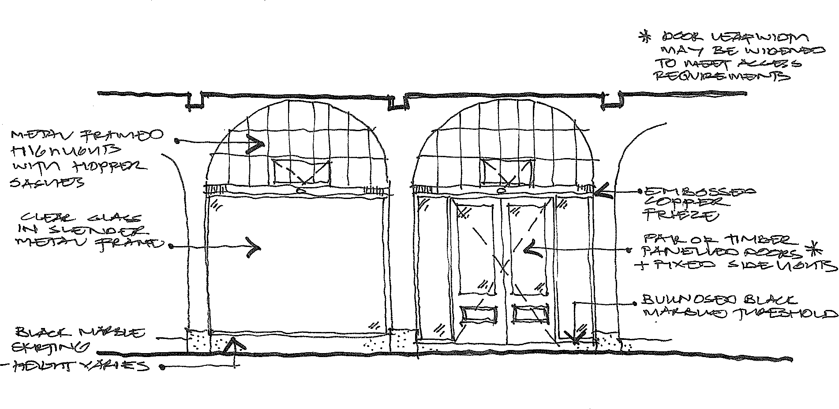

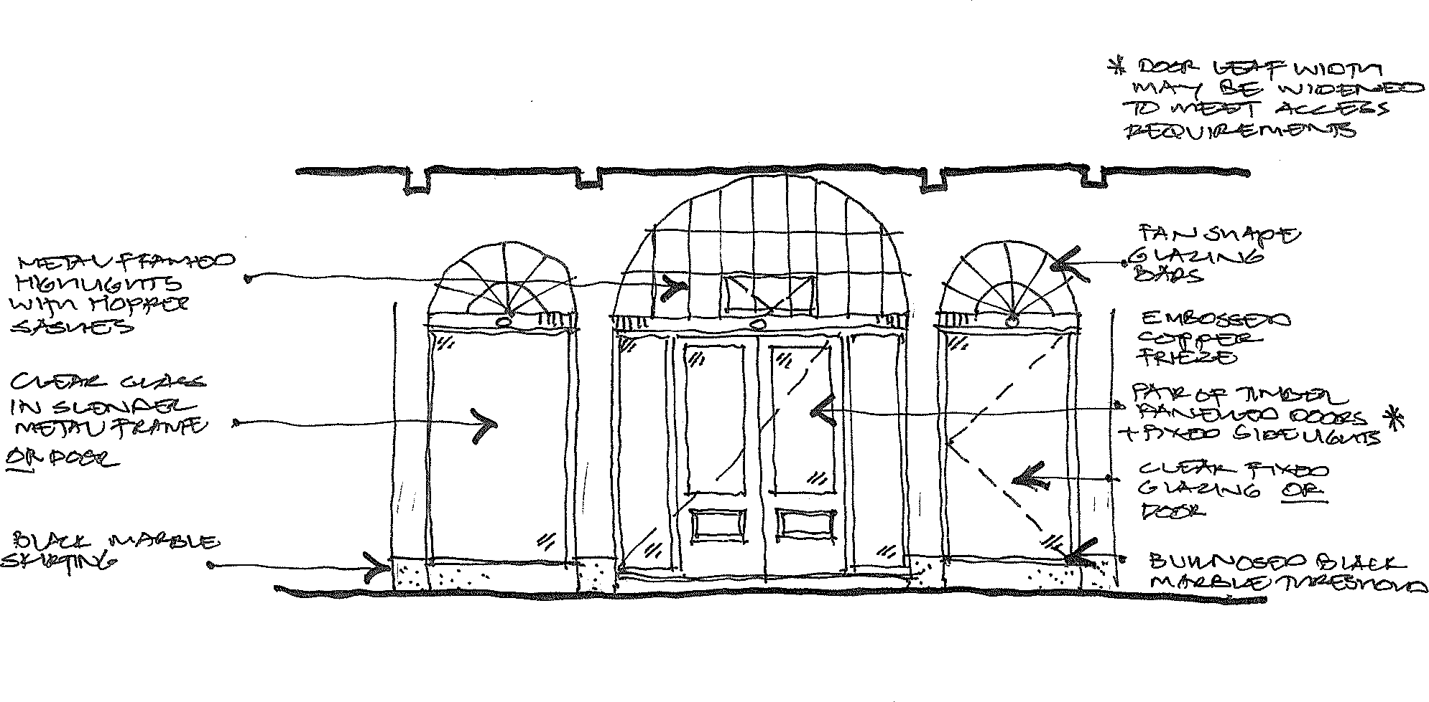

Original Centre Portal Shopfront

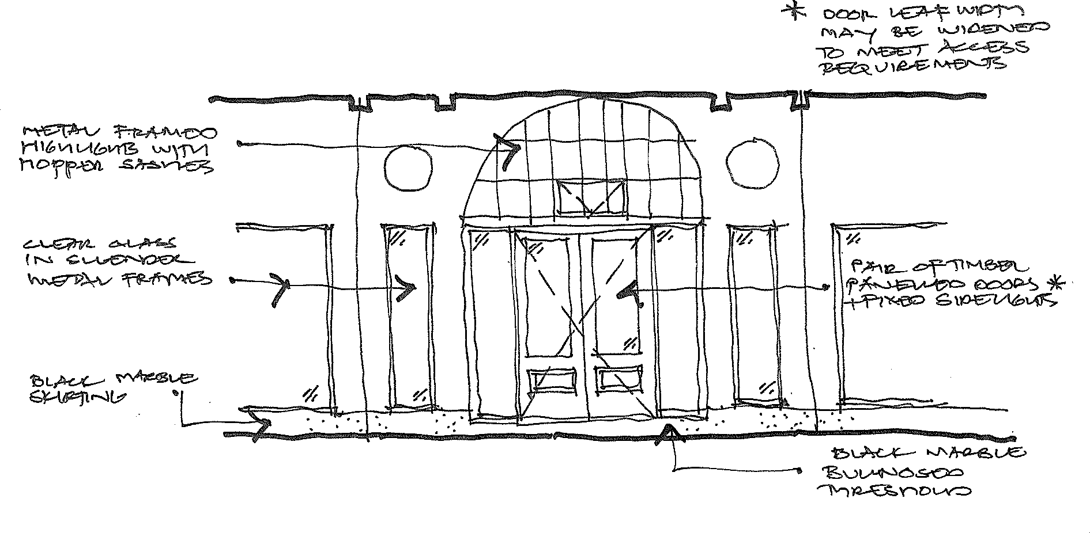

Original Corner Portal Shopfront

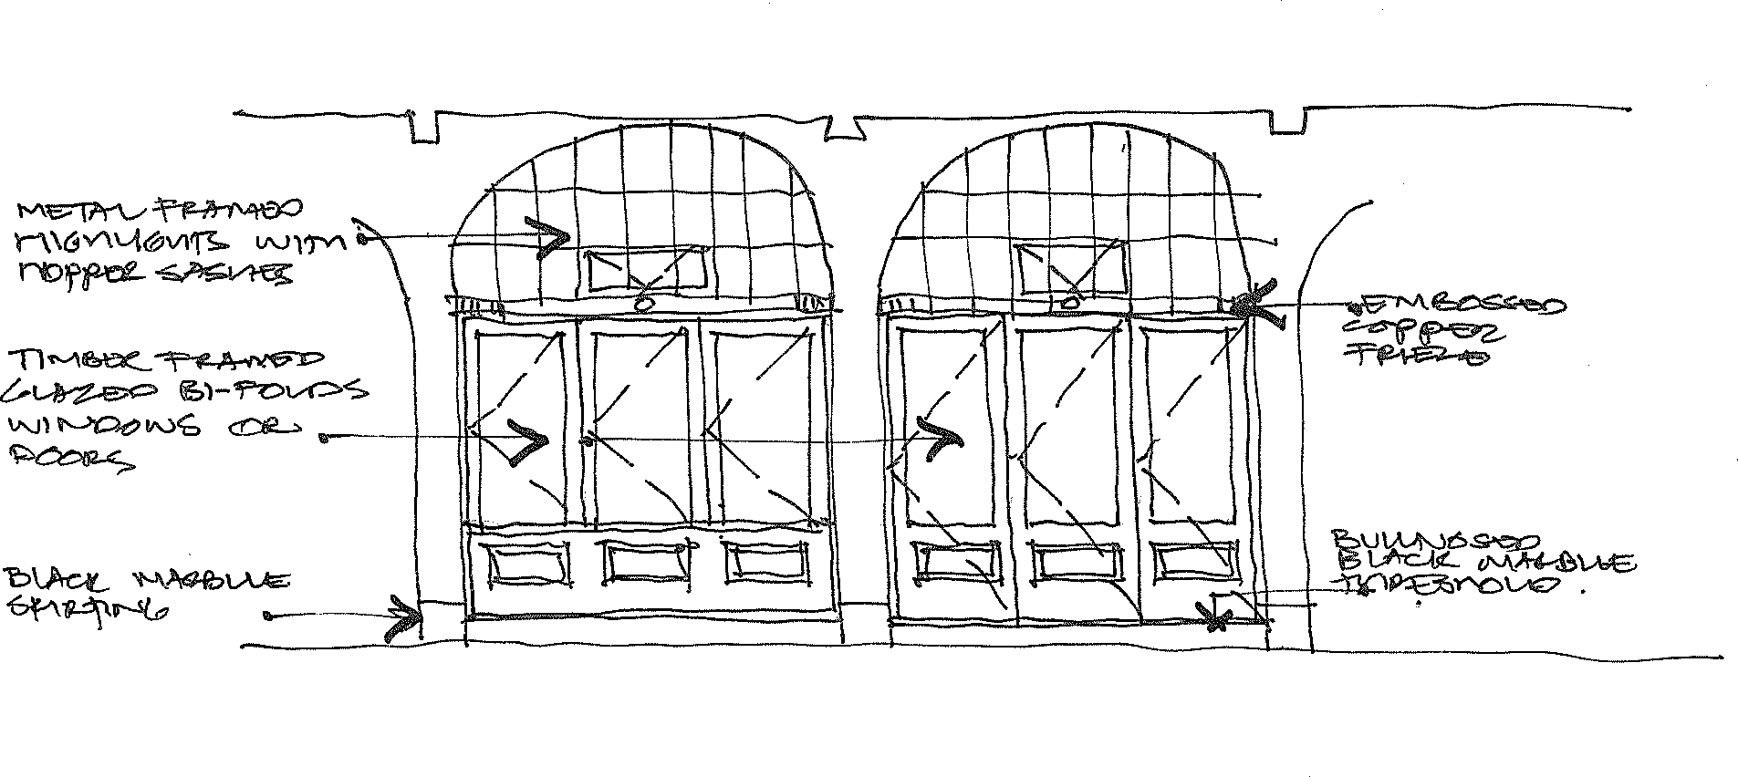

Alternative for Bi-Fold Windows & Doors

PHILIPLEESONARCHITECTS
4 / 9 M c K a y St r e e t T ur ne r A C T 2 6 12 P 0 2 6 29 5 3 3 11 E i n f o @ p h i l i p l e e s o n . c o m . a u
Black Marble Skirting Detail
S y d n e y a n d M e lb o u r n e B u i l d i n g s C M P
Scale 1:1 at A4
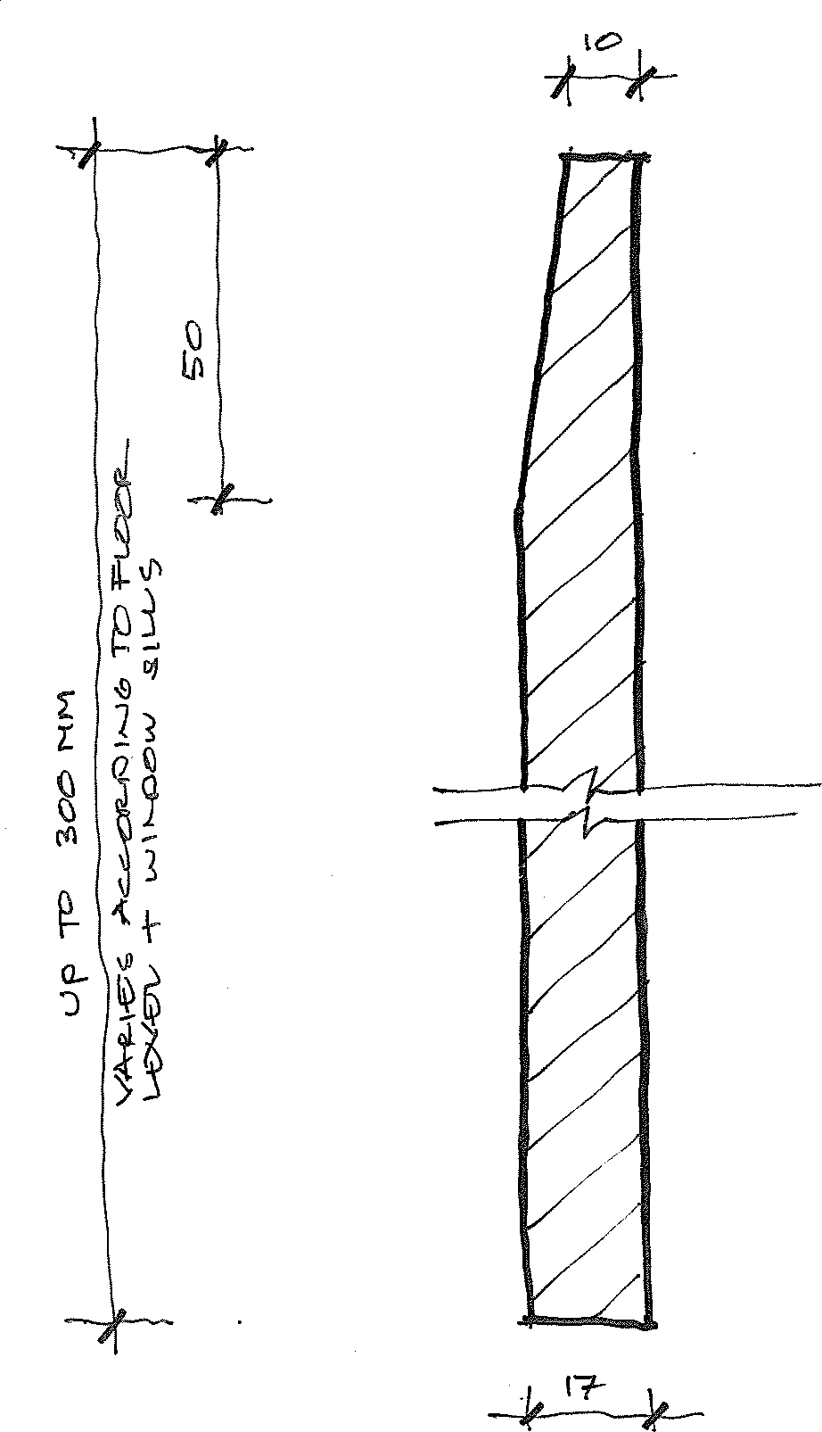

Original Concrete Colonnade Paving - Standard Tooled Joint Layout
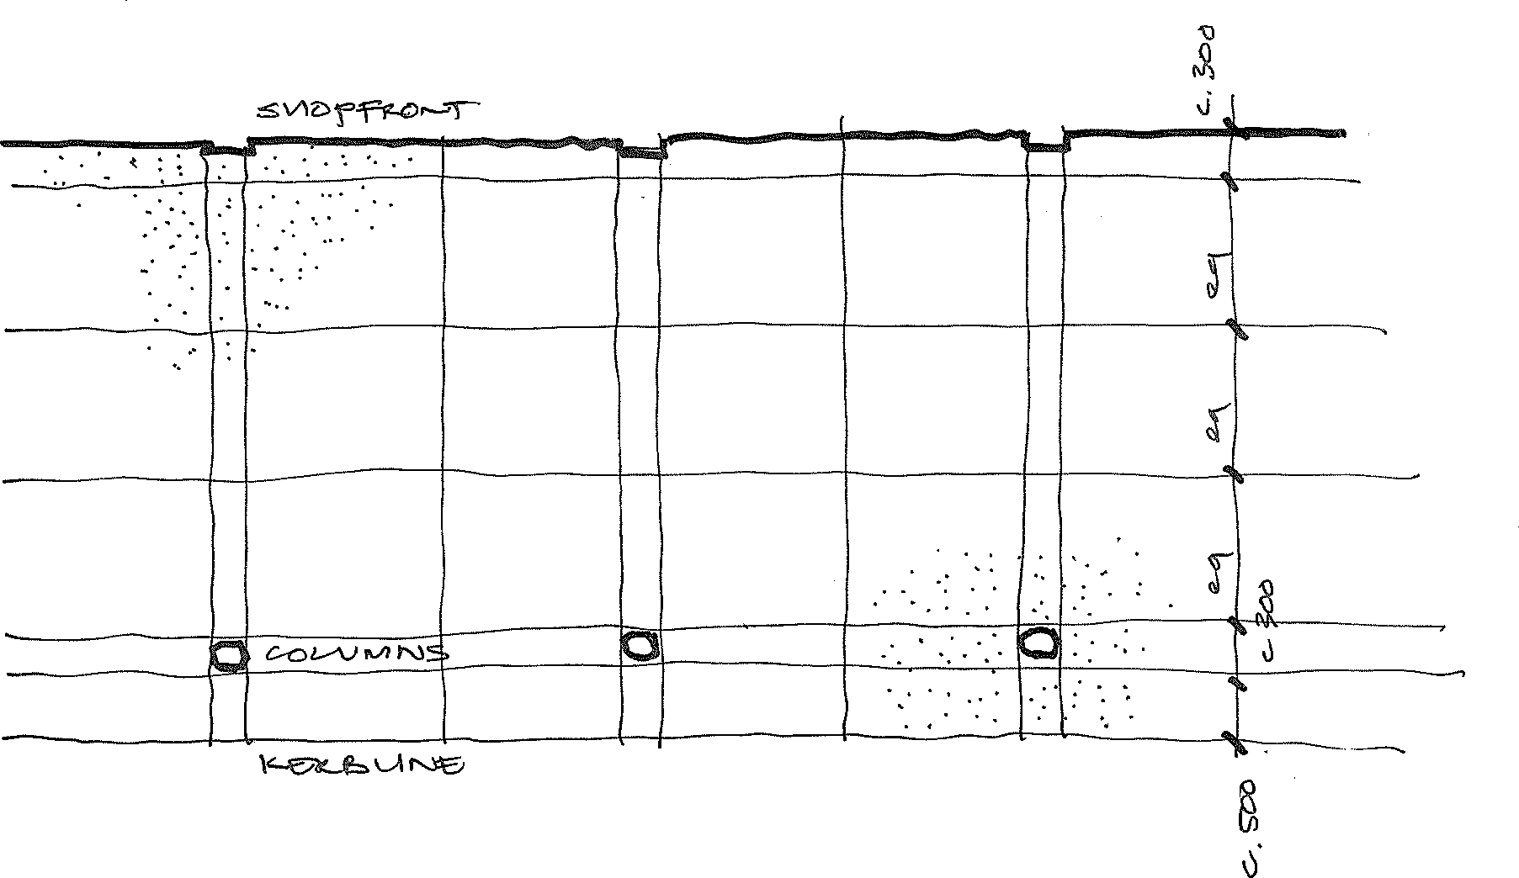

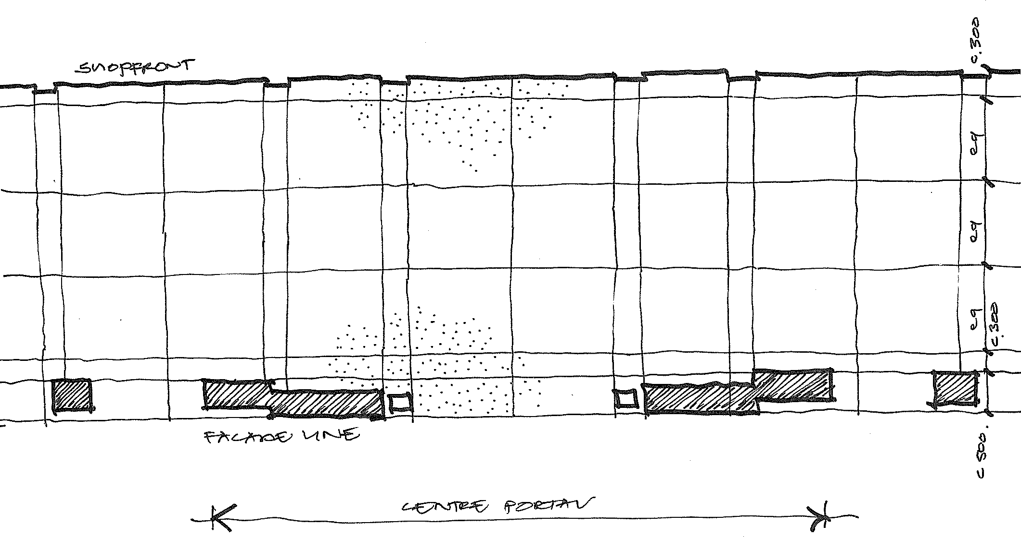

Original Concrete Colonnade Paving - Tooled Joint Layout at Centre Portals

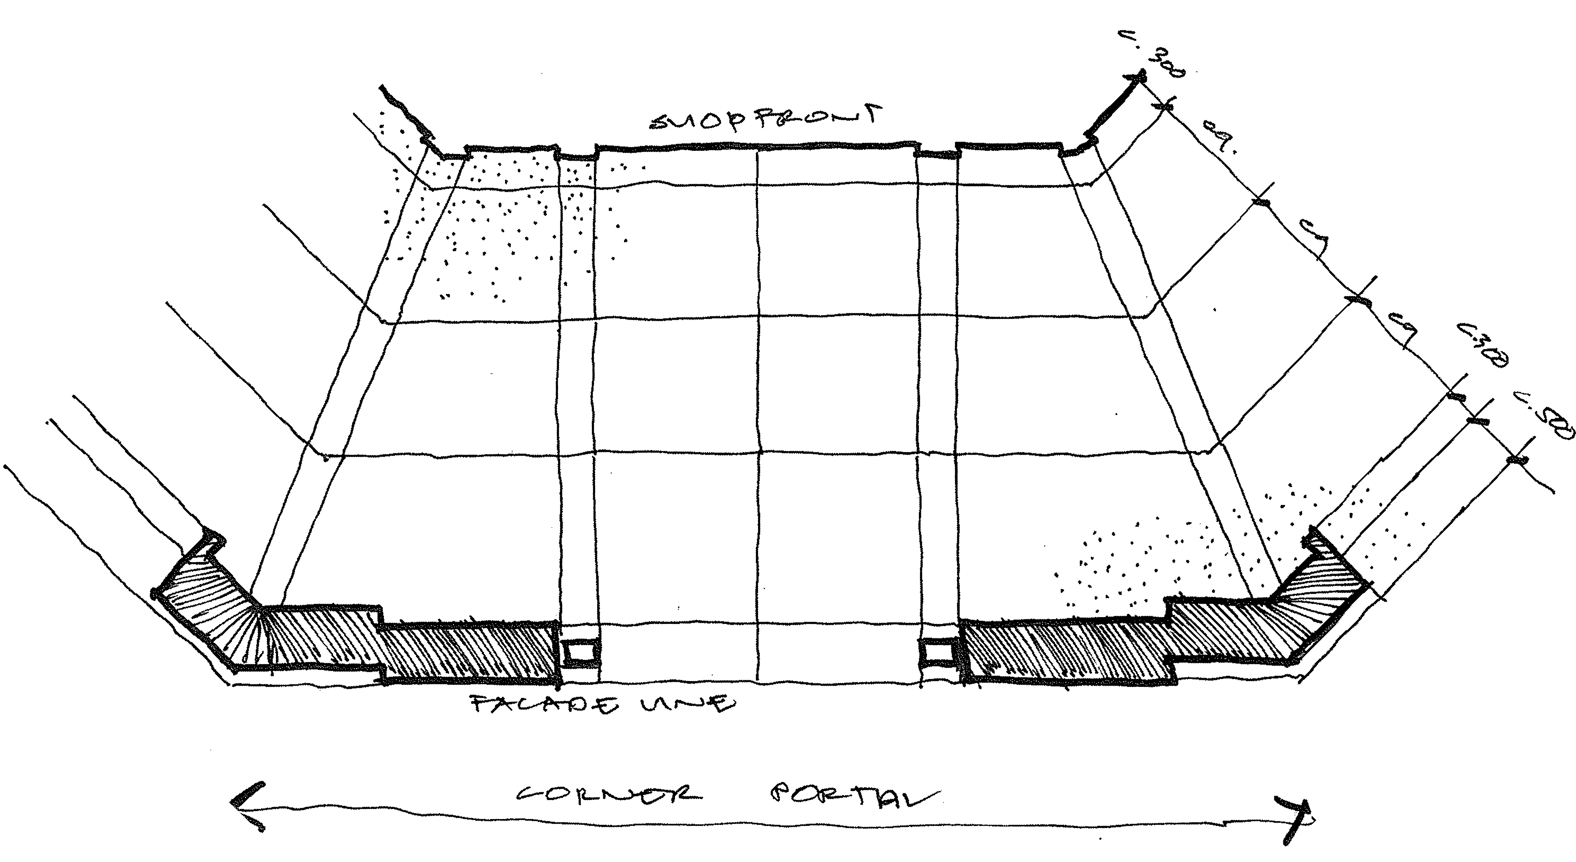

Scale 1:50 at A4

Colour Scheme 1 - Original Colour Scheme

Element | Colour / Specification
Rendered external walls | Breathable finish such as Porters Mineral Paint  AS2700 X42 Biscuit  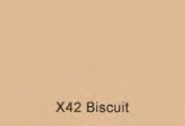
Pilasters, mouldings, reveals, beams, lintels, corbels, beads, columns, capitals, spandrels, bulls-eye,
Colonnade Ceiling | AS 2700 X33 Warm White  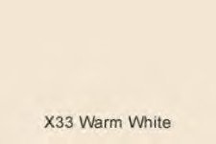
Doors | AS2700 R63 Red Oxide  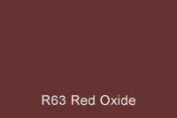
Rafters
Eave Soffits | AS2700 Y35 Off White  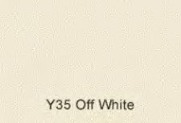
Gutters | AS2700 R64 Deep Indian Red  
Shopfront window frames | Copper (unpainted)  
Frieze above doors
Highlight windows
Skirting and thresholds | Black Marble (unpainted)


Colour Scheme 2 – Alternative Colour Scheme

Element | Colour / Specification
Rendered external walls | AS2700 Y34 Cream  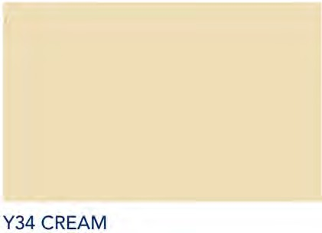
Pilasters, mouldings, reveals, beams, lintels, corbels, beads, columns, capitals, spandrels, bulls-eye, | AS2700 N14 White  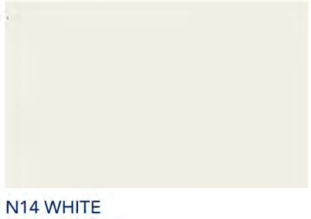
Column Bases | AS2700 Y51 Bronze Olive  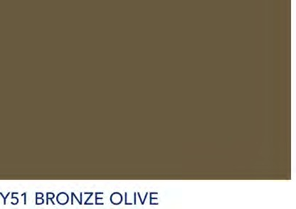
Colonnade Ceiling | AS2700 N14 White  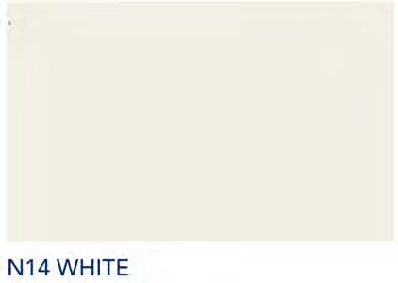
Doors | AS2700 R63 Red Oxide
Rafters
Eave Soffits | AS2700 N14 White

Gutters | AS2700 R64 Deep Indian Red
Shopfront window frames | Copper (unpainted)
Frieze above doors
Highlight windows
Skirting and thresholds | Black Marble (unpainted)

Conservation Works
  - Recommended Conservation, Repairs, Restoration and Reconstruction Actions
The following table schedules recommended repairs, conservation, restoration and reconstruction actions generally applicable across the Sydney and Melbourne Buildings. For specific actions block by block refer to the block inventories in Appendix B. Approval of this CMP indicates ACT Heritage Council approval of these actions.

Element | Description | Recommended Actions | Priority  U – Urgent: 6 months O – Overdue: 1-2 years R - Recommended  D - Desirable
Façade Walls | Rendered masonry | Repair movement cracks | O
Façade Walls | Rendered masonry | Repair spalling render | O
Façade Walls | Rendered masonry | Remove peeling paint, prepare surface and re-  paint | O
Decorative Mouldings | Painted in-situ render and pre-cast elements including corbels,  roundels, scrolls | Repair or replace chipped elements to match originals and  make good paint finish | O
Verandah Openings | Some original open verandahs with pairs of French doors in masonry  wall | Most areas sound
Verandah Openings | Many instances of tinted glazing in unobtrusive frames – some rear walls and doorways intact,  most not intact | Most areas sound
Verandah Openings | Some 1950s style steel framed windows | Replace with modern tinted glass in  unobtrusive frames | D
Verandah Openings | Some older timber framed windows | Replace with modern tinted glass in  unobtrusive frames | D
Eave soffits | Painted V jointed timber boards | Repair or replace  damaged sections to match original details | O
Rafters | Exposed, scrolled detail, painted timber | Repair or replace  damaged sections to match original details | O
Eave Gutters | Painted galvanized “Ogee” profile | Repair damaged  sections to match original details. | O
Eave Gutters | Modern Colorbond | Ideally replace with painted galvanized steel to match original  details | D
Downpipes | Painted rectangular gal.  steel | Repair or replace  damaged sections to | O

match original details, sizes and fixing details.
Rationalise locations with the input of an hydraulic consultant
 | Modern Colorbond | Ideally replace with painted galvanized steel to match original  details. | D
 | Modern round PVC | Ideally replace with painted galvanized steel to match original  details. | D
Front roof | Original “Cordova” style terracotta tiles | Repair or replace as required to match existing details  ACT Heritage files indicate recent repairs utilised Bristile La Escandella “Curvado” profile tiles in colour  ”Roja”. | O
 | Modern reproduction  “Cordova” style tiles | Generally sound
Rear roofs | A few areas of original “Cordova” style terracotta  tiles | Repair or replace as required to match  existing details | O
Rear roofs | Various later roof forms  and materials
Colonnade interior walls | Painted rendered masonry | Address sources of damage. Repair areas  of spalling render. | O
Colonnade interior walls |  | Remove peeling paint, prepare surface and re-  paint | O
Colonnade floor | Tiles or bitumen over original tooled concrete | Ideally restore the original concrete paving. If infeasible apply a new large format tile or paver which interprets the character of the original scored concrete and is able to be sourced over the long term when future repair or  replacement is required. | D
Colonnade floor |  | Address lack of proper drainage behind walls at corner, centre and  laneway portals. | O

A solution could be to create appropriate falls in new floor surface to stainless steel sleeve
pipes draining through walls to the verge
Colonnade Beams | Painted render, moulded edges | Repair chipped areas and make good  paintwork | O
Verandah Drainage | Painted gal.steel downpipes on face of Colonnade beams | Assess if verandah drainage is required (e.g. is the verandah still open or now enclosed). If not required remove and make good beam and ceiling finishes.  If drainage still required determine the best way to achieve this (e.g. is a downpipe still required across face of beam or is there a less obtrusive solution which has less impact on intrinsic  features) | O
Colonnade Ceilings | Painted asbestos cement sheet and timber battens | Repair / replace damaged fabric as required to match original details as closely as possible. (Use FC sheet in place of AC sheet)  Make good paint finishes | O
Colonnade Ceilings | Painted off form concrete | Make good paint finishes | O
Shopfront Glazing | A few sections of original oxidized brass frames  and plate glass windows | Conserve and maintain original shopfront  glazing | R
Shopfront Glazing | Various shopfronts | Various conditions | G/F/P
Doors | Various | Various conditions | G/F/P
Skirtings | Some sections of original black marble skirting | Repair as required and maintain | R
Skirtings | Some sections of  reproduction black marble skirting | Retain and maintain | R
Skirtings | Various later skirting types | Ideally replace to match original details. | D
Ventilators | Some sections of original  brass ventilators | Repair as required and  maintain | G

 | Various later vent types | Ideally replace with reproduction vents to match original details and locations – may not be possible where modern concrete slabs  have been installed. | D
Shopfront upper walls | Painted rendered masonry | Make good where required to achieve a smooth rendered finish and make good paint  finish. | O
Shopfront Pilasters | Painted render, moulded edge detail | Restore / reconstruct poorly repaired sections to match  original details. | D
Shopfront Pilasters |  | Ideally remove later cladding materials and  reconstruct to match original details. | D
Frieze | Painted embossed copper | Retain original fabric, repair as required and  maintain. | R
Frieze |  | Remove modern cladding and restore  original fabric. | O
Frieze |  | Remove unsympathetic replacements and reconstruct to match  original details. | D
Frieze |  | Consider painting modern timber reproductions to match  general colour scheme | D
Highlights | Painted metal frames, multi-paned, hopper sashes | Retain original fabric,  repair as required. | R
Highlights | Painted metal frames, multi-paned, hopper sashes | Replace unsympathetic modern highlights to match originals as  closely as possible | D
Highlights | Painted metal frames, multi-paned, hopper sashes | Remove paint or  boarding from glazing. | D
Rear walls | A few original “Canberra  Red” brick walls | Generally sound
Rear walls | Later “Canberra Red” brick walls | Mostly sound. Some
Rear Openings | Some original double hung windows, glass louvred windows, timber  doors | Mostly sound
Rear Openings | A variety of later timber and metal door and  window openings | Various conditions

  - Recommend Recurring Maintenance Actions
The following maintenance guide is written on the basis of a ‘whole of building’ program. Whether this is feasible will depend on future management arrangements.

Element | Works | Timing
Rainwater goods | Clean out gutters and downpipes and ensure that the building is waterproof and rainwater is effectively discharged away  from the building | Every six months
Building Envelope & Roof Space | Check for rodent activity. Block entry points as required taking care not to  damage significant fabric | Annually
Stormwater pits and  grated drains | Clean out, keep clear of weeds and  debris | Every six months
Walls | Inspect for cracking and impact damage.  Repair as required | Every two years
Timber elements | Check timber elements for rot, termite or borer attack. Repair as required | Annually
Windows | Check windows to ensure they are intact and operate freely. Repair as required. | Annually
Doors | Check doors to ensure they are intact  and operate freely. Repair as required. | Annually
Roof | Check roofs for structural soundness, ensure waterproof, vermin proof and free from rust. | Annually
Structural | Carry out an annual inspection of the roof framing  Address any structural issues noted  taking care not to damage significant fabric. | Annually
Exterior painted finishes | Clean all surfaces of dirt and cobwebs | Annually
 | Check for paint splitting, peeling or cracking | Every two years
 | Establish a cyclic repainting and touch up program. | Where acrylic paints are used, complete repaint every  10 years, touch up annually as required.
Pest Inspection | Commission a pest inspection by an accredited pest controller.  Attend to any issues as required. | Annually

References
Heritage Management Publications
Kerr, J.S. Conservation Plan: a guide to the preparation of conservation plans for places of European cultural significance. Sydney: J.S. Kerr on behalf of the National Trust of Australia NSW, June 2004
Marquis-Kyle, P & Walker, M. The Illustrated Burra Charter: Good Practice for Heritage Places. Sydney: Australia Inc., Ed 7, 2013

Heritage Listings
ACT Heritage Register Entry Sydney and Melbourne Buildings
Professional Reports
Craftech Heritage Services Pty Ltd, Sydney and Melbourne Buildings Historic paint finishes analysis, April 2020.

Appendix A: The Burra Charter



The Australia ICOMOS Charter for Places of Cultural Significance
2013

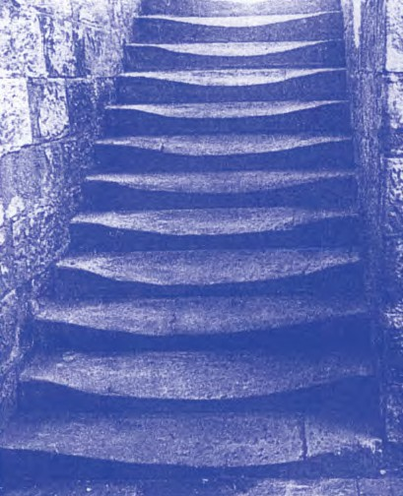


Australia ICOMOS Incorporated
International Council on Monuments and Sites

ICOMOS
ICOMOS (International Council on Monuments and Sites) is a non-governmental professional organisation formed in 1965, with headquarters in Paris. ICOMOS is primarily concerned with the philosophy, terminology, methodology and techniques of cultural heritage conservation. It is closely linked to UNESCO, particularly in its role under the World Heritage Convention 1972 as UNESCO’s principal adviser on cultural matters related to World Heritage. The 11,000 members of ICOMOS include architects, town planners, demographers, archaeologists, geographers, historians, conservators, anthropologists, scientists, engineers and heritage administrators. Members in the 103 countries belonging to ICOMOS are formed into National Committees and participate in a range of conservation projects, research work, intercultural exchanges and cooperative activities. ICOMOS also has 27 International Scientific Committees that focus on particular aspects of the conservation field. ICOMOS members meet triennially in a General Assembly.

Australia ICOMOS
The Australian National Committee of ICOMOS (Australia ICOMOS) was formed in 1976. It elects an Executive Committee of 15 members, which is responsible for carrying out national programs and participating in decisions of ICOMOS as an international organisation. It provides expert advice as required by ICOMOS, especially in its relationship with the World Heritage Committee. Australia ICOMOS acts as a national and international link between public authorities, institutions and individuals involved in the study and conservation of all places of cultural significance. Australia ICOMOS members participate in a range of conservation activities including site visits, training, conferences and meetings.
Revision of the Burra Charter
The Burra Charter was first adopted in 1979 at the historic South Australian mining town of Burra. Minor revisions were made in 1981 and 1988, with more substantial changes in 1999.
Following a review this version was adopted by Australia ICOMOS in October 2013.
The review process included replacement of the 1988 Guidelines to the Burra Charter with Practice Notes which are available at: australia.icomos.org
Australia ICOMOS documents are periodically reviewed and we welcome any comments.
Citing the Burra Charter
The full reference is The Burra Charter: The Australia ICOMOS Charter for Places of Cultural Significance, 2013. Initial textual references should be in the form of the Australia ICOMOS Burra Charter, 2013 and later references in the short form (Burra Charter).

© Australia ICOMOS Incorporated 2013
The Burra Charter consists of the Preamble, Articles, Explanatory Notes and the flow chart.
This publication may be reproduced, but only in its entirety including the front cover and this page.
Formatting must remain unaltered. Parts of the Burra Charter may be quoted with appropriate citing and acknowledgement.
Cover photograph by Ian Stapleton.
Australia ICOMOS Incorporated [ARBN 155 731 025]
Secretariat: c/o Faculty of Arts Deakin University
Burwood, VIC 3125 Australia
http://australia.icomos.org/ ISBN 0 9578528 4 3

The Burra Charter
(The Australia ICOMOS Charter for Places of Cultural Significance, 2013)

Preamble
Considering the International Charter for the Conservation and Restoration of Monuments and Sites (Venice 1964), and the Resolutions of the 5th General Assembly of the International Council on Monuments and Sites (ICOMOS) (Moscow 1978), the Burra Charter was adopted by Australia ICOMOS (the Australian National Committee of ICOMOS) on 19 August 1979 at Burra, South Australia. Revisions were adopted on 23 February 1981, 23 April 1988, 26 November 1999 and 31
October 2013.
The Burra Charter provides guidance for the conservation and management of places of cultural significance (cultural heritage places), and is based on the knowledge and experience of Australia ICOMOS members.
Conservation is an integral part of the management of places of cultural significance and is an ongoing responsibility.
Who is the Charter for?
The Charter sets a standard of practice for those who provide advice, make decisions about, or undertake works to places of cultural significance, including owners, managers and custodians.
Using the Charter
The Charter should be read as a whole. Many articles are interdependent.
The Charter consists of:
- Definitions Article 1
- Conservation Principles Articles 2–13
- Conservation Processes Articles 14–25
- Conservation Practices Articles 26–34
- The Burra Charter Process flow chart.
The key concepts are included in the Conservation Principles section and these are further developed in the Conservation Processes and Conservation Practice sections. The flow chart explains the Burra Charter Process (Article 6) and is an integral part of

the Charter. Explanatory Notes also form part of the Charter.
The Charter is self-contained, but aspects of its use and application are further explained, in a series of Australia ICOMOS Practice Notes, in The Illustrated Burra Charter, and in other guiding documents available from the Australia ICOMOS web site: australia.icomos.org.
What places does the Charter apply to?
The Charter can be applied to all types of places of cultural significance including natural, Indigenous and historic places with cultural values.
The standards of other organisations may also be relevant. These include the Australian Natural Heritage Charter, Ask First: a guide to respecting Indigenous heritage places and values and Significance 2.0: a guide to assessing the significance of collections.
National and international charters and other doctrine may be relevant. See australia.icomos.org.
Why conserve?
Places of cultural significance enrich people’s lives, often providing a deep and inspirational sense of connection to community and landscape, to the past and to lived experiences. They are historical records, that are important expressions of Australian identity and experience. Places of cultural significance reflect the diversity of our communities, telling us about who we are and the past that has formed us and the Australian landscape. They are irreplaceable and precious.
These places of cultural significance must be conserved for present and future generations in accordance with the principle of inter-generational equity.
The Burra Charter advocates a cautious approach to change: do as much as necessary to care for the place and to make it useable, but otherwise change it as little as possible so that its cultural significance is retained.

Article 1. Definitions
For the purposes of this Charter:
  - Place means a geographically defined area. It may include elements, objects, spaces and views. Place may have tangible and intangible dimensions.

  - Cultural significance means aesthetic, historic, scientific, social or spiritual value for past, present or future generations.
Cultural significance is embodied in the place itself, its fabric, setting, use, associations, meanings, records, related places and related objects.
Places may have a range of values for different individuals or groups.
  - Fabric means all the physical material of the place including elements, fixtures, contents and objects.

  - Conservation means all the processes of looking after a place so as to retain its cultural significance.
  - Maintenance means the continuous protective care of a place, and its setting.
Maintenance is to be distinguished from repair which involves
restoration or reconstruction.

  - Preservation means maintaining a place in its existing state and retarding deterioration.
  - Restoration means returning a place to a known earlier state by removing accretions or by reassembling existing elements without the introduction of new material.
  - Reconstruction means returning a place to a known earlier state and is distinguished from restoration by the introduction of new material.
  - Adaptation means changing a place to suit the existing use or a proposed use.
  - Use means the functions of a place, including the activities and traditional and customary practices that may occur at the place or are dependent on the place.

Place has a broad scope and includes natural and cultural features. Place can be large or small: for example, a memorial, a tree, an individual building or group of buildings, the location of an historical event, an urban area or town, a cultural landscape, a garden, an industrial plant, a shipwreck, a site with in situ remains, a stone arrangement, a road or travel route, a community meeting place, a site with spiritual or religious connections.
The term cultural significance is synonymous with cultural heritage significance and cultural heritage value.
Cultural significance may change over time and with use.
Understanding of cultural significance may change as a result of new information.

Fabric includes building interiors and sub-­‐‑ surface remains, as well as excavated material.
Natural elements of a place may also constitute fabric. For example the rocks that signify a Dreaming place.
Fabric may define spaces and views and these may be part of the significance of the place.
See also Article 14.

Examples of protective care include:
- maintenance — regular inspection and cleaning of a place, e.g. mowing and pruning in a garden;
- repair involving restoration — returning dislodged or relocated fabric to its original location e.g. loose roof gutters on a building or displaced rocks in a stone bora ring;
- repair involving reconstruction — replacing decayed fabric with new fabric
It is recognised that all places and their elements change over time at varying rates.

New material may include recycled material salvaged from other places. This should not be to the detriment of any place of cultural significance.

Use includes for example cultural practices commonly associated with Indigenous peoples such as ceremonies, hunting and fishing, and fulfillment of traditional obligations. Exercising a right of access may be a use.

  - Compatible use means a use which respects the cultural significance of a place. Such a use involves no, or minimal, impact on cultural significance.
  - Setting means the immediate and extended environment of a place that is part of or contributes to its cultural significance and distinctive character.

  - Related place means a place that contributes to the cultural significance of another place.
  - Related object means an object that contributes to the cultural significance of a place but is not at the place.

Setting may include: structures, spaces, land, water and sky; the visual setting including views to and from the place, and along a cultural route; and other sensory aspects of the setting such as smells and sounds. Setting may also include historical and contemporary relationships, such as use and activities, social and spiritual practices, and relationships with other places, both tangible and intangible.

Objects at a place are encompassed by the definition of place, and may or may not contribute to its cultural significance.

  - Associations mean the connections that exist between people and a place.
  - Meanings denote what a place signifies, indicates, evokes or expresses to people.
  - Interpretation means all the ways of presenting the cultural significance of a place.

Conservation Principles
Article 2. Conservation and management
  - Places of cultural significance should be conserved.
  - The aim of conservation is to retain the cultural significance of a
place.
  - Conservation is an integral part of good management of places of
cultural significance.
  - Places of cultural significance should be safeguarded and not put at risk or left in a vulnerable state.
Article 3. Cautious approach
  - Conservation is based on a respect for the existing fabric, use, associations and meanings. It requires a cautious approach of changing as much as necessary but as little as possible.

  - Changes to a place should not distort the physical or other evidence it provides, nor be based on conjecture.
Article 4. Knowledge, skills and techniques
  - Conservation should make use of all the knowledge, skills and disciplines which can contribute to the study and care of the place.
Associations may include social or spiritual values and cultural responsibilities for a place.

Meanings generally relate to intangible dimensions such as symbolic qualities and memories.
Interpretation may be a combination of the treatment of the fabric (e.g. maintenance, restoration, reconstruction); the use of and activities at the place; and the use of introduced explanatory material.

The traces of additions, alterations and earlier treatments to the fabric of a place are evidence of its history and uses which may be part of its significance. Conservation action should assist and not impede their understanding.

  - Traditional techniques and materials are preferred for the conservation of significant fabric. In some circumstances modern techniques and materials which offer substantial conservation benefits may be appropriate.
Article 5. Values
  - Conservation of a place should identify and take into consideration all aspects of cultural and natural significance without unwarranted emphasis on any one value at the expense of others.

  - Relative degrees of cultural significance may lead to different
conservation actions at a place.

Article 6. Burra Charter Process
  - The cultural significance of a place and other issues affecting its future are best understood by a sequence of collecting and analysing information before making decisions. Understanding cultural significance comes first, then development of policy and finally management of the place in accordance with the policy. This is the Burra Charter Process.
  - Policy for managing a place must be based on an understanding of its cultural significance.
  - Policy development should also include consideration of other factors affecting the future of a place such as the owner’s needs, resources, external constraints and its physical condition.
The use of modern materials and techniques must be supported by firm scientific evidence or by a body of experience.

Conservation of places with natural significance is explained in the Australian Natural Heritage Charter. This Charter defines natural significance to mean the importance of ecosystems, biodiversity and geodiversity for their existence value or for present or future generations, in terms of their scientific, social, aesthetic and life-­‐‑support value.
In some cultures, natural and cultural values are indivisible.
A cautious approach is needed, as understanding of cultural significance may change. This article should not be used to justify actions which do not retain cultural significance.

The Burra Charter Process, or sequence of investigations, decisions and actions, is illustrated below and in more detail in the accompanying flow chart which forms part of the Charter.

Understand Significance
⬇⬇

Develop Policy
⬇⬇

Manage in Accordance with Policy

  - In developing an effective policy, different ways to retain cultural significance and address other factors may need to be explored.
  - Changes in circumstances, or new information or perspectives, may require reiteration of part or all of the Burra Charter Process.
Article 7. Use
  - Where the use of a place is of cultural significance it should be retained.
  - A place should have a compatible use.
Options considered may include a range of uses and changes (e.g. adaptation) to a place.

The policy should identify a use or combination of uses or constraints on uses that retain the cultural significance of the place. New use of a place should involve minimal change to significant fabric and use; should respect associations and meanings; and where appropriate should provide for continuation of activities and practices which contribute to the cultural significance of the place.

Article 8. Setting
Conservation requires the retention of an appropriate setting. This includes retention of the visual and sensory setting, as well as the retention of spiritual and other cultural relationships that contribute to the cultural significance of the place.
New construction, demolition, intrusions or other changes which would adversely affect the setting or relationships are not appropriate.
Article 9. Location
  - The physical location of a place is part of its cultural significance. A building, work or other element of a place should remain in its historical location. Relocation is generally unacceptable unless this is the sole practical means of ensuring its survival.
  - Some buildings, works or other elements of places were designed to be readily removable or already have a history of relocation. Provided such buildings, works or other elements do not have significant links with their present location, removal may be appropriate.
  - If any building, work or other element is moved, it should be moved to an appropriate location and given an appropriate use. Such action should not be to the detriment of any place of cultural significance.
Article 10. Contents
Contents, fixtures and objects which contribute to the cultural significance of a place should be retained at that place. Their removal is unacceptable unless it is: the sole means of ensuring their security and preservation; on a temporary basis for treatment or exhibition; for cultural reasons; for health and safety; or to protect the place. Such contents, fixtures and objects should be returned where circumstances permit and it is culturally appropriate.

Article 11. Related places and objects
The contribution which related places and related objects make to the
cultural significance of the place should be retained.
Article 12. Participation
Conservation, interpretation and management of a place should provide for the participation of people for whom the place has significant associations and meanings, or who have social, spiritual or other cultural responsibilities for the place.
Article 13. Co-existence of cultural values
Co-existence of cultural values should always be recognised, respected and encouraged. This is especially important in cases where they conflict.

Setting is explained in Article 1.12.

For example, the repatriation (returning) of an object or element to a place may be important to Indigenous cultures, and may be essential to the retention of its cultural significance.
Article 28 covers the circumstances where significant fabric might be disturbed, for example, during archaeological excavation.
Article 33 deals with significant fabric that has been removed from a place.

For some places, conflicting cultural values may affect policy development and management decisions. In Article 13, the term cultural values refers to those beliefs which are important to a cultural group, including but not limited to political, religious, spiritual and moral beliefs. This is broader than values associated with cultural significance.

The Burra Charter, 2013 Australia ICOMOS Incorporated — 5

Conservation Processes
Article 14. Conservation processes
Conservation may, according to circumstance, include the processes of: retention or reintroduction of a use; retention of associations and meanings; maintenance, preservation, restoration, reconstruction, adaptation and interpretation; and will commonly include a combination of more than one of these. Conservation may also include retention of the contribution that related places and related objects make to the cultural significance of a place.
Article 15. Change
  - Change may be necessary to retain cultural significance, but is undesirable where it reduces cultural significance. The amount of change to a place and its use should be guided by the cultural significance of the place and its appropriate interpretation.

  - Changes which reduce cultural significance should be reversible, and be reversed when circumstances permit.

  - Demolition of significant fabric of a place is generally not acceptable. However, in some cases minor demolition may be appropriate as part of conservation. Removed significant fabric should be reinstated when circumstances permit.
  - The contributions of all aspects of cultural significance of a place should be respected. If a place includes fabric, uses, associations or meanings of different periods, or different aspects of cultural significance, emphasising or interpreting one period or aspect at the expense of another can only be justified when what is left out, removed or diminished is of slight cultural significance and that which is emphasised or interpreted is of much greater cultural significance.
Article 16. Maintenance
Maintenance is fundamental to conservation. Maintenance should be undertaken where fabric is of cultural significance and its maintenance is necessary to retain that cultural significance.
Article 17. Preservation
Preservation is appropriate where the existing fabric or its condition constitutes evidence of cultural significance, or where insufficient evidence is available to allow other conservation processes to be carried out.

Conservation normally seeks to slow deterioration unless the significance of the place dictates otherwise. There may be circumstances where no action is required to achieve conservation.

When change is being considered, including for a temporary use, a range of options should be explored to seek the option which minimises any reduction to its cultural significance.
It may be appropriate to change a place where this reflects a change in cultural meanings or practices at the place, but the significance of the place should always be respected.
Reversible changes should be considered temporary. Non-­‐‑reversible change should only be used as a last resort and should not prevent future conservation action.

Maintaining a place may be important to the fulfilment of traditional laws and customs in some Indigenous communities and other cultural groups.

Preservation protects fabric without obscuring evidence of its construction and use. The process should always be applied:
- where the evidence of the fabric is of such significance that it should not be altered; or
- where insufficient investigation has been carried out to permit policy decisions to be taken in accord with Articles 26 to 28.
New work (e.g. stabilisation) may be carried out in association with preservation when its purpose is the physical protection of the fabric and when it is consistent with Article 22.

6 — Australia ICOMOS Incorporated The Burra Charter, 2013

Article 18. Restoration and reconstruction
Restoration and reconstruction should reveal culturally significant aspects of the place.
Article 19. Restoration
Restoration is appropriate only if there is sufficient evidence of an earlier state of the fabric.
Article 20. Reconstruction
  - Reconstruction is appropriate only where a place is incomplete through damage or alteration, and only where there is sufficient evidence to reproduce an earlier state of the fabric. In some cases, reconstruction may also be appropriate as part of a use or practice that retains the cultural significance of the place.
  - Reconstruction should be identifiable on close inspection or through additional interpretation.
Article 21. Adaptation
  - Adaptation is acceptable only where the adaptation has minimal impact on the cultural significance of the place.

  - Adaptation should involve minimal change to significant fabric, achieved only after considering alternatives.
Article 22. New work
  - New work such as additions or other changes to the place may be acceptable where it respects and does not distort or obscure the cultural significance of the place, or detract from its interpretation and appreciation.
  - New work should be readily identifiable as such, but must respect and have minimal impact on the cultural significance of the place.
Article 23. Retaining or reintroducing use
Retaining, modifying or reintroducing a significant use may be appropriate and preferred forms of conservation.

Article 24. Retaining associations and meanings
  - Significant associations between people and a place should be respected, retained and not obscured. Opportunities for the interpretation, commemoration and celebration of these associations should be investigated and implemented.
  - Significant meanings, including spiritual values, of a place should be respected. Opportunities for the continuation or revival of these meanings should be investigated and implemented.

Places with social or spiritual value may warrant reconstruction, even though very little may remain (e.g. only building footings or tree stumps following fire, flood or storm). The requirement for sufficient evidence to reproduce an earlier state still applies.

Adaptation may involve additions to the place, the introduction of new services, or a new use, or changes to safeguard the place. Adaptation of a place for a new use is often referred to as ‘adaptive re-­‐‑use’ and should be consistent with Article 7.2.

New work should respect the significance of a place through consideration of its siting, bulk, form, scale, character, colour, texture and material. Imitation should generally be avoided.
New work should be consistent with Articles 3, 5, 8, 15, 21 and 22.1.

These may require changes to significant fabric but they should be minimised. In some cases, continuing a significant use, activity or practice may involve substantial new work.

For many places associations will be linked to aspects of use, including activities and practices.
Some associations and meanings may not be apparent and will require research.

Article 25. Interpretation
The cultural significance of many places is not readily apparent, and should be explained by interpretation. Interpretation should enhance understanding and engagement, and be culturally appropriate.

Conservation Practice
Article 26. Applying the Burra Charter Process
  - Work on a place should be preceded by studies to understand the place which should include analysis of physical, documentary, oral and other evidence, drawing on appropriate knowledge, skills and disciplines.
  - Written statements of cultural significance and policy for the place should be prepared, justified and accompanied by supporting evidence. The statements of significance and policy should be incorporated into a management plan for the place.

  - Groups and individuals with associations with the place as well as those involved in its management should be provided with opportunities to contribute to and participate in identifying and understanding the cultural significance of the place. Where appropriate they should also have opportunities to participate in its conservation and management.
  - Statements of cultural significance and policy for the place should be periodically reviewed, and actions and their consequences monitored to ensure continuing appropriateness and effectiveness.
Article 27. Managing change
  - The impact of proposed changes, including incremental changes, on the cultural significance of a place should be assessed with reference to the statement of significance and the policy for managing the place. It may be necessary to modify proposed changes to better retain cultural significance.
  - Existing fabric, use, associations and meanings should be adequately recorded before and after any changes are made to the place.
Article 28. Disturbance of fabric
  - Disturbance of significant fabric for study, or to obtain evidence, should be minimised. Study of a place by any disturbance of the fabric, including archaeological excavation, should only be undertaken to provide data essential for decisions on the conservation of the place, or to obtain important evidence about to be lost or made inaccessible.

In some circumstances any form of interpretation may be culturally inappropriate.

The results of studies should be kept up to date, regularly reviewed and revised as necessary.

Policy should address all relevant issues, e.g. use, interpretation, management and change.
A management plan is a useful document for recording the Burra Charter Process, i.e. the steps in planning for and managing a place of cultural significance (Article 6.1 and flow chart). Such plans are often called conservation management plans and sometimes have other names.
The management plan may deal with other matters related to the management of the place.

Monitor actions taken in case there are also unintended consequences.

  - Investigation of a place which requires disturbance of the fabric, apart from that necessary to make decisions, may be appropriate provided that it is consistent with the policy for the place. Such investigation should be based on important research questions which have potential to substantially add to knowledge, which cannot be answered in other ways and which minimises disturbance of significant fabric.
Article 29. Responsibility
The organisations and individuals responsible for management and decisions should be named and specific responsibility taken for each decision.
Article 30. Direction, supervision and implementation
Competent direction and supervision should be maintained at all stages, and any changes should be implemented by people with appropriate knowledge and skills.
Article 31. Keeping a log
New evidence may come to light while implementing policy or a plan for a place. Other factors may arise and require new decisions. A log of new evidence and additional decisions should be kept.
Article 32. Records
  - The records associated with the conservation of a place should be placed in a permanent archive and made publicly available, subject to requirements of security and privacy, and where this is culturally appropriate.
  - Records about the history of a place should be protected and made publicly available, subject to requirements of security and privacy, and where this is culturally appropriate.
Article 33. Removed fabric
Significant fabric which has been removed from a place including contents, fixtures and objects, should be catalogued, and protected in accordance with its cultural significance.
Where possible and culturally appropriate, removed significant fabric including contents, fixtures and objects, should be kept at the place.
Article 34. Resources
Adequate resources should be provided for conservation.

New decisions should respect and have minimal impact on the cultural significance of the place.

The best conservation often involves the least work and can be inexpensive.

Words in italics are defined in Article 1.

The Burra Charter Process
Steps in planning for and managing a place of cultural significance
The Burra Charter should be read as a whole.
Key articles relevant to each step are shown in the boxes. Article 6 summarises the Burra Charter Process.
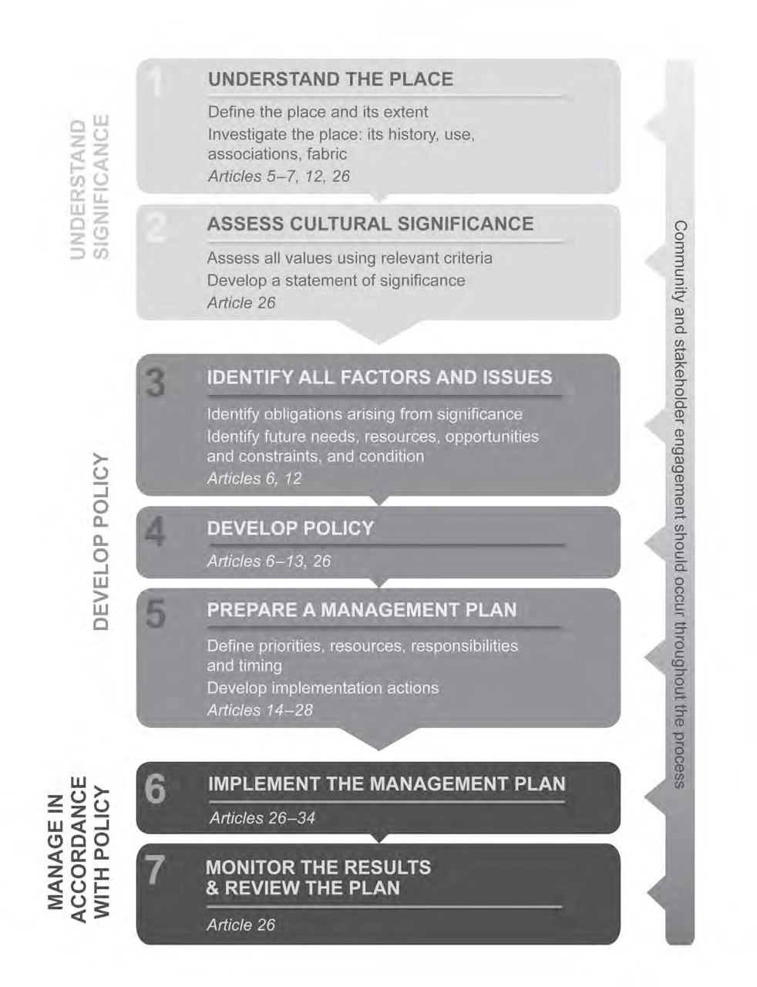

Appendix B: Block Inventories
These block inventories were compiled in 2020 by David Hobbes and Alanna King of Philip Leeson Architects. They record the current nature/integrity of each shopfront, identifying elements that are original, modified and/or intrusive. Recommended repairs and conservation works are noted on a block by block basis.

  - Sydney Building, Alinga Street

Block | Part Block 1, Section 48
Location | NW corner
Street No. | 92 Alinga St
Business Name | Vacant
Former Businesses
Shopfront Elements
Skirting | Painted timber, some recently replaced
Ventilators | Some original, some damaged, painted black
Spandrels | Timber paneled, painted black
Walls | Painted render, two colours, patchy, dirty, redundant fixings
Main Windows | 3 part timber frame, painted black
Thresholds | Quarry tile, aluminium strip
Ramps | No
Doors | Black powdercoated alum. Sliding, fixed sidelights
Frieze | Original embossed metal to sides, none above corner doors
Highlights | Original metal frame, intact
Colonnade Beams | Painted concrete, decorative mouldings, corbels, minor chips, dirty
Colonnade Floor | Quarry tiles, marked, chipped
Ceiling | Board & batten, painted OK
Services | Glass ball light on ceiling, redundant conduits
Signage | Wall fixed
Façade Elements
Roof | Behind corner portal
Walls | Painted render, extensive peeling paint, patchy colour, crack to RHS portal/façade wall
Verandah | Fixed glass, black frame
Soffit | Painted decorative outriggers Painted timber boards
Gutters | Original? OG gutter,
Downpipes | UPVC LHS portal, discharges to ground UPVC RHS portal, in ground pipe
Lights | Original collars on portal, no fittings
Signs | Original “Sydney Building” sign in portal, business sign in portal – unsympathetic?
Original Elements | - Painted masonry walls, pilasters, columns, beams  - Painted panelled ceiling, frieze, highlight
Past Modifications | - Skirting replaced  - Ventilators removed  - Windows and doors replaced  - Highlight hopper removed  - Verandah enclosed  - Colonnade floor tiled  - Lighting & signage changed

Intrusive Elements | - Surface conduits, modern & missing ventilator
Recommended Repairs & Conservation Works | - Replace timber skirting with new black stone to match original  - Fit new brass ventilators to match original  - Repair walls  - Replace threshold to approved design  - Reconstruct glazing bars to hopper  - Address downpipe on beam face  - Repaint whole to approved colour scheme  - Replace colonnade floor to approved design  - Rationalise services

Block | Part Block 1, Section 48
Location | NW corner
Street No. | 92 Alinga St
Business Name | Vacant
Former Businesses
Shopfront Elements
Skirting | No
Ventilators | No
Spandrels | No
Walls | Painted render, patchy, dirty
Main Windows | 3 part timber frame, painted black
Thresholds | Concrete, chipped edges
Ramps | No
Doors | - 2 x swing doors, timber panels and sidelights, black  - 3 part timber bifolds, black
Frieze | Original embossed metal
Highlights | Original metal frame, intact
Colonnade Beams | Painted concrete, decorative mouldings, corbels, minor chips, dirty, redundant fixings
Colonnade Floor | Quarry tiles, marked, chipped
Ceiling | Board & batten, painted OK
Services | Glass ball light on ceiling, redundant conduits
Signage | Suspended from beam, face panels missing
Façade Elements
Roof | Original Cordova style terracotta roof tiles
Walls | Painted render, minor cracks, peeling paint
Verandah | Fixed glass, black frame
Soffit | Painted decorative outriggers Painted timber boards
Gutters | OG gutter, dirty, rust
Downpipes | UPVC return to upper wall
Lights | No
Signs | No
Original Elements | - Painted masonry walls, pilasters, columns, beams  - Painted panelled ceiling, frieze, highlight
Past Modifications | - Skirting replaced  - Ventilators removed  - Windows and doors replaced  - Highlight hopper removed  - Verandah enclosed  - Colonnade floor tiled

 | - Lighting & signage changed
Intrusive Elements | - Surface conduits, modern & missing ventilator
Recommended Repairs & Conservation Works | - Replace timber skirting with new black stone to match original  - Fit new brass ventilators to match original  - Repair walls  - Replace threshold to approved design  - Reconstruct glazing bars to hopper  - Address downpipe on beam face  - Repaint whole to approved colour scheme  - Replace colonnade floor to approved design  - Rationalise services

Block | Block 25, Section 48
Location | Middle of run
Street No. | 102 Alinga St
Business Name | Brew Nation (Café)
Former Businesses | Dept. of Defence (first floor)
Shopfront Elements
Skirting | Timber, painted black
Ventilators | One modern, one missing
Spandrels | Timber paneled, painted black
Walls | Painted render, damaged, marked, peeling paint
Main Windows | 3 part timber frame, fixed, painted black
Thresholds | Quarry tile, aluminium strip
Ramps | No
Doors | Timber framed, pair of swing doors, fixed sidelights, painted black
Frieze | Original embossed metal, painted black
Highlights | Original metal frame, intact, hopper replaced with fixed glass
Colonnade Beams | Painted concrete, decorative mouldings, corbels, Minor paint peeling & chips
Colonnade Floor | Quarry tiles, marked, chipped
Ceiling | Board & batten, recently replaced
Services | Glass ball light on ceiling, speakers, junction boxes
Signage | Wall fixed
Façade Elements
Roof | Original Cordova style terracotta tiles
Walls | Painted render, minor cracks, peeling paint, sticker on column, cracks  to RHS lane portal
Verandah | Enclosed, fixed glass, bronze anodised frame
Soffit | Painted decorative outriggers  Painted timber boards, some damaged, section of FC sheet, wasps nest
Gutters | OG gutter, rusty, peeling paint
Downpipes | UPVC RHS lane portal, discharges to ground
Lights | Ball lights, speaker on wall
Signs | No
Original Elements | - Painted masonry walls, pilasters, columns, beams  - Terracotta tiled roof  - Metal frieze  - Arched highlight windows  - OG gutter  - Painted timber boards and outriggers to eave soffit

Past Modifications | - Skirting replaced  - Ventilators removed  - Windows and doors replaced  - Ceiling replaced  - Highlight hopper removed  - Colonnade floor tiled  - Lighting & signage changed  - Downpipe added  - Services added  - Verandah enclosed
Intrusive Elements | - Surface conduits  - Modern & missing ventilator  - UPVC downpipe
Recommended Repairs & Conservation Works | - Replace timber skirting to match original  - Fit new brass ventilators to match original  - Repair walls  - Replace threshold to approved design  - Reconstruct glazing bars to hopper  - Repaint whole to approved colour scheme  - Rationalise services  - Replace downpipe to approved design  - Repair/replace damaged soffit

Block | Block 5, Section 48
Location | Corner of laneway
Street No. | 106 Alinga St
Business Name | Hotpot (restaurant, ground floor) Scientology (first floor)
Former Businesses | Billiard Saloon
Shopfront Elements
Skirting | Moulded concrete, painted brown
Ventilators | No
Spandrels | No
Walls | Painted render, damaged, marked, peeling paint
Main Windows | Black PC aluminium framed fixed window, 5 part bi-fold above brown  painted timber paneled spandrel with timber serving bench
Thresholds | No
Ramps | No
Doors | - Frameless glass, brass fittings, inset to stair lobby  - 5 part full height bi-fold to restaurant
Frieze | Original embossed metal, painted brown, 1 section patched
Highlights | Original metal frame, intact, one hopper replaced with fixed glass, all glazing painted over
Colonnade Beams | Painted concrete, decorative mouldings, corbels,  Fine crack on one beam, damaged by former signage fixtures
Colonnade Floor | Quarry tiles, poorly patched, cracked chipped  Water pooling against inner face of façade
Ceiling | Board and batten, painted, patched
Services | Glass ball light on ceiling, switches, surface conduit, security system, fairy lights suspended
Signage | 1 wall sign, 1 drop sign on beam, illuminated
Façade Elements

Roof | Behind parapet
Walls | Minor cracks, peeling paint, patch where sign changed, parapet  capping dirty
Laneway facade | Minor cracks, patchy paint, fixed glazing to upper windows with bronze anodised frame, kliplok sheeting over lower windows, rectangular  downpipe and orig. rain head, traffic signs on wall, dirty capping
Verandah | Enclosed, 1950s steel framed windows, painted brown in centre arch,  fixed glazing on flanks
Soffit | No
Gutters | No
Downpipes | No
Lights | No
Signs | No
Original Elements | - Painted masonry walls, pilasters, columns, beams  - Painted panelled ceiling, frieze, highlight
Past Modifications | - Skirting replaced  - Ventilators removed  - Windows and doors replaced  - Colonnade floor tiled  - Lighting & signage changed  - Verandah enclosed
Intrusive Elements | Intrusive Elements  - Windows and Doors  - Surface conduits  - Kliplok over lane windows
Recommended Repairs & Conservation Works | Recommended Repairs / Refurbishment  - Scabble back concrete skirting. Fit new black stone to match original  - Fit new brass ventilators to match original  - Repair damaged original fabric  - Replace thresholds to approved design  - Replace doors and windows to approved design  - Reconstruct glazing bars to hopper  - Repaint whole to approved colour scheme  - Replace colonnade floor to approved design  - Rationalise services  - New drainage outlet in outer wall  - New signage to approved standards

Block | Part Block 6, Section 48
Location | Corner of laneway
Street No. | 112-116 Alinga St
Business Name | Transport Canberra
Former Businesses | Blue Moon Café 1928 - ?
Shopfront Elements
Skirting | Moulded concrete, painted
Ventilators | No
Spandrels | No
Walls | Painted render, damaged, marked, peeling paint, patch where sign  removed
Main Windows | Black PC aluminium framed fixed window
Thresholds | Quarry tiles

Ramps | Inside door
Doors | - RHS - Black PC aluminium, sliding and fixed panel  - LHS – glazed timber and highlight to stair lobby, slatted timber on plywood to store?
Frieze | Original embossed metal, painted black, dents and hole
Highlights | Original metal frame, intact, one hopper replaced with fixed glass, all glazing painted over RHS, sign LHS
Colonnade Beams | Painted concrete, decorative mouldings, corbels
Colonnade Floor | Quarry tiles, poorly patched, cracked chipped Water pooling against inner face of façade
Ceiling | Board and batten, painted
Services | Glass ball light on ceiling, security camera on frieze
Signage | LHS on base of highlight
Façade Elements
Roof | Behind parapet
Walls | Fresh paint, dirty at base, dirty parapet capping,
Verandah | Enclosed, anodised aluminium frame
Soffit | No
Gutters | No
Downpipes | No
Lights | Round ball light
Signs | On portal cartouche
Laneway facade | Grafitti, 3 levels of windows, white PC aluminium fixed to upper, clear  anodised aluminium fixed to bottom, steel bars, drenchers over windows, traffic signs
Original Elements | - Painted masonry walls, pilasters, columns, beams  - Painted panelled ceiling, frieze, highlight
Past Modifications | Past Modifications  - Skirting replaced  - Ventilators removed  - Windows and doors replaced  - Colonnade floor tiled  - Lighting & signage changed  - Verandah enclosed
Intrusive Elements | Intrusive Elements  - Windows and Doors  - Surface conduits  - Sign on highlight
Recommended Repairs & Conservation Works | Recommended Repairs / Refurbishment  - Scabble back concrete skirting. Fit new black stone to match original  - Fit new brass ventilators to match original  - Repair damaged original fabric  - Replace thresholds to approved design  - Replace doors and windows to approved design  - Reconstruct glazing bars to hopper  - Repaint whole to approved colour scheme  - Replace colonnade floor to approved design  - Rationalise services  - New drainage outlet in outer wall

Block | Block 26, Section 48
Location | Middle of run
Street No. | 118 Alinga St
Business Name | Tatsuke (Japanese Restaurant, ground floor)
Former Businesses | Commonwealth Dept. of Health 1932 - ? (first floor)
Shopfront Elements
Skirting | Black stone (marble?)
Ventilators | No
Spandrels | No
Walls | Pilasters clad in red marble tiles, upper wall rendered, mark where sign removed
Main Windows | Black PC aluminium frame, fixed
Thresholds | No
Ramps | No. Step up inside door
Doors | Black PC aluminium, swing door & 3 part bi-fold
Frieze | Original embossed metal, concealed by signage
Highlights | Bronze metal, top panes painted black, mesh vents in 2 lower panes of each bay
Colonnade Beams | Painted concrete, decorative mouldings, corbels,  Unsympathetic service conduits, marks left by former beam, fixed spotlight
Colonnade Floor | Quarry tiles, stained, cracked
Ceiling | Board and batten, painted, peeling paint, cobwebs
Services | Glass ball light on ceiling, extensive conduits, GPO, switches, junction  boxes, spotlights
Signage | Wall fixed and partly over highlights
Façade Elements
Roof | Original Cordova style terracotta tiles
Walls | Painted render, columns worn & dirty at base,
Verandah | Enclosed, fixed glazing, black frame
Soffit | Painted decorative outriggers Painted timber board
Gutters | OG gutter, rust, sagging
Downpipes | No
Lights | No
Signs | No
Original Elements | - Painted masonry walls, pilasters, columns, beams  - Painted panelled ceiling, frieze, highlights
Past Modifications | - Skirting replaced  - Ventilators removed  - Windows and doors replaced  - Pilasters tiled  - Verandah enclosed  - Threshold replaced  - Colonnade floor tiled  - Lighting & signage changed
Intrusive Elements | - Marble tiles on pilasters  - Doors & windows  - Surface conduits  - Sign over highlights

Recommended Repairs & Conservation Works | - Fit new brass ventilators to match original  - Remove marble tiles and repair walls  - Fit threshold to approved design  - Replace doors and windows to approved design  - Repaint whole to approved colour scheme  - Replace colonnade floor to approved design  - Rationalise services  - Remove signage from highlights

Block | Part Block 2, Section 48 (1 bay only – stair lobby)
Location | Middle of run
Street No. | 122 Alinga St
Business Name | Mr Wolf (Club, ground floor)
Former Businesses | Commonwealth Dept. of Health 1932 - ? (first floor)
Shopfront Elements
Skirting | No
Ventilators | No
Spandrels | No
Walls | Holes from former signage fixings
Main Windows | None
Thresholds | Checkerplate steel
Ramps | No. Step up inside door
Doors | Timber panel swing door and fixed leaf, porthole window
Frieze | Original embossed metal, holes from former fixings
Highlights | Original, painted black, cream paint on glass
Colonnade Beams | Painted concrete, decorative mouldings, corbels, Water staining, peeling paint
Colonnade Floor | Quarry tiles, stained, cracked
Ceiling | Board and batten, painted, cobwebs, one sheet sagging
Services | Security alarm
Signage | No
Façade Elements
Roof | Original Cordova style terracotta tiles
Walls | Painted render, columns worn & dirty at base,
Verandah | Enclosed, fixed glazing, black frame
Soffit | Painted decorative outriggers  Painted timber board
Gutters | OG gutter, rust, sagging
Downpipes | No
Lights | No
Signs | No
Original Elements | - Painted masonry walls, pilasters, columns, beams  - Painted panelled ceiling, frieze, highlight
Past Modifications | - Skirting replaced  - Ventilators removed  - Windows and doors replaced  - Threshold replaced  - Verandah enclosed  - Colonnade floor tiled  - Lighting & signage changed
Intrusive Elements | - Surface conduits  - Door & threshold

Recommended Repairs & Conservation Works | - Repair damaged original fabric  - Replace thresholds to approved design  - Remove paint from highlight glazing  - Replace door to approved design  - Repaint whole to approved colour scheme  - Replace colonnade floor to approved design  - Rationalise services  - Repair / replace gutter

Block | Part Block 2, Section 48 (1 bay only – stair lobby)
Location | Middle of run
Street No. | 122 Alinga St
Business Name | Capital Pancakes (Restaurant, basement)
Former Businesses | Commonwealth Dept. of Health 1932 - ? (first floor)
Shopfront Elements
Skirting | No
Ventilators | No
Spandrels | No
Walls | Holes from former signage fixings
Main Windows | None
Thresholds | Quarry tiles
Ramps | None. Step up inside door
Doors | Timber framed, glazed, swing, fixed sidelight, brass fittings, inset
Frieze | Original embossed metal, covered by signage
Highlights | Hopper replaced with board
Colonnade Beams | Painted concrete, decorative mouldings, corbels, Dirty, cobwebs, water staining
Colonnade Floor | Quarry tiles, stained, cracked
Ceiling | Board and batten, painted, cobwebs
Services | Glass ball light on ceiling, conduit, spotlight on beam
Signage | 2 wall mounted projecting, 1 over base of highlight
Façade Elements
Roof | Original Cordova style terracotta tiles
Walls | Painted render
Verandah | Enclosed, fixed glazing, black frame
Soffit | Painted decorative outriggers  Painted FC sheet
Gutters | OG gutter, rust, sagging
Downpipes | No
Lights | No
Signs | No
Original Elements | - Painted masonry walls, pilasters, columns, beams  - Painted panelled ceiling, frieze, highlight
Past Modifications | - Skirting removed  - Ventilators removed  - Door replaced  - Threshold removed  - Verandah enclosed  - Colonnade floor tiled  - Lighting & signage changed  - Highlight replaced
Intrusive Elements | - Surface conduits

 | - Signage over highlight & frieze
Recommended Repairs & Conservation Works | - Repair original fabric as required  - Fit threshold to approved design  - Replace door to approved design  - Repaint whole to approved colour scheme  - Replace colonnade floor to approved design  - Rationalise services  - Remove signage from frieze  - Repair/replace gutter

Block | Part Block 2, Section 48
Location | Close to NE corner
Street No. | 122 Alinga St
Business Name | Zambrero (Mexican Restaurant, ground floor)
Former Businesses | Commonwealth Dept. of Health 1932 - ? (first floor)  Beard Watson Furniture 1957 - ?
Shopfront Elements
Skirting | Original black marble
Ventilators | Brass, 1 original, 1 black perf. alum.
Spandrels | No
Walls | Pilasters clad in red marble tile, painted black
Main Windows | Original oxidised brass frame, fixed glass
Thresholds | Black granite
Ramps | No, step
Doors | Bronze anodised aluminum frame, painted black, hinged doors & sidelights
Frieze | Original embossed metal
Highlights | Slightly different frame, but likely original
Colonnade Beams | Painted concrete, decorative mouldings, corbels, water staining
Colonnade Floor | Quarry tiles, stained
Ceiling | Board and batten, painted, cobwebs, water damage, 1 panel bowed
Services | Glass ball light on ceiling, conduit above main windows
Signage | Sticker on window
Façade Elements
Roof | Original Cordova style terracotta tiles
Walls | Painted render
Verandah | Enclosed, fixed glazing, black frame
Soffit | Painted decorative outriggers  Painted FC sheet
Gutters | OG gutter, peeling paint, rust, sagging
Downpipes | Painted gal. round into RHS NE portal
Lights | No
Signs | No
Original Elements | - Painted masonry walls, pilasters, columns, beams  - Painted panelled ceiling  - 1 brass ventilator  - Glass shopfront in oxidised brass frame  - Metal frieze  - Arched highlights
Past Modifications | - 1 Ventilator replaced  - Door replaced

- Threshold replaced
- Colonnade floor tiled
- Verandah enclosed
- Lighting & signage changed
- Pilasters clad in red marble tile
Intrusive Elements | - Surface conduits  - Red marble tiles
Recommended Repairs & Conservation Works | - Fit new brass ventilator to match original  - Repair walls  - Replace thresholds to approved design  - Repair glazing bars in highlight  - Address downpipe on beam face  - Replace doors to approved design  - Repaint whole to approved colour scheme  - Repair bowed colonnade ceiling  - Replace colonnade floor to approved design  - Rationalise services & relocate door sensor off frieze

  - Sydney Building, East Row

Block | Part Block 2, Section 48
Location | NE Corner
Street No. | 47 East Row
Business Name | Elora (bubble tea, ground floor)
Former Businesses | Commonwealth Dept. of Health 1932 - ? (first floor) Beard Watson Furniture 1957 - ?
Shopfront Elements
Skirting | Original marble, chipped
Ventilators | 2 original, 1 missing, 2 modern
Spandrels | No
Walls | Pilasters clad in red marble tile, painted black
Main Windows | Original oxidised brass frame, fixed glass
Thresholds | Black granite (modern)
Ramps | No
Doors | Bronze anodised frame, glazed, swing, fixed sidelight, brass fittings
Frieze | Original embossed metal, several holes from service fixings
Highlights | Original, hoppers operative, covered in thick dust
Colonnade Beams | Painted concrete, decorative mouldings, corbels, redundant fixings,  peeling paint
Colonnade Floor | Quarry tiles, stained, cracked
Ceiling | Board and batten, painted, cobwebs
Services | Conduit, spotlight, ball light on ceiling
Signage | Fixed over original window, LHS inside window
Façade Elements
Roof | Behind parapet
Walls | Rendered, peeling paint, graffiti, shabby at base,
Verandah | Enclosed, fixed glazing black frame
Soffit | No
Gutters | No
Downpipes | No
Lights | White ball light
Signs | Original “Sydney Building” on portal, sympathetic “Pancake Parlour” on portal
Original Elements | - Painted masonry walls, pilasters, columns, beams  - Painted panelled ceiling  - Glass shopfront in oxidised brass frame  - Metal frieze  - Arched highlights
Past Modifications | - Skirting removed  - Some ventilators replaced  - Door replaced  - Threshold replaced  - Verandah enclosed  - Colonnade floor tiled  - Lighting & signage changed  - Pilasters clad in red marble tiles
Intrusive Elements | - Surface conduits  - Red marble tiles
Recommended Repairs & Conservation Works | - Fit new brass ventilator to match original  - Repair damaged original fabric

- Remove red marble tiles and make good walls
- Replace thresholds to approved design
- Replace doors to approved design
- Repaint whole to approved colour scheme
- Replace colonnade floor to approved design
- Rationalise services

Block | Block 17, Section 48
Location | Middle of run
Street No. | 43-45 East Row
Business Name | Free Choice Tobacconist
Former Businesses | Owner John Tickner, leased by Mr Allan as Butcher’s shop & office 1928 -  First floor offices rented by Superannuation Board and South African High Commission  Burnt out & rebuilt 1950
Shopfront Elements
Skirting | Original black marble
Ventilators | Modern brass, oversized
Spandrels | No
Walls | Pilasters clad in red marble tile, painted black Holes from former fixings
Main Windows | No
Thresholds | Black granite
Ramps | No
Doors | Black PC frame, glazed swing door, sidelight
Frieze | Original embossed metal, painted, security alarm fixed on it
Highlights | Original, glass painted over, tape residue on glazing bars
Colonnade Beams | Painted concrete, decorative mouldings, corbels,
Colonnade Floor | Quarry tiles, stained, cracked
Ceiling | Board and batten, painted
Services | Ball light on ceiling, security alarm
Signage | Stickers on window
Façade Elements
Roof | Original Cordova style terracotta tiles
Walls | Painted render, minor cracks, peeling paint, shabby at base
Verandah | Enclosed, fixed glazing, black frame
Soffit | Painted decorative outriggers  Painted FC sheet, wasps nests, cobwebs
Gutters | Quad gutter, rust, sagging
Downpipes | No
Lights | No
Signs | No
Original Elements | - Painted masonry walls, pilasters, columns, beams  - Painted panelled ceiling  - Black marble skirtings  - Metal frieze  - Arched highlights
Past Modifications | - Ventilators replaced  - Red marble tiles on pilasters  - Door replaced  - Verandah enclosed

- Threshold replaced
- Colonnade floor tiled
- Lighting & signage changed
Intrusive Elements | - Surface conduits  - Red marble tiles
Recommended Repairs & Conservation Works | - Fit new brass ventilators to match original  - Repair damaged original fabric  - Remove red marble tiles and make good walls  - Replace door to approved design  - Repaint whole to approved colour scheme  - Replace colonnade floor to approved design  - Rationalise services  - Remove security alarm from frieze  - Clean tape from highlight windows and remove paint from glass

Block | Block 17, Section 48
Location | Middle of run
Street No. | 39 East Row
Business Name | Revolution CD / Lobby to the Brass Room (Club)
Former Businesses | Owned by Helen Brackenreg 1925  J. Costeto’s Fruit & Veg 1950 Burnt and rebuilt 1950 Goodlands Grocery post 1950  Superannuation Board above
Shopfront Elements
Skirting | Maroon ceramic tiles
Ventilators | No
Spandrels | No
Walls | Maroon ceramic tiles on pilasters, rendered above
Main Windows | White PC aluminium, fixed glazing
Thresholds | Ceramic tile
Ramps | No
Doors | White PC aluminium frame, glazed, sidelight, scuffed
Frieze | Concealed by signage
Highlights | Original, single opening panel at top of each arch, painted white
Colonnade Beams | Painted concrete, decorative mouldings, corbels  Collapsed & rusting metal dp across face, supported on white PC. aluminium channel, water damage to outer wall
Colonnade Floor | Quarry tiles, dirty, cracks
Ceiling | Board and batten, painted, patched, nails visible
Services | Conduit, security lights, white glass ball on ceiling
Signage | Fixed over frieze, pill type on wall, illuminated
Façade Elements
Roof | Original Cordova style terracotta tiles
Walls | Painted render, minor cracks, peeling paint
Verandah | Enclosed, 1950s steel frame windows, painted white, hole from former AC
Soffit | Painted decorative outriggers  Painted FC sheet, broken panels, loose facsia
Gutters | Quad gutter, rust, sagging
Downpipes | Round UPVC returns to upper wall, leaking

Lights | Small white ball light
Signs | No
Original Elements | - Painted masonry walls, pilasters, columns, beams  - Painted panelled ceiling  - Metal frieze  - Arched highlights
Past Modifications | - Skirting replaced  - Ventilators removed  - Maroon tile cladding & threshold  - Doors replaced  - Threshold replaced  - Verandah enclosed  - Colonnade floor tiled  - Lighting & signage changed
Intrusive Elements | - Surface conduits  - Maroon tiles  - Signage over frieze  - White PC doors
Recommended Repairs & Conservation Works | - Fit skirtings to match original  - Fit new brass ventilator to match original  - Remove maroon tiles and make good walls  - Replace doors & windows to approved design  - Repaint whole to approved colour scheme  - Replace colonnade floor to approved design  - Rationalise services  - Replace downpipe on beam  - Repair water damaged wall  - Remove signage from frieze

Block | Block 18, Section 48
Location | Middle of run
Street No. | 35 East Row
Business Name | Iori Japanese Restaurant
Former Businesses | Owned by Helen Brackenreg 1925 Studman’s Deli 1930-1944  Goodlands Grocery 1948-5  T. Samios Fish Café above Burnt and rebuilt 1950  J Costello’s & Fish Café post 1950
Shopfront Elements
Skirting | Painted particleboard
Ventilators | No
Spandrels | No
Walls | Painted particleboard over pilasters, render above, marks from former fixings
Main Windows | Fixed glazing in silicone seal
Thresholds | Shallow tiled ramp in reveal depth
Ramps | No
Doors | Clear anodised aluminium frame, glazed panels
Frieze | Lost or concealed behind board
Highlights | Original, glass painted over

Colonnade Beams | Painted concrete, decorative mouldings, corbels, dp running across face, rusted, water stains
Colonnade Floor | Quarry tiles, stained, chipped & cracked
Ceiling | Board and batten, painted, cobwebs
Services | Conduit, glass ball on ceiling
Signage | Illuminated “pill type” wall sign
Façade Elements
Roof | Original Cordova style terracotta tiles
Walls | Painted render, minor cracks, peeling paint, shabby at base & columns
Verandah | 1950s steel frame windows, painted white, AC unit
Soffit | Painted decorative outriggers  Painted FC sheet - loose, loose fascia
Gutters | Quad gutter, dirty
Downpipes | No
Lights | No
Signs | No
Original Elements | - Painted masonry walls, pilasters, columns, beams  - Painted panelled ceiling  - Arched highlights
Past Modifications | - Skirting replaced  - Ventilators removed  - Particleboard over pilasters  - Windows & doors replaced  - Threshold replaced  - Verandah enclosed  - Colonnade floor tiled and ramp added  - Lighting & signage changed
Intrusive Elements | - Surface conduits  - Doors  - Particleboard skirtings & pilasters
Recommended Repairs & Conservation Works | - Fit skirtings to match original  - Fit new brass ventilators to match original  - Remove particleboard from pilasters and make good walls  - Replace thresholds  - Replace doors to approved design  - Repaint whole to approved colour scheme  - Replace colonnade floor to approved design  - Rationalise services  - Replace downpipe on beam  - Repair / replace frieze  - Remove paint from highlights

Block | Block 19, Section 48
Location | Middle of run
Street No. | 35 East Row
Business Name | No 1 Asian Dessert Place / Stair Lobby to Loft Life City Church
Former Businesses | N. Fisk Civic Deep Freeze Shop Burnt and rebuilt 1950  Post 1950 ground floor Deli, first floor Cafe
Shopfront Elements
Skirting | Small section of original black marble on LHS pilaster  Particleboard planter across rest

Ventilators | Concealed or lost
Spandrels | Concealed or lost
Walls | Painted particleboard over central pilaster 1960s mosaic tile to LHS pilaster
Main Windows | No
Thresholds | Tiles
Ramps | Short plywood step ramp
Doors | - Solid timber door and frame, fixed highlight over  - Clear anodised aluminium frame, glazed 3 part bi-fold
Frieze | Mostly concealed by signage, original section at LHS
Highlights | Original, painted burnt orange
Colonnade Beams | Painted concrete, decorative mouldings, corbels, dp running across face, rusted, water stains
Colonnade Floor | Quarry tiles, stained, chipped & cracked
Ceiling | Board and batten, painted, cobwebs, 3 damaged panels
Services | Conduit, light on beam, wall spotlight, surface conduit to sign over frieze
Signage | 2 x suspended from beam and secured by wire to colonnade column, fixed to frieze and windows
Façade Elements
Roof | Original Cordova style terracotta tiles
Walls | Painted render, minor cracks, peeling paint, shabby at base & columns
Verandah | 1950s steel frame windows, painted white, AC unit
Soffit | Painted decorative outriggers Painted FC sheet
Gutters | Quad gutter, dirty
Downpipes | Unpainted square gal. return to upper wall, rough cut holes in wall
Lights | No
Signs | No
Original Elements | - Painted masonry walls, pilasters, columns, beams  - Painted panelled ceiling  - Metal frieze?  - Arched highlights  - One section of marble sklirting
Past Modifications | - Skirting covered with particleboard  - Ventilators removed or concealed  - Particleboard over pilasters  - Ceramic tiles to 1 pilaster  - Windows & Doors replaced  - Threshold replaced  - Verandah enclosed  - Colonnade floor tiled and ramp added  - Lighting & signage changed
Intrusive Elements | - Surface conduits  - Particleboard coverings & ramp  - Tiled pilaster  - Doors  - Sign on frieze
Recommended Repairs & Conservation Works | - Remove particleboard coverings to reveal extent of original fabric under  - Fit skirtings to match original  - Fit new brass ventilators to match original

- Remove ceramic tiles and make good walls
- Replace thresholds
- Replace windows and doors to approved design
- Repaint whole to approved colour scheme
- Replace colonnade floor to approved design
- Rationalise services
- Replace damaged ceiling panels
- Replace downpipes on beam & facade
- Remove signage from frieze

Block | Block 20, Section 48
Location | Partly behind centre portal
Street No. | 33 & 33A East Row
Business Name | Vacant (formerly Croissant D’Or) / Lobby to separate tenancy 33A
Former Businesses | Possibly a Pharmacy operated by Charles Thompson
Shopfront Elements
Skirting | Ceramic tiles
Ventilators | No
Spandrels | No
Walls | Painted particleboard over pilasters Upper rendered wall very discoloured
Main Windows | Clear anodised aluminium frame painted green, fixed glazing
Thresholds | No
Ramps | Tiled
Doors | - Clear anodised aluminium frame, swing door & sidelight to 33A  - Clear anodised aluminium frame, painted green, swing door & sidelight to 33
Frieze | Original embossed metal, junction box and security alarm fixed on it
Highlights | Original, painted green, wall exhaust fan in one pane of each bay
Colonnade Beams | Painted concrete, decorative mouldings, corbels,  1 concrete corbel chipped
Colonnade Floor | Asphalt, partly worn exposing original concrete paving
Ceiling | Board and batten, painted, cobwebs, damaged split panel, discoloured
Services | Redundant conduit, original fluted metal light collar on beam, light on beam, wall spotlight, surface conduit to sign over frieze
Signage | “Pill type” wall sign
Façade Elements | Partly behind centre portal
Roof | Original Cordova style terracotta tiles
Walls | Painted render, very old and peeling paint, minor cracks, blue timber baffle in upper part of archway
Verandah | Enclosed, very old painted timber windows
Soffit | Painted decorative outriggers  Painted FC sheet - loose, loose fascia
Gutters | Quad gutter, dirty
Downpipes | Painted gal round dp returns into RHS portal, rusted out
Lights | Small round ball light – very dirty
Signs | No
Original Elements | - Painted masonry walls, pilasters, columns, beams  - Painted panelled ceiling  - Metal frieze  - Arched highlights
Past Modifications | - Skirting replaced

- Ventilators removed
- Particleboard over pilasters
- Windows & Doors replaced
- Verandah enclosed
- Threshold removed
- Colonnade floor tiled and ramp added
- Lighting & signage changed
Intrusive Elements | - Surface conduits  - Tiled skirting  - Particleboard cladding  - Windows and doors  - Services on frieze & highlight
Recommended Repairs | - Remove particleboard cladding and make good walls
& Conservation Works | - Fit skirtings to match original
 | - Fit new brass ventilators to match original
 | - Fit thresholds
 | - Replace windows and doors to approved design
 | - Repaint whole to approved colour scheme
 | - Replace colonnade floor to approved design
 | - Rationalise services
 | - Replace damaged ceiling panels
 | - Replace downpipe on beam
 | - Remove services from frieze & highlight and make good
 | - Repair chipped beam corbel

Block | Block 30, Section 48
Location | Behind centre portal
Street No. | 27 East Row
Business Name | Vacant (formerly Phoenix Bar) / Lobby to first floor
Former Businesses | Shop & Residence 1934 - ?
Shopfront Elements
Skirting | Quarry tiles, partly painted
Ventilators | No
Spandrels | Panelled timber with signage
Walls | Rendered wall damaged by former signage fixings, painted red and yellow
Main Windows | White PC aluminium, 3 part bi-fold
Thresholds | Tiles & concrete
Ramps | Short concrete ramp inside LHS door, step at RHS door
Doors | RHS Black PC aluminium, checkerplate bottom panel, glazed above LHS timber frame, ply lower panel, glazed above
Frieze | Original embossed metal, covered by particleboard panel over RHS door
Highlights | Original, no hopper, flanked by two small arches with radial glazing bars
Colonnade Beams | Painted concrete, decorative mouldings, corbels,
Colonnade Floor | Quarry tiles, chipped, marked
Ceiling | Board and batten, painted, 9 square panels, holes from former fixings
Services | Redundant conduit
Signage | No

Façade Elements
Roof | Behind centre portal
Walls | Rendered, painted, dirty capping, minor cracking.
Verandah | 1950s steel frame windows, painted white
Soffit | No
Gutters | No
Downpipes | No
Lights | No
Signs | No
Original Elements | - Painted masonry walls, pilasters, columns, beams  - Painted panelled ceiling  - Metal frieze  - Arched highlights
Past Modifications | - Skirting replaced  - Ventilators removed  - Windows & Doors replaced  - Threshold removed  - Verandah enclosed  - Colonnade floor tiled and ramp added  - Lighting & signage changed
Intrusive Elements | - Surface conduits  - Doors and windows
Recommended Repairs & Conservation Works | - Fit skirtings to match original  - Repair damage to original fabric  - Fit new brass ventilators to match original  - Fit thresholds  - Replace windows and doors to approved design  - Repaint whole to approved colour scheme  - Replace colonnade floor to approved design  - Rationalise services  - Remove panel from frieze

Block | Block 21, Section 48
Location | Partly behind centre portal
Street No. | 23 East Row
Business Name | Ground Floor Vacant / Lobby to first floor
Former Businesses | ?
Shopfront Elements
Skirting | Quarry tiles, partly painted
Ventilators | No
Spandrels | Panelled timber with boarding over
Walls | Rendered wall damaged by former signage fixings, centre pilaster  covered in old small ceramic mosaics painted red
Main Windows | Covered in plywood board
Thresholds | Tiles
Ramps | No, step
Doors | - Pair timber swing to shop  - Single timber swing to lobby
Frieze | Original embossed metal, covered by particleboard
Highlights | Original, hoppers blocked, glass painted over
Colonnade Beams | Painted concrete, decorative mouldings, corbels,
Colonnade Floor | Asphalt, poor

Ceiling | Board and batten, recently painted
Services | Redundant conduit, batten holder light fittings on ceiling
Signage | “Pill type” wall sign
Façade Elements | Partly behind centre portal
Roof | Original Cordova style terracotta tiles
Walls | Painted render, very old and peeling paint, minor cracks, graffiti, plywood panel under upper RHS window
Verandah | Enclosed, fixed glass, bronze anodised frame
Soffit | Painted decorative outriggers  Painted timber boards, loose & damaged timber fascia
Gutters | Painted OG gutter, leaves
Downpipes | No
Lights | Original light collar on LHS portal, no fitting
Signs | No
Original Elements | - Painted masonry walls, pilasters, columns, beams  - Painted panelled ceiling
Past Modifications | - Skirting replaced  - Ventilators removed  - Windows & doors replaced  - Threshold removed  - Colonnade floor asphalted  - Lighting & signage changed
Intrusive Elements | - Surface conduits  - Windows and doors  - Panels over frieze
Recommended Repairs & Conservation Works | - Fit skirtings to match original  - Fit new brass ventilators to match original  - Repair damaged original fabric  - Fit thresholds  - Replace windows and doors to approved design  - Repaint whole to approved colour scheme  - Replace colonnade floor to approved design  - Rationalise services  - Remove panel from frieze

Block | Block 22, Section 48
Location | Middle of run
Street No. | 19-21 East Row
Business Name | Alice’s Thai (restaurant) G, Sideway (Club) F
Former Businesses | Possibly J.B. Young’s Menswear 1929 - ? Kodak Australia 1933
Shopfront Elements
Skirting | Black ceramic tile, missing on LHS pilaster
Ventilators | No
Spandrels | No
Walls | Rendered pilasters and upper wall
Main Windows | PC aluminium 3 part bi-folds, checkerplate below, glazed above
Thresholds | Ceramic tile
Ramps | Conc. ramp inside door to restaurant
Doors | - PC Aluminium swing door & sidelight (restaurant)  - Solid timber, swing door and fixed panel (lobby to club)
Frieze | Presence unknown, painted timber board in that location

Highlights | Original including hoppers, entirely painted over, LHS separating from reveal
Colonnade Beams | Painted concrete, decorative mouldings, corbels,
Colonnade Floor | Quarry tiles, chipped, marked
Ceiling | Modern board and batten, painted,
Services | Redundant conduit, ball light on ceiling, junction box,
Signage | Pill type illuminated sign with surface conduit, sandwich board
Façade Elements
Roof | Original Cordova style terracotta tiles
Walls | Painted render, peeling paint, minor cracks
Verandah | Enclosed, fixed glass, bronze anodised frame
Soffit | Painted decorative outriggers Painted timber boards
Gutters | Painted OG gutter
Downpipes | No
Lights | No
Signs | No
Original Elements | - Painted masonry walls, pilasters, columns, beams  - Painted panelled ceiling  - Metal frieze?  - Arched highlights
Past Modifications | - Skirting replaced  - Ventilators removed  - Windows & doors replaced  - Threshold replaced  - Colonnade floor tiled and ramp added  - Lighting & signage changed
Intrusive Elements | - Surface conduits  - Doors and windows  - Tiled skirting and threshold  - Cladding over frieze  - Highlights painted over
Recommended Repairs & Conservation Works | - Fit skirtings to match original  - Fit new brass ventilators to match original  - Repair damaged original fabric  - Fit thresholds  - Replace windows and doors to approved design  - Repaint whole to approved colour scheme  - Replace colonnade floor to approved design  - Rationalise services  - Remove cladding from frieze  - Remove paint from highlight glass  - Repair highlight reveal

Block | Block 23, Section 48
Location | Middle of run
Street No. | 15-17 East Row
Business Name | Franco of Canberra (Hairdressers) G Vacant F
Former Businesses | Capitol Café 1929 - ?
Shopfront Elements
Skirting | Black ceramic tile

Ventilators | No
Spandrels | No
Walls | Rendered pilasters and upper wall, recent paintwork slightly scuffed
Main Windows | Fixed glass in painted timber frame
Thresholds | Ceramic tile
Ramps | Tiled ramp inside door to shop, step to FF lobby
Doors | 2 x painted timber frame, swing, glazed panels and highlight
Frieze | Presence unknown, painted timber board in that location
Highlights | Original including hoppers, frame? painted white
Colonnade Beams | Painted concrete, decorative mouldings, corbels,
Colonnade Floor | Quarry tiles, chipped, marked
Ceiling | Modern board and batten, painted,
Services | Ball light on ceiling, junction box
Signage | Pill type illuminated sign with surface conduit
Façade Elements
Roof | Modern Cordova style terracotta roof tiles
Walls | Painted render, OK
Verandah | Fixed glazing, bronze anodised frame.
Soffit | Painted decorative outriggers  Painted FC sheet, cobwebs, loose fascia
Gutters | OG, painted gal. cobwebs
Downpipes | UPVC return to upper wall
Lights | No
Signs | No
Original Elements | - Painted masonry walls, pilasters, columns, beams  - Painted panelled ceiling  - Metal frieze?
Past Modifications | - Skirting replaced  - Ventilators removed  - Windows & doors replaced  - Threshold replaced  - Verandah enclosed  - Colonnade floor tiled and ramp added  - Lighting & signage changed
Intrusive Elements | - Surface conduits  - Doors and windows  - Tiled skirting and threshold  - Cladding over frieze
Recommended Repairs & Conservation Works | - Fit skirtings to match original  - Fit new brass ventilators to match original  - Fit thresholds  - Repair damage to original fabric  - Replace windows and doors to approved design  - Repaint whole to approved colour scheme  - Replace colonnade floor to approved design  - Rationalise services  - Remove cladding from frieze

Block | Block 24, Section 48
Location | Middle of run
Street No. | 11 East Row
Business Name | Kebaba (Turkish Restaurant) G

 | Fifth Domain (IT Services) F
Former Businesses | Stationery & Tobacconist 1927 - ?  Capitol Newsagency 1934 - ?
Shopfront Elements
Skirting | Quarry tiles
Ventilators | No
Spandrels | No
Walls | Rendered pilasters and upper wall
Main Windows | Clear anodised alum frames painted white
Thresholds | Quarry tile, vinyl plank
Ramps | None - steps
Doors | - Clear anodised aluminium frames painted white, swing door and sidelight.  - Clear anodised aluminium, swing
Frieze | Intact, painted white, dented, CCTV camera fixed on it
Highlights | Original including hoppers, frame and glass painted white
Colonnade Beams | Painted concrete, decorative mouldings, corbels,  PVC downpipe on face, brackets missing, fixing bracket from former sign
Colonnade Floor | Quarry tiles, chipped, marked, missing tiles,
Ceiling | Modern board and batten, painted,
Services | Ball light on ceiling, speaker fixed on highlight
Signage | Pill type illuminated sign with surface conduit
Façade Elements
Roof | Modern Cordova style terracotta roof tiles
Walls | Painted render, reasonable condition
Verandah | Fixed glazing, bronze anodised frame.
Soffit | Painted decorative outriggers Painted FC sheet, cobwebs
Gutters | OG, painted gal. cobwebs
Downpipes | UPVC return to upper wall
Lights | Light collar on wall, fitting missing
Signs | No
Original Elements | - Painted masonry walls, pilasters, columns, beams  - Painted panelled ceiling  - Metal frieze  - Arched highlights
Past Modifications | - Skirting replaced  - Ventilators removed  - Windows & doors replaced  - Threshold replaced  - Verandah enclosed  - Colonnade floor tiled and ramp added  - Lighting & signage changed
Intrusive Elements | - Surface conduits  - Doors and windows  - Tiled skirting and threshold, vinyl plank threshold  - Camera on frieze
Recommended Repairs & Conservation Works | - Fit skirtings to match original  - Fit new brass ventilators to match original  - Repair damage to original fabric  - Fit thresholds

- Replace windows and doors to approved design
- Repaint whole to approved colour scheme
- Replace colonnade floor to approved design
- Rationalise services
- Remove camera from frieze
- Remove paint from highlight glazing
- Replace downpipe on beam
- Remove redundant fixings and make good finishes

Block | Part Block 4, Section 48
Location | Middle of run
Street No. | 1 East Row / 121 London Circuit
Business Name | Stair Lobby – to first floor and basement
Former Businesses | Cusacks Furniture 1933 - ?  Churchills Grocery Store 1949 - ? Gloucester Restaurant F 1948 - ?
Shopfront Elements
Skirting | No
Ventilators | No
Spandrels | No
Walls | Rendered pilasters and upper wall
Main Windows | No
Thresholds | Ceramic tiles
Ramps | No - step
Doors | - Solid, V joint painted, timber, swing  - V joint painted, timber, glazed upper panel, swing
Frieze | Covered with timber board or lost
Highlights | Lost. Replaced with single piece of glass with etched impression of small panes
Colonnade Beams | Painted concrete, decorative mouldings, corbels,
Colonnade Floor | Quarry tiles, chipped, marked
Ceiling | Modern board and batten, painted, movement at beam
Services | Ball light on ceiling
Signage | Pill type illuminated sign with surface conduit
Façade Elements
Roof | Modern Cordova style terracotta roof tiles
Walls | Painted render, reasonable condition
Verandah | Fixed glazing, bronze anodised frame.
Soffit | Painted decorative outriggers Painted FC sheet, loose fascia
Gutters | OG, painted gal. cobwebs
Downpipes | No
Lights | No
Signs | No
Original Elements | - Painted masonry walls, pilasters, columns, beams  - Painted panelled ceiling
Past Modifications | - Skirting replaced  - Ventilators removed  - Windows & doors replaced  - Threshold replaced  - Frieze covered or removed  - Verandah enclosed

- Highlight glazing removed
- Colonnade floor tiled and ramp added
- Ceiling replaced
- Lighting & signage changed
Intrusive Elements | - Surface conduits  - Cladding over frieze?
Recommended Repairs & Conservation Works | - Fit skirtings to match original  - Fit new brass ventilators to match original  - Repair damage to original fabric  - Fit thresholds  - Replace windows and doors to approved design  - Remove cladding and make good or replace frieze  - Fit highlight glazing to match original  - Repaint whole to approved colour scheme  - Replace colonnade floor to approved design  - Rationalise services  - Remove cladding from frieze

Block | Part Block 4, Section 48
Location | Middle of run
Street No. | 1 East Row
Business Name | Dina’s Liquor
Former Businesses | Cusacks Furniture 1933 - ? Churchills Grocery Store 1949 - ?  Gloucester Restaurant F 1948 - ?
Shopfront Elements
Skirting | Quarry tiles
Ventilators | No
Spandrels | No
Walls | Rendered pilasters and upper wall
Main Windows | Fixed frameless glass including highlight, bronze brackets
Thresholds | Ceramic tiles
Ramps | No, step
Doors | Frameless glass, brass fittings
Frieze | No
Highlights | No
Colonnade Beams | Painted concrete, decorative mouldings, corbels
Colonnade Floor | Quarry tiles, chipped, marked
Ceiling | Modern board and batten, painted, movement at joints
Services | Ball light on ceiling
Signage | Pill type illuminated sign with surface conduit
Façade Elements
Roof | Modern Cordova style terracotta roof tiles
Walls | Painted render, okay condition
Verandah | Fixed glazing, bronze anodised frame.
Soffit | Painted decorative outriggers Painted FC sheet, loose fascia
Gutters | OG, painted gal. cobwebs
Downpipes | No
Lights | No
Signs | No
Original Elements | - Painted masonry walls, pilasters, columns, beams

Past Modifications | - Skirting replaced  - Ventilators removed  - Windows & doors replaced  - Threshold replaced  - Frieze removed  - Verandah enclosed  - Highlight glazing removed  - Colonnade floor tiled and ramp added  - Ceiling replaced  - Lighting & signage changed
Intrusive Elements | - Surface conduits  - Doors and windows
Recommended Repairs & Conservation Works | - Fit skirtings to match original  - Fit new brass ventilators to match original  - Fit thresholds  - Repair damage to original fabric  - Replace windows and doors to approved design  - Repaint whole to approved colour scheme  - Fit frieze to match original  - Fit highlight glazing to match original  - Replace colonnade floor to approved design  - Rationalise services

  - Sydney Building, London Circuit

Block | Part Block 4, Section 48
Location | SE corner
Street No. | 1 East Row / 121 London Circuit
Business Name | Vacant
Former Businesses
Shopfront Elements
Skirting | No
Ventilators | No
Spandrels | No
Walls | Rendered pilasters and upper wall, marked and dirty, patchy from former fixings
Main Windows | Frameless glass, bronze brackets, including highlights.
Thresholds | Ceramic tiles
Ramps | Tiled in colonnade
Doors | Frameless glass swing door with brass & ss fittings, corner door sealed shut
Frieze | Lost
Highlights | Lost
Colonnade Beams | Painted concrete, decorative mouldings, corbels,
Colonnade Floor | Quarry tiles, chipped, marked
Ceiling | Modern board and batten, painted, movement at joints
Services | Ball light on ceiling, speaker on wall, surface conduit, timber box,
Signage | 2 x pill type
Façade Elements
Roof | Corner parapet
Walls | Painted render, peeling paint, cobwebs, dirty mouldings
Verandah | Fixed glazing, bronze anodised frame.
Soffit | No
Gutters | No
Downpipes | UPVC RHS portal, discharges to ground, connection to sub-surface pipe broken
Lights | No
Signs | Original “Sydney Building” in portal, unsympathetic modern sign in portal
Original Elements | - Painted masonry walls, pilasters, columns, beams  - Painted panelled ceiling
Past Modifications | - Skirting replaced  - Ventilators removed  - Frieze removed  - Highlight glazing removed  - Windows & doors replaced  - Verandah enclosed  - Threshold replaced  - Colonnade floor tiled and ramp added  - Lighting & signage changed
Intrusive Elements | - Surface conduits  - Highlight glazing
Recommended Repairs & Conservation Works | - Fit skirtings to match original  - Fit new brass ventilators to match original

- Repair damage to original fabric
- Fit thresholds
- Replace windows and doors to approved design
- Fit frieze to match original
- Fit highlight glazing to match original
- Repaint whole to approved colour scheme
- Replace colonnade floor to approved design
- Rationalise services
- Remove cladding from frieze

Block | Part Block 4, Section 48
Location | Middle of run
Street No. | 121 London Circuit
Business Name | Lobby to Strategic Psychology on upper floor and doorway to basement (sealed shut)
Former Businesses
Shopfront Elements
Skirting | No
Ventilators | No
Spandrels | No
Walls | Rendered pilasters and upper wall
Main Windows | No
Thresholds | Red granite tile, ss edge strip
Ramps | No, step
Doors | Inset, frameless glass swing doors, ss fittings, white painted plaster soffit
Frieze | Lost
Highlights | Lost, replaced with frameless glass set 1m back from shopfront line
Colonnade Beams | Painted concrete, decorative mouldings, corbels, water staining LHS
Colonnade Floor | Quarry tiles, chipped, marked
Ceiling | Modern board and batten, painted
Services | Ball light on ceiling, CCTV and fire alarm on entry soffit
Signage | On door
Façade Elements
Roof | Modern Cordova style terracotta roof tiles
Walls | Painted render, reasonable condition
Verandah | Fixed glazing, black frame.
Soffit | Painted decorative outriggers Painted FC sheet, loose fascia
Gutters | OG, painted gal.
Downpipes | No
Lights | No
Signs | No
Original Elements | - Painted masonry walls, pilasters, columns, beams
Past Modifications | - Skirting replaced  - Ventilators removed  - Windows & doors replaced  - Threshold replaced  - Frieze removed  - Verandah enclosed  - Highlight glazing removed  - Colonnade floor tiled and ramp added

 | - Lighting & signage changed
Intrusive Elements | - Surface conduits  - Doors and windows  - Highlight glazing
Recommended Repairs | - Fit skirtings to match original
& Conservation Works | - Fit new brass ventilators to match original
 | - Repair damage to original fabric
 | - Fit thresholds
 | - Replace windows and doors to approved design
 | - Fit frieze to match original
 | - Fit highlight glazing to match original
 | - Repaint whole to approved colour scheme
 | - Replace colonnade floor to approved design
 | - Rationalise services

Block | Block 28, Section 48
Location | Middle of run
Street No. | 117 London Circuit
Business Name | Capital Kebab (Middle Eastern Restaurant)
Former Businesses | Shoe shop 1932 - ?  Commonwealth Dept, first floor, 1929 -?
Shopfront Elements
Skirting | Quarry tiled in colonnade
Ventilators | No
Spandrels | No
Walls | Rendered pilasters and upper wall
Main Windows | No
Thresholds | Quarry tiles
Ramps | 1 step, 1 ramp in colonnade
Doors | - Black PC aluminium 4 part bi-fold  - Pair frameless glass, swing, brass fittings, fixed sidelights
Frieze | Lost
Highlights | Lost, replaced with frameless glass
Colonnade Beams | Painted concrete, decorative mouldings, corbels, LHS beam has painted metal dp and brackets,
Colonnade Floor | Quarry tiles, chipped, marked
Ceiling | Board and batten, painted, dirty, 1 panel broken
Services | Ball light on ceiling, redundant power point, surface conduit
Signage | Pill type illuminated sign with surface conduit, flashing sign in window
Façade Elements
Roof | Modern Cordova style terracotta roof tiles
Walls | Painted render, reasonable condition
Verandah | Fixed glazing, black frame.
Soffit | Painted decorative outriggers  Painted FC sheet
Gutters | OG, painted gal.
Downpipes | UPVC RHS lane portal discharges to ground, not connected to sub-  surface clay pipe
Lights | No
Signs | No
Original Elements | - Painted masonry walls, pilasters, columns, beams  - Painted panelled ceiling

Past Modifications | - Skirting replaced  - Ventilators removed  - Windows & Doors replaced  - Threshold replaced  - Frieze removed  - Highlight glazing removed  - Colonnade floor tiled and ramp added  - Lighting & signage changed
Intrusive Elements | - Surface conduits  - Doors and windows  - Highlight glazing
Recommended Repairs & Conservation Works | - Fit skirtings to match original  - Fit new brass ventilators to match original  - Fit thresholds  - Replace windows and doors to approved design  - Fit frieze to match original  - Fit highlight glazing to match original  - Repaint whole to approved colour scheme  - Replace colonnade floor to approved design  - Rationalise services

Block | Block 31, Section 48
Location | Corner of laneway
Street No. | 111 - 113 London Circuit
Business Name | Lobby to Property Concept & Management F  Burmese Curry Place (Restaurant) G
Former Businesses | Shoe shop 1932 - ?  Commonwealth Dept, first floor, 1929 -?
Shopfront Elements
Skirting | Brown painted wall
Ventilators | No
Spandrels | No
Walls | Rendered pilasters and upper wall, beige colour, dirty
Main Windows | Fixed glass in brass frame
Thresholds | - Black granite  - Reconstituted stone
Ramps | No, step
Doors | Frameless glass swing doors with brass fittings
Frieze | Original intact, stepped at original doorways
Highlights | Intact including hoppers, painted white
Colonnade Beams | Painted concrete, decorative mouldings, corbels,
Colonnade Floor | Quarry tiles, chipped, marked
Ceiling | Board and batten, painted, water damage, cobwebs
Services | Ball light on ceiling, fire alarm, security alarm, old light fitting bracket in laneway arch
Signage | No
Façade Elements
Roof | Behind portal
Walls | Painted render, flaking, patchy render LHS, patchy colour
Verandah | Fixed glazing, black frame.
Soffit | No
Gutters | No

Downpipes | No
Lights | White ball on original collar
Signs | 2 unsympathetic signs on portal
Laneway facade | 3 different wall colours, white timber framed windows, multi-paned, recessed colorbond downpipe and rain head, traffic signs
Original Elements | - Painted masonry walls, pilasters, columns, beams  - Painted panelled ceiling  - Metal frieze  - Arched highlights
Past Modifications | - Skirting removed  - Ventilators removed  - Windows & doors replaced  - Verandah enlcosed  - Threshold replaced  - Colonnade floor tiled and ramp added  - Lighting & signage changed
Intrusive Elements | - Surface conduits
Recommended Repairs & Conservation Works | - Fit skirtings to match original  - Fit new brass ventilators to match original  - Fit thresholds  - Replace windows and doors to approved design  - Repaint whole to approved colour scheme  - Replace colonnade floor to approved design  - Rationalise services

Block | Block 32, Section 48
Location | Corner of laneway
Street No. | 101 London Circuit
Business Name | Mooseheads (Pub)
Former Businesses
Shopfront Elements
Skirting | Black painted timber
Ventilators | Modern brass
Spandrels | Painted cement panelled
Walls | Rendered pilasters and upper wall
Main Windows | Clear finished timber frame, 6 part bi-folds
Thresholds | Granite look tile, inset rubber mat
Ramps | Tiled ramp in inset
Doors | Inset, clear finished timber frame, copper panels, pair of swing doors and sidelights
Frieze | Original, copper painted finish, radiator fixed on it, holes from former fixings
Highlights | Reproduction in black PC frame, sympathetic glazing bars, no hoppers
Colonnade Beams | Painted concrete, decorative mouldings, corbels,
Colonnade Floor | Quarry tiles
Ceiling | Board and batten, painted, dirty, cobwebs
Services | Ball light on ceiling, sprinklers, security cameras, speakers, radiator fixed to frieze
Signage | Wall and window signs, including inner face of outer wall
Façade Elements
Roof | Behind parapet
Walls | Painted render, two colours

Verandah | Fixed glazing, black frame.
Soffit | No
Gutters | No
Downpipes | Painted gal. rectangular LHS lane portal discharges to ground
Lights | Clear ball on portal
Signs | 2 x banners, 1 x sign on portal, 2 x flags on alum. Poles - unsympathetic
Laneway facade | 3 wall colours, black powder coated window frames to upper floor, black PC louvre in verandah opening, security lights, floodlight on  parapet, painted gal. dp and rainhead, ss safety rail above parapet
Original Elements | - Painted masonry walls, pilasters, columns, beams  - Painted panelled ceiling  - Metal frieze
Past Modifications | Extensively refurbished following a fire in 2002  - Skirting replaced  - Ventilators replaced  - Windows & Doors replaced  - Threshold replaced  - Frieze refurbished  - Highlight glazing replaced  - Colonnade floor tiled and ramp added  - Lighting & signage changed
Intrusive Elements | - Surface conduits  - Radiators fixed on frieze
Recommended Repairs & Conservation Works | - Fit skirtings to match original  - Fit new brass ventilators to match original  - Fit thresholds  - Repaint whole to approved colour scheme  - Replace colonnade floor to approved design  - Rationalise services, relocate heaters from frieze

Block | Part Block 3, Section 48
Location | Middle of run
Street No. | 99 London Circuit
Business Name | Stair lobby to vacant premises
Former Businesses | Snow’s Drapery 1927 - ?  Fletcher Jones Clothing Store 1970s – 2010s
Shopfront Elements
Skirting | Black painted timber RHS Black marble RHS
Ventilators | No
Spandrels | No
Walls | Rendered pilasters and upper wall
Main Windows | Frameless glass in brass channel
Thresholds | Quarry tile
Ramps | No, step
Doors | Frameless swing door with brass fittings
Frieze | Original intact, painted cream
Highlights | Lost. Replaced with frameless glass with bronze brackets, remnant  timber dowels in arch reveal (to fix former highlight unit)
Colonnade Beams | Painted concrete, decorative mouldings, corbels, cobwebs
Colonnade Floor | Quarry tiles

Ceiling | Board and batten, painted, cobwebs, damaged
Services | Ball light on ceiling, junction boxes, surface conduits
Signage | Pill type wall sign and surface conduit
Façade Elements
Roof | Modern Cordova style terracotta roof tiles
Walls | Painted render, reasonable condition
Verandah | Fixed glazing, black frame.
Soffit | Painted decorative outriggers  Painted boards
Gutters | OG, painted gal.
Downpipes | No
Lights | No
Signs | Lease sign in upper window
Original Elements | - Painted masonry walls, pilasters, columns, beams  - Painted panelled ceiling  - Metal frieze
Past Modifications | - Skirting replaced  - Ventilators removed  - Windows & doors replaced  - Threshold replaced  - Verandah enclosed  - Highlight glazing removed  - Colonnade floor tiled and ramp added  - Lighting & signage changed
Intrusive Elements | - Surface conduits  - Highlight glazing
Recommended Repairs & Conservation Works | - Fit skirtings to match original  - Fit new brass ventilators to match original  - Fit thresholds  - Replace windows and doors to approved design  - Fit highlight glazing to match original  - Repaint whole to approved colour scheme  - Replace colonnade floor to approved design  - Rationalise services  - Repair damaged colonnade ceiling

Block | Part Block 3, Section 48
Location | Close to SW corner
Street No. | 99 London Circuit
Business Name | Super 24 (Convenience Store)
Former Businesses | Snow’s Drapery 1927 - ?  Fletcher Jones Clothing Store 1970s – 2010s
Shopfront Elements
Skirting | Black marble
Ventilators | Modern brass, 2 types
Spandrels | No
Walls | Rendered pilasters and upper wall
Main Windows | Fixed glass in black PC frame,
Thresholds | Black tiles
Ramps | No. Floor lowered
Doors | Black PC frame, sliding glazed door
Frieze | Original intact, painted cream

Highlights | Intact, including hoppers
Colonnade Beams | Painted concrete, decorative mouldings, corbels, ,
Colonnade Floor | Quarry tiles
Ceiling | Board and batten, painted, cobwebs,
Services | Ball light on ceiling, junction box
Signage | Pill type wall sign, concealed wiring
Façade Elements
Roof | Modern Cordova style terracotta roof tiles
Walls | Painted render, reasonable condition
Verandah | Fixed glazing, black frame.
Soffit | Painted decorative outriggers  Painted boards, cobwebs
Gutters | OG, painted gal. dirty
Downpipes | No
Lights | No
Signs | Lease sign in upper window
Original Elements | - Painted masonry walls, pilasters, columns, beams  - Painted panelled ceiling  - Skirting  - Metal frieze  - Arched highlights
Past Modifications | - Skirting replaced  - Ventilators replaced  - Windows & doors replaced  - Verandah enclosed  - Threshold replaced  - Colonnade floor tiled and ramp added  - Lighting & signage changed
Intrusive Elements | - Surface conduits  - Doors and windows
Recommended Repairs & Conservation Works | - Fit skirtings to match original  - Fit new brass ventilators to match original  - Fit thresholds  - Replace windows and doors to approved design  - Repaint whole to approved colour scheme  - Replace colonnade floor to approved design  - Rationalise services

Block | Part Block 3, Section 48
Location | SW corner
Street No. | 99 London Circuit
Business Name | Outback Jacks (Restaurant)
Former Businesses | Snow’s Drapery 1927 - ?  Fletcher Jones Clothing Store 1970s – 2010s
Shopfront Elements
Skirting | Black marble
Ventilators | Modern brass
Spandrels | No
Walls | Rendered pilasters and upper wall, two colours
Main Windows | - Fixed glass in black PC frame,  - Black PC frame, fixed glass below, 6 part stacked sliders above
Thresholds | Vinyl plank floor

Ramps | No, floor lowered?
Doors | Clear finished timber frame, pair of timber paneled, glazed above, fixed  sidelights
Frieze | Original intact, painted
Highlights | Intact, including hoppers, painted?
Colonnade Beams | Painted concrete, decorative mouldings, corbels, ,
Colonnade Floor | Quarry tiles
Ceiling | Board and batten, painted, cobwebs, panels split, battens damaged
Services | Ball light on ceiling, junction box, surface conduit
Signage | 2 pill type wall sign, heritage sign in colonnade
Façade Elements
Roof | Behind corner portal
Walls | Painted render, two colours, minor cracks
Verandah | Fixed glazing, black frame.
Soffit | Painted decorative outriggers Painted boards
Gutters | Quad profile, painted gal.
Downpipes | Painted round gal. LHS portal and return to upper wall
Lights | No
Signs | Original “Sydney Building” in portal, unsympathetic business sign in  portal
Original Elements | - Painted masonry walls, pilasters, columns, beams  - Painted panelled ceiling  - Metal frieze  - Arched highlights
Past Modifications | - Skirting replaced  - Ventilators removed  - Windows & doors replaced  - Threshold replaced  - Verandah enclosed  - Colonnade floor tiled and ramp added  - Lighting & signage changed
Intrusive Elements | - Surface conduits  - Doors and windows  - Highlight glazing
Recommended Repairs & Conservation Works | - Fit skirtings to match original  - Fit new brass ventilators to match original  - Fit thresholds  - Replace windows and doors to approved design  - Repaint whole to approved colour scheme  - Replace colonnade floor to approved design  - Rationalise services  - Repair damaged ceiling battens

  - Sydney Building, Northbourne Avenue

Block | Block 16, Section 48
Location | Middle of run
Street No. | 30 Northbourne Ave
Business Name | Vacant G  Functional 45 Training (Fitness) F
Former Businesses | Bill Prowse’s Tabacconist & Hairdressers 1927 – 1940s Residence above  McGlades’ Jewellers? 1940s – ?
Shopfront Elements
Skirting | Black painted concrete slab edge proud of wall face
Ventilators | No
Spandrels | No
Walls | Rendered pilasters and upper wall, two colours
Main Windows | Fixed glass in black PC frame
Thresholds | Black painted concrete
Ramps | No, step
Doors | Black PC frame, frameless swing doors, ss fittings
Frieze | Original intact, painted cream
Highlights | Intact, including 1 hopper, painted cream
Colonnade Beams | Painted concrete, decorative mouldings, corbels, Painted metal dp on face, original light bracket
Colonnade Floor | Quarry tiles, mismatched types, cracked, stained
Ceiling | Board and batten, painted, cobwebs, sagging, loose batten, poorly caulked
Services | Ball lights on ceiling
Signage | Pill type wall sign, wiring?
Façade Elements
Roof | Modern? Cordova style terracotta roof tiles
Walls | Painted render, reasonable condition
Verandah | Fixed glazing, black frame.
Soffit | Painted decorative outriggers  Painted boards, cobwebs
Gutters | Quad profile, painted gal.
Downpipes | Painted gal. round return to upper wall
Lights | White ball on wall roundel
Signs | No
Original Elements | - Painted masonry walls, pilasters, columns, beams  - Painted panelled ceiling  - Metal frieze  - Arched highlights
Past Modifications | - Skirting replaced  - Ventilators removed  - Windows & doors replaced  - Threshold replaced  - Verandah enclosed  - Colonnade floor tiled and ramp added  - Lighting & signage changed
Intrusive Elements | - Surface conduits  - Doors and window

Recommended Repairs & Conservation Works | - Fit skirtings to match original  - Fit new brass ventilators to match original  - Fit thresholds  - Replace windows and doors to approved design  - Repaint whole to approved colour scheme  - Replace colonnade floor to approved design  - Repair damaged ceiling  - Rationalise services

Block | Block 15 , Section 48
Location | Middle of run
Street No. | 32 Northbourne Ave
Business Name | Vacant G  Freestyle Tattoo Studio F
Former Businesses | Ally Nish’s Sports Store? 1930 - ? ground floor  Dept. of Home Affairs Electoral Branch, first floor, 1932 - ?
Shopfront Elements
Skirting | Black painted concrete
Ventilators | No
Spandrels | Modern black subway tiles
Walls | Rendered pilasters and upper wall, two colours
Main Windows | Black PC frame, 4 part bi-fold above timber bench
Thresholds | No
Ramps | Inset mat & ramp in alcove
Doors | Inset, clear anodised frame, glazed doors, ss fittings, painted masonite ceiling
Frieze | Original intact, painted, 1 patched hole
Highlights | Intact, including hoppers?, painted?
Colonnade Beams | Painted concrete, decorative mouldings, corbels
Colonnade Floor | Quarry tiles
Ceiling | Board and batten, painted, cobwebs
Services | Ball light on ceiling, fire alarm, camera, radiator at base of highlight,  speaker
Signage | 2 x pill type wall signs, wiring?
Façade Elements
Roof | Modern? Cordova style terracotta roof tiles
Walls | Painted render, reasonable condition
Verandah | Fixed glazing, black frame.
Soffit | Painted decorative outriggers Painted boards, cobwebs
Gutters | Quad profile, painted gal.
Downpipes | Rectangular UPVC return to upper wall
Lights | No
Signs | “No Smoking” sign on column
Original Elements | - Painted masonry walls, pilasters, columns, beams  - Painted panelled ceiling
Past Modifications | - Skirting replaced  - Ventilators removed  - Windows & doors replaced  - Threshold replaced  - Verandah enclosed  - Colonnade floor tiled and ramp added

 | - Lighting & signage changed
Intrusive Elements | - Surface conduits  - Spandrel tiles  - Doors and windows  - Radiator fixed to highlight
Recommended Repairs & Conservation Works | - Fit skirtings to match original  - Fit new brass ventilators to match original  - Fit thresholds  - Replace windows and doors to approved design  - Relocate radiator from highlight  - Repaint whole to approved colour scheme  - Replace colonnade floor to approved design  - Rationalise services

Block | Block 14, Section 48
Location | Middle of run
Street No. | 36 Northbourne Ave
Business Name | Token Barcade & Kitchen (Games Lounge), ground floor Lobby to de Rhome Architects F
Former Businesses | Dept. of Home Affairs Electoral Branch, first floor 1932 - ?
Shopfront Elements
Skirting | Small section of brown painted stone
Ventilators | No
Spandrels | No
Walls | Rendered pilasters and upper wall, dirty
Main Windows | Black PC frame, 4 part bi-fold, black painted ply below
Thresholds | Ceramic tiles
Ramps | In alcove
Doors | - Clear anodised aluminium frame, pair swing doors, ground floor  - Black PC frame, glazed swing door, first floor Inset, painted FC soffit
Frieze | 1 bay intact, painted orange  1 bay lost or concealed by timber board,
Highlights | Intact, including hoppers, top RHS reveal damaged by service  penetrations
Colonnade Beams | Painted concrete, decorative mouldings, corbels,
Colonnade Floor | Quarry tiles
Ceiling | Board and batten, painted, water stains, damaged panels
Services | Lots of surface conduit
Signage | Pill type wall signs, old fixings on wood blocks on ceiling
Interior | Intact plaster ceilings and cornice, stair lobby and stair to upper floor
Façade Elements
Roof | Modern? Cordova style terracotta roof tiles
Walls | Painted render, very poor condition, redundant metal strap on column, scuffed
Verandah | Fixed glazing, black frame.
Soffit | Painted decorative outriggers  Painted boards, cobwebs, damaged fascia RHS
Gutters | OG profile, painted gal. rusted
Downpipes | Painted gal. round return to upper wall
Lights | No
Signs | No

Original Elements | - Painted masonry walls, pilasters, columns, beams  - Painted panelled ceiling  - Skirting  - Part of metal frieze  - Arched highlights
Past Modifications | - Ventilators removed  - Windows & doors replaced  - Threshold replaced  - Part of frieze removed  - Highlight glazing removed  - Colonnade floor tiled and ramp added  - Lighting & signage changed
Intrusive Elements | - Surface conduits  - Doors and windows
Recommended Repairs & Conservation Works | - Fit new brass ventilators to match original  - Fit thresholds  - Replace windows and doors to approved design  - Fit new section of frieze to match original  - Repair damaged highlight reveal  - Repaint whole to approved colour scheme  - Replace colonnade floor to approved design  - Rationalise services  - Repair damaged colonnade ceiling panels

Block | Block 13, Section 48
Location | Partly behind centre portal
Street No. | 38 Northbourne Ave
Business Name | Reload Bar and Games
Former Businesses
Shopfront Elements
Skirting | Small section of brown painted stone, rest missing
Ventilators | No
Spandrels | No
Walls | Rendered pilasters and upper wall, 1 pilaster clad in FC sheet
Main Windows | Black PC frame, fixed PC panel below, 4 part bi-fold above
Thresholds | Concrete slab
Ramps | Tiled ramp in colonnade
Doors | Black PC frame, pair glazed swing doors, fixed sidelights
Frieze | Intact, painted? Corflute sign over  LH bay lost or concealed by timber board
Highlights | RHS intact, including hoppers, painted? LHS lost, fixed painted glass
Colonnade Beams | Painted concrete, decorative mouldings, cobwebs
Colonnade Floor | Quarry tiles, ramped to door
Ceiling | Board and batten, painted, dirty, water stains
Services | Original light bracket on 1 beam, 1 broken 1 missing ball light, speakers,surface conduit, CCTV cameras, power point
Signage | Pill type wall sign, corflute on frieze, sign on pilasters, doors, inner face  of outer wall
Interior | Intact plaster ceilings and cornice, stair lobby and stair to upper floor
Façade Elements | Partly behind centre parapet
Roof | Original? Cordova style terracotta roof tiles

Walls | Painted render, peeling paint, cracks
Verandah | 3 part glazing, black frame, hopper in centre
Soffit | Painted decorative outriggers  Painted boards, some loose, some rotten
Gutters | Quad profile, painted gal.
Downpipes | No
Lights | Original collar, no fitting
Signs | No
Original Elements | - Painted masonry walls, pilasters, columns, beams  - Painted panelled ceiling  - Part of metal frieze  - Part of arched highlights
Past Modifications | - Skirting mostly removed  - Ventilators removed  - Fibre cement sheet cladding to one pilaster  - Windows & doors replaced  - Threshold replaced  - Verandah enclosed  - Part of frieze removed  - Part of highlight glazing removed  - Colonnade floor tiled and ramp added  - Lighting & signage changed
Intrusive Elements | - Surface conduits  - FC cladding to pilaster  - Doors and windows  - Frameless highlight glazing  - Corflute sign over part of frieze  - Excessive signage generally
Recommended Repairs & Conservation Works | - Fit skirtings to match original  - Fit new brass ventilators to match original  - Remove FC cladding and make good pilaster  - Fit thresholds  - Replace windows and doors to approved design  - Remove corflute sign from frieze  - Repair, replace frieze to match original  - Replace part of highlight glazing to match original  - Repaint whole to approved colour scheme  - Replace colonnade floor to approved design  - Rationalise services  - Remove excessive signage

Block | Block 29 Section 48
Location | Behind centre portal
Street No. | 40 Northbourne Ave
Business Name | Vacant
Former Businesses | Jimmy Johnson’s Menswear & Leather?, ground floor Dept. of Treasury, Pensions Branch, first floor
Shopfront Elements
Skirting | No
Ventilators | No
Spandrels | No

Walls | Rendered pilasters and upper wall, patchy, dirty, original pilaster moulding rendered over
Main Windows | Rust red PC frame, fixed glass below, hopper at top, fixed glass in small arched flanking windows.
Thresholds | Concrete
Ramps | None - step
Doors | Rust red PC frame, pair glazed swing doors, fixed sidelights and highlight
Frieze | Lost
Highlights | Lost, rust red PC frame, fixed glazing
Colonnade Beams | Painted concrete, decorative mouldings, cobwebs, water stains,  damage from former fixings
Colonnade Floor | Quarry tiles
Ceiling | Board and batten, painted, cobwebs,1 panel broken, damage from former fixings, poorly patched
Services | Surface conduit, junction boxes, alarm, redundant switches
Signage | Sign suspended from beam?
Façade Elements
Roof | Behind parapet
Walls | Painted render, peeling paint, cracks
Verandah | 3 part glazing, black frame, hopper in centre
Soffit | No
Gutters | No
Downpipes | Round painted gal. LHS portal
Lights | Original collar, no fitting
Signs | No
Original Elements | - Painted masonry walls, pilasters, columns, beams  - Painted panelled ceiling
Past Modifications | - Skirting removed  - Ventilators removed  - Pilaster moulding detail rendered over  - Windows & doors replaced  - Threshold replaced  - Verandah enclosed  - Frieze removed  - Highlight glazing removed  - Colonnade floor tiled and ramp added  - Lighting & signage changed
Intrusive Elements | - Surface conduits  - Doors and windows  - Highlight glazing  - Render on pilaster moulding detail
Recommended Repairs & Conservation Works | - Fit skirtings to match original  - Fit new brass ventilators to match original  - Make good pilaster moulding to match original detail  - Fit thresholds  - Replace windows and doors to approved design  - Fit frieze to match original  - Fit highlight glazing to match original  - Repaint whole to approved colour scheme  - Replace colonnade floor to approved design  - Repair damaged colonnade ceiling

- Rationalise services

Block | Blocks 9-12, Section 48
Location
Street No. | 42 – 50 Northbourne Ave
Business Name | Verity Lane Market (Food Outlets)  New fitout under construction
Former Businesses | J.B. Youngs
Shopfront Elements
Skirting | New black marble
Ventilators | No
Spandrels | Black painted timber panelled
Walls | Rendered pilasters and upper wall, many redundant fixings recently removed, requires making good, moulding detail lost from 1 pilaster, some  chips, dirty
Main Windows | Black painted timber frame, 3 part bi-folds
Thresholds | New burnished concrete slab flush with colonnade floor
Ramps | No
Doors | Black painted frames, pair swing doors paneled below, glazed above,  fixed sidelights and highlights
Frieze | Intact, painted cream
Highlights | Intact, including some hoppers, painted black
Colonnade Beams | Painted concrete, decorative mouldings, corbels,  holes from former fixings, chipped, peeling paint, poor patching, assumed will be made good in current works
Colonnade Floor | Quarry tiles, some missing, poor patching
Ceiling | New board and batten, painted
Services | Ball lights on ceiling, new junction boxes on beam faces
Signage | No
Façade Elements
Roof | Original? Cordova style terracotta roof tiles
Walls | Painted render, peeling paint, cracks, old brackets for drop down blinds on corbels of outer wall
Verandah | Fixed glazing, black frame
Soffit | Painted FC sheet  Painted decorative outriggers
Gutters | OG profile, painted gal. dirty
Downpipes | Painted round gal. returns to upper wall, one missing – hole remains
Lights | Original collar, no fitting
Signs | No
Original Elements | - Painted masonry walls, pilasters, columns, beams  - Painted panelled ceiling  - Metal frieze  - Arched highlights
Past Modifications | - Skirting replaced (to match original)  - Ventilators removed  - Windows & doors replaced  - Moulding detail lost from one pilaster  - New internal concrete floor and general fitout  - Threshold removed  - Verandah enclosed

- Colonnade floor tiled
- Lighting & signage changed
Intrusive Elements | - None
Recommended Repairs & Conservation Works | - Repaint whole to approved colour scheme  - Replace colonnade floor to approved design  - Rationalise services

Block | Part Block 1, Section 48 (1 bay)
Location | Close to NW corner
Street No. | 54 Northbourne Ave
Business Name | Lobby to Pilates Business, first floor
Former Businesses | J.B. Youngs
Shopfront Elements
Skirting | Black painted cement
Ventilators | No
Spandrels | No
Walls | Rendered pilasters and upper wall, peeling paint, damage from former fixings
Main Windows | No
Thresholds | Ceramic tiles
Ramps | No, step
Doors | Inset, clear anodised aluminium, chanel, frameless fixed glass, frameless swing door, ss fittings
Frieze | Intact, painted, hole in upper moulding
Highlights | Lost, replaced with frameless glass
Colonnade Beams | Painted concrete, decorative mouldings, corbels, water stains, peeling paint, redundant fixings
Colonnade Floor | Quarry tiles
Ceiling | New board and batten, painted
Services | Ball light on ceiling, junction box
Signage | No
Façade Elements
Roof | Original? Cordova style terracotta roof tiles
Walls | Painted render, peeling paint, cracks
Verandah | Fixed glazing, black frame
Soffit | Painted FC sheet  Painted decorative outriggers
Gutters | OG profile, painted gal. dirty
Downpipes | Painted round gal. returns to upper wall
Lights | No
Signs | No
Original Elements | - Painted masonry walls, pilasters, columns, beams  - Painted panelled ceiling  - Metal frieze
Past Modifications | - Skirting replaced (to match original)  - Ventilators removed  - Windows & doors replaced  - Highlight glazing replaced  - New internal concrete floor and general fitout  - Threshold replaced  - Colonnade floor tiled

- Verandah enclosed
- Colonnade ceiling replaced
- Lighting & signage changed
Intrusive Elements | - Surface conduit  - Highlight glazing
Recommended Repairs & Conservation Works | - Repaint whole to approved colour scheme  - Replace colonnade floor to approved design  - Rationalise services

Block | Part Block 1, Section 48
Location | Close to NW corner
Street No. | 54 Northbourne Ave
Business Name | Ziggy’s Barber
Former Businesses | J.B. Youngs
Shopfront Elements
Skirting | Black painted cement
Ventilators | No
Spandrels | No
Walls | Rendered pilasters and upper wall, dirty
Main Windows | No
Thresholds | Ceramic tiles
Ramps | No, step
Doors | Bronze anodised frame, fixed glazing, glazed swing door.
Frieze | Intact, painted? power point fixed on it.
Highlights | Intact, including hoppers, painted? A/C box fitted into 3 lower panes, suspended from ceiling beam on metal straps
Colonnade Beams | Painted concrete, decorative mouldings, corbels, water stains,
Colonnade Floor | Quarry tiles, missing grout, poorly patched
Ceiling | Board and batten, painted
Services | Ball light on ceiling, junction box on beam, a/c unit in highlight,  condenser pipe down door frame
Signage | Wall sign, revolving illuminated barber pole on pilaster, duct tape at base, window decals
Façade Elements
Roof | Original? Cordova style terracotta roof tiles
Walls | Painted render, peeling paint, cracks
Verandah | Fixed glazing, black frame
Soffit | Painted FC sheet  Painted decorative outriggers
Gutters | OG profile, painted gal. dirty
Downpipes | Painted round gal. returns to upper wall
Lights | No
Signs | No
Original Elements | - Painted masonry walls, pilasters, columns, beams  - Painted panelled ceiling  - Metal frieze  - Arched highlights
Past Modifications | - Skirting removed?  - Ventilators removed  - Windows & doors replaced  - Verandah enclosed  - New internal concrete floor and general fitout

- Threshold removed
- Colonnade floor tiled
Intrusive Elements | - Surface conduits, duct tape  - Windows and doors  - AC unit in highlight window  - Power point on frieze
Recommended Repairs & Conservation Works | - Fit new brass ventilators to match original  - Fit thresholds  - Replace windows and doors to approved design  - Repaint whole to approved colour scheme  - Replace colonnade floor to approved design  - Rationalise services  - Remove AC unit and make good highlight glazing

  - Melbourne Building, West Row

Block | Part Block 56, Section 1
Location | NW corner
Street No. | 40 West Row
Business Name | P.J O’Reilly’s (Pub)
Former Businesses | Commonwealth Govt. Dept.
Shopfront Elements
Skirting | Black marble with bevelled top – scuffed and marked
Ventilators | Brass – scuffed, paint drips
Spandrels | Painted rendered masonry below windows – paint chipped, dirty
Walls | Rendered pilasters and upper wall
Main Windows | Timber frames, painted brown, each bay divided into three
Thresholds | Yellow terazzo
Ramps | Tiled - in colonnade
Doors | Timber framed, painted brown, decorative applied film
Frieze | Embossed metal with centre roundel, painted cream
Highlights | Metal frames painted brown, hopper sashes, paint overruns
Colonnade Beams | Painted concrete, decorative mouldings, corbels – dirty, 1 chipped corbel, peeling paint
Colonnade Floor | Ceramic tile – some chips, staining, poor patching
Ceiling | Painted off form concrete, paint peeling  Small scotia cornice, holes from former fixings
Services | White glass ball lights on beams, CCTV, speakers, pendant spotlights, drenchers on ceiling above windows
Signage | Square timber frame, suspended from ceiling Heritage sign in NW corner inside colonnade
Façade Elements
Roof | Original Cordova style terracotta tiles
Walls | Painted render. Old notice marks LHS Cobwebs, minor cracks, peeling paint  Old fixings
Verandah | Open
Soffit | Painted decorative outriggers  Painted timber boards, peeling paint
Gutters | OG painted galvanized gutter, blocked with leaves
Downpipes | Painted gal. round, damaged bracket and mounting block
Lights | Ball lights, collars missing  Water damage to roundel at ball light facing West Row
Signs | Unsympathetic sign in corner portal  Posters on portal flanks
Original Elements | - Painted masonry walls, pilasters, columns, beams  - Terracotta tiled roof  - Painted concrete ceiling  - Marble skirting  - Brass vents  - Metal frieze  - Arched highlight windows  - Open verandah  - Painted gal. OG gutter  - Painted round gal. downpipes and brackets on timber blocks  - Painted timber boards and outriggers to eave soffit

Past Modifications | - New doors and windows  - New thresholds  - Lighting changed  - Signage Colonnade tiling
Intrusive Elements | - Peeling no smoking signs on columns  - Surface conduits  - Façade signage and posters
Recommended Repairs & Conservation Works | - Repaint whole to approved colour scheme  - Replace colonnade floor to approved design  - Rationalise services  - Remove former fixings and patch holes  - Replace damaged dp bracket and mounting block  - Repair water damage at façade roundel

Block | Part Block 56, Section 1
Location | Middle of run
Street No. | 48 West Row
Business Name | Mama’s Trattoria (Italian Restaurant)
Former Businesses | Commonwealth Govt. Dept.
Shopfront Elements
Skirting | Black marble with bevelled top – scuffed and marked
Ventilators | Brass – scuffed, paint drips
Spandrels | Painted rendered masonry below windows – paint chipped, dirty
Walls | Rendered pilasters and upper wall
Main Windows | Timber frames, painted brown, each bay divided into three
Thresholds | Yellow terazzo
Ramps | Tiled - in colonnade
Doors | Timber framed, painted brown, decorative applied film
Frieze | Embossed metal with centre roundel, painted cream, number on boss
Highlights | Metal frames painted brown, hopper sashes
Colonnade Beams | Painted concrete, decorative mouldings, corbels – dirty, water stains
Colonnade Floor | Ceramic tile – some chips, staining, poor patching
Ceiling | Painted off form concrete, paint peeling
Services | White glass ball lights on beams, drenchers on ceiling above windows,  some redundant fixtures and fittings, ugly surface conduits
Signage | Square timber frame, suspended from ceiling, decals in windows
Façade Elements
Roof | Original Cordova style terracotta tiles
Walls | Painted render.  Cobwebs, minor cracks, peeling paint Stickers on columns
Verandah | Open
Soffit | Painted decorative outriggers  Painted timber boards, peeling paint, some rot and bowing, loose fascia
Gutters | OG painted gal. gutter, blocked with leaves
Downpipes | No
Lights | No
Signs | No
Original Elements | - Painted masonry walls, pilasters, columns, beams  - Terracotta tiled roof  - Painted concrete ceiling

- Marble skirting
- Brass vents
- Metal frieze
- Arched highlight windows
- Open verandah
- Painted gal. OG gutter
- Painted round gal. downpipes and brackets on timber blocks
- Painted timber boards and outriggers to eave soffit
Past Modifications | - New doors and windows  - New thresholds  - Lighting changed  - Signage  - Colonnade tiling  - Various services
Intrusive Elements | - Stickers on columns  - Surface conduits  - Redundant services and fixings  - Lettering on frieze
Recommended Repairs & Conservation Works | - Repaint whole to approved colour scheme  - Replace colonnade floor to approved design  - Rationalise services  - Remove former fixings and patch holes

Block | Part Block 56, Section 1
Location | Partly behind centre portal
Street No. | 32 West Row
Business Name | Yum Cha & CBD Chinese Restaurant
Former Businesses | Commonwealth Govt. Dept.
Shopfront Elements
Skirting | Black marble with bevelled top – scuffed and marked
Ventilators | Brass – scuffed, paint drips
Spandrels | None
Walls | Rendered & painted pilasters and wall above
Main Windows | Timber frames, painted brown, each bay divided into three, bi-fold  action
Thresholds | Yellow terazzo
Ramps | Tiled - in colonnade
Doors | Pair of swing doors, timber framed, painted brown, fixed sidelights
Frieze | Embossed metal with centre roundel, painted cream, lettering on boss
Highlights | Metal frames painted brown, hopper sashes
Colonnade Beams | Painted concrete, decorative mouldings, corbels – dirty, water stains, redundant fixings
Colonnade Floor | Ceramic tile – some chips, staining, poor patching
Ceiling | Painted off form concrete, paint peeling
Services | White glass ball lights on beams, spotlights, drenchers on ceiling above  windows
Signage | Square timber frame, suspended from ceiling
Façade Elements
Roof | Original Cordova style terracotta tiles
Walls | Painted render.  Cobwebs, minor cracks, peeling paint

 | Water damage RHS portal
Verandah | Open
Soffit | Painted decorative outriggers Painted timber boards, rotten board  Hole where from former dp return removed
Gutters | OG painted gal. gutter
Downpipes | Painted gal. round. Damaged bracket and mounting block
Lights | Ball lights, collars missing
Signs | No
Original Elements | - Painted masonry walls, pilasters, columns, beams  - Terracotta tiled roof  - Painted concrete ceiling  - Marble skirting  - Brass vents  - Metal frieze  - Arched highlight windows  - Open verandah  - Painted gal. OG gutter  - Painted round gal. downpipes and brackets on timber blocks  - Painted timber boards and outriggers to eave soffit
Past Modifications | - New doors and windows  - New thresholds  - Lighting changed  - Signage  - Colonnade tiling  - Various services
Intrusive Elements | - Surface conduits  - Lettering on frieze
Recommended Repairs & Conservation Works | - Repaint whole to approved colour scheme  - Repair water damage RHS portal  - Replace colonnade floor to approved design  - Rationalise services  - Replace ball light collars  - Repair chipped corbel  - Remove former fixings and patch holes  - Replace rotten soffit board  - Patch hole or replace dp above verandah

Block | Part Block 56, Section 1
Location | Centre portal
Street No. | 28 West Row
Business Name | Quest Canberra (Serviced Apartments)
Former Businesses | Commonwealth Govt. Dept.
Shopfront Elements
Skirting | Black marble with bevelled top – scuffed and marked
Ventilators | No
Spandrels | Painted rendered masonry panel
Walls | Rendered & painted pilasters and wall above
Main Windows | Narrow windows flanking entry, timber frames, painted brown, small arches over, Flemish glass
Thresholds | Yellow terazzo
Ramps | Tiled step ramp and ramp to verge

Doors | Timber framed, pair of swing doors painted brown, fixed sidelights
Frieze | Original over flanking openings  Plain timber, painted cream over centre door, lettering over doors
Highlights | Metal frames painted brown, Flemish glass
Colonnade Beams | Painted concrete, decorative mouldings, corbels – dirty
Colonnade Floor | Ceramic tile – some chips, staining, poor patching
Ceiling | Painted off form concrete, paint peeling, redundant fixings
Services | Spotlights
Signage | Square timber frame, suspended from ceiling
Façade Elements
Roof | Original Cordova style terracotta tiles behind parapet
Walls | Painted render.  Cobwebs, minor cracks, peeling paint
Verandah | Open
Soffit | No
Gutters | No
Downpipes | No
Lights | No
Signs | Fixed in portal
Original Elements | - Painted masonry walls, pilasters, columns, beams  - Terracotta tiled roof  - Painted concrete ceiling  - Marble skirting  - Metal frieze partly intact  - Arched highlight windows  - Open verandah
Past Modifications | - New doors and windows  - New thresholds  - Lighting changed  - Signage  - Colonnade tiling  - Various services
Intrusive Elements
Recommended Repairs & Conservation Works | - Repaint whole to approved colour scheme  - Repair chipped corbel  - Replace colonnade floor to approved design  - Rationalise services

Block | Part Block 56, Section 1
Location | Partly behind centre portal
Street No. | 24 West Row
Business Name | Indian Accent (Restaurant)
Former Businesses | Commonwealth Govt. Dept.
Shopfront Elements
Skirting | Black marble with bevelled top – scuffed and marked. 1 section missing on pilaster
Ventilators | Brass – scuffed, paint drips
Spandrels | Painted rendered masonry panel
Walls | Rendered & painted pilasters and wall above

Main Windows | Timber frames, painted brown, 3 panels, centre slider, movement cracking in 1 arched reveal
Thresholds | Yellow terazzo
Ramps | Tiled ramp in colonnade
Doors | Centre entry pair timber framed, painted brown, fixed sidelights
Frieze | Plain timber, painted cream, lettering on boss
Highlights | Metal frames painted brown, hopper sashes
Colonnade Beams | Painted concrete, decorative mouldings, corbels – dirty, redundant  metal straps on face, 1 broken corbel
Colonnade Floor | Ceramic tile – some chips, staining, poor patching
Ceiling | Painted off form concrete, paint peeling
Services | White glass ball lights on beams, pendant spotlights, drenchers on ceiling above windows, fire alarm, flag supports on walls
Signage | Square timber frame, suspended from ceiling
Façade Elements
Roof | Original Cordova style terracotta tiles
Walls | Painted render  Cobwebs, moderate cracks, peeling paint
Verandah | Open
Soffit | Painted decorative outriggers, loose fascia board below Painted timber boards
Gutters | OG painted gal. gutter, unsightly mesh
Downpipes | Painted gal. round against portal, loose missing brackets, rotten timber block, UPVC pipe at base
Lights | No
Signs | No
Original Elements | - Painted masonry walls, pilasters, columns, beams  - Terracotta tiled roof  - Painted concrete ceiling  - Marble skirting  - Brass vents  - Metal frieze  - Arched highlight windows  - Open verandah  - Painted gal. OG gutter  - Painted round gal. downpipes and brackets on timber blocks  - Painted timber boards and outriggers to eave soffit
Past Modifications | - New doors and windows  - New thresholds  - Lighting changed  - Signage  - Colonnade tiling  - Various services
Intrusive Elements | - Surface conduits  - Metal straps on beam  - Flag supports  - UPVC downpipe
Recommended Repairs & Conservation Works | - Repaint whole to approved colour scheme  - Replace missing section of skirting  - Repair cracks in arched reveal  - Replace colonnade floor to approved design  - Rationalise services

Block | Part Block 56, Section 1
Location | Middle of run
Street No. | 20 West Row
Business Name | Madam Lu (Malaysian Restaurant)
Former Businesses | Commonwealth Govt. Dept.
Shopfront Elements
Skirting | Black marble
Ventilators | No
Spandrels | No
Walls | Rendered & painted pilasters and wall above
Main Windows | Timber frames, painted brown, each bay divided into three, bifold action, timber panels at base
Thresholds | Yellow terazzo
Ramps | Tiled ramp at entry
Doors | Centre entry pair timber framed, painted brown, fixed sidelights
Frieze | Embossed metal, painted cream, lettering on boss
Highlights | Metal frames painted brown, hopper sashes
Colonnade Beams | Painted concrete, decorative mouldings, corbels – dirty
Colonnade Floor | Ceramic tile – some chips, staining, poor patching  Outer step precast conc., chipped
Ceiling | Painted off form concrete, paint peeling
Services | White glass ball lights on beams, pendant spotlights, drenchers on  ceiling above windows, redundant fixings on ceiling
Signage | Square timber frame, suspended from ceiling
Façade Elements
Roof | Original Cordova style terracotta tiles
Walls | Painted render.  Cobwebs, minor cracks, peeling paint
Verandah | Open
Soffit | Painted decorative outriggers Painted timber board  Loose facsia
Gutters | OG painted gal. gutter
Downpipes | Painted gal. round
Lights | No
Signs | No
Original Elements | - Painted masonry walls, pilasters, columns, beams  - Terracotta tiled roof  - Painted concrete ceiling  - Marble skirting  - Brass vents  - Metal frieze  - Arched highlight windows  - Open verandah  - Painted gal. OG gutter  - Painted round gal. downpipes and brackets on timber blocks  - Painted timber boards and outriggers to eave soffit
Past Modifications | - New doors and windows  - New thresholds  - Lighting changed  - Signage

- Colonnade tiling
- Various services
Intrusive Elements | - Surface conduits  - Redundant fixings
Recommended Repairs & Conservation Works | - Repaint whole to approved colour scheme  - Replace colonnade floor to approved design  - Rationalise services

Block | Part Block 56, Section 1
Location | Middle of run
Street No. | 16 West Row
Business Name | B One Restaurant / Florist
Former Businesses | Commonwealth Govt. Dept.
Shopfront Elements
Skirting | Black marble with bevelled top – RHS damaged
Ventilators | No
Spandrels | Timber panel, painted brown
Walls | Rendered & painted pilasters and wall above
Main Windows | LHS bifold panel above spandrel, painted brown RHS full height bifold, painted brown
Thresholds | Yellow terazzo
Ramps | Tiled step ramp
Doors | Centre entry pair timber framed, painted brown, fixed sidelights
Frieze | Plain timber, painted cream, lettering on boss
Highlights | Metal frames painted brown, hopper sashes
Colonnade Beams | Painted concrete, decorative mouldings, corbels – dirty
Colonnade Floor | Ceramic tile –poor patching (tiles and concrete)
Ceiling | Painted off form concrete, paint peeling
Services | White glass ball lights on beams, drenchers on ceiling above windows
Signage | Square timber frame, suspended from ceiling, flashing sign on window with surface wire
Façade Elements
Roof | Original Cordova style terracotta tiles
Walls | Painted render.  Cobwebs, minor cracks, peeling paint Efflorescence (salt leaching) at base of column
Verandah | Open
Soffit | Painted decorative outriggers Painted timber boards  Loose fascia board under gutter
Gutters | OG painted gal. gutter
Downpipes | No
Lights | Ball light on wall
Signs | No
Original Elements | - Painted masonry walls, pilasters, columns, beams  - Terracotta tiled roof  - Painted concrete ceiling  - Marble skirting  - Arched highlight windows  - Open verandah  - Painted gal. OG gutter

- Painted round gal. downpipes and brackets on timber blocks
- Painted timber boards and outriggers to eave soffit
Past Modifications | - New doors and windows  - New thresholds  - Lighting changed  - Frieze removed  - Signage  - Colonnade tiling  - Various services
Intrusive Elements | - Surface conduits
Recommended Repairs & Conservation Works | - Repaint whole to approved colour scheme  - Replace colonnade floor to approved design  - Rationalise services  - Replace damaged section of skirting  - Repair chipped corbel  - Secure loose fascia board

  - Melbourne Building, London Circuit

Block | Part Block 56, Section 1
Location | SW corner
Street No. | 55 London Circuit
Business Name | Mezzalira (Restaurant)
Former Businesses | Commonwealth Govt. Dept.
Shopfront Elements
Skirting | Black marble with bevelled top – scuffed and marked, cracked on 1 pilaster, replaced with black granite on 1 pilaster, movement at corner entry, painted brown at corner and south side, cracked paintwork on 1  pilaster
Ventilators | Brass – scuffed, paint drips, 1 loose
Spandrels | Masonry panels flanking corner doors
Walls | Rendered & painted pilasters and wall above
Main Windows | Bronze anodised frame, full fixed glazing, 2 reveals chipped render
Thresholds | Yellow terazzo
Ramps | Tiled step ramp
Doors | Modern timber, clear finished, fixed glass sidelights, sliding door on  easternmost bay
Frieze | No, clear finished modern timber
Highlights | Metal frames painted brown, hopper sashes, 1 modified with PC alum  louvres in place of original hopper
Colonnade Beams | Painted concrete, decorative mouldings, corbels – dirty, 1 chipped corbel
Colonnade Floor | Ceramic tile – some cracked, water pooling against outer walls
Ceiling | Painted off form concrete, water damage
Services | Heater suspended on chains, roll down blinds in arches, ss floor fixings,  speakers, drenchers, pendent lights
Signage | Square timber frame, suspended from ceiling, redundant fixings Heritage sign inside corner portal
Façade Elements
Roof | Original Cordova style terracotta tiles
Walls | Painted render, patchy colour  Cobwebs, minor cracks, dirt, peeling paint Octopus straps on column
Verandah | Open
Soffit | Painted decorative outriggers Painted timber boards, some loose
Gutters | OG painted gal. gutter, damaged at end
Downpipes | Painted gal. round, gal brackets and timber mounting blocks Damaged return E side of portal, missing dp bracket and mounting  block
Lights | Non original ball light collars
Signs | Sympathetic lettering on portal
Original Elements | - Painted masonry walls, pilasters, columns, beams  - Terracotta tiled roof  - Painted concrete ceiling  - Marble skirting  - Brass vents  - Arched highlight windows  - Open verandah  - Painted gal. OG gutter

- Painted round gal. downpipes and brackets on timber blocks
- Painted timber boards and outriggers to eave soffit
Past Modifications | - New doors and windows  - New thresholds  - Lighting changed  - Frieze replaced  - Signage  - Colonnade tiling  - Various services
Intrusive Elements | - Surface conduits  - Redundant fixings  - Non original ball light collars
Recommended Repairs & Conservation Works | - Repaint whole to approved colour scheme  - Replace damaged section of skirting, replace granite section with marble to match original  - Secure loose ventilator  - Repair chipped render  - Repair chipped corbel  - Address drainage against outer wall  - Replace colonnade floor to approved design  - Rationalise services  - Secure loose soffit boards  - Remove octopus strap from column  - Address source of efflorescence on column and make good  - Repair damaged downpipes, replace missing brackets and mounting block

Block | Part Block 56, Section 1
Location | Middle of run
Street No. | 59 London Circuit
Business Name | Da Rosario (Café/Takeaway)
Former Businesses | Commonwealth Govt. Dept.
Shopfront Elements
Skirting | Painted brown
Ventilators | Brass
Spandrels | No
Walls | Rendered & painted pilasters and wall above
Main Windows | No
Thresholds | Yellow terazzo
Ramps | No
Doors | Modern timber, brown varnish
Frieze | Embossed metal with centre boss, painted cream, lettering on boss
Highlights | Met Metal frames painted brown, modern glass louvre
Colonnade Beams | Painted concrete, decorative mouldings, corbels – dirty
Colonnade Floor | Ceramic tile – some cracked
Ceiling | Generally concrete, 1 lightweight panel, painted – holes in soffit, sheet coming loose
Services | No
Signage | Square timber frame, suspended from ceiling, wall sign
Façade Elements
Roof | Original Cordova style terracotta tiles

Walls | Painted render  Cobwebs, minor cracks, dirt, peeling paint
Verandah | Open
Soffit | Painted decorative outriggers  Painted timber boards, some loose & split
Gutters | OG painted gal. gutter
Downpipes | Painted gal. round, gal brackets and timber mounting blocks
Lights | No
Signs | No
Original Elements | - Painted masonry walls, pilasters, columns, beams  - Terracotta tiled roof  - Painted concrete ceiling  - Marble skirting  - Brass vents  - Metal frieze  - Arched highlight windows  - Open verandah  - Painted gal. OG gutter  - Painted round gal. downpipes and brackets on timber blocks  - Painted timber boards and outriggers to eave soffit
Past Modifications | - New doors and windows  - New thresholds  - Lighting changed  - Signage  - Colonnade tiling  - Various services
Intrusive Elements
Recommended Repairs & Conservation Works | - Repaint whole to approved colour scheme  - Replace colonnade floor to approved design  - Rationalise services  - Secure loose & split soffit boards

Block | Part Block 56, Section 1
Location | Middle of run
Street No. | 61 London Circuit
Business Name | Charcoal Restaurant (since 1962) G Darryl Perkins Solicitor, first floor
Former Businesses | Commonwealth Govt. Dept.
Shopfront Elements
Skirting | No. Wall painted brown at base of pilasters, small plain concrete  section to RHS, chipped
Ventilators | No
Spandrels | No
Walls | Rendered & painted pilasters and wall above
Main Windows | Clear anodised frame, fixed glazing
Thresholds | Original marble?
Ramps | No, step up
Doors | Glazed centre door, clear anodised frame, canvas awning over Similar door at RHS to lobby and stair to first floor
Frieze | Original embossed metal, painted brown, unsympathetic GPO and light
Highlights | Metal frames painted brown, hopper sashes, yellow Flemish glass

Colonnade Beams | Painted concrete, decorative mouldings, corbels, damaged where sign removed
Colonnade Floor | Asphalt, damaged
Ceiling | Lightweight panel, timber battens, painted
Services | Extensive surface conduit
Signage | Suspended illuminated sign
Façade Elements
Roof | Original Cordova style terracotta tiles
Walls | Painted render  Cobwebs, minor cracks, dirt, peeling paint
Verandah | Painted steel framed windows
Soffit | Painted FC sheet  Painted decorative outriggers
Gutters | Quad profile painted gal., damaged, wire mesh unsightly
Downpipes | Small painted gal. dp on beam
Lights | No
Signs | No
Original Elements | - Painted masonry walls, pilasters, columns, beams  - Terracotta tiled roof  - Bullnosed marble threshold  - Metal frieze  - Arched highlight window frames  - Painted outriggers to eave soffit
Past Modifications | - New doors and windows  - Lighting changed  - Signage  - Colonnade surface  - Various services  - Flemish glass in highlight windows  - Verandah enclosed
Intrusive Elements | - Surface conduits  - Services on frieze  - Yellow Flemish glass  - Asphalt paving  - Canvas awning over door
Recommended Repairs & Conservation Works | - Repaint whole to approved colour scheme  - Fit new skirting to approved material and detail  - Fit new brass ventilators to match original  - Repair damaged beam render  - Replace glazing in highlight with clear glass  - Replace doors and windows to approved design  - Remove canvas awning  - Rationalise services & relocate light and power point off frieze  - Replace colonnade floor to approved design  - Rationalise services  - Replace gutter to match original OG profile in painted gal. steel.

Block | Part Block 56, Section 1
Location | Corner of laneway
Street No. | 65 London Circuit

Business Name | Lemongrass Thai Restaurant, ground floor Bar Rochford, first floor
Former Businesses | Commonwealth Govt. Dept.
Shopfront Elements
Skirting | No. Wall painted brown at base of pilasters, cracked, damaged
Ventilators | No
Spandrels | Painted timber panel
Walls | Rendered & painted pilasters and wall above
Main Windows | 3 parts per bay, fixed
Thresholds | Yellow terazzo
Ramps | No
Doors | Pair timber doors, fixed sidelights, painted brown
Frieze | Original embossed metal, painted cream, stepped out at original door ways , lettering on boss
Highlights | Metal frames painted brown, hopper sashes
Colonnade Beams | Painted concrete, decorative mouldings, corbels, damaged where sign removed
Colonnade Floor | Ceramic tiles, missing outer edge capping
Ceiling | Lightweight panel, timber battens, painted
Services | Extensive surface conduit, ball light on beam
Signage | Suspended coloured sign,  Blackboard and wall sign for Bar Rochford
Façade Elements
Roof | Original Cordova style terracotta tiles behind parapet
Walls | Painted render  Cobwebs, minor cracks, dirt, extensive peeling paint Small chip to moulding lower RHS portal  Unsightly spray foam insulation on laneway wall
Verandah | Steel framed casement windows
Soffit | No
Gutters | No
Downpipes | No
Lights | Ball light on portal LHS
Signs | Unsympathetic sign on portal
Laneway facade | Painted timber framed, multi-paned windows, steel security mesh to  lower windows, dented painted gal. recessed dp in laneway, spray foam on wall
Original Elements | - Painted masonry walls, pilasters, columns, beams  - Terracotta tiled roof  - Metal frieze  - Arched highlight window frames  - Painted outriggers to eave soffit
Past Modifications | - New doors and windows  - New thresholds  - Verandah enclosed  - Lighting changed  - Signage  - Colonnade surface  - Various services
Intrusive Elements | - Surface conduits  - Spray foam on laneway wall

Recommended Repairs & Conservation Works | - Repaint whole to approved colour scheme  - Fit new skirting to approved material and detail  - Fit new brass ventilators to match original  - Repair damaged beam render  - Replace doors and windows to approved design  - Rationalise services  - Replace colonnade floor to approved design  - Repair damaged gutter, fit new steel mesh gutter guard  - Repair damaged downpipe  - Repair small chip to moulding lower RHS portal  - Remove unsightly spray foam insulation on laneway wall

Block | Part Block 56, Section 1
Location | Corner of laneway
Street No. | 71-73 London Circuit
Business Name | Canberra City Health Network
Former Businesses | Australian Provincial Insurance Ken Oliphant Architect Commonwealth Govt. Dept.  Canberra Freemason’s Lodges
Shopfront Elements
Skirting | No. Wall painted brown at base of pilasters
Ventilators | No
Spandrels | No
Walls | Rendered & painted pilasters and wall above
Main Windows | Fixed glazing, original metal frame?
Thresholds | Quarry tiles
Ramps | No
Doors | Frameless, pair of glazed centre doors, fixed sidelights
Frieze | Original embossed metal, painted brown
Highlights | Fixed glass in slim metal frame
Colonnade Beams | Painted concrete, decorative mouldings, corbels
Colonnade Floor | 150mm quarry tile
Ceiling | Lightweight panel, timber battens, painted
Services | Surface conduit, security alarm on ceiling
Signage | 2 x projecting wall signs, 1 suspended on beam
Façade Elements
Roof | Original Cordova style terracotta tiles behind parapet
Walls | Painted render  Recently painted cream good condition
Verandah | 3 part fixed glazing in bronze anodised frame
Soffit | Painted FC sheet  Painted decorative outriggers
Gutters | Semi concealed rusted downpipes draining gutter behind façade  parapet
Downpipes | RHS portal painted rectangular gal. stops 1.5m above ground
Lights | Small ball lights – not same as others
Signs | Unsympathetic sign in laneway portal
Laneway facade | Patchy wall colour, original painted gal rainhead, new white PVC downpipe, dented, windows?
Original Elements | - Painted masonry walls, pilasters, columns, beams

- Terracotta tiled roof
- Metal frieze
- Arched highlight window frames
- Painted outriggers to eave soffit
Past Modifications | - New doors and windows  - New thresholds  - Verandah enclosed  - Lighting changed  - Signage  - Colonnade surface  - Various services
Intrusive Elements | - Surface conduits
Recommended Repairs & Conservation Works | - Repaint whole to approved colour scheme  - Fit new skirting to approved material and detail  - Fit new brass ventilators to match original  - Repair damaged beam render  - Fit new threshold  - Replace doors and windows to approved design  - Rationalise services  - Replace colonnade floor to approved design  - Repair damaged gutter, fit new steel mesh gutter guard  - Replace unsympathetic and damaged downpipes

Block | Block 17 Section 1
Location | Middle of run
Street No. | 77 London Circuit
Business Name | Vacant
Former Businesses | Australian Provincial Insurance Ken Oliphant Architect Commonwealth Govt. Dept.  Canberra Freemason’s Lodges
Shopfront Elements
Skirting | No. Wall painted brown at base of pilasters, cracked
Ventilators | Brass – scuffed, paint drips, 1 loose
Spandrels | Timber panelled
Walls | Rendered & painted pilasters and wall above
Main Windows | 3 parts per bay, fixed, frame?
Thresholds | Tiled
Ramps | No
Doors | Frameless glass, bronze anodised jambs
Frieze | Original embossed metal, painted brown
Highlights | Metal frames painted brown, hopper sashes
Colonnade Beams | Painted concrete, decorative mouldings, corbels
Colonnade Floor | 150mm quarry tile
Ceiling | Lightweight panel, timber battens, painted
Services | Extensive surface conduit, lights, security
Signage
Façade Elements
Roof | Original Cordova style terracotta tiles
Walls | Painted render  Recently painted cream, minor scuff marks

Verandah | Fixed glazing, frame?
Soffit | Painted FC sheet  Painted decorative outriggers
Gutters | Original OG gutter
Downpipes | Modern PVC downpipe RHS portal
Lights | Small ball lights – not same as others
Signs | Unsympathetic sign in laneway portal
Original Elements | - Painted masonry walls, pilasters, columns, beams  - Terracotta tiled roof  - Metal frieze  - Arched highlight window frames  - Painted outriggers to eave soffit
Past Modifications | - New doors and windows  - New thresholds  - Verandah enclosed  - Lighting changed  - Signage  - Colonnade surface  - Various services
Intrusive Elements | - Surface conduits
Recommended Repairs & Conservation Works | - Repaint whole to approved colour scheme  - Fit new skirting to approved material and detail  - Fit new threshold  - Replace doors and windows to approved design  - Rationalise services  - Install ramp  - Replace colonnade floor to approved design  - Fit new steel mesh gutter guard  - Replace unsympathetic downpipes with painted gal. steel

Block | Part Block 16 Section 1
Location | Middle of run
Street No. | 81 London Circuit
Business Name | Financial Services – Lobby & stairs to first floor
Former Businesses | Commonwealth Bank 1927 – 1990s
Shopfront Elements
Skirting | Quarry tiles
Ventilators | No
Spandrels | No
Walls | Rendered & painted pilasters and wall above
Main Windows | Fixed glass, clear anodised aluminium frame
Thresholds | Tiled
Ramps | No
Doors | Frameless glass, auto sliding
Frieze | Original embossed metal, painted brown, door activator
Highlights | Metal frames painted brown, hopper sashes
Colonnade Beams | Painted concrete, decorative mouldings, corbels
Colonnade Floor | 150mm quarry tile
Ceiling | Lightweight panel, timber battens, painted
Services | Extensive surface conduit, lights, security, fire alarm
Signage | No, redundant fixings

Façade Elements
Roof | Original Cordova style terracotta tiles
Walls | Painted render  Recently painted cream, minor scuff marks
Verandah | Fixed glazing, clear anodised aluminium frame
Soffit | Painted timber boards Painted decorative outriggers
Gutters | Original OG gutter, minor peeling paint
Downpipes | ?
Lights | ?
Signs | ?
Original Elements | - Painted masonry walls, pilasters, columns, beams  - Terracotta tiled roof  - Metal frieze  - Arched highlight window frames  - Painted outriggers to eave soffit  - Part of metal frieze
Past Modifications | - Skirting removed  - Ventilators removed  - Windows and doors replaced  - LHS frieze removed  - LHS highlight replaced  - New thresholds  - Verandah enclosed  - Lighting changed  - Signage  - Colonnade surface  - Various services
Intrusive Elements | - Surface conduits  - Door activator
Recommended Repairs & Conservation Works | - Fit new black marble skirting to match original  - Install ventilators to match originals  - Remove door activator from existing frieze  - Replace missing frieze to match existing original  - Repaint whole to approved colour scheme  - Fit new threshold  - Replace colonnade floor to approved design  - Fit new steel mesh gutter guard

Block | Part Block 16 Section 1
Location | SE corner
Street No. | 81 London Circuit
Business Name | Commonwealth Bank 1927 – Present
Shopfront Elements
Skirting | Quarry tiles
Ventilators | No
Spandrels | No, full height glazing
Walls | Rendered & painted pilasters and wall above
Main Windows | Fixed fully gazed bays Timber sill and jambs

 | ATM in one bay
Thresholds | Tiled
Ramps | Inside door
Doors | Glazed, sliding, clear anodised frame
Frieze | Original embossed metal, painted brown on each side  Lost or covered up over corner door
Highlights | Metal frames painted brown, hopper sashes
Colonnade Beams | Painted concrete, decorative mouldings, corbels,  Small metal dp along 1 face
Colonnade Floor | Quarry tiles – some cracked & loose grout
Ceiling | Lightweight panel, timber battens, painted
Services | Surface conduit, lights, security, ball lights, redundant fixings
Signage | 2 x pill type signs, illuminated No smoking signs on pilasters  Heritage sign inside corner portal
Façade Elements
Roof | Original Cordova style terracotta tiles
Walls | Painted render  Recently painted cream, minor scuff marks Flagpoles both sides of portal  ACT Heritage Plaque on portal wall
Verandah | Fixed 2 panel glazing to upper arch, clear anodised aluminium frame
Soffit | Painted timber boards Painted decorative outriggers
Gutters | OG painted gal. gutter, minor peeling paint
Downpipes | Round gal dp RHS portal Round UPVC dp LHS portal  No mounting blocks
Lights | White ball light on portal
Signs | Unsympathetic sign on portal  Flagpoles on portals
Original Elements | - Painted masonry walls, pilasters, columns, beams  - Terracotta tiled roof  - Metal frieze  - Arched highlight window frames  - Painted outriggers to eave soffit
Past Modifications | - Skirting removed  - Ventilators removed  - Windows and doors replaced  - Frieze removed from corner door  - LHS highlight replaced  - New thresholds  - Verandah enclosed  - Lighting changed  - Signage  - Colonnade surface  - Various services
Intrusive Elements | - Door activator

Recommended Repairs & Conservation Works | - Fit new black marble skirting to match original  - Install ventilators to match originals  - Remove CCTV from existing frieze  - Replace or uncover missing frieze to match existing original  - Repaint whole to approved colour scheme  - Fit new threshold  - Replace doors and windows to approved design  - Rationalise services  - Remove redundant fixings and patch  - Replace colonnade floor to approved design  - Fit new steel mesh gutter guard  - Address issues with downpipe

  - Melbourne Building, Northbourne Avenue

Block | Block 15 Section 1
Location | Middle of run
Street No. | 29-33 Northbourne Ave
Business Name | Eyecare Plus (Optometrist)
Former Businesses | Commonwealth Bank 1927 – 1990s
Shopfront Elements
Skirting | Quarry tiles
Ventilators | No
Spandrels | No, full height glazing
Main Windows | Fixed fully glazed bays, frames?
Thresholds | Tiled
Ramps | Tiled, in colonnade
Doors | Timber framed, clear finish, glazed panel
Frieze | Original embossed metal, painted brown, minor dents
Highlights | Metal frames painted brown, hopper sashes
Colonnade Beams | Painted concrete, decorative mouldings, corbels
Colonnade Floor | Quarry tiles – some cracked & loose grout
Ceiling | Lightweight panel, timber battens, painted
Services | Extensive surface conduit, lights, security broken/missing light
Signage | Drop sign from beam
Façade Elements
Roof | Original Cordova style terracotta tiles
Walls | Painted render  Recently painted cream, minor scuff marks
Verandah | Fixed glazing, frame?
Soffit | Painted FC sheet  Painted decorative outriggers
Gutters | Original OG gutter, minor peeling paint
Downpipes | PVC downpipe return - gutter to upper wall
Lights | ?
Signs | Unsympathetic sign on portal
Original Elements | - Painted masonry walls, pilasters, columns, beams  - Terracotta tiled roof  - Metal frieze  - Arched highlight window frames  - Painted outriggers to eave soffit
Past Modifications | - Skirting removed  - Ventilators removed  - Windows and doors replaced  - New thresholds  - Verandah enclosed  - Lighting changed  - Signage  - Colonnade surface  - Various services
Intrusive Elements | - Surface conduits

Recommended Repairs & Conservation Works | - Fit new black marble skirting to match original  - Install ventilators to match originals  - Repair damaged frieze  - Repaint whole to approved colour scheme  - Fit new threshold  - Replace doors and windows to approved design  - Rationalise services  - Remove redundant fixings and patch  - Replace colonnade floor to approved design  - Fit new steel mesh gutter guard

Block | Block 14 Section 1
Location | Middle of run
Street No. | 33 Northbourne Ave
Business Name | Bleachers Sports Bar
Former Businesses | Royal Insurance Company
Shopfront Elements
Skirting | Quarry tiles
Ventilators | No
Spandrels | No, full height glazing
Main Windows | Fixed fully glazed bays, frames?
Thresholds | Tiled
Ramps | Inside
Doors | Modern timber framed, clear finish, glazed panel
Frieze | Original embossed metal, painted brown
Highlights | Metal frames painted brown, hopper sashes, timber frames in two sashes ( on outside)
Colonnade Beams | Painted concrete, decorative mouldings, corbels, PVC drainpipe on 1 face
Colonnade Floor | Quarry tiles – some cracked & loose grout Flush to verge
Ceiling | Lightweight panel, timber battens, painted
Services | Extensive surface conduit, lights with covers missing, security, speaker
Signage | ?
Façade Elements
Roof | Original Cordova style terracotta tiles
Walls | Painted render  Recently painted cream, minor scuff marks
Verandah | Fixed glazing, frame?
Soffit | Painted FC sheet  Painted decorative outriggers
Gutters | Original OG gutter, minor bowing
Downpipes | PVC downpipe return - gutter to upper wall
Lights | ?
Signs | Unsympathetic sign on portal
Original Elements | - Painted masonry walls, pilasters, columns, beams  - Terracotta tiled roof  - Metal frieze  - Arched highlight window frames  - Painted outriggers to eave soffit
Past Modifications | - Skirting removed

- Ventilators removed
- Windows and doors replaced
- New thresholds
- Verandah enclosed
- Lighting changed
- Signage
- Colonnade surface
- Various services
Intrusive Elements | - Surface conduits
Recommended Repairs & Conservation Works | - Fit new black marble skirting to match original  - Install ventilators to match originals  - Repaint whole to approved colour scheme  - Fit new threshold  - Replace doors and windows to approved design  - Rationalise services  - Remove redundant fixings and patch  - Replace colonnade floor to approved design  - Fit new steel mesh gutter guard

Block | Block 13, Section 1
Location | Middle of run
Street No. | 37 Northbourne Ave
Business Name | For lease
Former Businesses | Sui Spa 2020  Woodgers & Calthorpe Estate Agents
Shopfront Elements
Skirting | Quarry tiles
Ventilators | No
Spandrels | No, full height glazing
Main Windows | Fixed fully glazed bays, clear finished timber frames
Thresholds | Tiled
Ramps | Inside
Doors | Modern timber framed, clear finish, glazed panel
Frieze | Original embossed metal, painted brown in 1 bay, Modern timber to match original detail, clear finished
Highlights | Metal frames painted brown, hopper sashes
Colonnade Beams | Painted concrete, decorative mouldings, corbels, PVC drainpipe on 1 face
Colonnade Floor | Quarry tiles – some cracked & loose grout Flush to verge
Ceiling | Lightweight panel, timber battens, painted
Services | Extensive surface conduit, lights, redundant fixings & switch
Signage | Illuminated pill type, surface conduit
Façade Elements
Roof | Original Cordova style terracotta tiles
Walls | Painted render  Old fixings on column  Peeling paint, minor cracks, cobwebs
Verandah | Fixed glass, anodised, frame
Soffit | Painted FC sheet  Painted decorative outriggers
Gutters | Original OG gutter
Downpipes | ?

Lights | ?
Signs | Unsympathetic sign on portal
Original Elements | - Painted masonry walls, pilasters, columns, beams  - Terracotta tiled roof  - Metal frieze  - Arched highlight window frames  - Painted outriggers to eave soffit
Past Modifications | - Skirting removed  - Ventilators removed  - Windows and doors replaced  - New thresholds  - Verandah enclosed  - Lighting changed  - Signage  - Colonnade surface  - Various services
Intrusive Elements | - Surface conduits
Recommended Repairs & Conservation Works | - Fit new black marble skirting to match original  - Install ventilators to match originals  - Repaint whole to approved colour scheme  - Fit new threshold  - Replace doors and windows to approved design  - Rationalise services  - Remove redundant fixings and patch  - Replace colonnade floor to approved design  - Fit new steel mesh gutter guard

Block | Block 12, Section 1
Location | Behind centre portal
Street No. | 39-47 Northbourne Ave
Business Name | Vacant
Former Businesses | Taj Mahal Restaurant 2020  Commonwealth Govt. Depts. Ground and first floors 1929 - ?
Shopfront Elements
Skirting | Quarry tiles
Ventilators | No
Spandrels | No, full height glazing
Main Windows | Fixed fully glazed bays, brass frames
Thresholds | Tiled
Ramps | Quarry tiled, in colonnade
Doors | Frameless glass, brass fittings
Frieze | Original embossed metal, painted brown, in 2 bays only
Highlights | Metal frames painted brown, hopper sashes, missing in centre archway frameless glass with bronze fittings
Colonnade Beams | Painted concrete, decorative mouldings, corbels, small metal dp along 1 face?  Cracks on upper wall below beam
Colonnade Floor | Quarry tiles – some cracked & loose grout

 | Flush to verge
Ceiling | Lightweight panel, timber battens, painted
Services | Extensive surface conduit, lights, security, old light collar on beam, old sign fitting on beam, light on ceiling wall fixed, CCTV, security light on frieze, alarm
Signage | ?
Façade Elements
Roof | Original Cordova style terracotta tiles
Walls | Painted render  Damaged upper column head  Peeling paint, minor cracks, cobwebs Damage to top of pediment
Verandah | Painted steel frame
Soffit | Painted FC sheet  Painted decorative outriggers
Gutters | Original OG gutter, dirty and loose LHS
Downpipes | ?
Lights | Ball lights missing
Signs | Unsympathetic sign on portal
Original Elements | - Painted masonry walls, pilasters, columns, beams  - Terracotta tiled roof  - Metal frieze  - Arched highlight window frames  - Painted outriggers to eave soffit
Past Modifications | - Skirting removed  - Ventilators removed  - Windows and doors replaced  - New thresholds  - Verandah enclosed  - Lighting changed  - Signage  - Colonnade surface  - Various services
Intrusive Elements | - Surface conduits
Recommended Repairs & Conservation Works | - Fit new black marble skirting to match original  - Install ventilators to match originals  - Repaint whole to approved colour scheme  - Fit new threshold  - Replace doors and windows to approved design  - Rationalise services  - Remove redundant fixings and patch  - Replace colonnade floor to approved design  - Fit new steel mesh gutter guard  - Address downpipe on beam?  - Repair wall cracks below beam

Block | Block 11, Section 1
Location | Part middle of run, part centre portal
Street No. | 39-47 Northbourne Ave
Business Name | Vacant

Former Businesses | Momoda Restaurant 2020  Commonwealth Govt. Depts. First floor 1929 - ? Old Soldier’s Club 1940
Shopfront Elements
Skirting | Polished red granite tiles
Ventilators | No
Spandrels | No, full height glazing
Main Windows | Fixed fully glazed bays, brass frames
Thresholds | Tiled
Ramps | Quarry tiled, in colonnade
Doors | Glazed, swing, clear anodised frame
Frieze | Original embossed metal, painted brown CCTV fixed on  Missing over corner door
Highlights | Metal frames painted brown, hopper sashes, missing in centre archway frameless glass with bronze fittings
Colonnade Beams | Painted concrete, decorative mouldings, corbels, Small metal dp along 1 face?
Colonnade Floor | Quarry tiles – some cracked & loose grout
Ceiling | Lightweight panel, timber battens, painted
Services | Extensive surface conduit, lights, security, old light collar on beam
Signage | Pill type light, illuminated
Façade Elements
Roof | Original Cordova style terracotta tiles, ?
Walls | Painted render  Damaged upper column head Peeling paint, minor cracks, cobwebs
Verandah | Painted steel frame windows
Soffit | Painted FC sheet  Painted decorative outriggers
Gutters | Original OG gutter, dirty and loose LHS
Downpipes | ?
Lights | Old surface conduit LHS
Signs | Unsympathetic sign on portal
Original Elements | - Painted masonry walls, pilasters, columns, beams  - Terracotta tiled roof  - Metal frieze  - Arched highlight window frames  - Painted outriggers to eave soffit
Past Modifications | - Skirting removed  - Ventilators removed  - Windows and doors replaced  - New thresholds  - Verandah enclosed  - Lighting changed  - Signage  - Colonnade surface  - Various services
Intrusive Elements | - Surface conduits  - Red granite skirting

Recommended Repairs & Conservation Works | - Fit new black marble skirting to match original  - Install ventilators to match originals  - Repaint whole to approved colour scheme  - Fit new threshold  - Replace doors and windows to approved design  - Rationalise services  - Remove redundant fixings and patch  - Replace colonnade floor to approved design  - Fit new steel mesh gutter guard  - Address downpipe on beam

Block | Block 10, Section 1
Location | Middle of run
Street No. | 49 Northbourne Ave
Business Name | Asian Noodle House
Former Businesses | Commonwealth Govt. Depts. First floor 1929 - ? Old Soldier;’s Club 1940
Shopfront Elements
Skirting | Polished red granite tiles
Ventilators | No
Spandrels | No, full height glazing
Main Windows | Cream PC Alum. fixed glazing
Thresholds | Polished red granite tiles
Ramps | Inside door?
Doors | Glazed, swing, cream PC aluminium frame
Frieze | No
Highlights | No, modern PC aluminium frames.
Colonnade Beams | Painted concrete, decorative mouldings, corbels, Small metal dp along 1 face?
Colonnade Floor | Quarry tiles – some cracked & loose grout
Ceiling | Lightweight panel, timber battens, painted
Services | Extensive surface conduit, lights, security
Signage | Wall sign with fluoro light
Façade Elements
Roof | Original Cordova style terracotta tiles?
Walls | Painted render  Damaged upper column head Peeling paint, minor cracks, cobwebs
Verandah | Black plasteel window frame 1 opening sash
Soffit | Painted FC sheet  Painted decorative outriggers
Gutters | Original OG gutter
Downpipes | ?
Lights | Old surface conduit LHS
Signs | Unsympathetic sign on portal
Original Elements | - Painted masonry walls, pilasters, columns, beams  - Terracotta tiled roof  - Metal frieze  - Arched highlight window frames  - Painted outriggers to eave soffit
Past Modifications | - Skirting removed  - Ventilators removed

- Windows and doors replaced
- New thresholds
- Verandah enclosed
- Lighting changed
- Signage
- Colonnade surface
- Various services
Intrusive Elements | - Surface conduits  - Red granite skirting  - Verandah enclosure
Recommended Repairs & Conservation Works | - Fit new black marble skirting to match original  - Install ventilators to match originals  - Repaint whole to approved colour scheme  - Fit new threshold  - Replace doors and windows to approved design  - Rationalise services  - Remove redundant fixings and patch  - Replace colonnade floor to approved design  - Fit new steel mesh gutter guard Verandah?

Block | Block 9, Section 1
Location | Middle of run
Street No. | 51-57 Northbourne Ave
Business Name | National Hearing Centre
Former Businesses
Shopfront Elements
Skirting | Quarry tiles
Ventilators | No
Spandrels | No, full height glazing, damage to base of pilasters
Main Windows | Frameless glass, ss fittings & brass fittings
Thresholds | Quarry tiles
Ramps | Quarry tiles, in colonnade
Doors | Frameless, glazed, swing, brass fittings
Frieze | No, frameless glass
Highlights | No
Colonnade Beams | Painted concrete, decorative mouldings, corbels, Small PVC dp along 1 face
Colonnade Floor | Quarry tiles – some cracked & loose grout
Ceiling | Lightweight panel, timber battens, painted, sprinklers
Services | Extensive surface conduit, ball lights, security Concealed light behind frieze
Signage | Pill type, illuminated clashes with ball light
Façade Elements
Roof | Original Cordova style terracotta tiles, ?
Walls | Painted render  Damaged upper column head Peeling paint, minor cracks, cobwebs  Old hooks
Verandah | Glazed with anodised aluminium frame
Soffit | Painted FC sheet  Painted decorative outriggers

Gutters | Original OG gutter
Downpipes | ?
Lights | Old surface conduit LHS
Signs | ?
Original Elements | - Painted masonry walls, pilasters, columns, beams  - Terracotta tiled roof  - Painted outriggers to eave soffit
Past Modifications | - Skirting removed  - Ventilators removed  - Frieze removed  - Highlights removed  - Windows and doors replaced  - New thresholds  - Verandah enclosed  - Lighting changed  - Signage  - Colonnade surface  - Various services
Intrusive Elements | - Surface conduits
Recommended Repairs & Conservation Works | - Fit new black marble skirting to match original  - Install ventilators to match originals  - Replace frieze to match original  - Replace highlights to match original  - Repaint whole to approved colour scheme  - Fit new threshold  - Replace doors and windows to approved design  - Rationalise services  - Remove redundant fixings and patch  - Replace colonnade floor to approved design  - Fit new steel mesh gutter guard

Block | Block 9, Section 1
Location | Middle of run
Street No. | 53-55 Northbourne Ave
Business Name | Atrium Centre
Former Businesses
Shopfront Elements
Skirting | Quarry tiles
Ventilators | No
Spandrels | No, full height glazing, damage to base of pilasters
Main Windows | Frameless glass  Inset porch at entry doors Polished red granite tiles
Thresholds | Quarry tiles
Ramps | No
Doors | Glazed, swing, clear anodised frame, brass fittings
Frieze | Original embossed metal, painted cream  Fluoro strip light behind pelmet at rear
Highlights | No, frameless glass
Colonnade Beams | Painted concrete, decorative mouldings, corbels
Colonnade Floor | Quarry tiles – some cracked & loose grout

Ceiling | Lightweight panel, timber battens, painted, sprinklers
Services | Extensive surface conduit, ball lights, security  Concealed light behind frieze
Signage | Pill type, illuminated clashes with ball light
Façade Elements
Roof | Original Cordova style terracotta tiles
Walls | Painted render  Damaged upper column head  Peeling paint, minor cracks, cobwebs Old hooks
Verandah | Glazed with anodised aluminium frame
Soffit | Painted FC sheet  Painted decorative outriggers
Gutters | Original OG gutter
Downpipes | ?
Lights | Old surface conduit LHS
Signs
Original Elements | - Painted masonry walls, pilasters, columns, beams  - Terracotta tiled roof  - Painted outriggers to eave soffit
Past Modifications | - Skirting removed  - Ventilators removed  - Frieze removed  - Highlights removed  - Windows and doors replaced  - New thresholds  - Verandah enclosed  - Lighting changed  - Signage  - Colonnade surface  - Various services
Intrusive Elements | - Surface conduits
Recommended Repairs & Conservation Works | - Fit new black marble skirting to match original  - Install ventilators to match originals  - Replace frieze to match original  - Remove light  - Replace highlights to match original  - Repaint whole to approved colour scheme  - Fit new threshold  - Replace doors and windows to approved design  - Rationalise services  - Remove redundant fixings and patch  - Replace colonnade floor to approved design  - Fit new steel mesh gutter guard

Block | Block 8, Section 1
Location | Middle of run
Street No. | 55 Northbourne Ave
Business Name | Wax Monkey
Former Businesses | Prime Minister’s Dept. 1932 - ? First floor  C. Williams Bicycle Shop 1933 - ? Ground floor

Shopfront Elements
Skirting | Quarry tiles
Ventilators | No
Spandrels | No, full height glazing, damage to base of pilasters
Main Windows | Frameless glass
Thresholds | Quarry tiles
Ramps | No
Doors | Glazed, swing, ss fittings
Frieze | Original embossed metal, painted cream
Highlights | No, frameless glass
Colonnade Beams | Painted concrete, decorative mouldings, corbels  small metal dp along 1 face
Colonnade Floor | Quarry tiles – some cracked & loose grout
Ceiling | Lightweight panel, timber battens, painted, sprinklers
Services | Extensive surface conduit, ball lights, security
Signage | Pill type, illuminated
Façade Elements
Roof | Original Cordova style terracotta tiles
Walls | Painted render  Damaged upper column head Peeling paint, minor cracks, dirt Old hook on column
Verandah | ?
Soffit | Painted FC sheet  Painted decorative outriggers
Gutters | Original OG gutter, dirty
Downpipes | ?  Wasps nest on dp return
Lights | Old surface conduit LHS
Signs
Original Elements | - Painted masonry walls, pilasters, columns, beams  - Terracotta tiled roof  - Painted outriggers to eave soffit
Past Modifications | - Skirting removed  - Ventilators removed  - Frieze removed  - Highlights removed  - Windows and doors replaced  - New thresholds  - Verandah enclosed  - Lighting changed  - Signage  - Colonnade surface  - Various services
Intrusive Elements | - Surface conduits

Recommended Repairs & Conservation Works | - Fit new black marble skirting to match original  - Install ventilators to match originals  - Replace highlights to match original  - Repaint whole to approved colour scheme  - Fit new threshold  - Replace doors and windows to approved design  - Rationalise services  - Remove redundant fixings and patch  - Replace colonnade floor to approved design  - Fit new steel mesh gutter guard

Block | Block 7, Section 1
Location | Middle of run
Street No. | 59 Northbourne Ave
Business Name | Amici (Bar & Deli)
Former Businesses | OK Stores (Dept. Store) 1927 – 1950s
Shopfront Elements
Skirting | Quarry tiles
Ventilators | No
Spandrels | Modern timber panelled, painted
Main Windows | Frameless glass
Thresholds | Quarry tiles
Ramps | No
Doors | Frameless glass, swing door, fixed sidelights, brass fittings
Frieze | Original embossed metal, painted brown
Highlights | Original, painted black
Colonnade Beams | Painted concrete, decorative mouldings, corbels  water stains
Colonnade Floor | Quarry tiles – some cracked & loose grout
Ceiling | Lightweight panel, timber battens, painted, sprinklers
Services | Modern ball lights, speakers
Signage | Wall fixed on brackets
Façade Elements
Roof | Original Cordova style terracotta tiles, ?
Walls | Render, recently painted cream Damaged upper column head Minor dirt  Old fixings on column  Old nails on upper wall
Verandah | Glazed, clear anodised aluminium frame
Soffit | Painted FC sheet  Painted decorative outriggers
Gutters | Original OG gutter
Downpipes | ?
Lights | Old surface conduit LHS
Signs | ?
Original Elements | - Painted masonry walls, pilasters, columns, beams  - Terracotta tiled roof  - Painted outriggers to eave soffit
Past Modifications | - Skirting removed  - Ventilators removed

- Windows and doors replaced
- New thresholds
- Verandah enclosed
- Lighting changed
- Signage
- Colonnade surface
- Various services
Intrusive Elements | - Surface conduits
Recommended Repairs & Conservation Works | - Fit new black marble skirting to match original  - Install ventilators to match originals  - Repaint whole to approved colour scheme  - Fit new threshold  - Replace doors and windows to approved design  - Rationalise services  - Remove redundant fixings and patch  - Replace colonnade floor to approved design  - Fit new steel mesh gutter guard

Block | Block 6, Section 1
Location | NE corner
Street No. | 63 Northbourne Ave
Business Name | Bistro Nguyen (Vietnamese Restaurant)
Former Businesses | Govt. Savings Bank 1927 – 1931, ground floor Civic Post Office 1931 – 1950s  Prime Minister’s Dept, first floor
Shopfront Elements
Skirting | Quarry tiles
Ventilators | No
Spandrels | No, full height glazing
Main Windows | Full height fixed glazing in timber beading
Thresholds | Quarry tiles
Ramps | Quarry tiled step ramp at corner entry
Doors | Frameless glass doors on corner, frameless four part bi-folds each side, clear anodised fittings top & bottom
Frieze | Original embossed metal, painted cream, street number on boss
Highlights | Original, painted black
Colonnade Beams | Painted concrete, decorative mouldings, corbels Minor paint peeling & cracks
Colonnade Floor | Quarry tiles –chipped, water pooling behind wall
Ceiling | Lightweight panel, timber battens, painted, sprinklers
Services | Dirty ball lights, no collars
Signage | Unsympathetic sign in portal
Façade Elements
Roof | Original Cordova style terracotta tiles
Walls | Minor dirt, cracks, peeling paint, cobwebs Rusty pediment capping  Unsympathetic flagpoles both flanking portal Old fixings  Glue residue from former sign N side  N side RHS bay paint peeling on column
Verandah | Glazed, clear anodised aluminium frame in three parts on corner Open on N side

 | Holes above lower arches – drain from upper verandah?
Soffit | Painted timber board, loose board  Painted decorative outriggers Wasp nest N side
Gutters | Original OG gutter
Downpipes | Round gal. downpipe LHS portal, dented
Lights | Old surface conduit LHS
Signs | Wall fixed “pill type”, illuminated
Original Elements | - Painted masonry walls, pilasters, columns, beams  - Terracotta tiled roof  - Painted outriggers to eave soffit
Past Modifications | - Skirting removed  - Ventilators removed  - Windows and doors replaced  - New thresholds  - Verandah enclosed  - Lighting changed  - Signage  - Colonnade surface  - Various services
Intrusive Elements | - Surface conduits  - Portal sign
Recommended Repairs & Conservation Works | - Fit new black marble skirting to match original  - Install ventilators to match originals  - Repaint whole to approved colour scheme  - Fit new threshold  - Replace doors and windows to approved design  - Rationalise services  - Remove redundant fixings and patch  - Replace colonnade floor to approved design  - Fit new steel mesh gutter guard

  - Melbourne Building, Alinga Street

Block | Part Block 6, Section 1
Location | Middle of run
Street No. | 82 Alinga St
Business Name | Sport & Spinal Physiotherapy (upstairs) Podiatry
Former Businesses | ?
Shopfront Elements
Skirting | No?
Ventilators | No
Spandrels | No, full height glazing
Main Windows | Full height fixed glazing in brass frame
Thresholds | Quarry tiles
Ramps | Quarry tiled step ramp at corner entry
Doors | Frameless glass sliding, brass trim, inset
Frieze | Original embossed metal, painted cream, street number on boss
Highlights | Original, painted black, including hopper
Colonnade Beams | Painted concrete, decorative mouldings, corbels Minor paint peeling & cracks
Colonnade Floor | Quarry tiles – chipped
Ceiling | Lightweight panel, timber battens, painted, peeling paint
Services | Glass ball lights on beams
Signage | Wall fixed “pill type”, clashes with ball lights
Façade Elements
Roof | Original Cordova style terracotta tiles, ?
Walls | Minor dirt, cracks, peeling paint, cobwebs Old string on columns
Verandah | Glazed, clear anodised aluminium frame
Soffit | Painted timber board, loose board  Painted decorative outriggers Wasp nest N side
Gutters | Original OG gutter
Downpipes | Round gal. downpipe LHS portal, dented
Lights | Ball lights, dirty
Signs | Wall fixed “pill type”, illuminated
Original Elements | - Painted masonry walls, pilasters, columns, beams  - Terracotta tiled roof  - Painted outriggers to eave soffit
Past Modifications | - Skirting removed  - Ventilators removed  - Windows and doors replaced  - New thresholds  - Verandah enclosed  - Lighting changed  - Signage  - Colonnade surface  - Various services
Intrusive Elements | Surface conduits

Recommended Repairs & Conservation Works | - Fit new black marble skirting to match original  - Install ventilators to match originals  - Repaint whole to approved colour scheme  - Fit new threshold  - Replace doors and windows to approved design  - Rationalise services  - Remove redundant fixings and patch  - Replace colonnade floor to approved design  - Fit new steel mesh gutter guard

Block | Block 5, Section 1
Location | Middle of run
Street No. | 76 Alinga St
Business Name | Smiths Bookshop
Former Businesses | Prime Minister’s Dept. 1932 - ?, ground and first floors
Shopfront Elements
Skirting | Quarry tiles
Ventilators | No
Spandrels | Modern timber panelled, three parts
Main Windows | Modern, timber frame, sliding painted brown
Thresholds | Quarry tiles
Ramps | Plywood step ramp in colonnade
Doors | Frameless glass swing doors, fixed sidelights, brass fittings
Frieze | Original embossed metal, painted cream
Highlights | Original, painted brown, including hopper
Colonnade Beams | Painted concrete, decorative mouldings, corbels Minor paint peeling & cracks
Colonnade Floor | Quarry tiles –chipped
Ceiling | Lightweight panel, timber battens, painted, peeling paint
Services | Glass ball lights on beams, sprinklers
Signage | Wall fixed “pill type”, illuminated, concealed wiring
Façade Elements
Roof | Original Cordova style terracotta tiles
Walls | Minor dirt, cracks, peeling paint, cobwebs
Verandah | Open, clear plastic blind Drain holes in wall below
Soffit | Painted timber board, loose board  Painted decorative outriggers Wasp nest
Gutters | Original OG gutter
Downpipes | ?
Lights | Ball lights, dirty
Signs | Sign on pilaster LHS lane portal
Original Elements | - Painted masonry walls, pilasters, columns, beams  - Terracotta tiled roof  - Painted outriggers to eave soffit
Past Modifications | - Skirting removed  - Ventilators removed  - Windows and doors replaced  - New thresholds

- Verandah enclosed
- Lighting changed
- Signage
- Colonnade surface
- Various services
Intrusive Elements | Surface conduits
Recommended Repairs & Conservation Works | - Fit new black marble skirting to match original  - Install ventilators to match originals  - Repaint whole to approved colour scheme  - Fit new threshold  - Replace doors and windows to approved design  - Rationalise services  - Remove redundant fixings and patch  - Replace colonnade floor to approved design  - Fit new steel mesh gutter guard

Block | Block 4, Section 1
Location | Corner of laneway
Street No. | 72 Alinga St
Business Name | Smiths Performance Space
Former Businesses | Public Service Board 1932 – 1950s, ground floor Prime Minister’s Dept. 1932 - ?, first floor
Shopfront Elements
Skirting | Quarry tiles
Ventilators | No
Spandrels | No, full height glazing
Main Windows | Full height fixed glazing in timber beading
Thresholds | Quarry tiles
Ramps | Quarry tiled step ramp
Doors | Frameless glass swing doors, fixed sidelights, brass fittings
Frieze | Original embossed metal, painted cream,
Highlights | Original, painted brown, including hopper
Colonnade Beams | Painted concrete, decorative mouldings, corbels Minor paint peeling paint & cracks
Colonnade Floor | Quarry tiles – skirting chipped at inside corner of colonnade façade, near laneway
Ceiling | Lightweight panel, timber battens, painted, peeling paint, poorly patched,  1 extra batten
Services | Glass ball lights on beams, sprinklers, shadow of original light in laneway arch
Signage | Wall fixed “pill type”, illuminated, concealed wiring
Façade Elements
Roof | Original Cordova style terracotta tiles, ?
Walls | Minor dirt, cracks, peeling paint, cobwebs Pediment dirty  Posters on portal
Laneway façade | Fixed glazing in anodised aluminium frames Walls dirty  Black paint spill Drenchers over windows

Verandah | Open, clear plastic blind Drain holes in wall below
Soffit | Painted timber board, loose board  Painted decorative outriggers Wasp nest
Gutters | Original OG gutter
Downpipes | ?
Lights | Ball lights, dirty
Signs | Wall fixed “pill type”, west facing panel missing
Original Elements | - Painted masonry walls, pilasters, columns, beams  - Terracotta tiled roof  - Painted outriggers to eave soffit
Past Modifications | - Skirting removed  - Ventilators removed  - Windows and doors replaced  - New thresholds  - Verandah enclosed  - Lighting changed  - Signage  - Colonnade surface  - Various services
Intrusive Elements | Surface conduits
Recommended Repairs & Conservation Works | - Fit new black marble skirting to match original  - Install ventilators to match originals  - Repaint whole to approved colour scheme  - Fit new threshold  - Replace doors and windows to approved design  - Rationalise services  - Remove redundant fixings and patch  - Replace colonnade floor to approved design  - Fit new steel mesh gutter guard

Block | Part Block 56, Section 1
Location | Corner of laneway
Street No. | 70 Alinga St
Business Name | Briscola (Italian Restaurant)
Former Businesses | Prime Minister’s Dept. 1932 - ?, ground and first floors
Shopfront Elements
Skirting | Black painted stone, splayed top
Ventilators | Original brass
Spandrels | Painted panelled masonry, peeling paint
Main Windows | Timber frame, three panelled, painted brown
Thresholds | Yellow terrazzo, painted black, scratched
Ramps | Ceramic tiled, in colonnade
Doors | Timber framed, pair of swing doors, fixed sidelights, painted brown
Frieze | Original embossed metal, painted brown
Highlights | Original, painted brown, including hopper
Colonnade Beams | Painted concrete, decorative mouldings, corbels

 | Minor paint peeling & cracks
Colonnade Floor | Ceramic tiles
Ceiling | Painted concrete, minor cracks & peeling paint
Services | Glass ball light on beam, sprinklers, spotlights
Signage | Timber framed, square suspended from ceiling
Façade Elements
Roof | Original Cordova style terracotta tiles, ?
Walls | Minor dirt, cracks, peeling paint, cobwebs Chipped wall LHS at lane
Verandah | Open
Laneway facade | Windows: 1 fixed glass, 1 black alum frame, 1 white timber frame ( multi- paned)  Drenchers to windows  No lower windows (bricked up)
Soffit | Painted timber board, loose board Painted decorative outriggers
Gutters | Original OG gutter
Downpipes | PVC downpipe RHS, unsympathetic brackets
Lights | ?
Signs | Unsympathetic wall signs
Original Elements | - Painted masonry walls, pilasters, columns, beams  - Terracotta tiled roof  - Painted outriggers to eave soffit
Past Modifications | - Windows and doors replaced  - New thresholds  - Lighting changed  - Signage  - Colonnade surface  - Various services
Intrusive Elements | Surface conduits
Recommended Repairs & Conservation Works | - Repaint whole to approved colour scheme  - Fit new threshold  - Replace doors and windows to approved design  - Rationalise services  - Remove redundant fixings and patch  - Replace colonnade floor to approved design  - Fit new steel mesh gutter guard

Block | Part Block 56, Section 1
Location | Middle of run
Street No. | 76 Alinga St
Business Name | Blue Olive Cafe
Former Businesses | Prime Minister’s Dept. 1932 - ?, ground and first floors
Shopfront Elements
Skirting | Original stone
Ventilators | Original brass
Spandrels | Painted paneled masonry
Main Windows | 3 part timber frame bi-folds painted brown
Thresholds | Yellow terazzo

Ramps | Ceramic tile, in colonnade
Doors | Timber framed, pair of swing doors, fixed sidelights, painted brown
Frieze | Original embossed metal, painted cream, street number and lettering intrusive
Highlights | Original, painted brown, including hopper
Colonnade Beams | Painted concrete, decorative mouldings, corbels Minor paint peeling & cracks
Colonnade Floor | Ceramic tiles
Ceiling | Concrete, painted, peeling paint
Services | Glass ball light on beam, sprinklers, spotlights, speakers
Signage | Timber framed, square suspended from ceiling
Façade Elements
Roof | Original Cordova style terracotta tiles,
Walls | Minor dirt, cracks, peeling paint, cobwebs
Verandah | Open
Soffit | Painted timber board, loose board Painted decorative outriggers
Gutters | Original OG gutter
Downpipes | ?
Lights | Ball lights?
Signs | ?
Original Elements | - Painted masonry walls, pilasters, columns, beams  - Terracotta tiled roof  - Painted outriggers to eave soffit
Past Modifications | - Windows and doors replaced  - New thresholds  - Verandah enclosed  - Lighting changed  - Signage  - Colonnade surface  - Various services
Intrusive Elements | Surface conduits
Recommended Repairs & Conservation Works | - Repaint whole to approved colour scheme  - Fit new threshold  - Replace doors and windows to approved design  - Rationalise services  - Remove redundant fixings and patch  - Replace colonnade floor to approved design  - Fit new steel mesh gutter guard

END.

Appendix C: Historical Information from the 2011 CMP

3. Overview History

Introduction
The history set out below deals with aspects of the social history of the Sydney and Melbourne Buildings, rather than with their architectural history. The latter has been covered by Rosemarie Willett in the July 1993 Conservation Management Plan for the buildings prepared by Philip Cox, Richardson, Taylor and Partners (that history was originally prepared in 1988). However, the current history does fill something of a gap in the architectural history by identifying those architects who supervised the construction of the buildings or who were early leaseholders and thus investors in the buildings.

The first part of the history consists of an overview, covering the sale of the two city sections on which the Sydney and Melbourne Buildings were erected – Section 48 and Section 1, respectively – the construction of the buildings, the builders, early leaseholders, occupants and uses. The second part of the history is a lot-by-lot account of what the research has revealed about the construction, occupancy and use of each allotment in the two buildings, provided in Appendix C. For reasons outlined below, this account is not comprehensive, but should be taken as a starting point for an in-depth study of each allotment. Such a study, which would amount to sixty separate histories, or one for every allotment, is far beyond the scope of the current plan. It could be undertaken piecemeal as needed to amplify and modify the material presented here.
It will become apparent that the quantity and quality of information about individual allotments varies greatly, that more information is available for earlier periods rather than later, especially after 1954, and that the information is better for the Sydney Building than it is for the Melbourne Building. There are several reasons for this. One of the most surprising is that, while a degree of research has been undertaken on some of the better- known occupants of the two buildings, it was discovered that relatively little research has been carried out overall. It is almost as though the buildings, so well known to Canberrans, have been taken for granted as far as recording their history goes.

From the earliest days, too, quite a number of government departments and instrumentalities leased a substantial amount of office space in the two buildings. Their occupation of such office space over a long period has tended to be overlooked in the limited research that has been carried out. The focus has been more on private businesses using the buildings rather than the important and long-term use by government bodies.

In relation to the comparative amount of information available about the two buildings, the Sydney Building was completed and occupied earlier than the Melbourne Building – the last 40 per cent of which was not finished until February 1946 – and, as such, it simply has a longer history than the Melbourne Building. The preponderance of information about the two buildings in earlier years, particularly before 1955, derives from the availability of sources. An outstanding source of information is the digitised versions of the Canberra Times and Queanbeyan Age available on the National Library website. But currently, the Canberra Times has only been digitised up to the end of 1954 and the Queanbeyan Age up to the end of 1927.

Another major factor affecting the availability of source material for all periods was the lack of file sources. Although access requests were submitted to the National Archives

early in this project for the clearance of a number of files on the two buildings, none of them have so far been cleared. It is also a reflection of the lack of research that has been carried out on the two buildings that all of these files have never before been cleared for public access! In addition to the files requested at the National Archives, requests were made to the ACT Government via Archives ACT for approximately twenty files dealing with leases in the two buildings. None of these files, which had been transferred from Commonwealth custody to the ACT, have been made available.

The material presented in this report has been compiled from the sources that were available during the project and, inevitably and as will be seen, there are gaps, anomalies and outright contradictions. These can only be made good by extensive further research. One of the maddening features of the available source material is that it provided conflicting information or absolutely failed to specify what building or lot a particular tenant or shop occupied. Such, for example, is the case with Verity Hewitt’s bookshop. Canberra’s first ‘serious’ bookshop, she opened it in East Row in the Sydney Building on 1 April 1938, reputedly above what used to be Leo’s Cafe. Unfortunately, it seems that Leo’s Café was on Northbourne Avenue, rather than on East Row. The bookshop subsequently moved location several times, at one point occupying premises next door to the Blue Moon Café.¹

It should finally be noted that the terms ‘allotment’ or simply ‘lot’ have been used throughout this history to refer to each separate leasehold in the City sections – nos. 48 and 1 – occupied by the Sydney and Melbourne Buildings. The term used at the time was
‘block’, but this was dropped because it was felt that it might cause confusion with
‘section’ or other large area of urban land. However, the term block is now in use again.

Early Plans for Civic
In April 1911, the Commonwealth Government announced that an international competition was to be held for a design for the new federal capital of Australia. The competition was launched in September of that year and, in May 1912, the competition judges awarded first prize to the design submitted by Walter Burley Griffin of Chicago. In his original 1911 plan, Griffin fixed on the northern side of the Molonglo River as the
location for the city’s commercial, administrative, cultural and recreational activities. Originally, he envisaged that Civic Centre, as its name implies, would serve as the site for Canberra’s administrative or municipal functions, as well as for the general post office, law courts, corporate offices, and banks and other financial institutions. The Centre would be bounded by a great hexagonal road of boulevarde dimensions which he called City Circuit, but which was re-named London Circuit in the early 1920s. The great hexagonal boulevarde would surround City Hill, with a large civic or municipal building crowning the hill, and offices or shops surrounding the Civic Centre.²

On the same side of the Molonglo River, Griffin located the city’s commercial activities in a Market Centre 1.75 miles southeast of his Civic Centre, along the Municipal Axis (now Constitution Avenue). The Market Centre was situated at the point where the Municipal

¹ CT, 2 Apr 1938, p. 4; Suzanne Edgar, ‘Fitzhardinge, Hope Verity (1908-1986)’, Australian Dictionary Of Biography (ADB), vol. 17, pp. 396-7; http://www.legislation.act.gov.au/di/2006-177/current/pdf/2006-
177.pdf , p. 7.
² Parliament of Australia, Senate, Report from the Select Committee appointed to inquire into and report upon the Development of Canberra (hereafter: Senate, Report … upon the Development of Canberra), Canberra, Commonwealth Government Printer, September 1955, pp. 49, 54; O.H.K. Spate, ‘Social Structure and Function’, in H.L. White (ed.), Canberra: A Nation’s Capital, Canberra, Australian and New Zealand Association for the Advancement of Science, 1954, pp. 234-5.

Axis met the eastern arm of the Parliamentary Triangle. The site is now occupied by the Russell Defence complex. In his revised plan of October 1913, Griffin showed a Recreational Group of institutions, mostly of a highbrow nature, arrayed along the southern side of the Municipal Axis between his Civic and Market Centres.³

This schema underwent a considerable modification after Griffin’s appointment as Federal Capital Director of Design and Construction was terminated at the end of 1920. In his place, the Commonwealth Government established the Federal Capital Advisory Committee (FCAC) to inquire into and give recommendations on the plans for and the building of the city. The committee consisted of five members under the chairmanship of the prominent architect, John Sulman (later knighted).

Under Sulman’s strong influence, the FCAC decided to co-locate the civic and commercial centre in the City Hill area, both as a money-saving measure and because the committee members feared the spread of ribbon commercial development along Constitution Avenue. To ensure that the commercial buildings to be erected at Civic Centre would be of a quality appropriate to the national capital, Sulman drew up conceptual plans for a Retail Traders block in 1922. More detailed plans were later drawn up by the Federal Capital Commission (FCC) architect, J H Kirkpatrick, with input from J S Murdoch, H M Rolland and D E Limburg.

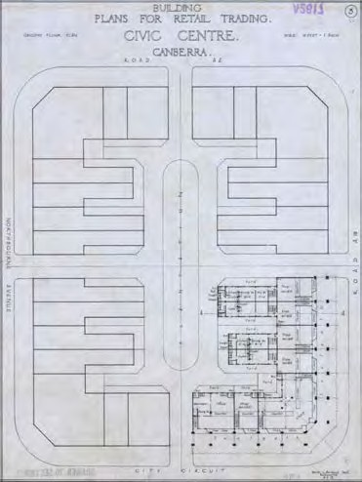
Figure 22. Sydney Building, ground floor plan, 1924
Source: National Archives of Australia, A2617, Section 90/893

³ G.J.R. Linge, Canberra: Site and City, Canberra, ANU Press, 1975, p. 11.

More information on the development of these plans and the architectural origins of the buildings, extracted from the 1993 conservation management plan, can be found in Appendix C.

Initially, Sulman and his fellow members of the FCAC envisaged that the Retail Traders block at Civic would be erected by and for such government institutions as the Commonwealth Bank, the Post Office, municipal offices and a public library. Leftover space would be leased to ‘banks, insurance and other companies, retail traders and the professional and commercial community.’ For reasons of economy, the government
decided instead that the Civic commercial leases would be put up for auction and that the successful bidders would have to erect part of the building on the lot or lots that they had acquired. That is, they would have to build at their own expense the relevant part of the Sydney or Melbourne Building on their lot(s) according to the overall plans for each building. Construction had to start within two years of purchase and had to be completed within three years. The purchasing leaseholders would also be compelled to submit plans for their parts of the building for approval and to ensure that the buildings complied with the plans. This meant, in effect, that they had to engage qualified architects to supervise construction.⁴

The successor to the FCAC, the Federal Capital Commission (FCC) was established at the beginning of 1925 under the chairmanship of Sir John Butters, with a mandate backed by wide-ranging powers to press forward with the development of Canberra. In the six years of its existence, the FCC would produce more on the ground than had been achieved hitherto or would be achieved for almost three decades afterwards.⁵

First Sale of Civic Leases
The first auction of commercial leases at Civic was held on 12 December 1924, a few weeks before the FCC was due to take office. A total of 28 allotments was offered for lease, all of them in Section 48, the future site of the Sydney Building. Two further allotments, nos. 29 and 30, were initially reserved from sale. Of the 28 lots put up for sale, four were designated as sites for banks. These lots were nos. 7 and 8 fronting London Circuit, and nos. 5 and 6 fronting Alinga Street. The joint auctioneers for the sale were the firm of Richardson and Wrench from Sydney and the local ‘firm of returned soldiers in
Queanbeyan’, Woodgers and Calthorpe.

In the event, the auction was a failure. Only six of the 28 allotments sold, including two of the four sites for banks (lots 7 and 8). And one of the six allotments that sold was purchased by Woodgers and Calthorpe. A positive aspect of the auction, however, was the fact that four of the lots that were taken up sold at prices above their upset value, the lowest value that the Commonwealth would accept for each lot or, in other words, the reserve price. In the case of the two bank sites that were sold, the prices they fetched were well in excess of the upset value. Another allotment, no. 3, was disposed of by private sale soon after the auction and, in fact, probably on the same day. Woodgers and Calthorpe managed to sell the remaining 21 allotments over the next six months, the firm reporting in August 1925 that it had ‘recently completed the sale of the balance of business sites at

⁴ First Annual Report of the Federal Capital Commission for the Period ended 30th June, 1925, p. 9; (Canberra Times) CT, 18 Nov 1931, p. 2.
⁵ This and part of the next paragraph are based on Brendan O’Keefe, ‘Parliament House Vista: Historical Analysis’, 2007; and Rosemary Willett, History Section of Philip Cox and Partners, ‘Sydney and Melbourne Buildings Conservation Plan’, Vol. 1, July 1993.

Civic Centre.’⁶

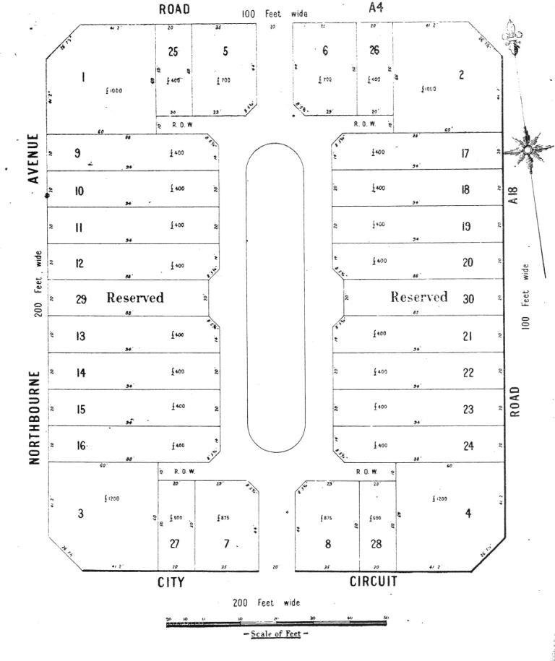
Figure 23. Sale plan of Section 48, the future site of the Sydney Building
Source: From Commonwealth Gazette, no. 77, 18 October 1924

The purchasers of the allotments were quite varied in composition, with mixed motives and intentions for their purchases. Some were small businessmen who were intent on erecting shops for themselves; these included the newsagent R J Dunne, J T Tambakis of Wyalong, and probably F H Boland, who ran a music store and a picture theatre in Queanbeyan. Another group that was also clearly aiming to build premises for their own purposes consisted of four banks, the Commercial Banking Company of Sydney, the Bank of Australasia, the Commercial Bank of Australia and the Government Savings Bank of NSW. All four eventually erected bank branches in Civic, though the Commercial Bank disposed of its lease in Section 48 in favour of what it no doubt felt was a better location in Section 1 on London Circuit (lot 19), part of the future Melbourne Building. Among the original purchasers were yet others who may never have had any intention of building themselves, but were intending to sell on their leases at a profit before they had to commence construction work under the conditions of purchase. These may have included Woodgers and Calthorpe (lot 28) and Norman Moses (lot 3).

A final group of purchasers were developers who were aiming to make a profit by building and then subleasing their premises. This group included: George Inglis Hudson, dentist, chemist, entrepreneur and inventor of the famous Hudson’s Eumenthol Jujubes; Mrs Helen
J. Brackenreg, wife of James C. Brackenreg, the local Lands Officer in the Lands and Survey Department; a Major Prisk (possibly Ralph Carlyle Geoffrey Prisk); Canberra Shops Limited, in which the Melbourne architects Oakley and Parkes were shareholders; the Canberra Building and Investment Company, whose director was A J Morgan and

⁶ (Queanbeyan Age) QA, 16 Dec 1924, p. 2; 11 Aug 1925, p. 2.

which was formed in 1925 specifically to undertake private development projects in Canberra; and the Melbourne-based Laristan Building and Investment Company. The directors of this last company were the Nationalist Senator H.E. Elliott and his brother,
C.R. Elliott. The Senator was none other than the distinguished war hero and solicitor, Brigadier General Harold Edward (‘Pompey’) Elliott, who had first been elected a Senator for the Nationalist Party in 1919.
One consequence of such powerful business interests buying the leases was that they were able to exert considerable pressure to have changes made to the design of the Sydney Building and to the conditions of the leases. In late 1925, all but one of the lessees petitioned the FCC for the whole building to be re-designed. The FCC instituted a review, in the course of which it carried out consultations with representatives of the lessees and
‘architects of standing’. The outcome was ‘a solution acceptable to the lessees’ which, the Commission claimed, ‘conserved the architectural principles of the sale plan.’ Revised plans for the building were drawn up and ‘the leases were adjusted in accordance with the amended plan of the subdivision.’ The revised plans increased the width of the arcades, the shop areas on the ground floor and the space on the first floor, while doing away with plantations at the rear of the lots so that trucks and cars could manoeuvre more easily. In addition, provision was made for the erection of buildings on lots 29 and 30 which had originally been reserved from sale. The amended plan for the subdivision was also adopted as the basis for the Melbourne Building.⁷

In the meantime, no start was made on the construction of the Sydney Building. As late as July 1926, eighteen months after the auction, there was ‘no sign of buildings’ on any of the lots. Aside from the time spent in carrying out the review, a good part of the reason for the delay was that, with its exacting architectural standards the Sydney Building, its construction represented a very expensive undertaking. In other areas where the aesthetic demands were less stringent, private business development was able to get established much more quickly and cheaply. This was the case both at Eastlake (Kingston) and Braddon where commercial enterprises opened in 1925 and 1926 respectively.⁸

Figure 24. Perspective drawing of proposed building, 1926
Source: National Archives of Australia, A3560, 2410
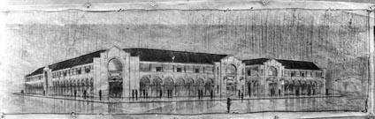
With the deadline approaching for a start to be made on the Sydney Building, construction was finally underway on seven of the leases by November 1926, while contracts had been let for the imminent commencement of building on another five leases. The first two

⁷ Second Annual Report of the Federal Capital Commission for the Period ended 30th June, 1926, p. 10;
Willett, in ‘Sydney and Melbourne Buildings Conservation Plan’, Vol. 1, July 1993, pp. 20, 22.
⁸ CT, 18 Nov 1926, p. 9; Jim Gibbney, Canberra 1913-1953, Canberra, AGPS, 1988, pp. 78, 103, 105; Linge, Canberra: Site and City, p. 19; Brendan O’Keefe, ‘An architect of the 1920s: James Wallace Sproule’, CHJ, new series no. 62, October 2009, pp. 28-30.

shops at Civic – Bill Prowse’s hairdressing salon and tobacconist shop (lot 16) and R.J. Dunne’s newsagency and stationery business (lot 24) – eventually opened in May, probably on the same day, Monday 2 May 1927.⁹

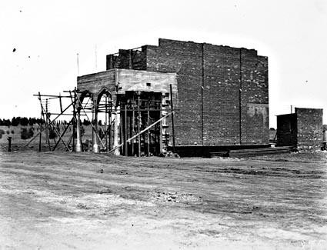
Figure 25. First part of the Sydney and Melbourne Buildings under construction, 1926
Source: National Archives of Australia, A3560, 875

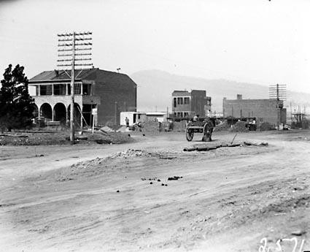
Figure 26. Intersection of Northbourne Avenue and London Circuit looking east with part of the Sydney Building, 1926 Source: National Archives of Australia, A3560, 2571

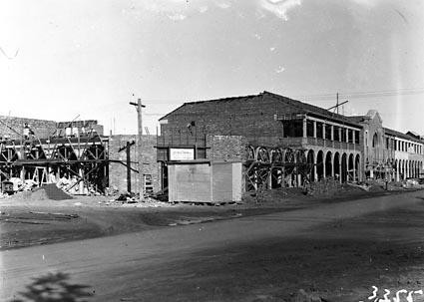
Figure 27. Sydney Building? under construction, 1927
Source: National Archives of Australia, A3560, 3355

⁹ CT, 18 Nov 1926, p. 9; 3 May 1927, p. 5; 6 May 1927, p. 9.

Table 1. Original purchases and purchasers of the lots in Section 48 – future site of the Sydney Building by date order of purchase
Section | Lot | Purchase Date | Purchaser | Upset Value | Price Paid | Sources
48 | 7 | 12.12.1924 | Commercial Banking Co. of Sydney | £875 | £2050 | QA 16.12.1924
48 | 8 | 12.12.1924 | Bank of Australasia | £875 | £1550 | QA 16.12.1924
48 | 23 | 12.12.1924 | J.T. Tambakis, Wyalong NSW | £400 | £400 | QA 16.12.1924
48 | 24 | 12.12.1924 | R.J. Dunne | £400 | £400 | QA 16.12.1924
48 | 27 | 12.12.1924 | F.H. Boland | £500 | £600 | QA 16.12.1924
48 | 28 | 12.12.1924 | Woodgers & Calthorpe | £500 | £700 | QA 16.12.1924
48 | 3 | By 16.12.1924 | Norman Moses, Queensland | £1200 | £1200 | QA 16.12.1924
48 | 5 | By 23.12.1924 | Commercial Bank of Australia | £700 | £700 | QA 23.12.1924
48 | 6 | By 23.12.1924 | Government Savings Bank of NSW | £700 | £700 | QA 23.12.1924
48 | 21 | By 23.12.1924 | J.E. O’Connell, Kogarah | £400 | £400 | QA 23.12.1924
48 | 20 | By 23.12.1924 | J.W. Keegan, Yass | £400 | £400 | QA 23.12.1924
48 | 2 | By 8.4.1925 | George Inglis Hudson | £1000 |  | A199: FC1926/239
48 | 26 | By 8.4.1925 | George Inglis Hudson | £400 |  | A199: FC1926/239
48 | 18 | By 11.8.1925 | Mrs Helen J. Brackenreg | £400 |  | CHJ, no. 15, p9; QA 11.8.1925
48 | 19 | By 11.8.1925 | Mrs Helen J. Brackenreg | £400 |  | CHJ, no. 15, p9; QA 11.8.1925
48 | 22 | By 11.8.1925 | Mrs Helen J. Brackenreg | £400 |  | CHJ, no. 15, p9; QA 11.8.1925
48 | 1 | By 11.8.1925 | *George Inglis Hudson |  |  | QA 11.8.1925
48 | 4 | By 11.8.1925 | *Canberra Shops Ltd |  |  | QA 11.8.1925
48 | 9 | By 11.8.1925 | Two Sydney sisters |  |  | QA 11.8.1925; CDHS Newsletter, no.  416, Apr 2008
48 | 10 | By 11.8.1925 | Two Sydney sisters |  |  | QA 11.8.1925; CDHS Newsletter, no.  416, Apr 2008
48 | 11 | By 11.8.1925 | Two Sydney sisters |  |  | QA 11.8.1925; CDHS Newsletter, no.  416, Apr 2008
48 | 12 | By 11.8.1925 | Two Sydney sisters |  |  | QA 11.8.1925; CDHS Newsletter, no.  416, Apr 2008
48 | 13 | By 11.8.1925 | *Fink & Plottel |  |  | QA 11.8.1925
48 | 14 | By 11.8.1925 | *Fink & Plottel |  |  | QA 11.8.1925
48 | 15 | By 11.8.1925 | *Major Prisk |  |  | QA 11.8.1925
48 | 16 | By 11.8.1925 | *Oakley & Parkes or Canberra Building &  Investment Company |  |  | QA 11.8.1925

Table 1. Original purchases and purchasers of the lots in Section 48 – future site of the Sydney Building by date order of purchase
Section | Lot | Purchase Date | Purchaser | Upset Value | Price Paid | Sources
48 | 17 | By 11.8.1925 | *J.C. Tickner |  |  | QA 11.8.1925
48 | 25 | By 11.8.1925 | *George Inglis Hudson |  |  | QA 11.8.1925
48 | 29 | Probably by  11.8.1925 | Initially reserved from sale; then Fink & Plottel |  |  | Cwlth Gazette 77, 18.10.24; QA  11.8.1925
48 | 30 | Probably by  11.8.1925 | Initially reserved from sale; then C. Bibb |  |  | Cwlth Gazette 77, 18.10.24; QA  11.8.1925
Note: * indicates the first known holders of that particular lease – in each of those cases, they may not have been the original purchaser of the leasehold.

Table 2. Development and developers of the Sydney Building including major additions and alterations up to the mid 1930s
Section | Lot | Developing Leaseholder | Building Type | Architect(s) | Builder(s) | Approval of Plans | Completion/ Occupation
48 | 1 | George Inglis Hudson | Shops | Herbert E. Ross & H.  Ruskin Rowe | George & Elphinstone | 24.2.27 | 17.2.28
48 | 2 | Canberra Shops Ltd | Shops | Oakley & Parkes | Simmie and Co | 4.4.27 | 19.6.28
48 | 3 | Fink & Plottel | Shop & offices | Joseph Plottel | Simmie and Co | 4.11.26 | 28.9.27
48 | 4 | Canberra Shops Ltd | Shops | Oakley & Parkes | Canberra Building &  Investment Co | 18.11.26 | 23.11.27
48 | 5 | O’Dwyer & Grant | Shops & offices | Joseph Plottel | George & Elphinstone | 10.12.26 | 14.2.28
48 | 6 | Oakley & Parkes | Shops | Oakley & Parkes | E. & W. Tofield | 21.12.26 | 18.10.27
48 | 6 | Oakley & Parkes | Additions | Oakley & Parkes | E. & W. Tofield | 1.12.27 | 10.1.28
48 | 7 | Commercial Banking Company of  Sydney | Bank & residence | Oakley & Parkes | Simmie and Co | 21.10.26 | 28.07.27
48 | 8 | Bank of Australasia | Bank & residence | Anketell & K. Henderson | Simmie and Co | 19.1.27 | 21.12.27
48 | 9 | Laristan Building & Investment Co | Shops & offices | Oakley & Parkes | Simmie and Co | 6.12.26 | 19.12.27
48 | 10 | Laristan Building & Investment Co | Shops & offices | Oakley & Parkes | Simmie and Co | 6.12.26 | 19.12.27
48 | 11 | Laristan Building & Investment Co | Shops & offices | Oakley & Parkes | Simmie and Co | 6.12.26 | 19.12.27
48 | 12 | Laristan Building & Investment Co | Shops & offices | Oakley & Parkes | Simmie and Co | 6.12.26 | 19.12.27
48 | 12 | Laristan Building & Investment Co | Temporary store | Not stated | L. Rowland | mid-1932 | N/A

Table 2. Development and developers of the Sydney Building including major additions and alterations up to the mid 1930s
Section | Lot | Developing Leaseholder | Building Type | Architect(s) | Builder(s) | Approval of Plans | Completion/ Occupation
48 | 13 | Fink & Plottel | Shops & offices | Joseph Plottel | Simmie and Co | 9.11.26 | 28.9.27
48 | 13 | T.H. Teather | Car shelter | K.H. Oliphant | Not stated | N/A | N/A
48 | 14 | Fink & Plottel | Shops & offices | Plotell, Burnet & Allsop | Simmie and Co | 9.11.26 | 28.9.27
48 | 14 | T.H. Teather | Car shelter | K.H. Oliphant | Not stated | N/A | N/A
48 | 15 | Oakley & Parkes | Shop & offices | Oakley & Parkes | Canberra Building &  Investment Co | 14.8.26 | 6.7.27
48 | 16 | Major Prisk | Shop & offices | Oakley & Parkes | Canberra Building &  Investment Co | 14.8.26 | 20.1.28
48 | 16 | Major Prisk | Alterations 1st floor | Oakley & Parkes | D.R. Tart | 22.8.27 | 21.12.27
48 | 17 | J.C. Tickner | Shop | Rudd & Limburg | P.L. Bond | 4.4.27 | 7.4.27 (sic)
48 | 17 | J.C. Tickner | Subdivision 1st floor | K.H. Oliphant | W.J. Perry | 24.11.27 | 29.3.28
48 | 18 | Mrs Helen J. Brackenreg | Shops & offices | Oakley & Parkes | P.L. Bond | 17.5.27 | 21.10.27
48 | 18 | Mrs Helen J. Brackenreg | Kitchen | Oakley & Parkes | B. Beazley | 28.10.27 | N/A
48 | 19 | Mrs Helen J. Brackenreg | Shops & offices | Oakley & Parkes | P.L. Bond | 17.5.27 | 21.10.27
48 | 20 | Dr W.G. Duffield | Shop & offices | Rudd & Limburg | Canberra Building &  Investment Co | 6.1.27 | 10.7.28
48 | 20 | Dr W.G. Duffield | Subdivision 1st floor | K.H. Oliphant | Canberra Building &  Investment Co | 19.4.28 | N/A
48 | 20 | Dr W.G. Duffield | Alterations | K.H. Oliphant | H. Johnson | 7.1.35 | N/A
48 | 21 | F.R. Clayton | Shop & offices | Oakley & Parkes | E. & W. Tofield | 21.12.26 | 22.8.27
48 | 21 | F.R. Clayton | Subdivision 1st floor  for residence | K.H. Oliphant | E. Spendlove | 12.6.29 | N/A
48 | 21 | F.R. Clayton | Laundry | K.H. Oliphant | H.J. Denholm | 00.10.29 | N/A
48 | 22 | Mrs Helen J. Brackenreg | Shop | Oakley & Parkes | Canberra Building &  Investment Co | 14.8.26 | 29.6.27
48 | 22 | Kodak Australia Ltd | Alterations | K.H. Oliphant | W.J. Perry | 31.7.33 | N/A
48 | 23 | J.T. Tambakis | Shop | Oakley & Parkes | Canberra Building & Investment Co or E.R.S.  Potter | 28.1.27 | 19.12.27
48 | 24 | R.J. Dunne | Shop | L.H. Rudd | P.L. Bond or Paynter &  Dixon Ltd | 29.10.26 | 19.12.27
48 | 24 | J. Cassidy | Building additions | K.H. Oliphant | C.D. Burrows | 11.4.32 | N/A
48 | 25 | George Inglis Hudson | Shops | Herbert E. Ross & H. | George & Elphinstone | 24.2.27 | 17.2.28

Table 2. Development and developers of the Sydney Building including major additions and alterations up to the mid 1930s
Section | Lot | Developing Leaseholder | Building Type | Architect(s) | Builder(s) | Approval of Plans | Completion/ Occupation
 |  |  |  | Ruskin Rowe
48 | 26 | Canberra Shops Ltd | Shops | Oakley & Parkes | Simmie and Co | 4.4.27 | 19.6.28
48 | 27 | F.W. Hyles &/or Miss Hyles | Shop & office | Oakley & Parkes | E. & W. Tofield | 6.12.26 | 22.8.27
48 | 27 | Miss Hyles | Additions | K.H. Oliphant | Simmie and Co | Late 1931 | N/A
48 | 27 | Miss Hyles | Subdivision 1st floor | K.H. Oliphant | W.J. Perry | 20.8.32 | N/A
48 | 28 | Woodgers & Calthorpe | Shop | Oakley & Parkes | Canberra Building & Investment Co | 14.8.26 | 25.11.27
48 | 29 | Fink & Plottel | Shops & offices | Joseph Plottel | Simmie and Co | 9.11.26 | 28.9.27
48 | 29 | Fink & Plottel | Kitchen | Plotell, Burnet & Allsop | Simmie and Co | 9.9.27 | N/A
48 | 30 | Bibb & Monck | Shop | Mitchell & Sproule | Canberra Building &  Investment Co | 28.1.27 | No completion  date
48 | 30 | Cassidy & Notaras | Shop & residence | K.H. Oliphant | H. Johnson | 29.8.34 | N/A
Principal source: CRS CP952/1, item Vol. 1

Second Sale of Civic Leases
The second auction of Civic leases took place on 29 May 1926. It was for eighteen lots in, or sixty per cent of, Section 1 – the future site of the Melbourne Building – the lots being numbers 4 to 21 inclusive. In contrast to the auction of lots in Section 48 in December 1924, purchasers were obliged to commence building on their lots within one year and to complete building within two years. In further contrast to the original auction, all eighteen lots were sold at the auction and all brought prices well above their upset value. Plans were submitted for construction and work commenced on the various parts of the building by late 1926 or early 1927, much sooner than had been the case with the Sydney Building. This, along with the fact that all lots sold at the auction, was no doubt a reflection of greater business confidence in the development of Canberra and of Civic in particular,
especially after the outcome of the FCC’s review into the design of Sydney and Melbourne Buildings.¹⁰

Figure 28. Sale plan for the first part of Section 1, the future site of the Melbourne Building
Source: From Commonwealth Gazette, no. 42, 6 May 1926

The new group of purchasers included three banks – the Commonwealth Bank, the Bank of NSW and the Commercial Bank – and two insurance companies, the Royal Insurance Company and the Australian Provincial Assurance Company. All were clearly intending to build on and occupy their allotments. The group also included a number of developers, such as Oakley and Parkes, the builder John Deans, V. Pringle of Yass, H. Morris and builders, the Hutchinson Brothers. Interestingly, among the purchasers, only one can be identified with certainty as a businessman who was intending to build and operate his own shop on the lot he bought. This was Cornelius O’Keefe, who purchased lot 7.

Third Sale of Civic Leases
The third and final auction of Civic leases was held on 9 April 1927. On offer were the last twelve lots available in Section 1, lots 1 to 3 and lots 22 to 30. Again, all the lots sold and at prices well in excess of their upset value. The most notable feature of the sale was that all of the purchasers were developers or investors, among whom were several architects. The purchasers included Canberra Shops Limited in which Oakley and Parkes had an interest, the Canberra Building and Investment Company, the Director of the Mt Stromlo Observatory, Dr W G Duffield, and two architects, L H Rudd and W E Limburg. As it turned out, none of the purchasers would ever build on their allotments.

Figure 29. Sale plan for the second part of Section 1, the site of the Melbourne Building Source: From Commonwealth Gazette, no. 29, 19 March 1927

Meanwhile, building was now proceeding rapidly in the Sydney Building and the first sixty per cent of the Melbourne Building. In May 1927, four shops were completed at Civic and another 26 were under construction, although these latter may have included some that were not in the Sydney or Melbourne Buildings. On 14 October 1927, the Canberra Times trumpeted that ‘Civic Centre is rapidly assuming its due place in Canberra and its colonnades will soon pulsate with the private business of the capital.’ Prime Minister S M Bruce officially opened Civic Centre on 3 December 1927. Looking to the future, Bruce proclaimed that Civic Centre, a name he personally disliked, would become
‘the great industrial and commercial centre of this great city’, ‘full of great and stately
buildings.’¹¹

¹¹ CT, 15 Jul 1927, p. 1; 14 Oct 1927, p. 10; 6 Dec 1927, p. 1.

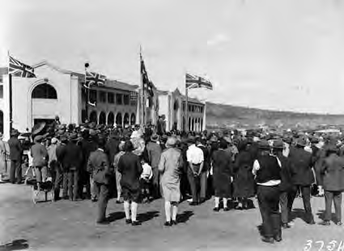
Figure 30. Opening of Civic Centre by Prime Minister S M Bruce, 1927
Source: National Archives of Australia, A3560, 3754

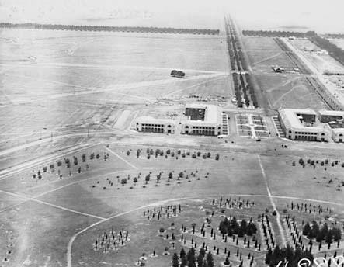
Figure 31. Aerial view of Sydney and partly completed Melbourne Building, 1928
Source: National Archives of Australia, A3560, 4888

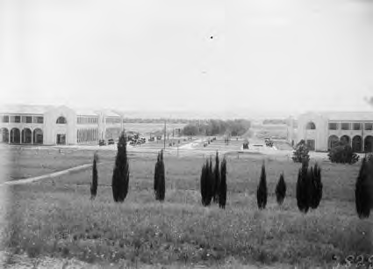
Figure 32. Sydney and Melbourne Buildings and view along Northbourne Avenue, 1928
Source: National Archives of Australia, A3560, 3825

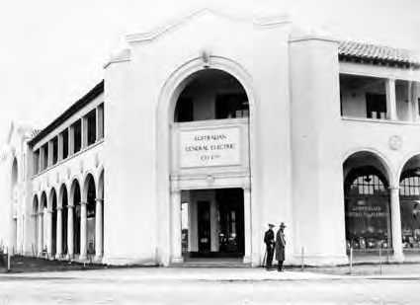
Figure 33. Premises of the Australian General Electric Co in the Sydney Building, 1928
Source: National Archives of Australia, A3560, 4151

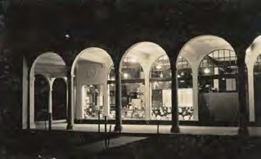
Figure 34. Premises of the Australian General Electric Co in the Sydney Building at night, 1928
Source: National Library of Australia, nla.pic- vn3104836

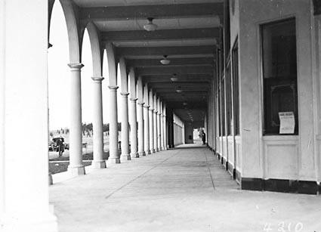
Figure 35. Melbourne Building colonnade, 1928
Source: National Archives of Australia, A3560, 4210

Table 3. Original purchases and purchasers of Section 1 – the future site of the Melbourne Building, by date order of purchase
Section | Lot | Purchase Date | Purchaser | Upset Value | Price Paid | Sources
1 | 4 | 29.5.1926 | McGill | £875 | £1400 | QA 1.6.1926
1 | 5 | 29.5.1926 | Oakley & Parkes | £500 | £1300 | QA 1.6.1926
1 | 6 | 29.5.1926 | John Deans | £1800 | £1800 | QA 1.6.1926
1 | 7 | 29.5.1926 | Cornelius O’Keefe | £500 | £1400 | QA 1.6.1926
1 | 8 | 29.5.1926 | G. Adams | £500 | £1300 | QA 1.6.1926
1 | 9 | 29.5.1926 | Hutchinson Brothers | £500 | £1300 | QA 1.6.1926
1 | 10 | 29.5.1926 | V. Pringle, Yass | £500 | £1450 | QA 1.6.1926
1 | 11 | 29.5.1926 | V. Pringle, Yass | £500 | £1250 | QA 1.6.1926
1 | 12 | 29.5.1926 | Morris | £500 | £1300 | QA 1.6.1926
1 | 13 | 29.5.1926 | F.R. Hayes | £500 | £1300 | QA 1.6.1926
1 | 14 | 29.5.1926 | Royal Insurance Co. Ltd. | £500 | £1800 | QA 1.6.1926
1 | 15 | 29.5.1926 | John Deans | £500 | £2100 | QA 1.6.1926
1 | 16 | 29.5.1926 | Commonwealth Bank | £2400 | £5600 | QA 1.6.1926
1 | 17 | 29.5.1926 | Australian Provincial  Assurance Assoc. Ltd. | £700 | £2300 | QA 1.6.1926
1 | 18 | 29.5.1926 | Australian Provincial  Assurance Assoc. Ltd. | £1225 | £2600 | QA 1.6.1926
1 | 19 | 29.5.1926 | Commercial Bank of Australia  Ltd. | £1225 | £2700 | QA 1.6.1926
1 | 20 | 29.5.1926 | Dr Finlay | £700 | £3000 | QA 1.6.1926
1 | 21 | 29.5.1926 | Bank of New South Wales | £2100 | £5200 | QA 1.6.1926
1 | 22 | 9.4.1927 | Federal Mutual Insurance Co.  Ltd. | £1000 | £3500 | CT 13.4.1927
1 | 23 | 9.4.1927 | L.H. Rudd, architect | £1000 | £2800 | CT 13.4.1927
1 | 24 | 9.4.1927 | Canberra Shops Ltd. | £1000 | £2200 | CT 13.4.1927
1 | 25 | 9.4.1927 | Canberra Shops Ltd. | £1000 | £2500 | CT 13.4.1927
1 | 26 | 9.4.1927 | Canberra Building &  Investment Co. Ltd. | £1000 | £2400 | CT 13.4.1927
1 | 27 | 9.4.1927 | Canberra Building &  Investment Co. Ltd. | £1000 | £2300 | CT 13.4.1927
1 | 28 | 9.4.1927 | Canberra Shops Ltd. | £1000 | £2600 | CT 13.4.1927
1 | 29 | 9.4.1927 | Canberra Shops Ltd. | £1000 | £2700 | CT 13.4.1927
1 | 30 | 9.4.1927 | D.E. Limburg | £1000 | £2900 | CT 13.4.1927
1 | 1 | 9.4.1927 | Dr W.G. Duffield | £3000 | £5100 | CT 13.4.1927
1 | 2 | 9.4.1927 | D.E. Limburg | £1000 | £2800 | CT 13.4.1927
1 | 3 | 9.4.1927 | Canberra Shops Ltd. | £1000 | £3500 | CT 13.4.1927

The Great Depression
By mid-1928, several banks, shops and other businesses, as well as various government departments and instrumentalities, were operating in both the Sydney and Melbourne Buildings. Already, however, in the second half of the year there were signs of economic decline. Indeed, in May 1929, the government conducted a survey to see if there was any justification for reimbursing the rents paid on leaseholds that remained unoccupied. The survey revealed that of the thirty allotments making up the Sydney Building only seven had been fully occupied since the building was completed. Another fifteen had been partly occupied, while one leaseholder had not completed construction of his portion of the building. The situation was much the same for the Melbourne Building. A couple of years later, some leaseholders were to complain that the government had allowed Kingston to
develop as Canberra’s main shopping centre at the expense of Civic. And the centre, too,

was somewhat distant from residential areas.¹²

Worse was to come for the Sydney and Melbourne Buildings. In October 1929, the Wall Street crash occurred, marking the beginning of the Great Depression. The Depression was an era of hardship for shops and other businesses in both buildings, but it was a period of particular distress for the leaseholders. By November 1931, for example, Canberra Shops Limited had invested around £50,000 over five years in developing its leases at Civic. However, its shareholders had ‘not had one penny return’ and were not likely to see any return for several more years. Further, with the evaporation of sources of finance to carry out construction work, Canberra Shops Limited together with the leaseholders of the other twelve allotments in Section 1 that had been purchased at the third auction in April 1927 all surrendered their leases. The allotments, making up the remainder of the Melbourne Building, thus remained undeveloped throughout the 1930s and into the 1940s.¹³

In the case of those leaseholders who hung onto their allotments in the Sydney Building and the existing part of the Melbourne Building, it was, overall, the continued rental of office space by government departments and instrumentalities that saved them from financial ruin. Almost all of these rental agreements were due to run out at the end of August 1932. But, as a means of reducing costs in the Depression, the Scullin government began to consider in mid-1930 the possibility of transferring into government-owned premises those departments that were renting office space in the two buildings. The proposal triggered alarm among the leaseholders. Senator Elliott, for example, who was clearly not averse to using his parliamentary position to protect his financial interests, raised a series of nineteen questions in Parliament, including ones that directly concerned his own company.¹⁴

The matter then lapsed for more than a year before it re-surfaced in late 1931. Again, the leaseholders were alarmed and incensed. In a bitter editorial entitled ‘Who is to pay for government default?’ in the Canberra Times in November 1931, the paper charged the government with failing to honour its ‘obligations’ to the leaseholders. The editorial
claimed that the government had induced people to purchase the leases by enthusiastically promoting Canberra’s prospects and promising to move government departments from Melbourne. But the government had failed to keep its promises. The editorial concluded,

‘There are people serving gaol sentences to-day only by reason of their having made similar representations to those made by the Government in connection with the sale of land, which subsequently proved to be false. But the Government does not go to gaol. It makes people and the property owners of Canberra pay for Government sins. It defaults; but they pay.’¹⁵

In Parliament the next day, Senator Duncan asked the Minister representing the Minister for Home Affairs, Arthur Blakeley, if it were a fact that the lessees ‘entered into heavy obligations on the definite understanding that departments would be transferred from Melbourne to Canberra.’ This drew the curt response that the ‘lessees at Civic Centre were

¹² Gibbney, Canberra 1913-1953, p. 143; W.G. Woodger, in transcript of meeting with Prime Minister J.A. Lyons, 3 March 1932, CRS A461, item D6/1/3.
¹³ Letter, W.G. Woodger to the Hon. Arthur Blakeley, 19 November 1931, CRS A1, item 1932/797; CT, 4 Mar 1937, p. 1.
¹⁴ Newspaper clipping of the Sun (Sydney), 15 July 1930; memorandum, P.A. Gourgaud, Secretary, Works
and Railways, to Secretary, Home Affairs, ‘Sublease of Premises: Civic Centre: Canberra: for
Commonwealth Purposes’, 6 August 1930; and Senate Notice Paper No. 61, 6 August 1930, all in CRS A1, item 1932/797.
¹⁵ CT, 18 Nov 1931, p. 2.

not entitled to assume that their premises would ever be utilized for the housing of government departments.’¹⁶

There was further agitation from the leaseholders who now formed themselves into the City Area Lessees Association, while further critical editorials appeared in the Canberra Times. At the end of February 1932, Oakley and Parkes, who had interests in a number of leases either in their own right or through Canberra Shops Limited, wrote directly to the new Prime Minister, J A Lyons, expressing their concerns about the situation. If the government were to vacate their leaseholdings, they said, they would be unable to meet their obligations to their bankers, or even to pay ground rents and rates to the government. ‘The only thing which is keeping these so-called shopping centres alive,’ they added, ‘is the fact that certain Government Departments are housed in the Buildings, and if they are removed, there will be no inducement for business people to remain in occupation of the Shops.’¹⁷

The agitation culminated in a face-to-face meeting between a deputation from the City Area Lessees Association and the Prime Minister. In the meeting, one of the spokesman for the deputation, T M Shakespeare, who was also the proprietor of the Canberra Times, charged that the government had ‘a moral, if not legal, responsibility’ to honour its promises to move government departments from Melbourne to Canberra. Another spokesman, and president of the association, W G Woodger, pressed for the government to renew its leases at Civic for at least another two years or until more departments were transferred from Melbourne.

None of this cut any ice with Lyons. He told the deputation,

‘You say there is a moral obligation on the Government either to renew the leases or bring up from Melbourne some other department to occupy the space available at the present time. So far as moral obligation is concerned, I do not see from what Mr. Woodgers (sic) has put before me tonight on what grounds that is based because I was not associated with any undertakings given.’

He bluntly informed the deputation, too, that he could not see ‘any possibility of bringing other departments from Melbourne at this time.’¹⁸

Realising that it could exert no legal, political or moral pressure on the government, the Lessees Association was thereafter reduced to pleading with the government to move at least one department up from Melbourne. The association even went so far as to write to Lyons detailing the office space available at Civic and Manuka that government departments could use if they were to move to Canberra.¹⁹ As it happened, though, the government does not appear to have vacated the space it was leasing at Civic, probably because there was little other office space available in the city. For the remainder of the 1930s and into the 1940s, the viability of the Sydney and Melbourne Buildings was underpinned by government departments renting space in them. In early 1939, for example, with apparently few other options available, the National Insurance Commission

¹⁶ Extract from Hansard, 19 November 1931, in CRS A1, item 1932/797.
¹⁷ Letter, Oakley and Parkes to Hon J.A. Lyons MP, 29 February 1932, CRS A1, item 1932/797.
¹⁸ T.M. Shakespeare, Woodger and Lyons, in transcript of meeting with Prime Minister, 3 March 1932, CRS A461, item D6/1/3.
¹⁹ Letter, Woodger to Hon C.W. Marr, Minister for Health, 28 May 1932, CRS A1, 1932/797; letter, Woodger, President, and W.H.B. Dickson, Treasurer, City Area Lessees Association, to probably PM Lyons, 21 November 1932, CRS A461, item D6/1/3.

took a lease until May 1941 on lot 17 and part of lot 18 in the Melbourne Building.²⁰

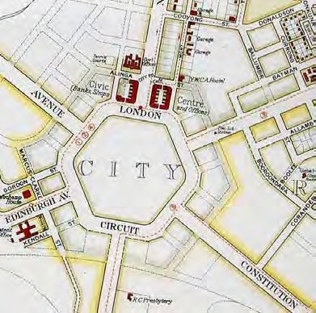
Figure 36. Detail of a 1933 plan of Canberra showing the extent of development in Civic
Source: 1933 Map of Canberra prepared by the Property & Survey Branch of the Department of the Interior, National Library of Australia

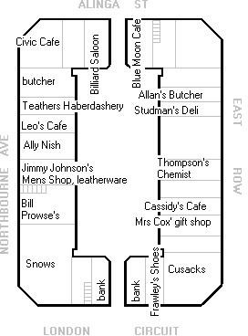
Figure 37. Plan of the Sydney Building by Michael Hall, based on the recollections of Roma Prowse. It shows occupants of the building around early to mid-1930s. The plan should be used with caution.
Source: CDHS Newsletter, June/July 2005

²⁰ Memorandum, A. Percival for Director-General, Property and Survey Branch, Dept of Works, to Secretary, PM’s Department, ‘Canberra, Subleasing of Premises at Civic Centre’, 14 February 1939, CRS A461, item D6/1/3.

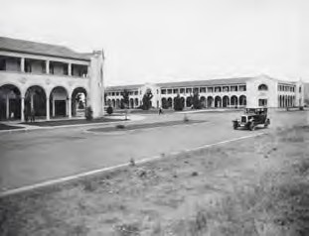

Completion of the Melbourne Building
Figure 38. Sydney and Melbourne Buildings, 1938
Source: Argus Newspaper Collection of Photographs, State Library of Victoria, H2002.199/755

Meanwhile, with a partial return to prosperity, the local business community began to lobby the government to complete the Melbourne Building, adding that they wanted it to include larger spaces for retail trading. The twelve lots that had been purchased at auction in April 1927 still remained vacant. In March 1937, the government responded positively to the business community’s representations and decided that it would indeed make
available larger lots for retail trading and ‘other approved purposes’ in the building.²¹ Nothing eventuated, however, possibly because neither the government nor anyone else was willing to commit funds to carry out the construction work. Instead, such was the shortage of office accommodation in Canberra, the government soon after mooted the idea of building two new secretariat buildings for itself between East and West Blocks. Again, the proposal went nowhere, and in 1941 the government reverted to the idea of completing the Melbourne Building mainly in order to provide much-needed office space for its own departments.²²

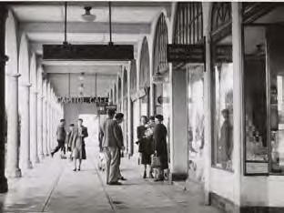
Figure 39. Sydney Building, East Row colonnade, about 1942
Source: National Library of Australia, nla.pic- vn4387467

On 22 November 1941, the Department of the Interior advertised for tenders to complete the Melbourne Building. The successful tenderers were Cody and Willis of Glebe in Sydney. After serious delays caused both by a shortage of labour during the war years and by Cody and Willis winning other major contracts in Canberra, the building was eventually

²¹ CT, 4 Mar 1937, p. 1; 21 Mar 1942, p. 2.
²² Senate, Report … upon the development of Canberra, September 1955, p. 15; CT, 11 Nov 1941, p. 4.

completed on 22 February 1946.²³ It then appears that the building was to a large extent occupied by government departments and other public, as opposed to private enterprise, bodies. In 1948, for example, the Canberra University College based itself in the building and remained operating there for about five years.²⁴

²³ The construction of the last part of the Melbourne Building is covered in detail in Willett, in ‘Sydney and Melbourne Buildings Conservation Plan’, Vol. 1, July 1993, pp. 49, 52, 60. See also CT, 22 Nov 1941, p. 3;
26 Mar 1943, p. 4.
²⁴ S.G. Foster and Margaret M. Varghese, The Making of the Australian National University, St Leonards NSW, Allen and Unwin, 1996, pp. 8, 144, 148.

Table 4. Development and developers of the Melbourne Building by approximate order of development
Section | Lot | Developing Leaseholder | Building Type | Architect(s) | Builder(s) | Approval of Plans | Completion/ Occupation
1 | 4 | Canberra Building & Investment Co | Shop & offices | N/A | Canberra Building &  Investment Co | N/A | N/A
1 | 5 | Oakley & Parkes | Shop & offices | Oakley & Parkes | E. & W. Tofield | By Feb 1927 | 21.12.27
1 | 6 | Government Savings Bank of NSW | Bank | N/A | N/A | N/A | 7 or 8.11.27
1 | 7 | Cornelius O’Keefe &/or J.V.  O’Keefe | Shop & offices | K.H. Oliphant | Canberra Building &  Investment Co | 21.1.27 | 7.10.27
1 | 8 | H.H. McNall & H.M. McCulloch | Shops | Joseland & Gilling | Colonel J. Walker | 21.12.26 | 9.9.27
1 | 9 | H.H. McNall & H.M. McCulloch | Shops | Joseland & Gilling | Colonel J. Walker | 21.12.26 | 9.9.27
1 | 10 | V. Pringle, Yass | Shops | Oakley & Parkes | A.M. Sweetnam | 21.12.26 | 28.2.27
1 | 10 | P.P. Con (sub) | Alterations &  additions to shop | K.H. Oliphant | Taylor & O’Connor | 9.5.39 | N/A
1 | 11 | V. Pringle, Yass | Shops | Oakley & Parkes | A.M. Sweetnam | 21.12.26 | 28.2.27
1 | 12 | H. Morris | Shop & offices | Oakley & Parkes | Canberra Building &  Investment Co | 17.1.27 | 14.12.27
1 | 13 | Cecil Hordern | Shops & offices | Oakley & Parkes | Irving & Spendelove | 6.12.26 | 28.7.27
1 | 13 | Woodgers & Calthorpe | Car shelter | N/A | F.J. Kestel | 30.5.29 | N/A
1 | 14 | Royal Insurance Co. Ltd. | Shop & offices | Oakley & Parkes | Canberra Building &  Investment Co | 16.3.27 | 7.10.27
1 | 15 | Canberra Building & Investment Co | Shop & offices | Oakley & Parkes | Canberra Building &  Investment Co | 13.10.26 | 25.11.27
1 | 16 | Commonwealth Bank | Banking premises | Works & Railways | Simmie & Co | 6.12.26 | 27.4.28
1 | 17 | Australian Provincial Assurance  Assoc. Ltd. | Offices | Burcham Clamp & Finch | George & Elphinstone | 23.12.26 | N/A
1 | 18 | Australian Provincial Assurance  Assoc. Ltd. | Offices | Burcham Clamp & Finch | George & Elphinstone | 23.12.26 | N/A
1 | 19 | Commercial Bank of Australia Ltd. | Bank & residence | Anketell & K. Henderson | Simmie & Co | 19.1.27 | 10.7.28
1 | 20 | Queensland National Bank | Banking chamber | Oakley & Parkes | Colonel J. Walker | 14.8.26 | 29.6.27
1 | 21 | Bank of New South Wales | Bank & residence | Oakley & Parkes | E. & W. Tofield | 17.2.27 | 15.11.27
1 | 21 | Bank of New South Wales | Additions | Oakley & Parkes | E. & W. Tofield | 24.11.27 | 10.1.28
1 | 1 | Department of the Interior | Offices |  | Cody & Willis, Glebe |  | 22.2.46
1 | 2 | Department of the Interior | Offices |  | Cody & Willis, Glebe |  | 22.2.46

Table 4. Development and developers of the Melbourne Building by approximate order of development
Section | Lot | Developing Leaseholder | Building Type | Architect(s) | Builder(s) | Approval of Plans | Completion/ Occupation
1 | 3 | Department of the Interior | Offices |  | Cody & Willis, Glebe |  | 22.2.46
1 | 22 | Department of the Interior | Offices |  | Cody & Willis, Glebe |  | 22.2.46
1 | 23 | Department of the Interior | Offices |  | Cody & Willis, Glebe |  | 22.2.46
1 | 24 | Department of the Interior | Offices |  | Cody & Willis, Glebe |  | 22.2.46
1 | 25 | Department of the Interior | Offices |  | Cody & Willis, Glebe |  | 22.2.46
1 | 26 | Department of the Interior | Offices |  | Cody & Willis, Glebe |  | 22.2.46
1 | 27 | Department of the Interior | Offices |  | Cody & Willis, Glebe |  | 22.2.46
1 | 28 | Department of the Interior | Offices |  | Cody & Willis, Glebe |  | 22.2.46
1 | 29 | Department of the Interior | Offices |  | Cody & Willis, Glebe |  | 22.2.46
1 | 30 | Department of the Interior | Offices |  | Cody & Willis, Glebe |  | 22.2.46
Principal sources: CRS CP952/1, item Vol. 1 and Canberra Times

Two Fires
On 28 December 1950, the ‘biggest fire in the history of Canberra’ destroyed part of the Sydney Building, including the South African High Commission offices, part of the Superannuation Board offices, and three shops on the eastern side. The shops that were damaged were Mr P J McGirr’s butcher’s shop, Mr J Costetos’s fruit, vegetable and
confectionery shop, Goodlands’ grocery store and, upstairs, Mr T Samios’s Canberra Fish Café. In addition, the Civic Deep Freeze Shop owned by Mr N. Fisk sustained minor water damage. The leases affected by the fire were those held by the estate of the late Dr W G Duffield, the Glen Mervyn Investments Companies and Mrs Brackenreg. Fortunately, all of them were insured against such eventualities.²⁵

The leaseholders swiftly engaged Ken Oliphant to prepare plans for the reconstruction of the damaged parts of the building and Oliphant, equally swiftly, completed the plans within a week of the fire. The most difficult part of the reconstruction as far as Oliphant was concerned was to find roof tiles that matched the existing ones on the building; he flew to Melbourne to try to find some. For all that, he hoped to have McGirr’s butcher’s shop ready for use soon. However, the whole rebuilding and re-occupation of the building was not complete until about October 1951. When the re-occupation occurred, the Superannuation Board took over the whole of the first floor space that had formerly been occupied by it and the South African High Commission; the latter vacated the premises. On the ground floor, Goodlands’ grocery store and Costetos’s fruit and vegetable shop changed places.²⁶

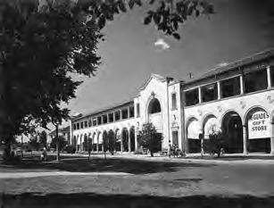
Figure 40. Sydney Building, 1951
Source: ACT Heritage Library, Department of Capital Territory Collection, 009165

A yet more destructive fire occurred on 11 April 1953. Described as ‘the most disastrous and costly fire in the history of Canberra’, it destroyed more than half of the western side of the Melbourne Building. The offices occupied by the Canberra University College, the Bureau of Mineral Resources and the Department of Social Services were almost completely gutted, while the offices of the Courts and Titles Registry, the Bank of NSW and Trans-Australia Airlines were damaged by flames and water.²⁷

In August 1953, the reconstruction of the burnt section of the Melbourne Building was placed in the hands of the Melbourne architectural firm of Hocking, Warren and Associates. With

²⁵ CT, 29 Dec 1950, p. 1; 13 Apr 1953, p. 1.
²⁶ CT, 3 Jan 1951, p. 4; 3 Aug 1951, p. 2.
²⁷ CT, 13 Apr 1953, p. 1.

the Royal Tour approaching, the reconstruction of the building, which was expected to cost
£80,000, was to be given top priority for completion. Externally, the building was to have the same appearance as before, but the interior was to be altered to cater for the Tourist Bureau,
the TAA office and ‘other Canberra services’. In December, the contract for the first stage of
reconstruction was let to Craft Builders of O’Connor ACT.²⁸

When completed, the reconstructed section of the building included on the ground floor enlarged and modernised offices for the Tourist Bureau, a remodelled office for TAA, Electricity House and offices for the Department of Social Services. The first floor housed the Superannuation Board, the Snowy Mountains Authority, the Electoral Office and the drafting section of the PMG’s Department. The Courts and Titles Office was also remodelled. In the meantime, the Canberra University College had quit the building and was forced to occupy a disused workers’ hostel in Childers Street.²⁹

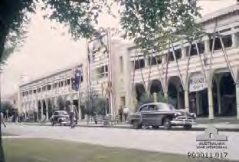
Figure 41. Sydney Building decorated for the royal tour in 1954
Source: Australian War Memorial, P03011.017

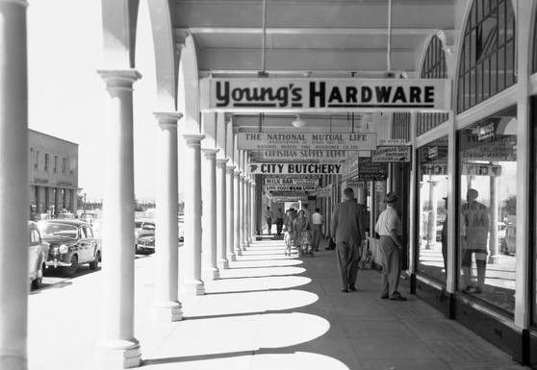
Figure 42. Sydney Building, East Row colonnade, about 1950s-1960s
Source: Frank Hurley, National Library of Australia, nla.pic-an23488132

Development from the 1950s Onward
Despite the fires, the Sydney and Melbourne Buildings as part of Civic as a whole began to thrive from 1950 onward. It started with the auction of two new sections for commercial buildings in that year. An important impetus for development was the 1955 report of the Senate Select Committee that had been appointed to inquire into the development of Canberra. The committee’s report resulted in the appointment in March 1958 of the National

²⁸ CT, 29 Aug 1953, p. 2; 22 Dec 1953, p. 6.
²⁹ CT, 16 Jul 1954, p. 2.

Capital Development Commission (NCDC), which was charged with the responsibility of pushing on with the building of the national capital. In the five years from 1959 to 1965, the NCDC oversaw the construction of a number of buildings in Civic, one outstanding commercial development being the opening of the Monaro Mall shopping centre in March 1963. With large department stores operating in Civic by this time, it was now incontestably the commercial and retail centre of Canberra.

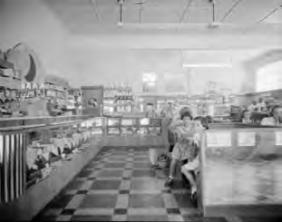
Figure 43. Blue Moon Café, Sydney Building, 1953
Source: National Library of Australia, nla.pic-vn4768704

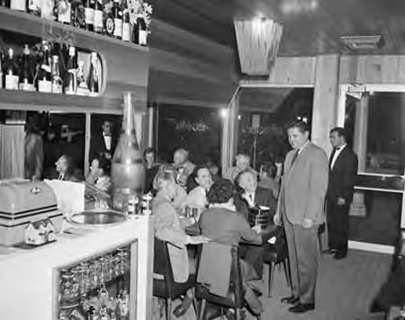
Figure 44. Charcoal Inn, now the Charcoal Restaurant, Melbourne Building, 1965, with owner Zarko Mijuskovic standing at centre Source: National Archives of Australia, A12111, 1/1965/16/61

But at the same time, a countervailing tendency was emerging in other parts of Canberra. From the beginning of the 1950s, small suburban shopping centres such as O’Connor and Ainslie were established specifically to cater to residents in those areas, while shopping centres already existed at Manuka and Kingston. These naturally would tend to drag customers away from Civic or, more specifically, from its smaller businesses like grocery
stores, butcher’s shops and greengrocers – people could access these sorts of suppliers closer to home. Further competition for Civic came with the establishment of major shopping centres at Woden, Belconnen and Tuggeranong which was part of the creation of new towns as the form for the development of Canberra. The design of the Sydney and Melbourne Buildings, moreover, did not lend itself to the scale of a department store or, indeed, large
specialty (or ‘category-killer’) types of store that appeared in the 1980s.

The outcome of these trends was the virtual disappearance from the two buildings of the

traditional small retail businesses that sold such staples as groceries, meat, vegetables and fruit. Instead, with Civic now relatively far from population centres and with the growth of nightlife and of eating out in the national capital, the buildings are now home to a large collection of restaurants, bars, pubs and nightclubs. While some might bemoan the negative impact of such businesses, they constitute a major new use for the two buildings and, without them, they might be largely unoccupied and even more rundown.

While a detailed study of current owners and businesses has not been undertaken, it is understood that some long-standing businesses still operate in the buildings. Perhaps the longest-running business is the Charcoal Restaurant in the Melbourne Building, which has operated since 1962. Its distinctive interior appears to retain a reasonably high degree of integrity from this period.

Comment
One obvious conclusion to be drawn from the foregoing is that, while the Sydney and Melbourne Buildings were supposed to have provided space for private businesses of various kinds, the buildings have equally for a large part of their history been de facto office buildings for government departments and instrumentalities. Indeed, it was to a considerable degree because these entities rented space in the buildings over a long period that they were viable commercial propositions for the leaseholders and were not left for years in a semi- abandoned and perhaps rundown state.

Summary of Physical Changes to the Buildings
While the external form and appearance of both the Sydney and Melbourne Buildings are generally unchanged since construction, when viewed from the surrounding streets, there has been considerable change to the shopfronts and first floor verandahs (information in this section is based on Philip Cox, Richardson, Taylor & Partners (1993, pp. 80-85), updated where possible, noting that interiors are not fully addressed in this plan). In the 1950s there was growing pressure for additional office space which saw the gradual glazing in of first floor verandahs. It is believed that shopfront changes have occurred in more recent decades.

In the colonnades, the paving has been changed to quarry tiles or bitumen, apparently laid on top of the original slab, and all of the treads at the edge have been replaced or obscured by later finishes. There are several types of non-original treads used. The lighting in the colonnades and on the facades has generally been replaced with modern ball fittings, and in the case of the Melbourne Building, the location of fittings in the colonnades has been moved from the underside of beams to the middle of the ceiling panels between beams.

Other substantial changes have been extensions into the courtyards and internal modifications.

There are numerous surface mounted conduits in the colonnades and elsewhere.

Sydney Building
All first floor verandahs of the Sydney Building have been glazed-in. For most blocks, the internal verandah walls remain, although some have been demolished. Changes to the shopfronts along the colonnades are many and varied. Structural change to the street facades is minimal.

Considerable changes have occurred in the courtyards of the Sydney Building. Many of the blocks have been extended for two storeys right up to the rear property line. Only a few remain to their original plan area. Some extensions have included a third floor.

Some blocks of the Sydney Building still retain original interior fabric, and in some cases this has been concealed by later finishes. In other cases only the original shell remains and the interior is entirely new. In the 1990s a new refurbishment trend became evident. Some blocks refurbished in this period had non-original suspended ceilings removed at ground level only, and the original plaster ceilings and cornices refurbished. These blocks now allow the original volume of the retail areas of the building to be appreciated.

Melbourne Building
The Melbourne Building verandahs at first floor have also been enclosed. Until the early 1980s all verandas were glazed-in. However, a change in NCDC policy concerning the Sydney and Melbourne Buildings saw some of the verandas restored along Alinga Street and West Row. In the other sections of the Melbourne Building, enclosed verandahs have been utilised in a similar way to the Sydney Building, with the internal wall being removed in some situations.
Other than changes arising from the 1953 fire, no structural changes have been made to the street facade of the Melbourne Building. As with the Sydney Building, other façade changes have affected shopfront windows.

The courtyard area of the Melbourne Building has seen less physical change than the Sydney Building. The main reasons for this relate to the fact that nearly half of the building was not constructed until 1944 and it was occupied over a long period by Government departments.

For the other parts of the building, most blocks have been extended. This consists of two or three storey face brick extensions to the rear site boundary.

The interiors of the Melbourne Building need to be separated into the former Government and Non-Government parts. Most of the former Government offices were gutted in a fire in 1953, and have been refurbished in recent years into bars, cafes and restaurants on the ground floor and serviced apartment accommodation on the first floor.

The Non-Government areas of the building have changed internally over the years. The principal remaining original elements (floors and ceilings) have in most cases been, concealed by new floor finishes and suspended ceilings. The extent of physical change to these elements is not known. Most blocks appear to have been refitted over the original structure and fabric, and at least a few have been completely gutted and refurbished.

Appendix C: Additional Historical Information

Extract from the 1993 CMP History

The following extract from the 1993 conservation management plan deals with the development of the design for the buildings and their architectural origins (Philip Cox, Richardson, Taylor & Partners 1993, pp. 31-41, 65-69).



The Construction of a Design

    - Introduction
In their 1922 report “concerning the layout of the Civic Centre,” the FCAC devoted significant time to the design of the Retail Traders block. The Committee felt that a dignified and orderly design was required for buildings for such prominent city sites. They were also determined that individual lessees not be allowed to build to suit their own convenience, the only result would be an “undignified and haphazard ugliness.”(45)
Sketch plans were prepared by the Committee, to illustrate an appropriate treatment, for one of the city blocks. The design was to change a number of times before construction.

The Original Design 1922-24
In 1922 the Chairman of the FCAC prepared a design for Sydney building for reasons outlined above. The design was based on the, “old Regent Street of London, and the Rue de Rivoli in Paris, each universally admitted to be the finest shopping Street in their respective cities”. (46) (Figs 16, 17)

The design showed,
“a self contained shopping centre surrounded by a continuous colonnade to give shelter from sun and rain, which retail traders find absolutely essential, and usually provide by ugly verandas. This block will accommodate all the shops on the ground floor and offices on the first floor It will also afford
temporary quarters in the earliest stage of occupation for the Governmental institutions until their
own buildings can be erected.. (47)

The Committee were concerned that the building should have an appearance of quality and should not be detracted from by the rubbish filled back alley‟s associated with many shopping centres. The plan‟s solution to this problem was;

“..the entire hiding of the inevitably untidy back quarters attached to shopping premises, which were shown to abut on a central tree planted court approached by one, entrance only. Thus shoppers could perambulate under shelter the whole block; consisting of a continuous line of shops, ” (48)

The preliminary plan dealt also with matters of structure, construction and occupancy and was addressed in the Committee‟s Civic Centre planning report as follows;

“By building such a block.., by reinforced concrete piers with light walls or partitions between, accommodation will be provided at a much cheaper rate for each occupant „than if he erected his own separate building or premises, and would therefore encourage those‟ whose services will be needed as soon as Parliament is transferred, to settle and commence business at once, instead of waiting to see – if they were justified in incurring an expenditure of capital ”

“The plan shows suggestive methods of subdivision by which the various grades of traders may be accommodated and the expansion of their business arranged for at a minimum of expense by removing the light division walls, so that any number of shops could be thrown into one. The shops are partly lock – up and, partly with dwellings attached to suit immediate requirements ”
“It will be noted that the dwellings are shown on the ground floor fronting onto an internal e planted courtyard to which access is obtained by a roadway one of the fronts. Eventually extension of the shops, bulk store and other accommodation would take their place.”

The Committee envisaged at the time that the traders block would be erected by and principally occupied by Government institutions. Proposed tenants were:

Post office, Commonwealth Bank, Municipal offices, Public Library, Co-op store for Government officials.
“The remainder would be let to banks, insurance and other companies, retail traders and the professional and commercial community.”
Public hall, billiard rooms, temporary cinema and work rooms. (49)

The proposed cost of construction of the block was £80,000 in 1922.

In September of 1922 the FCAC‟s plan was submitted to the Minister for Works and Railways and duly received approval. On 3 October the plan was approved by Cabinet, but a decision to build, was delayed until a sale of leases was decided on.

The Committee‟s plan was presented at the December 1924 land auctions as the plan to which construction must proceed.

Private Enterprise – The First Amendment
Soon after approval of the first plan was received, a change in the Cabinet saw the beginning of changes to the plan. The Sydney members of the FCAC (disbanded in 1924) were deeply concerned by the nature of changes being made to their plan by the Cabinet, due, to pressure from the lessees. (Fig 18 & 19)

Their concern was expressed in a letter to the Prime Minister (S.M. Bruce) in 1925 and stated:

“The evil effects of the alterations to the original plan, for which Cabinet, is responsible, did not end with those enumerated above, for the retail traders finding the” Cabinet pliable, have in their ignorance and short-sightedness worried the Commissioners into removing practically all restrictions, and a whittling process has begun which, if permitted, not only the subject buildings but those to follow will be no better than in any country town; and the ideals which all Australians will seek in Canberra cannot be realised.

The letter went on to express that they believed the lessees to be short-sighted and self interested, not realising the rapid changes which would accompany the arrival of Parliament in Canberra.

“and (the traders) are quite oblivious of ... the changes to city conditions that will take place and will render the buildings they propose to erect, out of date in a very few years, and meanwhile be a blot on the city‟s appearance. By rigid adherence to some definite scheme of city development alone can the Government‟s intention be realised.”

„..if the shopkeepers are allowed to do just as they please, there will be no chance of getting any better treatment in the eleven other blocks to be dealt with in future. A bad precedent will have been created which could only be got rid of by pulling it down, to say nothing of widespread public criticism of Federal aspirations. (50)

Changes to the plan which were opposed by the FCAC members included:
- the increasing of minimum shop frontages to 20 feet. Previously 12 to 15 feet.

- Breaking the block into four sections each separated by a 20 foot wide laneway.

“...exposing the whole back premises of the four separate blocks, the very thing the chairman‟s plan was
designed to avoid, and also destroying continuity of the colonnade.” (51)

- division of each of the four blocks into separate holdings, with residences on the first floor instead of offices etc.

The Committee further defended their scheme in their Final Report,

„..the scheme previously approved, afforded that flexibility and adaptability thought to be an important
necessity in the early stages of commercial development of Canberra.“ (52)

The Second Amendment
The purchase of Civic Centre leases at the December, 1924 auctions constituted an agreement by the purchaser to build his premises in accordance with a design exhibited at the auction.
Some objections to the design were raised before the auction, however it appears that lobbying of politicians after the auctions were the cause of the first and second design amendments.

In November of 1925 a petition opposing the approved plan, was presented to the Federal Capital Commission, signed by all but 1 lessee. In the petition, the leaseholders urged the FCC to give serious consideration to redesigning the whole block. Their principal objection related to the arcade to the perimeter of the block.
“if the arcade treatment is insisted upon, they will lose a certain amount of valuable space, as the blocks are none too deep, and also that the public will not be attracted by window displays as they will pass on the outer footpath and not notice what is shown inside the arcade.” (52)

In response to the lessees opposition and with consideration of the FCAC s expressed opinion, the FCC conducted an inquiry into the matter. As a result of the inquiry, the design was amended. (Fig 20) Important features of the amended design were as follows.

“(a) Increased shop area on the ground floor, by incorporation therein of the 8 ft shown as arcade on the original plan;
(b) An Arcade of greater width i.e. 2 ft, outside the shop line;

I Additional floor area on the first floor over the Arcade by an extension of 4 ft beyond the original building line with an 8 ft balcony.
- Increased area of residences at the rear by allowing for extension of the building to the backline of the allotment;

- The omission of the plantations at the rear of allotments and the provision of guarded trees only, thus affording greater space for manoeuvring traffic.
- The provision of buildings on Allotments 29 and 30 which where shown as reserved in the
original subdivisional plan.” (53)

It appears that some aesthetic changes were made to the facade treatment at this time. Those changes were proposed as a response to the semi – monumental nature of buildings designated for sites on the interior of London Circuit. Changes involved, the insertion of
„Architectural features‟ at the corners and the middle of each elevation. Construction of the blocks would proceed to the guidelines of the amended design.
…

  - Architectural Origins

Introduction
It is difficult to place sole authorship on one Architects‟ shoulders for the design of Sydney and Melbourne buildings. As stated in Section 2.4.9 [there] were a number of changes to the design before any construction took place.

The architectural concept around which the buildings were designed is attributed to J.S. Sulman, who in 1924 was the. Chairman of the Federal Capital Advisory Committee.

In his capacity as Chairman and Architect Sulman developed the design proposal which contained a continuous ground level colonnade to the perimeter of the block. The building wrapped around a service courtyard with access at only 2 points.

When changes to the design were made between 1925 and 1926, the Federal Capital Commission, were in Office. Noted Architect J.S. Murdoch was the Director General of Works for the Commission. Correspondence from the time records Murdoch‟s opinion being sought on issues relating to the design. The extent of Murdoch‟s input to the design changes is uncertain; however it can be assumed that he had some influence on the final design.

Control drawings drawn up by the Federal Capital Commission in 1926 were designed by their Architect J.H. Kirkpatrick and prepared by H.M. Rolland and D.E. Limburg in the Commission‟s office. As this was the design to which construction proceeded, it can be
argued that the Sydney and Melbourne buildings as they appear today were designed by J.H. Kirkpatrick in the office of the FCC from a conceptual design of J.S. Sulman. (A brief biography of the Architects Sulman and Kirkpatrick are included in Appendix E Volume 2 of the Conservation Plan.)

Architectural Styles

A study of available design drawings prepared between 1924 and 1927 clearly shows the hand of a number of architects.

The 1924 (Sulman) drawings are very symmetrical with lightly patterned repetitive facades. The architecture is definitely of the new „Federal Capital‟ style and bears strong similarities with Canberra Hotel (Murdoch) of the same era.

Concept drawings prepared between 1924 and 1926 portray an Architectural style influenced strongly by international trends. The style of this design reflects on the Deco Style of Architecture in favour in Europe at the time.

The main body of this design presented a strong horizontal line with a symmetrical repetitive facade. Decoration was minimal for most of the facade and was concentrated at the corner and mid facade elements. The roof of this design unlike the previous or later options was concealed behind a parapet.

The 1925 design (J.H. Kirkpatrick and FCC) has very strong ties with Brunelleschi‟s Foundling Hospital and the cloisters of the Church of San Lorenzo. The design is also representative of the „Federal Capital‟ style developing in the new Capital.

Federal Capital Architecture
The creation of a New National Capital called for the development of an Architecture of distinction, one which would portray the spirit of the Nation and the need to come to terms with a harsh climate. The question of what constituted a suitable Architecture was mooted by Australian architects as early as 1901. In 1901 George Sydney Jones stated at a Congress;

“the architecture should be essentially Australian (and.) not slavishly copy the art of past dead
centuries”(l).

Griffin‟s recommendation was;

“essentially uniformity in style,” but without” an adaptation of any historical style” (2).

The ideals of the Federal Capital Advisory Committee and Federal Capital Commission, presented variances of these views in their pursuit of a „perfect city‟ concept.

Thus it was that the architectural style which developed in the National Capital between 1924 and 1940 was not a pure style, rather, a blend of elements from current styles in other continents. Some of the influential Architects are outlined below.

The emergence of Federal Capital Architecture is attributed to Sir John Sulman, (Chairman of Federal Capital Advisory Committee). Sulman was born and trained in England. His work in England had been an active expression of the Arts and Crafts Movement.

Griffin arrived in Australia in 1913 with fresh experience of the Prairie style of Frank Lloyd Wright in his mind. Griffin and his wife Marion had spent some years working with Wright and had gained an understanding of the elements of the style – interlocking volumes and masses, low slung roof planes and sweeping horizontals. Unfortunately Griffin was not able to see any of his building designs constructed in the National Capital.

In 1918 student architects of Sydney University were being urged by Professor Leslie Wilkinson to:

“consider the virtues of designing for the climate along the lines of Mediterranean architecture in Spain and Italy.”(3)

The Spanish Mission style was popular in America at the time and assisted by Wilkinson‟s teaching and practice, emerged as a major influence in Canberra.
Federation Architecture, Australian Architectures first unique style was in decline in the early 1920‟s. Other styles which had some influence at the time were Queen Anne and Colonial Revival.

The early years of Federal Capital Architecture were a blend of Arts & Crafts, Prairie, Colonial Revival, Mediterranean and Spanish Mission styles. The edges of each style are not distinct; however some buildings demonstrate predominance of a particular period.

By 1930 Australian Architecture was turning toward the Art Deco Style. Canberra buildings constructed after 1930 demonstrate the influence of Deco. Once again they are not pure Deco, simply an adaptation of the principles to the developing Federal Capital Style.
Briefly, the features of Federal Capital Architecture style are:

- Simplicity and elegance.
- Careful massing and pleasant proportions.
- Symmetry.
- Red tile roofs, stuccoed walls and either ochred or painted white.
- Use of arches, round headed windows.
- Importance of setting.
- Minimal decoration.

(The preceding text to Clause 2.5.3 is an abridged and modified version of the description found in “Federal Capital Architecture” by Ken Charlton, and notes contained in the National Trust (ACT) Register of classified places.)

Block Histories

This section provides a block by block history of the Sydney and Melbourne Buildings. The historical records refer to lots but the current term is blocks.

Section 48 – Sydney Building

Section 48, Lot/Block 1 (Corner of Northbourne Avenue and Alinga Street)
This large allotment did not sell at the auction held on 12 December 1924, but it had been sold by 11 August 1925. The identity of the purchaser is not currently known, though it is likely to have been George Inglis Hudson, dentist, chemist, entrepreneur and inventor of the famous Hudson‟s Eumenthol Jujubes. Hudson certainly owned the leasehold on this and the neighbouring lot 25 by November 1926, at which point his Eumenthol Chemical Company was preparing to develop the two lots. Excavations and foundations for a „large shop and office building‟ covering both lots were underway by February 1927. The supervising architects for the project were Herbert E. Ross and H. Ruskin Rowe.¹

By 24 November 1927, Dr Arthur Cahill was seeking office accommodation on the first floor, but the Executive Architect of the FCC recommended against occupation at this date because some work still needed to be done. He thought that the building would be ready for occupation on 1 December 1927.²

In a referendum held in Canberra on 1 September 1928, the people of Canberra voted for the introduction of the sale of liquor from licensed premises in the Capital Territory. As a result, an Ordinance authorised the FCC alone to issue liquor licenses. It issued licences to the Canberra, Acton, Kurrajong and Wellington Hotels, as well as to three cafes that the Commission itself established at Civic, Manuka and Kingston. Liquor trading commenced in Canberra on 22 December 1928, with the Civic Café occupying lot 1 in the Sydney Building.³

The café soon acquired an unsavoury reputation. According to Bill Tully, it was known as the Blood-house‟ because of the fights that frequently broke out there. Quoting the Canberra University College annual, Prometheus, he referred to its „long dirty deal tables‟ which held beer „while the fights were on‟, as well as to its sawdust-covered floors which soaked up the blood. Charles Prowse recalled that as a child he gave the café „a wide berth as it was always rough and smelt so awful.‟ Because of the evil reputation of the Civic and other government- run liquor outlets, their leases were renewed in April 1935 on condition that they built modern hotels nearby. This led to the construction across the road of the Hotel Civic, which opened in August 1936, and concomitantly to the closure of the Civic Café.⁴

¹ Radley West, „Hudsons...the great antiseptic remedy‟, Pharmacy History Australia, vol. 3, no. 33, November 2007, p. 3; CT, 18 Nov 1926, p. 9; 24 February 1927, p. 10.
² CRS A292, item C1893.
³ Patricia Clarke, „The Journos‟ Pub: the Hotel Wellington 1927-1984‟, in Shirley Purchase (ed.), Canberra‟s
Early Hotels: A Pint-sized History, Canberra, CDHS, 1999, p. 92.
⁴ Bill Tully, „Civic‟s Same Named Pub: a Tight Ship on Choppy Waters‟, in Purchase (ed.), Canberra‟s Early Hotels, pp. 125-6. See also recollections of Roma Prowse, in „The Sydney Building – Civic‟s early retail hub‟, CDHS Newsletter, no. 399, June/July 2005, p. 7.

Meanwhile, by January 1932, the leaseholder of the lot was Lady Mildred Louise Calder, who also held the lease for the neighbouring lot 25 on Alinga Street. At that time, the first floor of both lots was occupied by the Department of Defence.⁵ Lady Calder was the wife of the British peer, Sir James Charles Calder, whose business interests included brewing; the
family‟s brewing business produced Calder‟s Ale. This might help to explain the fact that Lady Calder‟s investment in lot 1 included the Civic Café. Sir James and Lady Calder lived in Norfolk in England.⁶

The lot may later have been occupied by J.B. Young Ltd, which also had some other adjacent shop premises along Northbourne Avenue (see below).⁷

Section 48, Lot/Block 2 (Corner of Alinga Street and East Row)

This large allotment did not sell at the auction of 12 December 1924, but by 8 April 1925 both it and the neighbouring lot 26 in Alinga Street had been purchased by George Inglis Hudson. However, by November 1926, the lease on lot 2, together with those on lots 4, 26 and 28, had been purchased by Canberra Shops Ltd. The Melbourne architects, Oakley and Parkes, were shareholders in this company.⁸

By January 1932, the basement, ground and first floors of the building on both allotments were occupied by the Commonwealth Department of Health. Canberra Shops Ltd was still the leaseholder of both lots.⁹ The lot was later left vacant for many years, but was occupied by Beard Watson‟s furniture store by 1957.¹⁰

Section 48, Lot/Block 3 (Corner of Northbourne Avenue and London Circuit)

This large allotment did not sell at the auction of 12 December 1924, but by 16 December – and probably later on the same day as the auction – it had been sold privately to Norman Moses of Queensland at the upset value of £1200. Moses soon sold the lease on to the architects Fink and Plottel of Melbourne, who in turn sold it to Canberra Shops Ltd in November 1926. At this time, Simmie and Company of Sydney and Melbourne were erecting a building on the lot which was described as „the best in this section of Civic Centre‟. The building was to include a large shop on the ground floor, with offices above. The building was occupied on Saturday 17 September 1927.¹¹

Mr and Mrs E.R. Snow ran a drapery business in the building on this allotment for many years, as a result of which the site soon became known – and long remained – as Snow‟s Corner. Eli Robert (Bob) Snow was born in Hillgrove NSW and arrived in Canberra with his wife Ilote (formerly Gregg née Tyson) in 1927. He and his wife opened Snow‟s drapery, mercery and clothing store in their prime Civic location in late September 1927. A week
later, Mademoiselle Ursula, „Robe Specialist – Hemstitching & Pleating‟, opened her
business in Room 6 upstairs. At a later date, a Mrs Willis operated a dressmaking business in

⁵ „Schedule of Accommodation in Canberra: Sub-leased from Private Individuals or Firms: For Commonwealth
Purposes‟, 19 January 1932, CRS A461, item D6/1/3.
⁶ See http://genforum.genealogy.com/calder/messages/221.html .
⁷ Information from Pam and Alan Ray and Lady Lois Hicks (née Swindon).
⁸ CRS A199, item FC1926/239; Canberra Times, 18 November 1926, p. 9.
⁹ „Schedule of Accommodation in Canberra: Sub-leased from Private Individuals or Firms: For Commonwealth
Purposes‟, 19 January 1932, CRS A461, item D6/1/3.
¹⁰ Information from Lady Hicks.
¹¹ QA, 16 Dec 1924, p. 2; CT, 18 Nov 1926, p. 9; CRS A292, item C1893.

an upstairs room, perhaps taking over from Mademoiselle Ursula. The manager of Snow‟s shop, Harold Sisson, lived in a flat above the shop, adjoining the first floor residence of Bill Prowse and his family at lot 16.

Apart from their Civic shop, the Snows also operated their „Canberra Men and Boys‟ Wear‟ stores at Kingston and Manuka. After Ilote Snow died in September 1929, Bob married Flora Reid in 1932. He continued to run his shop at the corner of Northbourne Avenue and London Circuit until 1953 when he retired to Sydney. He died in Sydney on 30 November 1954.¹²

Bob and Ilote‟s son, Robert Alva Snow became a director of Canberra Shops Ltd, which later became Capital Property Trust. At some point, this entity acquired the leasehold of the Snows‟ shop. Bob‟s grandsons, George and Terry Snow, were much later involved in the redevelopment of part of the Sydney Building, possibly through Capital Property Trust.¹³

In the 1970s, the site became a Fletcher Jones store and remains so to the present day. The store had „vast‟ display windows which presented „traditional garments‟ that were favoured by „the likes of Tammy Fraser and Major General Alan Stretton in the „70s.‟ In the store‟s heyday in this decade, customers queued up at the door before the 9.00 am opening on Saturday mornings, with the store employing seventeen sales staff to cope with the rush.

By the mid-1990s, Fletcher Jones had become „surrounded by watering holes‟ whose patrons perpetrated occasional acts of vandalism on the store. On average, the store had to replace one of its display windows every three months, at not inconsiderable cost. In 1995, Capital Property Trust sold the leasehold of the property, calling it a „non-core property‟. The Fletcher Jones store, however, continued to occupy the site.¹⁴

The site has been used as a clothing store since late September 1927. This means that, at the time of writing, it has served continuously as a clothing store for a period of nearly 84 years.

Section 48, Lot/Block 4 (Corner of London Circuit and East Row)

This large allotment did not sell at the auction of 12 December 1924, but had been sold by 11 August 1925. The identity of the purchaser is not currently known. By November 1926, the lease on lot 4, together with those on lots 2, 26 and 28, had been purchased by Canberra Shops Ltd. In the same month, the architects Oakley and Parkes let a contract for the erection of a building on the allotment, the successful tenderer being the Canberra Building and Investment Company Ltd. Construction was to commence immediately.¹⁵

On 8 November 1927, Mr C.W. Davies applied to use the upper floor of this and lot 28
„primarily as refreshment rooms and for dancing‟, though he indicated that they might also be used for „meetings, concerts and other entertainments of like nature.‟ The FCC‟s Executive

¹² Gwen Pinner, „Two parliamentary openings‟, Canberra Historical Journal (hereafter CHJ), new series no. 22, September 1988, p. 3 ; „Mr. R.E. Snow Dies In Sydney‟, CT, 1 Dec 1954, p. 2; CT, 23 Sep 1927, p. 5, and 27 Sep 1927, pp. 5, 6; entries for Eli Robert Snow and Ilote Tyson, in Peter Procter, Biographical Register of Canberra and Queanbeyan: from the district to the Australian Capital Territory 1820-1930, Canberra, Heraldry and Genealogy Society of Canberra Inc., 2001, pp. 299, 320; recollections of Roma Prowse, in CDHS Newsletter, no. 399, pp. 6, 7.
¹³ Entry for Robert Alva Snow, in Procter, Biographical Register of Canberra and Queanbeyan, p. 299; Pinner,
CHJ, September 1988, p. 3.
¹⁴ „A piece of Canberra history for sale‟, Canberra Times, 25 March 1995.
¹⁵ CT, 18 Nov 1926, p. 9.

Architect, Robert Casboulte, stated that the premises were more than adequate for such purposes. At its meeting on 24 November, the FCC gave approval to Canberra Shops Ltd to lease portion of the premises erected on lots 4 and 28 to the Canberra Cafeteria and Catering Co. Ltd, for the purposes of a shop and refreshment rooms, and for the use of the upper floor as a café and for other subsidiary purposes, such as cabaret or dancing. However, the premises were not to be used as a public dancing hall or for entertainment for the general public in which a special charge would be made.¹⁶

In July 1928, the Executive Architect reported on the proposed use of the basement as a billiard saloon. By 12 August 1929, the Returned Sailors and Soldiers Imperial League of Australia had applied to use part of the building as club rooms and to hold smoke nights.¹⁷

By 25 March 1929, an unnamed Commonwealth department or departments was leasing 3,116 square feet of office space on the first floor of this lot and 880 square feet on the first floor of lot 28. Three years later, however, no government department was leasing space in the lot 4 building.¹⁸

On 1 September 1933, the Cusack family opened a large furniture store at Civic in the APA Building, next door to McKillop‟s Stock and Station Agency. APA, the Australian Provincial Assurance Association, owned lots 17 and 18 in the Melbourne Building, but Roma Prowse recalled that Cusacks occupied lot 4 of the Sydney Building.¹⁹

By February 1948, the first floor was being used as a restaurant called „The Gloucester‟, the proprietor of which was Vida Comb. In July 1952, she transferred the licence of the restaurant to Hollis Victor Thompson of Potts Point in Sydney. Meanwhile, by late 1949, the ground floor had become Churchills Grocery Store run by Charles Roland Churchill.²⁰

Section 48, Lot/Block 5 (Alinga Street)

This allotment did not sell at the auction of 12 December 1924, but by 23 December of that year it had been purchased by the Commercial Bank of Australia. The bank subsequently sold on the lease and instead, at the second auction on 29 May 1926, it purchased the lease on lot 19 in Section 1, in what was to become part of the Melbourne Building.²¹

The lease on lot 5 was purchased by a Mr O‟Dwyer of Caulfield VIC and his business
partner, Grant, later in 1926. In November of that year, it was reported that O‟Dwyer was preparing to develop the allotment. Plans were submitted by 10 December 1926 and building commenced in February 1927 under the supervision of a prominent Melbourne architect, Joseph Plottel. The builders were George and Elphinstone.²²

¹⁶ CRS A292, item C1893.
¹⁷ Memorandum, Executive Architect to Secretary FCC, „Building Regulations – Submission of Plans‟, 12
August 1929, CRS A292, item C1893.
¹⁸ Memorandum, Executive Architect to Accountant, „City Centre Buildings‟, 25 March 1929, CRS A292, item, C1893; „Schedule of Accommodation in Canberra: Sub-leased from Private Individuals or Firms: For Commonwealth Purposes‟, 19 January 1932, CRS A461, item D6/1/3.
¹⁹ CT, 1 Sep 1933, p. 2; recollections of Roma Prowse, in CDHS Newsletter, no. 399, p. 7.
²⁰ CT, 11 Feb 1948, p. 3; 15 Nov 1949, p. 5; 24 Jul 1952, p. 5.
²¹ QA, 23 Dec 1924, p. 2.
²² CT, 18 Nov 1926, p. 9; 24 Feb 1927, p. 10; CRS A292, item C1893.

²³ Recollections of Roma Prowse, in CDHS Newsletter, no. 399, p. 7.

This allotment did not sell at the auction of 12 December 1924, but by 23 December of that year it had been purchased by the Government Savings Bank of New South Wales. However, the bank later sold the lease and purchased in its stead the lease of the better and bigger site at Section 1 Lot 6 at the corner of Northbourne Avenue and Alinga Street. In November 1926, the architects Oakley and Parkes were preparing to develop Section 48 Lot 6 and, in February the following year, the firm of E. and W. Tofield of Manly NSW won the contract to erect the building.²⁴

Concrete footings for the bank had been completed by 17 June 1927. By 29 August 1927, Messrs E. and W. Tofield were erecting a building or buildings on this and lots 21 and 27. The building was complete on 17 October 1927. On 25 January 1928, the Executive Architect of the FCC informed the FCC‟s Secretary that the ceiling in the building had not been carried out in accordance with the detail provided by the Commission. This had been brought to the
notice of Oakley and Parkes and the contractors „on several occasions‟.²⁵

A few months after the successful opening by Bill Prowse and his family of a hairdressing and tobacconist business in the Sydney Building in May 1927 – see lot 16 below – Prowse‟s cousin, Richard Henry (Dick) Prowse, and his family followed him to Canberra. They took a lease on lot 6 and opened what was to become perhaps Canberra‟s best known café, the Blue Moon. The café was open by February 1928.²⁶

Val Emerton wrote in describing the café that,

„… the Prowses created a welcoming and homely atmosphere inside the Blue Moon for the many displaced and lonely workers transferred to Canberra for the opening of the new Parliament House and government offices.
The original café was in the style of old time „tea rooms with timber panelling hung with prints and mirrors, potted palms, Bentwood chairs and tables set with white linen for special occasions. Over the years Mrs. Prowse catered for a variety of social functions, engagement parties, the occasional wedding reception, and many meetings of business and church groups. She advertised „Meals at all hours‟ and must literally have spent hours over the enormous black cooking range in the kitchen at the back of the café preparing food. Her scones and cakes were renowned. In the evening when the shop closed, leftovers were often taken upstairs to the comfortable residence above the shop to be devoured by family and friends as they shared a warm fire in winter and enjoyed a game of cards or a sing-song around the pianola.

Mrs. Prowse must have been quite a remarkable woman. She brought up a family of eight children (only three of whom came to Canberra with their parents), cooked not only for the Blue Moon, her own family, friends and the occasional boarders, but it is told that just as a change of scene, most mornings in summer, she would walk across the paddocks, cross the Molonglo River, and take a swim in the new Manuka Pool. After her dip she would walk back to Civic, refusing any lifts that might be offered, and begin cooking large breakfasts for the early morning customers at the Blue Moon.‟²⁷

After nearly twenty years, the Prowse‟s retired from the Blue Moon and left Canberra in
November 1946. New proprietors took over in January 1947, but in the next year it was

²⁴ QA, 23 Dec 1924, p. 2; CT, 18 Nov 1926, p. 9; 24 Feb 1927, p. 2.
²⁵ CRS A292, item C1893.
²⁶ Val Emerton, „The Blue Moon Café – the Prowse connection‟, CDHS Newsletter, no. 399, June/July 2005,
pp. 4, 5; CT, 21 Feb 1928, p. 5.
²⁷ Emerton, CDHS Newsletter, no. 399, pp. 4-5.

By this time, the café was well established as a Canberra institution, a distinction it retained until it eventually closed. In 2005, Val Emerton lamented that the,

„…well known meeting place at the northern lane of the Sydney Building is no longer a café where once you would meet your friends for a milkshake after school, a pie, tea and scones, waffles or pancakes or a more substantial meal as a change from the fare provided at the many hostels and guest houses that were a part of the Civic scene for many years. The shop is still there, but is now an outlet for Oxfam sales, and all evidence of the Blue Moon Café has vanished.‟²⁹

Section 48, Lot/Block 7 (London Circuit)

The leasehold of this allotment was purchased by the Commercial Banking Company of Sydney at the auction held on 12 December 1924. It was one of only six lots that were sold out of the 28 that were put up for sale, as well as being one of the two sites for banks that were sold out of the four that were on offer.³⁰

The bank was erected by Simmie and Company in 1926-27. In a notice dated Wednesday 20 July 1927, the bank‟s manager announced that the bank was now open for business in Civic.³¹

Section 48, Lot/Block 8 (London Circuit)

The leasehold of this allotment was purchased by the Bank of Australasia at the auction held on 12 December 1924. It was one of only six lots that were sold out of the 28 that were offered, as well as being one of the two sites for banks that were sold out of the four that were on offer.³²

The ground floor of the building was completed by 7 October 1927 and the bank duly opened for business in the ground floor only on Monday 10 October. The whole building was eventually certified as complete on 21 December 1927.³³

On 7 June 1932, the bank announced that it was closing its branch at Civic on 11 July and that all of its business would be transferred to its Goulburn branch. The closure was a cost- cutting measure brought about by the dire economic circumstances of the Depression.³⁴

Section 48, Lot/Block 9 (Northbourne Avenue)
This allotment did not sell at the auction of 12 December 1924, but had been sold by 11 August 1925. According to Michael Hall, the purchasers of this and lots 10 to 12 were two Sydney sisters. By November 1926, the lease of lots 9 to 12 had been bought by the Laristan Building and Investment Company. This company was registered in Victoria and its

²⁸ CT, 27 Nov 1946, p. 2; 8 Feb 1947, p. 4; Gibbney, Canberra 1913-1953, p. 238.
²⁹ Emerton, CDHS Newsletter, no. 399, p. 4.
³⁰ QA, 16 Dec 1924, p. 2.
³¹ CT, 18 Nov 1926, p. 9; 22 July 1927, p. 9.
³² QA, 16 Dec 1924, p. 2.
³³ CRS A292, item C1893; CT, 11 Oct 1927, p. 4.
³⁴ CT, 9 Jun 1932, p. 2; copy of telegram, W.G. Woodger, President of City Area Lessees Association, to Hon. Archdale Parkhill, 8 June 1932, CRS A1, 1932/797.

other than the distinguished war hero, Brigadier General Harold Edward („Pompey‟) Elliott,
who had first been elected a Senator for the Nationalist Party in 1919.³⁵

Again according to Hall, Senator Elliott had wanted to purchase one allotment so that he could establish an office of his legal firm in Canberra. However, the only way he could obtain suitable land was to buy the four allotments from the Sydney sisters „at a considerable
premium‟. He then tried to sell off the three allotments he did not need, but the FCC prevented him from doing so. Rather ironically, when the branch of his legal firm under solicitor Eric Hart eventually opened in Canberra in late November 1926, it occupied offices in the Canberra Times Building.³⁶

In January 1927, Oakley and Parkes, as supervising architects, accepted the tender of Simmie and Company to erect a building for shops and offices that would cover all four of the allotments held by Elliott‟s company. The Laristan company evidently spent £10,000 in erecting the building, but then had trouble subletting retail and office space to tenants. As at January 1932, the first floor of the building covering allotments 9 to 12 was occupied by the Superannuation Board of the Department of Treasury. The ground floor of lot 9 was occupied from 1 October 1928 as the Civic Post Office, but it moved to Section 1 Lot 6 on 1 October 1931. According to Roma Prowse, lot 9 was afterwards occupied by a butcher‟s shop.³⁷

On behalf of the Laristan Building and Investment Company, Woodgers and Calthorpe auctioned the building covering lots 9-12 in March 1950. At that time, the building had four lock-up shops on the ground floor, with first floor office space subdivided and let to various government departments. All four lots were purchased by J.B. Young Ltd. J.B. Youngs had already been occupying three of the four shopping premises, including that at lot 9, for some time.³⁸

Section 48, Lot/Block 10 (Northbourne Avenue)

This allotment did not sell at the auction of 12 December 1924, but had been sold by 11 August 1925. According to Michael Hall, the purchasers of this and lots 9, 11 and 12 were two Sydney sisters. By November 1926, the lease of lots 9 to 12 had been bought by the Laristan Building and Investment Company. The Laristan Building and Investment Company was registered in Victoria and its principals were Senator H.E. Elliott and his brother C.R. Elliott. In January 1927, Oakley and Parkes, as supervising architects, accepted the tender of Simmie and Company to erect a building for shops and offices that would cover all four of the allotments held by Laristan. The company spent £10,000 in erecting the building, but then had difficulty subletting retail and office space to tenants.³⁹

According to Roma Prowse, John and Mary Teather opened a haberdashery on the ground
floor of lot 10. It is more likely, however, that it was the site of William Morris‟s bootmakers

³⁵ CT, 18 Nov 1926, p. 9; A.J. Hill, „Elliott, Harold Edward (Pompey) (1878-1931)‟, Australian Dictionary of
Biography, vol. 8, Melbourne University Press, 1981, pp. 428-31.
³⁶ Michael Hall, „Pompey goes to Canberra‟, CDHS Newsletter, no. 416, Apr 2008; CT, 2 Dec 1926, p. 8.
³⁷ CT, 6 Jan 1927, p. 11; 21 Oct 1932, p. 5; „Schedule of Accommodation in Canberra: Sub-leased from Private Individuals or Firms: For Commonwealth Purposes‟, 19 January 1932, CRS A461, item D6/1/3; Hall, CDHS Newsletter, no. 416, Apr 2008; recollections of Roma Prowse, in CDHS Newsletter, no. 399, p. 7.
³⁸ CT, 28 Feb 1950, p. 3; 13 Mar 1950, p. 2; information from Pam and Alan Ray, and Lady Hicks.
³⁹ CT, 18 Nov 1926, p. 9; 6 Jan 1927, p. 11; Hall, CDHS Newsletter, no. 416, Apr 2008.

shop. The Teathers owned lots 13 and 14 further along the Northbourne Avenue frontage. By January 1932, the first floor of the building covering all four of Laristan‟s allotments was occupied by the Superannuation Board of the Department of Treasury.⁴⁰

On behalf of the Laristan Building and Investment Company, Woodgers and Calthorpe auctioned the building covering lots 9-12 in March 1950. At that time, the building had four lock-up shops on the ground floor, with first floor office space subdivided and let to various government departments. All four lots were purchased by J.B. Young Ltd. The shop at lot 10 had been occupied a butcher‟s shop by Henry Thomas Hayward since at least the early 1940s.⁴¹

Section 48, Lot/Block 11 (Northbourne Avenue)

This allotment did not sell at the auction of 12 December 1924, but had been sold by 11 August 1925. According to Michael Hall, the purchasers of this and lots 9, 10 and 12 were two Sydney sisters. By November 1926, the lease of lots 9 to 12 had been bought by the Laristan Building and Investment Company. The Laristan Building and Investment Company was registered in Victoria and its principals were Senator H.E. Elliott and his brother C.R. Elliott. In January 1927, Oakley and Parkes, as supervising architects, accepted the tender of Simmie and Company to erect a building for shops and offices that would cover all four of the allotments held by Laristan. The company spent £10,000 in erecting the building, but then had difficulty subletting retail and office space to tenants.⁴²

If Roma Prowse‟s recollections can be trusted, part of the building – probably the ground floor – served as Leo‟s Café. This establishment had originally been known as the White Gate Café and was started by Harry Notaras around January 1929. Leo Sakellaridis, a
business associate of Notaras‟s, took it over in about February 1932 and retained the name. He soon called it Leo‟s White Gate Café and it quickly became known simply as Leo‟s. By January 1932, the first floor of the building covering all four of Laristan‟s allotments was occupied by the Superannuation Board of the Department of Treasury.⁴³

On behalf of the Laristan Building and Investment Company, Woodgers and Calthorpe auctioned the building covering lots 9-12 in March 1950. At that time, the building had four lock-up shops on the ground floor, with first floor office space subdivided and let to various government departments. All four lots were purchased by J.B. Young Ltd which had already been occupying three of the four shopping premises, including that at lot 11, for some time. The shop at lot 11 served as J.B. Young‟s delicatessen.⁴⁴

Section 48, Lot/Block 12 (Northbourne Avenue)
This allotment did not sell at the auction of 12 December 1924, but had been sold by 11

⁴⁰ Recollections of Roma Prowse, in CDHS Newsletter, no. 399, p. 7; CT, 15 Jul 1949, p. 2; „Schedule of Accommodation in Canberra: Sub-leased from Private Individuals or Firms: For Commonwealth Purposes‟, 19 January 1932, CRS A461, item D6/1/3.
⁴¹ CT, 16 May 1941, p. 5; 28 Feb 1950, p. 3; 13 Mar 1950, p. 2; information from Pam and Alan Ray, and Lady Hicks.
⁴² CT, 18 Nov 1926, p. 9; 6 Jan 1927, p. 11; Hall, CDHS Newsletter, no. 416, Apr 2008.
⁴³ Recollections of Roma Prowse, in CDHS Newsletter, no. 399, p. 7; CT, 22 Jan 1929, p. 5; 18 Feb 1932, p. 5;
„Schedule of Accommodation in Canberra: Sub-leased from Private Individuals or Firms: For Commonwealth
Purposes‟, 19 January 1932, CRS A461, item D6/1/3.
⁴⁴ CT, 28 Feb 1950, p. 3; 13 Mar 1950, p. 2; information from Pam and Alan Ray, and Lady Hicks.

August 1925. According to Michael Hall, the purchasers of this and lots 9 to 11 were two Sydney sisters. By November 1926, the lease of lots 9 to 12 had been bought by the Laristan Building and Investment Company. The Laristan Building and Investment Company was registered in Victoria and its principals were Senator H.E. Elliott and his brother C.R. Elliott. In January 1927, Oakley and Parkes, as supervising architects, accepted the tender of Simmie and Company to erect a building for shops and offices that would cover all four of the allotments held by Laristan. The company spent £10,000 in erecting the building, but then had difficulty subletting retail and office space to tenants.⁴⁵

By mid-1930, the lot (or probably just the ground floor) was occupied by a grocery store. This was probably R.J. Maloney‟s Provision Store (grocery and ironmongery shop) which had opened „three doors from the post office‟ on 8 February 1929.⁴⁶

In mid-1930, Laristan approached the department with a request to erect a temporary storage building of timber with a galvanised iron roof at the rear of the premises. The department indicated that only brick buildings could be erected on this section. However, an inspection by departmental officials revealed that galvanised iron structures had already been erected at the rear of a number of blocks and that they were being used as storage buildings and garages. They had been erected without approval.⁴⁷

As at January 1932, the first floor of the building covering all four of Laristan‟s allotments
was occupied by the Superannuation Board of the Department of Treasury.⁴⁸

On behalf of the Laristan Building and Investment Company, Woodgers and Calthorpe auctioned the building covering lots 9-12 in March 1950. At that time, the building had four lock-up shops on the ground floor, with first floor office space subdivided and let to various government departments. All four lots were purchased by J.B. Young Ltd which had already been occupying three of the four shopping premises, including that at lot 12, for some time. The shop at lot 12 may have served as J.B. Young‟s grocery department.⁴⁹

Section 48, Lot/Block 13 (Northbourne Avenue)

This allotment did not sell at the auction of 12 December 1924, but had been sold by 11 August 1925. The identity of the purchaser is not currently known. By November 1926, the leaseholders were Fink and Plottel, who also held the lots on either side, nos. 14 and 29. On their behalf, Simmie and Company began to erect in the middle of this month a building that would cover all three allotments. The supervising architects for construction of the building were Plotell, Burnet and Allsop. The building was occupied on Saturday 17 September 1927.⁵⁰

As at January 1932, the first floor of the building covering these allotments was occupied by the Pensions Branch of the Department of Treasury. The lease on this lot and the adjacent lots

⁴⁵ CT, 18 Nov 1926, p. 9; 6 Jan 1927, p. 11; Hall, CDHS Newsletter, no. 416, Apr 2008.
⁴⁶ CT, 8 Feb 1929, pp. 5, 6.
⁴⁷ Memorandum, P.A. Gourgaud, Secretary, to Civic Administrator, FCT Branch, Department of Home Affairs,
„Civic Centre: Melbourne and Sydney Buildings: Section 1 & 48‟, 18 July 1930, CRS A292, item, C1893.
⁴⁸ „Schedule of Accommodation in Canberra: Sub-leased from Private Individuals or Firms: For Commonwealth
Purposes‟, 19 January 1932, CRS A461, item D6/1/3.
⁴⁹ CT, 28 Feb 1950, p. 3; 13 Mar 1950, p. 2; information from Pam and Alan Ray, and Lady Hicks.
⁵⁰ CT, 18 Nov 1926, p. 9; CRS A292, item C1893.

14 and 29 was held at this time by the architectural firm of Fink and Plottel. However, the leases on lots 13 and 14 soon passed to T.H. Teather. This and / or lot 14 are much more likely to have been the site of the haberdashery business that Roma Prowse stated that John and Mary Teather opened on in ground floor premises on this side of the Sydney Building. By October 1927, John Teather was in occupation at „Civic Centre‟ and was advertising that he was agent for Malvern Star bicycles and a diverse range of other products, including pianos. In January 1928, he began to advertise that he was selling AB Pure Grade House Paint. He died at Civic in September 1929, but his widow and children carried on in business at Civic where they sold women‟s hats and clothing. Just to complicate the issue, Roma Prowse recalled that Jimmy Johnson‟s menswear and leatherware shop occupied either this or one of the allotments on either side.⁵¹

Section 48, Lot/Block 14 (Northbourne Avenue)

This allotment did not sell at the auction of 12 December 1924, but had been sold by 11 August 1925. The identity of the purchaser is not currently known. By November 1926, the leaseholders were Fink and Plottel, who also held lots 13 and 29. On their behalf, Simmie and Company began to erect in the middle of this month a building that would cover all three allotments. The supervising architects for construction of the building were Plotell, Burnet and Allsop. The building was occupied on Saturday 17 September 1927.⁵²

As at January 1932, the first floor of the building on this and the neighbouring lot 15 was occupied by the Electoral Branch of the Department of Home Affairs. At this time, the architectural firm of Fink and Plottel held the lease on this and on lots 13 and 29. Lots 13 and 14 were soon purchased by T.H. Teather. This and / or lot 14 are much more likely to have been the site of the haberdashery business that Roma Prowse stated that John and Mary Teather opened on in ground floor premises on this side of the Sydney Building. By October 1927, John Teather was in occupation at „Civic Centre‟ and was advertising that he was agent for Malvern Star bicycles and a diverse range of other products, including pianos. In January 1928, he began to advertise that he was selling AB Pure Grade House Paint. He died at Civic in September 1929, but his widow and children carried on in business at Civic where they sold women‟s hats and clothing. Just to complicate the issue, Roma Prowse recalled that
Jimmy Johnson‟s menswear and leatherware shop occupied either this or one of the
allotments on either side.⁵³

Section 48, Lot/Block 15 (Northbourne Avenue)

This lot did not sell at the auction of 12 December 1924, but had been sold by 11 August 1925. The identity of the purchaser is not currently known. By 1 July 1926, Oakley and Parkes had purchased the lease on the lot and submitted building plans for approval. By late August, they were supervising the erection of a building on this and lot 16 by the Canberra Building and Investment Company.⁵⁴

⁵¹ „Schedule of Accommodation in Canberra: Sub-leased from Private Individuals or Firms: For Commonwealth
Purposes‟, 19 January 1932, CRS A461, item D6/1/3; CT, 18 Oct 1927, p. 5; 20 Jan 1928, p. 5; 14 Jun 1928, p.
5; 9 Sep 1929, p. 2; 12 Dec 1930, p. 5; recollections of Roma Prowse, in CDHS Newsletter, no. 399, p. 7.
⁵² CT, 18 Nov 1926, p. 9; CRS A292, item C1893.
⁵³ „Schedule of Accommodation in Canberra: Sub-leased from Private Individuals or Firms: For Commonwealth Purposes‟, 19 January 1932, CRS A461, item D6/1/3; CT, 18 Oct 1927, p. 5; 20 Jan 1928, p. 5; 14 Jun 1928, p.
5; 9 Sep 1929, p. 2; 12 Dec 1930, p. 5; recollections of Roma Prowse, in CDHS Newsletter, no. 399, p. 7.
⁵⁴ CRS A292, item C1893.

According to one source, the leaseholder of this allotment by November 1926 was a Major Prisk. This may have been Ralph Carlyle Geoffrey Prisk who had served in the 6th Infantry Battalion in World War 1. At this stage, the building was the most advanced of any building on Section 48.⁵⁵ The reference to Prisk as the leaseholder of lot 15 may have been made in error for lot 16, of which he was certainly the leaseholder. Another possibility is that he was a business associate of Oakley and Parkes.

The ground floor of this allotment may have been occupied by Ally Nish‟s sports store, which at the latest was operating by mid-September 1930. Roma Prowse placed his store in an allotment further north along the Northbourne Avenue frontage of the building, but other sources report that it was close to the southern corner.⁵⁶

By January 1932, the first floor of the building on this and the neighbouring lot 14 was occupied by the Electoral Branch of the Department of Home Affairs. The lease on the lot was held at this time by Oakley and Parkes.⁵⁷

Section 48, Lot/Block 16 (Northbourne Avenue)
This allotment did not sell at the auction of 12 December 1924, but had been sold by 11 August 1925. The identity of the purchaser is not currently known, though it is quite likely to have been the architectural firm of Oakley and Parkes. By 1 July 1926, the firm had submitted building plans for approval and, by 26 August 1926, the Canberra Building and Investment Company was erecting a building on this and lot 15. Major Prisk is reported to have been the leaseholder in 1926-27, but confusingly Oakley and Parkes are said to have held the leasehold of the allotment in November 1926. It is possible that Oakley and Parkes were associated in business with Prisk.⁵⁸

In early May 1927, James William (Bill) Prowse opened a hairdressing salon and tobacconist business in the building. He advertised in the Canberra Times on 3 May that his was the
„First Civic Centre Shop‟. Quite probably in retaliation, R.J. Dunne took out a bigger
advertisement next to Prowse‟s in the Canberra Times of 6 May stating that his stationery and tobacconist business at Section 48, Lot 24, had opened on Monday 2 May and was the
„First Business to Open at Civic Centre.‟ It is likely that both businesses opened on the same
day, 2 May 1927.⁵⁹

On bringing his family came from Adelong to Canberra in 1926, Bill Prowse took a lease on a newsagency and hairdressing salon in Kennedy Street, Kingston. The business was successful, encouraging him to open another business in the new Sydney Building. According to Prowse‟s niece, Val Emerton, the salon in Civic sold the Melbourne newspapers and was
„the exclusive agency for Canberra souvenirs made in Shelley chinaware.‟ For some time,
Prowse was also the agent for Kodak film in Canberra.⁶⁰

⁵⁵ CT, 18 Nov 1926, p. 9.
⁵⁶ Information from Lady Hicks, and Pam and Alan Ray; recollections of Roma Prowse, in CDHS Newsletter, no. 399, p. 7; CT, 16 Sep 1930, p. 3.
⁵⁷ „Schedule of Accommodation in Canberra: Sub-leased from Private Individuals or Firms: For Commonwealth
Purposes‟, 19 January 1932, CRS A461, item D6/1/3.
⁵⁸ CRS A292, item C1893; CT, 18 Nov 1926, p. 9.
⁵⁹ CT, 3 May 1927, p. 5; 6 May 1927, p. 9.
⁶⁰ Emerton, CDHS Newsletter, no. 399, pp. 4, 6.

Val Emerton described the Prowse family‟s life in the Sydney Building,⁶¹

„The family lived above the shop in what was for then a quite spacious residence, with a double backyard at the rear of the shop and plenty of room for the four children to play. The three boys – Irwin, Charles and Keith – had a great time while they were there. They played cricket in the paddocks at the foot of City Hill and when a rogue ball found its way onto the roof of the Sydney Building they had no trouble shinning up a stack of boxes in the backyard to retrieve it. Finding this method satisfactory in gaining
access to the roof, they used it to search out birds‟ nests in the guttering, suspending the lightest brother
over the edge to look for the eggs. They often wonder now how they survived.‟

Bill Prowse even laid out a mini-golf course in the backyard for his sons.

It was no doubt to accommodate his family that at some point before 29 April 1929 Prowse began subdividing the upper floor of his premises. This was done without the approval or knowledge of the FCC and was only discovered by the Commission‟s Works Inspector when the work was already well under way.⁶² The FCC did not permit neon signs or any large advertising to be mounted on the Sydney and Melbourne Buildings, but the Commission did allow Prowse to set up a barber‟s pole outside his shop.⁶³

Prowse sold out of his business in Civic by the early 1940s and became a farmer and grazier, first at „Hill Station‟ and later at „Big Tinderry‟ on the Queanbeyan River. He died in March 1975.⁶⁴

After Prowse retired from the business, its site may have been the one that was taken over by Thomas and Glory McGlade and opened as a jewellery shop.⁶⁵ Glory McGlade was a member of the Snow family who were the proprietors of the large store on the neighbouring lot 3.

Section 48, Lot/Block 17 (East Row)

This allotment did not sell at the auction of 12 December 1924, but had been sold by 11 August 1925. The identity of the purchaser is not currently known.

By November 1926, the leaseholder was J.C. Tickner. This was John Carpenter Tickner, a grazier who held the lease on the former Gillespie family property, Horse Park. By 16 September 1927, the building was largely complete for Tickner, and the shop was occupied on Monday 19 September. The supervising architects were Rudd and Limburg. The building, a butcher‟s shop and office, was complete on 20 September 1927. As at 29 November 1928, this lot, owned by Tickner, was leased by Mr Allan, a butcher. Allan was illegally occupying a cottage at the Causeway because the living space he wished to occupy above his shop required some alteration to the bathroom. This had been submitted to the FCC for approval some time before, but no response had been forthcoming. The use of the allotment as a
butcher‟s shop by Allan fits to some extent with Roma Prowse‟s recollections, though she

⁶¹ Emerton, CDHS Newsletter, no. 399, p. 5.
⁶² Memorandum, Executive Architect to Secretary, FCC, „Subject: Works by Private Enterprise‟, 29 April 1929,
CRS A292, item, C1893.
⁶³ Recollections of Roma Prowse, in CDHS Newsletter, no. 399, p. 7.
⁶⁴ Emerton, CDHS Newsletter, no. 399, p. 6.
⁶⁵ Information from Lady Hicks , and Pam and Alan Ray.

thought the shop was on lot 18.⁶⁶

These premises very probably formed part of the Sydney Building that was burned out in
December 1950 and subsequently rebuilt. If at the time a butcher‟s shop still operated on the site, it would have been that of P.J. McGirr, while the leaseholder may have been Glen Mervyn Investments. Offices upstairs were rented by the Superannuation Board and the South African High Commission. After the rebuilding, only the Superannuation Board continued to rent office space on the first floor.

⁶⁶ CT, 18 Nov 1926, p. 9; CRS A292, item C1893; recollections of Roma Prowse, in CDHS Newsletter, no. 399,
p. 7.

Section 48, Lot/Block 18 (East Row)

This allotment did not sell at the auction of 12 December 1924, but by 11 August 1925 it and lots 19 and 22 had been purchased by Mrs Helen J. Brackenreg, wife of James C. Brackenreg, the local Lands Officer in the Lands and Survey Department. By 15 September 1927, the buildings on this and lot 19 were about 85 per cent complete for Mrs Brackenreg. The building contractor was P.L. Bond. The building was complete on 17 October 1927.⁶⁷

This allotment was part of the building that was burned out in December 1950 and subsequently rebuilt. At the time of the fire, the ground floor was probably occupied by J. Costetos‟ fruit and vegetable shop, with the Superannuation Board leasing space on the first floor. When the rebuilding was completed, Goodlands Grocery Store, which had occupied lot 19 next door, moved into lot 18, and Costetos occupied lot 19. The Superannuation Board continued to lease office space on the first floor.

Section 48, Lot/Block 19 (East Row)

This allotment did not sell at the auction of 12 December 1924, but by 11 August 1925 it and lots 18 and 22 had been purchased by Mrs Helen J. Brackenreg, wife of James C. Brackenreg, the local Lands Officer in the Lands and Survey Department. By 15 September 1927, the buildings on this and lot 18 were about 85 per cent complete for Mrs Brackenreg. The building contractor was P.L. Bond. The building was complete on 17 October 1927.⁶⁸

The plan of the Sydney Building based on Roma Prowse‟s recollections indicates that Lt 19 was the site of „Studman‟s Deli‟. Herbert James Studman opened a delicatessen on the East Row side of the Sydney Building in 1930 and operated it until he retired due to ill health in August 1944. The business was then taken over by R.R. Jordan and Company. By late 1948, Goodland‟s Grocery Store under its manager Warwick Ernest Saunders was occupying the ground floor of the building.⁶⁹

This part of the Sydney Building was among those that were burned out in the fire of 28
December 1950. Apart from Goodlands on the ground floor, T. Samios‟ Canberra Fish Café
operated on the first floor. When the building was rebuilt after the fire, Goodlands moved
into lot 18 next door, while J. Costetos‟ fruit and vegetable shop moved into the ground floor of lot 19. Samios appears to have reopened his fish café on the first floor.

Section 48, Lot/Block 20 (East Row)
This allotment did not sell at the auction of 12 December 1924, but by 23 December it had been purchased by J.W. Keegan of Yass, and later of Manuka. Keegan intended to build a shop and offices on his allotment, but he sold the lot to Dr W.G. Duffield by 29 July 1927.⁷⁰

In the fire of 28 December 1950, this part of the Sydney Building suffered some water damage. The business affected was Mr N. Fisk‟s Civic Deep Freeze Shop. As at November 1953, the ground floor of the building was being used as a delicatessen and the first floor as a

⁶⁷ J.R. Brackenreg, „Brackenreg lives and times‟, CHJ, new series no. 15, March 1985, p. 9; CRS A292, item C1893.
⁶⁸ Brackenreg, CHJ, March 1985, p. 9; CRS A292, item C1893.
⁶⁹ CT, 10 Nov 1939, p. 9; 16 Aug 1944, p. 3; 27 Nov 1948, p. 5.
⁷⁰ QA, 23 Dec 1924, p. 2; CT, 18 Nov 1926, p. 9; 29 Jul 1927, p. 11.

café. Acting on the instructions of the executors of Duffield‟s estate, Woodgers and
Calthorpe auctioned the premises on 28 November 1953.⁷¹

Section 48, Lot/Block 21 (East Row)

This allotment did not sell at the auction of 12 December 1924, but by 23 December it had
been purchased by J.E. O‟Connell of Kogarah NSW. By November 1926, the leaseholder was F.R. Clayton. In February 1927, Messrs E. and W. Tofield of Manly NSW were erecting a building for Clayton this allotment, under the supervision of Oakley and Parkes.⁷²

The plan of the Sydney Building based on Roma Prowse‟s recollections shows that Charles Thomson, a relative of the Prowse families, owned and operated a pharmacy somewhere along this part of the East Row frontage.

Section 48, Lot/Block 22 (East Row)

This allotment did not sell at the auction of 12 December 1924, but by 11 August 1925 it and lots 18 and 19 had been purchased by Mrs Helen J. Brackenreg, wife of James C. Brackenreg, the local Lands Officer in the Lands and Survey Department. This may have been the site at which J.B. Young‟s opened a menswear store „next to the Capitol Café‟ in August 1929. By July 1933, the leasehold was supposedly held by Kodak Australia, though this company may actually only have been leasing the premises from Mrs Brackenreg.⁷³

Section 48, Lot/Block 23 (East Row)

The leasehold of this allotment was purchased by J.T. Tambakis of Wyalong NSW at the auction held on 12 December 1924. It was one of only six lots that were sold out of the 28 that were offered. In November 1926, the Canberra Building and Investment Company Ltd was erecting a building on the site for Tambakis. The FCC‟s Assistant Architect reported on 14 December 1927 that the employees of Mr Tambakis‟ restaurant were using the upper floor for sleeping. He was concerned that the building included no bathroom.⁷⁴

Tambakis‟s business on this lot was probably the one taken over by cousins Jack Cassidy and Harry Notaras and operated under the name, the Capitol Café. They appear to have opened their café in July 1929 and continued to operate it for at least the next 25 years, though it might have moved to lot 30 which Cassidy and Theo Notaras developed in 1934.⁷⁵

Section 48, Lot/Block 24 (East Row)
The leasehold of this allotment was purchased by R.J. Dunne at the auction held on 12 December 1924. It was one of only six lots that were sold out of the 28 that were offered. In November 1926, Paynter and Dixon Ltd were erecting premises on the allotment for Dunne, with L.H. Rudd as supervising architect.⁷⁶

⁷¹ CT, 6 Nov 1953, p. 6.
⁷² QA, 23 Dec 1924, p. 2; CT, 24 Feb 1926, p. 2; 18 Nov 1926, p. 9; 30 Aug 1929, p. 6; CRS A292, item C1893.
⁷³ Brackenreg, CHJ, March 1985, p. 9; CRS CP 952/1, item Vol. 1.
⁷⁴ QA, 16 Dec 1924, p. 2; Brackenreg, CHJ, March 1985, p. 9; CT, 18 Nov 1926, p. 9; CRS A292, item C1893.
⁷⁵ CT, 19 Jul 1929, p. 5; 24 Dec 1954, p. 5.
⁷⁶ QA, 16 Dec 1924, p. 2; CT, 18 Nov 1926, p. 9.

On 6 May 1927, Dunne took out a large advertisement in the Canberra Times claiming that his stationery and tobacconist business on this allotment was the „First Business to Open at Civic Centre.‟ It is likely that his advertisement was in response to a claim made by J.W. Prowse in the Canberra Times of 3 May 1927 that his hairdressing and tobacconist business on lot 16 was the „First Civic Centre Shop‟. It is probable that both businesses opened on the same day, Monday 2 May 1927.⁷⁷

By 25 March 1929, an unnamed Commonwealth department was leasing 919 square feet of office space on the first floor of this lot, but the department had quit the space by January 1932. On 8 April 1929, Dunne sold his Federal Newsagency in the Sydney Building to C.J. Graham, of Kyogle. The business was subsequently purchased by Jack Cassidy and Harry Notaras and re-opened in May 1934 as the Capitol Newsagency. Apart from selling
newspapers in what they called „the Old Newsagency Shop – City‟, the partners sold books and stationery, and their shop also incorporated a modern hairdressing saloon operated by Albert (Jono) Johnson. Two years later, Cassidy and Notaras sold the business to Percy Cox, who already owned a newsagency in the Melbourne Building. Cox and his wife Dorothy then continued to run both newsagencies, though Dorothy Cox operated it more as a gift shop.⁷⁸

Section 48, Lot/Block 25 (Alinga Street)

This allotment did not sell at the auction of 12 December 1924, but had been sold by 11 August 1925. The identity of the purchaser is not currently known. In November 1926, it was reported that Hudson‟s Eumenthol Chemical Company was preparing to develop this and the neighbouring lot 1. Excavations and foundations for a „large shop and office building‟ covering both lots were underway by February 1927. The building was being erected for George Inglis Hudson, under the supervision of architects Herbert E. Ross and H. Ruskin Rowe.⁷⁹

By January 1932, the leaseholder of the lot was Lady Mildred Louise Calder, who also held the lease for the neighbouring lot 1 on the corner of Northbourne Avenue and Alinga Street. At that time, the first floor of both lots was occupied by the Department of Defence.⁸⁰

Section 48, Lot/Block 26 (Alinga Street)

This allotment did not sell at the auction of 12 December 1924, but by 8 April 1925 both it and the neighbouring corner lot 2 had been purchased by George Inglis Hudson. By November 1926, the lease on lot 26, together with those on lots 2, 4 and 28, had been purchased by Canberra Shops Ltd. By January 1932, the basement, ground and first floors of the building of lots 26 and 2 were occupied by the Commonwealth Department of Health.⁸¹

Section 48, Lot/Block 27 (London Circuit)

⁷⁷ CT, 3 May 1927, p. 3; 6 May 1927, p. 9.
⁷⁸ Memorandum, Executive Architect to Accountant, „Subject: City Centre Buildings‟, 25 March 1929, CRS A292, item, C1893; CT, 11 Apr 1929, p. 5; 18 May 1934, p. 3; 8 Jun 1934, p. 2; 21 Jan 1936, p. 3; recollections of Roma Prowse, in CDHS Newsletter, no. 399, p. 7; information from Lady Hicks, and Pam and Alan Ray.
⁷⁹ CT, 18 Nov 1926, p. 9; 24 Feb 1927, p. 10.
⁸⁰ „Schedule of Accommodation in Canberra: Sub-leased from Private Individuals or Firms: For Commonwealth
Purposes‟, 19 January 1932, CRS A461, item D6/1/3.
⁸¹ CRS A199, item FC1926/239; CT, 18 Nov 1926, p. 9; „Schedule of Accommodation in Canberra: Sub-leased from Private Individuals or Firms: For Commonwealth Purposes‟, 19 January 1932, CRS A461, item D6/1/3.

The leasehold of this allotment was purchased by F.H. Boland at the auction held on 12 December 1924. It was one of only six lots that were sold out of the 28 that were offered. By November 1926, the leaseholder of this allotment was F.W. Hyles for whom Colonel Walker was about to commence erecting a shop and office building. However, in February 1927, the building contract had passed to Messrs E. and W. Tofield of Manly NSW, at which time the allotment was the only vacant lot facing London Circuit in Section 48. This firm subsequently erected the building.⁸²

The plan of the Sydney Building based on Roma Prowse‟s recollections shows lot 27 as
„Robert‟s Chemist‟. This was Basil Roberts who was running his pharmacy there by November 1935, though he was probably not the first proprietor of a chemist shop on these premises.⁸³

Section 48, Lot/Block 28 (London Circuit)

The leasehold of this allotment was purchased by the auctioneers and real estate agents, Woodgers and Calthorpe, at the auction held on 12 December 1924. It was one of only six lots that were sold out of the 28 that were offered. By November 1926, the lease on lot 28, together with those on lots 2, 4 and 26, had been purchased by Canberra Shops Ltd. At this time, the Canberra Building and Investment Company Ltd was well advanced with the erection of a building on the lot, with Oakley and Parkes being the supervising architects. The building on this lot was certified as complete on 26 September 1927.⁸⁴

On 8 November 1927, Mr C.W. Davies applied to use the upper floor of this and lot 4
„primarily as refreshment rooms and for dancing‟, though they might also be used for
„meetings, concerts and other entertainments of like nature.‟ The FCC‟s Executive Architect stated that the premises were more than adequate for such purposes. At its meeting on 24 November, the FCC gave approval to Canberra Shops Ltd to lease portion of the premises erected on lots 4 and 28 to the Canberra Cafeteria and Catering Co. Ltd, for purposes of shop and refreshment rooms, and for use of the upper floor as a café and for other subsidiary purposes – such as cabaret or dancing. But the premises were not to be used as a public dancing hall or for entertainment for the general public for which a special charge would be made.⁸⁵

By 25 March 1929, however, an unnamed Commonwealth department or departments were leasing 880 square feet of office space on the first floor of this lot and 3,116 square feet on the first floor of lot 4. Roma Prowse‟s plan of the Sydney Building shows the lot being
occupied by Frawley‟s Shoe Store. However, it is very likely that Frawley‟s took over an existing shoe shop on the site from Jack McKinstry. He had operated a shoe shop on the site since March 1932.⁸⁶
Section 48, Lot/Block 29 (Northbourne Avenue)

⁸² QA, 16 Dec 1924, p. 2; CT, 18 Nov 1926, p. 9; 24 Feb 1927, p. 2; CRS A292, item C1893.
⁸³ CT, 23 Nov 1935, p. 3.
⁸⁴ QA, 16 Dec 1924, p. 2; CT, 18 Nov 1926, p. 9; CRS A292, item C1893.
⁸⁵ CRS A292, item C1893.
⁸⁶ Memorandum, Executive Architect to Accountant, „Subject: City Centre Buildings‟, 25 March 1929, CRS A292, item, C1893; recollections of Roma Prowse, in CDHS Newsletter, no. 399, p. 7; CT, 18 Mar 1932, p. 5; information from Pam and Alan Ray, and Lady Hicks.

This lot was reserved from sale at the auction held on 12 December 1924. By November 1926, however, the lease had been purchased by the Melbourne architects Fink and Plottel, who also held lots 13 and 14. On their behalf, Simmie and Company began to erect in the middle of this month a building that would cover all three allotments. As at 10 September 1927, Plotell, Burnet and Allsop were the architects for the building, as on lots 13 and 14. The building was occupied on Saturday 17 September. By January 1932, the first floor of the building covering the three allotments was occupied by the Pensions Branch of the
Department of Treasury. According to Roma Prowse‟s plan of the Sydney Building, the lot
may have been the site then or later of Jimmy Johnson‟s menswear and leatherware shop.⁸⁷

Section 48, Lot/Block 30 (East Row)

This lot was reserved from sale at the auction held on 12 December 1924. By November 1926, the leaseholder was C. Bibb, whose business partner was named Monck. Plans and specifications were approved on 28 January 1927 and a permit to build was issued to the Canberra Building and Investment Company on 1 August 1927. The architects George Mitchell and James Wallace (Wal) Sproule were to supervise the construction.
Commencement of building works should have taken place on 31 December 1926, with a stipulated completion date of 31 December 1927. In July, however, Bibb and Monck sold the lease to the Canberra Building and Investment Company. The company got as far as opening trenches for the foundations in August, but it then relinquished the building contract some time before mid-September. After the relinquishment, no further work was performed on the lot for several years.⁸⁸

By mid-1934, Jack Cassidy and Theo Notaras had purchased the lease on the allotment. They then hired architect Ken Oliphant to supervise the erection of a shop and residence on the site. In August 1934, Ken Oliphant called for tenders for the construction work, the tender being won by H. Johnson.⁸⁹

⁸⁷ CT, 18 Nov 1926, p. 9; CRS A292, item C1893; „Schedule of Accommodation in Canberra: Sub-leased from Private Individuals or Firms: For Commonwealth Purposes‟, 19 January 1932, CRS A461, item D6/1/3; recollections of Roma Prowse, in CDHS Newsletter, no. 399, p. 7.
⁸⁸ CT, 18 Nov 1926, p. 9; 29 Jul 1927, p. 11; CRS A292, item C1893.
⁸⁹ CT, 8 Aug 1934, p. 5.

Section 1 – Melbourne Building

By February 1928, the Executive Architect had discovered that Mr Lancaster of the British General Electric Company had a quantity of highly inflammable material stacked at the back of his premises in Section 1 (Lot not stated). Lancaster was issued with an urgent and definite notice that he should remove the material within 48 hours. By 5 April, no action had been taken.⁹⁰

Section 1, Lot/Block 1 (Corner of Alinga Street and West Row)

This lot was purchased at the third auction of Civic leases on 9 April 1927 by Dr W.G. Duffield. However, as with the other eleven lots sold at this auction, the onset of the Depression forced Duffield to surrender his lease. The lot thus formed part of the Melbourne Building that was not developed until the 1940s. Along with the rest of the unfinished portion of the building, it was completed as a government-funded project under the control of the Department of the Interior. The builders were Cody and Willis of Glebe in Sydney, and this section of the building was eventually completed on 22 February 1946. It then almost certainly provided office accommodation for a government department or instrumentality.

This part of the western side of the building was probably not affected by the fire of 11 April 1953.

Section 1, Lot/Block 2 (Alinga Street)

This lot was purchased at the third auction of Civic leases on 9 April 1927 by the Canberra architect D.E. Limburg. However, as with the other eleven lots sold at this auction, Limburg surrendered the lease when the Depression struck. The lot thus formed part of the Melbourne Building that was not developed until the 1940s. Along with the rest of the unfinished portion of the building, it was completed as a government-funded project under the control of the Department of the Interior. The builders were Cody and Willis of Glebe in Sydney, and this section of the building was eventually completed on 22 February 1946. It then almost certainly provided office accommodation for a government department or instrumentality.

Section 1, Lot/Block 3 (Alinga Street)

This lot was purchased at the third auction of Civic leases on 9 April 1927 by Canberra Shops Ltd, in which Oakley and Parkes were shareholders. However, as with the other eleven lots sold at this auction, Canberra Shops Ltd surrendered the lease after the onset of the Depression. The lot thus formed part of the Melbourne Building that was not developed until the 1940s. Along with the rest of the unfinished portion of the building, it was completed as a government-funded project under the control of the Department of the Interior. The builders were Cody and Willis of Glebe in Sydney, and this section of the building was eventually completed on 22 February 1946. It then almost certainly provided office accommodation for a government department or instrumentality.

Section 1, Lot/Block 4 (Alinga Street)

This lot was purchased at the second auction of Civic leases on 29 May 1926 by a person

⁹⁰ CRS A292, item C1893.

named McGill. However, the lease was subsequently purchased by the Canberra Building and Investment Company. In January 1932, the ground floor was occupied by the Public Service Board, while the first floor was serving as offices for part of the Prime Minister‟s Department.⁹¹ The Public Service Board still occupied the premises in the 1950s.⁹²

Section 1, Lot/Block 5 (Alinga Street)

This lot was purchased at the second auction of Civic leases on 29 May 1926 by Oakley and Parkes. By February 1927, Oakley and Parkes had awarded the contract to erect a building on the allotment to the firm of E. and W. Tofield of Manly NSW. By 29 August 1927, construction was well underway, and the building was certified as complete on 21 December. By January 1932, both the ground and first floor were occupied by part of the Prime
Minister‟s Department.⁹³

Section 1, Lot/Block 6 (Corner of Northbourne Avenue and Alinga Street)

This lot was purchased at the second auction of Civic leases on 29 May 1926 by the builder John Deans. However, Deans sold on the lease and it was bought by the Government Savings Bank of NSW. The bank had originally purchased lot 6 in what became the Sydney Building, but disposed of it in favour of the bigger and probably better located lot 6 in what would become the Melbourne Building. The Government Savings Bank of NSW eventually opened on the favourable corner position on 7 or 8 November 1927. In January 1932, the first floor was occupied by part of the Prime Minister‟s Department.⁹⁴

Following a run on the Government Savings Bank of NSW in 1931, it was absorbed by the Commonwealth Bank. The ground floor was then taken over as the Civic Post Office on 1 October 1931. It remained a post office until at least well into the 1950s.⁹⁵

Section 1, Lot/Block 7 (Northbourne Avenue)

This lot was purchased at the second auction of Civic leases on 29 May 1926 by a small
businessman, Cornelius (Con) O‟Keefe, who intended to open a grocery and general store on the site. The building was erected by the Canberra Building and Investment Company under the supervision of Ken Oliphant and was certified as complete on 26 September 1927. When it was finished, O‟Keefe opened his O.K. Stores in the ground floor, selling all manner of goods. In January 1932, the first floor was occupied by part of the Prime Minister‟s
Department. At the same time, as a subtenant of the department, O‟Keefe was renting the first
floor of lot 8 next door.⁹⁶
In February 1936, O‟Keefe sold the store to J.E. Cleary who came from Dunedoo NSW.
Cleary evidently expanded the business further, turning it into a department store, though the

⁹¹ „Schedule of Accommodation in Canberra: Sub-leased from Private Individuals or Firms: For Commonwealth
Purposes‟, 19 January 1932, CRS A461, item D6/1/3.
⁹² Information from Lady Hicks, and Pam and Alan Ray.
⁹³ CT, 24 Feb 1927, p. 2; CRS A292, item C1893; „Schedule of Accommodation in Canberra: Sub-leased from
Private Individuals or Firms: For Commonwealth Purposes‟, 19 January 1932, CRS A461, item D6/1/3.
⁹⁴ CRS A292, item C1893; CT, 8 Nov 1927, p. 1; „Schedule of Accommodation in Canberra: Sub-leased from
Private Individuals or Firms: For Commonwealth Purposes‟, 19 January 1932, CRS A461, item D6/1/3.
⁹⁵ CT, 21 Oct 1932, p. 5; information from Lady Hicks, and Pam and Alan Ray.
⁹⁶ CRS A292, item C1893; „Schedule of Accommodation in Canberra: Sub-leased from Private Individuals or
Firms: For Commonwealth Purposes‟, 19 January 1932, CRS A461, item D6/1/3.

premises must have been quite cramped. The O.K. Stores were still operating in 1950.⁹⁷

Section 1, Lot/Block 8 (Northbourne Avenue)

This lot was purchased at the second auction of Civic leases on 29 May 1926 by a G. Adams. Before the end of the year, however, ownership of the lease had passed to H.H. McNall and
H.M. McCulloch. They engaged Colonel J. Walker to build on this and the adjoining lot 9, under the supervision of architects Joseland and Gilling. In January 1932, the Prime
Minister‟s Department was leasing the first floor, but the department was in fact subletting the floor to the lessee of lot 7, Con O‟Keefe. A man named C. Williams – probably Cliff Williams – was running a bicycle shop on the ground floor of the building in December 1933.⁹⁸

Section 1, Lot/Block 9 (Northbourne Avenue)

This lot was purchased at the second auction of Civic leases on 29 May 1926 by builders, the Hutchinson Brothers. Before the end of the year, however, ownership of the lease had passed to H.H. McNall and H.M. McCulloch. They engaged Colonel J. Walker to build on this and the adjoining lot 8, under the supervision of architects Joseland and Gilling. By 25 March 1929, an unnamed Commonwealth department or departments were leasing 727 square feet of office space on the ground floor of this building, and 844 square feet on the first floor.⁹⁹

In early May 1940, the first floor of this and lots 10 and 11 were ready for occupation and use as an „Old Soldiers Club‟. The total floor space available was 2,150 square feet, which was divided into eight rooms.¹⁰⁰

Section 1, Lot/Block 10 (Northbourne Avenue)

This lot was purchased at the second auction of Civic leases on 29 May 1926 by V. Pringle of Yass. In February 1927, the contractor A.M. Sweetman, who was building the school at Ainslie, was awarded the contract from Pringle to erect a building on this and the neighbouring lot 11. The supervising architects were Oakley and Parkes. The building was certified as complete on 26 September 1927. By 25 March 1929, an unnamed Commonwealth department was leasing 800 square feet of office space on the ground floor of this building, while a Commonwealth department or departments were leasing 1763 square feet of space on the first floors of this and lot 11.¹⁰¹

In early May 1940, the first floor of this and lots 9 and 11 on either side of it were ready for occupation and use as an „Old Soldiers Club‟. The total floor space available was 2,150 square feet, which was divided into eight rooms.¹⁰²

⁹⁷ CT, 26 Feb 1936, p. 3; 10 Nov 1939, p. 8.
⁹⁸ „Schedule of Accommodation in Canberra: Sub-leased from Private Individuals or Firms: For
Commonwealth Purposes‟, 19 January 1932, CRS A461, item D6/1/3; CT, 22 Dec 1933, p. 3.
⁹⁹ CRS A292, item C1893.
¹⁰⁰ Memorandum, A. Percival to Secretary, Prime Minister‟s Department, „Office Accommodation: First Floor: Blocks 9, 10 and 11, Section 1, City: Canberra. Old Soldiers Club‟, 3 May 1940, CRS A461, item D6/1/3.
¹⁰¹ CT, 24 Feb 1927, p. 2; CRS A292, item C1893.
¹⁰² Memorandum, A. Percival to Secretary, Prime Minister‟s Department, „Office Accommodation: First Floor: Blocks 9, 10 and 11, Section 1, City: Canberra. Old Soldiers Club‟, 3 May 1940, CRS A461, item D6/1/3.

Section 1, Lot/Block 11 (Northbourne Avenue)

This lot was purchased at the second auction of Civic leases on 29 May 1926 by V. Pringle of Yass. By February 1927, the contractor A.M. Sweetman, who was building the school at Ainslie, won the contract to erect a building on this and the neighbouring lot 10 for Pringle.
The supervising architects were Oakley and Parkes. The building was certified as complete on 26 September 1927. By 25 March 1929, an unnamed Commonwealth department or departments were leasing 1763 square feet of space on the first floors of this and lot 10.¹⁰³

In early May 1940, the first floor of this and lots 9 and 10 were ready for occupation and use as an „Old Soldiers Club‟. The total floor space available was 2,150 square feet, which was divided into eight rooms.¹⁰⁴

Section 1, Lot/Block 12 (Northbourne Avenue)

This lot was purchased at the second auction of Civic leases on 29 May 1926 by a person named H. Morris. Morris was the developer of the allotment, employing the Canberra Building and Investment Company to erect the building under the supervision of Oakley and Parkes. By 25 March 1929, an unnamed Commonwealth department or departments were leasing 741 square feet of office space on the ground floor of this building, and 835 square feet on the first floor.¹⁰⁵

Whether Morris was connected to William Morris who ran a bootmaking business in the Melbourne Building is unknown. According to Roma Prowse, Morris the Bootmaker had a shop in the Sydney Building. In fact, Morris had a shop in the Melbourne Building, which was taken over by P.J. McGirr and W. Harvey as a butcher‟s shop in August 1949. Morris was to continue operating as a bootmaker in a shop next to the Post Office in the Sydney Building. It is possible that he had bootmaking shops simultaneously in both buildings.¹⁰⁶

Section 1, Lot/Block 13 (Northbourne Avenue)

This lot was purchased at the second auction of Civic leases on 29 May 1926 by F.R. Hayes. By December of that year, the owner of the lease was Cecil Hordern. Hordern engaged local builders Irving and Spendelove to erect shops and offices on the lot, under the supervision of Oakley and Parkes. The work was completed by late July 1927. It appears that the building on this lot was the Canberra headquarters of the real estate agents, Woodgers and Calthorpe.¹⁰⁷

Section 1, Lot/Block 14 (Northbourne Avenue)
This lot was purchased at the second auction of Civic leases on 29 May 1926 by the Royal Insurance Company Ltd. The company developed the site for itself, engaging the Canberra Building and Investment Company to erect the building under the supervision of Oakley and

¹⁰³ CT, 24 Feb 1927, p. 2; CRS A292, item C1893.
¹⁰⁴ Memorandum, A. Percival to Secretary, Prime Minister‟s Department, „Office Accommodation: First Floor: Blocks 9, 10 and 11, Section 1, City: Canberra. Old Soldiers Club‟, 3 May 1940, CRS A461, item D6/1/3.
¹⁰⁵ CRS A292, item C1893.
¹⁰⁶ Recollections of Roma Prowse, in CDHS Newsletter, no. 399, p. 7; CT, 15 Jul 1949, p. 2.
¹⁰⁷ Lady Hicks and Pam and Alan Ray (pers. comm.) located Woodgers and Calthorpe‟s office in approximately
this location.

Parkes.¹⁰⁸

Section 1, Lot/Block 15 (Northbourne Avenue)

This lot was purchased at the second auction of Civic leases on 29 May 1926 by the builder John Deans. However, Deans sold on the lease and it was bought by the Canberra Building and Investment Company. The company submitted plans by 5 October 1926 and a permit was granted to it by 27 October to erect offices on the site. Oakley and Parkes were the supervising architects. The building was certified as complete on 24 November 1927.¹⁰⁹

Section 1, Lot/Block 16 (Corner of Northbourne Avenue and London Circuit)

This lot was purchased at the second auction of Civic leases on 29 May 1926 by the Commonwealth Bank. The bank employed Simmie and Company to erect bank chambers, with architectural supervision by staff of the Department of Works and Railways. By 29 October 1927, bank staff were in occupation of the first floor by 29 October 1927, while the ground floor was „just ready‟ for occupation. Wunderlich Ltd were the contractors for
„supplying shop fronts etc.‟ at the bank. The bank opened on 31 October 1927.¹¹⁰
The Commonwealth Bank occupied this site until the 1990s, making it the longest continual occupant of any lot in either the Melbourne or Sydney Building.

Section 1, Lot/Block 17 (London Circuit)

This lot and the adjoining lot 18 were purchased at the second auction of Civic leases on 29 May 1926 by the Australian Provincial Assurance Association (APA) Ltd. In February 1927, the contractors George and Elphinstone were well advanced with the construction of a building on the two lots. The supervising architects were Burcham Clamp and Finch.¹¹¹

Aside from APA itself, office space in the APA Building as it was called was rented at various times by a number of other tenants. In September 1927, the architect Ken Oliphant moved into offices in the building, where he operated both on his own account and as an agent for two Melbourne firms of architects, his former employers, Oakley and Parkes, and Plottel, Burnet and Alsop. By 25 March 1929, an unnamed Commonwealth department or departments were leasing 2,475 square feet of office space on the first floor of this and lot 18. Two years later, the three Canberra Freemasons lodges secured a lease on part of the first floor of the building. They began to hold meetings in the rooms from November of that year, and continued to do so until the Masonic Centre was opened in National Circuit in May 1936.¹¹² At one time, Verity Hewitt‟s bookshop occupied premises on this allotment.¹¹³

Section 1, Lot/Block 18 (London Circuit)

This lot and the adjoining lot 17 were purchased at the second auction of Civic leases on 29

¹⁰⁸ CRS A292, item C1893.
¹⁰⁹ CRS A292, item C1893.
¹¹⁰ CT, 28 Oct 1927, p. 9; CRS A292, item C1893.
¹¹¹ CT, 24 Feb 1927, p. 10.
¹¹² CT, 30 Sep 1927, p. 9; CRS A292, item C1893; Robert J. Lindford, „Freemasonry in the Queanbeyan-
Canberra area 1877 to 1939‟, CHJ, new series no. 36, September 1995, p. 25.
¹¹³ Information from Lady Hicks, and Pam and Alan Ray.

May 1926 by the Australian Provincial Assurance Association (APA) Ltd. In February 1927, the contractors George and Elphinstone were well advanced with the construction of a building on the two lots. The supervising architects were Burcham Clamp and Finch.¹¹⁴

Aside from APA itself, office space in the APA Building as it was called was rented at various times by a number of other tenants. In September 1927, the architect Ken Oliphant moved into offices in the building, where he operated both on his own account and as an agent for two Melbourne firms of architects, his former employers, Oakley and Parkes, and Plottel, Burnet and Alsop. By 25 March 1929, an unnamed Commonwealth department or departments were leasing 2,475 square feet of office space on the first floor of this and lot 17. Two years later, the three Canberra Freemasons lodges secured a lease on part of the first floor of the building. They began to hold meetings in the rooms from November of that year, and continued to do so until the Masonic Centre was opened in National Circuit in May 1936.¹¹⁵ The ground floor space may

Section 1, Lot/Block 19 (London Circuit)

This lot was purchased at the second auction of Civic leases on 29 May 1926 by the Commercial Bank of Australia Ltd. The bank engaged Simmie and Company to build a bank and residence on the site, with Anketell and K, Henderson as supervising architects. It was recommended on 7 October 1927 that permission could be granted for the bank to occupy the ground floor only, and the bank duly opened for business on Monday 10 October.¹¹⁶

Section 1, Lot/Block 20 (London Circuit)

This lot was purchased at the second auction of Civic leases on 29 May 1926 by a Dr Finlay. However, he sold the lease on and it was in the hands of the Queensland National Bank by August. The bank employed Colonel J. walker to erect banking chambers, with Oakley and Parkes as supervising architects. The building was completed in July 1928.

Section 1, Lot/Block 21 (Corner of West Row and Northbourne Avenue)

This lot was purchased at the second auction of Civic leases on 29 May 1926 by the Bank of New South Wales. In February 1927, the firm of E. and W. Tofield of Manly NSW won the contract to erect a bank and residence on the site. Oakley and Parkes were the supervising architects. The building was completed November 1927, though some unspecified additions were made in the following January.¹¹⁷

The bank was damaged by flames and water in the fire that occurred on 11 April 1953. In August, responsibility for reconstruction of the burnt section of the building was given to the Melbourne architectural firm of Hocking, Warren and Associates. With the Royal Tour approaching, the reconstruction was accorded top priority for completion, with the building to retain the same external appearance as before. In December, the contract for the first stage of reconstruction was let to Craft Builders of O‟Connor ACT.¹¹⁸

¹¹⁴ CT, 24 Feb 1927, p. 10.
¹¹⁵ CT, 30 Sep 1927, p. 9; CRS A292, item C1893; Robert J. Lindford, „Freemasonry in the Queanbeyan-
Canberra area 1877 to 1939‟, CHJ, new series no. 36, September 1995, p. 25.
¹¹⁶ CRS A292, item C1893; CT, 11 Oct 1927, pp. 4, 5; 28 Oct 1927, p. 10.
¹¹⁷ CT, 24 Feb 1927, p. 2.
¹¹⁸ CT, 13 Apr 1953, p. 1; 29 Aug 1953, p. 2; 22 Dec 1953, p. 6.

Section 1, Lot/Block 22 (West Row)

This lot was purchased at the third auction of Civic leases on 9 April 1927 by the Federal Mutual Insurance Company Ltd. However, as with the other eleven lots sold at this auction, Federal Mutual surrendered its lease after the onset of the Depression. The lot thus formed part of the Melbourne Building that was not developed until the 1940s. Along with the rest of the unfinished portion of the building, it was completed as a government-funded project under the control of the Department of the Interior. The builders were Cody and Willis of Glebe in Sydney, and this section of the building was eventually completed on 22 February 1946. It then almost certainly provided office accommodation for a government department or instrumentality.

This part of the Melbourne Building was damaged in the fire that occurred on 11 April 1953, the fire destroying more than half of the building‟s western side. On this side of the building, the offices occupied by the Canberra University College, the Bureau of Mineral Resources and the Department of Social Services were almost completely gutted, while the offices of the Courts and Titles Registry, the Bank of NSW and Trans-Australia Airlines were damaged by flames and water.¹¹⁹

In August 1953, the reconstruction of the burnt section of the building was placed in the hands of the Melbourne architectural firm of Hocking, Warren and Associates. With the Royal Tour approaching, the reconstruction of the building was accorded top priority for completion. Externally, the building was to have the same appearance as before, but the
interior was to be altered to cater for the Tourist Bureau, the TAA office and „other Canberra services‟. In December, the contract for the first stage of reconstruction was let to Craft
Builders of O‟Connor ACT.¹²⁰

When completed, the reconstructed section of the building included on the ground floor enlarged and modernised offices for the Tourist Bureau, a remodelled office for TAA, Electricity House and offices for the Department of Social Services. The first floor housed the Superannuation Board, the Snowy Mountains Authority, the Electoral Office and the drafting section of the PMG‟s Department. The Courts and Titles Office was also remodelled.
In the meantime, the Canberra University College had quit the building and was forced to
occupy a disused workers‟ hostel in Childers Street.¹²¹

Section 1, Lot/Block 23 (West Row)

This lot was purchased at the third auction of Civic leases on 9 April 1927 by the Canberra architect L.H. Rudd. However, as with the other eleven lots sold at this auction, the onset of the Depression forced Rudd to surrender his lease. The lot thus formed part of the Melbourne Building that was not developed until the 1940s. Along with the rest of the unfinished portion of the building, it was completed as a government-funded project under the control of the Department of the Interior. The builders were Cody and Willis of Glebe in Sydney, and this section of the building was eventually completed on 22 February 1946. It then almost certainly provided office accommodation for a government department or instrumentality.

¹¹⁹ CT, 13 Apr 1953, p. 1.
¹²⁰ CT, 29 Aug 1953, p. 2; 22 Dec 1953, p. 6.
¹²¹ CT, 16 Jul 1954, p. 2.

This part of the Melbourne Building was damaged, if not destroyed, in the fire that occurred on 11 April 1953. The fire destroyed more than half of the building‟s western side. Offices occupied by the Canberra University College, the Bureau of Mineral Resources and the Department of Social Services were almost completely gutted, while the offices of the Courts and Titles Registry, the Bank of NSW and Trans-Australia Airlines were damaged by flames and water.¹²²

In August 1953, the reconstruction of the burnt section of the building was placed in the hands of the Melbourne architectural firm of Hocking, Warren and Associates. With the Royal Tour approaching, the reconstruction of the building was accorded top priority for completion. Externally, the building was to have the same appearance as before, but the interior was to be altered to cater for the Tourist Bureau, the TAA office and „other Canberra services‟. In December, the contract for the first stage of reconstruction was let to Craft
Builders of O‟Connor ACT.¹²³

When completed, the reconstructed section of the building included on the ground floor enlarged and modernised offices for the Tourist Bureau, a remodelled office for TAA, Electricity House and offices for the Department of Social Services. The first floor housed the Superannuation Board, the Snowy Mountains Authority, the Electoral Office and the drafting section of the PMG‟s Department. The Courts and Titles Office was also remodelled.
In the meantime, the Canberra University College had quit the building and was forced to
occupy a disused workers‟ hostel in Childers Street.¹²⁴

Section 1, Lot/Block 24 (West Row)

This lot was purchased at the third auction of Civic leases on 9 April 1927 by Canberra Shops Ltd, in which Oakley and Parkes had a financial interest. However, as with the other eleven lots sold at this auction, Canberra Shops Ltd surrendered the lease after the onset of the Depression. The lot thus formed part of the Melbourne Building that was not developed until the 1940s. Along with the rest of the unfinished portion of the building, it was completed as a government-funded project under the control of the Department of the Interior. The builders were Cody and Willis of Glebe in Sydney, and this section of the building was eventually completed on 22 February 1946. It then almost certainly provided office accommodation for a government department or instrumentality.

This part of the Melbourne Building was damaged, if not destroyed, in the fire that occurred on 11 April 1953. The fire destroyed more than half of the building‟s western side. Offices occupied by the Canberra University College, the Bureau of Mineral Resources and the Department of Social Services were almost completely gutted, while the offices of the Courts and Titles Registry, the Bank of NSW and Trans-Australia Airlines were damaged by flames and water.¹²⁵

In August 1953, the reconstruction of the burnt section of the building was placed in the hands of the Melbourne architectural firm of Hocking, Warren and Associates. With the Royal Tour approaching, the reconstruction of the building was accorded top priority for completion. Externally, the building was to have the same appearance as before, but the

¹²² CT, 13 Apr 1953, p. 1.
¹²³ CT, 29 Aug 1953, p. 2; 22 Dec 1953, p. 6.
¹²⁴ CT, 16 Jul 1954, p. 2.
¹²⁵ CT, 13 Apr 1953, p. 1.

interior was to be altered to cater for the Tourist Bureau, the TAA office and „other Canberra services‟. In December, the contract for the first stage of reconstruction was let to Craft
Builders of O‟Connor ACT.¹²⁶

When completed, the reconstructed section of the building included on the ground floor enlarged and modernised offices for the Tourist Bureau, a remodelled office for TAA, Electricity House and offices for the Department of Social Services. The first floor housed the Superannuation Board, the Snowy Mountains Authority, the Electoral Office and the drafting section of the PMG‟s Department. The Courts and Titles Office was also remodelled.
In the meantime, the Canberra University College had quit the building and was forced to
occupy a disused workers‟ hostel in Childers Street.¹²⁷

Section 1, Lot/Block 25 (West Row)

This lot was purchased at the third auction of Civic leases on 9 April 1927 by Canberra Shops Ltd, in which Oakley and Parkes had a financial interest. However, as with the other eleven lots sold at this auction, Canberra Shops Ltd surrendered the lease after the onset of the Depression. The lot thus formed part of the Melbourne Building that was not developed until the 1940s. Along with the rest of the unfinished portion of the building, it was completed as a government-funded project under the control of the Department of the Interior. The builders were Cody and Willis of Glebe in Sydney, and this section of the building was eventually completed on 22 February 1946. It then almost certainly provided office accommodation for a government department or instrumentality.

This part of the Melbourne Building was destroyed in the fire that engulfed more than half of the western side of the building on 11 April 1953. Offices occupied by the Canberra University College, the Bureau of Mineral Resources and the Department of Social Services were almost completely gutted, while the offices of the Courts and Titles Registry, the Bank of NSW and Trans-Australia Airlines were damaged by flames and water.¹²⁸

In August 1953, the reconstruction of the burnt section of the building was placed in the hands of the Melbourne architectural firm of Hocking, Warren and Associates. With the Royal Tour approaching, the reconstruction of the building was accorded top priority for completion. Externally, the building was to have the same appearance as before, but the interior was to be altered to cater for the Tourist Bureau, the TAA office and „other Canberra services‟. In December, the contract for the first stage of reconstruction was let to Craft
Builders of O‟Connor ACT.¹²⁹
When completed, the reconstructed section of the building included on the ground floor enlarged and modernised offices for the Tourist Bureau, a remodelled office for TAA, Electricity House and offices for the Department of Social Services. The first floor housed the Superannuation Board, the Snowy Mountains Authority, the Electoral Office and the drafting section of the PMG‟s Department. The Courts and Titles Office was also remodelled.
In the meantime, the Canberra University College had quit the building and was forced to
occupy a disused workers‟ hostel in Childers Street.¹³⁰

¹²⁶ CT, 29 Aug 1953, p. 2; 22 Dec 1953, p. 6.
¹²⁷ CT, 16 Jul 1954, p. 2.
¹²⁸ CT, 13 Apr 1953, p. 1.
¹²⁹ CT, 29 Aug 1953, p. 2; 22 Dec 1953, p. 6.
¹³⁰ CT, 16 Jul 1954, p. 2.

Section 1, Lot/Block 26 (West Row)

This lot was purchased at the third auction of Civic leases on 9 April 1927 by the Canberra Building and Investment Company. However, as with the other eleven lots sold at this auction, the company surrendered the lease after the onset of the Depression. The lot thus formed part of the Melbourne Building that was not developed until the 1940s. Along with the rest of the unfinished portion of the building, it was completed as a government-funded project under the control of the Department of the Interior. The builders were Cody and Willis of Glebe in Sydney, and this section of the building was eventually completed on 22 February 1946. It then almost certainly provided office accommodation for a government department or instrumentality.

This part of the Melbourne Building was destroyed in the fire that engulfed more than half of the western side of the building on 11 April 1953. Offices occupied by the Canberra University College, the Bureau of Mineral Resources and the Department of Social Services were almost completely gutted, while the offices of the Courts and Titles Registry, the Bank of NSW and Trans-Australia Airlines were damaged by flames and water.¹³¹

In August 1953, the reconstruction of the burnt section of the building was placed in the hands of the Melbourne architectural firm of Hocking, Warren and Associates. With the Royal Tour approaching, the reconstruction of the building was accorded top priority for completion. Externally, the building was to have the same appearance as before, but the
interior was to be altered to cater for the Tourist Bureau, the TAA office and „other Canberra services‟. In December, the contract for the first stage of reconstruction was let to Craft
Builders of O‟Connor ACT.¹³²

When completed, the reconstructed section of the building included on the ground floor enlarged and modernised offices for the Tourist Bureau, a remodelled office for TAA, Electricity House and offices for the Department of Social Services. The first floor housed the Superannuation Board, the Snowy Mountains Authority, the Electoral Office and the drafting section of the PMG‟s Department. The Courts and Titles Office was also remodelled. In the meantime, the Canberra University College had quit the building and was forced to occupy a disused workers‟ hostel in Childers Street.¹³³

Section 1, Lot/Block 27 (West Row)

This lot was purchased at the third auction of Civic leases on 9 April 1927 by the Canberra Building and Investment Company. However, as with the other eleven lots sold at this auction, the company surrendered the lease after the onset of the Depression. The lot thus formed part of the Melbourne Building that was not developed until the 1940s. Along with the rest of the unfinished portion of the building, it was completed as a government-funded project under the control of the Department of the Interior. The builders were Cody and Willis of Glebe in Sydney, and this section of the building was eventually completed on 22 February 1946. It then almost certainly provided office accommodation for a government department or instrumentality.

¹³¹ CT, 13 Apr 1953, p. 1.
¹³² CT, 29 Aug 1953, p. 2; 22 Dec 1953, p. 6.
¹³³ CT, 16 Jul 1954, p. 2.

This part of the Melbourne Building was probably destroyed in the fire that engulfed more than half of the western side of the building on 11 April 1953. Offices occupied by the Canberra University College, the Bureau of Mineral Resources and the Department of Social Services were almost completely gutted, while the offices of the Courts and Titles Registry, the Bank of NSW and Trans-Australia Airlines were damaged by flames and water.¹³⁴

In August 1953, the reconstruction of the burnt section of the building was placed in the hands of the Melbourne architectural firm of Hocking, Warren and Associates. With the Royal Tour approaching, the reconstruction of the building was accorded top priority for completion. Externally, the building was to have the same appearance as before, but the
interior was to be altered to cater for the Tourist Bureau, the TAA office and „other Canberra services‟. In December, the contract for the first stage of reconstruction was let to Craft
Builders of O‟Connor ACT.¹³⁵

When completed, the reconstructed section of the building included on the ground floor enlarged and modernised offices for the Tourist Bureau, a remodelled office for TAA, Electricity House and offices for the Department of Social Services. The first floor housed the Superannuation Board, the Snowy Mountains Authority, the Electoral Office and the drafting section of the PMG‟s Department. The Courts and Titles Office was also remodelled.
In the meantime, the Canberra University College had quit the building and was forced to
occupy a disused workers‟ hostel in Childers Street.¹³⁶

Section 1, Lot/Block 28 (West Row)

This lot was purchased at the third auction of Civic leases on 9 April 1927 by Canberra Shops Ltd, in which Oakley and Parkes were shareholders. However, as with the other eleven lots sold at this auction, Canberra Shops Ltd surrendered the lease after the onset of the Depression. The lot thus formed part of the Melbourne Building that was not developed until the 1940s. Along with the rest of the unfinished portion of the building, it was completed as a government-funded project under the control of the Department of the Interior. The builders were Cody and Willis of Glebe in Sydney, and this section of the building was eventually completed on 22 February 1946. It then almost certainly provided office accommodation for a government department or instrumentality.

Section 1, Lot/Block 29 (West Row)
This lot was purchased at the third auction of Civic leases on 9 April 1927 by Canberra Shops Ltd, in which Oakley and Parkes were shareholders. However, as with the other eleven lots sold at this auction, Canberra Shops Ltd surrendered the lease after the onset of the Depression. The lot thus formed part of the Melbourne Building that was not developed until the 1940s. Along with the rest of the unfinished portion of the building, it was completed as a government-funded project under the control of the Department of the Interior. The builders were Cody and Willis of Glebe in Sydney, and this section of the building was eventually completed on 22 February 1946. It then almost certainly provided office accommodation for a government department or instrumentality.

Section 1, Lot/Block 30 (West Row)

¹³⁴ CT, 13 Apr 1953, p. 1.
¹³⁵ CT, 29 Aug 1953, p. 2; 22 Dec 1953, p. 6.
¹³⁶ CT, 16 Jul 1954, p. 2.

This lot was purchased at the third auction of Civic leases on 9 April 1927 by the Canberra architect D.E. Limburg. However, as with the other eleven lots sold at this auction, Limburg surrendered the lease after the onset of the Depression. The lot thus formed part of the Melbourne Building that was not developed until the 1940s. Along with the rest of the unfinished portion of the building, it was completed as a government-funded project under the control of the Department of the Interior. The builders were Cody and Willis of Glebe in Sydney, and this section of the building was eventually completed on 22 February 1946. It then almost certainly provided office accommodation for a government department or instrumentality.

PHILIP LEESON ARCHITECTS January 2022

Appendix D: ACT Heritage Citation

SYDNEY & MELBOURNE BUILDINGS CMP 181

  +   | Entry to the ACT Heritage Register  Heritage Act 2004

20032. Melbourne and Sydney Buildings
Sections 1 and 48
CITY

This document has been prepared by the ACT Heritage Council.

This entry which was previously part of the old heritage places or the old heritage objects registers (as defined in the Heritage Act 2004), as the case may be, is taken to be registered under the Heritage Act 2004.

Conservation Requirements (including Specific Requirements), as defined under the Heritage Act 2004, that are contained within this document are taken to be Heritage Guidelines applying to this place or object, as the case may be.

Information restricted under the old heritage places register or old heritage objects register is restricted under the Heritage Act 2004.

Contact: | ACT Heritage Council | c/o Secretary | PO Box 144 | Lyneham ACT 2602
Enquiries: | phone 02 6207 2164 | fax 02 6207 5715 |  | e-mail heritage@act.gov.au

 |  | Helpline: 02 6207 9777 Website : www.cmd.act.gov.au  E-mail: EnvironmentACT@act.gov.au

- Melbourne and Sydney Buildings [V78]¹

Location
District of Canberra Central, Division of City, Sections 1 and 48 as identified in Figure 32 and indicated on the Territory Plan Map by the Heritage Places Register Overlay H32.

Features Intrinsic To The Heritage Significance Of The Place
The place comprises:
  - exterior facade of the Melbourne and Sydney Buildings;
  - remaining original interiors;
  - central courtyards and remaining internal lightwells; and
  - London Plane trees (Platanus x acerfolia) in the interior courtyards of both buildings.

Statement Of Significance
The buildings are good examples of the Inter-War Mediterranean style, displaying key features of the style such as light-coloured smooth walling, medium pitch roofs of Roman pattern tiles, round arches, arcaded loggias and formal entrance treatments.

The Melbourne and Sydney Buildings were the earliest major developments in Civic, and are commercial buildings, associated with the early development of Canberra. The buildings were based on design principles set by prominent architect, J S Sulman and the design work was finalised by J H Kirkpatrick. The buildings have been the model to establish the colonnade principle which is now an important element throughout Civic.

The Melbourne and Sydney Buildings have played and continue to play a role as landmarks in Civic. They provided a focus in establishing the early character and scale of the city's retail and business area, and they dominated development in Civic from the 1920s until the late 1950s.

The Melbourne and Sydney Buildings’ design and details exhibit particular aesthetic characteristics, which were inherent in the original design and are valued by the community today.

The London Plane trees are rare large specimens of their species in the ACT.

Specific Requirements
In accordance with s.54 of the Land (Planning and Environment) Act 1991, the following requirements are identified as essential to the conservation of the heritage significance of this place. The requirements are intended to implement the following conservation policy for the place:
The existing buildings are to be conserved and appropriately maintained, including any original interiors.

- Building including alterations and additions
  - The external fabric of the buildings is to be conserved. Where significant original fabric of interiors is found to exist, it shall be retained where practicable as part of any redevelopment.
  - There is to be no increase in height of the original buildings. Extensions to the rear of either building must not rise above the ridge line of the existing tiled roof, nor extend past the property line, and must adopt a sensitive and cohesive design approach which acknowledges and respects the form and scale of the original building.
  - Where first floor balconies are currently open, no enclosures shall be permitted.

- Layout
  - Existing driveway entry points are to be retained and no additional ones are to be developed.
  - The central courtyards and remaining internal light wells are to be retained.

- Landscape elements
  - The existing trees in the internal courtyards are to be conserved and appropriately maintained. Where replacement of the existing trees is required the replacements shall be of the same species.

1 [V78: Added to Heritage Places Register 12/12/1997 (Variation Number 78)]

Figure 32: Melbourne and Sydney Buildings





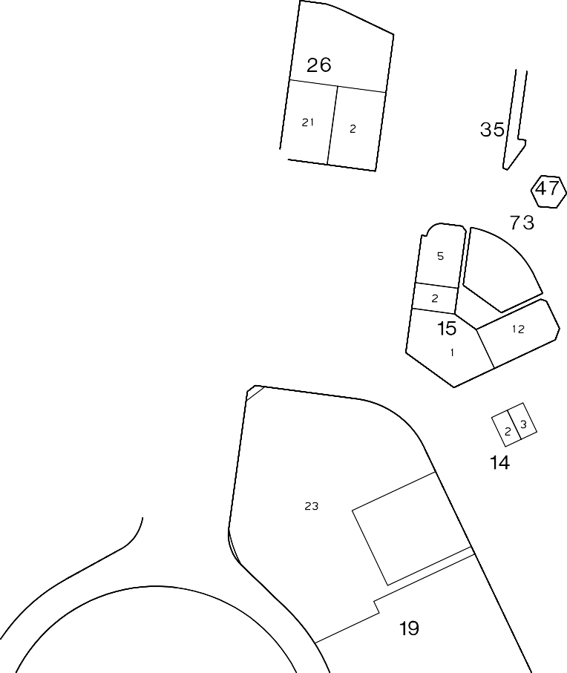





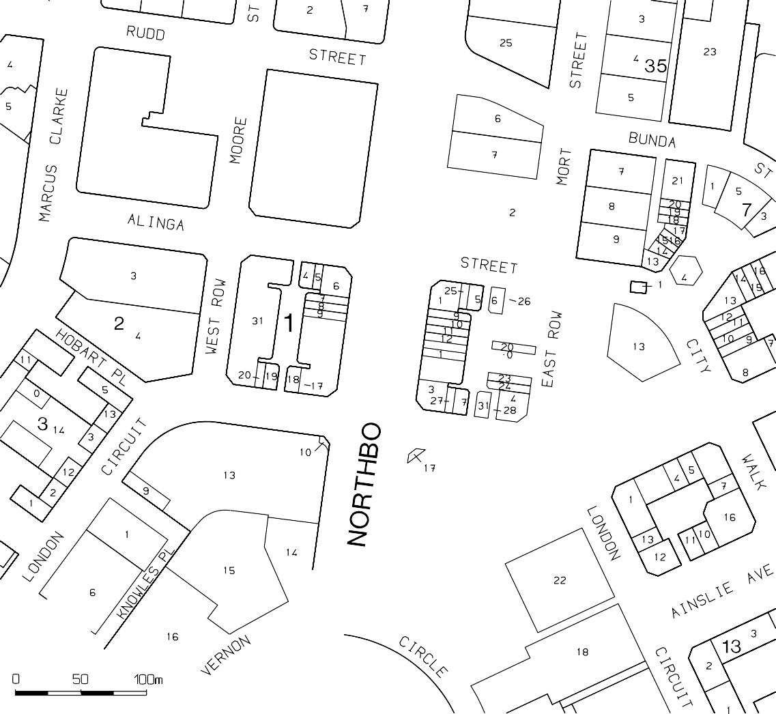

2

PHILIP LEESON ARCHITECTS January 2022

Appendix E: ACT Tree Register Entry

SYDNEY & MELBOURNE BUILDINGS CMP 182


ACT Tree Register
Registered Trees  Section 1 City | Number  RT 256B
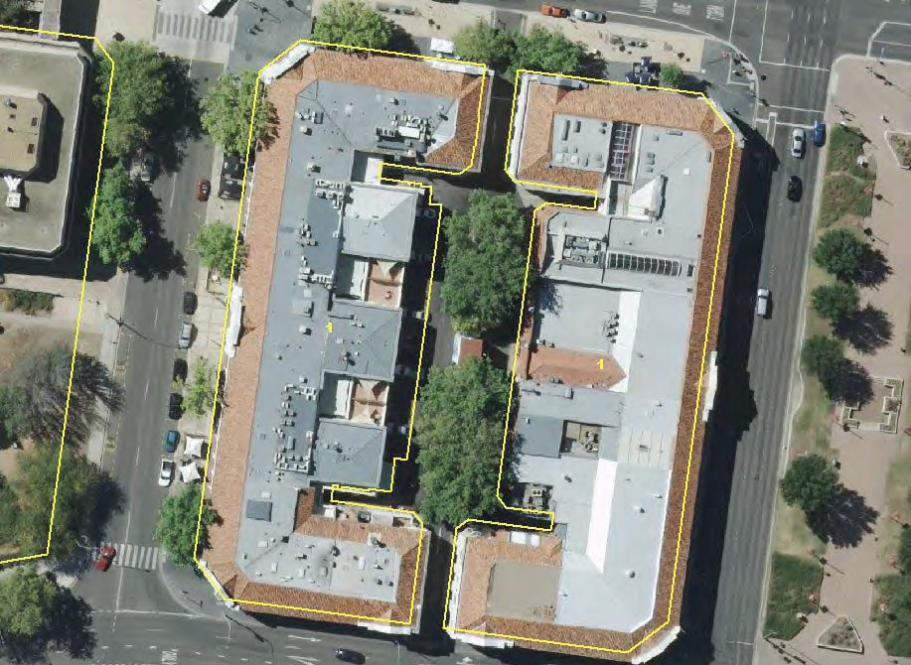

Tree Details:
Street address | Odgers Lane City – Melbourne Building |  | N  R4 | R1  R3 | R2
Location on block | In the middle of the block. |  | N  R4 |  | R2
Botanical name: | Platanus x hispanica syn. Platanus x acerifolia |  | N  R4 |  | R2
Botanical name: | 6 plantings |  | N  R4 |  | R2
Common name: | London plane |  | N  R4 |  | R2
Tree height: | ~16m |  | N  R4 |  | R2
 | Broadest Diameter | ~12m | N  R4 |  | R2
Canopy dimensions: | Radial Measurements | R1:~5m; R2: ~6m;  R3: ~5m; | N  R4 |  | R2
 |  | R4: ~6m | N  R4 |  | R2
Trunk circumference: | ~2.4m |  | N  R4 |  | R2
Number of trunks: | 1 |  | N  R4 |  | R2
 | E 693720.93 to 693566.86 |  | N  R4 |  | R2
Grid co-ordinates: | N 609397.43 to 6093921.57 |  | N  R4 |  | R2

Registration Criteria that presently apply, other criteria may apply after further assessment.

Natural or cultural heritage value
Object: The object of this value is to identify trees that are of particular importance to the community due to their intrinsic heritage values.
A tree may be considered to be of natural or cultural heritage value when it is:
  - associated with a significant public figure or important historical event; or
  - of high cultural heritage value to the community or cultural group, including trees associated with aboriginal heritage and culture; or
  - associated with a heritage nominated place and representative of that same historic period.

Landscape and aesthetic value
Object: The object of this value is to identify trees that are of particular importance to the community due to their substantial contribution to the surrounding landscape.
A tree may be considered to be of landscape and aesthetic value if it is situated in a prominent location when viewed from a public place and it:
  - contributes significantly to the surrounding landscape based on its overall form, structure, vigour and aesthetic values; or
  - represents an outstanding example of the species, including age, size or habit; or

Tree Register ACT
Pursuant to Part 15 Section 118 of the Tree Protection Act 2005 (R1), the above mentioned trees are taken to be registered
Registration status

Registered

Requests for further information should be made to:
Tree Protection Unit PO Box 158
Canberra City, ACT 2601
Telephone: (02) 6207 6127
Facsimile: (02) 6207 5956 Email: treeprotection@act.gov.au


ACT Tree Register

Tree Registration
City Section 48

RT0256A

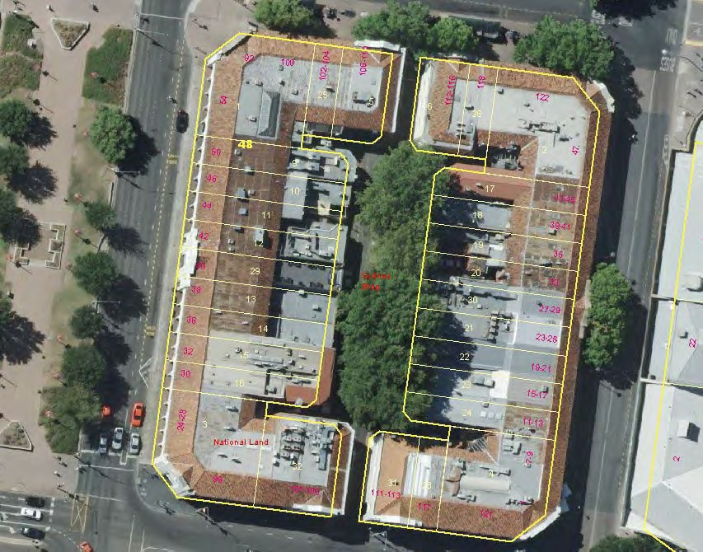

Street address | Verity Lane City - Sydney Building |  | 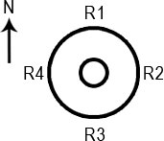
Location on block | Middle
Botanical name: | Platanus x hispanica syn. Platanus x
Botanical name: | acerifolia 6 plantings
Common name: | London plane
Tree height: | ~16m +
 | Broadest Diameter | 12 m
Canopy dimensions: | Radial | R1: 6m;  R2: 6m;
 | Measurements | R3: 6m;
 |  | R4: 6m
Trunk | ~2.4m
circumference:
Number of trunks: | 1
Grid co-ordinates: | E 693720 to 693713.41
Grid co-ordinates: | N 6093948 to 6093901.69

(1) Natural or cultural heritage value
Object: The object of this value is to identify trees that are of particular importance to the community due to their intrinsic heritage values.
A tree may be considered to be of natural or cultural heritage value when it is:
- associated with a significant public figure or important historical event; or
- of high cultural heritage value to the community or cultural group, including trees associated with aboriginal heritage and culture; or
- associated with a heritage nominated place and representative of that same historic period.
(2) Landscape and aesthetic value
Object: The object of this value is to identify trees that are of particular importance to the community due to their substantial contribution to the surrounding landscape.
A tree may be considered to be of landscape and aesthetic value if it is situated in a prominent location when viewed from a public place and it:
- contributes significantly to the surrounding landscape based on its overall form, structure, vigour and aesthetic values; or
- represents an outstanding example of the species, including age, size or habit.

ACT Tree Register
Pursuant to Part 15 Section 118 of the Tree Protection Act 2005 (R1), the above mentioned tree is taken to be registered
Registration Status Registered
Requests for further information should be made to:
Tree Protection Unit GPO Box 158
Canberra City, ACT 2601
Telephone: (02) 6207 6127
Facsimile: (02) 6207 5956 Email: treeprotection@act.gov.au

PHILIP LEESON ARCHITECTS January 2022

Appendix F: Drawings of the Sydney and Melbourne Buildings

SYDNEY & MELBOURNE BUILDINGS CMP 183

  - REPAIR BLISTERING AND WATER DAMAGED RENDER NEAR BASE OF WALL
*

ALINGA STREET
STATEMENT OF INTENT
THE WORKS DESCRIBED IN THESE DRAWINGS AND ASSOCIATED SCHEDULES ARE RECOMMENDED AS THE MINIMUM REQUIRED TO RESTORE THE STREET FACADES AND COVERED ARCADES OF THE SYDNEY AND MELBOURNE BUILDINGS TO A SOUND PHYSICAL CONDITION AND A GENERAL APPEARANCE CONSISTENT WITH THEIR HERITAGE VALUES
General Notes
All measurements are in millimetres
Figured dimensions take precedence over scaled dimensions
Builder to verify all dimensions on site and seek instructions before proceeding if any discrepancies are found

PJ O'REILLY'S

BLUE OLIVE DELI CAFE

LA POSSADA CAFE

NEWS AGENCY

SMITHS ALI BABA
BOOKSHOP
LEGAL CHAMBERS STAIR LOBBY

STUDENT FLIGHTS
PAINTING NOTES - SYDNEY AND MELBOURNE BUILDINGS
WORKS MARKED * ARE ESSENTIAL ITEMS FOR COMPLETION BEFORE COMMENCEMENT OF PAINTING
- FILL ALL MINOR CRACKS IN WALLS TO BE PAINTED AFTER CHECKING THE INTEGRITY OF SURROUNDING RENDER AND MAKING GOOD AS NECESSARY TO PROVIDE A SOUND SURFACE
*
- REMOVE ALL REDUNDANT FIXTURES INCLUDING WALL PLUGS, BOLTS, BRACKETS, SADDLES, CONDUITS, PIPEWORK, SIGN MOUNTS AND ELECTRICAL FIXTURES
* 3. FILL ALL HOLES AND CHIPS IN RENDER
- REMOVE ALL VEGETATION, DIRT, BIRD NESTS AND WASP NESTS FROM PARAPETS AND WALL TRIMS, CLEAN AND RESTORE SURFACES THOROUGHLY BEFORE PAINTING
*
- REMOVE ANY FLAKING PAINT, SALT GROWTH, AND UNSOUND RENDER AND MAKE GOOD ALL SURFACES TO PROVIDE A SOUND AND TRUE SURFACE FOR PAINTING
*

1.14 RE-ATTACH CONDUIT AT TOP OF WALL

1.13 REMOVE METAL STRAPS FROM FACE OF BEAMS

SABAYON RESTAURANT

CATALDOS SALON

NATIONAL HEARING CARE

SEOUL

STAIR LOBBY
GENERAL NOTES - SYDNEY AND MELBOURNE BUILDINGS
WORKS MARKED * ARE ESSENTIAL ITEMS FOR COMPLETION BEFORE COMMENCEMENT OF PAINTING
* 1. REPAIR OR REPLACE ANY DISLODGED OR DAMAGED ROOF TILES
- CHECK ALL ROOF GUTTERS FOR CORRECT FALLS TO DOWNPIPES AND ADJUST AS NECESSARY TO RECTIFY, JOIN AND SUPPORT ANY LOOSE OR DISCONNECTED GUTTERING TO FORM CONTINUOUS RUNS THE FULL LENGTH OF EACH ROOF EDGE, FALLING TO BOTH ENDS.
*
- ANY NON-CONFORMING OR MISMATCHED SECTIONS OF GUTTER SHALL BE REPLACED WITH NEW HERITAGE PROFILE COLORBOND GUTTER TO ARCHITECT'S SELECTION, TO FORM CONTINUOUS RUNS THE FULL LENGTH OF EACH ROOF EDGE
*
- ALL PVC DOWNPIPES AND ALL RECTANGULAR METAL DOWNPIPES SHALL BE REPLACED WITH CIRCULAR COLORBOND DOWNPIPES TO
*

Amendments This drawing published 17/11/2008 12:05 PM

1.12 REMOVE METAL STRAPS FROM FACE OF BEAMS

1.11 REPAIR DAMAGED FLOOR TILES

ASIAN CAFE

QUEST SERVICED APARTMENTS

REJ CAFE
RESTAURANT

ANISE RESTAURANT

MUDDLE BAR
PALACE RESTAURANT

VACANT

VACANT

VACANT

CLUB X

COMMONWEALTH BANK

STAIR

  - REMOVE OVERHEAD SIGN AND CONDUITS

  - REPAIR FLOOR TILES

  - REMOVE OVERHEAD SIGN AND CONDUITS

  - REMOVE OVERHEAD FLUORESCENT LIGHT
AND CONDUITS
ARCHITECT'S SELECTION, LOWEST 2400 MM OF DOWNPIPES TO BE GALVANISED STEEL PIPE TO RESIST IMPACT DAMAGE (TO FUTURE DETAIL), PAINT FINISH. FIX DOWNPIPES WITH NEW PRE-FINISHED STEEL DOWNPIPE BRACKETS WITH EXTENDED LEG FIXED DIRECTLY TO MASONRY WALL WITH COATED ROOFING SCREWS INTO PLASTIC WALL PLUGS
- ALL EXISTING CONCEALED DOWNPIPES AND INTERMEDIATE ELBOW DOWNPIPES ARE TO BE DISCONNECTED AND REMOVED WHERE POSSIBLE. INSTALL NEW DOWNPIPES AS DESCRIBED ABOVE AT BOTH ENDS OF EACH LENGTH OF CONTINUOUS ROOF EDGE WHERE NOT ALREADY PRESENT
NORTHBOURNE AVENUE
*
- ALL DOWNPIPES SHALL BE CONNECTED TO UNDERGROUND STORMWATER SYSTEM
*
- RE-GROUT TERRACOTTA FLOOR TILES TO ENTIRE GROUND FLOOR ARCADE AREA OF SYDNEY BUILDING INCLUDING REPLACING ANY BROKEN OR MISSING TILES WITH MATCHING NEW TILES
- REPLACE ALL SMALLER DIAMETER AND MISSING LIGHT FITTINGS ON BOTH SYDNEY AND MELBOURNE BUILDINGS WITH LARGE SPHERICAL LIGHTS TO MATCH EXIST AS PRESENTLY INSTALLED ON WESTERN (QUEST APARTMENTS) PORTION OF MELBOURNE BUILDING (SUBJECT TO HERITAGE ADVICE)
- ANY PARAPET TOPS NOT ALREADY CAPPED WITH A WATERPROOF CAPPING ARE TO BE BE WATERPROOFED TO FUTURE DETAIL
*
- REMOVE ALL NON-CONFORMING SIGNS FROM ARCADES AND REPLACE WITH NEW OVERHEAD SIGNS OF CONSISTENT DESIGN TO FUTURE DETAIL. THE SQUARE SUSPENDED SIGNS AS PRESENTLY INSTALLED IN THE WESTERN PORTION OF THE MELBOURNE BUILDING MAY BE AN APPROPRIATE DESIGN (SUBJECT TO HERITAGE ADVICE)
- REMOVE ALL ILLUMINATED SIGNS FROM STREET FACADES AS SHOWN ON THE ELEVATIONS AND REPLACE WITH PAINTED OR LOW-RELIEF NON- ILLUMINATED SIGNS STRICTLY CONFINED TO THE EXISTING DESIGNATED SIGN PANELS LOCATED AT THE CENTRE OF EACH GABLE ARCH

- A COMPLETE REVIEW OF THE ROOF DRAINAGE SYSTEM (GUTTERS, DOWNPIPES, AND STORMWATER CONNECTIONS) FOLLOWED BY REMEDIAL WORK INVOLVING REPLACEMENT OF MUCH OF THE SYSTEM ON BOTH BUILDINGS, DONE AS A SINGLE INTEGRATED PROJECT, IS CONSIDERED ESSENTIAL TO COMPLETE BEFORE PAINTING WORKS BEGIN. THIS IS NECESSARY BECAUSE MUCH OF THE EXISTING DAMAGE TO RENDER AND PAINT HAS RESULTED FROM LEAKING OF GUTTERS AND DOWNPIPES, SOME OF WHICH ARE CONCEALED INSIDE MASONRY WALLS AND ARE NOT ACCESSIBLE FOR REPAIR
*
Rev
A

Client
Date
17.11.08
WEST ROW
ODGERS LANE
Description
ISSUED FOR STAKE HOLDER DISCUSSION

north

MEZZALIRA RESTAURANT

CHARCOAL RESTAURANT
STAIR LOBBY

LEMON GRASS RESTAURANT
STAIR
STAIR

KING SIZE BIG & TALL

CBA AREA ADMIN

INSPIRED

KEY

CONSPICUOUS CRACKS IN RENDER (TO BE REPAIRED - REFER PAINTING NOTE 1, SHEET A 01)
t +61 2 6239 4333 | f +61 2 6239 4366
- / 10 kennedy st | po box 4700
kingston act 2604
act arch reg no 935 | nsw arch reg no 6904 ABN 32 042 803 344

1.10 REPAIR BLISTERING AND WATER
*

AREA TO BE REPAIRED OR MADE GOOD AS NOTED
Project
Sydney & Melbourne Buildings Facade Refurbishment

DAMAGED RENDER NEAR BASE OF WALL
YWCA ENTRY
ITEM TO BE REPAIRED, MADE GOOD, OR REMOVED AS NOTED
Address Section 1 & Section 48 CANBERRA CITY ACT 2601
Drawing Melbourne Building - Ground Floor Plan




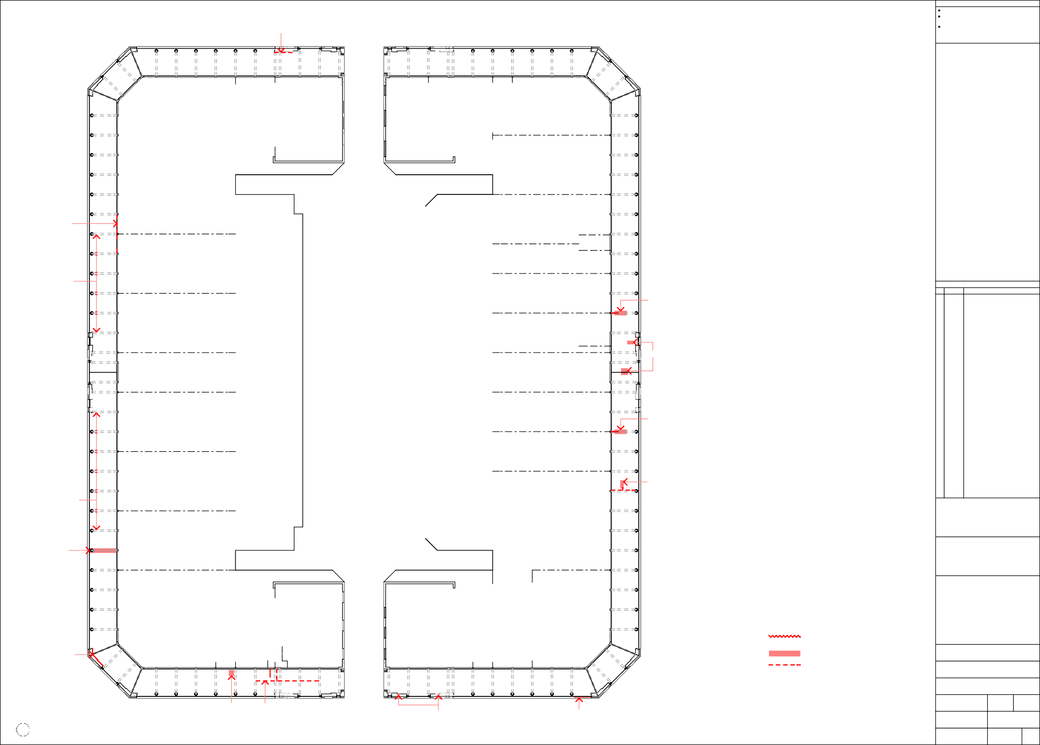

1.9 REPAIR HOLES IN SOFFIT
*

Melbourne Building - Ground Floor Plan
1
1:200

1.8 REMOVE CONDUITS FROM SOFFIT

LONDON CIRCUIT

1.7 REMOVE SEMI-CONCEALED RUSTED DOWNPIPES, CAP STORMWATER CONNECTION BELOW PAVING LEVEL,
BRICK UP DOWNPIPE RECESSES, RENDER AND PAINT TO MATCH SURROUNDING WALLS
*

  - REPAIR BROKEN AND MISSING
NOSING PAVERS
Scale
AS SHOWN @ A1
Date
10-10-08

Project No.

08-346
Drawn
BC

Drawing No.

A 01
Checked

Issue
A

* 1.1 REMOVE EXISTING WOODEN DOWNPIPE FIXING BLOCKS AND * 1.2 REPLACE ROTTED SECTIONS OF LOWERMOST SOFFIT BOARD * 1.3 REMOVE EXISTING WOODEN DOWNPIPE FIXING BLOCKS AND * 1.4 REPAIR TIMBER WALL FASCIA, REFIX SECURELY TO FINISH BRACKETS, MAKE GOOD RENDER, FIT NEW DOWNPIPE AND REPLACE WITH NEW L.O.S. TREATED HARDWOOD BOARD BRACKETS, MAKE GOOD RENDER, FIT NEW DOWNPIPE FLUSH WITH ADJOINING  BRACKETS (REFER GENERAL NOTE 4, SHEET A 01) TO MATCH EXISTING BRACKETS (REFER GENERAL NOTE 4, SHEET A 01), CLEAR OUT STORMWATER CONNECTION AND RE-GROUT AROUND BASE OF DOWNPIPE  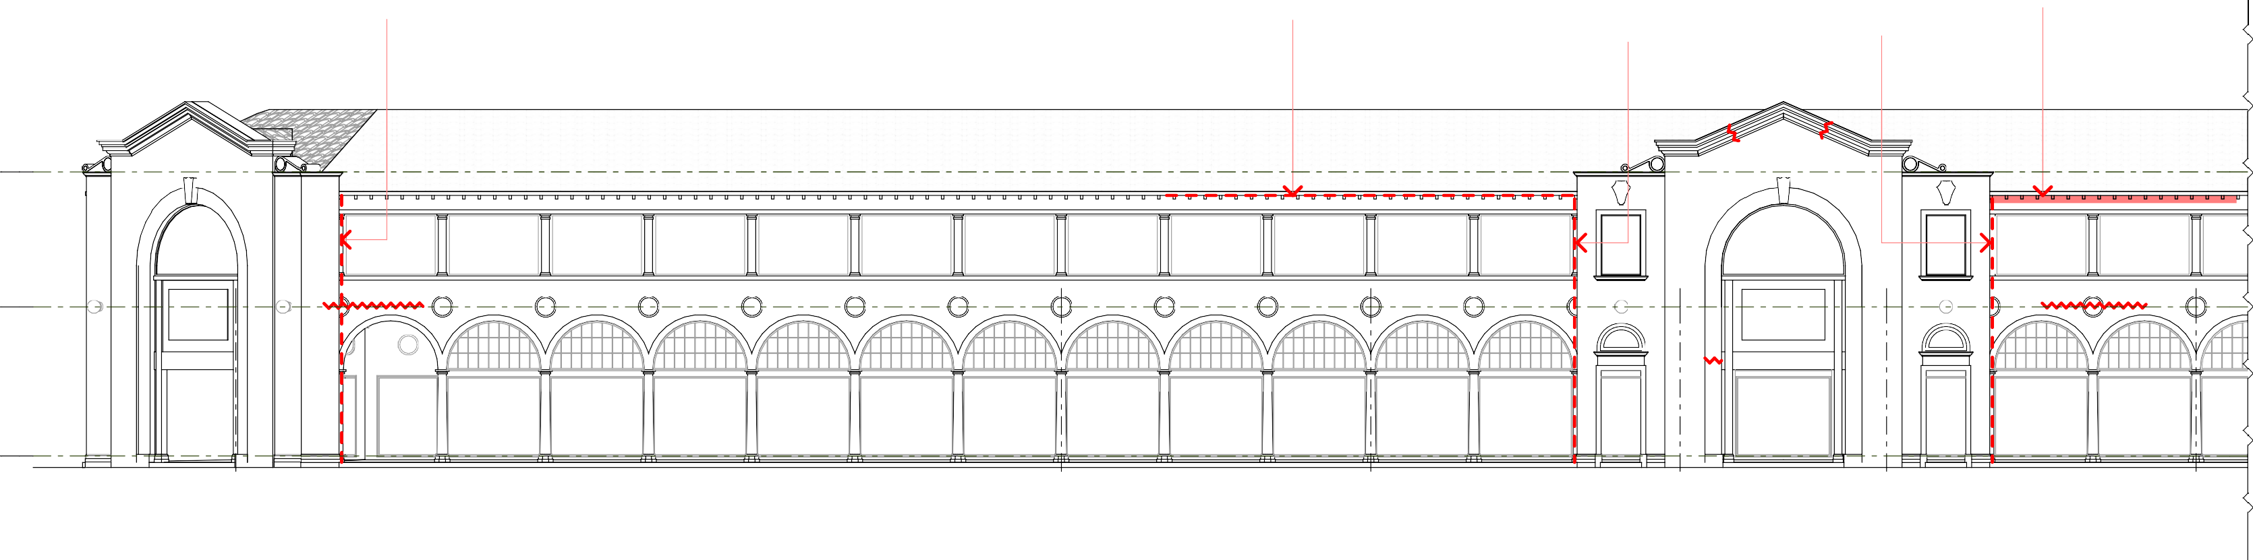  +8 395  Top of Parapet  +4 405  First Floor  ±0  Ground Floor  PJ O'REILLY'S SABAYON ASIAN QUEST SERVICED REJ CAFE RESTAURANT CAFE APARTMENTS RESTAURANT  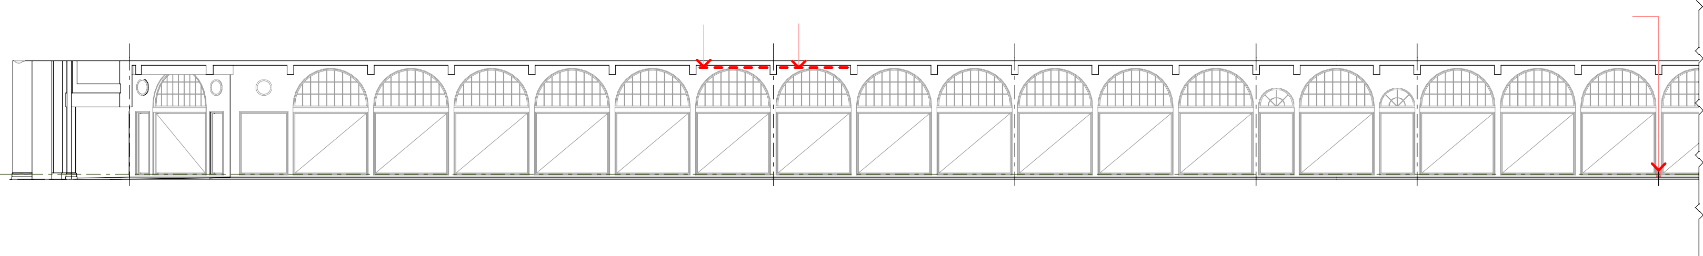    1 Melbourne Building - West Row Elevation - Part A  1:100  2.1 RE-ATTACH EXISTING CONDUIT TO WALL 2.2 REPLACE MISSING BLACK STONE SKIRTING  NO NO NO NO  WORK WORK WORK WORK  ±0  Ground Floor  PJ O'REILLY'S SABAYON ASIAN QUEST SERVICED REJ CAFE RESTAURANT CAFE APARTMENTS RESTAURANT  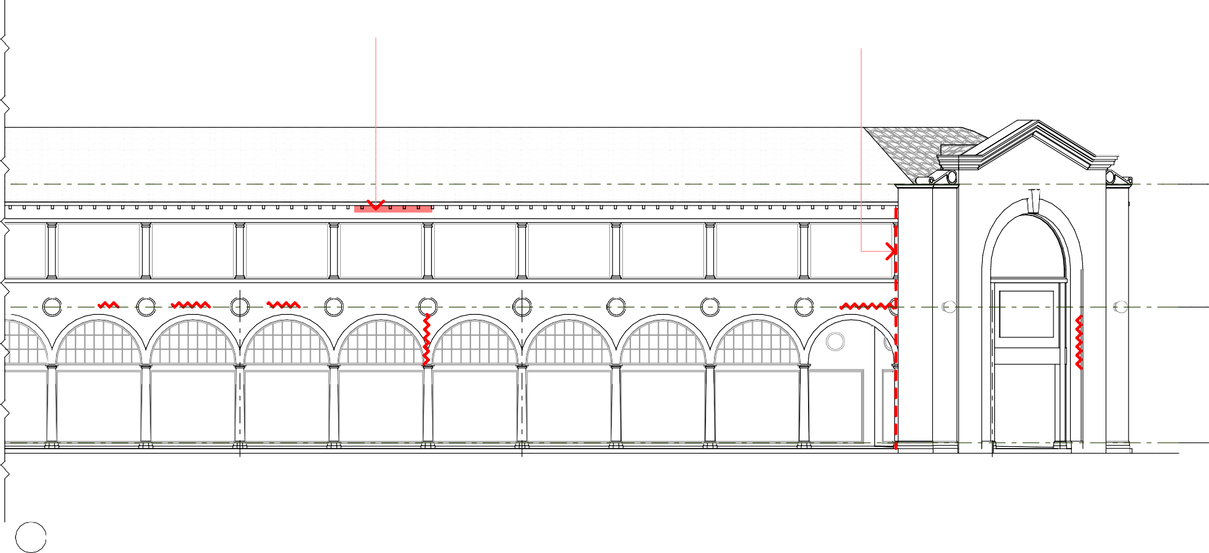  - Melbourne Building - West Row Shopfront Elevation - Part A  1:100  * 3.1 RE-ATTACH TIMBER WALL FASCIA SECURELY TO FINISH FLUSH * 3.2 REMOVE EXISTING WOODEN DOWNPIPE FIXING BLOCKS AND WITH ADJOINING BRACKETS, MAKE GOOD RENDER, FIT NEW DOWNPIPE  BRACKETS (REFER GENERAL NOTE 4, SHEET A 01)  +8 395  Top of Parapet  +4 405  First Floor KEY  CONSPICUOUS CRACKS IN RENDER (TO BE REPAIRED - REFER PAINTING NOTE 1, SHEET A 01)  AREA TO BE REPAIRED OR MADE GOOD AS NOTED  ITEM TO BE REPAIRED, MADE GOOD, OR REMOVED AS NOTED  ±0  Ground Floor  ANISE MUDDLE MEZZALIRA  RESTAURANT BAR RESTAURANT  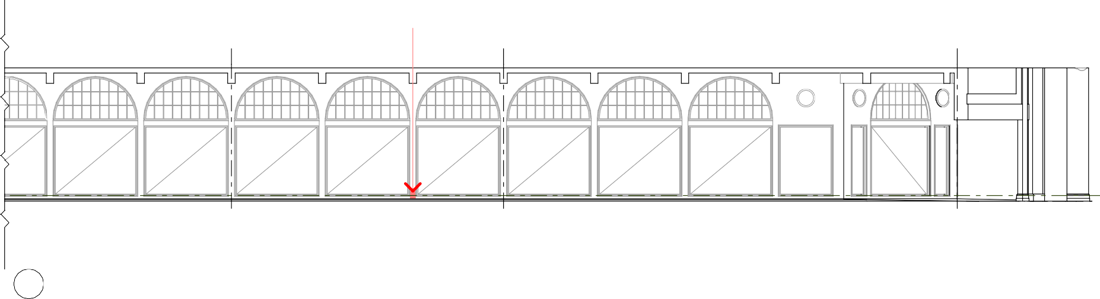  - Melbourne Building - West Row Elevation - Part B  1:100  4.1 REPLACE MISSING BLACK STONE SKIRTING  NO NO  WORK WORK  ±0  Ground Floor  ANISE MUDDLE MEZZALIRA  RESTAURANT BAR RESTAURANT  4 Melbourne Building - West Row Shopfront Elevation - Part B  1:100 | General Notes
All measurements are in millimetres
Figured dimensions take precedence over scaled dimensions
Builder to verify all dimensions on site and seek instructions before proceeding if any discrepancies are found
 | Amendments This drawing published 17/11/2008 12:05 PM
 | Rev | Date | Description
 | A | 17.11.08 | ISSUED FOR STAKE HOLDER DISCUSSION
 | north
 | Client

t +61 2 6239 4333 | f +61 2 6239 4366
4 / 10 kennedy st | po box 4700
kingston act 2604

act arch reg no 935 | nsw arch reg no 6904 ABN 32 042 803 344
 | Project Sydney & Melbourne Buildings Facade Refurbishment
 | Address Section 1 & Section 48 CANBERRA CITY ACT 2601
Drawing Melbourne Building -
Elevations 1
 | Scale  AS SHOWN @ A1 |  |  | Drawn  BC | Checked
Date
10-10-08
 | Project No.  08-346 |  |  | Drawing No.  A 02 |  | Issue  A
NO WORK TO
SHOPFRONT
NO WORK TO
SHOPFRONT
NO WORK TO
SHOPFRONT
NO WORK TO
SHOPFRONT
NO WORK TO
SHOPFRONT
NO WORK TO
SHOPFRONT
NO WORK TO
SHOPFRONT
RK TO
FRONT
NO WORK TO
SHOPFRONT
NO WORK TO
SHOPFRONT
NO WORK TO
SHOPFRONT
NO WORK TO
SHOPFRONT
NO WORK TO
SHOPFRONT
NO WORK TO
SHOPFRONT
NO WORK TO
SHOPFRONT
NO WORK TO
SHOPFRONT
NO WORK TO
SHOPFRONT
NO WORK TO
SHOPFRONT
NO WORK TO
SHOPFRONT
NO WORK TO
SHOPFRONT
NO WORK TO
SHOPFRONT
NO WORK TO
SHOPFRONT
NO WORK TO
SHOPFRONT
NO WORK TO
SHOPFRONT
NO WORK TO
SHOPFRONT
NO WO
SHOP

  - INSTALL NEW CIRCULAR METAL DOWNPIPES AND BRACKETS (REFER GENERAL NOTE 4, SHEET A 01)
*

  - ADJUST FALLS ON EXISTING GUTTER TO SUIT NEW DOWNPIPE LOCATIONS
*

  - REPLACE GUTTER TO MATCH EXISTING ADJACENT AND JOIN TO EXISTING ADJACENT TO FORM A CONTINUOUS RUN
*

  - REPAIR RENDER AROUND RAINHEAD
*

  - REPAIR BROKEN RENDER TRIM
General Notes
All measurements are in millimetres
Figured dimensions take precedence over scaled dimensions
Builder to verify all dimensions on site and seek instructions before proceeding if any discrepancies are found

+8 395
Top of Parapet
+8 395
Top of Parapet

+4 405
First Floor
+4 405
First Floor

±0
Ground Floor
STAIR
STAIR

MEZZALIRA RESTAURANT

STAIR LOBBY

CHARCOAL RESTAURANT

LEMON GRASS RESTAURANT
±0
Ground Floor

LEMON GRASS RESTAURANT

Melbourne Building - London Circuit Elevation - Part A
1
1:100
Melbourne Building - Odgers Lane East Elevation - Part A
1:100
2

  - REMOVE BROWN PAINT FROM EXISTING BLACK STONE SKIRTING, POLISH & SEAL SKIRTING TO MATCH ORIGINAL ADJACENT

Amendments This drawing published 17/11/2008 12:05 PM

Rev
A
Date
17.11.08
Description
ISSUED FOR STAKE HOLDER DISCUSSION

NO WORK

NO WORK
NO WORK TO
SHOPFRONT
NO WORK TO
SHOPFRONT
NO WORK TO
SHOPFRONT
NO WORK TO
SHOPFRONT
NO WORK TO
SHOPFRONT
NO WORK TO
SHOPFRONT
NO WORK TO
SHOPFRONT
NO WORK TO
SHOPFRONT
NO WORK TO
SHOPFRONT

±0
Ground Floor
STAIR
STAIR

MEZZALIRA RESTAURANT

STAIR LOBBY

CHARCOAL RESTAURANT

LEMON GRASS RESTAURANT

Melbourne Building - London Circuit Shopfront Elevation - Part A
3
1:100

  - REPLACE EXIST BOX GUTTER AND FLASHINGS BEHIND PARAPET WITH NEW COLORBOND
*
  - REPAIR RENDERED TRIM

  - REMOVE EXISTING RECTANGULAR DOWNPIPE AND PVC DOWNPIPE AND INSTALL NEW CIRCULAR METAL DOWNPIPES
*
AND BRACKETS (REFER GENERAL NOTE 4, SHEET A 01)
  - REPAIR CORNER OF RENDERED TRIM

+8 395
Top of Parapet
+8 395
Top of Parapet

  - FIT NEW COLORBOND RAINHEAD AND
*
DOWNPIPE TO MATCH OPPOSITE SIDE OF LANE

+4 405
First Floor
+4 405
First Floor

north

Client

KING SIZE BIG & TALL
±0
Ground Floor

KING SIZE BIG & TALL

YWCA ENTRY

CBA AREA ADMIN

INSPIRED
±0
Ground Floor

Melbourne Building - Odgers Lane West Elevation - Part B
4
1:100
Melbourne Building - London Circuit Elevation - Part B
1:100
5

KEY

  - REPAIR BROKEN RENDER AND FILL BOLT HOLES

  - REMOVE BOLTS AND REDUNDANT ELECTRICAL FIXTURES, FILL HOLES

  - REMOVE SIGN
t +61 2 6239 4333 | f +61 2 6239 4366
4 / 10 kennedy st | po box 4700
kingston act 2604
act arch reg no 935 | nsw arch reg no 6904 ABN 32 042 803 344

CONSPICUOUS CRACKS IN RENDER (TO BE REPAIRED - REFER PAINTING NOTE 1, SHEET A 01)
Project
Sydney & Melbourne Buildings Facade Refurbishment

AREA TO BE REPAIRED OR MADE GOOD AS NOTED

ITEM TO BE REPAIRED, MADE GOOD, OR REMOVED AS NOTED

NO WORK

NO WORK

±0
NO WORK TO
SHOPFRONT
NO WORK TO
SHOPFRONT
NO WORK TO
SHOPFRONT
NO WORK TO
SHOPFRONT
NO WORK TO
SHOPFRONT
NO WORK TO
SHOPFRONT
NO WORK TO
SHOPFRONT
NO WORK TO
SHOPFRONT
NO WORK TO
SHOPFRONT
Address Section 1 & Section 48 CANBERRA CITY ACT 2601
Drawing Melbourne Building - Elevations 2

KING SIZE BIG & TALL

YWCA ENTRY

CBA AREA ADMIN

INSPIRED
Ground Floor
Scale
AS SHOWN @ A1
Date
Drawn
BC
Checked

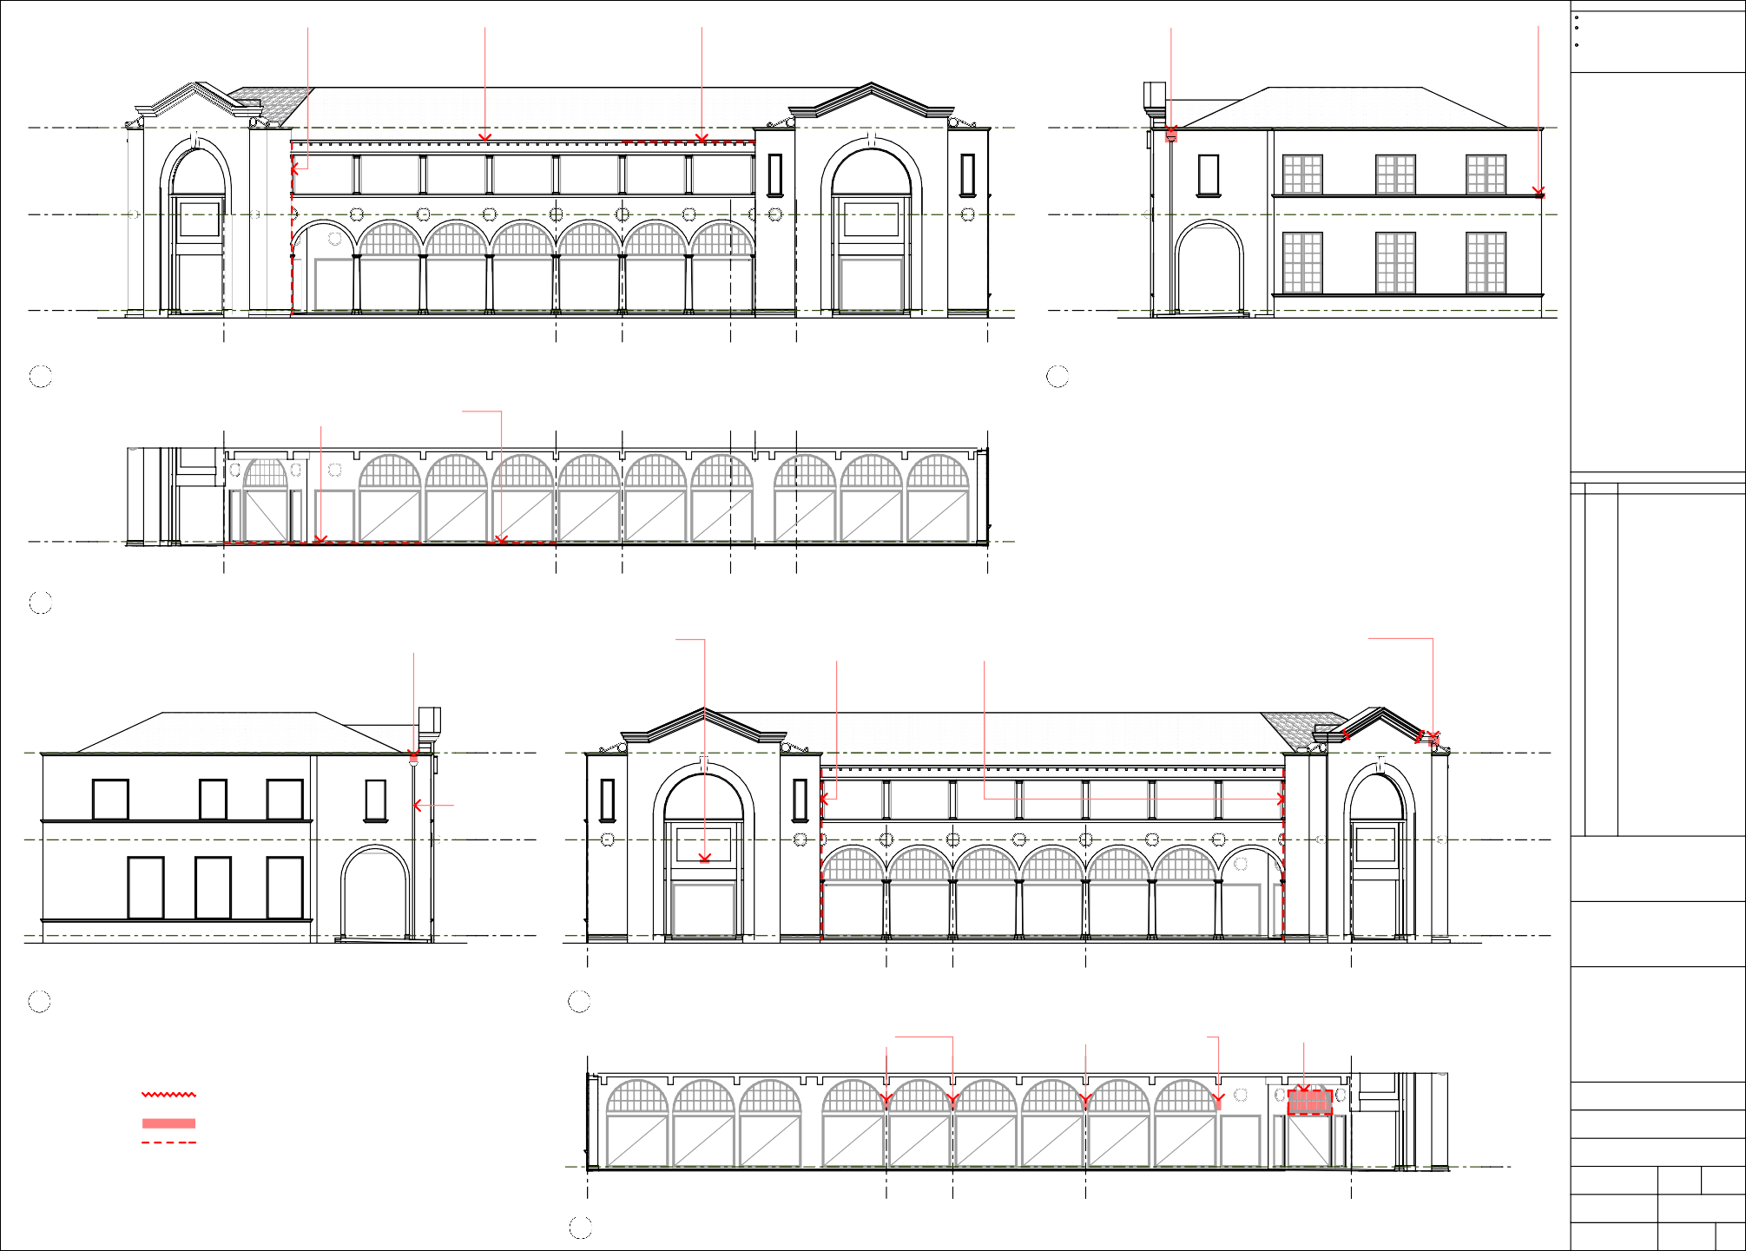
Melbourne Building - London Circuit Shopfront Elevation - Part B
6
1:100
10-10-08

Project No.

08-346

Drawing No.

A 03

Issue
A

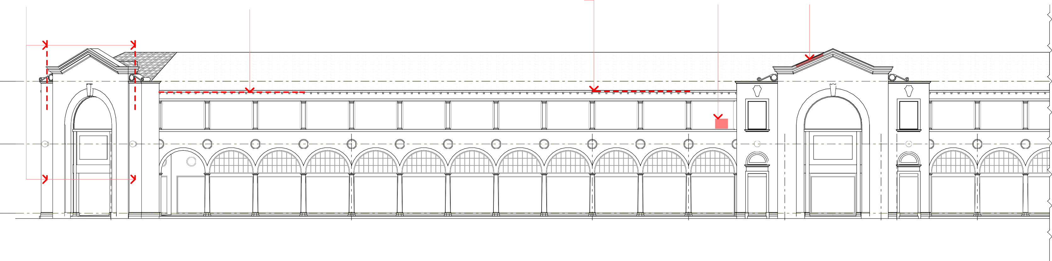  1.1 REMOVE FLAGPOLES AND CLEATS AND MAKE GOOD * 1.2 REPLACE ROTTED SECTIONS OF LOWERMOST SOFFIT BOARD * 1.3 REPLACE GUTTER TO MATCH EXISTING ADJACENT AND JOIN 1.4 REMOVE WINDOW-MOUNTED AIR CONDITIONER 1.5 REPAIR RENDERED CORNICE RENDER AND REPLACE WITH NEW L.O.S. TREATED HARDWOOD BOARD TO EXISTING ADJACENT TO FORM A CONTINUOUS RUN, AND MAKE GOOD WINDOW  TO MATCH EXISTING REMOVE EXISTING ELBOW DOWNPIPES, ADJUST FALL OF  ENTIRE GUTTER TO SUIT DOWNPIPES AT BOTH ENDS  +8 395  Top of Parapet  +4 405  First Floor  ±0  Ground Floor  INSPIRED COMMONWEALTH CLUB VACANT VACANT STAIR VACANT SEOUL PALACE BANK X ENTRY RESTAURANT  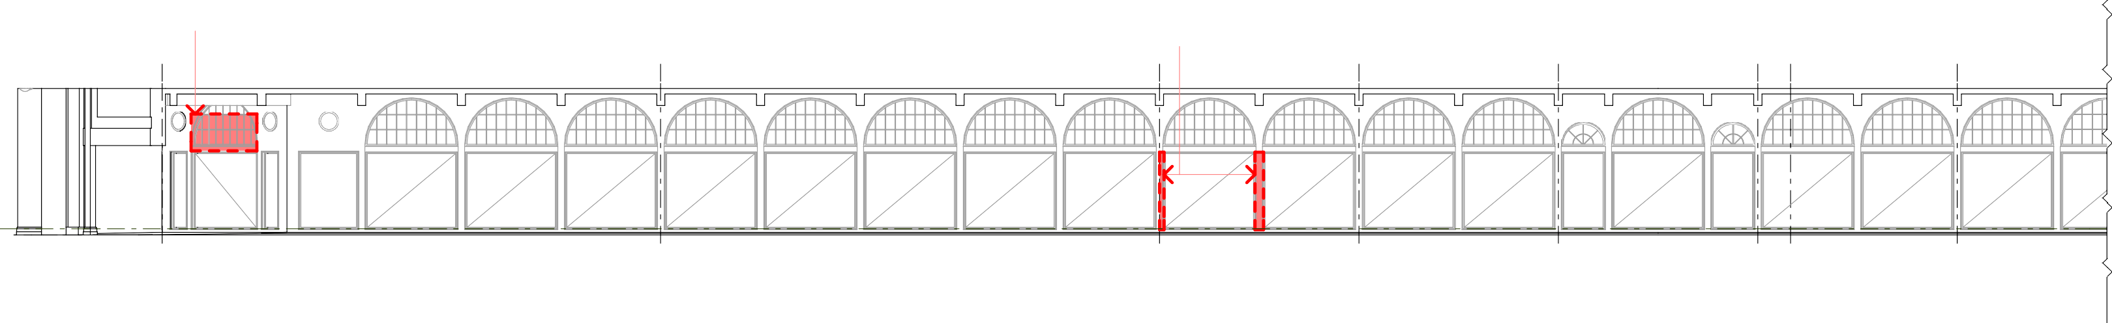    1 Melbourne Building - Northbourne Avenue Elevation - Part A  1:100  2.1 REMOVE SIGN 2.2 REMOVE TILE CLADDING, RESTORE RENDERED  MASONRY ARCHES WITH SALIENT BEADING TO  MATCH ORIGINAL DETAIL  NO NO NO NO  WORK WORK WORK WORK  ±0  Ground Floor  INSPIRED COMMONWEALTH CLUB VACANT VACANT STAIR VACANT SEOUL PALACE BANK X ENTRY RESTAURANT  2 Melbourne Building - Northbourne Avenue Shopfront Elevation - Part A  1:100  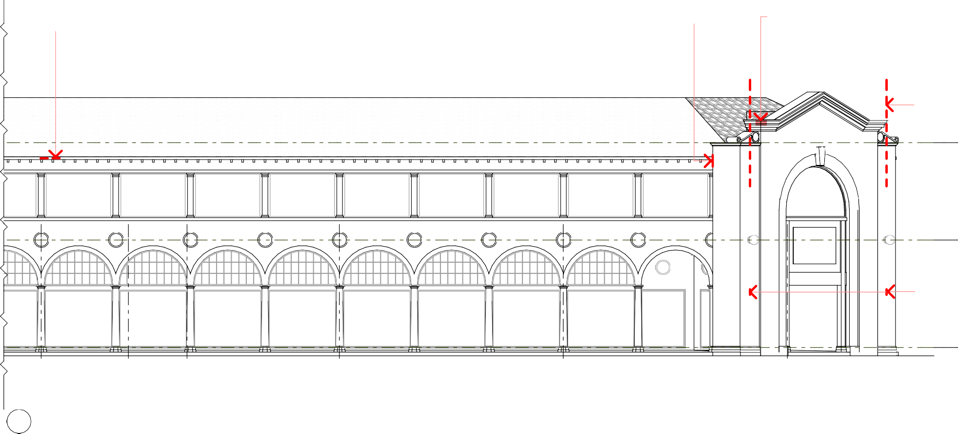  * 3.1 REPAIR * 3.2 REPAIR HOLES IN WALL BEHIND DOWNPIPE AND 3.3 REPAIR RENDERED CORNICE  GUTTER AT END OF GUTTER  3.4 REMOVE FLAGPOLES AND MAKE GOOD  +8 395  Top of Parapet  +4 405  First Floor  KEY  CONSPICUOUS CRACKS IN RENDER (TO BE REPAIRED - REFER  3.5 REMOVE CLEATS AND PAINTING NOTE 1, SHEET A 01)  MAKE GOOD  AREA TO BE REPAIRED OR MADE GOOD AS NOTED  ITEM TO BE REPAIRED, MADE GOOD, OR REMOVED AS NOTED  ±0  Ground Floor  NATIONAL STAIR CATALDOS STUDENT ALI BABA HEARING CARE ENTRY SALON FLIGHTS  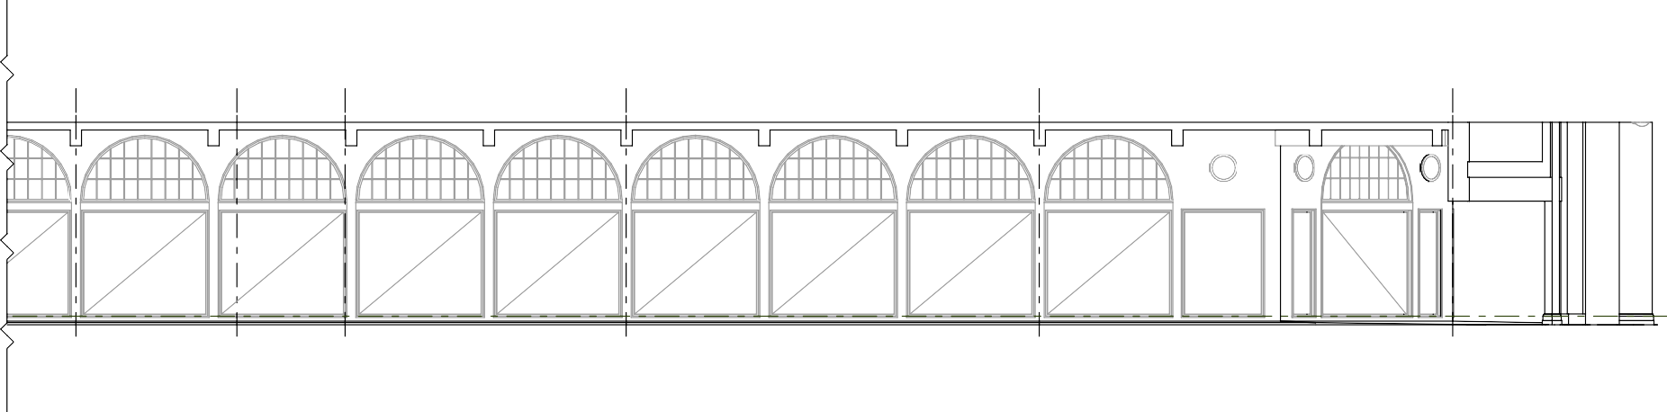  3 Melbourne Building - Northbourne Avenue Elevation - Part B  1:100  NO NO  WORK WORK  ±0  Ground Floor  NATIONAL STAIR CATALDOS STUDENT ALI BABA HEARING CARE ENTRY SALON FLIGHTS  4Melbourne Building - Northbourne Avenue Shopfront Elevation - Part B  1:100 | General Notes
All measurements are in millimetres
Figured dimensions take precedence over scaled dimensions
Builder to verify all dimensions on site and seek instructions before proceeding if any discrepancies are found
 | Amendments This drawing published 17/11/2008 12:05 PM
 | Rev | Date | Description
 | A | 17.11.08 | ISSUED FOR STAKE HOLDER DISCUSSION
 | north
 | Client

t +61 2 6239 4333 | f +61 2 6239 4366
4 / 10 kennedy st | po box 4700
kingston act 2604

act arch reg no 935 | nsw arch reg no 6904 ABN 32 042 803 344
 | Project Sydney & Melbourne Buildings Facade Refurbishment
 | Address Section 1 & Section 48 CANBERRA CITY ACT 2601
Drawing Melbourne Building -
Elevations 3
 | Scale  AS SHOWN @ A1 |  |  | Drawn  BC | Checked
Date
10-10-08
 | Project No.  08-346 |  |  | Drawing No.  A 04 |  | Issue  A
NO WORK TO
SHOPFRONT
NO WORK TO
SHOPFRONT
NO WORK TO
SHOPFRONT
NO WORK TO
SHOPFRONT
NO WORK TO
SHOPFRONT
NO WORK TO
SHOPFRONT
NO WORK TO
SHOPFRONT
RK TO
FRONT
NO WORK TO
SHOPFRONT
NO WORK TO
SHOPFRONT
NO WORK TO
SHOPFRONT
NO WORK TO
SHOPFRONT
NO WORK TO
SHOPFRONT
NO WORK TO
SHOPFRONT
NO WORK TO
SHOPFRONT
NO WORK TO
SHOPFRONT
NO WORK TO
SHOPFRONT
NO WORK TO
SHOPFRONT
NO WORK TO
SHOPFRONT
NO WORK TO
SHOPFRONT
NO WORK TO
SHOPFRONT
NO WORK TO
SHOPFRONT
NO WORK TO
SHOPFRONT
NO WORK TO
SHOPFRONT
NO WORK TO
SHOPFRONT
NO WO
SHOP

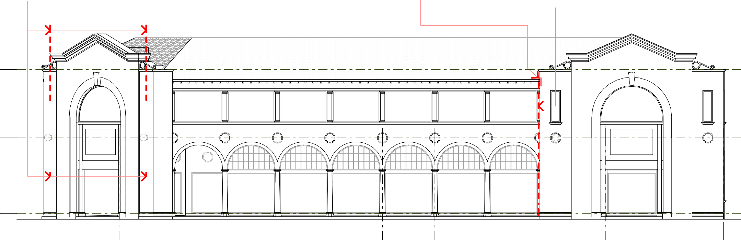  1.1 REMOVE FLAGPOLES AND CLEATS AND MAKE GOOD * 1.2 REPAIR RENDER BEHIND DOWNPIPE AND AT END * 1.3 REMOVE PVC DOWNPIPE AND INSTALL NEW CIRCULAR RENDER OF GUTTER METAL DOWNPIPE AND BRACKETS (REFER GENERAL  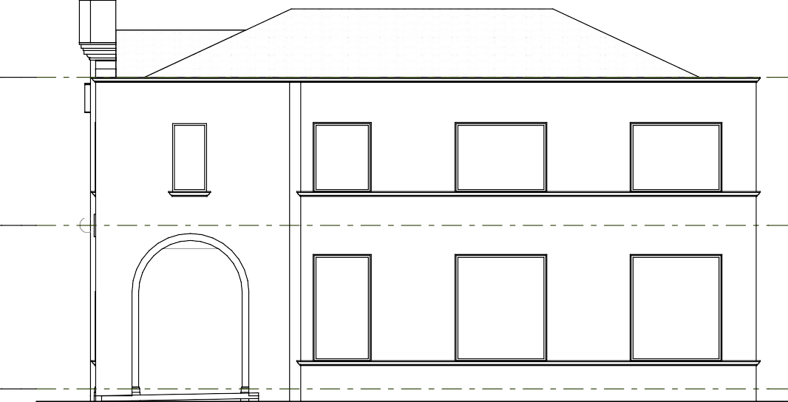  NOTE 4, SHEET A 01)  +8 395 +8 395  Top of Parapet Top of Parapet  +4 405 +4 405  First Floor First Floor  ±0 ±0  Ground Floor Ground Floor  ALI BABA LEGAL SMITHS NEWS NEWS  CHAMBERS BOOKSHOP AGENCY AGENCY  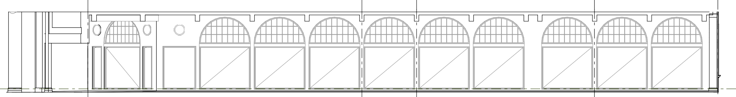  1 Melbourne Building - Alinga Street Elevation - Part A 2 Melbourne Building - Odgers Lane West Elevation - Part A  1:100 1:100  NO NO  WORK WORK  ±0  Ground Floor  ALI BABA LEGAL SMITHS NEWS  CHAMBERS BOOKSHOP AGENCY  3 Melbourne Building - Alinga Street Shopfront Elevation - Part A  1:100    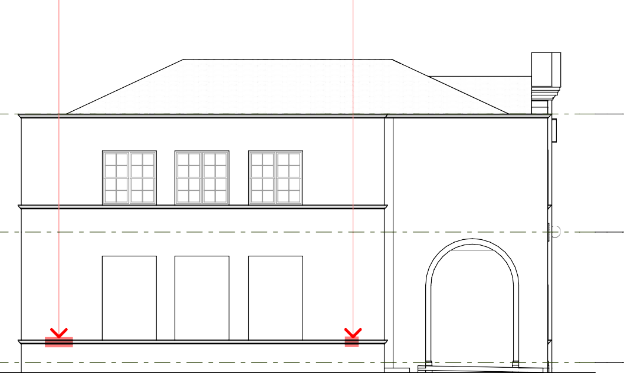  4.1 REPAIR BROKEN 4.2 REPAIR BROKEN * 5.1 REMOVE PVC DOWNPIPE AND INSTALL NEW CIRCULAR * 5.2 REMOVE EXISTING METAL DOWNPIPE AND INSTALL  RENDER TRIM RENDER TRIM METAL DOWNPIPE AND BRACKETS (REFER GENERAL NEW CIRCULAR METAL DOWNPIPE AND BRACKETS    NOTE 4, SHEET A 01) (REFER GENERAL NOTE 4, SHEET A 01)  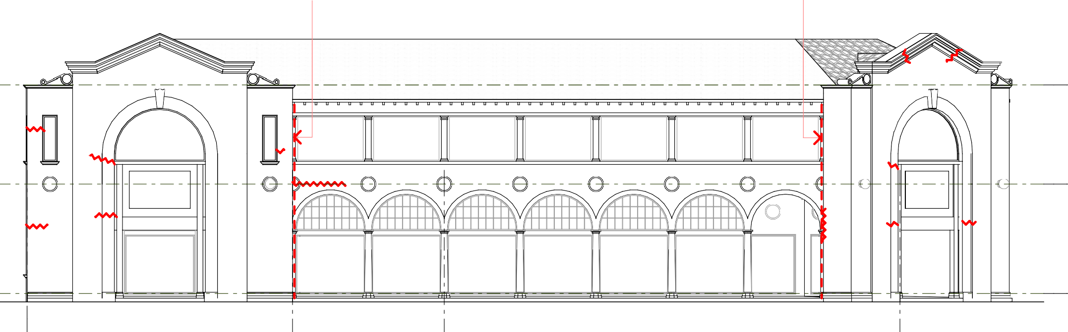  +8 395 +8 395  Top of Parapet Top of Parapet  +4 405 +4 405  First Floor First Floor  ±0 ±0  Ground Floor Ground Floor  LA POSSADA LA POSSADA BLUE OLIVE PJ O'REILLY'S CAFE CAFE DELI CAFE  4 Melbourne Building - Odgers Lane East Elevation - Part B 5 Melbourne Building - Alinga Street Elevation - Part B  1:100 1:100  KEY  CONSPICUOUS CRACKS IN RENDER (TO BE REPAIRED - REFER PAINTING NOTE 1, SHEET A 01)  AREA TO BE REPAIRED OR MADE GOOD AS NOTED  ITEM TO BE REPAIRED, MADE GOOD, NO NO  OR REMOVED AS NOTED WORK WORK  ±0  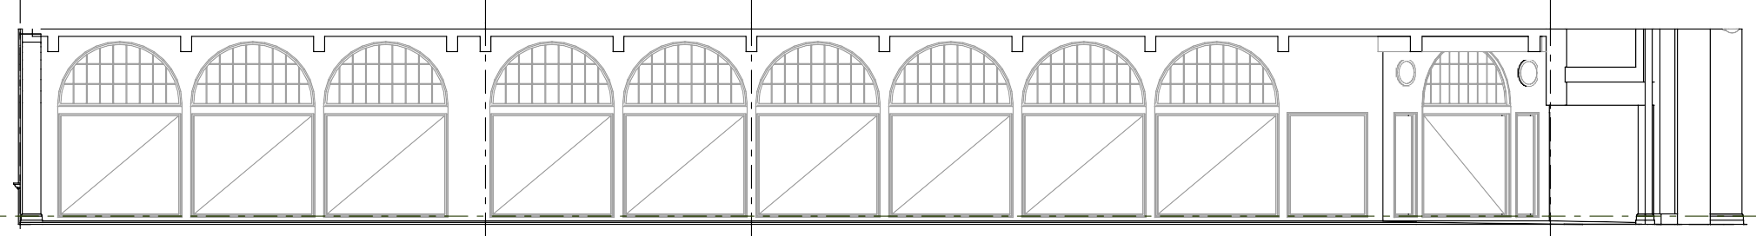  Ground Floor  LA POSSADA BLUE OLIVE PJ O'REILLY'S CAFE DELI CAFE    6 Melbourne Building - Alinga Street Shopfront Elevation - Part B  1:100 | General Notes
All measurements are in millimetres
Figured dimensions take precedence over scaled dimensions
Builder to verify all dimensions on site and seek instructions before proceeding if any discrepancies are found
 | Amendments This drawing published 17/11/2008 12:05 PM
 | Rev | Date | Description
 | A | 17.11.08 | ISSUED FOR STAKE HOLDER DISCUSSION
 | north
 | Client

t +61 2 6239 4333 | f +61 2 6239 4366
4 / 10 kennedy st | po box 4700
kingston act 2604

act arch reg no 935 | nsw arch reg no 6904 ABN 32 042 803 344
 | Project Sydney & Melbourne Buildings Facade Refurbishment
 | Address Section 1 & Section 48 CANBERRA CITY ACT 2601
Drawing Melbourne Building -
Elevations 4
 | Scale  AS SHOWN @ A1 |  |  | Drawn  BC | Checked
Date
10-10-08
 | Project No.  08-346 |  |  | Drawing No.  A 05 |  | Issue  A
NO WORK TO
SHOPFRONT
NO WORK TO
SHOPFRONT
NO WORK TO
SHOPFRONT
NO WORK TO
SHOPFRONT
NO WORK TO
SHOPFRONT
NO WORK TO
SHOPFRONT
NO WORK TO
SHOPFRONT
NO WORK TO
SHOPFRONT
NO WORK TO
SHOPFRONT
NO WORK TO
SHOPFRONT
NO WORK TO
SHOPFRONT
NO WORK TO
SHOPFRONT
NO WORK TO
SHOPFRONT
NO WORK TO
SHOPFRONT
NO WORK TO
SHOPFRONT
NO WORK TO
SHOPFRONT
NO WORK TO
SHOPFRONT
NO WORK TO
SHOPFRONT

  - REMOVE EXISTING PAVING AND TREE ROOTS, LAY NEW TERRACOTTA FLOOR
TILES TO MATCH EXISTING ON NEW CONCRETE SLAB TO FUTURE DETAIL

  - REMOVE TREE ROOTS AND REPAIR DAMAGED PAVING
AND FLOOR TILES

ALINGA STREET

  - REMOVE TREE ROOTS AND REPAIR DAMAGED PAVING
AND FLOOR TILES

STATEMENT OF INTENT
THE WORKS DESCRIBED IN THESE DRAWINGS AND ASSOCIATED SCHEDULES ARE RECOMMENDED AS THE MINIMUM REQUIRED TO RESTORE THE STREET FACADES AND COVERED ARCADES OF THE SYDNEY AND MELBOURNE BUILDINGS TO A SOUND PHYSICAL CONDITION AND A GENERAL APPEARANCE CONSISTENT WITH THEIR HERITAGE VALUES
General Notes
All measurements are in millimetres
Figured dimensions take precedence over scaled dimensions
Builder to verify all dimensions on site and seek instructions before proceeding if any discrepancies are found

1.27 REMOVE ILLUMINATED OVERHEAD SIGNS
PAINTING NOTES - SYDNEY AND MELBOURNE BUILDINGS
WORKS MARKED * ARE ESSENTIAL ITEMS FOR COMPLETION BEFORE COMMENCEMENT OF PAINTING
- FILL ALL MINOR CRACKS IN WALLS TO BE PAINTED AFTER CHECKING THE INTEGRITY OF SURROUNDING RENDER AND MAKING GOOD AS NECESSARY TO PROVIDE A SOUND SURFACE
STAIR LOBBY
*

1.26 REPAIR BULLNOSE PAVERS AND TILES

1.25 REPAIR FLOOR TILES

1.24 REPAIR BULLNOSE PAVERS AND TILES

1.23 REPAIR DAMAGED FC SOFFIT
*

1.22 REMOVE OR
CONCEAL GAS PIPES
AND CONDUITS (REFER ELEVATION)

1.21 REPAIR BULLNOSE PAVERS AND TILES

QUICK & GO GILBERTS
BOOKS

ZYGY'S BARBER

STAIR LOBBY

MECHE BAR

ICBM BAR

COFFEE CLUB

CASH STOP

SUNRISE FOOD BAR

VACANT

TASUKI RESTAURANT

TEK'S CRIB

ZAMBRERO RESTAURANT
PANCAKE PARLOUR

VACANT

SULTAN'S

FLIP SIDE EXCHANGE

IORI RESTAURANT

  - REPAIR FLOOR TILES

  - REMOVE RUSTED HORIZONTAL DOWNPIPE AND DRIP TRAY AND
*
MAKE GOOD RENDER TO SIDE OF BEAM AND COLUMN BELOW

  - REPAIR FLOOR TILES
- REMOVE ALL REDUNDANT FIXTURES INCLUDING WALL PLUGS, BOLTS, BRACKETS, SADDLES, CONDUITS, PIPEWORK, SIGN MOUNTS AND ELECTRICAL FIXTURES
* 3. FILL ALL HOLES AND CHIPS IN RENDER
- REMOVE ALL VEGETATION, DIRT, BIRD NESTS AND WASP NESTS FROM PARAPETS AND WALL TRIMS, CLEAN AND RESTORE SURFACES THOROUGHLY BEFORE PAINTING
*
- REMOVE ANY FLAKING PAINT, SALT GROWTH, AND UNSOUND RENDER AND MAKE GOOD ALL SURFACES TO PROVIDE A SOUND AND TRUE SURFACE FOR PAINTING
*

GENERAL NOTES - SYDNEY AND MELBOURNE BUILDINGS
WORKS MARKED * ARE ESSENTIAL ITEMS FOR COMPLETION BEFORE COMMENCEMENT OF PAINTING
* 1. REPAIR OR REPLACE ANY DISLODGED OR DAMAGED ROOF TILES
- CHECK ALL ROOF GUTTERS FOR CORRECT FALLS TO DOWNPIPES AND ADJUST AS NECESSARY TO RECTIFY, JOIN AND SUPPORT ANY LOOSE OR DISCONNECTED GUTTERING TO FORM CONTINUOUS RUNS THE FULL LENGTH OF EACH ROOF EDGE, FALLING TO BOTH ENDS.
*
- ANY NON-CONFORMING OR MISMATCHED SECTIONS OF GUTTER SHALL BE REPLACED WITH NEW HERITAGE PROFILE COLORBOND GUTTER TO ARCHITECT'S SELECTION, TO FORM CONTINUOUS RUNS THE FULL LENGTH OF EACH ROOF EDGE
*
- ALL PVC DOWNPIPES AND ALL RECTANGULAR METAL DOWNPIPES SHALL BE REPLACED WITH CIRCULAR COLORBOND DOWNPIPES TO
*

Amendments This drawing published 17/11/2008 12:05 PM

1.17 REPAIR BULLNOSE PAVERS AND TILES

1.16 REPAIR COLUMN BASE

1.15 REPAIR BULLNOSE PAVERS AND TILES

NORTHBAR

AD LAB

MERCURY BAR

NOODLE HOUSE

BAR 32

THE BEAT BOX

1.20 REINSTATE MISSING LIGHT

1.19 REMOVE EXISTING ASPHALT AND REPLACE WITH NEW TERRACOTTA FLOOR TILES TO MATCH
EXISTING ON NEW CONCRETE SLAB TO FUTURE DETAIL

1.18 REPLACE DAMAGED SOFFITS WITH NEW TO MATCH EXISTING TO FUTURE DETAIL,
*
REMOVE CONDUITS AND FLOODLIGHTS

  - REPLACE DAMAGED SOFFITS WITH NEW TO MATCH EXISTING TO FUTURE DETAIL,
REMOVE CONDUITS AND FLOODLIGHTS
VERITY LANE
*
ROLOS PIZZA BAR

CROISSANT D'OR

SHOOTERS BAR

THE PHOENIX BAR

RANI'S RESTAURANT

PHO PHU QUOC RESTAURANT

STAIR

PASHA'S KEBABS

(UNIDENTIFIED)

  - REMOVE EXISTING ASPHALT AND REPLACE WITH NEW TERRACOTTA
FLOOR TILES TO MATCH EXISTING ON NEW CONCRETE SLAB TO FUTURE DETAIL

  - REPAIR FLOOR TILES

  - REMOVE EXISTING ASPHALT AND REPLACE WITH NEW TERRACOTTA
FLOOR TILES TO MATCH EXISTING ON NEW CONCRETE SLAB TO FUTURE DETAIL

  - REINSTATE MISSING LIGHT FITTING AND REMOVE EXPOSED CONDUITS
FROM SOFFIT
ARCHITECT'S SELECTION, LOWEST 2400 MM OF DOWNPIPES TO BE GALVANISED STEEL PIPE TO RESIST IMPACT DAMAGE (TO FUTURE DETAIL), PAINT FINISH. FIX DOWNPIPES WITH NEW PRE-FINISHED STEEL DOWNPIPE BRACKETS WITH EXTENDED LEG FIXED DIRECTLY TO MASONRY WALL WITH COATED ROOFING SCREWS INTO PLASTIC WALL PLUGS
- ALL EXISTING CONCEALED DOWNPIPES AND INTERMEDIATE ELBOW DOWNPIPES ARE TO BE DISCONNECTED AND REMOVED WHERE POSSIBLE. INSTALL NEW DOWNPIPES AS DESCRIBED ABOVE AT BOTH ENDS OF EACH LENGTH OF CONTINUOUS ROOF EDGE WHERE NOT ALREADY PRESENT
EAST ROW
*
- ALL DOWNPIPES SHALL BE CONNECTED TO UNDERGROUND STORMWATER SYSTEM
*
- RE-GROUT TERRACOTTA FLOOR TILES TO ENTIRE GROUND FLOOR ARCADE AREA OF SYDNEY BUILDING INCLUDING REPLACING ANY BROKEN OR MISSING TILES WITH MATCHING NEW TILES
- REPLACE ALL SMALLER DIAMETER AND MISSING LIGHT FITTINGS ON BOTH SYDNEY AND MELBOURNE BUILDINGS WITH LARGE SPHERICAL LIGHTS TO MATCH EXIST AS PRESENTLY INSTALLED ON WESTERN (QUEST APARTMENTS) PORTION OF MELBOURNE BUILDING (SUBJECT TO HERITAGE ADVICE)
- ANY PARAPET TOPS NOT ALREADY CAPPED WITH A WATERPROOF CAPPING ARE TO BE BE WATERPROOFED TO FUTURE DETAIL
*
- REMOVE ALL NON-CONFORMING SIGNS FROM ARCADES AND REPLACE WITH NEW OVERHEAD SIGNS OF CONSISTENT DESIGN TO FUTURE DETAIL. THE SQUARE SUSPENDED SIGNS AS PRESENTLY INSTALLED IN THE WESTERN PORTION OF THE MELBOURNE BUILDING MAY BE AN APPROPRIATE DESIGN (SUBJECT TO HERITAGE ADVICE)
- REMOVE ALL ILLUMINATED SIGNS FROM STREET FACADES AS SHOWN ON THE ELEVATIONS AND REPLACE WITH PAINTED OR LOW-RELIEF NON- ILLUMINATED SIGNS STRICTLY CONFINED TO THE EXISTING DESIGNATED SIGN PANELS LOCATED AT THE CENTRE OF EACH GABLE ARCH

- A COMPLETE REVIEW OF THE ROOF DRAINAGE SYSTEM (GUTTERS, DOWNPIPES, AND STORMWATER CONNECTIONS) FOLLOWED BY REMEDIAL WORK INVOLVING REPLACEMENT OF MUCH OF THE SYSTEM ON BOTH BUILDINGS, DONE AS A SINGLE INTEGRATED PROJECT, IS CONSIDERED ESSENTIAL TO COMPLETE BEFORE PAINTING WORKS BEGIN. THIS IS NECESSARY BECAUSE MUCH OF THE EXISTING DAMAGE TO RENDER AND PAINT HAS RESULTED FROM LEAKING OF GUTTERS AND DOWNPIPES, SOME OF WHICH ARE CONCEALED INSIDE MASONRY WALLS AND ARE NOT ACCESSIBLE FOR REPAIR
*
Rev
A

Client
Date
17.11.08
NORTHBOURNE AVENUE
Description
ISSUED FOR STAKE HOLDER DISCUSSION

north

DINA'S LIQUOR

FLETCHER JONES

MOOSEHEADS
STAIR LOBBY

ZEN YAI RESTAURANT

HUONG RESTAURANT

CAFE MACCHIATO
STAIR LOBBY

  - REPAIR BUBBLING AND WATER DAMAGED RENDER NEAR BASE OF
*
WALLS

KEY

CONSPICUOUS CRACKS IN RENDER (TO BE REPAIRED - REFER PAINTING NOTE 1, SHEET A 01)
t +61 2 6239 4333 | f +61 2 6239 4366
4 / 10 kennedy st | po box 4700
kingston act 2604
act arch reg no 935 | nsw arch reg no 6904 ABN 32 042 803 344

AREA TO BE REPAIRED OR MADE GOOD AS NOTED
Project
Sydney & Melbourne Buildings Facade Refurbishment

ITEM TO BE REPAIRED, MADE GOOD, OR REMOVED AS NOTED
Address Section 1 & Section 48 CANBERRA CITY ACT 2601
Drawing Sydney Building - Ground Floor Plan

1.14 MAKE GOOD WATER DAMAGED RENDER ON BEAM ABOVE
*

LONDON CIRCUIT

* 1.13 ENSURE EXISTING CONCEALED
Scale
AS SHOWN @ A1
Date
10-10-08
Drawn
BC
Checked

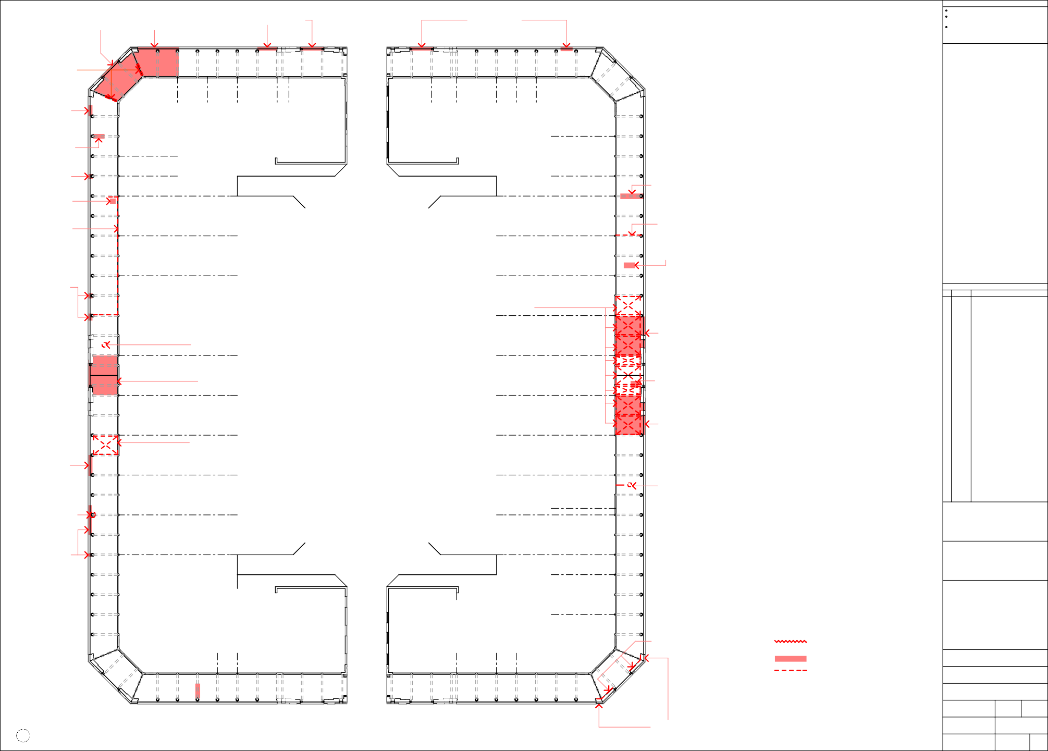
Sydney Building - Ground Floor Plan
1
1:200
DOWNPIPES ARE DISCONNECTED FROM STORMWATER SYSTEM AND CAPPED BELOW PAVING LEVEL

Project No.

08-346

Drawing No.

A 06

Issue
A

  - INSTALL NEW CIRCULAR METAL DOWNPIPE AND
*
BRACKETS (REFER GENERAL NOTE 4, SHEET A 06)

  - REPAIR SECTION OF TIMBER WALL FASCIA TO FINISH FLUSH WITH ADJOINING

  - REPLACE GUTTER WITH NEW HERITAGE PROFILE CONTINUOUS RUN (REFER GENERAL NOTE 3 ON SHEET A 06),
*
REMOVE EXISTING ELBOW DOWNPIPES, ADJUST FALL OF ENTIRE GUTTER TO SUIT NEW DOWNPIPES AT BOTH ENDS

  - REPAIR LOOSE AND DAMAGED TILES AT ROOF
EDGE (TYPICAL)
*

  - INSTALL NEW CIRCULAR METAL DOWNPIPE AND
BRACKETS (REFER GENERAL NOTE 4, SHEET A 06)
*

1.9 REMOVE
*
SIGN BOARD

  - MAKE GOOD FLAKING, CRACKING, WATER DAMAGED RENDER AND
RESTORE TO A SMOOTH, TRUE AND SOUND SURFACE SUITABLE FOR PAINTING (WATERPROOFING OF PARAPET TOP MAY BE REQUIRED)
*

  - INSTALL NEW CIRCULAR METAL DOWNPIPE AND
BRACKETS (REFER GENERAL NOTE 4, SHEET A 06)
*
General Notes
All measurements are in millimetres
Figured dimensions take precedence over scaled dimensions
Builder to verify all dimensions on site and seek instructions before proceeding if any discrepancies are found

+8 395
*
Top of Parapet

+4 405
First Floor

  - REMOVE
ILLUMINATED
SIGN

±0
Ground Floor

CAFE MACCHIATO

DINA'S LIQUOR

(UNIDENTIFIED)
PASHA'S | AIR | PHO PHU QUOC | RANI'S | THE PHOENIX | SHOOTERS | CROISSANT | ROLOS
KEBABS | ST | RESTAURANT | RESTAURANT | BAR | BAR | D'OR | PIZZA BAR

Sydney Building - East Row Elevation - Part A
1
1:100

  - REMOVE PAINT FROM GLASS, CLEAN UP AND REPAINT
MULLIONS AND FRAME

  - REMOVE ALUMINIUM FRAMED SHOPFRONT AND REPLACE WITH NEW SHOPFRONTS LOCATED ENTIRELY WITHIN THE MASONRY ARCHES AND SET BACK FROM FRONT SURFACE OF ARCHES ON THE SAME PLANE AS THE GLAZING PANELS ABOVE (NOTE THAT THE EXISTING
SHOPFRONT FRAMING PROTRUDES ONTO THE PUBLIC WALKWAY AND IS IN BREACH OF HERITAGE PROTECTION LEGISLATION)

  - REMOVE PAINT FROM GLASS, CLEAN UP AND REPAINT
MULLIONS AND FRAME

  - REMOVE PAINT FROM GLASS, CLEAN UP AND
REPAINT MULLIONS AND FRAME

  - REMOVE SIGN AND PERSPEX, MAKE
GOOD RENDER AND GLAZING PANEL

  - REMOVE SIGN AND PAINT FROM GLAZING
  - REMOVE COPPER INFILL AND RESTORE GLAZING PANEL TO MATCH ORIGINALS

Amendments This drawing published 17/11/2008 12:05 PM

NO WORK

NO WORK

NO WORK
NO WORK TO
SHOPFRONT
NO WORK TO
SHOPFRONT
NO WORK TO
SHOPFRONT
NO WORK TO
SHOPFRONT

NO WORK
NO WORK TO
SHOPFRONT
Rev
A
NO WORK TO
SHOPFRONT
NO WORK TO
SHOPFRONT
NO WORK TO
SHOPFRONT
NO WORK TO
SHOPFRONT
NO WORK TO
SHOPFRONT
NO WORK TO
SHOPFRONT
NO WORK TO
SHOPFRONT
NO WORK TO
SHOPFRONT
Date
17.11.08
Description
ISSUED FOR STAKE HOLDER DISCUSSION

±0
Ground Floor

CAFE MACCHIATO

DINA'S LIQUOR

(UNIDENTIFIED)

PASHA'S KEBABS

PHO PHU QUOC RESTAURANT
STAIR

RANI'S RESTAURANT

THE PHOENIX BAR

SHOOTERS BAR

CROISSANT D'OR

ROLOS PIZZA BAR

Sydney Building - East Row Shopfront Elevation - Part A
2
1:100

  - REMOVE SHOPFRONT AND REPLACE WITH NEW SHOPFRONT LOCATED ENTIRELY WITHIN THE ORIGINAL MASONRY ARCHES AND SET BACK FROM FRONT SURFACE OF ARCHES ON THE SAME PLANE AS THE GLAZING PANELS ABOVE (NOTE THAT THE EXISTING SHOPFRONT IS IN BREACH
OF HERITAGE PROTECTION LEGISLATION). RESTORE RENDERED MASONRY ARCHES WITH SALIENT BEADING TO MATCH ORIGINAL DETAIL

  - REMOVE WINDOW MOUNTED AIR CONDITIONERS AND REINSTATE WINDOWS

  - REPLACE GUTTER WITH NEW HERITAGE PROFILE CONTINUOUS RUN (REFER GENERAL NOTE 3 ON SHEET A 06),
*
REMOVE EXISTING ELBOW DOWNPIPES, ADJUST FALL OF ENTIRE GUTTER TO SUIT NEW DOWNPIPES AT BOTH ENDS

  - INSTALL NEW CIRCULAR METAL DOWNPIPE AND
BRACKETS (REFER GENERAL NOTE 4, SHEET A 06)
*

+8 395
Top of Parapet

+4 405
First Floor

KEY

north

CONSPICUOUS CRACKS IN RENDER (TO BE REPAIRED - REFER PAINTING NOTE 1, SHEET A 01)

IORI RESTAURANT

FLIP SIDE EXCHANGE

SULTAN'S

VACANT

ZAMBRERO RESTAURANT

±0
Ground Floor
AREA TO BE REPAIRED OR MADE GOOD AS NOTED

ITEM TO BE REPAIRED, MADE GOOD, OR REMOVED AS NOTED

Client

Sydney Building - East Row Elevation - Part B
3
1:100

  - REMOVE PAINT FROM GLASS, CLEAN UP AND REPAINT
MULLIONS AND FRAME

  - REMOVE SIGN, MAKE GOOD RENDER AND
GLAZING PANEL

  - REMOVE PAINT FROM GLASS, CLEAN UP AND REPAINT
MULLIONS AND FRAME

t +61 2 6239 4333 | f +61 2 6239 4366
4 / 10 kennedy st | po box 4700
kingston act 2604
act arch reg no 935 | nsw arch reg no 6904 ABN 32 042 803 344

Project
Sydney & Melbourne Buildings Facade Refurbishment

NO WORK
NO WORK TO
SHOPFRONT
NO WORK TO
SHOPFRONT
NO WORK TO
SHOPFRONT
NO WORK TO
SHOPFRONT

NO WORK

±0
Ground Floor
Address Section 1 & Section 48 CANBERRA CITY ACT 2601
Drawing Sydney Building - Elevations 1

IORI RESTAURANT
FLIP SIDE EXCHANGE
SULTAN'S
VACANT
ZAMBRERO RESTAURANT
Scale
AS SHOWN @ A1
Drawn
BC
Checked

  - REMOVE SHOPFRONT AND REPLACE WITH NEW SHOPFRONT LOCATED ENTIRELY WITHIN THE ORIGINAL MASONRY ARCHES AND SET BACK FROM FRONT SURFACE OF ARCHES ON THE SAME PLANE AS THE GLAZING PANELS ABOVE (NOTE THAT THE EXISTING SHOPFRONT IS IN BREACH
OF HERITAGE PROTECTION LEGISLATION). RESTORE RENDERED MASONRY ARCHES WITH SALIENT BEADING TO MATCH ORIGINAL DETAIL

  - REMOVE STONE CLADDING. RESTORE RENDERED MASONRY ARCHES WITH SALIENT BEADING TO MATCH
ORIGINAL DETAIL

Date

10-10-08

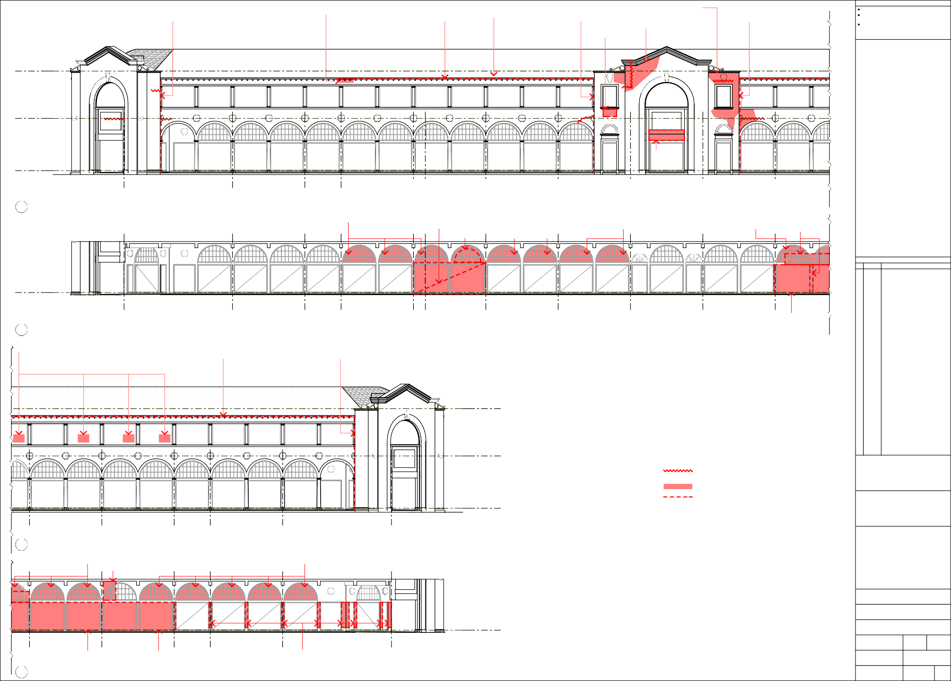
Sydney Building - East Row Shopfront Elevation - Part B
4
1:100

Project No.

08-346
Drawing No.

A 07
Issue
A

1.1 REMOVE FLOODLIGHT AND * 1.2 REMOVE EXISTING RECTANGULAR DOWNPIPE AND  CONDUITS AND MAKE GOOD INSTALL NEW CIRCULAR METAL DOWNPIPE AND  RENDER SURFACE BRACKETS (REFER GENERAL NOTE 4, SHEET A 06)  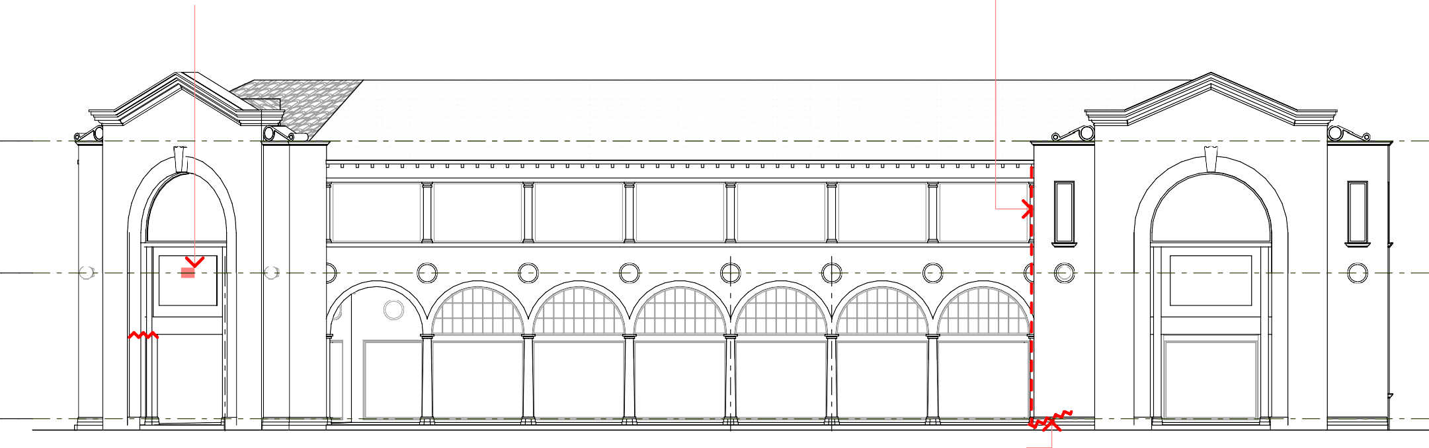  +8 395 +8 395  Top of Parapet Top of Parapet  +4 405 +4 405  First Floor First Floor  ±0 ±0  Ground Floor Ground Floor  FLETCHER STAIR * 1.3 REPAIR RENDER AT MOOSEHEADS MOOSEHEADS JONES LOBBY BASE OF WALL  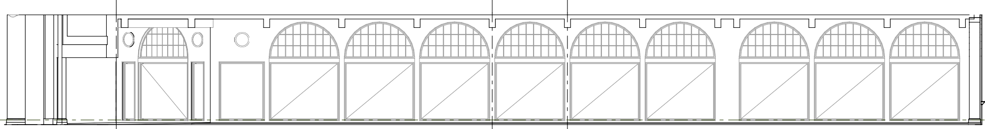  1 Sydney Building - London Circuit Elevation - Part A 2 Sydney Building - Verity Lane East Elevation - Part A  1:100 1:100  NO NO  WORK WORK  ±0  Ground Floor  FLETCHER STAIR MOOSEHEADS  JONES LOBBY    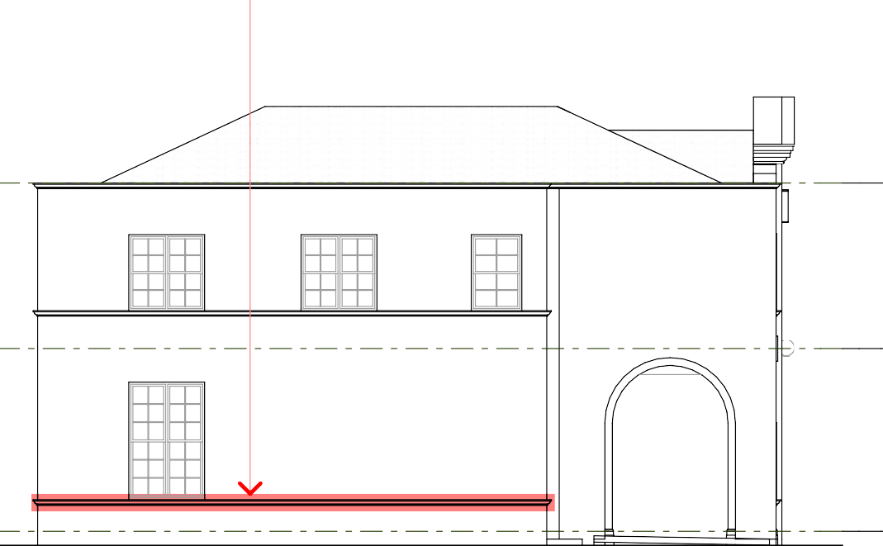    3 Sydney Building - London Circuit Shopfront Elevation - Part A  1:100  4.1 REPAIR DAMAGED * 5.1 REPAIR RENDER AT END OF * 5.2 REMOVE EXISTING RECTANGULAR DOWNPIPE AND * 5.3 REPAIR GUTTER AND LOOSE ROOF TILES (REFER * 5.4 REMOVE EXISTING ELBOW AND CONCEALED DOWNPIPE AND RENDER TRIM GUTTER INSTALL NEW CIRCULAR METAL DOWNPIPE AND GENERAL NOTES, SHEET A 06) INSTALL NEW CIRCULAR METAL DOWNPIPE AND BRACKETS  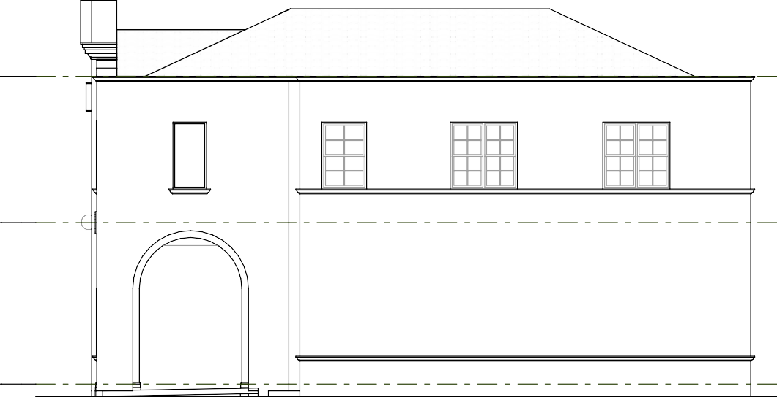    BRACKETS (REFER GENERAL NOTE 4, SHEET A 06) (REFER GENERAL NOTE 4, SHEET A 06)  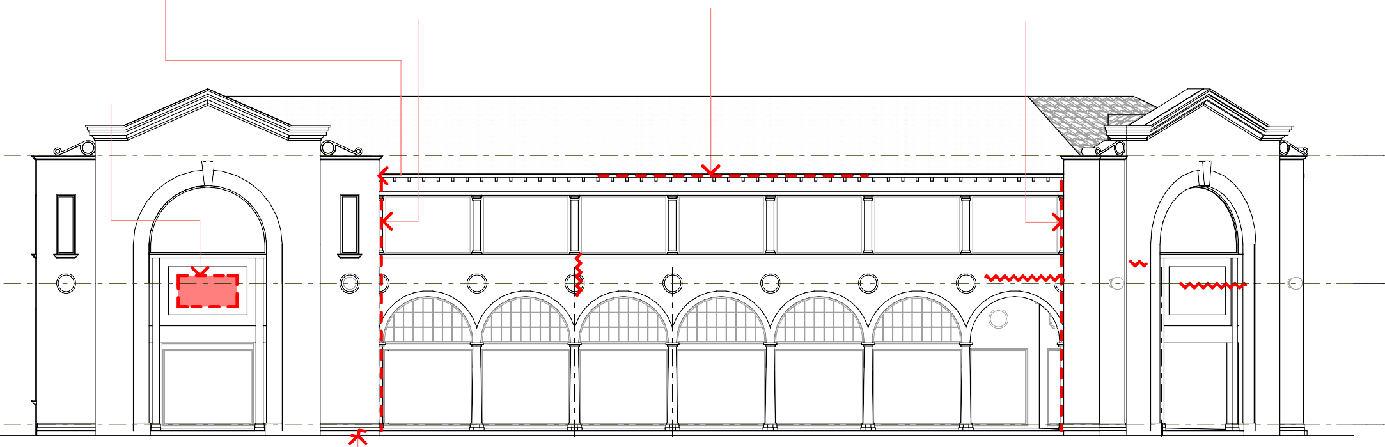  5.6 REMOVE ILLUMINATED SIGN AND MAKE GOOD  RENDER SURFACE  +8 395 +8 395  Top of Parapet Top of Parapet  +4 405 +4 405  First Floor First Floor    ±0 ±0  Ground Floor Ground Floor  ZEN YAI RESTAURANT ZEN YAI * 5.5 REPAIR RENDER AT HUONG STAIR CAFE RESTAURANT BASE OF WALL RESTAURANT LOBBY MACCHIATO    4 Sydney Building - Verity Lane West Elevation - Part B 5 Sydney Building - London Circuit Elevation - Part B  1:100 1:100  KEY  CONSPICUOUS CRACKS IN RENDER (TO BE REPAIRED - REFER PAINTING NOTE 1, SHEET A 01)  AREA TO BE REPAIRED OR MADE GOOD AS NOTED  ITEM TO BE REPAIRED, MADE GOOD, NO NO  OR REMOVED AS NOTED WORK WORK  ±0  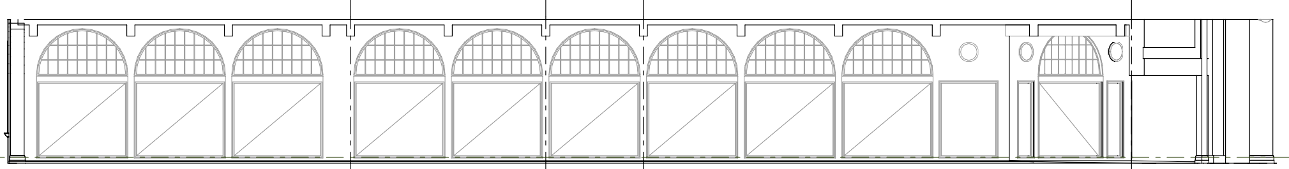  Ground Floor  ZEN YAI HUONG STAIR CAFE RESTAURANT RESTAURANT LOBBY MACCHIATO    6 Sydney Building - London Circuit Shopfront Elevation - Part B  1:100 | General Notes
All measurements are in millimetres
Figured dimensions take precedence over scaled dimensions
Builder to verify all dimensions on site and seek instructions before proceeding if any discrepancies are found
 | Amendments This drawing published 17/11/2008 12:05 PM
 | Rev | Date | Description
 | A | 17.11.08 | ISSUED FOR STAKE HOLDER DISCUSSION
 | north
 | Client

t +61 2 6239 4333 | f +61 2 6239 4366
4 / 10 kennedy st | po box 4700
kingston act 2604

act arch reg no 935 | nsw arch reg no 6904 ABN 32 042 803 344
 | Project Sydney & Melbourne Buildings Facade Refurbishment
 | Address Section 1 & Section 48 CANBERRA CITY ACT 2601
Drawing Sydney Building -
Elevations 2
 | Scale  AS SHOWN @ A1 |  |  | Drawn  BC | Checked
Date
10-10-08
 | Project No.  08-346 |  |  | Drawing No.  A 08 |  | Issue  A
NO WORK TO
SHOPFRONT
NO WORK TO
SHOPFRONT
NO WORK TO
SHOPFRONT
NO WORK TO
SHOPFRONT
NO WORK TO
SHOPFRONT
NO WORK TO
SHOPFRONT
NO WORK TO
SHOPFRONT
NO WORK TO
SHOPFRONT
NO WORK TO
SHOPFRONT
NO WORK TO
SHOPFRONT
NO WORK TO
SHOPFRONT
NO WORK TO
SHOPFRONT
NO WORK TO
SHOPFRONT
NO WORK TO
SHOPFRONT
NO WORK TO
SHOPFRONT
NO WORK TO
SHOPFRONT
NO WORK TO
SHOPFRONT
NO WORK TO
SHOPFRONT

1.1 REINSTATE MISSING 1.2 REMOVE ILLUMINATED * 1.3 INSTALL NEW CIRCULAR * 1.4 RESTORE EXISTING GUTTER (REFER GENERAL NOTE 3 * 1.5 INSTALL NEW CIRCULAR 1.6 REMOVE ILLUMINATED * 1.7 INSTALL NEW CIRCULAR  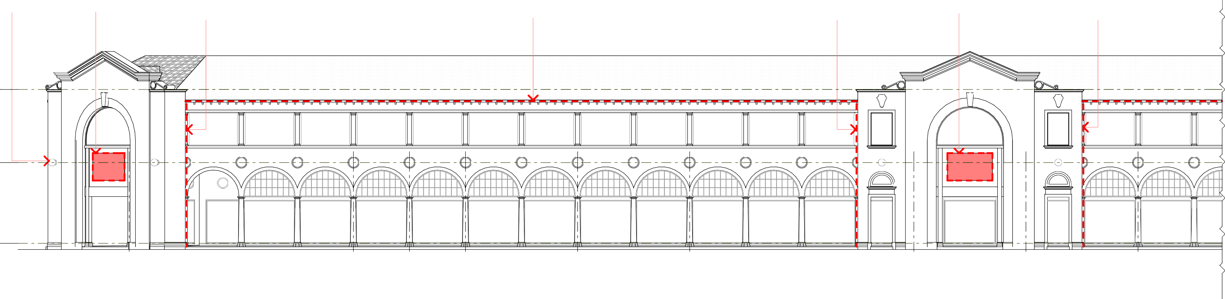  LIGHTS (REFER SIGN AND MAKE GOOD METAL DOWNPIPE AND ON SHEET A 06), REMOVE EXISTING ELBOW METAL DOWNPIPE AND SIGN AND MAKE GOOD METAL DOWNPIPE AND  GENERAL NOTE 8, RENDER SURFACE BRACKETS (REFER GENERAL DOWNPIPES, ADJUST FALL OF ENTIRE GUTTER TO BRACKETS (REFER GENERAL RENDER SURFACE BRACKETS (REFER GENERAL  SHEET A 06) NOTE 4, SHEET A 06) SUIT NEW DOWNPIPES AT BOTH ENDS NOTE 4, SHEET A 06) NOTE 4, SHEET A 06)  +8 395  Top of Parapet  +4 405  First Floor  ±0  Ground Floor  QUICK & GO ZYGY'S STAIR MECHE BAR ICBM BAR NORTHBAR AD LAB MERCURY NOODLE BARBER LOBBY BAR HOUSE  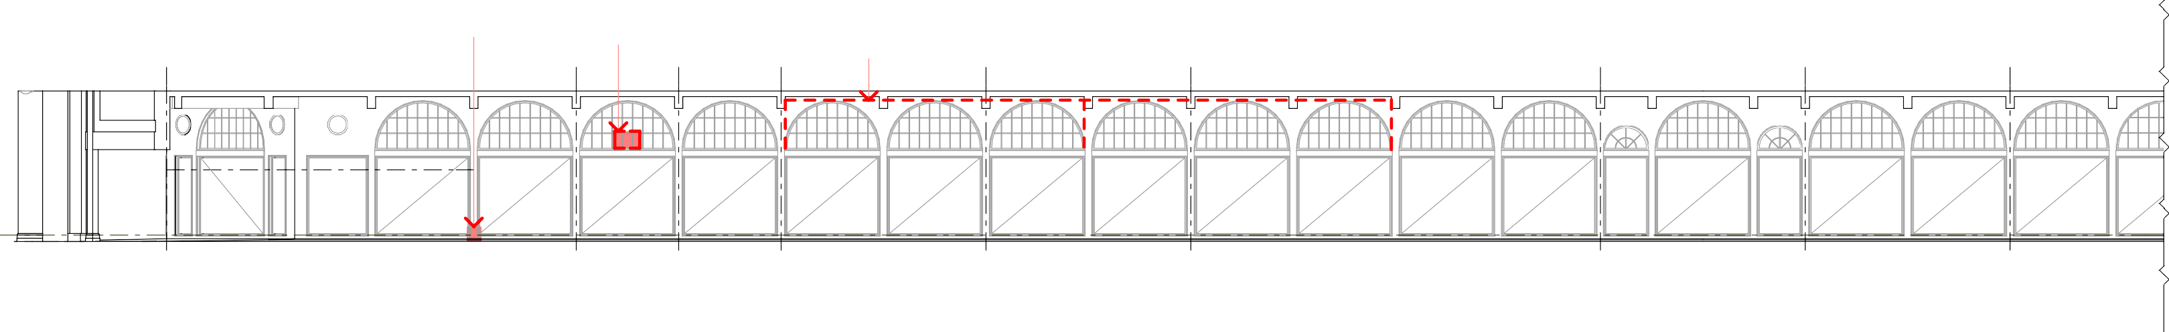  1 Sydney Building - Northbourne Avenue Elevation - Part A  1:100  * 2.1 REPAIR 2.2 REMOVE WINDOW MOUNTED AIR 2.3 REMOVE SURFACE-MOUNTED GAS PIPES AND CONDUITS TO RENDER CONDITIONER AND REINSTATE GAS HEATERS AND REPLACE WITH NEW CONCEALED PIPES  GLAZING INCLUDING MULLIONS AND CONDUITS. CONCEAL ABOVE SOFFIT OR INSIDE BUILDING OR BY CHASING INTO WALL. MAKE GOOD RENDER SURFACE  NO NO NO NO  WORK WORK WORK WORK  ±0  Ground Floor  QUICK & GO ZYGY'S STAIR MECHE BAR ICBM BAR NORTHBAR AD LAB MERCURY NOODLE BARBER LOBBY BAR HOUSE    2 Sydney Building - Northbourne Avenue Shopfront Elevation - Part A  1:100  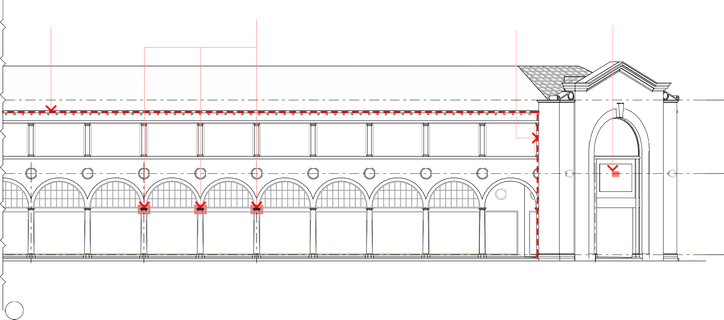  * 3.1 REPLACE GUTTER WITH NEW HERITAGE PROFILE 3.2 REPAIR MASONRY * 3.3 INSTALL NEW CIRCULAR 3.4 REMOVE FLOODLIGHT AND  CONTINUOUS RUN (REFER GENERAL NOTE 3 ON SHEET A 06), COLUMN CAPITALS METAL DOWNPIPE AND CONDUITS AND MAKE GOOD  REMOVE EXISTING ELBOW DOWNPIPES, ADJUST FALL OF BRACKETS (REFER GENERAL RENDER SURFACE  ENTIRE GUTTER TO SUIT NEW DOWNPIPES AT BOTH ENDS NOTE 4, SHEET A 06)  +8 395  Top of Parapet  +4 405  First Floor  KEY  CONSPICUOUS CRACKS IN RENDER (TO BE REPAIRED - REFER PAINTING NOTE 1, SHEET A 01)  AREA TO BE REPAIRED OR MADE GOOD AS NOTED  ITEM TO BE REPAIRED, MADE GOOD, OR REMOVED AS NOTED  ±0  Ground Floor  BAR 32 THE BEAT BOX FLETCHER JONES  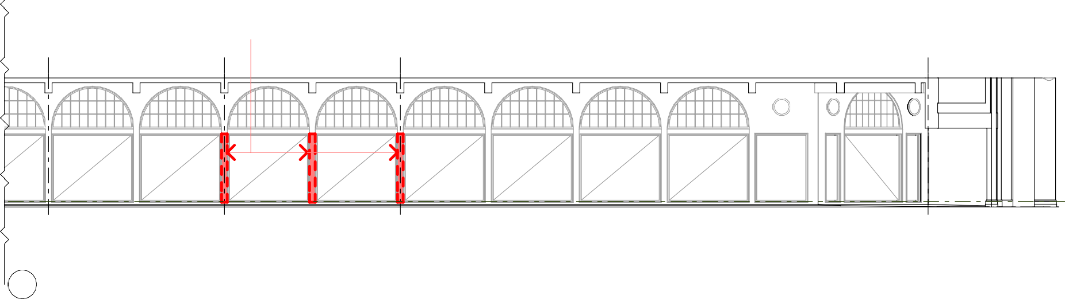  3 Sydney Building - Northbourne Avenue Elevation - Part B  1:100  4.1 REMOVE STONE CLADDING. RESTORE RENDERED MASONRY ARCHES WITH SALIENT BEADING TO MATCH  ORIGINAL DETAIL  NO NO  WORK WORK  ±0  Ground Floor  BAR 32 THE BEAT BOX FLETCHER JONES  4 Sydney Building - Northbourne Avenue Shopfront Elevation - Part B  1:100 | General Notes
All measurements are in millimetres
Figured dimensions take precedence over scaled dimensions
Builder to verify all dimensions on site and seek instructions before proceeding if any discrepancies are found
 | Amendments This drawing published 17/11/2008 12:05 PM
 | Rev | Date | Description
 | A | 17.11.08 | ISSUED FOR STAKE HOLDER DISCUSSION
 | north
 | Client

t +61 2 6239 4333 | f +61 2 6239 4366
4 / 10 kennedy st | po box 4700
kingston act 2604

act arch reg no 935 | nsw arch reg no 6904 ABN 32 042 803 344
 | Project Sydney & Melbourne Buildings Facade Refurbishment
 | Address Section 1 & Section 48 CANBERRA CITY ACT 2601
Drawing Sydney Building -
Elevations 3
 | Scale  AS SHOWN @ A1 |  |  | Drawn  BC | Checked
Date
10-10-08
 | Project No.  08-346 |  |  | Drawing No.  A 09 |  | Issue  A
NO WORK TO
SHOPFRONT
NO WORK TO
SHOPFRONT
NO WORK TO
SHOPFRONT
NO WORK TO
SHOPFRONT
NO WORK TO
SHOPFRONT
NO WORK TO
SHOPFRONT
NO WORK TO
SHOPFRONT
RK TO
FRONT
NO WORK TO
SHOPFRONT
NO WORK TO
SHOPFRONT
NO WORK TO
SHOPFRONT
NO WORK TO
SHOPFRONT
NO WORK TO
SHOPFRONT
NO WORK TO
SHOPFRONT
NO WORK TO
SHOPFRONT
NO WORK TO
SHOPFRONT
NO WORK TO
SHOPFRONT
NO WORK TO
SHOPFRONT
NO WORK TO
SHOPFRONT
NO WORK TO
SHOPFRONT
NO WORK TO
SHOPFRONT
NO WORK TO
SHOPFRONT
NO WORK TO
SHOPFRONT
NO WORK TO
SHOPFRONT
NO WORK TO
SHOPFRONT
NO WO
SHOP

* 1.1 INSTALL NEW CIRCULAR * 1.2 REMOVE ELBOW DOWNPIPES AND REPLACE GUTTER WITH NEW * 2.1 REMOVE METAL COVER PLATE, REPLACE DOWNPIPE WITH NEW COLORBOND METAL DOWNPIPE AND HERITAGE PROFILE CONTINUOUS RUN (REFER GENERAL NOTE 3 INCLUDING AN INSPECTION PORT AT BASE, INSPECT AND CLEAN OUT  BRACKETS (REFER GENERAL ON SHEET A 06), REMOVE EXISTING ELBOW DOWNPIPES, ADJUST STORMWATER CONNECTION AT BASE, INSTALL NEW 15 MM COMPRESSED FC  NOTE 4, SHEET A 06) FALL OF ENTIRE GUTTER TO SUIT NEW DOWNPIPES AT BOTH ENDS COVER PLATE FIXED WITH SS SCREWS AND PAINT TO MATCH WALL  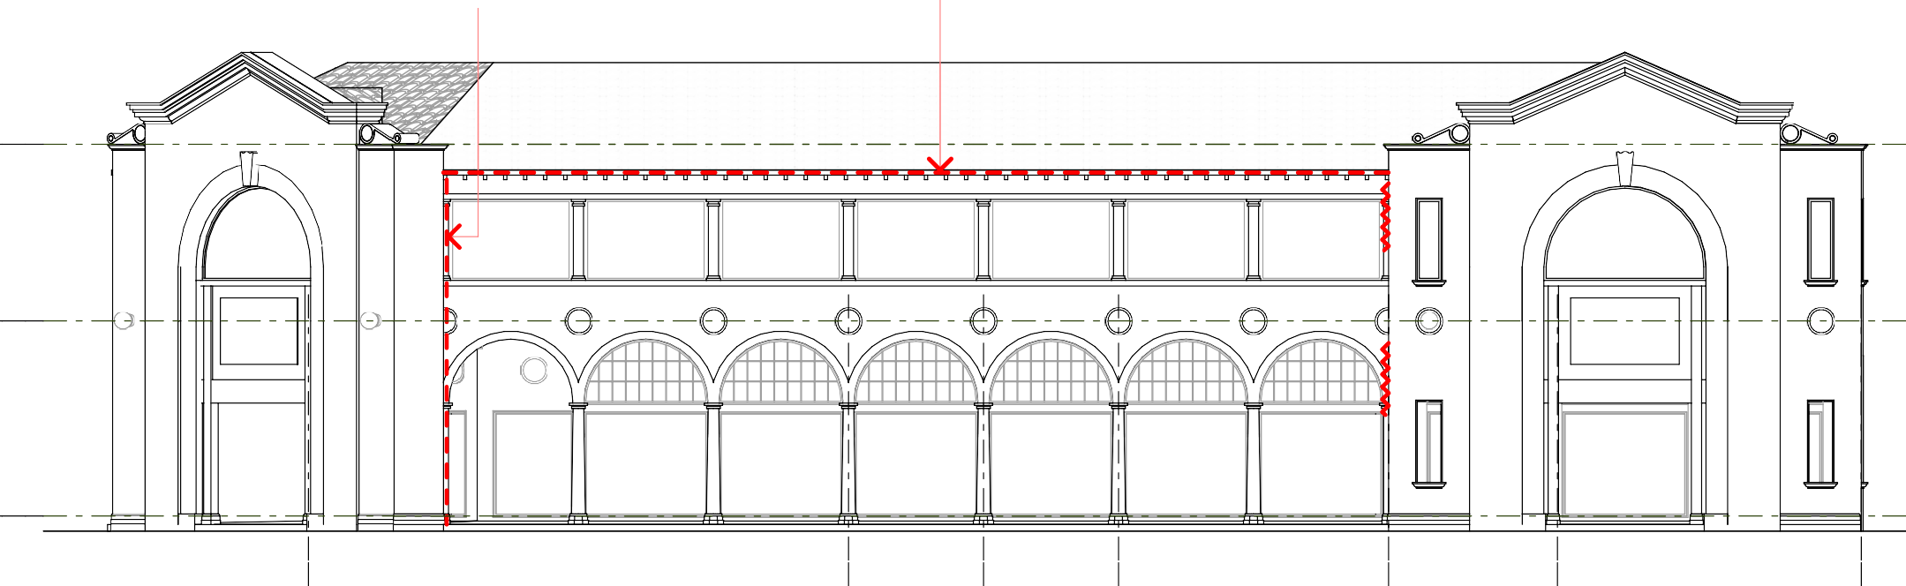  +8 395 +8 395  Top of Parapet Top of Parapet  +4 405 +4 405  First Floor First Floor  ±0 ±0  Ground Floor Ground Floor  ZAMBRERO PANCAKE TEK'S TASUKI STAIR VACANT VACANT RESTAURANT PARLOUR CRIB RESTAURANT LOBBY  1 Sydney Building - Alinga Street Elevation - Part A 2 Sydney Building - Verity Lane West Elevation - Part A  1:100 1:100  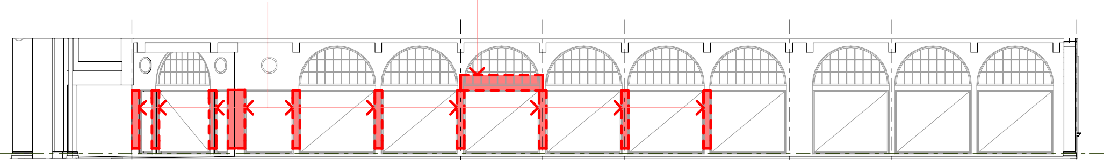  3.1 REMOVE STONE CLADDING. RESTORE RENDERED 3.2 REMOVE SIGN AND REINSTATE GLAZED MASONRY ARCHES WITH SALIENT BEADING TO MATCH PANELS INCLUDING MULLIONS  ORIGINAL DETAIL  NO NO  WORK WORK  ±0  Ground Floor  ZAMBRERO PANCAKE TEK'S TASUKI STAIR VACANT RESTAURANT PARLOUR CRIB RESTAURANT LOBBY    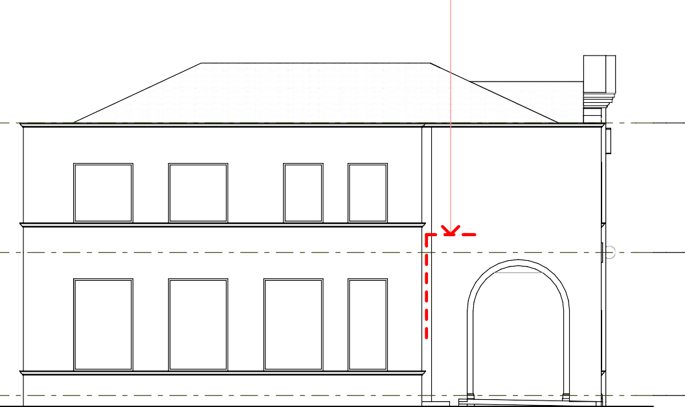  3 Sydney Building - Alinga Street Shopfront Elevation - Part A  1:100  4.1 CONCEAL EXISTING SURFACE-MOUNTED PIPE BY RELOCATING INSIDE 5.1 REPAIR RENDER * 5.2 STRAIGHTEN AND SUPPORT EXISTING GUTTER 5.3 REPAIR MASONRY * 5.4 CONNECT DOWNPIPE TO STORMWATER 5.5 REMOVE ILLUMINATED  BUILDING OR BY CHASING INTO WALL, MAKE GOOD RENDER SURFACE TRIM USING NEW BRACKETS TO MATCH EXISTING COLUMN CAPITALS (REFER GENERAL NOTES, SHEET A 06) SIGN AND MAKE GOOD  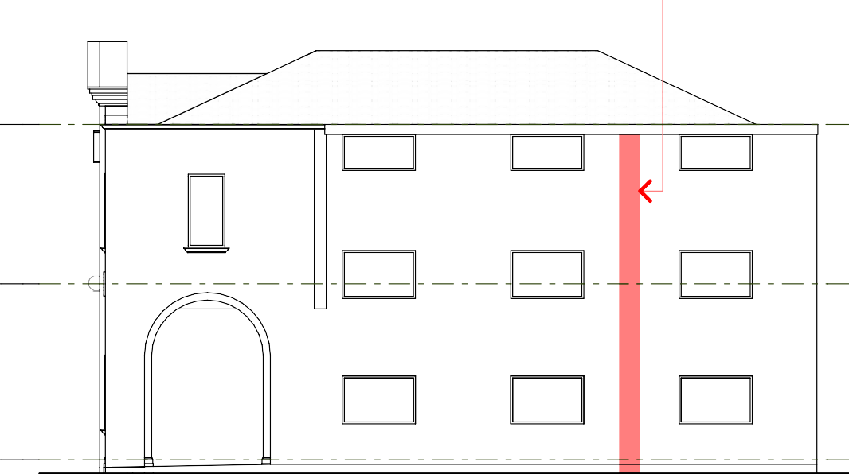  RENDER SURFACE  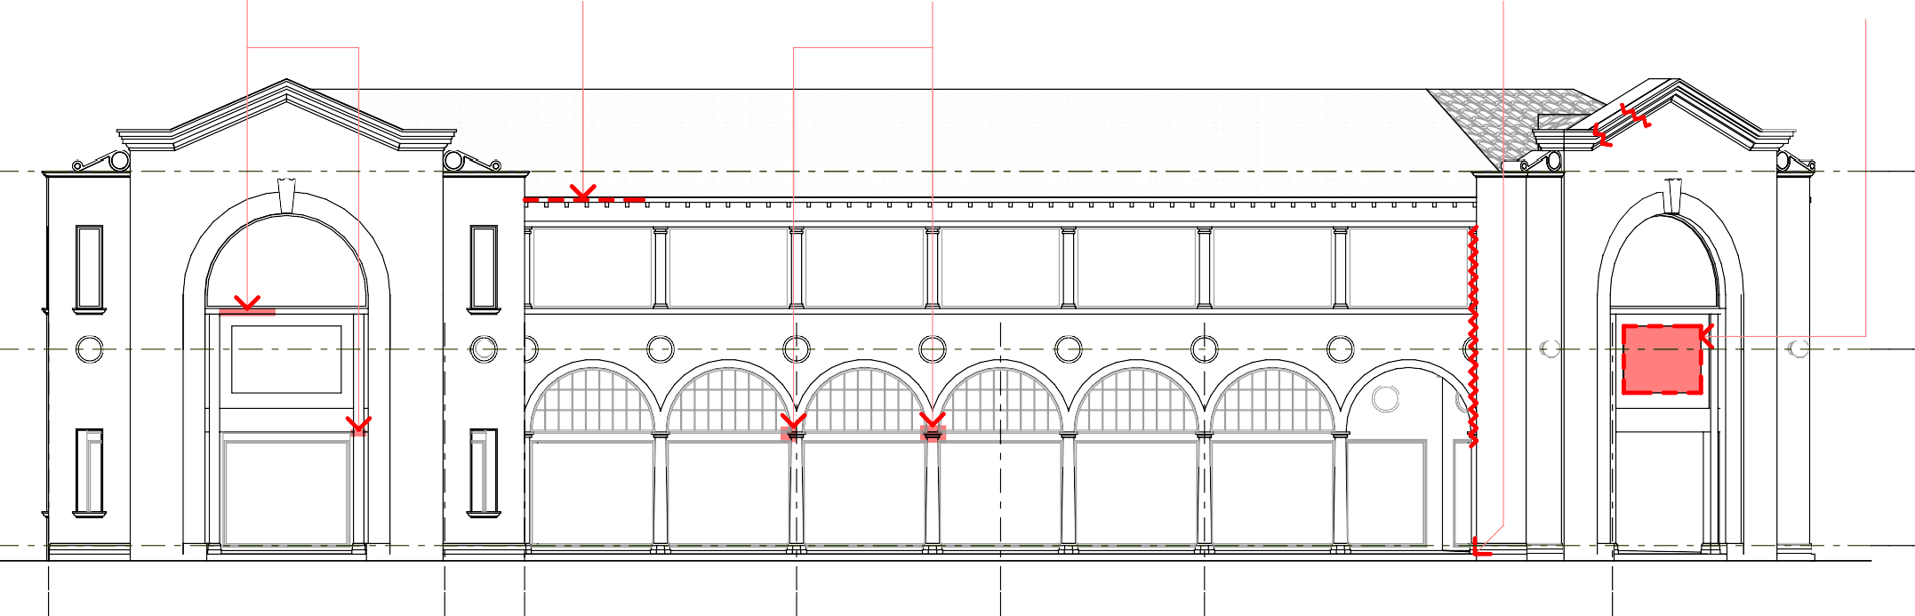  +8 395 +8 395  Top of Parapet Top of Parapet  +4 405 +4 405  First Floor First Floor  ±0 ±0  Ground Floor Ground Floor  SUNRISE FOOD BAR SUNRISE CASH COFFEE GILBERTS QUICK & GO FOOD BAR STOP CLUB BOOKS  4 Sydney Building - Verity Lane East Elevation - Part B 5 Sydney Building - Alinga Street Elevation - Part B  1:100 1:100  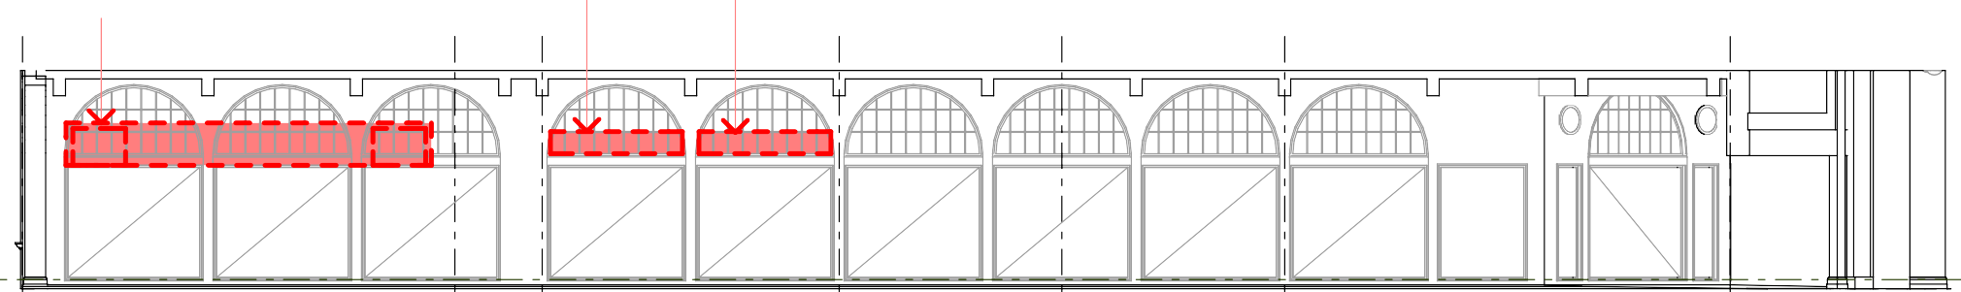  6.1 REMOVE SIGN AND WINDOW-MOUNTED AIR 6.2 REMOVE SIGNS, REINSTATE GLAZED CONDITIONERS, REINSTATE GLAZED PANELS INCLUDING MULLIONS  PANELS INCLUDING MULLIONS  KEY  CONSPICUOUS CRACKS IN RENDER (TO BE REPAIRED - REFER PAINTING NOTE 1, SHEET A 01)  AREA TO BE REPAIRED OR MADE GOOD AS NOTED  ITEM TO BE REPAIRED, MADE GOOD, NO NO  OR REMOVED AS NOTED WORK WORK  ±0  Ground Floor  SUNRISE CASH COFFEE GILBERTS QUICK & GO  FOOD BAR STOP CLUB BOOKS    6 Sydney Building - Alinga Street Shopfront Elevation - Part B  1:100 | General Notes
All measurements are in millimetres
Figured dimensions take precedence over scaled dimensions
Builder to verify all dimensions on site and seek instructions before proceeding if any discrepancies are found
 | Amendments This drawing published 17/11/2008 12:05 PM
 | Rev | Date | Description
 | A | 17.11.08 | ISSUED FOR STAKE HOLDER DISCUSSION
 | north
 | Client

t +61 2 6239 4333 | f +61 2 6239 4366
4 / 10 kennedy st | po box 4700
kingston act 2604

act arch reg no 935 | nsw arch reg no 6904 ABN 32 042 803 344
 | Project Sydney & Melbourne Buildings Facade Refurbishment
 | Address Section 1 & Section 48 CANBERRA CITY ACT 2601
Drawing Sydney Building -
Elevations 4
 | Scale  AS SHOWN @ A1 |  |  | Drawn  BC | Checked
Date
10-10-08
 | Project No.  08-346 |  |  | Drawing No.  A 10 |  | Issue  A
NO WORK TO
SHOPFRONT
NO WORK TO
SHOPFRONT
NO WORK TO
SHOPFRONT
NO WORK TO
SHOPFRONT
NO WORK TO
SHOPFRONT
NO WORK TO
SHOPFRONT
NO WORK TO
SHOPFRONT
NO WORK TO
SHOPFRONT
NO WORK TO
SHOPFRONT
NO WORK TO
SHOPFRONT
NO WORK TO
SHOPFRONT
NO WORK TO
SHOPFRONT
NO WORK TO
SHOPFRONT
NO WORK TO
SHOPFRONT
NO WORK TO
SHOPFRONT
NO WORK TO
SHOPFRONT
NO WORK TO
SHOPFRONT
NO WORK TO
SHOPFRONT

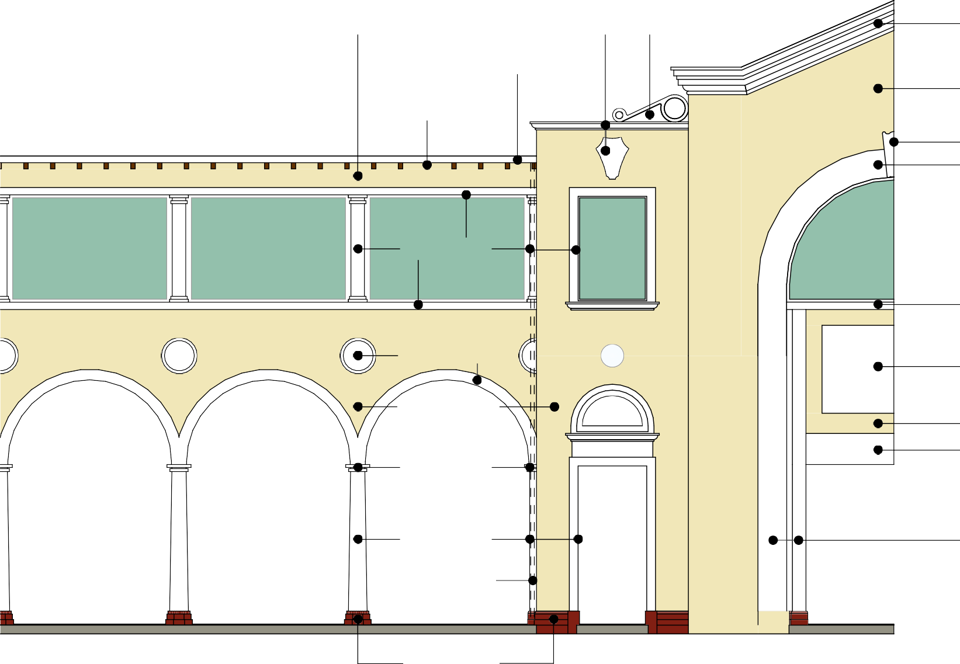  COLOUR CREAM COLOUR WHITE COLOUR WHITE COLOUR WHITE  (GUTTER, SOFFIT)  COLOUR CREAM  COLOUR BROWN (EXPOSED RAFTERS)  COLOUR WHITE COLOUR WHITE  COLOUR WHITE  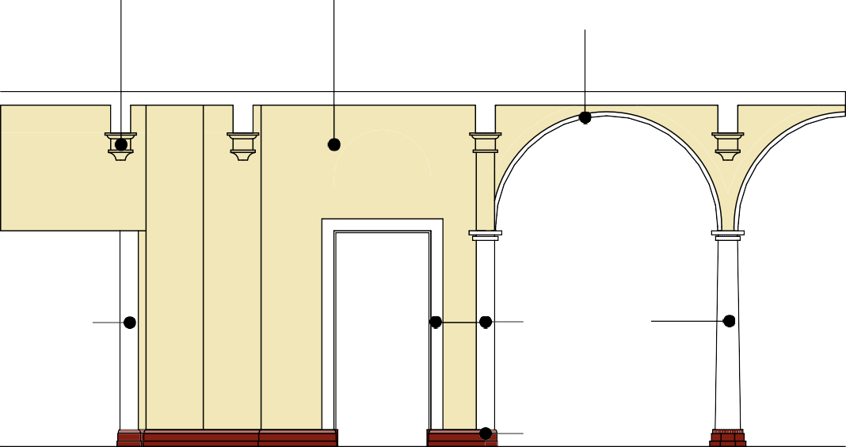  COLOUR CREAM COLOUR CREAM COLOUR WHITE (ROUND MOULDING  COLOUR WHITE AND REVEAL)  COLOUR WHITE  COLOUR WHITE  COLOUR CREAM  COLOUR CREAM  COLOUR WHITE  COLOUR WHITE    COLOUR COLOUR WHITE  COLOUR WHITE COLOUR WHITE WHITE  COLOUR CREAM (DOWNPIPES)  COLOUR BROWN  COLOUR BROWN    - Typical Facade Colours 3 Typical Colours - Rear of Arcade  1:50 1:50  COLOUR WHITE COLOUR CREAM COLOUR WHITE COLOUR CREAM (ROUND MOULDING (SOFFIT AND ALL  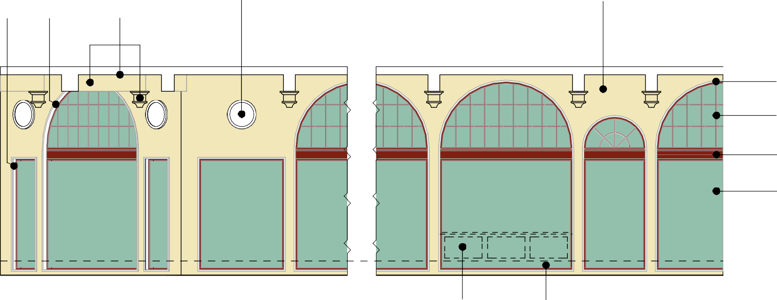  AND REVEAL) FACES OF BEAMS)  COLOUR WHITE  (ROUND MOULDING AND REVEAL)  COLOUR INDIAN RED  (MULLIONS AND WINDOW FRAME)  COLOUR INDIAN RED  COLOUR SCHEME NOTES - SYDNEY AND MELBOURNE BUILDINGS  GENERALLY NO WORK TO SHOPFRONT  GLAZING / ENTRANCE PANELS UNLESS COLOURS SPECIFIED BELOW CONFORM TO THOSE RECOMMENDED BY THE  NOTED OTHERWISE ON DRAWINGS AND HERITAGE UNIT OF ENVIRONMENT ACT, AS FORMULATED BY PEGRUM AND  SCHEDULES ASSOCIATES CONSERVATION ARCHITECTS (FEBRUARY 2000), WHICH HAVE BEEN IMPLEMENTED ON THE WESTERN PORTION OF THE MELBOURNE BUILDING. ALL PAINTING WORK SHALL CONFORM TO THAT DOCUMENT.  COLOUR WHITE = DULUX "WHITE" FULL GLOSS EXTERIOR ACRYLIC COLOUR CREAM = DULUX "CANDLE WAX" SEMI-GLOSS EXTERIOR ACRYLIC COLOUR BROWN = PASCOL "MID BROWN" FULL GLOSS EXTERIOR ACRYLIC  COLOUR CREAM TO ORIGINAL RESTORE BLACK COLOUR INDIAN RED = PASCOL "INDIAN RED" FULL GLOSS EXTERIOR ACRYLIC SUB-SILL PANELS (STALLBOARDS) STONE SKIRTING  WHERE PRESENT WHERE PRESENT    - Typical Shopfront Colours  1:50 | General Notes
All measurements are in millimetres
Figured dimensions take precedence over scaled dimensions
Builder to verify all dimensions on site and seek instructions before proceeding if any discrepancies are found
 | Amendments This drawing published 17/11/2008 12:05 PM
 | Rev | Date | Description
 | A | 17.11.08 | ISSUED FOR STAKE HOLDER DISCUSSION
 | north
 | Client

t +61 2 6239 4333 | f +61 2 6239 4366
4 / 10 kennedy st | po box 4700
kingston act 2604

act arch reg no 935 | nsw arch reg no 6904 ABN 32 042 803 344
 | Project Sydney & Melbourne Buildings Facade Refurbishment
 | Address Section 1 & Section 48 CANBERRA CITY ACT 2601
 | Drawing Colour Scheme
 | Scale  AS SHOWN @ A1 |  |  | Drawn  BC | Checked
Date
10-10-08
 | Project No.  08-346 |  |  | Drawing No.  A 11 |  | Issue  A

