

Youth Justice Strategic Plan (Draft)
  - For consultation June 2026
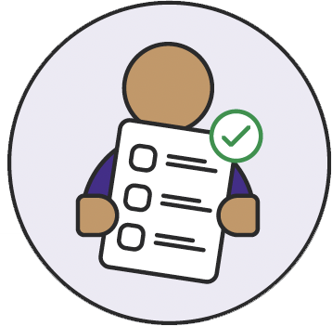
  - Easy Read version
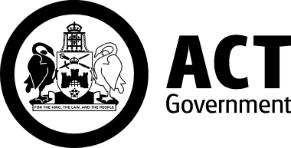

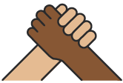
We acknowledge First Nations people
Acknowledge means we know this is true and important.
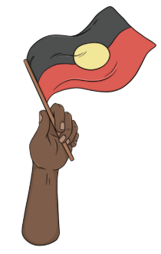
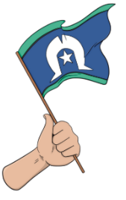
We acknowledge the First Nations people who belong to the land around the ACT.
First Nations people are Aboriginal and Torres Strait Islander people.
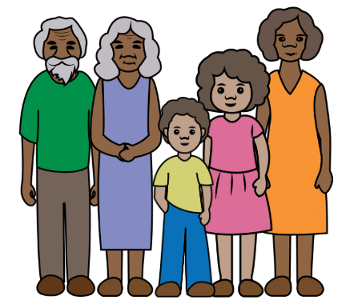
We acknowledge how First Nations families care for their children so they grow up strong.

About Easy Read


Easy Read uses images and simple words to explain things.

We will bold and explain words that may be new or hard.
Easy Read has the main information.
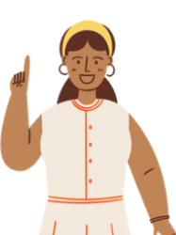


You can find the full details on our website yoursayconversations.act.gov.au/youth-justice-reform
You can get someone to help you read this book.

About this book

This book is from the ACT Government. When the book says we it means the ACT Government.

This book is about the ACT Youth Justice Strategic Plan.

We will call it the Plan in this book.
The Plan is a draft. This means we want to hear from you before we finish it.

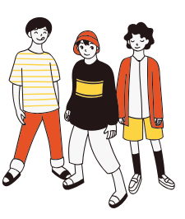
ACT Youth Justice Strategic Plan
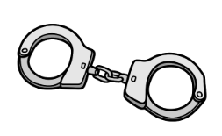
Youth is children and young people aged 0 to 21 years old. We will call them young people in this book.
The youth justice system is what happens when young people do crime. It includes

- community services

- police
- court
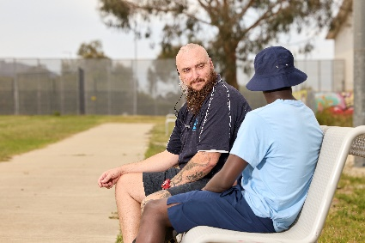
- Bimberi.
Bimberi is a Youth Justice Centre where some young people must stay after doing crime.


Why the Plan is important
Some young people do crime because
- they need help
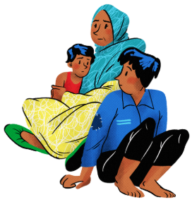
- their family needs help
- they have had trauma.
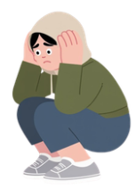
Trauma is when something bad happens to a person. It can
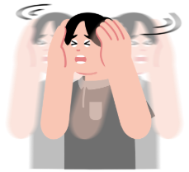
- change how they feel and act
- last for a long time.
The Plan says

- what areas of the youth justice system we want to improve
- what actions we will take to help young people.


Focus areas of the Plan

A focus area means something important that we want to work on first.
The Plan has 6 focus areas

- Early support
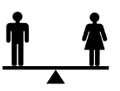
- Divert young people from youth justice

- Get rid of discrimination
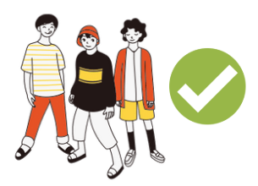
- Use a caring and healing approach
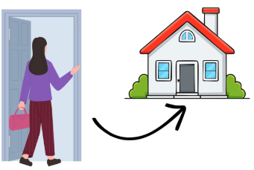
- Respect young people’s rights
- Help young people return home.

1 Early support

Early support means helping young people and their families soon after a problem starts.
Early support gives young people help so
- their problems do not get worse

- they are less likely to do crime.
Early support helps young people to
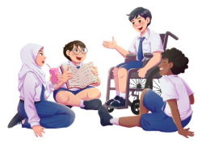
- heal from trauma

- feel like they belong
- do well in life.

Actions
We will continue services to help young people avoid doing crime. This means help with
- mental health problems
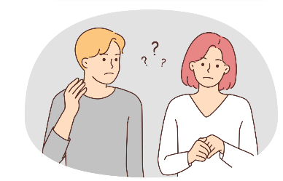
- complex needs
- sexual behaviours that could hurt others or themselves.

We will look at better ways to help young people stay in school.
We will review

- our services

- the way we report on how our services help
- changes to law to see if they work well.

2 Divert young people from youth justice
Divert means a young person is not punished right away. Instead we give them help.
When a young person is punished they may

- be more likely to do crime again
- feel like their trauma is worse.
When we divert young people instead it can

- help them heal
- keep the community safer.

Actions
We will look at how services can help keep young people out of youth justice.

Services can include
- finding somewhere safe to live
- help to stay out of Bimberi

- help for young people who are accused of a crime and waiting for court.

We will look at how services can help young people heal from trauma.
We will improve the way services work together to help young people.

3 Get rid of discrimination
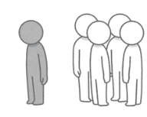
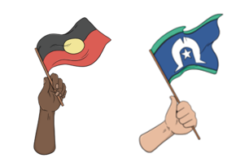
Discrimination is when someone is treated unfairly because of something different about them.
We know First Nations people often deal with discrimination.

We want to help reduce the number of First Nations people in the youth justice system.

Actions

We will work with First Nations services so they can help more people.
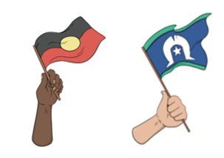
We will look at why First Nations young people are often not diverted from youth justice.
We will learn from reports that tell us how to best help First Nations young people.
We will continue mental health services for young people.

4 Use a caring and healing approach
A caring and healing approach means we will help young people to

- heal from trauma

- get the help they need
- go on to live a good life.

Actions
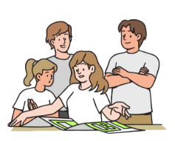
We will make a model of care for Bimberi.
A model of care means a plan for how we will help young people in Bimberi.
We will look at better ways to help young people stay in school.
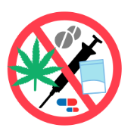
We will look at the services for young people in Bimberi. This includes
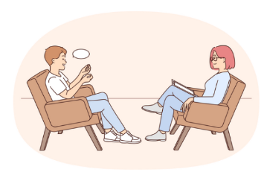
- alcohol and drug services

- counselling

- body scans instead of strip searches
- health services.

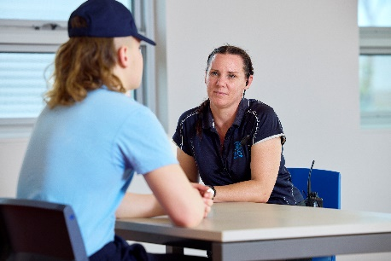
5 Respect young people’s rights
Respect means listening to young people and caring about how they feel.
Rights are rules about how people should be treated.
For example, you have the right to
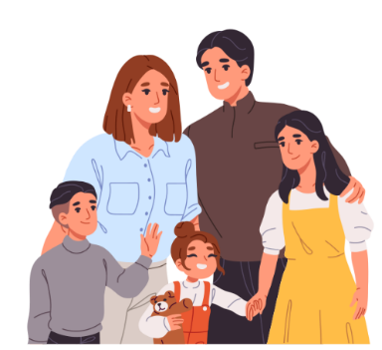
- be treated fairly

- be safe
- get help from a lawyer.

Actions
We will review the law to make sure it protects young people and their rights.
We will look at how courts could work faster to decide what young people must do.
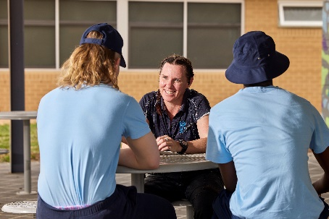
We will work with people who check on how we run Bimberi to make sure
- young people get services they need
- we protect the rights of young people.
We will check actions from other plans that tell us how to support young people with disability.

6 Help young people return home
Some young people who do crime must spend time in Bimberi. Going home after Bimberi can feel scary.
We will help young people return home.
This means help with things like


- finding a job
- a safe place to live
- going to school
- support for good mental health.

Actions

We will help young people to find a safe place to live when they return home from Bimberi.
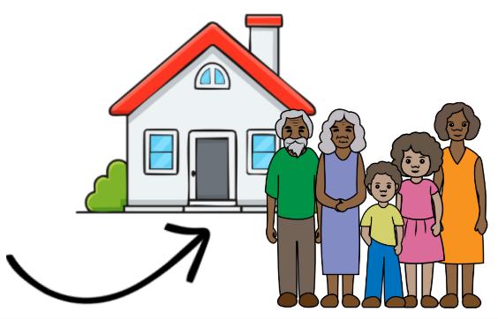
We will work with other services to help young people in Bimberi join in their community.
We will work with First Nations services to help young people return home.

Tell us what you think

About the draft Plan
You can tell us things like

- if the focus areas make sense

- if something is hard to understand.
You need to tell us by 11 August 2026.

Ways to tell us

Phone call
- we can call you if you send us an email with your name and phone number.

Email HCSDStrategicPolicyworkallocation@act.gov.au

Website yoursayconversations.act.gov.au/youth-justice-reform
Health and Community Services Directorate created this Easy Read document in June 2026. Images used are with permission and some word explanations are from The Easy Read Toolbox. Feedback for improvement is welcome.

