

consultation paper

ACT volunteering statement

action plan 2018-2019
community services directorate
2017
Content
purpose 3
volunteering snapshot 4
Background 4
act volunteering statement 2017 6
ACTION PLAN 6
Draft actions 7
Recognised 7
Actions: 7
Valuable 7
Actions: 7
Diverse 7
Actions: 7
Supported 7
Actions: 7
HOW TO JOIN THE CONVERSATION 8
Next steps 8

purpose
The ACT Volunteering Statement (2017) is a high-level, principles-based document that requires an accompanying action plan. The ACT Volunteering Statement Action Plan (Action Plan) includes actions for ACT Government directorates and Volunteering and Contact ACT, to realise the intentions of the ACT Volunteering Statement.
The Action Plan is designed to contribute to:
- More effective engagement and management of volunteers
- More integrated, person-centred and effective support for volunteers and volunteer involving organisations.
- Individual wellbeing, social inclusion and community connectedness
- Higher quality services and activities for the Canberra community as a result of the contribution of volunteers.
The ACT Government supports and recognises volunteers through its funding of Volunteering and Contact ACT, the peak body for volunteering and a key enabler of volunteering services in the ACT. The ACT Government also supports National Volunteer Week in May each year and International Volunteer Day held on 5 December 2017 each year.

ACT Government supports volunteer best practice by undertaking background checking free of charge for volunteers engaged in regulated activities, through the Working with Vulnerable Children (Background Checking) Act 2012.

ACT Government directorates facilitate and support the involvement of volunteers in many areas, including sport and recreation, health, education, environment, tourism, major events, emergency services, libraries and community services.

volunteering snapshot
Volunteering plays an important role within the ACT community and it contributes to building healthier and more resilient individuals, communities and natural environments. The Volunteering and Contact ACT report The State of Volunteering in the ACT 2013 found that volunteers contribute over $1.5 billion to the ACT economy annually (p 5).
The overall rate of adult volunteering in the ACT is 36.8%, which is high compared to most Australian jurisdictions. For people aged 35-44 years, the rate is even higher at 46% (ABS, General Social Survey, 2014, Table 22.1). Of the people who volunteered in the last 12 months in the ACT, the type of organisations chosen included education (30.1%), sport and physical recreation organisations (29%), welfare/community organisations (17.7%), religious organisations (17.7%) and health (12%). Some volunteers were involved in more than one type of organisation (GSS, 2014, Table 23.1).
The top three reasons people say they volunteer are to:
• give something back to the community;
• help the community; and
• make a difference.
Volunteering has significant personal benefits, with 95% of individuals reporting feelings of wellbeing as a result of volunteering. Despite these benefits, there are various barriers to individual involvement in volunteering, such as time constraints and difficulties in finding out about volunteering opportunities. This helps to explain why nine out of 10 volunteer involving organisations say they need more volunteers.
There are numerous volunteer involving organisations in the ACT, from charities such as the Smith Family and the Red Cross, to emergency agencies such as the ACT State Emergency Service and the ACT Rural Fire Service, and a host of sports clubs, community arts organisations and parent associations.

Background
In 2011 the ACT Government launched the initial ACT Volunteering Statement to establish a whole of government approach to volunteering. On 24 September 2014, the ACT Legislative Assembly passed a resolution calling on the ACT Government to review and update the 2011 ACT Volunteering Statement.
In May 2017 the Minister for Community Services and Social Inclusion launched the refreshed ACT Volunteering Statement and indicated that the ACT Government would develop an action plan to realise the intentions of the Statement.
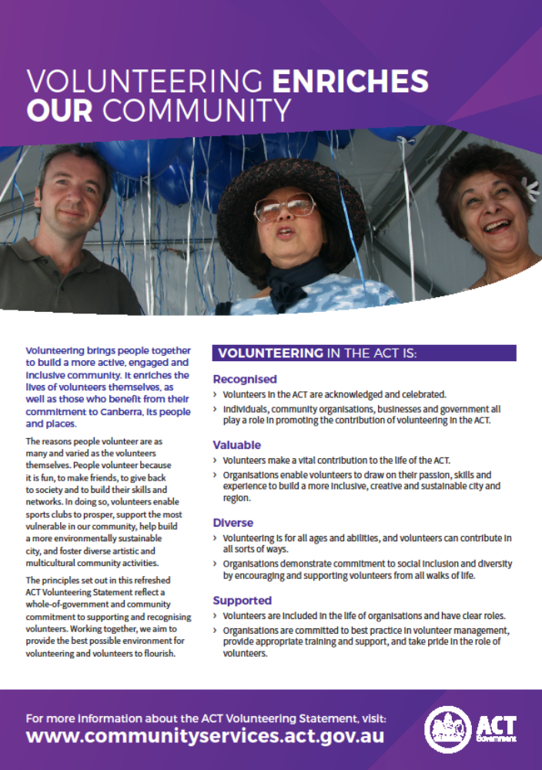
ACT Volunteering Statement (2017)

act volunteering statement 2017
The ACT Volunteering Statement represents a central point of reference for volunteering in the ACT. It reflects a whole-of-government and community approach to supporting and recognising volunteers. The Statement sets out four high-level principles – that volunteering in the ACT is recognised, valuable, diverse and supported – as a platform for good practice in volunteer engagement, management and support.
Extensive consultations with the community in 2016 and across government in 2017 contributed to the development of the ACT Volunteering Statement, including:
- Community consultation conducted by Volunteering and Contact ACT in 2016
- Consultation for ACT Government representatives, facilitated by Volunteering and Contact ACT in 2016
- Consultation across ACT Government directorates, conducted by the Community Services Directorate in 2017
- Ongoing conversations between the Community Services Directorate and Volunteering and Contact ACT in 2016-17.
These consultations also produced a draft list of actions to implement the ACT Volunteering Statement.

ACTION PLAN
The ACT Volunteering Statement Action Plan is based on the four principles outlined in the ACT Volunteering Statement (Recognised, Valuable, Diverse and Supported).
Concurrent with the Action Plan, the ACT Community Services Industry Workforce Plan 2017-2020 will promote strategies to support shared training programs and cross skilling of workers, including the upskilling of volunteers.

An evaluation of the Action Plan will be conducted at the end of the implementation period, in order to develop a second action plan to further support volunteering in the ACT.
A draft list of eight actions is provided below as a starting point for further discussion and consultation. Two actions are listed under each of the four principles in the ACT Volunteering Statement. The actions would be the responsibility of government and/or volunteer involving organisations. You are invited to rank these actions and propose your own in a brief online survey (details below).

Draft actions
Volunteering in the ACT is:

Recognised
- Volunteers in the ACT are acknowledged and celebrated
- Individuals, community organisations, businesses and government all play a role in promoting the contribution of volunteering in the ACT

Actions:
- Hold an event on International Volunteer Day to acknowledge and celebrate volunteers in the Canberra Region
- Market volunteering to government, business, and the wider community to ensure that people are aware of the breadth of opportunities available

Valuable
- Volunteers make a vital contribution to the life of the ACT
- Organisations enable volunteers to draw on their passion, skills and experience to build a more inclusive, creative and sustainable city and region

Actions:
- Conduct research to identify the trends, issues, challenges and opportunities affecting volunteering in the Canberra Region
- Encourage collaboration to link people with meaningful volunteering opportunities

Diverse
- Volunteering is for all ages and abilities, and volunteers can contribute in all sorts of ways
- Organisations demonstrate commitment to social inclusion and diversity by encouraging and supporting volunteers from all walks of life

Actions:
- Create pathways to volunteering for people experiencing barriers
- Tailored promotion of volunteering opportunities for people from diverse backgrounds

Supported
- Volunteers are included in the life of organisations and have clear roles
- Organisations are committed to best practice in volunteer management, provide appropriate training and support, and take pride in the role of volunteers

Actions:
- Provide volunteer involving organisations with access to resources and templates to facilitate effective, safe and sustainable volunteer involvement, including information on how existing grant programs can help organisations support their volunteers
- Support the professional development of volunteers and managers of volunteers
THINK:
- What are your top three priorities of the actions above?
- Are there other actions you would like to see included in the action plan?
You can respond by survey, email, mail or in person (see below).

HOW TO JOIN THE CONVERSATION
The experiences and advice from people and organisations across the ACT will shape how the Action Plan is refreshed. The consultation period is from 5 December 2017 to 18 February 2018. To contribute your own ideas to this conversation, please:
- Complete a brief online survey at the Your Say website: https://www.yoursay.act.gov.au/
- Email your ideas to: policy@vc-act.org.au
- Mail to: ‘Volunteering consultation’, Volunteering and Contact ACT, PO Box 128, CIVIC SQUARE ACT 2608; or
- Attend the consultation event. Details will be available from Volunteering and Contact ACT and the ACT Government, closer to the event.

Next steps
Feedback from consultation will contribute to the development of the ACT Volunteering Statement Action Plan, to be launched in the first half of 2018. Following the launch, the Action Plan will be circulated to volunteer-involving organisations and the wider community.

Community Services Directorate
2017

An application fee of $82.00 applies to people who are employed to work with vulnerable people. Registration is free for volunteers; however, if the volunteer also works in a regulated activity, they are still required to pay the $82.00 fee (Source: Access Canberra).

