
Supplements to the ACT Nature Conservation Strategy 2026–2036
- Climate adaptation for nature conservation in the ACT
- Landscape-scale conservation for a Nature Positive ACT
- Effective restoration practice in the ACT
City and Environment Directorate
Insert Directorate
Supplement A to the ACT Nature Conservation Strategy 2026–2036
Climate adaptation for nature conservation
in the ACT
This supplementary document translates the NCS vision for a connected Nature Positive landscape into policy and technical guidance to support proactive, accountable, and coordinated decision-making.
City and Environment Directorate
Insert Directorate

Table of Contents
Table of Contents 2
Climate adaptation for nature in the ACT 3
What is climate change adaptation? 3
Why does climate change adaptation matter? 3
How is climate change impacting nature in the ACT? 4
What is climate change adaptation for conservation? 6
Resist – Accept – Direct (RAD): a shared climate lens 9
Climate adaptation in the NCS 10
Appendix A: Causal pathways toward climate adaptation 11
Appendix B: Supplement A glossary 12

Climate adaptation for nature in the ACT
This supplementary document translates into action the Nature Conservation Strategy (NCS) vision to ensure Canberra is a city thriving within a healthy and flourishing natural environment, where the aspirations for conserving nature reflect Canberrans’ love for their bush capital. To achieve the NCS goals, and to give nature the best chance of success in the face of climate change, conservation must embed a climate change adaptation lens.
This supplement lays the foundation for how to adapt to climate change impacts by embedding a climate change adaptation lens into nature conservation. It aims to provide conservation partners with information and tools to support climate-adaptive and anticipatory decision-making and planning.

What is climate change adaptation?
Tackling climate change involves two key approaches: mitigation and adaptation.
Mitigation means reducing the causes of climate change – mainly by cutting greenhouse gas emissions, and by increasing natural systems that absorb like carbon, forests, wetlands, and healthy soils.
Adaptation means taking action – whether by individuals, communities, or governments – to deal with the effects of today’s changing climate, and to anticipate and prepare for additional changes projected for the future. This requires understanding current impacts and anticipating future changes.
Adaptation actions will be taken at different scales and could include adjustments to strategies and plans, targeted investments, building knowledge in particular areas, or changing policies and on-ground management strategies. Some actions will be adjustments to business as usual, others will involve more significant changes in management and decision making.
Some actions, such as restoring native vegetation and protecting healthy ecosystems can contribute to both mitigation and adaptation. There are important co-benefits and strategic overlaps between emissions reduction and climate adaptation for nature. Mechanisms such as biodiversity and carbon offsets present opportunities to simultaneously advance adaptation objectives while contributing to mitigation targets. Integrating these approaches can enhance ecological resilience and deliver more holistic climate outcomes.

Why does climate change adaptation matter?
Adaptation for nature is critical to protect nature and the places we value in the ACT.
Climate change is already affecting nature in the ACT. Reducing emissions contributes to efforts to limit the rate of global climate change and avoid the worst impacts of climate change. However local climate change adaptation is also essential to reduce the impacts of climate changes that are already being experienced, and future impacts that cannot be avoided by mitigation. The future climate and its impacts on nature will not resemble the past. Failure to anticipate and adjust to these changes could be costly.

That’s why adaptation is just as important as mitigation—it helps communities, ecosystems, and infrastructure cope with the changes that are already underway. Adaptation is an ongoing process - it isn’t something that happens once and is finished. All areas of nature conservation need to take it into account when developing and implementing policies, plans, and on-ground management.
The cost of not adapting is likely to be extremely high. Investing in adaptation actions now will be more cost-effective, easier, and more effective compared to postponing action.

How is climate change impacting nature in the ACT?
The ACT’s climate has changed in recent decades, becoming warmer, drier, and facing increasing bushfire risk. The ACT and wider NSW regions have already warmed by 1.4°C since national records began in 1910. Temperatures in the ACT and New South Wales have warmed 1.4 times the global average. Climate change has already pushed many impacts – extreme temperatures and weather events – outside the range of recorded recent natural variability.
In the ACT, we are currently experiencing, and are projected to experience with increasing intensity, the following impacts:
- Increased extreme heat
- Increased temperatures, during the day and night, in summer and in winter
- Increased severe fire weather, and more fire in the landscape
- Changes to rainfall, with irregular and intense rainfall events and extended periods of drought
- More frequent and intense weather events
- Changes to waterway flows, levels, and regimes
- Increased rainfall variability
By 2090, without significant reductions in global emissions, average temperature is likely to increase 3.7°C and average rainfall is likely to decrease 12.9%, with run-off decreasing by a larger amount. Temperature and rainfall extremes will extend well beyond these averages. Climate change is bringing major challenges for conservation in the ACT, with wide-ranging impacts on nature and biodiversity. Our current systems are under pressure, and adapting how we care for the environment will help protect biodiversity and strengthen ecosystem resilience.
It is increasingly important to consider short, medium, and long-term climate change impacts in conservation decisions. We can start with practical, step-by-step improvements that build on what is already working, but making sure this action sets us up to develop and implement more significant policy and management shifts if they are needed over time. Without climate action, we risk falling short of national strategic goals—like protecting and conserving 30% of Australia’s landmass by 2030. By planning ahead and adapting early, we can better protect nature for future generations.

Widespread and significant changes in ecosystems are occurring and further change is inevitable. Climate change will increase the pressure on nature in the ACT, by exacerbating existing threats and introducing new ones. Climate change is likely to impact:
- Distribution: Climate-sensitive ecosystems will shrink or vanish, while more tolerant ecosystems may expand
- Composition: Native species may decline, with increases in invasive plants and pests
- Structure: Dominant species like eucalypts may be lost, and ecosystems may no longer resemble their current structure
- Function: Some ecosystems will no longer provide suitable habitat for species or may not provide the same ecosystem services like pollination, water filtration or carbon storage
In addition to warming and changes to rainfall, increases in carbon dioxide in the air also directly affect how plants grow.
Many climate change impacts will be cumulative such as reduced rainfall stressing plants and warmer temperatures favouring pathogens. Climate impacts also compound with other risks such as habitat loss and fragmentation, overgrazing, altered bushfires, weeds and pests. Compounding risks occur when multiple climate hazards happen simultaneously or close together, intensifying their combined impact. The expected cycle of alternating between more intense drought and wet years is likely to promote the growth and spread of invasive weeds, including new weed species from outside the ACT region.
Other changes may include changes in the seasonality of species and acceleration of environmental degradation and biodiversity loss. As a result of climate change, threatened species will have a much higher chance of going extinct, and many more species may become threatened.
As the climate changes, conservation will increasingly involve managing change and ecological transformation. Ecological transformation is “the dramatic and effectively irreversible shift in multiple ecological characteristics of an ecosystem, the basis of which is a high degree of turnover in ecological communities”. Ecological thresholds are already being exceeded, leading to the potential for widespread and rapid transformation of our ecosystems. Modelling suggests ecological change will be significant and widespread, driven by the amount of climate change that is projected to occur towards the end of the century . We will need to continue managing many current threats, but also understand and prepare for the new challenges arising from the prospect of widespread and rapid transformation of our ecosystems.
What climate change impacts are already occurring or likely to occur?
- Changes and loss of alpine and sub-alpine ecosystems, including negative changes in the composition and stability of alpine and subalpine environments resulting in a loss of these ecosystems is a key risk for natural environment in the ACT
- Forests that require long periods between fires to regenerate will be affected by more frequent fires – Alpine Ash forests in Namadgi
- Animals such as the Grey-headed Flying Fox are being pushed to their thermal limits during extreme heat events, causing mass die offs in some areas of Australia
- Temperate grassy and woodland ecosystems are likely to undergo structural changes, potentially with declining trees due to moisture stress and altered shrub-grass balance
- Reduced stream flows and wetland conditions

What is climate change adaptation for conservation?
As the climate and our landscapes change, we will need to adapt the way we do conservation in the ACT. There are two parallel things we need to do:
- Support species and ecosystems as they respond naturally to the changing climate by ensuring there is abundant, well connected, environmentally diverse habitat that is free of significant threats such as disturbance and exotic predators and competitors, so that natural process such as behavioural changes, range shifts, and evolution can occur rapidly (Figure 1).
- Adapt the way we do conservation and management by updating our conservation objectives, policies, processes, and management to recognise and integrate the reality of significant ecological change (Figure 1). We can start doing this by applying a climate lens and adaptation tools (see section on “Out Strategic Approach”) to plans, policies, and legislation, and considering how communities’ connection to nature in the ACT will be affected. These actions will ensure that we can adjust our research, policies, and aspirations to enable management that effectively supports the environment as it changes.
These two types of adaptation actions are intertwined - both are necessary and require deliberate action. Efforts to resist current pressures – such as habitat loss and invasive species – are likely to remain effective in the near-term and may become even more critical as climate change intensifies. For example, with increased disturbances and dislocation of species ranges and their climatic niches, both available habitat area and habitat without the extra pressure of exotic species will be increasingly important both for the persistence of current native species and those that may be establishing from elsewhere.
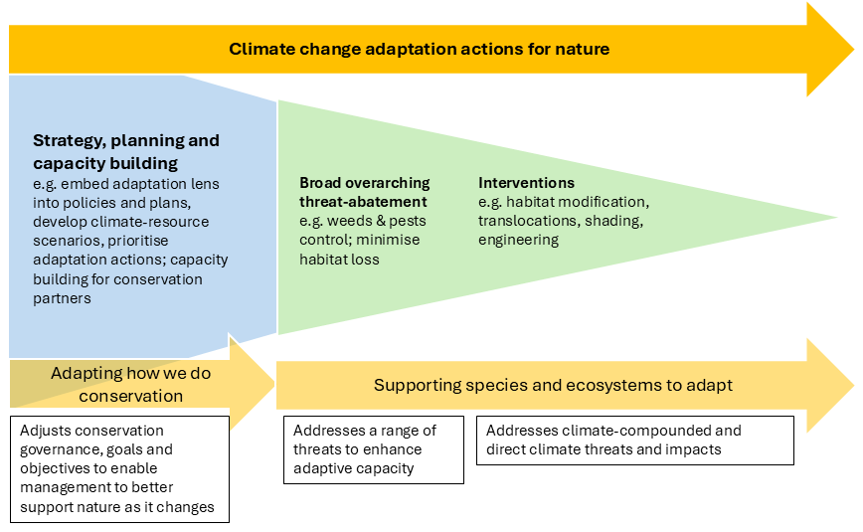
Figure 1: A continuum of different types of climate change adaptation actions for nature
Principles for climate adaptation for nature
A climate change adaptation lens applied to conservation policy and management decisions will help ensure they can effectively anticipate, prepare and respond to the impacts of climate change on nature in the ACT. The ACT Climate Adaptation for Nature initiative co-developed seven principles for climate adaptation for nature. The process of helping nature and conservation management to adjust to climate change will be shaped by:

Principle 1: Learning
Adaptation necessarily involves innovation and experimentation, learning from what works and what doesn’t, and responding to new information when it becomes available. The successes and failures of interventions need to be robustly monitored and analysed to draw out lessons and insights and these need to be communicated and shared to foster learning. Adaption also involves learning to think and talk about change and being comfortable with accommodating ambiguities that will arise where a changing future is inconsistent with the way we currently make sense of nature.

Principle 2: Inclusivity
Stakeholders hold diverse values about nature, so inclusive adaptation must engage a wide range of perspectives and knowledge systems. This includes honouring the deep connection many people including Traditional Custodians have with Country and valuing their cultural and ecological knowledge.

Principle 3: Incorporating Ngunnawal knowledge
Adaptation offers a chance to integrate Ngunnawal Traditional Custodians’ knowledge into climate-adaptive land management. This must be done with full respect for their intellectual property and cultural rights.

Principle 4: Systems thinking
Viewing our connection to management of nature as a system helps reveal the complex interconnections between ecological, social, and institutional components that need to be addressed in adaptation. This approach prepares us for unexpected interactions and broadens the focus beyond individual assets to entire systems. Systems thinking is an approach to problem-solving that examines the dynamic interactions between multiple connected processes. Using systems concepts in adaptation planning can help reveal relationships, interactions and interdependencies between how we understand nature and change, how we relate to and value nature, and how we make management and other decisions affecting it.

Principle 5: Place based
Ecological impacts of climate change vary by location, and the connections people have to nature are often place-based. Adaptation must be tailored to local contexts, values, and futures. Scenario planning and narrative development can help make local processes and priorities explicit.

Principle 6: Common narratives and visioning
Engaging communities in imagining future scenarios helps identify shared values and guide adaptation choices. This process clarifies trade-offs and acknowledges that preserving current values may not always be possible.

Principle 7: Evidence-based decision making and accommodating uncertainty
There is strong evidence that climate change is having increasing impacts on nature, but there will always be much uncertainty in the detail of future novel changes. Adaptation must be grounded in good data about observed changes and anticipation of future change, but most importantly it needs to enable flexible responses that are effective under different futures and can be updated as new information emerges.

Futures thinking - a forward-facing, long-term approach
Futures thinking is a strategic approach that explores possible, probable, and preferred future scenarios to inform long-term planning and decision-making. Adopting a long-term, futures thinking approach in conservation planning helps anticipate ecological changes and consider compounding and cascading events. By exploring multiple plausible futures (see Box 1), it is possible to identify proactive 'no regrets' adaptation actions that are robust across different possible future climates. In this way, we can adapt to climate change while addressing future uncertainty. It also helps account for the lifetime of a decision, ensuring that decisions we make now that have long-term consequences are made considering future climate change impacts.
Box 1. Scenario planning for conservation
Scenario planning is an adaptation tool widely used in natural resource management and National Parks planning and management. Scenario planning helps conservation managers explore a range of possible futures, rather than relying on a single prediction. By considering different ways climate and environmental conditions might unfold, it challenges assumptions and supports more flexible, resilient decision-making. Scenario planning is a useful approach to use prior to applying RAD. This approach uses a small number of carefully developed scenarios – each representing a distinct set of future conditions – to guide planning and identify strategies that can perform well across a variety of future outcomes.

Resist – Accept – Direct (RAD): a shared climate lens
Resist – Accept – Direct (RAD) is a shared climate lens that helps people grapple with the implications of climate change for conservation management. RAD articulates three types of conservation actions in response to climate change: Resist, Accept, and Direct. The framework helps us be strategic and forward-looking in the intent, design, and choice of actions, rather than base our management objectives, by default, on past baseline conditions and our current aspirations to resist change.
Resist (R) actions are interventions that are intended to maintain ecosystems in their current state, or restore them to a historical state. Resist actions aim to maintain or restore ecosystem composition, structure, processes or function on the basis of historical or acceptable current conditions. Many current conservation actions are Resist oriented. Resist actions will typically be most effective for relatively small amounts of climate change and in restricted situations to seek to maintain very highly valued ecological features.
Accept (A) actions embrace changes that cannot be feasibly resisted or directed, by allowing ecosystem composition, structure, processes and function to change autonomously. Given the scale of climate change, the limitations of conservation efforts, and resource constraints, adopting an 'accept' strategy is likely to become increasingly common. Management approaches may need to evolve to accommodate and embrace these changes."
Direct (D) actions aim to guide the trajectory of ecological change, where resisting is unrealistic, or there is an opportunity to shape a desirable future ecological state. Direct interventions actively shape change in ecosystem composition, structure, processes or function towards preferred new conditions. Most often it will involve nudging the natural direction of change rather than whole-sale ecosystem engineering.
A conservation plan can involve a mixture of activities, resisting some impacts, directing some changes and accepting others, and their emphasis can vary over time.

Climate adaptation in the NCS
Three outputs and four targets directly related to climate change adaptation have been identified in the NCS Theory of Change (Appendix B). Actionable steps to achieve the targets are outlined in Table 1.
Table.1 NCS Outputs, targets and actionable steps related to climate adaptation for conservation
NCS Output | NCS Target | Actionable steps
8. Understanding and capacity to  respond to climate risks is developed | 8a: Case-based climate change risk assessments are completed | - Undertake scenario-based climate change vulnerability and risk assessments for key conservation values in the ACT, to identify key risks and vulnerabilities  - Evaluate climate implications for conservation goals and identify potential adaptation strategies  - Identify key research gaps to determine research priorities to pursue through research collaborations
 | 8b: Preparedness, response and recovery planning for priority values is undertaken | - Develop an assessment of the susceptibility of priority conservation values to bushfire, flood, and extreme heat events  - Identify key preparedness, response, recovery, and learning actions required to protect and restore these values in the event of an extreme event  - Identify roles and responsibilities of conservation partners and experts
15. Conservation policies and plans  integrate climate adaptation measures | 15: Guidance and tools for climate-adaptive planning are developed and used | - Develop guidance and information to embed climate risk and adaptation principles into conservation policies, plans, and decision-making  - Identify and share locally relevant data, tools, and case studies  - Targeted species distribution modelling for high-risk species is scoped  - Synthesise latest climate adaptation research and translate it into practical insights, tools, and guidance for conservation planning and decision-making.
22. Nature conservation approaches  are adapted to a changing climate | 22: On-ground climate adaptation measures are prioritised, trialled and evaluated | - Review and evaluate existing trials  - Scope and develop a policy for novel environmental management actions  - Develop a prioritisation framework and select adaptation measures based on (8a)  - Support mechanisms to build and retain below and above ground carbon stocks with biodiversity benefits

Appendix A: Causal pathways toward climate adaptation
Figure 2 illustrates the causal pathways identified in the NCS Theory of Change that are necessary and sufficient for the achievement of climate adaptation goals of the Strategy. Primary causal links are indicated by dark shading and arrows, supporting causal links are indicated by lighter shading and arrows.
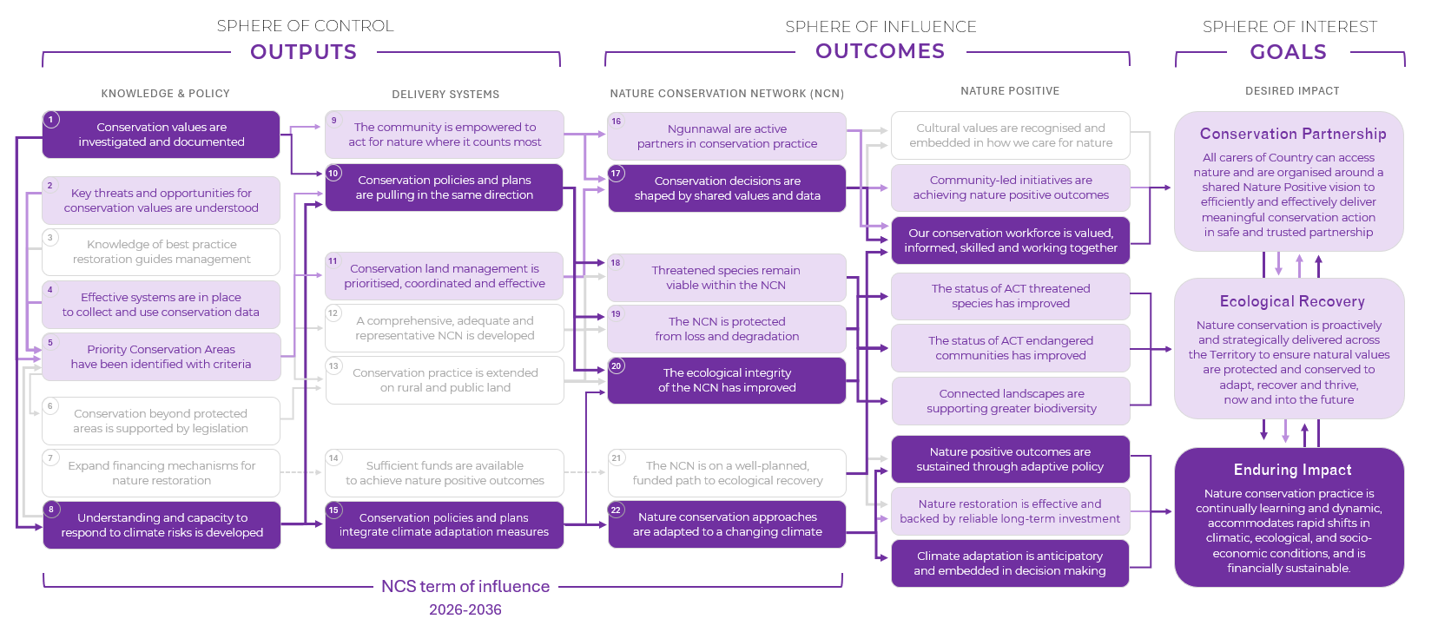
Figure 2. The NCS Theory of Change showing causal pathways for the achievement of climate adaptation goals

Appendix B: Supplement A glossary
Term | Definition
Adaptive Capacity | Adaptive capacity of natural systems refers to an organism’s natural ability to respond to climate change—either by making use of emerging opportunities or by minimizing harmful impacts. This capacity differs among species, depending on their unique traits and characteristics.  Adaptive capacity of social systems refers to the ability of communities, institutions, and networks to adjust to climate change and other environmental pressures. This includes their capacity to learn, innovate, reorganize, and respond effectively to risks and opportunities
Anticipate | To actively consider and prepare for potential future changes, challenges, or opportunities before they occur. In conservation, anticipating involves using data, trends, and scenario planning to foresee how ecosystems, species, and environmental conditions might respond to climate change, enabling proactive and informed decision-making.
Biodiversity | Is the variability among living organisms from all sources (including terrestrial, marine and other aquatic systems and the ecological complexes of which they are part) and includes diversity within species and between species, and of ecosystem.
Causal Pathway | A backwards mapping from a strategic goal through all the long and short-term outcomes to the outputs needed to achieve it, identifying a logic arrangement of causal links between these.
Climate Change Adaptation | Means taking action, whether by individuals, communities, or governments, to deal with the effects of today’s changing climate, and to anticipate and prepare for additional changes projected for the future. This requires understanding current impacts and anticipating future changes.
Climate Change Mitigation | Actions to limit the extent of long-term climate change caused by human emissions of greenhouse gases and by increasing natural systems that absorb like carbon, forests, wetlands, and healthy soils.
Climate Hazard | The potential occurrence of a natural or human-induced physical event or trend that may cause loss of life, injury, or other health impacts, as well as damage and loss to property, infrastructure, livelihoods, service provision, ecosystems and environmental resources.
Climate-adaptive | An approach to conservation that anticipates future climate conditions and builds in the capacity to adjust policy and strategy, methods and goals in response to both projected and observed climate impacts. See also: Climate Change Adaptation.
Climatic Niche | A specific or ideal climate condition that a species needs to survive and reproduce. For instance- the right temperature range, rainfall levels and other seasonal patterns. Changes in this climate niche forces a species to move and find its climate niche.
Composition | Referred to here is the species composition, which is the total number of different species within a community. It includes richness and diversity.
Conservation Value | The relative value of a parcel of land based on a suite of ecological, social and cultural values.
Critical Habitat | Habitat for a protected matter, species or ecological community that is critical to the long-term survival and recovery of that matter, species or community. An area will only become Critical Habitat if it is formally declared under the Nature Conservation Act.
Distribution | Ecosystem distribution is a spatial arrangement and variation of different ecosystem across a region, determined by conditions or factors including climate, topography, human activities. With the climate change, this distribution is going to get affected-climate sensitive ecosystems may shrink or disappear, while climate tolerant ecosystems may expand into other areas.
Ecological Threshold | The point at which there is an abrupt change in an ecosystem quality, property or phenomenon, or where small changes in environmental driver produce large responses in the ecosystem.
Ecological Transformation | The dramatic and effectively irreversible shift in multiple ecological characteristics of an ecosystem, the basis of which is a high degree of turnover in ecological communities.
Ecosystem Function | It refers to the processes and activities within an ecosystem that are essential for the ecosystem to function properly and provide services that have social, cultural and ecological values.
Environmental Degradation | The decline in the quality, health and functioning of the natural environment due to climate change or combined effects of climate change and other pressures like invasive species or feral animals or bush fires.
Exposure | Exposure to climate change refers to the extent to which a system—such as a species, ecosystem, community, or infrastructure—is subject to climate-related hazards. These hazards can include temperature extremes, changes in rainfall, sea-level rise, bushfires, floods, and other environmental shifts. Exposure is determined by the geographic location and environmental context of the system.
Fragmentation | Fragmentation here refers to Habitat Fragmentation, an umbrella term describing the complete process by which habitat loss or artificial barriers result in the division of large, continuous habitats into a greater number of smaller patches of lower total area, isolated from each other by a matrix of dissimilar habitats and is not just the pattern of spatial arrangement of remaining habitat. A matter gets worse if climate change and habitat fragmentation interact-a fragmented habitat will be isolated and disconnected, limiting species movement and reducing that climate adaptation potential. A connected habitat or landscape is therefore more resilient.
Function | Ecosystem function. It refers to the processes and activities within an ecosystem that are essential for the ecosystem to function properly and provide services having social, cultural and ecological values.
Futures Thinking | Futures thinking is a strategic approach that explores possible, probable, and preferred future scenarios to inform long-term planning and decision-making. In conservation, it helps anticipate how ecosystems, species, and environmental conditions might change under different climate and socio-political pathways. By considering a range of futures, it supports proactive, flexible, and resilient strategies that can adapt to uncertainty and emerging challenges.
Habitat Loss | Habitat loss is the process where a natural environment is unable to support its native species, leading to a decline in biodiversity and potential extinctions.
Intellectual Property | Intellectual property refers to creations of the mind. It could include a brand, logo, invention, design or artistic work, or new plant variety. Indigenous Cultural and Intellectual Property or ICIP refers to the rights of Australia’s First Nations (Aboriginal and Torres Strait Islander) peoples to their heritage.  (Definitions from IP Australia and Australian Indigenous Cultural & Intellectual Property Protocol, Feb 2023)
Invasive Species | Introduced plants and animals that can establish quickly and spread to the point of threatening native communities and ecosystems.
Mitigation | Mitigation here refers to climate change mitigation. Actions to limit the extent of long-term climate change caused by human emissions of greenhouse gases and by increasing natural systems that absorb like carbon, forests, wetlands, and healthy soils.
Nature Conservation Network (NCN) | A strategic, cross-tenure network of lands and waters in the ACT under some form of long-term protection or conservation and active conservation management – including green and blue corridors and climate refugia – managed for Nature Positive conservation outcomes. The NCN integrates formal reserves and PCAs beyond the formal protected network – including stewardship lands and urban green and blue space and infrastructure – to deliver functional connectivity and ecological resilience across ACT landscapes.
Nature Conservation Strategy (NCS) | A statement of (1) proposals to protect, manage, restore and conserve native species and significant ecosystems of the Territory, and (2) strategies to address actual and potential impacts of climate change. The NCS also includes anything required to be included by a conservator guideline.
Nature Positive | A term used to describe circumstances where nature – species and ecosystems – is being repaired and is regenerating rather than being in decline.
Outcomes | Flow-on effects expected to result from our strategic outputs interacting with other things happening in the wider world; these may be short to long-term. Outcomes can also be described as pre-conditions for achieving a goal.
Outputs | The immediate results of activities within the sphere of control of the Strategy to deliver.
Overgrazing | It is a practice of an animal extensively grazing on the native vegetation that exceeds the land's capacity to regenerate and leads to land degradation.
Protected Area | A clearly defined geographical space, recognised, dedicated and managed, through legal or other effective means, to achieve the long-term conservation of nature with associated ecosystem services and cultural values.
Resist–Accept–Direct (RAD) | A framework that helps with decision-making, providing a shared climate lens that helps people grapple with the implications of climate change for conservation management.
Range Shift | Refers to the geographical redistribution of species from their previous boundaries in response to the changing climate conditions. Highly related to climate niche and ecosystem distribution.
Regeneration | The efforts made to restore, renew, or increase the diversity of species and ecosystems in an environment. These efforts are natural-without human intervention, where ecosystems recover on their own or they are human assisted as shown under the ecological restoration approaches (refer to Supplement C).
Resilience | Resilience here refers to ecosystem resilience. The ability of natural areas (ecosystems) to persevere and adjust despite changes and disturbances as a result of changing land use and climate change impacts. Resilience depends upon the continuity of ecological processes, e.g. energy flows, nutrient cycles, hydrological cycles, food webs
Risk | The potential for adverse consequences when something of value is at stake, and the outcome is uncertain. Because the likelihood and impact of climate threats are often uncertain, and people may value those impacts differently, it’s helpful to define risk in a broader way.
Scenario Planning | A strategic tool used to explore and prepare for multiple plausible futures by developing narratives or models based on different combinations of environmental, social, and policy drivers. In conservation, it helps decision-makers anticipate how ecosystems, species, and land use might respond under varying climate conditions, enabling more flexible and resilient planning. Rather than predicting a single outcome, scenario planning supports adaptive strategies by considering uncertainty and change.
Sensitivity | Sensitivity to climate change refers to the degree to which a system, whether ecological, social, or economic, is affected by climate-related changes, such as shifts in temperature, precipitation, or extreme weather events.
Species Composition | The total number of different species within a community. It includes richness and diversity.
Species Dislocation | Refers to a situation where a species is moved from its natural habitat or shifts away from its traditional range due to environmental changes.
Structure | Ecosystem structure. It refers to the organization and composition of objects within an ecosystem, such as plant biomass, animal populations, and key elements like nitrogen and phosphorus ratios. It also includes spatial variations, biodiversity, and physical characteristics like size and location.
Systems Thinking | an approach to problem-solving that examines the dynamic interactions between multiple connected processes.
Thermal Limits | They refer to the range of temperatures (not too cold or too hot) within which an organism can survive, function, and reproduce. Beyond these limits, the organisms experience physiological stress that can result into injury and even death.

Supplement B to the ACT Nature Conservation Strategy 2026–2036
Landscape-scale conservation for a
Nature Positive ACT
This supplementary document translates the NCS vision for a connected Nature Positive landscape into policy and technical guidance to support proactive, accountable, and coordinated conservation decision-making while enhancing speed and certainty of development approval.
City and Environment Directorate
Insert Directorate

Table of Contents
Table of Contents 2
Landscape-scale conservation in the ACT 4
What is landscape-scale conservation? 4
Why does landscape-scale conservation matter? 4
Landscape-scale conservation principles 5
Key issues 5
Our strategic approach to landscape-scale conservation 6
Appendix A: Causal pathways toward landscape-scale conservation 11
Appendix B: Supplement B glossary 12

Landscape-scale conservation in the ACT
There is a compelling need for reform of the ACT’s framework for nature conservation to enable more strategic, landscape-scale planning alongside urban development and climate adaptation imperatives; to catalyse more diversified, collaborative approaches to conservation of the environment beyond traditional government-managed areas; and to embed financial sustainability for long-term impact. This supplement is for planners, policymakers, developers, land managers, and the community to operationalise the NCS vision in a complex urban-agricultural landscape. The supplement seeks to align landscape-scale conservation with the ACT Landscape Plan and ACT Planning Strategy.

What is landscape-scale conservation?
Landscape-scale conservation is a strategic approach that considers entire ecosystems, habitats, ecological processes and services across large geographic areas, rather than focusing on individual sites or species. Broadly, best practice landscape-scale conservation aims to:
- Maintain ecological connectivity (e.g., wildlife corridors)
- Protect biodiversity by conserving and restoring diverse habitats
- Adapt to environmental changes, such as climate change
- Support ecosystem services
This approach requires collaboration among multiple sectors and partners to balance nature conservation goals with land use such as agriculture, development, or recreation.

Why does landscape-scale conservation matter?
Landscape-scale conservation matters because:
- Ecosystems don’t follow boundaries: Wildlife, water, and ecological processes move across large areas, not just within parks or reserves.
- It enables reconciliation of multiple competing land uses: Housing and infrastructure are significant priorities for Canberra, and strategic landscape level planning can enable reconciliation with conservation priorities.
- It supports cultural and spiritual connections: Traditional Custodians have deep, long-standing cultural ties to entire landscapes, not just isolated sites.
- Enhances biodiversity: Many species need large, connected habitats to survive and reproduce. Fragmented landscapes can isolate populations and lead to decline.
- Resilience to climate change: As species shift their ranges due to changing climates, large, connected landscapes help them move and adapt.
- Sustains ecosystem services: Clean air, water, pollination, and carbon storage depend on healthy, functioning ecosystems that span large areas.
- It supports nature’s contribution to people: Whole, functioning ecosystems are a key element of nature’s ability to contribute to people’s quality of life
- Efficient conservation investment: Coordinated efforts across a landscape reduce redundancy and maximise the impact of resources and actions.
- Maximises ACT government efforts: Recent machinery of government changes have sought to amalgamate custodianship, budget, expertise and staffing required so we may collectively collaborate on land management practices to achieve desired conservation outcomes.
In short, landscape-scale conservation helps build a more holistic, effective, and future-proof approach to conservation harmonised with other land uses.

Landscape-scale conservation principles
The ACT Nature Conservation Strategy (NCS) embeds the following principles with respect to landscape-scale planning for improved ecological outcomes:
- Nature Positive: Landscape-scale planning must seek measurable ecological gains in nature, not just "impact minimisation".
- Harm mitigation: Priority Conservation Areas (PCAs) will form the backbone of landscape-scale planning; by development avoiding these areas we reinforce the mitigation hierarchy.
- Future-ready: Landscape-scale planning must be dynamic and responsive to climate change by combining anticipatory planning with adaptive conservation management.
- Functional connection: Landscape-scale planning must prioritise woodland, grassland, riparian/aquatic connectivity, including through urban and rural lands.
- Sensitive design: Landscape-scale planning must implement Biodiversity Sensitive Urban Design (BSUD) to protect and enhance biodiversity across our growing city.
- Ecosystem health: Landscape-scale planning must seek to protect ecosystem services and maintain or restore ecological function and across all tenures.

Key issues
While Canberra is known as the ‘Bush Capital’, the reality of implementing coordinated, large-scale nature conservation is complex. Here are the key issues:
- Land-use pressures: Canberra is growing rapidly, and demand for housing and infrastructure can clash with conservation goals. Strategic conservation must compete with production and development interests, which can be politically and economically dominant.
- Fragmented governance and land tenure: The ACT contains a mix of urban, rural, and conservation lands, with public and private landowners, and major jurisdictional overlaps (e.g. ACT Government, federal agencies like the National Capital Authority, and regional NSW authorities). Implementing cohesive strategies across boundaries is difficult but crucial.
- Climate change and increased bushfire risk: The ACT is highly vulnerable to heatwaves, drought, and bushfires. These disturbances threaten biodiversity and ecosystem integrity. Planning must accommodate increasing climate variability and integrate fire ecology with conservation goals.
- Maintaining ecological connectivity: The ACT is uniquely located in a transitional zone between alpine, woodland, and grassland ecosystems, making its rich biodiversity highly dependent on functional connectivity. Connecting fragmented patches into viable ecological networks is vital but technically challenging.
Other challenges include predicting how species and ecosystems will respond to climate change and securing necessary investment over decades to effectively implement, maintain and adapt landscape-scale planning decisions and approaches.
Despite these challenges, the ACT has strong environmental awareness, expansive public green space, and planning frameworks that can be leveraged to lead innovative conservation at scale.

Our strategic approach to landscape-scale conservation

The Nature Conservation Network
A foundational pillar of the Nature Conservation Strategy is creating the Nature Conservation Network (NCN). Comprised of the ACT’s existing network of formal reserves and protected areas, and the addition of Priority Conservation Areas (see below), the NCN represents a strategic, landscape-scale, cross-tenure system of connected lands and water bodies managed for conservation outcomes. Within the NCN, ecological connectivity is actively maintained and enhanced enabling species movement, ecosystem functions, and climate adaptation. The NCN operationalises the Territory’s commitment to a Nature Positive future by providing a clear, spatially mapped framework that guides land-use planning, investment, and stewardship towards demonstrable ecological gains. Through the NCN, Canberra’s growth, agricultural activity, and urban design are integrated with the needs of nature, ensuring that biodiversity can thrive alongside a vibrant, liveable city.
To improve nature conservation outcomes in the ACT, landscape-scale conservation needs to:
- Balance urban growth with conservation by integrating environmental priorities into planning and development decisions to ensure long-term ecological security.
- Establish coordinated, cross-tenure governance approaches to align conservation strategies across public, private, and regional boundaries.
- Establish frameworks that allow for community wide contribution to conservation through stewardship.
- Establish a secure funding mechanism for financial sustainability.
- Incorporate climate resilience into conservation planning to protect biodiversity under increasing environmental variability.
- Design and implement habitat corridors and green infrastructure to connect fragmented ecosystems and support species movement across the landscape.
The following section outlines how the NCS supports these objectives.

Balancing urban growth with conservation
Our pathway to a connected, resilient, and Nature Positive ACT hinges on a shared understanding of what matters most in our natural environment and where it occurs.
This begins with identifying and mapping critical habitat for priority species across the ACT, along with mapping the values that are crucial to ecosystem function, such as connectivity needs, hydrological features and climate refugia - focussing first on areas under greatest pressure (lowlands) then expanding to cover the entire ACT.
Once these values are mapped, a strategic decision making process is undertaken between Planning and Environment sections within ACT Government whereby currently planned development and future planned transport, infrastructure and densification needs will be overlaid on a map of the critical values outlined above and a series of decisions will be made around the ecological, cultural and social value of each area, resulting in the mapping of Priority Conservation Areas (PCAs) that are effective and acceptable for both ecological and urban planning purposes. PCAs will be protected from inappropriate development by the Nature Conservation Act 2014 (NCA).
PCAs will occur across tenure, provide ecological information to shape the Urban Growth Boundary, and can contribute to shaping the ACT Landscape Plan and future revisions of the ACT Planning Strategy, District Strategies and the Territory Plan.
In undertaking this approach, the ACT Government will contribute to the following NCS targets:
- Priority conservation values are identified
- A map PCAs, reflecting critical habitat, is created
- PCAs are legislated and published
- The protection of underrepresented ecosystems is increased
- Loss of PCA extent is reduced to near zero

Establishing governance approaches
A dedicated policy – the Conserved Area Policy (CAP) – can be developed under the NCA. The CAP can set out appropriate land uses and management dependent on the values present and the tenure they occur on, ensuring land use is compatible with the conservation values in these areas.
CAP objectives and requirements can apply across multiple tenures. For example, for Public Unleased Land the CAP could be applied in the issuing of permits under the Public Unleased Lands Act 2013. In Urban Open Space (UOS), it can be applied to shape management under an amended Urban Open Space Land Management Plan. In Rural Leased Lands CAP requirements can be embedded in Land Management Agreements. Proposed development in a PCA would trigger the application of an Environmental Significance Opinion or Environmental Impact Statement.
Effectively conserved PCAs would constitute ‘other effective area-based conservation measures’ or OECMs, widely acknowledged as key tools in achieving national and global conservation goals (see Fitzsimons for an overview).
In undertaking this approach, the ACT Government will contribute to the following NCS targets:
- A Conserved Area Policy is developed
- Conservation goals are embedded across relevant governance frameworks
- Area of rural land managed for conservation is increased
- Area of unreserved public land managed for conservation is increased
- Loss of PCA extent is reduced to near zero

Establishing Stewardship Frameworks
A landscape scale approach to conservation creates opportunities for positive conservation outcomes to be achieved by leaseholders across multiple tenures via stewardship actions. Biodiversity stewardship is defined as entering into agreements with private and communal landowners as a way of securing land for biodiversity conservation. Often, these agreements facilitate the protection of high value conservation areas that provide a variety of ecosystem services such as biodiversity conservation. It is proposed that a supportive regulatory and legislative framework is developed through NCA reform for stewardship activities.
It must be noted that financial incentives are just one of many factors influencing landholder participation in conservation programs. Eligibility rules, guidance, and the availability of enabling expertise and contractors are crucial for the uptake of desired land management changes and will need to be resourced appropriately. Similarly financial incentives will be implemented alongside behaviour research to fully understand the drivers for participation in incentive schemes.
In undertaking this approach, the ACT Government will contribute to the following NCS targets:
- A Stewardship Scheme for rural lands is introduced
- Area of rural land managed for conservation is increased

Expand funding mechanisms and distributing funds equitably
Achieving Nature Positive and facilitating continued stewardship will require ongoing investment of both time and resources. Crucially, appropriate resourcing will be required so that the additional burden does not fall across under resourced ACT Government sections.
The NCS will seek to build on and strengthen existing restoration funding mechanisms and contribution schemes already functioning within ACT Government and will explore options to establish a financing mechanism with the core purpose of supporting nature conservation activities. . To ensure flexibility, independence and long-term focus and ensure finances are spent in an effective and timely manner, this mechanism may be administered by an independent trust – an approach adopted in several other Australian states.
A key revenue source for this funding mechanism would be via restoration contributions for the loss of native habitat values. Conservation values lost to development will be appropriately compensated for, either through replacement ratio that ensures a Nature Positive outcome, or through the payment of restoration contributions. Replacement ratios and calculators for contributions will be allowed for under the Nature Conservation Act and fully elucidated under a dedicated Restoration Contribution Policy (RCP). This could be supported by reworked legislation, the CAP and internal policy documents that clearly articulate how any funds would be assigned, ensuring equitable and fair distribution towards highest priority areas.
In undertaking this approach, the ACT Government will contribute to the following NCS target:
- A policy and financing mechanism to fund nature restoration is created
- A Nature Conservation Network (NCN) Investment Model is developed, resourced and implemented

Incorporating climate resilience
To ensure that landscape-scale conservation in the ACT remains effective in the face of climate change, conservation planning must embed a climate adaptation lens. Climate change is already altering ecosystems through increased heat, drought, severe fires, and changing rainfall, and these effects will intensify over time. Landscape-scale conservation must therefore be both anticipatory (planning for expected changes) and adaptive (responding to those already underway).
This involves two interlinked approaches: (1) supporting ecological adaptation by protecting and restoring large, connected, and diverse habitats, enabling natural processes like species migration, behavioural shifts, and evolution to occur in response to climate stress; and (2) adapting conservation practice by embedding climate adaptation principles into policies, objectives, and on-ground actions, recognising that some ecosystems will transform, and conservation strategies may need to shift from resisting change to directing or accepting it.
For landscape-scale conservation to be climate-ready, planning must identify and protect climate refugia, maintain and enhance ecological connectivity, integrate scenario-based risk assessments into conservation decision making and trial and evaluate on-ground climate adaptation measures such as targeted revegetation with future climate in mind or fire-adapted management regimes.
In undertaking this approach, the ACT Government will contribute to the following NCS targets:
- Case-based climate risk assessments are completed
- Preparedness, response and recovery planning for priority values is undertaken
- Guidance and tools for climate-adaptive planning are developed and used
- On-ground climate adaptation measures are prioritised, trialled and evaluated
These targets will help ensure that the ACT’s conservation network remains robust under a range of future climate scenarios, and that efforts are prioritised in areas where adaptation potential is high. For further information, please see Supplement A: Climate adaptation for nature conservation.

Connecting fragmented ecosystems
The NCS aims to conserve and enhance functional connectivity across the ACT, with a focus on urban and peri-urban aquatic-riparian, forest, woodland and grassland habitats. Critical connectivity corridors must be maintained, while restoration will be prioritised based on an area’s potential to have a positive impact on PCAs. As ecological restoration is a slow and challenging process connectivity gains may not be fully realised within the life of the strategy, so success will be measured based on: (a) the probability of connectedness, (b) a shared connectivity focus for site management; and (c) restoration practices implemented to restore connectivity.
Connectivity will be measured for each ecosystem using probability of connectedness: a metric developed in Melbourne by Kirk et al. (2023) that provides a scientifically proven measure of functional connectivity. Analysing spatial data – on suitable habitat and movement barriers – at different points in time over the life of the strategy will support tracking against NCS targets, where the aim is to maintain or increase the probability of connectedness for each ecosystem. When assessing functional connectivity, it is important to also account for the extent of habitats. Connectivity as a standalone measure can be misleading, because clearing habitat can artificially ‘improve’ connectivity where isolated fragments are lost. The NCS connectivity targets must be met without a loss of total habitat extent.
In undertaking this approach, the ACT Government will contribute to the following NCS targets:
- Biodiversity Sensitive Urban Design (BSUD) guidelines are reviewed and implemented appropriately
- Connectivity of grassland and aquatic-riparian environments is maintained
- Connectivity of woodlands and forests is increased
Achieving these NCS connectivity targets will require effective restoration and appropriate management of habitat across other land uses, which may include urban greening in alignment with the Urban Forest Strategy 2020-2045 and consistent and rigorous application of BSUD.

Appendix A: Causal pathways toward landscape-scale conservation
Figure 1 illustrates the causal pathways identified in the NCS Theory of Change that are necessary and sufficient for the achievement of landscape-scale conservation planning goals. Primary causal links are indicated by dark shading and arrows, supporting causal links are indicated by lighter shading.
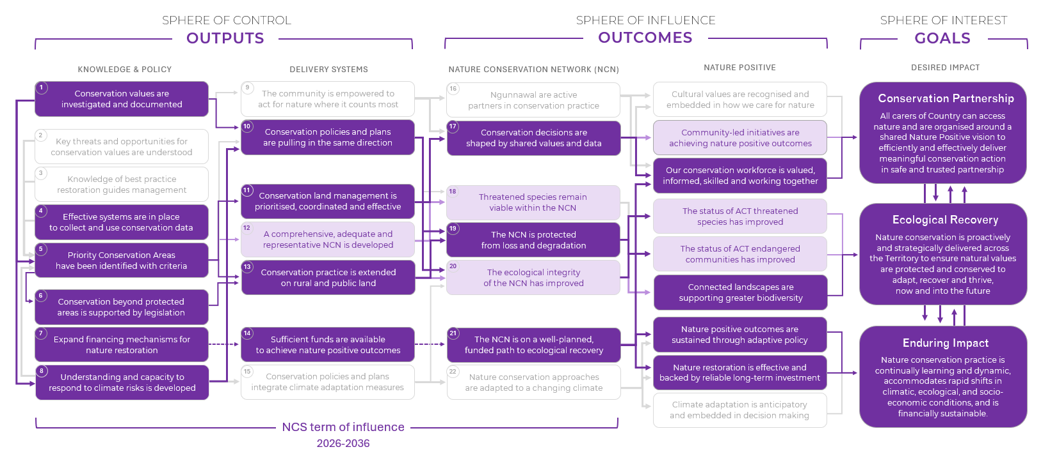
Figure 1. The NCS Theory of Change showing causal pathways for the achievement of landscape-scale conservation planning goals

Appendix B: Supplement B glossary
Term | Definition
ACT Landscape Plan | A set of planning and management framework that guide how ACT landscape and its assets—such as vegetation, open spaces, and nature strips—are protected, managed, and integrated into development across the Territory.
Biodiversity-Sensitive Urban Design (BSUD) | An approach to urban design that incorporates 5 core ecological principles to conserve and enhance biodiversity within urban and peri-urban environments. Specifically, BSUD requires designs to maintain or create habitat for target species, facilitate dispersal, minimise disturbance and other threats, facilitate natural processes, and facilitate positive human-native interactions.
Climate Resilience | Climate resilience in relation to conservation planning refers to the ability of ecosystems, species, and conservation systems (policies, plans, management tools, the NCN) to withstand, adapt to, and recover from the impacts of climate change. On the Landscape conservation planning, this would mean designing and managing natural areas in a way that they anticipate and respond appropriately to climate change impacts or hazards.
Conserved Area | A geographically defined area other than a Protected Area, which is governed and managed in ways that achieve positive and sustained long-term outcomes for the in-situ conservation of biodiversity, with associated ecosystem functions and services and where applicable, cultural, spiritual, socio-economic, and other locally relevant values. See also OECM; Other area-based Effective Conservation Measures.
Conserved Area Policy (CAP) | A policy framework that guides the identification, management of Priority Conservation Areas located outside of the formal protected area network. The management aspects of the PCAs that covers conservation and restoration objectives are set out by this policy based on the ecological, cultural, or climate resilience values and tenure they occur on. The policy will also outline the mechanisms for incentive schemes for supporting land custodians involved in contributing to nature conservation outcomes.
Critical Habitat | Habitat for a protected matter, species or ecological community that is critical to the long-term survival and recovery of that matter, species or community. An area will only become Critical Habitat if it is formally declared under the Nature Conservation Act.
District Strategy | District Strategies provide spatial plans for Canberra’s nine districts. They identify areas for growth and change, reflect local character, and guide development to support housing, services, transport, and sustainability. Each strategy aligns with the broader Planning Strategy and informs future zoning and development decisions.
Ecological Connectivity | The degree to which landscapes allow for the movement of species, ecological processes, and genetic exchange. Connectivity is crucial for ecosystem resilience and species survival, especially under climate change.
Ecological Transformation | The dramatic and effectively irreversible shift in multiple ecological characteristics of an ecosystem, the basis of which is a high degree of turnover in ecological communities.
Ecosystem Services | Ecosystem services are the benefits provided to humans through the transformations of resources (or environmental assets, including land, water, vegetation and atmosphere) into a flow of essential goods and services e.g. clean air, water, and food.
Fragmentation | Fragmentation here refers to Habitat Fragmentation, an umbrella term describing the complete process by which habitat loss or artificial barriers result in the division of large, continuous habitats into a greater number of smaller patches of lower total area, isolated from each other by a matrix of dissimilar habitats and is not just the pattern of spatial arrangement of remaining habitat. A matter gets worse if climate change and habitat fragmentation interact-a fragmented habitat will be isolated and disconnected, limiting species movement and reducing that climate adaptation potential. A connected habitat or landscape is therefore more resilient.
Functional Connectivity | A measure of how easily organisms can move across a landscape based on habitat suitability, spatial arrangement, and barriers. Often quantified through metrics like Probability of Connectedness (Pc).
Future-ready | Refers to a principle of landscape-scale conservation planning that is designed to be proactive, flexible, and resilient in the face of climate change and ecological uncertainty.
Harm Mitigation | Harm mitigation is the strategic process of avoiding, minimising, restoring, and offsetting ecological impacts, with a strong emphasis on avoiding development in Priority Conservation Areas (PCAs) to protect biodiversity and ecosystem function.
Landscape-scale Conservation | A strategic approach that considers entire ecosystems, habitats, ecological processes and services across large geographic areas, rather than focusing on individual sites or species.
Nature Conservation Act  (NC Act) | Referred here is the Nature Conservation Act 2014 (NC Act). It is the principal legislation of the ACT that provides the legal framework for the protection, conservation and enhancement of biodiversity of the Territory.
Nature Conservation Network (NCN) | A strategic, cross-tenure network of lands in the ACT under some form of long-term protection or conservation and active conservation management – including green corridors and climate refugia – managed for Nature Positive conservation outcomes. The NCN integrates formal reserves and PCAs beyond the formal protected network – including stewardship lands and urban green space and infrastructure – to deliver functional connectivity and ecological resilience across ACT landscapes.
Nature Positive | A term used to describe circumstances where nature – species and ecosystems – is being repaired and is regenerating rather than being in decline.
Other Effective Area-Based Conservation Measures (OECM) | Other area-based Effective Conservation Measures (also Conserved Area): A geographically defined area other than a Protected Area, which is governed and managed in ways that achieve positive and sustained long-term outcomes for the in-situ conservation of biodiversity, with associated ecosystem functions and services and where applicable, cultural, spiritual, socio-economic, and other locally relevant values. Includes private conservation agreements and community-managed lands.
Planning Strategy | The ACT Planning Strategy sets long-term goals for Canberra’s growth to 2050. It guides land use, infrastructure, and environmental planning to support a compact, sustainable, and resilient city, focusing new housing within existing urban areas and aligning development with community, climate, and transport priorities.
Priority Conservation Area (PCA) | Spatially defined areas identified as critical to achieving long-term Nature Positive conservation outcomes in the ACT. PCAs may include land both within and beyond the formal protected area network, including urban open space and rural leased lands. PCAs will contain critical habitat plus the area needed to support critical ecosystem function, providing focus for recovery programs and financial investment. These areas will be determined by strategic decision-making to align with Planning priorities, ensuring development is avoided in these critical areas to support functional connectivity and climate resilience.
Protected Area | A clearly defined geographical space, recognised, dedicated and managed, through legal or other effective means, to achieve the long-term conservation of nature with associated ecosystem services and cultural values.
Reserve | Refers to wilderness areas, national parks, nature reserves, catchment areas and special purpose reserves prescribed in Schedule 1 of the Nature Conservation Regulation 2015 (NC Regulations) that are protected under the NC Act.
Restoration Contribution | A mechanism for offsetting biodiversity losses from development by contributing financially to a dedicated fund to support habitat restoration, stewardship, or conservation actions elsewhere.
Restoration Contribution Policy (RCP) | A policy instrument under the NC Act that governs how financial contributions for biodiversity loss are calculated, collected, and allocated to achieve nature positive outcomes.
Stewardship | The active management and care of land to maintain or enhance its conservation values, often undertaken by private or community landholders through formal agreements or incentive schemes.
Territory Plan | The Territory Plan is the ACT’s statutory planning instrument under the Planning Act 2023. It regulates land use and development through zones, policies, and codes. It ensures development aligns with strategic planning goals and provides the legal basis for assessing development applications.
Urban Open Space (UOS) | Public land reserved under the territory plan as ‘urban open space’ with a primary objective to provide for public and community use of the area, or develop the area for public and community use.

Supplement C to the ACT Nature Conservation Strategy 2026–2036
Effective restoration practice in the ACT
This supplementary document translates the NCS vision for a connected Nature Positive landscape into policy and technical guidance to support proactive, accountable, and coordinated decision-making.
City and Environment Directorate
Insert Directorate

Table of Contents
Table of Contents 2
Ecosystem restoration in the ACT 4
What is restoration? 4
Why does restoration matter? 4
Our strategic approach to restoration 5
Appendix A: Causal pathways toward better restoration practice 13
Appendix B: Supplement C glossary 14

Ecosystem restoration in the ACT

What is restoration?
The ACT Government is committed to the restoration of ecosystems that have experienced degradation, damage, or destruction. Ecosystem restoration is defined as the process of assisting the recovery of such ecosystems to a state that reflects the structure, function, and trajectory of a comparable, healthy reference ecosystem.
Importantly, restoration does not aim to return ecosystems to a pristine state as defined at a fixed point in the past—often pre-1750. Instead, the restoration target represents the highest and most achievable level of recovery, acknowledging contemporary environmental conditions and constraints. This approach allows for changes in ecosystem conditions due to factors such as climate, and changes that may not be recoverable (such as several pest plants, animals and uncontrollable pathogens, urbanisation), while still reducing threats and promoting native species and ecological function.
To ensure restored ecosystems are resilient and functional under anticipated temperature and precipitation changes over the coming decades, restoration must use sing a mix of climate-informed restoration practices. This will become an increasingly important element of ecosystem restoration as the intensity and rate of climate change increases.
Restoration activities in the ACT involve targeted physical interventions aimed at halting ongoing degradation and re-establishing ecological integrity and function. These efforts are guided by scientific research, climate and spatial analysis, and long-term ecological monitoring.
In the ACT, ecosystem restoration is a collaborative, cross-tenure endeavour. It actively engages the ACT community, farmers, public and private land managers, researchers, restoration practitioners, and Traditional Owners. This inclusive approach ensures that diverse knowledge systems and expertise contribute meaningfully to restoration outcomes.
A primary objective of this document is to develop and implement effective methods and resources that enhance the extent, condition, and resilience of native ecosystems across the ACT.

Why does restoration matter?
Historic and ongoing land use, water management practices and urbanisation have significantly altered the extent, connectivity, and condition of native ecosystems in the ACT. Many of the ACTs remnant ecosystems support unique plant and animal species which are found only in south-eastern Australia, including several that are rare, threatened, or endemic to the ACT.
The introduction and spread of invasive plant species and feral animals have added further ecological stress, contributing to the degradation of native terrestrial and riparian ecosystems. These pressures have led to the loss of species, ecological communities, and essential ecosystem functions, undermining biodiversity, cultural values, and the wellbeing of communities that depend on ecosystem services.
Without effective and sustained restoration, the distinctive landscapes, flora and fauna of the ACT face increasing threats and irreversible loss. However, restored ecosystems are more resilient to disturbances and shocks and therefore reduce the long-term costs of managing environmental threats and change. Ecosystem restoration delivers both ecological and social benefits, including:
- Enhanced ecosystem services (e.g. clean air, water, and soil health)
- Increased areas of high-quality, connected native habitat
- Improved outcomes for threatened species
- Greater community engagement in environmental stewardship
- Expanded access to healthy natural spaces, including parks and reserves and waterways
- Supporting climate change mitigation and adaptation
These outcomes support the ACT’s broader environmental, cultural, and social objectives.

Our strategic approach to restoration
The following section draws from the ‘National Restoration Standards for restoration in Australia’¹, adapted from the ‘International principles and standards for the practice of ecological restoration’. These six principles and standard have been developed to support restoration and are detailed below in reference to how the ACT is applying these to restoration in future.

Principle 1: Ecological restoration practice is based on an appropriate local indigenous reference ecosystem.
“A model adopted to identify the particular ecosystem that is the target of the restoration project. This involves describing the specific compositional, structural and functional ecosystem attributes requiring reinstatement before the desired outcome (the restored state) can be said to have been achieved.”1

Reference Ecosystems and Benchmarking in the ACT
A reference ecosystem serves as the target condition for restoration projects. According to Principle 1 of the ‘National Restoration Standards’1, full recovery is achieved when a site reaches a comparable ecological condition and trajectory to its reference ecosystem. Importantly, the reference ecosystem is not a fixed historical state; it incorporates anticipated changes due to global climate change and reflects a dynamic restoration target that can be seen as the highest and best level of recovery possible.
To implement Principle 1, the ACT Government is developing Reference Ecosystem Benchmarks for each Plant Community Type (PCT). PCTs are spatial polygons that define the type and extent of known vegetation communities within the ACT , and are similar to the PCT found in BioNet in NSW. We use them here to define different communities based on similar abiotic and biotic elements. These communities will also likely have similar threats and restoration interventions.
While these PCTs are focussed on terrestrial ecosystem, a similar approach of defining different aquatic communities can and should be developed. For example, based on physical geomorphic, structural component and flow type.
Reference Ecosystem Benchmarks for PCTs are being established using 15 years of monitoring data from the highest-quality sites available. These benchmarks represent high ecological condition, defined by ecosystem function, vegetation structure, species composition, and faunal assemblages. To ensure accuracy, multiple sites are used to account for natural variability, and exotic species are excluded. Where data on benchmark values is lacking, we will refer to NSW BioNet Vegetation Condition Benchmarks.
Benchmarks have been developed for the following PCTs:
- PCT 1: Natural Temperate Grassland
- PCT 16: Yellow Box – Blakely's Red Gum Grassy Woodland
- PCT 18: Broad-leaved Peppermint – Apple Box Tableland Woodland
- PCT 25: Red Stringybark – Scribbly Gum Tableland Forest
As monitoring coverage expands, additional benchmarks will be developed for other vegetation, wetland and riparian communities across the ACT. Benchmarks for water ecosystems can and should also be developed around the same principles by defining different states based on presence and absence of key components e.g. floodplain presence, underwater structural habitat, water quality.
In applying this principle, the ACT Government will contribute to the following Nature Conservation Strategy (NCS) targets:
- Critical datasets required to achieve Nature Positive objectives are maintained
- Representation of ecosystems in existing protected areas is assessed

Principle 2: Restoration inputs will be dictated by level of resilience and degradation
“Skilful assessment of the capacity for natural recovery should be done prior to prescribing whether regeneration-based or reintroduction-based approaches are needed. This is essential to optimise success but is also important to assist prioritisation.”1

Ecosystem Resilience and Degradation in the ACT
Ecosystems vary in their level of intactness and function, and a greater level of intervention is needed where an ecosystem is degraded and non-functioning (Figure 1). Improving function and intactness is the basis for restoration. ACT PCTs have been further stratified into ‘zones’, which reflect the current ecological condition of PCTs relative to benchmark thresholds. We use the PCT zone condition states to classify (see Principle 1) ecosystems by their level of degradation and resilience, combined with on ground monitoring to assess the exact level of ecological condition (Principle 4).

Ecological Restoration Approaches in the ACT
Selecting an appropriate restoration approach based on the degree of ecosystem degradation and resilience is essential to achieving effective and cost-efficient ecological recovery. In the ACT, three primary restoration approaches defined in ‘National Restoration Standards’1 are recognised:
- Facilitated Natural Regeneration
This approach is applied to areas with high ecological resilience. Restoration efforts focus on the active and ongoing removal of threats such as invasive plant species and feral animals. Revegetation is not required, as native species are present in sufficient numbers to regenerate naturally once competition is reduced. The objective is to shift the ecological balance in favour of native species dominance.
- Assisted Regeneration
This method is used where key components of the ecosystem—such as native understorey, shrubs, trees, or characteristic fauna—are absent or severely diminished. Natural regeneration is limited, and recovery must be supported through interventions such as direct seeding, planting of tube stock, species translocations, and habitat enhancements (e.g. coarse woody debris). Threat management remains an integral part of this approach.
- Reconstruction
Applied to sites that are severely degraded or ecologically collapsed, this approach requires intensive intervention to re-establish ecosystem function. Techniques may include landform reconstruction, soil remediation, reconnection of waterways and natural flows, and the reintroduction of native plant and animal species. Ongoing threat control is essential to support long-term recovery and alignment with reference ecosystem benchmarks.
Each site may exhibit varying levels of degradation across different ecological attributes, and as such, a combination of these approaches may be applied to achieve restoration objectives. All restoration approaches require the ongoing removal of threats (weeds, pests, poor environmental flows, obsolete infrastructure) to reach full recovery, which is when country is healthy, self-sustaining, resilient and on the same trajectory as the reference ecosystem.
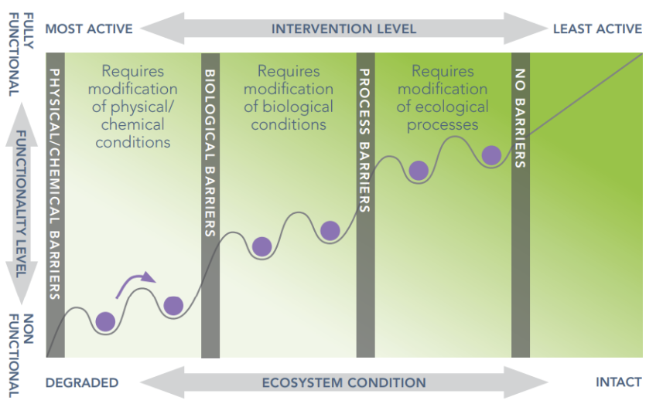
Figure 1. Conceptual model of ecosystem degradation and restoration. (Adapted from Keenleyside et al 2012, after Whisenant 1999, and Hobbs & Harris 2001). The troughs in the diagram represent basins of stability in which an ecosystem property (ball) can remain in a steady state prior to being shifted by a restoration activity past a barrier (peaks) towards a higher functioning state. Notes: (1) Cessation or mitigation of the original drivers of degradation at the site (e.g. land clearing, mining, grazing, etc.) is assumed to have already occurred as the first stage of the restoration; (ii) A site’s pre-restoration condition may start at any point along the trajectory; (iii) Biological barriers can be complex (not necessarily involving lack of propagules); (iv) In some cases overcoming one barrier type (e.g. physical-chemical barriers) may be sufficient alone; and, (v) small barriers of any type may occur in any sequence along the degradation/ recovery trajectory. Cited from SERA 20211.

Restoration Prioritisation and Spatial Planning
To implement Principle 2, the ACT Government has developed the ACT Restoration Priority Map, a spatial decision-support tool that identifies priority areas for ecological restoration. This map integrates ecological condition data and overlays it onto Plant Community Types (PCTs) to identify the highest functioning and most intact areas, to the least functioning and intact areas. Currently, the map is limited to several terrestrial ecosystems, but could be expanded to riparian and waterway ecosystems. The map provides filtered views that suggest the most likely restoration approach for each area, based on available data. It also highlights missing ecological components and estimates the cost of reintroducing those elements, supporting informed and strategic restoration planning across the ACT.
In applying this principle, the ACT Government will contribute to the following NCS targets:
- Priority conservation values are identified
- A map of Priority Conservation Areas (PCAs), reflecting critical habitats, is created
- A spatialised community conservation guide is created

Principle 3: Recovery of ecosystem attributes is facilitated by identifying clear targets, goals and objectives.
“A restoration project will have greater transparency, manageability and improved chances of success if the restoration targets and goals are clearly defined and translated into measurable objectives. These can then be used to monitor progress over time, applying adaptive management approaches.”1

Restoration Planning and Implementation
To support the implementation of Principle 3, the ACT Government has developed a Restoration Planning Template to guide the design and delivery of restoration projects. This tool assists practitioners in defining restoration actions over an annual cycle and aligning them with long-term ecological goals.
The planning framework includes:
- Goals (5–10 years): Broad, long-term ecological outcomes.
- Targets: Specific benchmarks aligned with reference ecosystem.
- Objectives (annual): Clearly defined steps toward achieving targets.
Objectives must be SMART (Specific, Measurable, Achievable, Reasonable, and Time-bound) and should be developed collaboratively with all relevant stakeholders, in accordance with Principle 6.
The planning process is supported by a Restoration Planning Checklist, developed by the Australian Association for Bush Regenerators (AABR), and aligned with the principles of the ‘National Restoration Standards’1. This checklist ensures consistency, accountability, and alignment with best-practice ecological restoration standards. The list is:
- Resourcing
- Stakeholder engagement
- External context assessment
- Reference ecosystem identification
- Baseline inventory of ecological values and threats
- Risk management
- Targets, goals and objectives
- Restoration treatment planning
- Planning of monitoring, evaluation and reporting
In applying this principle, the ACT Government will contribute to the following NCS targets:
- Threats to priority conservation values are identified and evaluated
- Critical knowledge gaps in management effectiveness are addressed
- A policy and financing mechanism to fund nature restoration is created
- Preparedness, response and recovery planning for priority values is undertaken
- A spatialised community conservation guide is created
- Land managers are engaged in conservation-focused biosecurity actions
- Representation of ecosystems in existing protected areas is assessed
- Restoration of PCAs is delivered with Ngunnawal
- The loss of priority conservation values to weeds is halted or reversed
- Appropriate fire regimes are maintained across the Nature Conservation Network (NCN)
- Active and effective restoration is sustained on at least 50% of PCAs

Principle 4: The goal of ecological restoration is full recovery, insofar as possible, even if outcomes take long timeframes or involve high inputs.
“Qualification of a project as an ecological restoration activity is not determined by the duration of the project but by the intent to achieve the highest and best level of recovery possible.”1

Monitoring Recovery and Adaptive Management
Full ecosystem recovery is shaped by a range of factors, including the site's baseline condition, biotic and abiotic interactions, seasonal and climatic variability, and the type and intensity of restoration interventions. Recovery is a long-term process that may span several decades—often between 30 and 100 years—and requires consistent, sustained investment.
In many cases, full recovery to historical conditions may not be feasible due to irreversible changes such as dam construction, species extinctions, or landscape transformation. However, the goal remains to achieve the highest possible level of ecological recovery possible given conditions.
Reliable funding and long-term commitment are essential for meeting this principle. Without it, restoration gains can be lost, leading to declines in biodiversity, degradation of high-quality ecosystems, and erosion of financial investments, public confidence, and institutional trust.
Understanding the condition of a site is critical for effective restoration planning, adaptive management, and measuring progress toward the reference ecosystem. Monitoring recovery trajectories helps ensure that restoration efforts remain on track and that ecological improvements are being achieved over time.
To implement Principle 4, the ACT Government uses the ACT Recovery Wheel, a tool that applies quantitative metrics to monitor ecological recovery over time. The Recovery Wheel supports long-term project continuity and helps safeguard restoration outcomes.
Key features include:
- Six core attributes of a reference ecosystem, each with associated sub-attributes.
- Ecological indicators scored on a scale from 1 (lowest condition) to 5 (equivalent to reference condition).
- Visual representation of baseline condition and changes over time (Figure 2).
The Recovery Wheel enables practitioners to:
- Rapidly assess the ecological condition of a site.
- Identify missing components relative to the reference ecosystem.
- Inform restoration goals and site-specific actions.
- Monitor ecological change through repeated assessments.
- Support adaptive management and guide annual planning.
- Track recovery over long timespans, acknowledging that some ecosystems can be difficult to recover
Recovery Wheel scores for individual sites and across the ACT will be made available through an Ecological Condition Dashboard, providing transparency and supporting evidence-based decision-making.
In applying this principle, the ACT Government will contribute to the following NCS targets:
- Critical knowledge gaps in management effectiveness are addressed
- Critical datasets required to achieve Nature Positive objectives are maintained
- Management effectiveness of PCAs is evaluated
- Impact thresholds of priority pests are identified and managed to in PCAs
- Loss of PCA extent is reduced to near zero
- The loss of priority conservation values to weeds is halted or reversed
- Active and effective restoration is sustained on at least 50% of PCAs
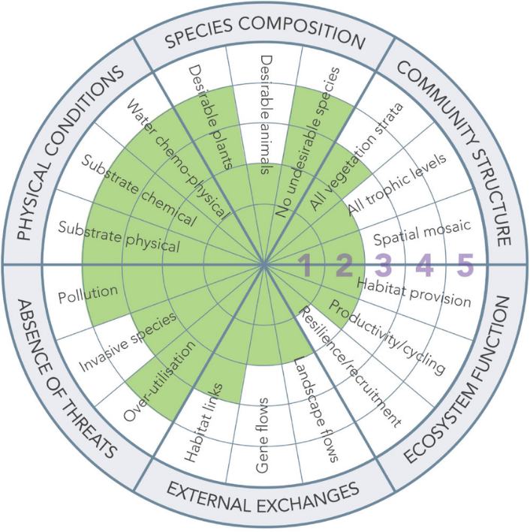
Figure 2. Example of a recovery wheel filled in against the condition across the indicators and six core attributes.

Principle 5: Restoration science and practice are synergistic.
“The practice of ecological restoration requires a high degree of ecological knowledge that can be drawn from practitioner experience, Traditional Ecological Knowledge, Local Ecological Knowledge and scientific discovery. These forms of knowledge are the product of observation, experimentation, and trial and error, whether formal or informal.”1

Collaboration and Improving Restoration Knowledge
Restoration is most effective when we understand the ecological processes that support recovery. Working together helps achieve better outcomes, build knowledge, and improve restoration methods over time. Principle 5 is applied in several ways to support learning and collaboration in the ACT. Active collaboration between ecologists, climate and spatial scientists, database managers, species experts, Traditional Custodians, practitioners and community contributes to addressing knowledge gaps that ensure nature positive, climate-resilient ecosystem restoration into the future.
The Environment, Heritage & Planning (EHP) Restoration Steering Committee was formed in 2023 to coordinate and oversee restoration work in the ACT. Its Terms of Reference have been agreed upon by representatives from across the ACT Government. The committee ensures that all groups work together with a shared strategy and common restoration goals.
In 2024, an internal ACT Government working group was established to facilitate knowledge sharing and improve internal processes. This Restoration Community of Best Practice brings together field practitioners and researchers to discuss and solve restoration challenges they face in their work.
This principle is also supported by the development and use of a Spatial Database Tool to track restoration activities across the ACT estate. This tool allows users to link restoration actions to specific targets and record project details, including site locations, actions taken, and associated effort and costs. This tracking helps assess the effectiveness of restoration work and provides valuable insights into recovery progress, best practices, and cost-efficiency. While currently in development, the aim is to allow all restoration practitioners (Government and non-Government) to enter their restoration activities into this database, to learn and plan restoration together.
The ACT Government plans to establish an annual seminar series to promote collaboration and knowledge sharing across the ACT Community.
In applying this principle, the ACT Government will contribute to the following NCS targets:
- Threats to priority conservation values are identified and evaluated
- A threat prioritisation framework is developed
- Critical knowledge gaps in management effectiveness are addressed
- Critical conservation datasets are collected in a standardised way
- Critical datasets required to achieve Nature Positive objectives are maintained
- A spatialised community conservation guide is created
- Restoration of PCAs is delivered with Ngunnawal
- Management effectiveness of PCAs is evaluated.
- The NCS Indicator Framework is reported on biennially

Principle 6: Social aspects are critical to successful ecological restoration
“Without considering social values and benefits, particularly relationships between a site and its stakeholders, a restoration project may not gain the social support needed for success and may fail to deliver important benefits to ecosystems and to society.”1

Stakeholder Engagement in Restoration Planning
Securing stakeholder agreement is essential to clearly define the goals and targets of a restoration project, identify funding sources, clarify roles and responsibilities, and build collaboration. Effective stakeholder involvement leads to stronger community support, fewer conflicts, and more successful restoration outcomes. Large-scale restoration projects should include Traditional Custodians early in the planning process. Their perspectives, cultural knowledge, and preferred ways of working must be respected and integrated. This inclusive approach fosters a deeper, shared understanding of ACT Country and supports more meaningful and lasting restoration outcomes. Box 6 provides an excerpt from the ‘National Restoration Standards’1 on Traditional Custodian restoration (SERA 20211).
Box 6. Indigenous peoples and restoration
Indigenous peoples in Australia are the oldest continuous culture on Earth and are well placed to teach other Australians more appropriate ways to live within and manage Australian ecosystems. As a result of this recognition, Indigenous groups can and do play a major role in ecological restoration and rehabilitation practice and research, including that relating to the improved management of social-ecological systems.
About 40% of Australia’s land mass is recognized under Australian law as Indigenous-owned, with much land and water still under claim or viewed as never ceded. Caring for Country is a traditional and contemporary practice both within remote Indigenous lands and lands closer to regional and urban centres. Many Indigenous peoples are utilising their land, social capital, and ecological knowledge to better their people and environment, working in collaboration with all other sectors of society
Ecological restoration and rehabilitation activities are a major source of employment for Indigenous Australians and help to reconnect younger generations with their cultural heritage from which they have been, and continue to be, actively dispossessed. As such, benefits can and must flow from restoration to Indigenous peoples, a process that will benefit the whole of society as the world seeks to rebuild a more restorative relationship between our species and the rest of nature.
Many actions already mentioned in this document will help meet this principle. For example, the ACT Restoration Priority Map (Principal 2), Restoration Planning Template (Principle 3), Spatial Database Tool (Principle 4), Restoration Community of Best Practice (Principle 5) will provide multiple avenues for stakeholder consultation as a core part of project planning.
In applying this principle, the ACT Government will contribute to the following NCS targets:
- A Stewardship Scheme for rural lands is introduced
- A spatialised community conservation guide is created
- Restoration of PCAs is delivered with Ngunnawal

Appendix A: Causal pathways toward better restoration practice
Figure 3 illustrates the causal pathways identified in the NCS Theory of Change that are necessary and sufficient for the achievement of ecological restoration goals. Primary causal links are indicated by dark shading and arrows, supporting causal links are indicated by lighter shading and arrows.
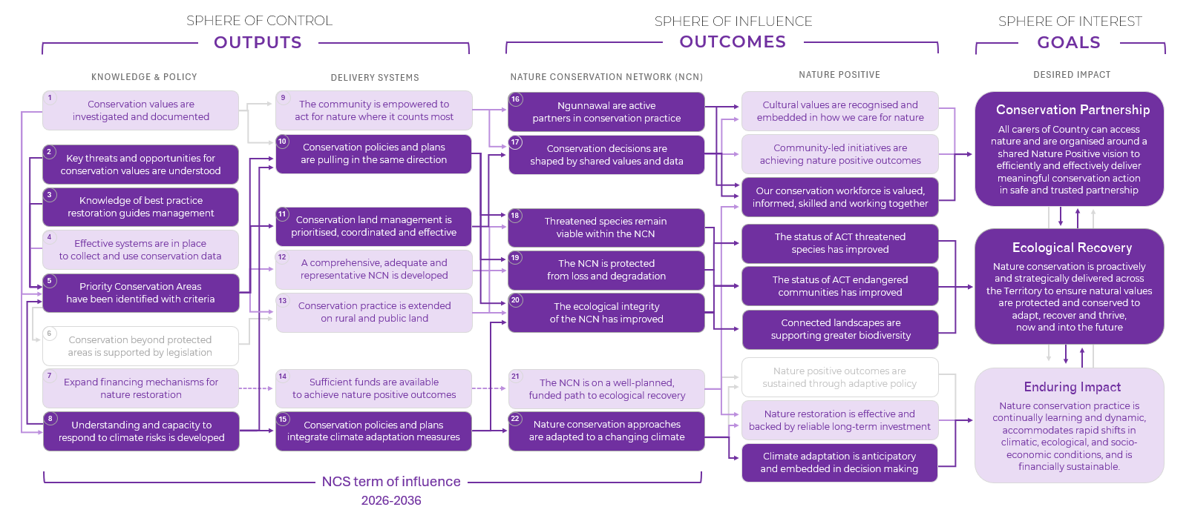
Figure 3. The NCS Theory of Change showing causal pathways for the achievement of ecological restoration goals

Appendix B: Supplement C glossary
Term | Definition
Abiotic | The non-living components of an ecosystem such as water, sunlight, soil, temperature.
ACT Recovery Wheel | A tool that applies quantitative metrics to monitor ecological recovery over time.
ACT Restoration Priority Map | Spatial decision-support tool that identifies priority areas for ecological restoration. This map integrates ecological condition data and overlays it onto Plant Community Types (PCTs) to identify the highest functioning and most intact areas, to the least functioning and intact areas.
Assisted Regeneration | Natural regeneration is limited, and recovery must be supported through interventions such as direct seeding, planting of tube stock, species translocations, and habitat enhancements (e.g. coarse woody debris). Threat management remains an integral part of this approach.
Australian Association for Bush Regenerators (AABR) | AABR is an association incorporated under the Associations Incorporation Act 1984 NSW. It is managed by committee of volunteers. It was established in 1986, out of concern for the continuing survival and integrity of bushland and its dependent fauna. Its aim is to promote the study and practice of ecological restoration and foster and encourage effective management of natural areas by qualified people, based on sound ecological principles.
Baseline Condition | Refers to the initial ecological state of a site before restoration or intervention begins. It serves as the reference point for assessing change, planning restoration actions, and measuring progress toward recovery.
Biodiversity | The variability among living organisms from all sources (including terrestrial, marine and other aquatic systems and the ecological complexes of which they are part) and includes diversity within species and between species, and of ecosystem.
Biotic | The living components of an ecosystem such as plants, animals, bacteria, fungi.
Causal Pathway | A backwards mapping from a strategic goal through all the long and short-term outcomes to the outputs needed to achieve it, identifying a logic arrangement of causal links between these.
Ecological Condition Dashboard | A digital platform that provides transparent, accessible, and spatially explicit information on the ecological condition and recovery progress of conservation sites across the ACT.
Ecosystem Degradation | The decline in the health and functionality of an ecosystem from environmental damage and resulting in the loss of biodiversity, reduced ecosystem services, and impaired ecological processes.
Ecosystem Function | It refers to the processes and activities within an ecosystem that are essential for the ecosystem to function properly and provide services that have social, cultural and ecological values.
Ecosystem Resilience | The ability of natural areas (ecosystems) to persevere and adjust despite changes and disturbances as a result of changing land use and climate change impacts. Resilience depends upon the continuity of ecological processes such as energy flows, nutrient cycles, hydrological cycles and food webs.
Ecosystem Restoration | The process of assisting the recovery of such ecosystems to a state that reflects the structure, function, and trajectory of a comparable, healthy reference ecosystem (SERA 2021).
Endemic | In the context of a plant or an animal species, endemic refers to a species that is unique to a specific geographic location and found nowhere else in the world.
Environmental Stewardship | The active management and care of land to maintain or enhance its conservation values, often undertaken by private or community landholders through formal agreements or incentive schemes.
Facilitated Natural Regeneration | Restoration efforts that focus on the active and ongoing removal of threats such as invasive plant species and feral animals. Revegetation is not required, as native species are present in sufficient numbers to regenerate naturally once competition is reduced.
Fire Regime | It refers to the natural pattern, frequency, and intensity of fires that occur in a particular ecosystem over time.
Full Recovery | When country is healthy, self-sustaining, resilient and on the same trajectory as the reference ecosystem.
Invasive Species | Introduced plants and animals that can establish quickly and spread to the point of threatening native communities and ecosystems.
Nature Conservation Network (NCN) | A strategic, cross-tenure network of lands in the ACT under some form of long-term protection or conservation and active conservation management – including green corridors and climate refugia – managed for Nature Positive conservation outcomes. The NCN integrates formal reserves and PCAs beyond the formal protected network – including stewardship lands and urban green space and infrastructure – to deliver functional connectivity and ecological resilience across ACT landscapes.
Nature Conservation Strategy (NCS) | A plan or a statement of proposals that guides to protect, manage and conserve native species indigenous to the ACT, and significant ecosystems of the territory. It contains strategies to address actual and potential impacts of climate change and includes anything required to be included by a conservator guideline.
Nature Positive | A term used to describe circumstances where nature – species and ecosystems – is being repaired and is regenerating rather than being in decline.
NCS Indicator Framework | A structured tool that defines measurable indicators for outputs, outcomes, and impacts defined under the NCS, enabling one to measure progress and evaluate achievements towards positive ecological, cultural and social gains.
Outcomes | Flow-on effects expected to result from our strategic outputs interacting with other things happening in the wider world; these may be short to long-term. Outcomes can also be described as pre-conditions for achieving a goal.
Outputs | The immediate results of activities within the sphere of control of the Strategy to deliver.
Priority Conservation Area (PCA) | Spatially defined areas identified as critical to achieving long-term Nature Positive conservation outcomes in the ACT. PCAs may include land both within and beyond the formal protected area network, including urban open space and rural leased lands. PCAs will contain critical habitat plus the area needed to support critical ecosystem function, providing focus for recovery programs and financial investment. These areas will be determined by strategic decision-making to align with Planning priorities, ensuring development is avoided in these critical areas to support functional connectivity and climate resilience.
Plant Community Type (PCT) | Spatial polygons that are mapped based on defined Plant Community Types; a specific assemblage of plant species that are determined to make up an ecological community, e.g. Natural Temperate Grassland of the South-Eastern Tablelands or White Box-Yellow Box-Blakely’s Red Gum Grassy Woodland.
Reconstruction | A restoration approach that requires intensive intervention to re-establish ecosystem function. Techniques may include landform reconstruction, soil remediation, reconnection of waterways and natural flows, and the reintroduction of native plant and animal species. Ongoing threat control is essential to support long-term recovery and alignment with reference ecosystem benchmarks.
Reference Ecosystem Benchmark | A set of ecological benchmarks derived from data that define reference ecosystems.
Reference State | The highest and best level of recovery possible as defined by reference ecosystem benchmarks.
Remnant Ecosystem | A patch of native vegetation or habitat that has survived clearing, degradation or any other human intervention as a result of protection, resilience, geographical or environmental factors.
Reserve | Refers to wilderness areas, national parks, nature reserves, catchment areas and special purpose reserves prescribed in Schedule 1 of the Nature Conservation Regulation 2015 (NC Regulations) that are protected under the NC Act.
Resilience | The ability of natural areas (ecosystems) to persevere and adjust despite changes and disturbances as a result of changing land use and climate change impacts. Resilience depends upon the continuity of ecological processes such as energy flows, nutrient cycles, hydrological cycles and food webs.
Revegetation | The process of re-establishing native vegetation in an area where it has been lost or significantly reduced. Under the restoration approach, the assisted and reconstruction stages require revegetation intervention because natural regeneration becomes limited.
Society for Ecological Restoration (SERA) | The Society for Ecological Restoration Australasia (SERA) is a neutral, independent, non-profit organisation that connects restoration industries across Australasia and through the peak international body for restoration (SER) globally. SER advances the science, practice and policy of ecological restoration to sustain biodiversity, improve resilience in a changing climate, and re-establish an ecologically healthy relationship between nature and culture.
SMART targets | A Specific, Measurable, Achievable, Realistic and Time-bound statement for what should be accomplished. In this Strategy, each target will be directly linked to an objective and act as quantitative benchmarks for evaluating success of the Strategy.
Theory of Change (ToC) | Theory of change in terms of the NCS is a logical explanation of how specific actions are connected to the outputs, outcomes and goals. It maps the steps and pathways needed to achieve short, middle term and long-term conservation outcomes.
Transformer Weed | Invasive plant species that have impact to the extent that they change the character, condition, form or nature of ecosystems over a substantial area relative to the extent of that ecosystem.

Climate change in Australia. Accessed 24/6/2025 at: https://www.climatechangeinaustralia.gov.au/en/changing-climate/future-climate-scenarios/global-warming-levels/australian-warming/
Australia’s Strategy for Nature 2024-2030, Commonwealth of Australia 2024.
Michael J. Drielsma, et al. (2017). Bridging the gap between climate science and regional-scale biodiversity conservation in south-eastern Australia, Ecological Modelling, Volume 360, (343-362).
Schuurman et al. (2021) Navigating Ecological Transformation: Resist–Accept–Direct as a Path to a New Resource Management Paradigm.
Ferrier S., Harwood T. & Williams K. J. (2012) Using Generalised Dissimilarity Modelling to assess potential impacts of climate change on biodiversity composition in Australia, and on the representativeness of the National Reserve System. CSIRO Climate Adaptation 62 Flagship Working Paper No. 13E. http://www.csiro.au/en/Organisation-Structure/Flagships/Climate-Adaptation-Flagship/CAF-working-papers.aspx
Hilbert D. W. & Fletcher C. S. (2012) Using artificial neural networks to assess the impacts of future climate change on ecoregions and major vegetation groups in Australia. CSIRO Climate Adaptation Flagship Working Paper No. 13H.
Climate Change Risk Assessment for the ACT, 2022.
Webb, B (2011) Impacts of Climate on the Canberra Nature Park: Risks and Responses. Report for the ACT Office of the Commissioner for Sustainability and the Environment.
Figure Source: Alexandra C & Dunlop M (in prep), adapted from Mason, Claire; Hartog, Jason; NESP 2.7 AdaptLog Core Team (2024): Adaptation Catalogue for Conservation (AdaptLog). CSIRO. http://hdl.handle.net/102.100.100/614570?index=1
Fitzsimons, J. A., Hazin, C., & Smith, J. L. (2025). Common misconceptions of ‘other effective area-based conservation measures’ (OECMs) and implications for global conservation targets. Biodiversity, 4(1), 8.
Kirk, H. et al. (2023) ‘Ecological connectivity as a planning tool for the conservation of wildlife in cities’, Methods, 10.
Standards Reference Group SERA (2021) National Standards for the Practice of Ecological Restoration in Australia. Edition 2.2. Society for Ecological Restoration Australasia.
Gann, G.D., McDonald, T., Walder, B., Aronson, J., Nelson, C.R., Jonson, J., Hallett, J.G., Eisenberg, C., Guariguata, M.R., Liu, J. and Hua, F. (2019). International principles and standards for the practice of ecological restoration. Restoration Ecology. 27 (S1): S1-S46, 27(S1), pp.S1-S46.
AABR Restoration Planning Checklist

