

Engagement experience
of canberrans
Engagement REPORT
Chief Minister, treasury and economic development Directorate
february 2019

ContentS
Executive Summary 3
why we engaged 4
TiMELine of EngagemeNT 5
What we heard 6
Summary of key insights from the engagement 6
what we asked 7
who we heard from and how 7
THE RESULTS OF the engagement IN DETAIL 8
SAMPLE OF online CommentS RECEIVED 11
NEXT STEPS 12
Appendices 13
A Online survey questions 13
B ONLINE SURVEY RESULTS 15
C Phone Survey Questions and results 19

Executive Summary
The ACT Government has committed to more representative engagement with the
ACT community. The Whole of Government Communication and Engagement Strategy 2017 to 2019 was launched with a commitment that government is working towards:
- greater coordination of projects and initiatives that need the community’s views
- improved listening through engagement activities and across government to ensure the right areas of government hear the views of the community, and
- improvement in ‘closing the loop’ and giving feedback on how the views, time and energy of the community has contributed to decisions and outcomes.
With the purpose of better understanding the engagement experience of Canberrans, at the beginning of 2018 the Chief Minister, Treasury and Economic Development Directorate (CMTEDD) surveyed the community about their engagement experience via telephone and online. The key themes in the feedback indicated that while the ACT Government’s online engagement platform YourSay was relatively user-friendly and accessible, the directorate could improve awareness of the website. The feedback indicated a need to improve accountablity in providing feedback and outcomes of engagement processes, and to better report on how different groups and stakeholders are involved in engagements.
The feedback received led to the introduction of Reports on What We Heard and guidelines for more timely engagement or consultation reports for engagements on YourSay. It has also helped refine what is included on YourSay engagements.
An updated Whole of Government Communications and Engagement Plan was released in February 2019. A follow up survey opened at the same time.

why we engaged

Understanding the engagement challenge
A telephone survey conducted in 2017 found 33% of the Canberran community actively sought to engage with the ACT government.
However, how Canberrans were experiencing the government’s engagement and consultation activities was not well understood.
Given the anecdotal and general nature of engagement experience feedback, it has been difficult to detach the engagement experience from the actual subject or topic of the engagement. It has not been a routine part of engagement or consultation activities to seek feedback on the process of engagement or how people experienced the process.

Measuring the engagement experience
To improve engagement practices within government and the engagement experiences of the community and stakeholders, it is important to understand engagement participant’s satisfaction or support for the process.
In much the same way that customer experience is measured, this engagement took the principles that guide engagement activities and asked a series of simple questions to determine what kind of an engagement experience was delivered.

ACT Government Engagement Principles:
- We provide meaningful engagements where the community has clear, relevant and timely information to help shape decisions.
- We are accountable when we engage and we give the community feedback to help them understand how they are contributing to decisions, projects and policies.
- We are responsive to the community seeking to grow strong relationships for future collaboration and cooperation.
- We are inclusive and respectful when we engage, finding ways to ensure engagement is equitable.

Engaging on the experience
From 14 February to 23 March 2018, the Canberra community was invited to share their engagement experiences through a survey on the YourSay online engagement platform. The government launched a new, regular YourSay email newsletter for subscribers, directing people to participate in the survey. The e-newsletter now is delivered regularly and highlights new opportunities to have your say as well as provides updates and outcomes on previous projects.
A statistically representative telephone survey of Canberrans was conducted in March 2018 to gauge general community awareness of the YourSay platform.
The conversation has continued beyond the survey and representatives of CMTEDD have been meeting with key stakeholders such as the ACT Council of Social Service and the Combined Community Councils to understand experiences in greater depth.
A Report on What We Heard was released on YourSay in November 2018 when stakeholder meetings had concluded.
QUICK STATS
600  Survey responses via phone survey | 288  Survey responses via YourSay | 33%  awareness of YourSay | 81%  found YourSay easy to use | 6,000  subscribers to the new YourSay e-newsletter

TiMELine of EngagemeNT

What we heard

Summary of key insights

Why the community engages
- Almost 60% of respondents to the YourSay survey said they participate in engagements to seek out more information on projects or initiatives, with the remainder participating because they either agree or disagree with the subject of the engagement.

How the community engages
- When asked how they engage with government, most respondents to the online research said they read the Our Canberra newsletter or visit YourSay. Lodging a form on Fix My Street, calling Access Canberra and attending community events were also popular ways to engage.
- The March 2018 phone survey indicates 33% of Canberrans are aware of YourSay and 13% have used it. 81% of those who have used it found it easy.
- Respondents to the research want government to bring conversations to where they are – online or face-to-face.

What the community cares about
- Most respondents to the YourSay survey said that in the future, they would like to engage on transport, land and planning and city services.
- Canberra community initiatives, environment and health are also hot topics of interest.

What the community likes
- Consistent information structure on YourSay encourages people to participate.
- Information in plain English with a clear call to action helps people engage.

What the community needs
- A summary of what was heard and how it informs government decisions or action.
- An understanding of who else has been engaged or who participated.

what we asked
We asked about why you engage with the ACT Government, how you engage, your awareness of engagement platforms, your topics of interest, and your experience of the engagement, such as whether you:
- found the information presented in the engagement clear and easy to understand,
- knew how you could participate, have your say, share your views, ideas and experiences,
- understood how your input would be used to inform or shape a decision, and
- understood how others were being involved in the process.
We wanted to understand the engagement experience of the Canberra community and peak bodies to identify areas for improvement.

who we heard from and how
We invited people to share their views via a survey at www.yoursay.act.gov.au. An email was sent to more than 3,000 YourSay subscribers notifying them about the survey (the subscriber list has now grown to more than 6,000). There was a total of 288 respondents. Most of the respondents were members of the community (90.24%). A small number of responses were received from peak bodies or interest groups (2.79%), community councils (2.44%), business owners or operators (2.44%), service providers (1.05%) and other (1.05%). A detailed breakdown of the survey results is available at Appendix B.
A total of 600 randomly selected Canberrans participated in the statistically representative telephone survey. There were around 86 participants from each region of North Canberra; South Canberra; Woden; Weston Creek; Belconnen; Gungahlin; and Tuggeranong. Around half were male and half were female. Ages were as follows:
- 18-24 years 16%
- 25-34 years 17%
- 35-44 years 12%
- 45-54 years 22%
- 55-64 years 15%
- 65-74 years 11%
- 75+ years 7%
Nine percent identified as coming from a non-English speaking background, nine percent identified as having a disability, and one percent identified as Aboriginal or Torres Strait Islander.
Members of CMTEDD Communications and Engagement met with the ACT Council of Social Service (ACTCOSS), the peak representative body for people living with low incomes or disadvantage, and not-for-profit community organisations in the Australian Capital Territory. Some of the organisations they represent were also in attendance. We also met with the Combined Community Councils.

THE RESULTS OF the engagement IN DETAIL

The telephone survey
Building on previous research conducted in 2017 that showed 33% of Canberrans actively sought to engage with government, 600 Canberrans were asked through a statistically representative phone survey if they had ever accessed or provided feedback on the ACT Government’s YourSay website.

Awareness and use of YourSay
n=600; Sourced from phone survey results March 2018.
81% of respondents who had used the site found it easy to use. Of the respondents who had provided feedback, 78% felt they had sufficient opportunity to have their say through YourSay. Of the respondents who hadn’t provided feedback through YourSay, 55% said they would be interested in doing so in the future.
This indicates that although the government’s major online platform is relatively user-friendly and accessible, we can improve our awareness level of the website. The Our Canberra newsletter, delivered to 187,000 households and the inboxes of more than 50,000 subscribers, offers an opportunity to increase awareness of YourSay and specific engagement opportunities.

The online survey
All 288 respondents were able to identify at least one method they used to engage with the government. Respondents were able to select more than one response.
- Reading Our Canberra was the most popular response (69.10%), followed by visiting the YourSay website (57.99%), using the Fix My Street form (47.57%), attending community events (38.54%) and calling Access Canberra (36.46%).
- Writing correspondence by letter or email (35.42%) was slightly more popular than following or commenting on government social media (32.64%).
- As would be expected, due to limits on the number of people who can participate, the least popular selections were calling in to Chief Minister Talkback and being part of small select stakeholder meetings, councils or advisory boards.
When asked why they participated in engagement with the ACT Government, 59.51% said they wanted to find out more about a proposal, initiative or issue, 22.18% said it was because they supported a proposal, initiative or issue, and 18.13% said it was because they opposed a proposal, initiative or issue.

Why respondents participated in engagement with the ACT Government

More than two thirds of respondents agreed or somewhat agreed that when they participated in an engagement they found the information clear and easy to understand, they understood how they could participate, and they understood how others were being involved in the process. Fewer respondents agreed that they understood how their input would be used to inform or shape a decision. Please refer to Appendix B for a breakdown of results.
When asked to think about their most recent engagement, the main areas of consultation for online respondents were land and planning (27.08%); Canberra community and city services (22.92%); and transport (18.75%).
When asked what topic areas they would like to have their say on in the future online respondents said transport (73.61%); land and planning (72.22%); Canberra community and city services (70.83%); environment (64.93%); health (52.43%); community safety (47.22%); and education (44.79%).

The community and stakeholder meetings
At the Community Council meetings the directorate heard concerns about the number of engagement activities councils are invited to respond to in a short timeframe, that government often engages too late once it has come up with all the options, and that closing the loop with the community is important in establishing trust. The directorate heard that Canberrans need to be well informed to be able to engage meaningfully and that government needs to be clear on the parameters of what is being consulted on.
Community Council leaders make significant efforts to engage all parts of the community promoting the Council meetings and opportunities to provide feedback on key proposals, but they find it difficult to engage all parts of the community, particularly younger people. The Councils see government working in silos where information is not shared across directorates.
Meetings with ACTCOSS raised similar issues particularly in terms of the short timeframes they were given to provide feedback. ACTCOSS reported that significant time and effort is given to making submissions to government and stakeholders are often not informed of how their feedback has influenced or shape decision-making. The directorate heard that these peak bodies have a genuine desire to work in partnership with government, want to be engaged early in the development of policy, and want to improve the engagement between government and the community sector.

SAMPLE OF online CommentS RECEIVED
“I hope that this is a genuine attempt to consult. The government has a significant amount of work to do to catch up.” has a significant amount of work to do to catch up.” Participant 105

“My biggest criticism of the ACT Government consultation is the follow up – what were the results of the consultation and what impact did that have on the project or issue.” a significant amount of work to do to catch up.” Participant 105

“Many of the documents and feedback published on yoursay are difficult to understand. They appear to be written for bureaucrats or people with significant industry knowledge.” a significant amount of work to do to catch up.” Participant 105

“To ensure equitable participation in engagement activities I think it is important to consider communication, information and accessibility needs of all Canberra residents.” significant amount of work to do to catch up.” Participant 105

“Government only listens to do-gooders and minority groups, some govvie employee personal agenda. The people who actually do what’s right are ignored ….” a significant amount of work to do to catch up.” Participant 105

“Keep up the good work.” significant amount of work to do to catch up.” Participant 105

“I really appreciate getting emails regarding what is going on in Canberra.….” significant amount of work to do to catch up.” Participant 105

“Thanks for your good work and consulting us who live with the outcomes.” significant amount of work to do to catch up.” Participant 105

NEXT STEPS
The feedback received during this engagement led to the introduction of public summary reports (Reports on What We Heard ) and a renewed effort to provide timely engagement or consultation reports for engagements on YourSay. It has also helped to refine what is included on YourSay engagements, such as information to help users understand who else has been engaged over the life of the project.
Consistent information structures are now being implemented for all online engagements on YourSay. The use of plain English is being encouraged in our engagement materials and a summary of telephone survey results is being published. We are introducing a whole of government customer relationship management system to share information received from key stakeholders across directorates.
We will continue to:
- improve YourSay as an online place for engagement
- integrate with OurCanberra
- be present at community events
- contribute to DeliberateACT community of interest
- increase use of social media; and
- clearly identify all the different ways people can engage.
The insights about how Canberrans engage with government will help track improvements and inform practical steps to improve the experience of Canberrans.
The questions for the February 2019 engagement survey have been developed to measure how government is tracking since the 2018 survey and to give more insight as to how well the community thinks government is meeting the engagement principles.
CMTEDD will continue to work with community councils to improve how together we better engage with Canberrans.
Work will continue with peak bodies to recommit to the ACT Social Compact to support government and the community sector working in partnership.

Appendices

A Online survey questions
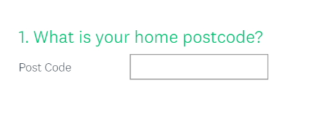
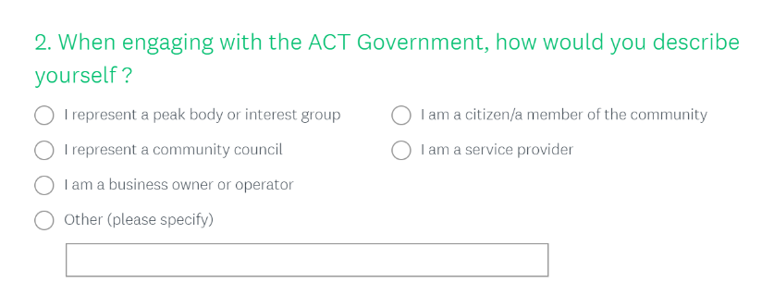
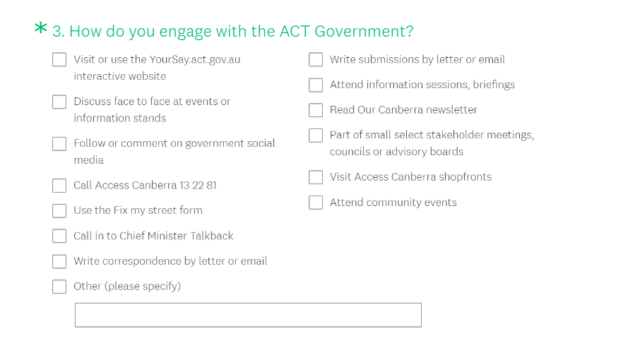
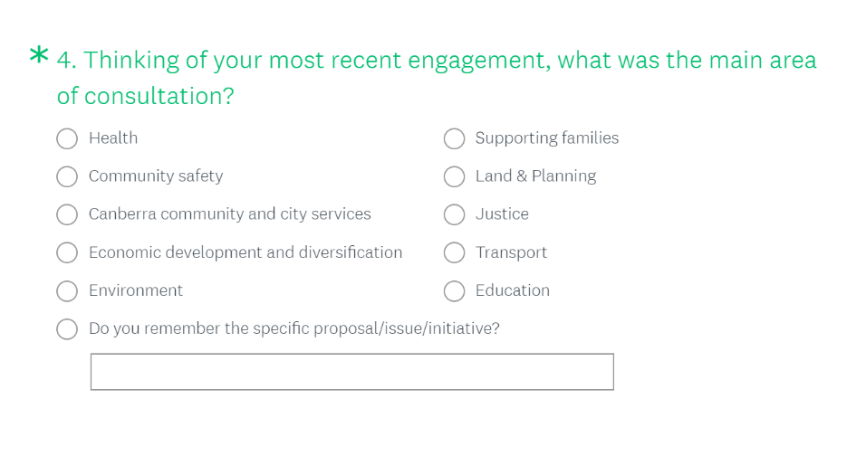
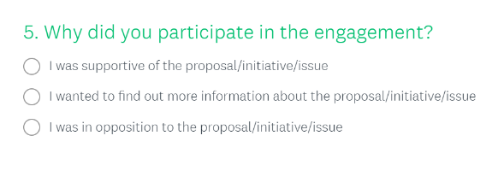
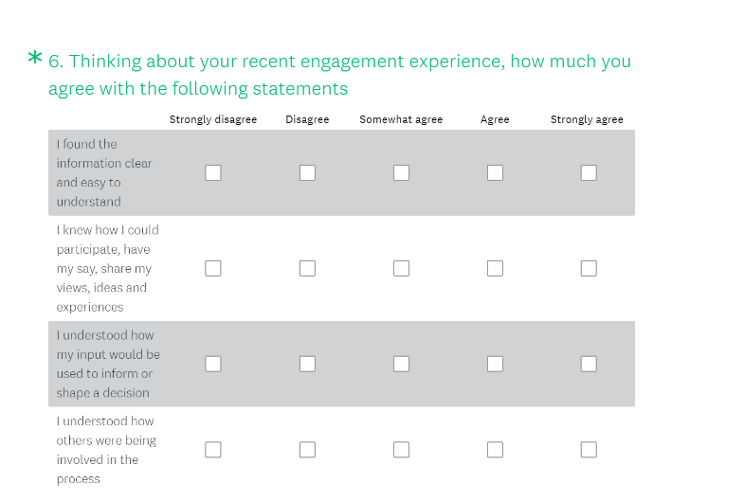
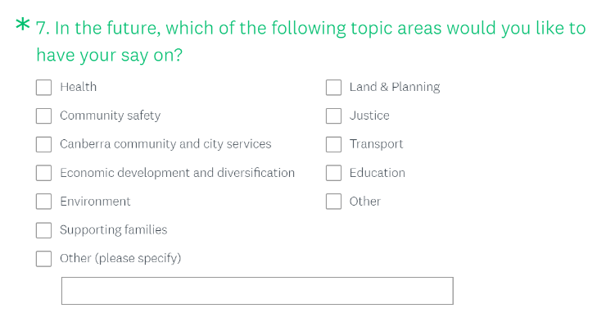
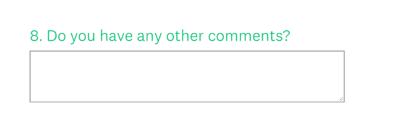

B ONLINE SURVEY RESULTS
Question 2 - When engaging with the ACT Government, how would you describe yourself?
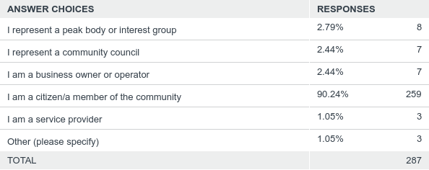
Question 3 - How do you engage with the ACT Government?
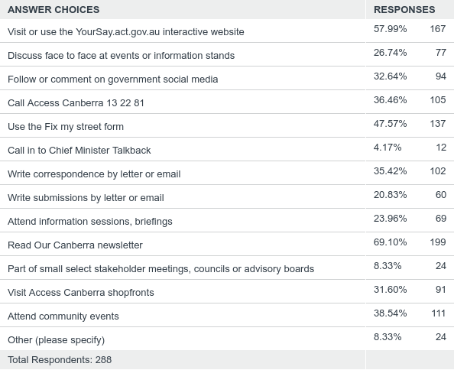
Question 4 - Thinking of your most recent engagement, what was the main area of consultation?
Note: Responses to ‘Do you remember the specific proposal/issue/initiative?’ were grouped in to relevant areas and the final percentages are reflected in the “Results of the Engagement in Detail” section of this report.
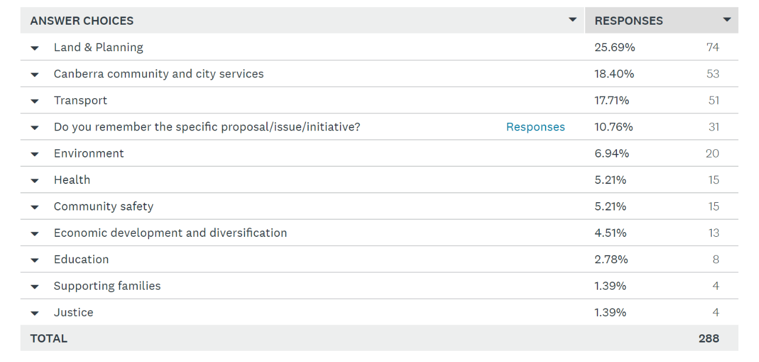
Question 5 - Why did you participate in the engagement?
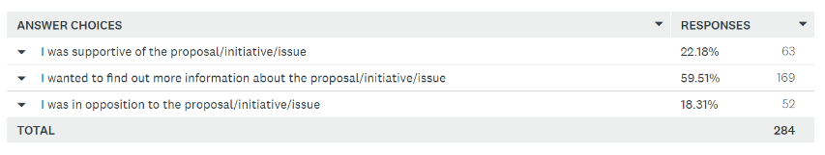
Question 6 – Thinking about your recent engagement, how much do you agree with the following statements?
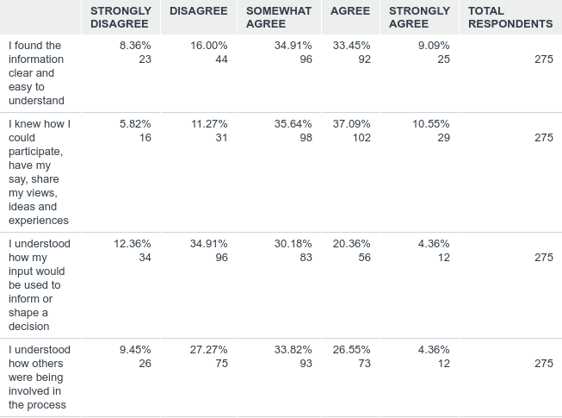
Question 7- In the future, which of the following topic areas would you like to have your say on?
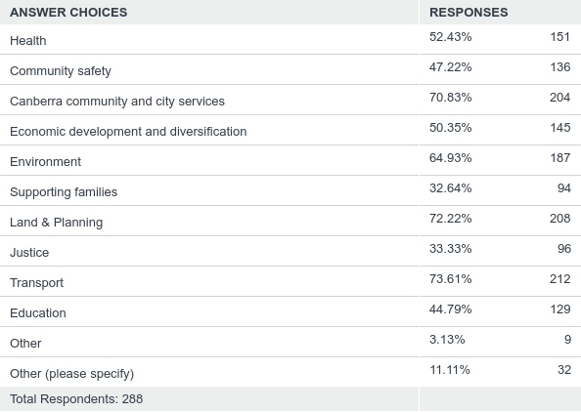

C Phone Survey Questions and results
The following questions were included as part of a telephone survey in March 2018.

Have you ever accessed or provided feedback on the ACT Government’s YourSay website?
N=600 respondents

To what extent would you agree or disagree with the following statements?
Data sourced from phone survey March 2018.

Chief Minister, Treasury & Economic Development Directorate
February 2019

