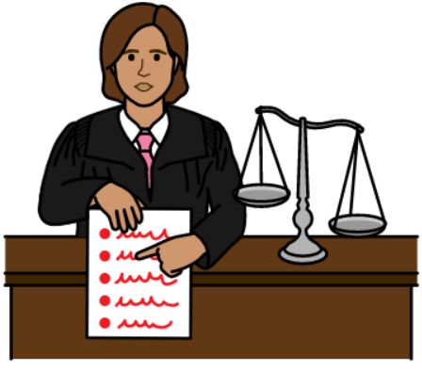
Senior Practitioner Act Review


Easy English

The ACT Government made a law called the Senior Practitioner Act 2018.


This will be called the SP Act from now on in this book.


The Government is now doing a review of the SP Act.

A review means to

- check the law
- see how it is working
and
- see if it can be made better.


The SP Act is a law that helps to reduce the use of restrictive practices.

What is a restrictive practice?

A restrictive practice is something that stops you from
- doing something that you have the right to do
or
- moving however you want to move.


Restrictive practices can be
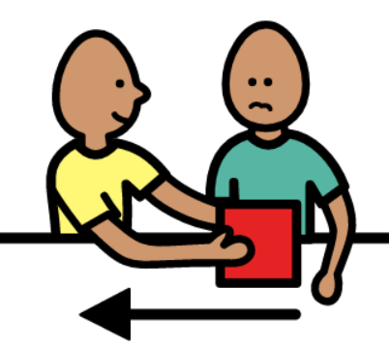
- medication to change your behaviour, such as to calm you down when you are angry
- taking things you want to use away
- clothes that stop you from doing things, like scratching or touching your body
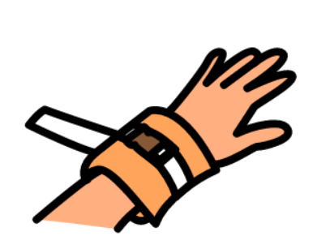
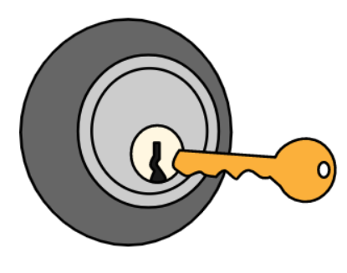
- locking doors that stop you from going somewhere
- having something attached or tied to your body to stop you from moving
- someone holding you to stop you from moving
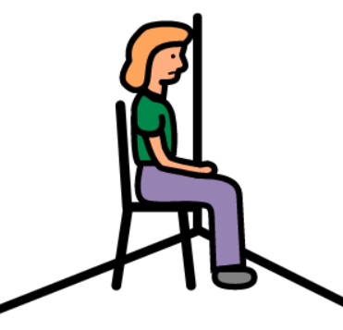
- being kept somewhere on your own where you can not get out.


Some things to protect you from being hurt are not restrictive practices, such as
- holding your hand when you are crossing the road.

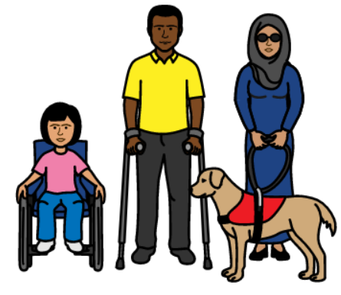
Restrictive practices mostly happen to
- people with disabilities

and
- children and young people.


These people may not be able to
- speak up to stop restrictive practices
- speak up to say how restrictive practices make them feel.


The SP Act aims to protect the rights and freedom of these people.


Restrictive practices can make the person experiencing it feel
- sad
- distressed
- scared

- ashamed
- angry
- embarrassed.

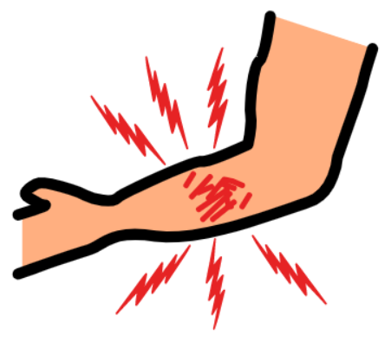
Restrictive practices can cause physical and emotional harm.


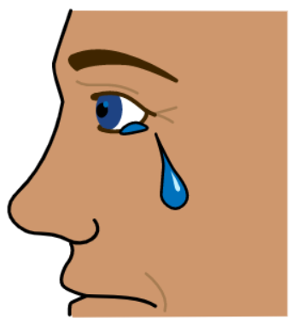
They can cause trauma that lasts a long time.

This is why we need to reduce the use of restrictive practices.

What is the SP Act?
The SP Act is a law that checks the use of restrictive practices by service providers.


Service providers are people or organisations that give services in
- education (this includes preschools and childcare)
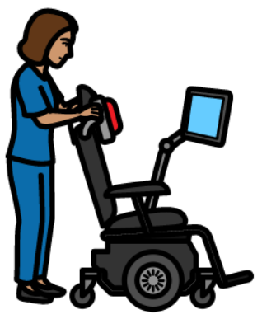
- disability
and
- the care and protection of children.

The SP Act says that service providers should only use restrictive practices
- as little as possible
- as a last resort (when nothing else has worked)
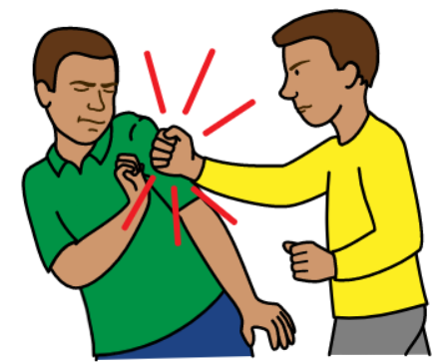
- in the least restrictive way
- when someone is in danger of hurting themselves or others
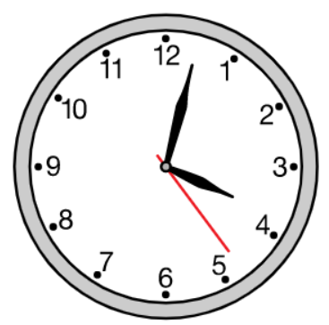
and
- for the shortest amount of time needed.

The SP Act makes sure that if restrictive practices are used, they need to
- respect the person’s human rights
- protect the person and others from harm

- be clearly written down
- reduce the need for restrictive practices in the future
- make sure the people using the restrictive practices are responsible for their behaviours and actions.


The SP Act gives power to someone called the Senior Practitioner.


The Senior Practitioner teaches service providers about the rules and checks if they are being followed.



The SP Act says that the Senior Practitioner needs to

- give permission or not give permission to the use of restrictive practices
- make rules and guidelines to make sure best practice is followed
- educate others about restrictive practices
- make sure everyone who needs it has access to restrictive practice documents
- make sure service providers know when the use of a restrictive practice is appropriate.


The Senior Practitioner aims to help children, young people and people living with disability to
- have a better quality of life
and
- be protected from treatments that are bad and limit their freedom.

The SP Act can only manage the use of restrictive practices by service providers.

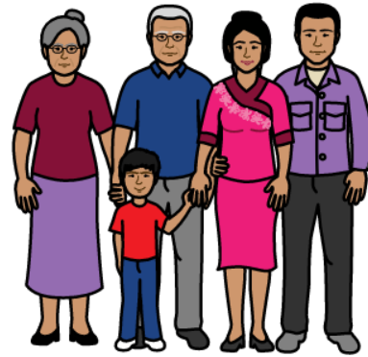
It does not control the use of restrictive practices by family members or informal supports.


The SP Act does not apply in some settings such as
- some mental health settings
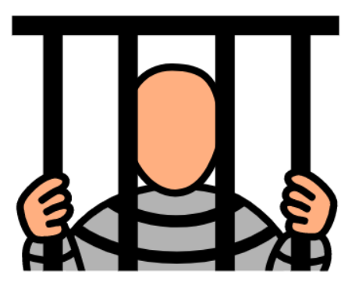
and
- prison settings.

Why are we checking the SP Act?
The SP Act says that the Government needs to
- review it

and
- do a report of the review after 5 years of it running.

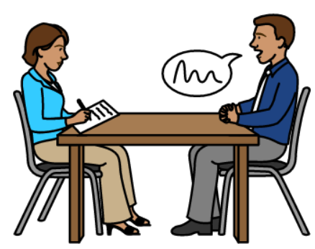
The Government is talking to service providers and members of the community to get their thoughts on how the SP Act is working.


We want feedback from you about your experiences with restrictive practices.

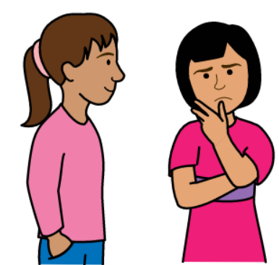
We are interested in finding out
- any issues around how the SP Act is working.
- If the SP Act is working to stop and reduce restrictive practices.

What do we want to know from you?

We want to know
- if restrictive practices have still been used on you or people you know in the last 5 years?

- how does having restrictive practices used on you by service providers make you feel?

- what could service providers do instead of restrictive practices?

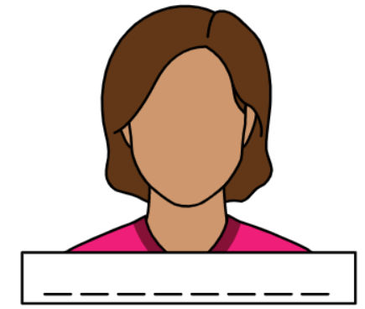
We will tell the Government all the ideas that people have said to us, without telling them who said it.


Your feedback can make the laws about restrictive practices better.


How do you share your feedback?
You can give feedback in many ways.

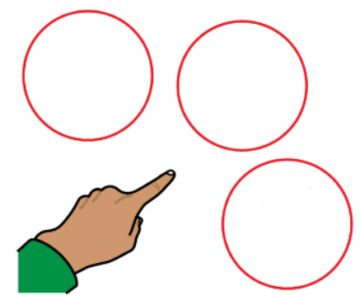


Choose the option that works best for you.


Online:
Go to Review of Senior Practitioner Act 2018


Upload your feedback
and/or
Fill out the survey
Send via post:

Mail a written copy of your feedback to
Human Services Policy, Community Services Directorate, GPO Box 158, Canberra ACT 2601

Phone
13 22 81


Email seniorpractitioneractconsultation@act.gov.au

JFA Purple Orange made this Easy English book in November 2023.

