Mental Health Act review


About Easy Read
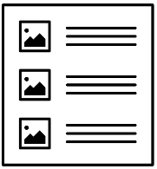
Easy Read uses images and simple words to explain things.
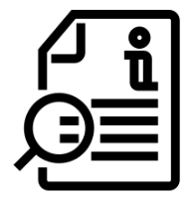
We will bold and explain words that may be new or hard.

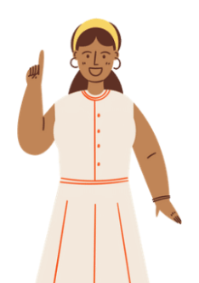
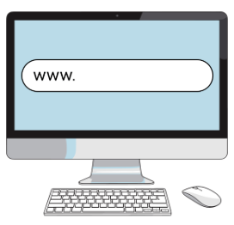
You can find the full details on our website bit.ly/mhactreview
You can get someone to help you read this book.

About this book
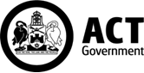
This book is from the ACT Government.
When the book says we it means the ACT Government.
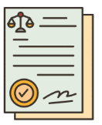
This book is about the Mental Health Act.
The Mental Health Act is a law.
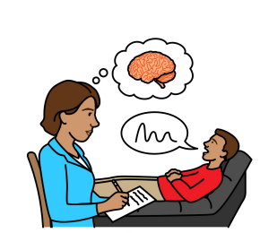
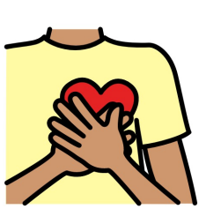
This law says what mental health care people need.

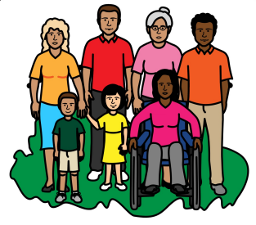
Sometimes a person may have a mental illness and cannot make safe choices.
This law says what the person needs to be safe.


What we want to know
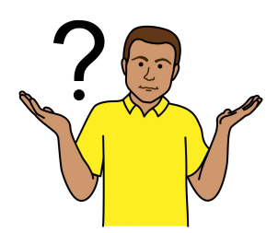
We want to know if the law is working well
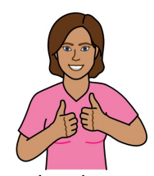
We want to know if the law should change.
What you say can help make the law better.

Tell us what you think
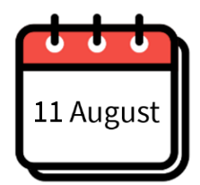
You need to tell us by 23 October 2026.
23 October
You can:

- read the discussion paper online
(not Easy Read)
bit.ly/mhactpaper
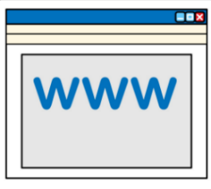

- do the survey online (not Easy Read)
bit.ly/mhactsurvey
- share your feedback online
bit.ly/mhactfeedback

- send an email to mhactreview@act.gov.au

If you need help
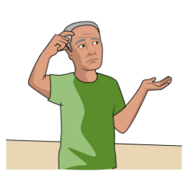
Someone can help you give your feedback.
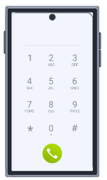

Call the ACT Disability, Aged and Carer Advocacy Service (ADACAS).
Call ADACAS on 02 5124 6137
9am to 5pm Monday to Friday.

How we will use your feedback
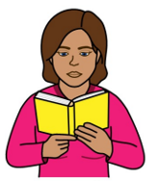

What you say will help us know if the law needs to change.
We will:
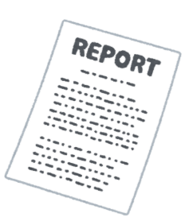
- read your feedback
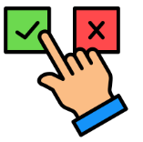
- write a report
- decide if the law needs to change.

The report will be shared online.
The report will say what feedback we had. bit.ly/mhactreview

Review topics
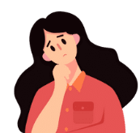
Topics in this review may be upsetting.
These topics are:
- mental health
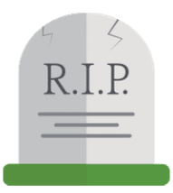
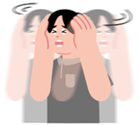
- mental illness
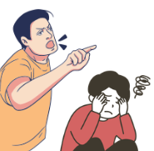
- suicide

- family violence
- domestic violence.

Support services


You can contact support services.

Access Mental Health
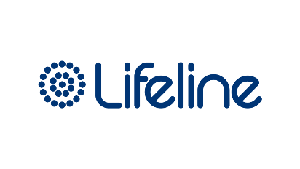
Call 1800 629 354

Lifeline
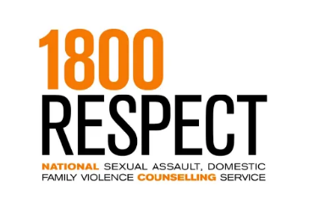
Call 13 11 14

1800RESPECT
Call 1800 737 732


Kids Helpline

Call 1800 55 1800

Call 000 in an emergency if someone is in danger

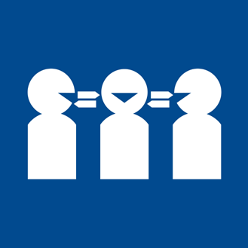
If you need help with English
Call the free Translating and Interpreting Service. You can call in your language.
Call 131 450
Tell them the phone number you want to call

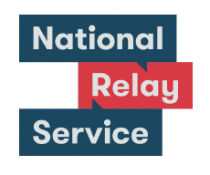
If you need help to speak or listen
Use the National Relay Service. You must sign up to the service first.
Website
accesshub.gov.au/nrs-helpdesk
Call 1800 555 660

Acknowledgement of Country
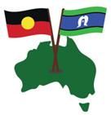
Aboriginal and Torres Strait Islander peoples are the First Peoples of Australia.
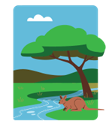
They have always looked after Country. Country means the land, water, sky and everything in them.
We respect the important connection they have with Country.

Health and Community Services Directorate created this Easy Read document in August 2026. Images used are with permission. Feedback for improvement is welcome.

