Community Use Program – Community Access Survey

Report on what we heard
The ACT Government is committed to improving community access to ACT public school facilities, including outdoor recreational facilities.
The ACT Government invited Canberrans to have their say about their experiences when accessing outdoor recreational school facilities when not in use by schools, from 29 October to 18 December 2025.
The survey focus was on nine identified ‘hub’ schools selected to participate in the program: Calwell Primary School, Canberra College, Erindale College, Evelyn Scott School, Gold Creek School, Hawker Primary School, Melba Copland College, Namadgi School and Telopea Park School.
The survey aimed to explore opportunities and barriers for community groups and individuals, and to gain a better understanding of the awareness, needs and desires of the community in relation to accessing school grounds.

The conversation
The ACT Government invited the community, including children and young people, who attend and/or live near to the nine participating schools to provide information on their experience accessing outdoor recreational school facilities (outside of a hired basis). We wanted to know more about which facilities are used and how often, and any suggestions for improvements for community to access.
The YourSay Conversations platform hosted an online survey for the community to provide feedback. A total of 323 surveys were completed and two further submissions were received by email.

Who we engaged
We promoted the consultation through:
- QR codes on 45 posters and 27 corflutes installed near the nine hub schools
- Hub schools’ newsletters and social media channels (where available)
- ACT Government Facebook
- Education Directorate Facebook and Instagram
- Emails to Community Councils and local resident groups
- ‘Our Canberra’ December 2025 print edition newsletters to four regions

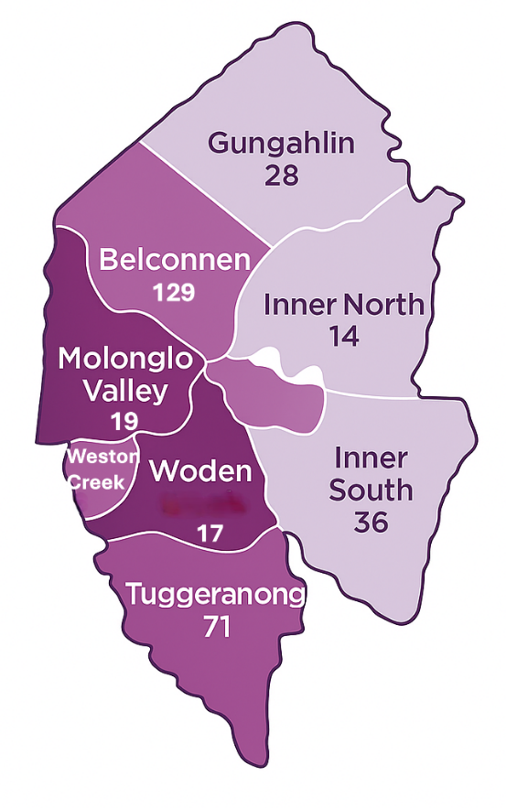
Survey responses came from all regions across Canberra, with the largest number from those living in Belconnen (40%) and Tuggeranong (22%). Responses were from across all age groups, with strong participation from the 35-44 age group (46%) and 45-54 age group (25%), reflective of the typical age ranges of parents/carers with students attending the hub schools. Hawker Primary School received the greatest number of responses (35% of the total responses received) followed by feedback on “Other” schools (22%). More than 15 languages were identified amongst the 14% of responses from those speaking languages other than English in their household.
Location
7
Valley
7
Valley

Key insights from the community
Benefits
Almost all respondents (96%) cited benefits in being able to access school grounds for recreational use outside of school hours. These benefits are grouped into five themes, listed below in order of the frequency of responses.

Physical Activity and Health
- Keeping children, families and the broader community active.
- Providing spaces and facilities for exercise, fitness, play, running, walking and ball skills.

Access to Facilities and Equipment
- Being able to use basketball, netball and tennis courts, ovals with goals and cricket nets free of charge makes sporting facilities more accessible.
- Providing access to bike and pump tracks, slides and play equipment that might otherwise not be available nearby.

Community Connection and Social Cohesion
- Meeting neighbours and building community connections.
- Facilitating informal sport and playdates, helping people connect across ages.

Safe Spaces Close to Home
- Schools provide safe, fenced or traffic-free areas for play.
- Merit in children being familiar with the school spaces before commencing school.
- Local schools are convenient, walkable neighbourhood spaces.

Equity, Affordability and Convenience
- Free access to sports facilities close to home, increases community equity.
- School grounds are highly valued by those living in apartments or with small yards.
- Increases active travel and reduces need to drive for exercise and sport.

Awareness
Notably, more than a third of survey respondents (37.5%) were unaware that community members have access to ACT public school grounds when they are not in use by the school or Outside School Hours Care, free of charge for unscheduled, informal, recreational use.

Access
Nearly three-quarters of respondents (73%) do access school grounds for recreational use outside of school hours.

The community survey found that:

  - School ovals are the facility most accessed by respondents (73%), followed by outdoor courts (65%) and then playgrounds (50%).
  - Basketball courts and tennis courts were specifically listed as high value outdoor courts.
  - More than three quarters of respondents like to play sports when they access school grounds (78%), with more than half using play equipment (55%) and two in five respondents engaging in exercise through walking or running (44%).
  - Around one in 15 respondents (7%) play with or exercise their dogs on school grounds.
  - One in 30 respondents (3%) teach children to ride bikes, skate or scoot on school grounds.
  - Most respondents access school grounds weekly for recreational use (41%), followed by daily users (20%) and those who access school grounds randomly (20%).
  - Almost 9 in 10 respondents (88%) use school grounds with a small group of friends or family, while more than a quarter (28%) use school grounds by themselves.

Nearly four in 10 respondents (38%) noted they were unable to access school grounds when they would like to when not in use by the school or Outside School Hours Care. Of these, most cited locked gates and fencing as restricting their access.

Close to half of these respondents did not go to another school when their preferred grounds were unavailable, with reasons given including distance from home or lack of knowledge about accessible facilities at other schools. Two in five respondents did access alternative school grounds, while a smaller number visited parks or carparks for recreation when they could not access their local school.

Suggested Improvements
Almost three-quarters of respondents (73%) suggested improvements that could be made to school grounds or the way the community accesses school grounds. The suggested improvements are grouped into the top five themes, listed below.

Access and Fencing
- Unlocking school gates after hours and weekends, including fenced courts.
- Consistent out-of-hours community access across schools.
- Clearer access points, pram-friendly paths, and safer entry routes.
Basketball and other Outdoor Courts
- Upgrading of rings, backboards, nets and court surfaces.
- Increasing availability of courts, including covered courts.
Maintenance and Upkeep
- Improving maintenance and tidiness of school grounds, including repairs and resurfacing of outdoor courts, sweeping debris and leaves, and increased mowing.
- Improving watering and turf condition, with drainage to prevent boggy ovals.
- Providing more bins for dog waste and rubbish, along with clear information on rules for dog use.
- Providing shaded seating, access to water bubblers and toilets.
Security and Safety
- There is clear appreciation for the need to balance access with prevention of vandalism.
- Installing cameras and other security strategies to deter vandalism whilst keeping grounds open for community.
- Controlling access by way of community keys, passes or bookings, and adding or upgrading lighting with oval floodlights for safe evening use.
Signage and Awareness
- Clear signage at schools about open areas, times and rules.
- Better online information on each school’s facilities and access arrangements.

What’s next?
The Community Use Program will use this feedback to inform future policy updates and guide infrastructure improvements for use of school grounds by community.
If you have any questions about the Community Access Survey or would like to be kept updated on progress of the Community Use Program, please email ACT.Education@act.gov.au.

To find out more about other Education Directorate initiatives, follow us on Facebook or Instagram.

Key Timings
Late October to December 2025 – Community Access Survey
YourSay community consultation period.
March - April 2026
Publish ‘what we heard’ report.
April 2026 and beyond
The Community Use Program will consider the feedback to make improvements to community access arrangements.

Thank you for your feedback
1,407  visitors to YourSay | 323  surveys completed | 2  written submissions received | 35  stakeholders emailed
72  corflutes and posters installed around the nine hub school facilities | 34,102  people reached through seven posts on ACT Government social media platforms | 155,000  Our Canberra December print editions delivered to households | 96%  of respondents cited benefits in accessing grounds for recreational use outside of school hours

