Idea submission guide

Purpose of this guide
This guide has been developed to help you prepare your submission for the ‘My little BIG idea’ project, giving it the best chance of success. While the idea you put forward is up to you and your imagination, this guide explores the types of outcomes you should aim to achieve with your idea.
You can find the application form at www.yoursayconversations.act.gov.au, or email us via askus@yoursay.act.gov.au.

About the My little BIG idea pilot
While focusing on connection and resilience, ‘My little BIG idea’ is also testing an exciting new way of involving the community in making decisions about ACT Government spending in their suburb. This approach is more responsive to community need, and as it is a pilot project, the outcomes will help inform future community engagement opportunities. For now, we’re starting with Page and Richardson to trial this new decision-making process.

Up to $40,000 is available to bring to life a community project that will help people feel more connected and resilient. Whether it’s a street library, fitness or cooking classes, a playgroup, event or series of activities, anyone with a connection to Page or Richardson is invited to submit their idea.

Once we’ve received the ideas, an ACT Government working group will assess whether they’re eligible. Then a Community Panel of residents from each suburb will participate in a workshop, review all the eligible ideas and shortlist three, which will then go to public vote. People will be able to vote in person or online. The idea that gets the most votes will receive up to $40,000 to make it a reality.

“When people discover what they have, they find power. When people join together in new connections and relationships, they build power. When people become more productive together, they exercise their power to address problems and realise dreams.”
- Mike Green, ABCD in Action

Developing your idea and submission

Top tips for developing a successful idea
 | Test your idea  Run it past other people in your neighbourhood to gauge their reaction.
 | Think it through  Come up with a plan for how you’ll bring your idea to life if it wins.
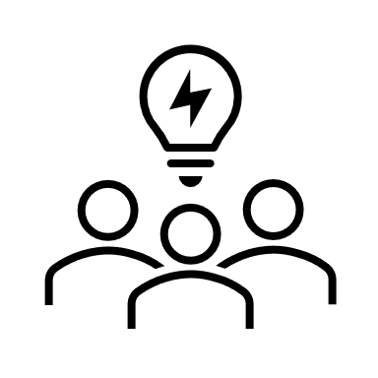 | Teamwork  Get a group of people together to develop an idea together to include a range of perspectives.
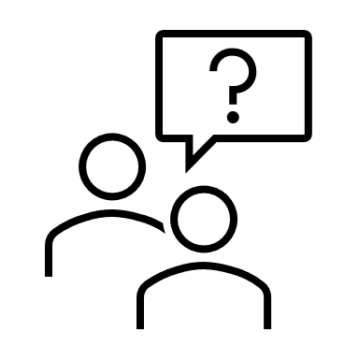 | Ask questions  What does your suburb need? Will your idea help people feel more connected and resilient?
 | Find inspiration  Research community projects in the ACT and interstate to get your imagination running.
 | Ask for help  We’re here to guide you when you need it, just email askus@yoursay.act.gov.au.

What is involved in putting a submission together?
Don’t worry, we’re not asking for an essay! As you’re developing your idea, keep the questions in the submission form in mind. In that form we’ll be asking you:
- To tell us about your idea in 300 words or less;
- How your idea will help people to feel more connected and resilient;
- How you plan to bring it to life if the community chooses your idea;
- About how much you think it will cost to make your idea a reality; and
- If there are any permits required, like building permits, land use or event permits.
You’re welcome to get creative with your submission – think about providing us with a video of you explaining your idea, putting a digital design together, or providing images of what it could look like to help us understand your vision. These could be as well as or instead of the written information, as long as all the questions are answered.

How your submission will be assessed

ACT Government eligibility assessment
Once we’ve received the ideas, an ACT Government working group will assess whether they’re eligible by considering if they:
- Fit within a budget of $40,000 or less;
- Can be completed within 12 months;
- Show they are inclusive and will involve the suburb’s community;
- Compliment or compete with other projects in the suburb; and
- Can be driven by community.

Community Panel shortlisting
We will ask locals to form a Community Panel for each suburb. The Community Panels will participate in a workshop to assess the eligible ideas and come up with a shortlist of three, which will then go to public vote.
Each Community Panel will be made up of a diverse group of about 30 people from each suburb. A small payment will be given to each participant for their time. To learn more about registering for a Community Panel visit www.yoursayconversationa.act.gov.au and click on the tile for your suburb.

During the workshop, the Community Panels will focus on how the ideas:
- Can improve connection, wellbeing, and resilience in the suburb;
- Provide opportunities for community members;
- Make the most of local skills and networks; and
- Can be driven by community.

Seven elements of resilient communities
As you develop your idea and submission, consider these 7 elements of resilient communities and think about how you can use them to explain why your idea should be selected.

- Strong and adaptable people
Strong and adaptable people feel fulfilled, and have hope, confidence, and self-belief. They develop positive relationships with others and connect with nature.
- Thriving local networks
To have thriving local networks is to connect with others and have places where people can gather.
- Strengths
There are great things in every community that provide a foundation for resilience, like strong networks, places to gather, volunteers.
- Connection
Resilient communities feel connected with their neighbours and know who they can go to for help when they need it.
- Broad benefits
Resilient communities make sure as many people as possible are provided for, so initiatives benefit whole suburbs and not just one group.
- Inclusion
Inclusion means everyone in a community has access and opportunity, and allowances are made for every ability, culture, age, gender, and lifestyle.
- Community leadership
Community leaders are people who support others, encourage people to participate and coordinate activities.

Why are we focusing on community connection and resilience?
A resilient community can anticipate, respond to and recover from changes in the world around it. Changes can happen quickly, like when a natural disaster strikes, or slowly, like an aging population. Communities are often faced with the challenges of fast and slow changes combined. Resilient communities are strong. They make the most of their assets and strengths, include everyone and bring people together.

The ACT Government is committed to giving communities a voice, and opportunity to tell us what they need to increase their connectedness and resilience.

Winning ideas

The person or group who submits the idea that gets the most votes will receive an email within 7 days to let them know their idea has been selected. This email will provide information on the next steps towards making the idea a reality.
Those with the winning idea will be supported by the ACT Government to make their idea a reality with:
- Project planning and help;
- Budgeting, reporting and money management; and
- Coaching or advice if it's needed.

Timings

Key dates
6 September 2023
Pilot begins! Ideas can be submitted.

2 October 2023
Last day to register for a Community Panel.

16 October 2023
Last day to submit ideas.

4 & 5 October 2023
Community Panel workshops.

13 November 2023
Public voting opens.

27 November 2023
Public voting closes.

11 December 2023
Announcement of winning ideas.

What now?
For everything you need to know, visit www.yoursayconversations.act.gov.au and click on the ‘My little BIG idea’ project for your suburb. Make sure you hit the ‘Follow’ button at the top to receive updates throughout the pilot.

Ideas can be submitted online via that page, or you can download a submission form and email it to askus@yoursay.act.gov.au.

