Discussion Paper
voluntary
assisted
dying
February 2023
Issued by: Justice & Community Safety Directorate in conjunction with ACT Health Directorate and Canberra Health Services

Contents
Message from the Minister for Human Rights 3
1. Introduction 4
1.1 What is voluntary assisted dying? 4
1.2 Objective and principles for reform 4
1.3 Purpose of this consultation 5
1.4 How to have your say 6
2. Consultation topics 7
2.1 Eligibility criteria 7
2.2 The process for request and assessment 14
2.3 The role of health professionals 21
2.4 The role of health services 28
2.5 Death certification and notification 30
2.6 Oversight, reporting and compliance 31
2.7 Other issues 35
Appendix 1 – List of consultation questions 36
Appendix 2 - Glossary 39
Appendix 3 – Summary of selected international jurisdictions 42

The ACT Government acknowledges Canberrans who have experienced, or are experiencing,
end of life suffering. We also acknowledge the hardships and grief experienced by their loved ones and carers. We are committed to listening, learning and understanding from these experiences in developing our approach to voluntary assisted dying in the ACT.
This paper contains information that may be distressing or uncomfortable. If you
need support, you can contact Lifeline on 13 11 14 for crisis support,
or Griefline on 1300 845 745 for anyone experiencing grief.

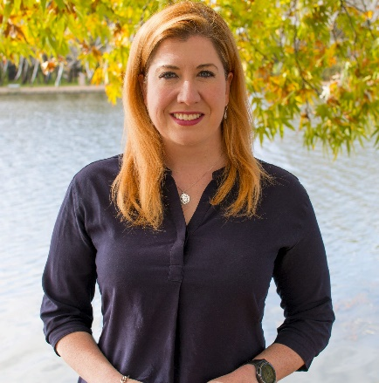
Message from the Minister for Human Rights
The ACT Government believes all Canberrans should have end of life choices that align with their rights, preferences and values. Canberrans should have access to quality health care, including end of life care, when they need it. However, we know that even with the best end of life care, some Canberrans with an advanced condition, illness or disease experience suffering near the end of their lives.
To promote the autonomy and dignity of those people, the ACT Government will consider how to approach and regulate access to voluntary assisted dying, as all states in Australia have done. Eligible people should be able to make informed choices about the end of their lives, with the support of health professionals and services.
The ACT Government has long advocated for the ability of the ACT to introduce voluntary assisted dying. In 1997, Federal parliament placed a ban on the Territories making laws about this important matter. For 25 years, the Canberra community and Legislative Assembly were prevented from considering an issue that deeply matters to them. This became increasingly unconscionable as all six Australian states progressively legislated for voluntary assisted dying.
On 1 December 2022, the Federal parliament passed the Restoring Territory Rights Bill 2022. The ACT Government and Legislative Assembly are now able to consider voluntary assisted dying legislation in a genuine way. The passage of the Restoring Territory Rights Act 2022 is a victory for democratic rights and human rights, and the result of a campaign more than a decade in the making. I credit the persistence of Canberrans in creating the momentum we needed to ensure that this issue got the attention it deserved, and a positive resolution.
I am proud to lead the ACT Government’s work on this important issue. I am working closely with the Minister for Health, with the support of the Chief Minister and Attorney-General, to ensure we consult deeply and broadly with our community about the ACT’s approach to voluntary assisted dying.
The ACT Government knows most Canberrans support voluntary assisted dying. We are interested in understanding how our communities want voluntary assisted dying to be approached in the ACT. This discussion paper is designed to inform you about voluntary assisted dying, how other Australian states have approached the matter, and some of the key questions the ACT should consider in developing an approach to voluntary assisted dying. This discussion paper asks questions to help you think about key issues, and you are also welcome to tell us about anything else you think we should consider. There are many other ways for you to engage with us, which you can find on our voluntary assisted dying YourSay website.
Thank you for taking the opportunity to engage on this important matter.
Tara Cheyne MLA
Minister for Human Rights

1. Introduction

What is voluntary assisted dying?
While each Australian state has its own legal definition of voluntary assisted dying, in Australia voluntary assisted dying generally refers a safe and effective medical process that gives an eligible person the option to end their suffering by choosing how and when they die. Voluntary assisted dying is not a choice between life or death, it is an additional choice that can be made by a person about the circumstances of their death. ‘Voluntary’ means that the practice is freely chosen by the person, and that they are competent to make decisions about voluntary assisted dying. This is a safeguard that seeks to uphold a person’s agency and autonomy and protect against potential abuse, coercion, or pressure.

1.2 Objective and principles for reform
An important objective of this consultation is to seek the community’s views on how to design a safe, effective, and accessible process for an eligible person to choose to access voluntary assisted dying in the ACT.
Any approach to voluntary assisted dying in the ACT will need to take into account a person’s human rights, the need for safeguards against abuse and the role of health professionals. Some of these issues were explored in the 2019 report of the ACT Legislative Assembly’s Select Committee into End of Life Choices in the ACT.
Voluntary assisted dying raises complex human rights considerations including the right to life, the right to privacy and autonomy, the right to equality and non-discrimination and the right to freedom of religion and personal beliefs. All Government Bills passed by the ACT Legislative Assembly are considered for human rights compatibility, so any proposed voluntary assisted dying law will need to demonstrate how it is consistent with the rights protected in the Human Rights Act 2004, including how any limitations on human rights are reasonable and justifiable.
We know that there are many ethical, personal, and professional issues for individuals, their carers, their families and health professionals relating to the implementation of voluntary assisted dying. We have identified several guiding principles that might underpin ACT legislation on voluntary assisted dying and complement ethical frameworks of health services and other care providers as well as existing professional codes of conduct:
- human life has intrinsic value,
- all people should be treated equally, fairly and without unlawful discrimination in relation to end of life choices,
- people should have choices about the things that matter to them, and this personal autonomy in relation to end of life choices should be respected,
- human rights must be respected, and any limitations on rights must be necessary, reasonable and justifiable.

1.3 Purpose of this consultation
The ACT Government recognises that the majority of Australians support voluntary assisted dying with appropriate safeguards in place. This consultation paper seeks the views of the ACT community about how voluntary assisted dying should be implemented in the ACT.
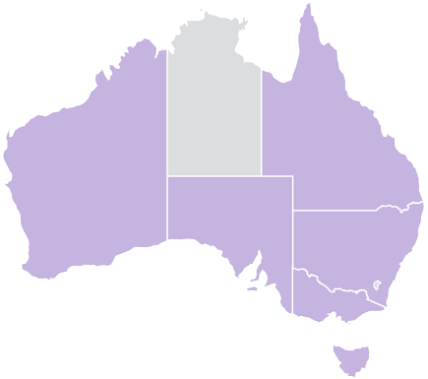
All Australian states have passed legislation to enable access to voluntary assisted dying subject to robust oversight and safeguarding frameworks. In contrast, since 1997 Commonwealth law has prevented the ACT and Northern Territory from making laws about voluntary assisted dying. In December 2022, after years of advocacy from the ACT Government, stakeholders, families and the broader community, the Commonwealth parliament removed this restriction, which means the ACT Government has the power to legalise voluntary assisted dying in the ACT.
Some of the key issues that would need to be addressed in legislating for voluntary assisted dying in the ACT are outlined in this paper, including how these issues have been addressed in Australia and internationally. The ACT Government is drawing from the legislation and experiences in other Australian states, noting that they are at different stages of implementation and that each jurisdiction has its own unique characteristics. For this reason, we are seeking the community’s guidance on several key aspects of the various Australian models. We are also interested in lessons learned internationally, where access to voluntary assisted dying has been in operation over many years. A summary of some international approaches is at Appendix 3 of this discussion paper.
The ACT Government understands that end of life choices can raise complex and difficult issues and that voluntary assisted dying is a deeply important legal, social and ethical issue for people in the ACT. The ACT Government is committed to quality end of life choices in the ACT and learning from those who have experienced, or do or expect to experience, intolerable suffering near the end of their life, as well as their carers, families and health professionals. The ACT Government is also committed to respecting and upholding all Canberrans’ rights to equality, non-discrimination and freedom of religion, conscience and belief.
The issues outlined in this consultation paper are intended to promote informed public debate, and do not represent a complete statement of the law.

1.4 How to have your say
This consultation paper asks questions we want to hear your views on. You may choose to respond to some or all questions, or alternatively provide feedback in a format that suits you. You are also welcome to provide general feedback.
To learn about your options to have your say, visit YourSay.act.gov.au/vad.

If you require this document in an alternative, accessible format, or if you require assistance in making a submission, please contact us at Access Canberra on 13 22 81.
Following community consultation, the ACT Government will prepare a listening report that summarises and reflects the feedback we have received. This report will inform the development of the legislation.

2. Consultation topics

2.1 Eligibility criteria
We want to know your views on the circumstances in which a person should have access to voluntary assisted dying. These might include the person’s diagnosis and prognosis, the amount of suffering they are experiencing, their ability to make voluntary decisions about voluntary assisted dying, and other considerations such as age and location. Clearly defining the eligibility criteria to access voluntary assisted dying will enhance end of life choices for certain people, and ensure that voluntary assisted dying is not an available option for others.
For example, in all Australian states, a person can only access voluntary assisted dying if they:

4
Meet residency requirements
5
Are at least 18 years of age

3
Are acting
voluntarily and without pressure
or duress
2
Have decision-making capacity in relation to voluntary
assisted dying
1
Have an
eligible
condition

1. What should the eligibility criteria be for a person to access voluntary assisted dying?

Eligible condition
Voluntary assisted dying should only be available for persons diagnosed with an eligible condition. It should not be available to any person seeking to end their life. It will be important to carefully define when a person’s illness, disease or condition qualifies as an eligible condition for accessing voluntary assisted dying.
As in all Australian states, a person will not be eligible for voluntary assisted dying solely because they have a mental illness or disability. Like any other person, a person with a disability or mental illness will have access to voluntary assisted dying only if they meet all eligibility criteria.
Under voluntary assisted dying laws in Australian states, a person has an eligible condition if they are diagnosed with at least one disease, illness or medical condition that is:
- advanced, progressive (or ‘irreversible’ in Tasmania), and will, or is expected to, cause death;
- incurable (in Victoria, South Australia and Tasmania only);
- expected to cause death:
  - within 12 months in the case of a neurodegenerative disorder; or
  - within 6 months for other conditions, illnesses or diseases (except for Queensland where a person can apply for voluntary assisted dying if they are expected to die within 12 months); and
- causing suffering that cannot be relieved in a way considered by the person to be tolerable.
Each of those aspects is considered below.

Advanced, progressive and will cause death
Outside of Australia, most countries with voluntary assisted dying schemes in place do not require that a person has a condition that is expected to cause their death.
However, in Australian states, voluntary assisted dying is only an option for those approaching death because of an advanced and progressive condition, illness or disease.
In Victoria and Western Australia, where voluntary assisted dying has been available for more than 12 months, the most common eligible conditions for a person accessing voluntary assisted dying are cancer or malignancy, neurodegenerative disorders, or respiratory failure.
As above, the ACT Government will be pursuing a model consistent with Australian states in that voluntary assisted dying is only an option for those approaching death because of an advanced and progressive condition, illness or disease. However, how this is defined and who this is available for are questions we are seeking your views on.

Suffering
Australian states require that a person is experiencing intolerable suffering before the person can access voluntary assisted dying. However, a person is not required to exhaust all treatment and management options, including options that the person would not find acceptable.
For example, Queensland requires that a person’s condition is causing them suffering, and that the person considers the suffering intolerable. Victoria, Western Australia and South Australia require that a person’s condition is causing them suffering, and the suffering cannot be relieved in a way the person considers tolerable. Both approaches require a registered medical practitioner to assess that a person’s suffering is caused by health condition itself, rather than by existential or psychological feelings or anguish about their condition or the end of their life. These approaches also require a registered medical practitioner to identify one condition that is causing suffering, rather than a combination of conditions.
Alternatively, Tasmania allows a registered medical practitioner to make a broader assessment of suffering that a person considers intolerable. A person’s suffering can be expected, anticipated or actual. The cause of a person’s suffering includes the condition itself, as well as the condition combined with other conditions, treatment the person may receive, treatment the person may receive combined with other conditions, complications arising from treatment and complications arising from treatment combined with other conditions. The Tasmanian approach gives greater flexibility for a person and their registered medical practitioner to access end of life options in order to relieve many kinds of suffering.

2. What kind of suffering should a person be experiencing or anticipating in order to be eligible to access voluntary assisted dying?

Timeframe for expected death
All states in Australia currently require that a person can only access voluntary assisted dying if a registered medical practitioner expects them to die within a certain timeframe. This restricts access to voluntary assisted dying to those who are expected to be very close to the end of their life. While this ensures that voluntary assisted dying is only an option when a person is already dying, a narrow time period may deny relief to some people who are suffering intolerably, but whose condition is not expected to cause death within the prescribed period.
In most states, a registered medical practitioner must expect a person to die within six months for non-neurodegenerative disorders, or 12 months for neurodegenerative disorders. The exception is Queensland, which uses a 12 month timeframe for all conditions. If a person is assessed for eligibility but is not expected to die within that timeframe, there is no restriction on them seeking another assessment in future, for example, after their condition deteriorates.
Some view these timeframes as bureaucratic and unduly restrictive, particularly because it is difficult to precisely determine a person’s life expectancy and timeframe for expected death. In addition, a person is required to go through a rigorous request and assessment process to access voluntary assisted dying, which takes time. In some cases, requests for voluntary assisted dying are made very close to the end of life and people may die before the voluntary assisted dying assessment process can be completed and the voluntary assisted dying substance administered.
In some other countries, eligibility criteria include a requirement that a person is diagnosed with a medical condition that will result in death, but without a prescribed timeframe for expected death. Research suggests that it is unlikely that more people would be eligible for voluntary assisted dying under such a model, but that they would become eligible earlier in their disease progression. This avoids some of the difficulties described above in relation to accessing voluntary assisted dying.
3. Should a person be expected to have a specified amount of time left to live in order to be eligible to access voluntary assisted dying? If so, what timeframe should this be? Should there be a different timeframe for different conditions, for example for neurodegenerative disorders? If there is no timeframe required, what should a prognosis be instead?

Decision-making capacity
Decision-making capacity means a person’s ability to make decisions about their life. This means that a person can understand everything that needs to be considered when making a decision, what the possible choices are, and what the potential consequences and outcomes of those choices could be. Generally, an adult is presumed to have decision-making capacity unless shown otherwise, and a young person under 18 is presumed to progressively gain evolving decision-making capacities.
To ensure that voluntary assisted dying is truly voluntary, a person should have decision-making capacity in relation to voluntary assisted dying at all stages of the voluntary assisted dying request and assessment process.
All Australian states require that a person must have decision-making capacity throughout the entire voluntary assisted dying process. In practice, this means that a person with an eligible condition that impairs their decision-making capacity (such as advanced dementia) may be not eligible for voluntary assisted dying. This also means a person who currently has decision-making capacity cannot request – for example, through an enduring power of attorney, health direction, or other advance care planning documents – that voluntary assisted dying be available if they lose decision-making capacity.

In many circumstances health professionals are responsible for assessing whether a person has decision-making capacity to consent to healthcare. This is the approach taken in Australian states in relation to voluntary assisted dying.
In other circumstances, legislation defines when a person has decision-making capacity. For example, laws relating to mental health provide a detailed definition of decision-making capacity and principles to be considered in assessing decision-making capacity. In contrast, laws relating to powers of attorney provide a broader definition, and laws relating to guardianship and management of property do not define decision-making capacity at all.
While the ACT Government considers that a person must have decision-making capacity to access voluntary assisted dying, we are seeking your views on how the assessment of capacity should be approached in the ACT.
4. How should a person’s decision-making capacity be defined or determined in relation to voluntary assisted dying?

Minimum age
All Australian states limit access to voluntary assisted dying to persons over 18 years of age, consistent with the legal age of being an adult in each Australian state. This requirement means that an eligible 18-year-old can choose to access voluntary assisted dying in Australian states, but a 17-year-old with an eligible condition who is similarly suffering near the end their life cannot.
We want to know your views on whether voluntary assisted dying should be restricted to adults aged 18 years and over, or whether eligible young people under 18 with the maturity and capacity to make decisions about voluntary assisted dying should also have access.
As outlined in the capacity section above, to ensure that voluntary assisted dying is truly voluntary, a person should have decision-making capacity in relation to voluntary assisted dying at all stages of the voluntary assisted dying request and assessment process. In the ACT, our human rights framework recognises that as a young person gets older and their circumstances change, they develop an evolving capacity to consider, understand and make important decisions. Young people under 18 are presumed to progressively gain evolving decision-making capacities. Some young people may develop decision-making capacity earlier than others. In the ACT, this is reflected in how a health professional assesses whether a person is a ‘mature minor’ to consent to treatment in some healthcare contexts.
For a matter as complex and important as voluntary assisted dying, for example, a five-year-old would not have decision-making capacity, but a late teenager may have decision-making capacity depending on all the circumstances. If a registered medical practitioner considers that a young person has the maturity and capacity to make their own decisions about voluntary assisted dying, denying them this choice may result in increased suffering and unfair outcomes.
The ACT’s human rights framework also requires that a young person’s right to protection and support is balanced with due consideration of their rights to autonomy and equality. Additional protections and supports may be required to ensure a young person’s human rights are upheld.
5. Should voluntary assisted dying be restricted to people above a certain age (for example, people 18 and over)?

Citizenship and residency requirements
In each Australian state, to be eligible for voluntary assisted dying a person must meet two residency requirements.
The second requirement is to demonstrate that the person has been ordinarily a resident in the state for 12 months. In Queensland and New South Wales, a person can apply for an exemption to the local residency requirements if they have a close or substantial connection to that state. This flexibility may make it easier for a person to access voluntary assisted dying if they live in a border community or have close family, friends or carers in that state.
The first requirement is to prove that a person is an Australian citizen or permanent resident. This criterion is designed to prevent individuals coming from overseas to seek voluntary assisted dying. In practice, in Victoria this criterion has been expanded because of difficulties experienced in Victoria around providing documentation that a person is a permanent resident. This criterion can also create difficulties for New Zealanders who may be long term residents of Australia but do not have permanent residency.

As voluntary assisted dying has been legislated in all Australian jurisdictions other than the ACT and Northern Territory, there may not be a need to require residency requirements for the ACT. However, if the ACT model for voluntary assisted dying varies significantly from the model implemented in the Australian states and residency requirements are not part of the eligibility criteria, this may lead to people travelling interstate to access voluntary assisted dying in the ACT.
An important question is how to ensure equitable access to voluntary assisted dying for eligible residents of nearby New South Wales regions who have a strong connection to the ACT and would otherwise utilise ACT health services. There is extensive cross border access to health services between the ACT and New South Wales. It will also be important to consider communities living near the border of the ACT and New South Wales.
6. Should a person be an Australian citizen or a long-term resident of Australia to access voluntary assisted dying in the ACT?
7. Given every Australian state now has voluntary assisted dying laws, is there any need for voluntary assisted dying in the ACT to be restricted to people who live in or have a close connection to the ACT?

Summary of consultation questions on eligibility criteria
- What should the eligibility criteria be for a person to access voluntary assisted dying?
- What kind of suffering should a person be experiencing or anticipating in order to be eligible to access voluntary assisted dying?
- Should a person be expected to have a specified amount of time left to live in order to be eligible to access voluntary assisted dying? If so, what timeframe should this be? Should there be a different timeframe for different conditions, for example for neurodegenerative disorders? If there is no timeframe required, what should a prognosis be instead?
- How should a person’s decision-making capacity be defined or determined in relation to voluntary assisted dying?
- Should voluntary assisted dying be restricted to people above a certain age (for example, people 18 and over)?
- Should a person be an Australian citizen or a long-term resident of Australia to access voluntary assisted dying in the ACT?
- Given every Australian state now has voluntary assisted dying laws, is there any need for voluntary assisted dying in the ACT to be restricted to people who live in or have a close connection to the ACT?

2.2 The process for request and assessment
An eligible person should have a safe and effective process for accessing voluntary assisted dying if they choose to do so. A person and their family, friends and carers should also be supported to navigate that process during a difficult time.
Voluntary assisted dying laws in each Australian state provide for a staged process for a person to formally request access to voluntary assisted dying, and to have their eligibility assessed by at least two qualified registered medical practitioners (also known as doctors and specialists). These two registered medical practitioners play a key role in the voluntary assisted dying processes in other Australian states:
- The consulting health professional works with the coordinating health professional to give an independent second opinion on the person’s eligibility to access voluntary assisted dying.
More information about the qualification requirements for a coordinating health professional can be found in ‘The role of health professionals’ section.
- The coordinating health professional becomes the person’s primary contact throughout the voluntary assisted dying request and assessment process. The coordinating health professional is responsible for conducting the first eligibility assessment, referring the person to a consulting health professional for a second eligibility assessment, receiving the second and third request, undertaking the final review, and in some cases, administering the voluntary assisted dying substance.
All states have broadly similar legislative processes (although with a slightly different approach in Tasmania) which is summarised on the following page:

8. What process should be in place in the ACT to ensure that an eligible person’s access
to voluntary assisted dying is safe and effective?

Navigating the process
In Australian states, the voluntary assisted dying request and assessment process formally starts when a person makes a first request for voluntary assisted dying to a registered medical practitioner who is qualified for, and accepts, the role of coordinating health professional.

Finding the right health professionals
In states where voluntary assisted dying is already implemented, there have been reports of people finding it difficult to find and make an appointment with a health professional who is willing and qualified to be a coordinating health professional or consulting health professional.
We want to know how to ensure a person can find and access a coordinating health professional, without having to make multiple appointments to find a coordinating health professional, and without limiting the privacy of health professionals who may not wish to be publicly identifiable as someone who can help a person access voluntary assisted dying.
Where a registered medical practitioner declines the role of a coordinating health professional or consulting health professional (for example, due to unavailability or not meeting qualification and training requirements), states generally do not require that health professional refer the person to another health professional or take any other action.
9. If a coordinating health professional or consulting health professional declines to be involved in a person’s request for voluntary assisted dying, should they be required to take any particular action?

Seeking another opinion
If the coordinating health professional or consulting health professional cannot assess a person’s eligibility for voluntary assisted dying, they can seek another opinion from a health professional, who must also meet certain eligibility requirements. We want to know whether a coordinating health professional or consulting health professional should also be able to seek guidance from an external oversight body, if it is difficult for the health professional to determine whether a person meets eligibility criteria.

Care Navigator Service


A Care Navigator Service is a service in which experienced health professionals (care navigators) provide support to anyone seeking access to, or is involved with, voluntary assisted dying. In Australian states, a Care Navigator Service has been established to support people considering accessing voluntary assisted dying, as well as medical professionals involved in voluntary assisted dying, and the family, friends and carers of a person considering voluntary assisted dying.
Support could include providing general and specific information, linking people with participating health professionals, and referring people, and their carers, friends and families to services and resources that best meet their needs and goals of care throughout their voluntary assisted dying journey. A Care Navigator Service could act as a central point of contact on voluntary assisted dying for the community, health professionals and service providers.
A Care Navigator Service could also enhance a person’s ability to make informed choices about voluntary assisted dying by ensuring that people are informed of all end of life options, including palliative care. Informed choice is recognised as important in supporting a person’s autonomy throughout the voluntary assisted dying request and assessment process. Having access to effective support and information could empower a person to come to an autonomous decision which reflects their personal preferences.

Making a request
All Australian states require a person’s request for voluntary assisted dying to be enduring (that is, ongoing) either as an explicit eligibility criterion or as a feature of the voluntary assisted dying request and assessment process. A person is required to make a request for voluntary assisted dying a number of times.
Every Australian state requires a person to make one of their requests for voluntary assisted dying in writing. The states build in various qualifications to this requirement, including that the request must be witnessed by two eligible witnesses. All states require that a witness be aged 18 or older and not believe that they may benefit, financially or otherwise, from the person’s death. In addition, most states require that a witness not be a person’s coordinating health professional or consulting health professional, family member, or someone responsible for providing health or professional care services to the person.
Every state requires that both a person’s formal written request for voluntary assisted dying be witnessed by sufficiently independent witnesses. Victoria and South Australia also require that a person’s verbal administration request be witnessed.
In some states, a coordinating health professional must apply for and be granted a permit by the voluntary assisted dying oversight body before prescribing a substance.
There are questions about whether there are aspects of the voluntary assisted dying request and assessment process that present undue barriers to access voluntary assisted dying, rather than as effective safeguards. For example, the ACT could choose to offer alternative options for people who are unable to write or sign documents and use translators for different languages as required or consider other communication such as use of gestures or disability aids.
10. Should witnesses be required for a person’s formal requests for voluntary assisted dying?
If so, who should be permitted to be a witness?

Allowing for time to reflect
Most Australian states impose a ‘cooling off period’ of five to nine days between the first and final request, but this can be waived if the person is likely to die or lose capacity in that period. In practice, in most states the minimum time over which the voluntary assisted dying request and assessment process could be completed is two days, but the Victorian experience, where prior approval for a voluntary assisted dying permit is required, shows that most applications take
a few weeks.
The policy intent of the ‘cooling off period’ is to balance the need to ensure a person’s decision is enduring and voluntary, with the need to avoid unnecessarily prolonging the person’s suffering and adding stress to an already stressful time. In practice, a cooling off period requires a person to wait to access voluntary assisted dying when they may already be in the final days of their life.
11. Should the process for seeking access to voluntary assisted dying require that a person take time to reflect (a ‘cooling off’ period) before accessing voluntary assisted dying?

Accessing and using a voluntary assisted dying substance
At the end of the voluntary assisted dying request and assessment process, a person would be permitted to access a voluntary assisted dying substance that can be used to cause the person’s death. Australian states take a broadly similar approach to regulating the prescription, management and administration of a voluntary assisted dying substance.
Around Australia, voluntary assisted dying substances are regulated by existing laws about poisons, drugs and therapeutic goods, in a nationally consistent way. The provision of a voluntary assisted dying substance in the ACT could also fit within this existing regulatory regime.

How is the substance prescribed?
A voluntary assisted dying substance can be prescribed by a registered medical practitioner. Around Australia, this is done by a person’s coordinating health professional. In some states, a coordinating health professional must apply for and be granted a permit by that state’s voluntary assisted dying oversight body before prescribing a substance. While this can provide an additional layer of oversight, it can also further delay a person’s access to voluntary assisted dying.
Because of the fatal consequences of taking a voluntary assisted dying substance, a coordinating health professional is generally required to give certain warnings and information to a person when prescribing the substance, and give the prescription directly to a pharmacist.

How is the substance dispensed?
The substance can then be dispensed by an authorised supplier. Some states specify that the supplier must be a pharmacist, and others provide for any registered health practitioner to become authorised. Generally, states require an authorised supplier to give the person (or their contact person) certain information and warnings, label the substance, and notify the voluntary assisted dying oversight body. In most states, a pharmacist has the same responsibilities as other health professionals in relation to conscientious objection.
Most states also require the substance to be stored in a locked box, and for any unused substance to be returned to the authorised supplier, who must then dispose of it. Most states make it a criminal offence to fail to return or dispose of an unused substance.

Using the voluntary assisted dying substance
After obtaining a voluntary assisted dying substance, a person should be able to choose to use the substance when they are ready. Some people may choose to not use the substance, but have the comfort of knowing an additional end of life choice is available. Generally, in Australia, the substance is taken orally when self-administered.
In some states, a coordinating health professional must apply for and be granted a permit by the voluntary assisted dying oversight body before a person is allowed to use a substance. While this can provide an additional layer of oversight, it can also further delay a person’s access to voluntary assisted dying.
Around Australia (except in New South Wales), self-administration of the voluntary assisted dying substance is the default. This means administration of the substance by an administering health professional is only available if self-administration is inappropriate or impossible. Some have argued that to truly exercise self-determination around voluntary assisted dying, a person should have a choice about the method of administration.
In Tasmania, there is a specific provision that if a person’s self-administration does not cause their death as planned (for example, the person incorrectly administered the substance), an administering health professional may step in and administer the remainder of the substance. This provision provides legal protection and certainty to an administering health professional in making a quick decision to help a person complete their voluntary assisted dying process where necessary.
12. Should a person have a choice between self-administration and administration by an administering health professional of a voluntary assisted dying substance?
13. Should one method of administration be prescribed as the default option, or should methods differ depending on the circumstances? Does this need to be prescribed in legislation, or is it a matter best determined between the registered medical practitioner and patient?
14. Are additional safeguards required when an administering health professional administers the voluntary assisted dying substance (as compared with self-administration) and, if so, what safeguards would be appropriate?
Administration must be witnessed in most states, meaning that another person must be in the same room when a person chooses to take the substance.
In all states, it is a criminal offence to use or administer a substance other than as authorised by law, and to fail to return an unused substance to a pharmacist.
15. Should administration of the voluntary assisted dying substance to an eligible person be witnessed by another person? If so, who should be permitted to be a witness?
16. What safeguards are necessary to determine whether or not a person has taken the voluntary assisted dying substance, and to return the voluntary assisted dying substance if it has not been taken?

Summary of consultation questions on the request and assessment process
- What process should be in place in the ACT to ensure that an eligible person’s access to voluntary assisted dying is safe and effective?
- If a coordinating health professional or consulting health professional declines to be involved in a person’s request for voluntary assisted dying, should they be required to take any particular action?
- Should witnesses be required for a person’s formal requests for voluntary assisted dying?
If so, who should be permitted to be a witness?
- Should the process for seeking access to voluntary assisted dying require that a person take time to reflect (a ‘cooling off’ period) before accessing voluntary assisted dying?
- Should a person have a choice between self-administration and administration by an administering health professional of a voluntary assisted dying substance?
- Should one method of administration be prescribed as the default option, or should methods differ depending on the circumstances? Does this need to be prescribed in legislation, or is it a matter best determined between the registered medical practitioner and patient?
- Are additional safeguards required when an eligible health professional administers the voluntary assisted dying substance (as compared with self-administration) and, if so, what safeguards would be appropriate?
- Should administration of the voluntary assisted dying substance to an eligible person be witnessed by another person? If so, who should be permitted to be a witness?
- What safeguards are necessary to determine whether or not a person has taken the voluntary assisted dying substance, and to return the voluntary assisted dying substance
if it has not been taken?

2.3 The role of health professionals
Health professionals have been integral to the implementation of voluntary assisted dying in Australia. Health professionals are the point of contact for a person seeking voluntary assisted dying, and have the expertise needed to ensure voluntary assisted dying is carried out in a safe manner and within the law. For many people, their general practitioner may be the first health professional they talk to about voluntary assisted dying.
Depending on the design of an approach to voluntary assisted dying in the ACT, a health professional’s role in relation to voluntary assisted dying in the ACT may include:
- Providing certain information on the voluntary assisted dying process and options.
- Ensuring the person requesting voluntary assisted dying meets the eligibility criteria.
- Providing expertise to inform decisions about whether to approve stages in the voluntary assisted dying request and assessment process.
- Ordering, dispensing and disposing of the voluntary assisted dying substance, following strict protocols.
- Provision of the voluntary assisted dying substance to the person for self-administration, or assisting with administration of the voluntary assisted dying substance.
- Certification of death in some circumstances.

Qualification requirements for health professionals
Health professionals who participate in the voluntary assisted dying process will require training and certification to do so. Australian states have all prescribed detailed criteria for health professionals who wish to participate in receiving the voluntary assisted dying request, assessment of the request, and administration process. Some states leave some of these criteria to regulations and policy, rather than setting them out in legislation. Some states also prescribe separate criteria for health professionals who wish to act as the health professional who administers the voluntary assisted dying substance (the ‘administering health professional’).

Coordinating health professionals and consulting health professionals
States impose broadly similar requirements on a health professional who wishes to act as a coordinating health professional or consulting health professional:
- Only a registered medical practitioner (including, in some states, an overseas-trained specialist who holds limited or provisional registration) may act as a coordinating health professional or consulting health professional to assess a person’s eligibility for voluntary assisted dying.
- All coordinating health professionals and consulting health professionals must have completed approved training.
- At least one of the coordinating health professional or consulting health professional must have a certain number of years’ work experience in general practice or another medical specialty field.
Aside from these commonalities, states take varying approaches to a range of other qualification requirements:
- Minimum experience: states require that to act as coordinating health professional or consulting health professional, a general practitioner must have a minimum of five to ten years of professional experience, and other medical specialists must have a minimum of one to five years of experience. Victoria and South Australia only require that one of the coordinating health professional or consulting health professional have a minimum level of experience. In states where a registered nurse or nurse practitioner may act as an administering health professional, they must have a minimum of two to five years of experience.
- Expertise: Victoria, South Australia and Tasmania require that either a coordinating health professional or consulting health professional (or both, in Tasmania) has relevant expertise and experience in the disease, illness or medical condition expected to cause the death of the person being assessed. In contrast, no such requirement exists in Western Australia, Queensland or New South Wales.
- Independence: In most states, a coordinating health professional and consulting health professional cannot be a family member of the person; and cannot know or believe that they will receive a financial or material benefit (other than their usual fees) from their involvement in the voluntary assisted dying process. Western Australia, Tasmania and New South Wales also impose these requirements on administrating health professionals. Tasmania is the only state to also ban certain family relationships and professional relationships between a coordinating health professional, consulting health professional and administering health professional.
In a small jurisdiction like the ACT, with limited health resources and a relatively small workforce, imposing narrow or inflexible health professional qualification requirements is likely to restrict the pool of health professionals who are eligible to participate in voluntary assisted dying, which in turn may restrict a person’s access to voluntary assisted dying.
Not every health professional who is eligible for voluntary assisted dying training will want to be involved. This occurs for a variety of reasons including individuals finding voluntary assisted dying confronting or in opposition with their training as health professionals. Health professionals may also hold a conscientious objection due to religious or personal beliefs.
The approach of Australian states has been to restrict the roles of coordinating health professionals and consulting health professionals to registered medical practitioners. We want to know if we should involve nurse practitioners – highly trained and experienced senior nurses – who have suitable qualifications and experience in assessing eligibility for voluntary assisted dying and administering the substance. This approach is taken in some regions of Canada, where a nurse practitioner can be one of the two health professionals who assess a person’s eligibility for voluntary assisted dying. Expanding the pool of health professionals who can help a person access voluntary assisted dying may greatly improve access and the effectiveness of the ACT’s approach.

Administering health professionals
In most Australian states, if a person does not self-administer the voluntary assisted dying substance, the coordinating health professional, or another registered health practitioner acts as the administering health professional.
Western Australia, Queensland and New South Wales allow a nurse practitioner, and Queensland and Tasmania allow a registered nurse, to act as an administering health professional. These states require registered nurses and nurse practitioners to have 2–5 years of experience and have completed approved training. Tasmania also requires that a registered nurse or nurse practitioner must not be a family member of the person and must not expect to benefit financially from the voluntary assisted dying process. Unlike coordinating health professionals and consulting health professionals, states do not require registered nurses or nurse practitioners to have relevant experience or expertise in the person’s condition.
17. Who should be permitted to be a person’s coordinating health professional or consulting health professional? For example, a registered medical practitioner, a nurse practitioner, or someone else?
18. What minimum qualification and training requirements should there be for health professionals engaged in the voluntary assisted dying process?
19. Which health professionals should be able to administer the voluntary assisted dying substance? For example, a registered medical practitioner, a nurse practitioner, registered nurse, or someone else?

Restrictions on health professionals initiating a discussion about voluntary assisted dying
Every Australian state regulates when voluntary assisted dying can be discussed, and which health professionals can do this. There are also restrictions on providing information about voluntary assisted dying. Every state except Queensland states that a breach of these requirements is, or is capable of being, professional misconduct under health professional conduct rules.
In practice, this prohibition can cause uncertainty for health professionals involved in voluntary assisted dying. For example, the prohibition does not apply if the person requests information about voluntary assisted dying, but people may disagree about whether a person’s request to receive information for all available treatment options is specific enough to be a request for information about voluntary assisted dying.
Victoria and South Australia
Registered health practitioners may discuss voluntary assisted dying with a person and provide information about it, but only if the person raises the topic first.
While the original policy intent of this measures in Victoria and South Australia was to safeguard against coercion and undue influence, there are questions as to whether the measure imposes an unnecessary barrier to accessing appropriate care and support and making informed end of life choices.
For example, in Victoria, where voluntary assisted dying laws have been in operation for over three years, these measures have been identified as an unnecessarily strict safeguard and a barrier to:
- Provision of information on all end-of-life care options available to a person, particularly given such a restriction of information does not occur in any other area of medicine;
- Respecting autonomy and persons being able to make an informed end of life choice;
- Full and open communication between health professionals and persons, and their carers and families;
- Accessibility for people with low levels of health literacy, or who feel unable to raise voluntary assisted dying for cultural, religious or personal reasons.
Western Australia, Tasmania, Queensland, and New South Wales
In Western Australia, Queensland and New South Wales, a registered medical practitioner can initiate voluntary assisted dying discussions with a person, as long as they provide the person with information about treatment and palliative care options at the same time. A nurse practitioner in Western Australia and Queensland can also do this.
In Tasmania, all registered health practitioners can initiate voluntary assisted dying discussions but must inform the person that a registered medical practitioner is the best person to discuss voluntary assisted dying with.
In New South Wales, health professionals may also initiate voluntary assisted dying discussions if they also inform the person that they have palliative care and treatment options available, and should discuss these with the person’s registered medical practitioner.

20. Should registered health practitioners or other health professionals be free to initiate a discussion about voluntary assisted dying, providing information alongside other treatment and management options such as palliative care, where appropriate?
21. Should health professionals be required to provide certain information to a person who asks about voluntary assisted dying, in addition to providing information about other treatment and management options such as palliative care?

Conscientious objection

Comparison of laws in other states
The ability to conscientiously object promotes the right to freedom of religion, conscience and belief contained in the Human Rights Act 2004 (ACT). However, this right may also be subject to reasonable limits and may need to be weighed against the rights of others.
A health professional’s ability to conscientiously object is recognised by the ACT law in limited contexts. For example, the Health Act 1993 (ACT) explicitly recognises that ACT registered medical practitioners and nurses may refuse ‘on religious or other conscientious grounds’ to prescribe, supply or administer an abortion medication, or assist in carrying out a surgical abortion.
All registered health professions have codes of conduct provided by the National Boards for each profession. Key concepts, common to all codes, include that registered health practitioners:
- Are entitled to not provide or directly participate in treatments to which they conscientiously object;
- Must inform their patient (and sometimes their colleagues) of their conscientious objection;
- Must inform the patient seeking the service they conscientiously object to that they have the right to see another health professional and ensure the patient has sufficient information to enable them to exercise that right;
- Must not use a conscientious objection to impede a patient’s access to treatments that are legal; and
- Must understand the limits of medicine in prolonging life and recognise when efforts to prolong life may not benefit the patient.
All Australian states recognise, to varying extents, that a health professional may choose to conscientiously object to being involved in voluntary assisted dying request and assessment processes, and the voluntary assisted dying substance administration process.
Most states explicitly note that a registered health practitioner may refuse to be involved in voluntary assisted dying. Tasmania’s law specifies that only a registered medical practitioner, registered nurse or pharmacist may conscientiously object.
22. What categories of persons or professions should be permitted to conscientiously object to being involved in voluntary assisted dying? Should this be limited to registered health practitioners?
States take varying approaches to mandating what some health professionals must do after conscientiously objecting to being involved in voluntary assisted dying:
- In Queensland, a registered health practitioner must give the person information about another provider who they believe is likely able to assist or provide the details of Queensland’s Care Navigator Service.
- In Tasmania, a registered medical practitioner must provide the person with the contact details of the Tasmanian Voluntary Assisted Dying Commission.
- In Western Australia and New South Wales, a registered medical practitioner who conscientiously objects to receiving a first request or acting as a person’s coordinating health professional or consulting health professional, must give the person certain prescribed information.
- In Victoria and South Australia, health professionals are not required to do anything after making a conscientious objection.
No state requires a health professional to disclose their conscientious objection to a person. This contrasts with current ACT laws regulating conscientious objection in relation to abortion, which require health professionals to disclose their conscientious objection to a person who requests abortion healthcare. There is a question about whether health professionals should, if a person seeks information about voluntary assisted dying, be required to inform a person of their conscientious objection.
23. Should health professionals who conscientiously object or who choose to not participate in the voluntary assisted dying process be required to declare their objection or non-participation to a person who is or may be interested in accessing voluntary assisted dying?
24. Should health professionals who conscientiously object to voluntary assisted dying be required to refer a person to other health professionals? Is there anything else that health professionals should be required to do if they conscientiously object, such as provide certain information about voluntary assisted dying?

Summary of consultation questions on the role of health professionals
- Who should be permitted to be a person’s coordinating health professional or consulting health professional? For example, a registered medical practitioner, a nurse practitioner, or someone else?
- What minimum qualification and training requirements should there be for health professionals engaged in the voluntary assisted dying process?
- Which health professionals should be able to administer the voluntary assisted dying substance? For example, a registered medical practitioner, a nurse practitioner, registered nurse, or someone else?
- Should registered health practitioners or other health professionals be free to initiate a discussion about voluntary assisted dying, providing information alongside other treatment and management options such as palliative care, where appropriate?
- Should health professionals be required to provide certain information to a person who asks about voluntary assisted dying, in addition to providing information about other treatment and management options such as palliative care?
- What categories of persons or professions should be permitted to conscientiously object to being involved in voluntary assisted dying? Should this be limited to registered health practitioners?
- Should health professionals who conscientiously object or who choose to not participate in the voluntary assisted dying process be required to declare their objection or non-participation to a person who is or may be interested in accessing voluntary assisted dying?
- Should health professionals who conscientiously object to voluntary assisted dying be required to refer a person to other health professionals? Is there anything else that health professionals should be required to do if they conscientiously object, such as provide certain information about voluntary assisted dying?

2.4 The role of health services

The role of palliative care
Voluntary assisted dying is not an alternative to effective palliative care. Rather voluntary assisted dying occurs in the spectrum of end of life choices – it is an additional choice that can be made by a person about the circumstances of their death. In states where voluntary assisted dying has already been implemented, the majority of people seeking to access voluntary assisted dying had previously engaged with the palliative care services.
Palliative care is holistic care for anyone who has a serious, incurable illness to assist them to have the best quality of life, and make each day as good as it can be. Palliative care can be provided from the moment of diagnosis, including whilst the person is having life prolonging treatment such as surgery, chemotherapy, radiotherapy.
Palliative care in the ACT encompasses a spectrum of public and private services including support, treatment, symptom management, and end of life care, commencing at any stage in a person’s advanced illness, disease or condition that is expected to cause their death.

Health services that decline to facilitate voluntary assisted dying
Some faith-based organisations may have a preference not to facilitate voluntary assisted dying, and may also have a preference to direct their employees not to assist with voluntary assisted dying request, assessment and administration processes. This is often referred to as institutional non-participation in voluntary assisted dying.
Australian states have considered how to balance effective access to voluntary assisted dying – including that a person may need the cooperation of a health service to achieve this – whilst also respecting the position of health services which prefer not to facilitate voluntary assisted dying. This also raises questions about how health services should manage differing beliefs about voluntary assisted dying among workers within a health service.
25. Should a health service be permitted to not facilitate voluntary assisted dying at its facilities, for example at a residential aged care facility, a hospital, or accommodation for people with a disability?
This is particularly relevant in the ACT, given our small healthcare sector, combination of denominational and non-denominational health services and residential aged care facilities, and significant palliative care service provision by faith-based organisations.
The ACT health system includes public and private sector providers that are owned or run by faith-based organisations. Calvary Health Care ACT, for example, is a Catholic entity contracted by the ACT Government to provide public hospital services through Calvary Public Hospital Bruce, and palliative hospice care through Clare Holland House. Calvary is a major provider of public palliative care in the ACT, including hospital, hospice, and in-reach palliative care services in people’s homes and all residential aged care facilities in the ACT. Calvary also provides care for private patients. BaptistCare, St Andrews Village, UnitingCare and Salvation Army are among other faith-based services providing aged care services in the ACT.
Australian states have taken different approaches to regulating this issue. Victorian, Western Australian and Tasmanian laws are silent on the issue. In contrast, Queensland, South Australian and New South Wales laws use a broadly similar model to regulate the ability and process by which some health services and care facilities, including residential aged care, hospices, respite care facilities and private hospitals, can choose not to facilitate voluntary assisted dying. Queensland recognises that some health services are not obliged to provide voluntary assisted dying services, and requires them to publish this information. In addition, some non-participating health services must meet certain minimum access requirements to facilitate a person’s access to voluntary assisted dying information and services. Some health services are expressly prohibited from hindering a person’s access to voluntary assisted dying information and services.
Where states have regulated institutional non-participation, they have tended to use different rules for permanent versus non-permanent residents of residential facilities. Some have legislated that a residential facility cannot prevent a person accessing voluntary assisted dying on the premises, because the facility is the person’s home. Others are required to facilitate or arrange reasonable transportation of a person to another appropriate location to access voluntary assisted dying-related services.
26. If a health service wishes to not facilitate voluntary assisted dying at its facilities, what is the minimum the provider should be required to do so that a person’s access to voluntary assisted dying is not hindered?

Summary of consultation questions on the role of health services
- Should a health service be permitted to not facilitate voluntary assisted dying at its facilities, for example at a residential aged care facility, a hospital, or accommodation for people with a disability?
- If a health service wishes to not facilitate voluntary assisted dying at its facilities, what is the minimum the provider should be required to do so that a person’s access to voluntary assisted dying is not hindered?

2.5 Death certification and notification
The process of notifying, registering and certifying deaths by accessing voluntary assisted dying raises a number of policy considerations for the ACT. Death certificates may hold an emotional significance for family and friends, and can also serve an important purpose for legal, public health and financial matters. The information recorded on death certificates is the major source of Australia’s mortality statistics for the Australian Bureau of Statistics.
In the ACT, deaths are required to be certified and notified according to the requirements set out in the Births, Deaths and Marriages Registration Act 1997 (ACT). Notification requirements oblige a person’s registered medical practitioner or funeral director to give notice to the Registrar-General, who is then responsible for recording the death on the births, deaths and marriages register administered by Access Canberra. Nurse practitioners are not permitted to certify death in the ACT.
While cause of death must be recorded in the ACT’s births, death and marriages register, the Registrar-General does have some discretion regarding the information that may be included on a death certificate, which is an extract of the information in the register. Under section 44 of the Births Deaths and Marriages Registration Act 1997 (ACT), in providing information extracted from the register, the Registrar-General must, as far as practicable, protect a person from unreasonable intrusion into the person’s privacy. This provision may be used to provide a death certificate to a family, on request, which omits certain details regarding a person’s cause of death. In some circumstances, it may be necessary for a certificate to be issued that contains a more detailed extract from the register to meet the requirements of certain entities such as insurers or Commonwealth bodies.
27. Should information about the Registrar-General’s discretion for death certificates under section 44 of the Births Deaths and Marriages Registration Act 1997 (ACT) be made available to families who may require support after a person dies by accessing voluntary assisted dying?
There are several policy considerations which will require some adjustment to this process in circumstances where a person has died by accessing voluntary assisted dying. Whether a person’s cause of death should be recorded as their underlying medical condition, or as death caused by a voluntary assisted dying substance, is a key question. It will also be necessary to consider whether any changes are required so that the ACT Coroner’s Court – which investigates certain deaths, including suicide and deaths in custody or care – is not unintentionally required to investigate deaths caused by voluntary assisted dying.

Comparison of laws in other states
All Australian states prescribe a legislative process for notifying their respective births, deaths and marriages registrar, and their respective voluntary assisted dying Board, that a person has died by accessing voluntary assisted dying. These requirements differ from general death notification and certification obligations.
All states ensure that the cause of death included on a person’s death certificate states the underlying disease, illness or medical condition from which the person suffered. Some states (Queensland, New South Wales and Western Australia) prohibit these documents including references to voluntary assisted dying, whereas Tasmania and South Australia are silent on whether voluntary assisted dying is included. New South Wales and Victoria require voluntary assisted dying to be referred on the death register as the ‘manner’ causing death, and a person’s underling condition noted as the cause’.
28. What should be recorded as the cause and manner of death for a person who has died by accessing voluntary assisted dying?

Summary of consultation questions on death certification and notification
- Should information about the Registrar-General’s discretion for death certificates under section 44 of the Births Deaths and Marriages Registration Act 1997 (ACT) be made available to families who may require support after a person dies by accessing voluntary assisted dying?
- What should be recorded as the cause and manner of death for a person who has died by accessing voluntary assisted dying?

2.6 Oversight, reporting and compliance
To ensure the ACT’s approach to voluntary assisted dying is robust and safe, we want to know how to collect information, oversee processes, and review decisions to monitor compliance. While there are many safeguards built into the voluntary assisted dying process, further safeguards can be achieved through a combination of oversight, reporting and compliance features. In Australian states, these safeguards include the existence of independent oversight bodies, provision for external review of certain decisions, civil and criminal liability for unlawful acts, and reporting requirements.
29. What sort of oversight mechanisms are needed to ensure voluntary assisted dying is safe and effective? In particular, should oversight focus more on retrospective compliance or prospective approval? Should oversight mechanisms be independent from government?

Compliance monitoring
All states have appointed an independent statutory authority with responsibility for monitoring the voluntary assisted dying system and the operation of the legislation. For example, there is a Voluntary Assisted Dying Review Board in Victoria, a Voluntary Assisted Dying Board in Western Australia, and a Voluntary Assisted Dying Commission in Tasmania.
Health professionals are already subject to a comprehensive legal, regulatory and ethical framework generally, and there are existing mechanisms to deal with concerns about health professionals’ conduct. To ensure compliance with voluntary assisted dying legislation in addition to those general oversight frameworks, most states rely on a combination of monitoring and oversight by an oversight body, and the investigative and enforcement powers of other entities. While the nature of the oversight body and the scope of its functions vary, states have typically opted to require oversight bodies to review cases retrospectively, that is, after the person’s death.
Most states have a voluntary assisted dying oversight body that is constituted with broad powers to review the exercise of any function under voluntary assisted dying legislation. For states other than Victoria and South Australia, this creates a system where compliance is monitored after a person has moved through the voluntary assisted dying process. For example, in Queensland, the Voluntary Assisted Dying Board reviews several key actors’ compliance with the Act, including the coordinating health professional and consulting health professional, for each completed request for voluntary assisted dying. In Victoria, forms lodged with the Voluntary Assisted Dying Review Board must be reviewed and approved before the next stage in the voluntary assisted dying process. When contemplated with a suspected breach of the legislation, most states empower their voluntary assisted dying oversight body to refer any matter that they identify may be relevant to other authorities, such as the police, coroner or the Australian Health Practitioner Regulation Agency.
In addition, some states also require their oversight body to promote continuous improvement in quality and safety of voluntary assisted dying; consult and engage with community organisations, government agencies, the Australian Health Practitioner Regulation Agency, and health professionals to promote compliance with the Act; approve voluntary assisted dying substances; approve voluntary assisted dying training for health professionals; issue guidelines on questions relating to a person’s eligibility to access voluntary assisted dying; and provide assistance to people who wish to access voluntary assisted dying. A distinct feature of the Tasmanian Voluntary Assisted Dying Commission is its own investigation function. When the Commission is notified of a suspected contravention of the legislation, the Commission may conduct an investigation, or may decide to refer the suspected contravention to another entity.
A key issue for the ACT’s consideration is whether oversight of voluntary assisted dying should include prospective approval (which could be done by an oversight body, or through a new function within the ACT Health Directorate, for example), or a retrospective review role. Implementation of voluntary assisted dying legislation into practice must balance the goals of safety and access – this means ensuring access to voluntary assisted dying is protected by rigorous safeguards, while seeking to streamline administrative processes to ensure this is not burdensome for those seeking to access it and does not cause undue delays.
There is evidence emerging from the early Victorian experience that the permit (pre-authorisation) process constitutes a potential barrier to timely access to voluntary assisted dying, and should be carefully evaluated before being adopted in other jurisdictions.
30. If an oversight body is established, should this body review or approve compliance with key stages in the voluntary assisted dying process as a person is progressing through the process? If so, what should these key stages be?

Mandatory reporting
All states require prescribed forms to be completed and submitted to that state’s voluntary assisted dying oversight body generally within 2-7 days of key steps in the voluntary assisted dying request and assessment process. Each state requires that the oversight body is notified:
- by a coordinating health professional or consulting health professional after a first assessment, second/consulting assessment, and final assessment;
- by a pharmacist after dispensing a voluntary assisted dying substance;
- by an administering health professional after administering a voluntary assisted dying substance;
- after disposing of any unused voluntary assisted dying substance (except Tasmania).
Most states also impose a range of other notification requirements, such as when a consulting health professional is appointed, a written request or declaration is made, an administration decision is revoked, a voluntary assisted dying substance is prescribed, a contact person is appointed, or a person applies for voluntary assisted dying transfers to a new health professional.

Review of eligibility decisions
In all states, the legislation provides a limited avenue to seek review of some elements of a health professional’s decision about whether a person is eligible, or not eligible, to access voluntary assisted dying.
Most states provide for a review to be conducted by the relevant state administrative tribunal. In New South Wales, the Supreme Court reviews decisions. In Tasmania, reviews are conducted by the Voluntary Assisted Dying Commission.
It should also be noted that a person and their family, friends or carers may have rights to make health complaints to the ACT Human Rights Commission if they believe health professionals or health services have acted unlawfully.
31. Should mechanisms be available to review the decisions of a coordinating health professional or consulting health professional in relation to a person’s eligibility to access voluntary assisted dying? If so, what kind of mechanisms, and what aspects of health professionals’ decisions should be reviewable?

Protection from liability
If enacted, voluntary assisted dying legislation will authorise certain acts that would otherwise be unlawful in the ACT. Voluntary assisted dying laws will also interact with several overarching legal, professional and ethical duties of medical and other health professionals to exercise reasonable skill and care in advising and treating a person. There are serious consequences, in civil and criminal law, if medical and health professionals fail in these duties, and cause harm as a result.
In order to ensure that health professionals have the confidence to assist a person to access voluntary assisted dying if desired, it will be important to have clarity about a health professional’s legal situation. For this reason, all Australian states have included some explicit protections from civil, criminal and professional liability. To enable the cultural and legal changes necessary to legalise voluntary assisted dying, the ACT would need to create protections from criminal and civil liability for a person who facilitates or is involved in voluntary assisted dying in accordance with legislation.
Consideration should also be given to whether and how ACT law should protect health professionals from liability for professional misconduct or contravention of a professional code of conduct if they act in accordance with the proposed voluntary assisted dying law.
32. What protections might be necessary for health professionals, and potentially others, who act in accordance with voluntary assisted dying legislation in good faith and without negligence?
33. Should there be specific offences for those who fail to comply with these requirements?

Summary of consultation questions on oversight, reporting and compliance
- What sort of oversight mechanisms are needed to ensure voluntary assisted dying is safe and effective? In particular, should oversight focus more on retrospective compliance or prospective approval? Should oversight mechanisms be independent from government?
- If an oversight body is established, should this body review or approve compliance with key stages in the voluntary assisted dying process as a person is progressing through the process? If so, what should these key stages be?
- Should mechanisms be available to review the decisions of a coordinating health professional or consulting health professional in relation to a person’s eligibility to access voluntary assisted dying? If so, what kind of mechanisms, and what aspects of health professionals’ decisions should be reviewable?
- What protections might be necessary for health professionals, and potentially others, who act in accordance with voluntary assisted dying legislation in good faith and without negligence?
- Should there be specific offences for those who fail to comply with these requirements?

2.7 Other issues

Interaction with other laws
Legalising voluntary assisted dying in the ACT may require consequential amendments to other ACT laws dealing with suicide. For example, although attempting suicide is not an offence under ACT law, a person who aids or abets the suicide or attempted suicide of another person is guilty of an offence. Other jurisdictions have addressed the potential interaction between criminal laws and voluntary assisted dying laws by making it clear that voluntary assisted dying is not suicide and the ACT would replicate this.

Other relevant learnings
This paper has drawn from the legislation that guided the creation and operation of approaches to voluntary assisted dying in the Australian states. While the passage of this legislation is relatively recent and has only commenced in some of these states, there may be implementation issues that may usefully be considered and addressed in ACT legislation. It may also be necessary to review our ACT legislation in future to ensure it remains fit for purpose.

Summary of consultation questions on other issues
- What other laws might need to change in the ACT to enable effective access to voluntary assisted dying?
- Are there experiences elsewhere in Australia or internationally that the ACT might usefully learn from in the development of its own approach to voluntary assisted dying?
- Are there any other matters you think should be considered in implementing voluntary assisted dying in the ACT?

Appendix 1 – List of consultation questions

Eligibility criteria
- What should the eligibility criteria be for a person to access voluntary assisted dying?
- What kind of suffering should a person be experiencing or anticipating in order to be eligible to access voluntary assisted dying?
- Should a person be expected to have a specified amount of time left to live in order to be eligible to access voluntary assisted dying? If so, what timeframe should this be? Should there be a different timeframe for different conditions, for example for neurodegenerative disorders? If there is no timeframe required, what should a prognosis be instead?
- How should a person’s decision-making capacity be defined or determined in relation to voluntary assisted dying?
- Should voluntary assisted dying be restricted to people above a certain age (for example, people 18 and over)?
- Should a person be an Australian citizen or a long-term resident of Australia to access voluntary assisted dying in the ACT?
- Given every Australian state now has voluntary assisted dying laws, is there any need for voluntary assisted dying in the ACT to be restricted to people who live in or have a close connection to the ACT?
The process for request and assessment
- What process should be in place in the ACT to ensure that an eligible person’s access to voluntary assisted dying is safe and effective?
- If a coordinating health professional or consulting health professional declines to be involved in a person’s request for voluntary assisted dying, should they be required to take any particular action?
- Should witnesses be required for a person’s formal requests for voluntary assisted dying? If so, who should be permitted to be a witness?
- Should the process for seeking access to voluntary assisted dying require that a person take time to reflect (a ‘cooling off’ period) before accessing voluntary assisted dying?
- Should a person have a choice between self-administration and administration by an administering health professional of a voluntary assisted dying substance?
- Should one method of administration be prescribed as the default option, or should methods differ depending on the circumstances? Does this need to be prescribed in legislation, or is it a matter best determined between the registered medical practitioner and patient?
- Are additional safeguards required when an eligible health professional administers the voluntary assisted dying substance (as compared with self-administration) and, if so, what safeguards would be appropriate?
- Should administration of the voluntary assisted dying substance to an eligible person be witnessed by another person? If so, who should be permitted to be a witness?
- What safeguards are necessary to determine whether or not a person has taken the voluntary assisted dying substance, and to return the voluntary assisted dying substance if it has not been taken?
The role of health professionals
- Who should be permitted to be a person’s coordinating health professional or consulting health professional? For example, a registered medical practitioner, a nurse practitioner, or someone else?
- What minimum qualification and training requirements should there be for health professionals engaged in the voluntary assisted dying process?
- Which health professionals should be able to administer the voluntary assisted dying substance? For example, a registered medical practitioner, a nurse practitioner, registered nurse, or someone else?
- Should registered health practitioners or other health professionals be free to initiate a discussion about voluntary assisted dying, providing information alongside other treatment and management options such as palliative care, where appropriate?
- Should health professionals be required to provide certain information to a person who asks about voluntary assisted dying, in addition to providing information about other treatment and management options such as palliative care?
- What categories of persons or professions should be permitted to conscientiously object to being involved in voluntary assisted dying? Should this be limited to registered health practitioners?
- Should health professionals who conscientiously object or who choose to not participate in the voluntary assisted dying process be required to declare their objection or non-participation to a person who is or may be interested in accessing voluntary assisted dying?
- Should health professionals who conscientiously object to voluntary assisted dying be required to refer a person to other health professionals? Is there anything else that health professionals should be required to do if they conscientiously object, such as provide certain information about voluntary assisted dying?

The role of health services
- Should a health service be permitted to not facilitate voluntary assisted dying at its facilities, for example at a residential aged care facility, a hospital, or accommodation for people with a disability?
- If a health service wishes to not facilitate voluntary assisted dying at its facilities, what is the minimum the provider should be required to do so that a person’s access to voluntary assisted dying is not hindered?
Death certification and notification
- Should information about the Registrar-General’s discretion for death certificates under section 44 of the Births Deaths and Marriages Registration Act 1997 (ACT) be made available to families who may require support after a person dies by accessing voluntary assisted dying?
- What should be recorded as the cause and manner of death for a person who has died by accessing voluntary assisted dying?
Oversight, reporting and compliance
- What sort of oversight mechanisms are needed to ensure voluntary assisted dying is safe and effective? In particular, should oversight focus more on retrospective compliance or prospective approval? Should oversight mechanisms be independent from government?
- If an oversight body is established, should this body review or approve compliance with key stages in the voluntary assisted dying process as a person is progressing through the process? If so, what should these key stages be?
- Should mechanisms be available to review the decisions of a coordinating health professional or consulting health professional in relation to a person’s eligibility to access voluntary assisted dying? If so, what kind of mechanisms, and what aspects of health professionals’ decisions should be reviewable?
- What protections might be necessary for health professionals, and potentially others, who act in accordance with voluntary assisted dying legislation in good faith and without negligence?
- Should there be specific offences for those who fail to comply with these requirements?
Other issues
- What other laws might need to change in the ACT to enable effective access to voluntary assisted dying?
- Are there experiences elsewhere in Australia or internationally that the ACT might usefully learn from in the development of its own approach to voluntary assisted dying?
- Are there any other matters you think should be considered in implementing voluntary assisted dying in the ACT?

Appendix 2 - Glossary

Administration of a substance means introducing a substance into the body of a person by any means, such as oral or intravenous administration.
Administering health professional means a health professional who administers a voluntary assisted dying substance to an eligible person.
Advance care planning means a series of steps a person can take to help plan for future health care, based on the principles of autonomy and dignity. It involves documents that provide a person’s health professionals, family, friends and carers with information about a person’s wishes for their health care in the event that they are not able to communicate their own wishes. In the ACT this can include an Enduring Power of Attorney, Health Direction, and Advance Care Plan Statement of Choices.
Care Navigator Service means a service for experienced health professionals (care navigators) to provide support to anyone seeking access to or information about voluntary assisted dying.
Conscientious objection means a person declines to participate in a lawful process – such as voluntary assisted dying – due to their personal beliefs, values, or moral concerns.
Consulting health professional means a health professional who conducts a second eligibility assessment for a person seeking access to voluntary assisted dying.
Coordinating health professional means a health professional who coordinates a person’s voluntary assisted dying process and is the primary contact for the person. They receive first, second and final requests from the person, conduct the first eligibility assessment, prescribe the voluntary assisted dying substance, and may also be the administering health professional if required.
Death certificate means an extract of the ACT register of births, death and marriages which contains information about a person’s cause of death. It is different from a Medical Certificate of Cause of Death, which is completed by a health professional to certify that a person has died.
Death notification is the mandatory notification of a death in the ACT to the Registrar of births, deaths and marriages.
Decision-making capacity means a person’s ability to make decisions about their life. This means that a person can understand things that need to be considered when making a decision, what the possible choices are, and what the potential consequences and outcomes of those choices could be.
Dispense means a pharmacist prepares and provides a voluntary assisted dying substance to a person in accordance with a valid prescription.
End of life care is care in the last few days or weeks of life in which a person is rapidly approaching death due to an illness, disease or condition. End of life care includes physical, spiritual, and psychosocial assessment, care and treatment provided by health professionals and ancillary staff. It also includes the support of families, friends and carers of a person, and extends to bereavement care.
Health professional, for the purpose of this discussion paper, is a general term referring to any registered health practitioner or other person providing health-related services. This includes, but is not limited to, a registered medical practitioner, registered nurse, nurse practitioner, and social worker.
Health service means a service provided to a person for any of the following purposes: assessing, recording, maintaining or improving the physical, mental or emotional health, comfort or wellbeing of a person; or diagnosing, treating or preventing an illness, disability, disorder or condition of a person. In this discussion paper, a health service generally refers to a health service provided by a health facility such as a hospital or nursing home.
Neurodegenerative disorder means a condition in which cells in the brain break down, causing problems with how people move, think, feel or behave. Examples of neurodegenerative disorders are motor neurone diseases, multiple sclerosis, Alzheimer’s, Parkinson’s and Huntington’s disease.
Nurse Practitioner means an endorsed Registered Nurse who works at an advanced level, and has the experience, expertise and authority to diagnose and treat people of all ages with a variety of acute or chronic health conditions. NPs have completed additional university study at Master’s degree level and are the most senior and independent clinical nurses in our health care system. The title "Nurse Practitioner" can only be used by a person who has been endorsed by the Nursing and Midwifery Board of Australia.
Oversight body means a body established to have oversight, monitoring and reporting functions in relation to voluntary assisted dying.
Palliative care means person and family-centred care provided for a person with an active, progressive, advanced disease, condition or illness, who has little or no prospect of cure and who is expected to die, and for whom the primary goal is to optimise the quality of life. Palliative care is care that helps people live their life as fully and as comfortably as possible when living with an illness, disease or condition expected to cause the person’s death. It includes care that identifies and treats symptoms which may be physical, emotional, spiritual or social.
Registered health practitioner means a person who practises a health profession and who is registered under the Health Practitioner Regulation National Law (ACT). A Health Practitioner also includes staff that provide a health service but that are not required to be registered under the National Law, for example, speech pathologists and dieticians. ‘Health profession’ means the following professions:
- Aboriginal and Torres Strait Islander health practice;
- Chinese medicine;
- chiropractic;
- dental (including the profession of a dentist, dental therapist, dental hygienist, dental prosthetist and oral health therapist);
- medical;
- medical radiation practice;
- midwifery;
- nursing;
- occupational therapy;
- optometry;
- osteopathy;
- paramedicine;
- pharmacy;
- physiotherapy;
- podiatry;
- psychology.
Registered medical practitioner means a person registered under the Health Practitioner Regulation National Law to practise in the medical profession (other than as a student). Also known as ‘doctors’, medical practitioners include general practitioners, physicians, surgeons and medical specialists. All medical practitioners must be registered with the Medical Board of Australia and meet registration standards.
Registered Nurse means a person who is registered under the Health Practitioner Regulation National Law (ACT) to practise as a nurse (other than as a student).
Self-administration means a person takes the voluntary assisted dying substance themselves rather than having the substance administered by an administering health professional.
Voluntary assisted dying substance means a prescribed substance or medication regulated by law that is used for the purpose of causing a person’s death. It is generally taken orally or by intravenous infusion, and can be self-administered or practitioner administered.

Appendix 3 – Summary of selected international jurisdictions
The below is an excerpt of Appendix C of the 2021 report of the Queensland Law Reform Commission, “A legal framework for voluntary assisted dying” Appendix C, available at: https://documents.parliament.qld.gov.au/tableOffice/TabledPapers/2021/5721T659.pdf.

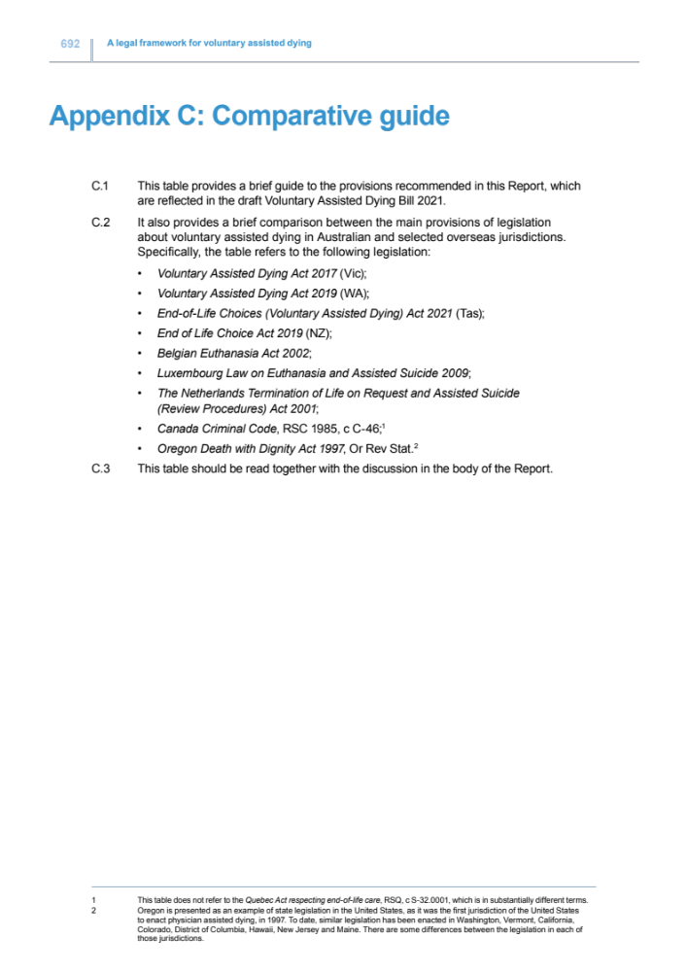
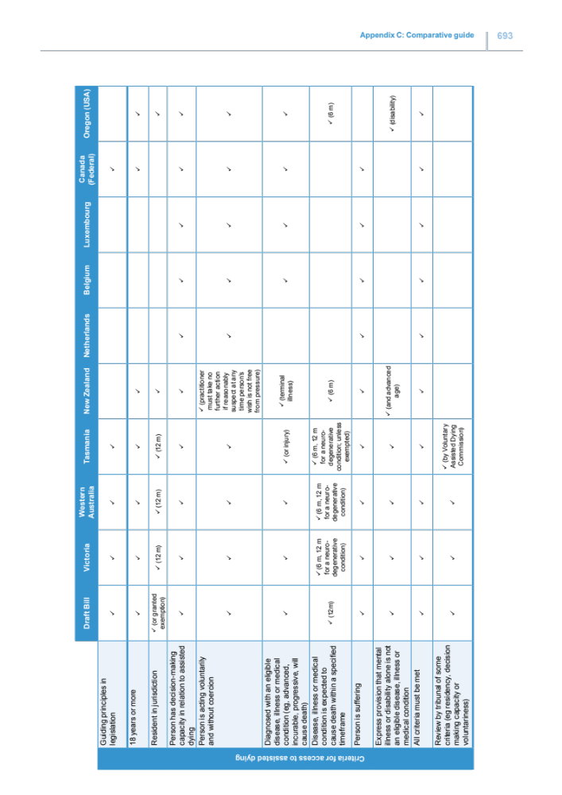
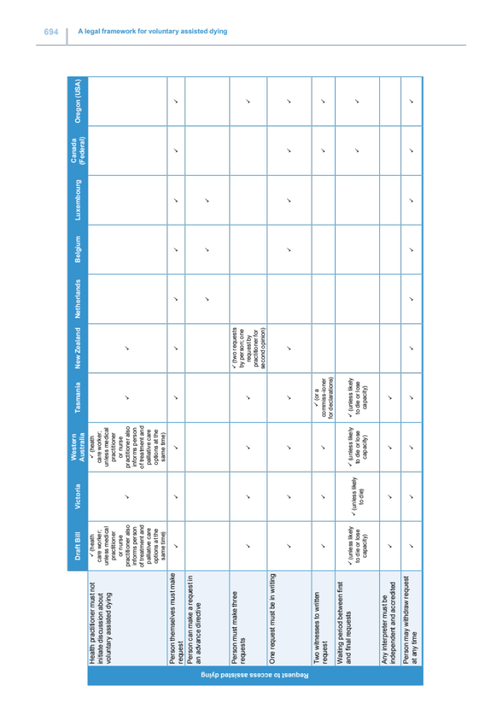
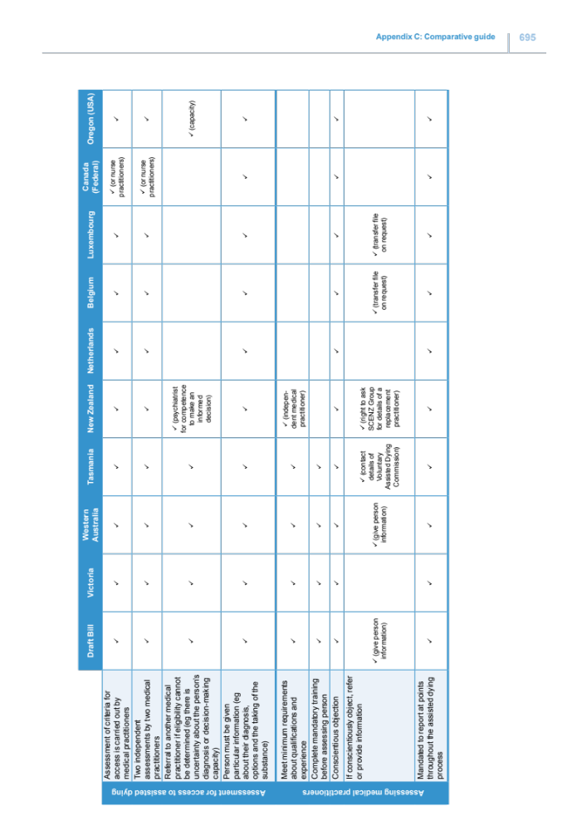
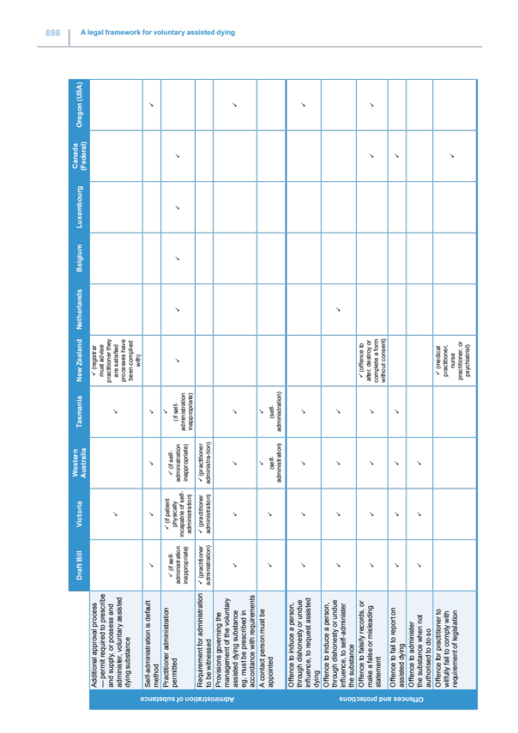
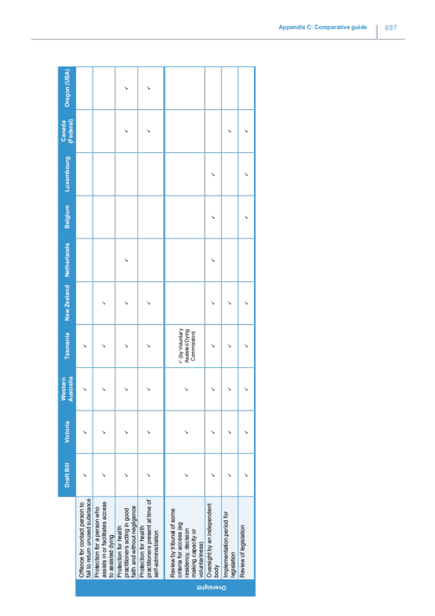

ACT Legislative Assembly (2019) Report: Select Committee into End of Life Choices in the ACT, 95, available at: https://www.parliament.act.gov.au/parliamentary-business/in-committees/previous-assemblies/select-committees-ninth-assembly/end-of-life-choices/inquiry-into-end-of-life-choices-in-the-act#tab1143329-5id.
See Australia Institute (2022) Polling – Territory rights and voluntary assisted dying, available at: https://australiainstitute.org.au/report/polling-research-territory-rights-and-voluntary-assisted-dying/.
Laws and practices can differ notably across jurisdictions in Australia and overseas. A comparative guide between the main provisions of legislation around voluntary assisted dying in Australia and selected overseas jurisdictions can be found in the report of the Queensland Law Reform Commission (2021) A legal framework for voluntary assisted dying, Appendix C, available at: https://documents.parliament.qld.gov.au/tableOffice/TabledPapers/2021/5721T659.pdf.
Ben White and Lindy Willmott, ‘A Model Voluntary Assisted Dying Bill’ (2019) 7(2) Griffith Journal of Law and Human Dignity 1, available at: https://eprints.qut.edu.au/198052/.
Ben White, Lindy Willmott, Katrine Del Villar, Jayne Hewitt, Eliana Close, Laura Ley Greaves, James Cameron, Rebecca Meehan and Jocelyn Downie, ‘Who is Eligible for Voluntary Assisted Dying? Nine Medical Conditions Assessed Against Five Legal Frameworks’ (2022) 45(1) University of New South Wales Law Journal 401, available at: https://eprints.qut.edu.au/211733/.
See eg the recommendations of ACT Legislative Assembly (2019) Report: Select Committee into End of Life Choices in the ACT, 95.
Bekker H , Thornton JG, Airey CM, et al. “Informed decision-making: an annotated bibliography and systematic review.” Health Technol Assess 1999;3:156.
Queensland Law Reform Commission (2021) A legal framework for voluntary assisted dying: Report no 79, [8.448], available at: https://documents.parliament.qld.gov.au/tableOffice/TabledPapers/2021/5721T659.pdf.
Queensland Law Reform Commission (2021) A legal framework for voluntary assisted dying: Report no 79, [8.444], available at: https://documents.parliament.qld.gov.au/tableOffice/TabledPapers/2021/5721T659.pdf.
Ben White and Lindy Willmott, ‘A Model Voluntary Assisted Dying Bill’ (2019) 7(2) Griffith Journal of Law and Human Dignity 1, available at: https://eprints.qut.edu.au/198052/.
Lindy Willmott, Ben White, Danielle Ko, James Downar and Luc Deliens, ‘Restricting Conversations about Voluntary Assisted Dying: Implications for Clinical Practice’ (2019) 10(1) BMJ Supportive and Palliative Care 105, available at: https://eprints.qut.edu.au/211733/.
See for example University of Tasmania (2021) Independent Review of the End of Life Choices (Voluntary Assisted Dying) Bill 2020, 79-81, available at: https://www.utas.edu.au/__data/assets/pdf_file/0009/1475568/Independent-review-voluntary-assisted-dying.pdf; White, BP, Willmott, L, Close, E and Downie, J (2021) ‘Legislative Options to Address Institutional Objections to Voluntary Assisted Dying in Australia’, UNSW Law Journal Forum, No 3, available at: https://www.unswlawjournal.unsw.edu.au/wp-content/uploads/2021/05/2021-3-White-et-al.pdf.
White BP, Willmott L, and Close E (2019) ‘Victoria's voluntary assisted dying law: clinical implementation as the next challenge’, Med J Aust 2019, 210(5), 207-209, available at: https://www.mja.com.au/journal/2019/210/5/victorias-voluntary-assisted-dying-law-clinical-implementation-next-challenge.
White, Ben, Willmott, Lindy, Sellars, Marcus, & Yates, Patsy (2021) Prospective oversight and approval of assisted dying cases in Victoria, Australia: a qualitative study of doctors’ perspectives. BMJ Supportive and Palliative Care, available at: https://eprints.qut.edu.au/210873/1/Submitted_Version_Prospective_oversight_BMJ.pdf.
Crimes Act 1900 (ACT), s 16.
Walter and Eliza Hall Institute of Medical Research, Neurodegenerative disorders (website), available at: https://www.wehi.edu.au/research-diseases/development-and-ageing/neurodegenerative-disorders
Palliative Care Australia, What is palliative care? (website), available at: palliativecare.org.au/resource/what-is-palliative-care/.

