ACT Disability Strategy
Have your say
Community Services Directorate, Inclusion and Participation

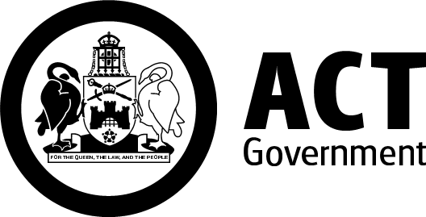




Easy English 2022

Hard Words

This document has some hard words.

The first time we write a hard word

- the hard word is in blue

- we will write what the hard word means.



You can get help with this document.

You can get someone to help you

- read this document

- know what it says

- find more information

This document comes from the ACT Government.
When you see the word ‘we’, it means the ACT Government.


What is the ACT Disability Strategy?
The ACT Disability Strategy is a plan to improve the lives of people with disability.
We will call it the Strategy.

The Strategy is
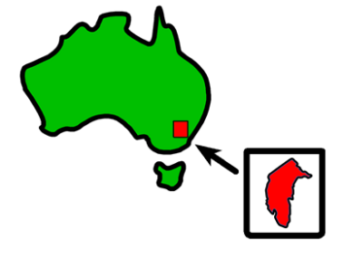
- a 10 year plan

- for people in the Australian Capital Territory or ACT.

The aim of the Strategy is to make the ACT more -
- inclusive

- accessible.

If something is inclusive, everyone can take part.

If something is accessible, everyone can use it. This might be:
- a place or a building
- transport
- a service
- information
- a website.
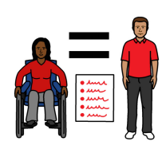
The Strategy will make sure that people with disability are
- treated the same as everyone else
- included in our community.

Why we need an ACT Disability Strategy

The ACT Government makes a lot of decisions, like

- laws for the ACT


- how we do business and set up services

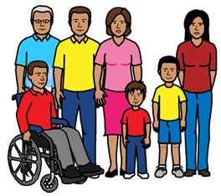
- what to spend money on.

These decisions affect the whole community, including people with disability.


The ACT Disability Strategy will guide our decisions, so that
- we listen to the views of people with disability
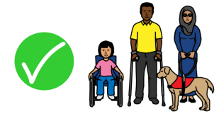
- the decisions we make help make the ACT a better place to live.

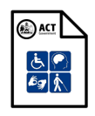
Why we need your help

We are making a new Disability Strategy for the ACT.

We believe in the idea “nothing about us without us”.
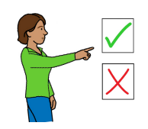
“Nothing about us without us” means people with disability must be part of the decisions governments make that will affect their lives.


We want
- to hear from people with disability

- the ACT Disability Strategy to say what you want it to say.

We want to know
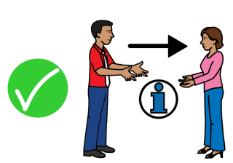
- what we should include in the Strategy

- how we can make sure your ideas are the focus of the Strategy

- how we can best include your ideas in the Strategy.


Your ideas and opinions will help us
- learn more about what matters to you

- make better and fairer decisions

- be more open about how we make decisions

- get good feedback on the decisions we make

- learn from things we did not do well in the past

- become better at listening to many views from many different people.

The chance to be part of the ACT Disability Strategy is also a good way for you to

- stand up for your rights

- advocate for you and others

- use your power to make change.

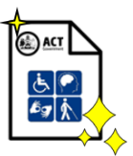

What this means for us
Your views on the Strategy are very important to us.

We want to make it easy for you to share your ideas with us.


We need to
- ask you what you want, in way that suits you


- give you time to tell us what is important to you

- listen to what you say

- include what you say in the Strategy
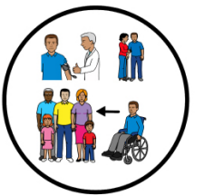


- turn the Strategy into actions.

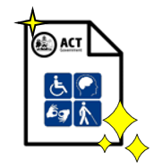
How you can help create the new ACT Disability Strategy


We made some different ways for you to take part.
- Open Public Forums
Open Public Forums are meetings where you can share ideas about what matters to you.

The meetings will be
- online and face-to-face
- led by people with disability


You can find out how to join an open public forum here:
Attend an open forum | ACT Disability Strategy | YourSay ACT

- Focused conversations
Focused conversations are public meetings that focus on one topic, like Health or Employment.


You can find out more about the focused conversations here:
Join a focused conversation | ACT Disability Strategy | YourSay ACT
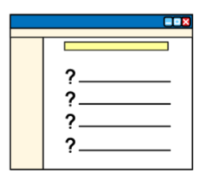
- Online survey
You can take part in the ACT Disability Strategy survey here:
ACT Disability Strategy Survey

- Kitchen Table Conversation kit.
The Kitchen Table Conversation kit is a way for you to have a conversation about the ACT Disability Strategy at home with family and friends.

The kit has cards on different topics, like
- Learning and developing skills
- Having a job and having enough money
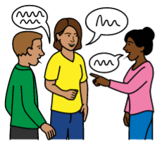
You can
- share your
- thoughts and views in small groups

- send the information back to us online.


You can find out more about the Kitchen Table Conversation Kit here:
Kitchen Table Conversations Kit | ACT Disability Strategy | YourSay ACT
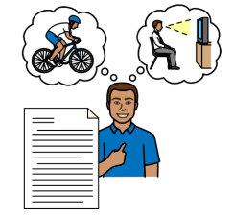
- Make a submission
A submission is a report about your experiences.

A submission can be
- your story about what worked well for you
or
- what did not work well for you
or
- a list of good ideas you have.

You can
- write a submission here:
https://yoursayconversations.act.gov.au/act-disability-strategy/upload-submission

or

- make a video submission here:
https://yoursayconversations.act.gov.au/act-disability-strategy/upload-video-submission

More information and resources

United Nations (2008). Convention on the Rights of Persons with Disabilities.

Australia’s Disability Strategy 2021-31

The ACT Disability Reference Group webpage

The Disability Justice Strategy

The Disability Justice Strategy consultation information

Advocacy for Inclusion wrote the Easy English on behalf of the ACT Government.

Contact details
2.02 Griffin Centre, 20 Genge Street Canberra City ACT 2601
Phone: 6257 4005
Email: info@advocacyforinclusion.org
ABN: 90 670 934 099

Image Acknowledgments
Picture Communication Symbols © 1981-2010 by Myer-Johnson LLC. All Rights Reserved Worldwide. Used with permission. Boardmaker™ is a trademark of Myer-Johnson LLC. Myer-Johnson LLC P.O box 1579. Solana Beach, CA 92075. Phone 858-550-0084




