


DRAFT Guide for tree removals on design grounds

Planning Act 2023
Territory Planning Authority

City and Environment Directorate

Environment, Planning and Sustainable Development Directorate

Environment, Planning and Sustainable Development Directorate

Environment, Planning and Sustainable Development Directorate

Contents
DRAFT Guide for tree removals on design grounds 1
Glossary 3
Version history 4
1. Context 5
Interaction with other legislation 5
Application of this process 5
2. Purpose of this guide 6
Who is this guide for? 6
3. Making an application 6
What the application needs to include 6
Other relevant documents that are not required for the application 7
4. Criteria – what is considered? 8
Location of tree and availability of developable area 8
Tree species and quality 9
Planning outcomes and design impacts 10
5. The process 11
The process – design grounds 13
6. Examples when tree removals may be supported or not supported on design grounds 14
7. Got questions? 18

Glossary
ACT | The Australian Capital Territory
the Authority | The Territory Planning Authority
DA | Development Application
Desired planning outcome | A development that responds to government’s planning priorities such as those outlined in the Planning Strategy, the District Strategies, or the Minister’s Statement of Planning Priorities, and is consistent with the Territory Plan.
Front zone | means the area of a block between the front boundary and the building line or at the minimum front setback of the lower floor level for the block whichever is greater. (Note: for the purpose of this definition, the front zone shall not be more than 10m from the front boundary).
the Planning Act | Planning Act 2023
Primary building zone | means the area between the front zone and a line projected 12m distant in a perpendicular line away from the front zone.
Protected matters | As defined in the Planning Act 2023
Protected tree | As defined in the Urban Forest Act 2023
Public tree | As defined in the Urban Forest Act 2023
Rear zone | means the area of a block behind the primary building zone.
Reasonable alternatives | feasible options and alternatives that provide a development that is substantially the same
Registered tree | As defined under the Urban Forest Act 2023
Regulated tree | As defined under the Urban Forest Act 2023
Remnant tree | As defined under the Urban Forest Act 2023
TAA | Tree Activity Application – an application made under the Urban Forest Act 2023 to remove or impact a protected tree.
Territory Plan | The primary planning instrument that guides planning and development in the ACT
TPZ | Tree Protection Zone. As per Section 13(1) of the Urban Forest Act 2023, protection zone for a protected tree means –  - the area under the canopy of the tree; and  - the 2m wide area surrounding the vertical projection of the canopy; and  - the 4m wide area surrounding the trunk as measured at 1m above natural ground level.  13(2) However, if another protection zone is defined in a tree management plan in force for the protected tree, that protection zone is the protection zone for the tree.
UFA | Urban Forest Act 2023

Version history
Version number | Approved by | Date
1.0 | XXX | XX/XX/XX

Context
Recent amendments to the Planning Act 2023 (the Planning Act) enable approval of applications to remove a public tree or regulated tree on planning grounds. That is, the tree removal can occur when it is associated with a future development and the removal will facilitate the achievement of a desired planning outcomes, provided it does not impact protected matters.
This guideline has been developed to set out matters that could or will be considered by the Territory Planning Authority (the Authority) when deciding whether to approve the removal of a tree under Part 7.1A of the Planning Act. This guideline also outlines the process, required documentation and other relevant considerations. This supports decision makers and proponents in making applications.
This process has been established to provide a quick and easy way for proponents to obtain a decision from the Authority on whether tree removal could proceed on planning grounds without needing to lodge a development application (DA).

Interaction with other legislation
This process interacts with the tree protection provisions under other ACT legislation, including:
- Urban Forest Act 2023
- Environment Protection Act 1997
- Nature Conservation Act 2014
- Heritage Act 2004.
This process is in addition to Tree Activity Applications (TAA) that are assessed under the criteria contained in the Urban Forest Act 2023 (the UFA). More information about the interrelationship between these processes is outlined in Section 5 below.
This process does not impact the protection provided to places or objects on the heritage register. The removal of heritage trees, registered trees and/or remnant trees cannot be considered under this process.
Other statutory approvals may be required to permit development, such as a development application. Please refer to the Guide to DAs for more information on when a DA may be required.

Application of this process
Table 1: When this process applies
Applies | Does not apply
- When a regulated tree and/or public tree are proposed for removal to facilitate a development proposal. This may include when the criteria for removal under the UFA is not meet. | - The removal of heritage trees  - The removal of registered trees  - The removal of remnant trees.  - Protected matters  - The removal of trees associated with a subdivision design application or equivalent stage (i.e. establishing greenfield estates)  Note: the location of heritage trees and registered trees is available on ACTMapi.

Purpose of this guide
This guide has been made under section 144G of the Planning Act. It outlines the criteria used to evaluate applications for tree removals on planning grounds under Part 7.1A of the Planning Act.
This guide outlines the:
- Criteria that a tree must meet to be approved for removal.
- Minimum documentation requirements for tree removal applications on design grounds.
- Pathway for applicants navigating through the process.

Who is this guide for?
This guide is for:
- Decision-makers to consider in making a decision.
- Developers or consultants navigating the ACT planning system.
- People wanting to learn more about what approvals might be needed for their home project.
- Community members wanting to learn more about removing or impacts to protected trees.
- Industry professionals in providing advice to their clients.

Making an application

What the application needs to include

Online application form
Complete an online application form. This will outline:
- the number of regulated and public trees proposed for removal
- reasons for tree removal
- site plan of the proposed development and reasonable alternatives to the proposed design

Authorisation from the lessee
A signed authorisation by the lessee(s) of the land on which the tree/s is located.
Tree Assessment Schedule
A Tree Assessment Schedule (TAS) prepared by a certified project arborist (minimum Australian Qualification Framework Level 5 in Arboriculture) or person with equivalent experience that outlines all of the following for the tree/s proposed to be removed:
- Contact details and qualifications (if applicable) or experience of person preparing the TAS
- Site attendance date
- Protection Status under the Urban Forest Act 2023
- Height
- Canopy Width
- Tree Protection Zone
- Structural Root Zone
- Circumference and Diameter of trunk at 1.4m above natural ground level
- Species (botanical name)
- Hollows
- Presence of nests*
- Tree Quality Classification, including estimated life expectancy
- Photographs
*Note: If a tree proposed for removal contains nests, the removal or disturbance of those nests requires a licence under the Nature Conservation Act 2014.

Statement of Intent
A written statement explaining how the proposed concept and the tree removal or any other associated works will facilitate a desired planning outcome to be achieved. This statement may be prepared by the owner/occupier or by an applicant on their behalf. Further information about the criteria is outlined in Section 4 of this guideline.

Notification of adjoining leases
If there is an adjoining place that has 1 or more dwellings on it, the proponent of the development proposal must take reasonable steps to give written information about the proposal to an occupier (a resident) of each dwelling, including site plans and information about the tree proposed to be removed.

Tree management plan
A tree management plan prepared in accordance with s88 of the UFA. Please find further information here.

Other relevant documents that are not required for the application

Canopy Contribution Agreement
If a regulated or public tree is approved for removal, the applicant must enter into a Canopy Contribution Agreement (CCA) under the UFA before the tree can be removed. Further information will be required to progress the CAA, which will be attached with the notice of decision.

Criteria – what is considered?
For an application to remove a public or regulated tree to be approved:
- The removal of the tree must facilitate the achievement of a desired planning outcome applying to the proposed development under the Territory Plan.
- The proposal must not involve a protected matter or a heritage or Aboriginal cultural tree.
To determine if the development will facilitate a desired planning outcome, each of the following criteria will be considered:
- The location of the tree and the availability of developable area within the block (area not covered by approved structures).
- Tree species, quality and estimated life expectancy.
- Planning outcomes and design impacts (see section below on Planning outcomes and design impacts)
In addition to the information below, examples are provided in Section 6 that illustrate when removal may or may not be supported.

Location of tree and availability of developable area
The assessment will consider the location of the tree and the potential impact of its removal, including:
- The area of the block the tree is situated within, for example:
- Front zone.
- Primary building zone.
- Rear zone.
- The availability of alternative developable areas within the block, including:
- Alternate areas that could accommodate the type of development being proposed.
- Location of existing approved structures or buildings.
- Location of a public tree, for example:
- Verge trees – in relation to new servicing requirements and/or construction requirements.
Examples of these considerations are outlined in Table 1 below. It should be noted that the characteristics outlined below are examples only.
Table 1: Key characteristics considered – location and availability of developable area
Characteristics favouring removal to a protected tree | Characteristics favouring retention of a protected tree
- Trees that occupy a substantial portion of the primary building zone. The primary building zone is critical for accommodating the principal building envelope.  - Where existing buildings or structures are not located within the primary building zone, the location of existing structures/buildings will be considered. | - Where a tree is located substantially within the front zone or rear zone and does not materially constrain the building envelope.
- The proposed development (designed in accordance with relevant requirements), even after reasonable relocation and redesign that considers all lawfully constructed buildings and structures to be retained, cannot be accommodated on the subject site without resulting in major impacts to the proposed tree, other trees, or approved buildings and structures to be retained on site or on adjoining blocks. | - The site has sufficient developable land to accommodate the type of development proposed following reasonable relocation or design.
- Trees located where their position limits the provision of essential servicing (such as accessways and utility services), and alternative solutions would result in greater overall tree loss. | - Retention of trees is to be prioritised where their location allows for the provision of essential servicing without significant constraint.

Tree species and quality
The assessment will consider:
- The tree species, including whether it is native, non-native or a pest species.
- The tree quality classification
- The amenity, cultural and ecological value of the tree.
- Age and life expectancy of the individual and species.
Examples of these considerations are outlined in Table 2 below. It should be noted that the characteristics outlined below are examples only.
Table 2: Key characteristics considered – tree species and quality
Characteristics favouring removal to a protected tree | Characteristics favouring retention of a protected tree
- Pest species (public trees only)  - Non-designated street tree (public trees only) | - Native species
- Tree is in poor health, for example it has:  - Dead or dying canopy with minimal foliage  - Trunk decay  - Severe pest or disease infestation that is unable to be remedied  - Short life expectancy for the species | - Tree is in good health, for example it has:  - Healthy foliage  - Good form and vigour  - No signs of disease or nutrient deficiency  - No limiting factors on life expectancy
- Low amenity and streetscape value  - No shade, cooling or microclimate value | - High amenity or streetscape value  - Improves visual character and contributes to a sense of place  - Provides shade, cooling and improved microclimate
- No heritage or cultural values associated with the tree | - The tree holds heritage or cultural value within the locality
- Tree is planted and does not provide, or provides only marginal, habitat value for protected fauna. | - Tree provides habitat value for protected fauna or is part of a naturally occurring ecological community.

Planning outcomes and design impacts
When assessing an application to remove a public or regulated tree, consideration will be given to the proposed development considering the territory plan, the design and its associated impacts. The assessment will also consider whether the proposal achieves a desired planning outcome. Considerations may include:
- Whether the development will improve the planning outcome to be achieved, such as:
- If it contributes additional dwellings to a site while effectively balancing site coverage with living infrastructure.
- The mix of dwelling types and sizes proposed and whether it can assist in delivering a more compact and efficient city.
- Efficient land use including appropriate siting of the proposed development.
- Whether the relevant tree is within or impacts:
    - Important ecological corridor for the district’s blue-green network
    - A strategic movement corridor
    - The functionality of commercial centres, community facilities and other social infrastructure.
    - Reasonable site utilisation of unleased territory land where the proposed use is permissible.
- Replacement planting and soft landscaping to mitigate the removal or damage to the protected tree/s.
- The overall impact to amenity on-site and beyond.
- Impact on essential site services, including vehicle access, easements, and service connections.
- Demonstrate that reasonable design alternatives have been considered, including at least one alternative design option that seeks to retain the tree where possible. Consideration of alternatives may include, but is not limited to:
- Relocation or reconfiguration of buildings and structures
- Relocation or realignment of driveways, access points, or underground/overhead services.
- Adjustments to building footprint, layouts or setbacks.
- Tree retention and protection options
Examples of these considerations are outlined in Table 3 below. It should be noted that the characteristics outlined below are examples only.
Table 3: Key characteristics considered – strategic planning context and design impacts
Characteristics favouring removal of a protected tree | Characteristics favouring retention of a protected tree
- The development delivers additional residential dwellings and includes a mixture of dwelling types and sizes within an existing urban footprint. | - The development delivers no additional residential density. For example, it is for a non-habitable structure only (a driveway, retaining wall, shed or deck) on an existing single residential block.
- The tree is located in a key area significantly impacting a strategic movement corridor, for example, rapid public transport routes and key freight networks. | - The tree is part of an important ecological corridor or the blue-green network, as identified in the relevant District Strategy.
- The tree is located in a key area impacting:  - Redevelopment that would support the ongoing viability of local and group centres.  - The delivery of key community facilities and social infrastructure, such as schools and health facilities. | - The location of the tree does not significantly constrain the planning or delivery of key community facilities or social infrastructure such as schools and health facilities.
- Replacement landscaping and plantings will deliver significantly more tree canopy coverage and permeability. | - Replacement landscaping and plantings will deliver significantly less tree canopy coverage and site permeability following development
- The tree offers little valuable shade to private and communal open spaces, the street or other areas of the site. | - The tree provides significant shade to communal open spaces, the street or other areas of the site, particularly during the summer solstice.
- The tree is significantly conflicting with required vehicle access or essential services, such as water, electrical and transport easements, which are unable to be relocated. | - The tree does not significantly conflict with any essential services.

The process
As highlighted in Figure 1, where a regulated or public tree is proposed for removal, it requires approval. Where the removal relates to a development proposal, this decision is made by the Territory Planning Authority under the Planning Act – either through this process or through a DA.
Where the removal or impacts are not related to a development proposal, this decision is made by the Decision-Maker under the Urban Forest Act.
Another process in available under the Urban Forest Act, which allows an application to be made for approval to undertake works within the TPZ where those works are likely to have minor impacts on a protected tree. This process is also outlined in Figure 1 below.
Figure 1: Process map
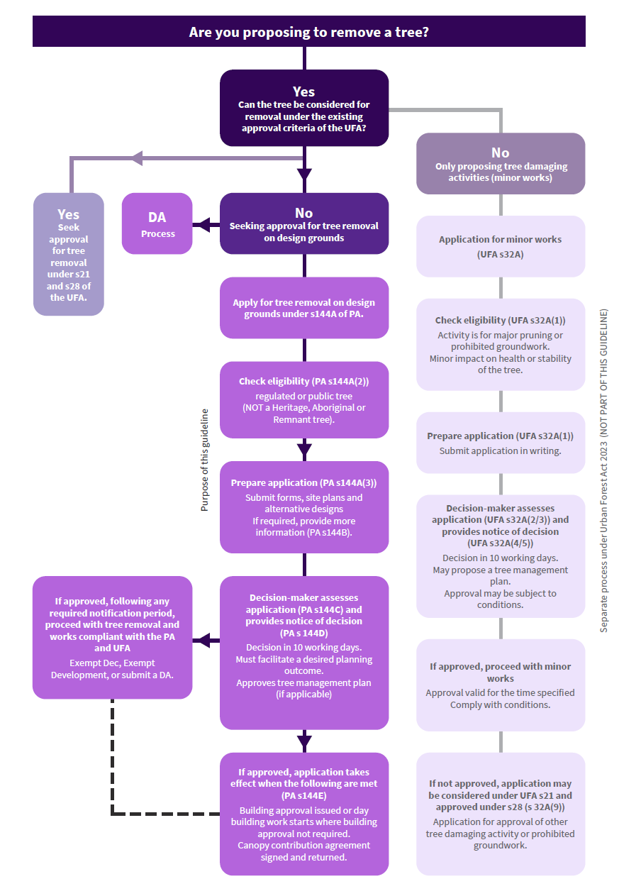

The process – design grounds
As outlined in Figure 1, applications to remove a public or regulated tree on design grounds follow this process:
- Lodgement of an application by the proponent
- Consideration by the Authority, in line with this Guideline
- The Authority may request further information to be provided within a specified period of time
- The Authority decides the application and provides a notice of decision to relevant parties.

Timeframe
The Authority is required to make a decision no later than 10 working days after the application is made. The 10-day timeframe applies only where the application is complete and no further information is required.
If additional information or amended plans are requested to address the relevant requirements, the assessment timeframe may be extended accordingly.
An approval granted under this process has the effect of ‘turning off’ offence provisions related to the removal of the identified tree.

Examples when tree removals may be supported or not supported on design grounds

Example 1 – When tree removals may be supported
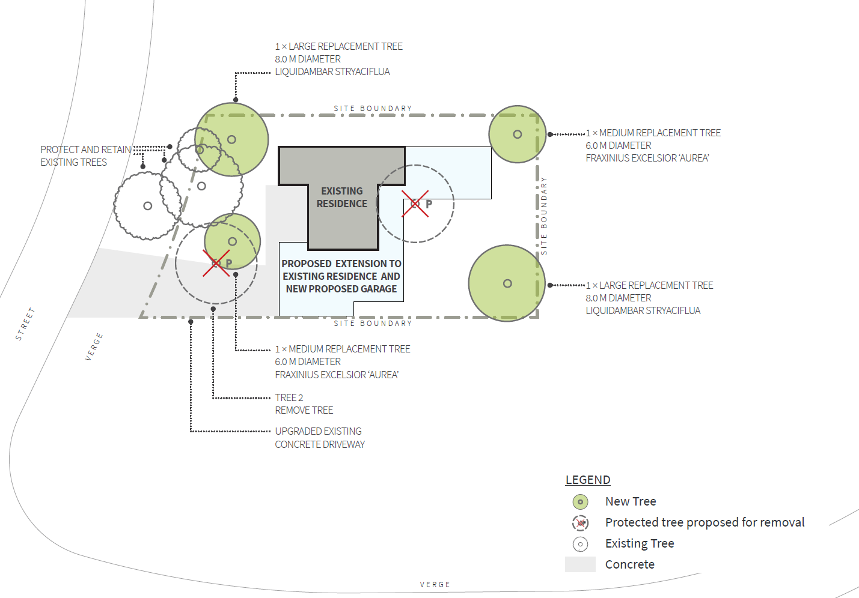
Table 4: Considerations of an example when tree removal may be supported on design grounds
Site and development context | - Zone: RZ1 Suburban Zone  - Site size: 747m²  - Current land use: Single dwelling (approx. 105m²)  - Proposed development: Proposed extension and garage to single dwelling.
Tree species and quality (relevant trees only) | Protected tree located near Existing Residence:  - Species name: Silver Birch  - Health and condition: Fair health, poor overall condition, significant decline  - No heritage or Aboriginal cultural value.  Protected tree located near the proposed driveway:  - Species name: Chinese Pistacia  - Health and condition: Fair health, poor overall condition, significant decline  - No heritage or Aboriginal cultural value.
Location of tree and developable area | - One protected tree is located immediately adjacent to the primary building zone and its retention would significantly restrict the site layout and flexibility in building design.  - While the other protected tree is within the front zone its removal accommodates the driveway. Alternate locations for a new driveway, such as at the north-western corner would necessitate the removal of several other existing trees within the site.
Strategic planning context | - The trees proposed for removal are not part of an ecological corridor, the blue-green network, nor is the development for important infrastructure or facilities
Planning outcomes and design impacts | - While the proposal does not deliver additional dwellings, the location of the trees and availability of developable land on the site (as highlighted above) significantly reduces the ability to accommodate a sensible extension to the single dwelling house. Retaining the tree located near the existing residence would prevent a practical and functional expansion to the south of the site, limiting design flexibility and resulting in any proposed works being located along the eastern boundary, posing potential impacts to adjoining residence.  - Retention of the regulated tree located in the front zone would require relocating the driveway to the northern part of the site, resulting in the removal of multiple trees and disrupting essential site services. Removal of this protected tree facilitates the least impactful design outcome overall.  - The design proposes two medium deciduous trees (Golden Ash) and two large deciduous trees (American sweetgum) as replacement planting in line with CCA requirements. These species are known for their ornamental value, and their inclusion will enhance the residential amenity of the site while contributing meaningfully to the long‑term development of canopy cover across the block.

Example 2 – When tree removal or tree damaging activities may not be supported
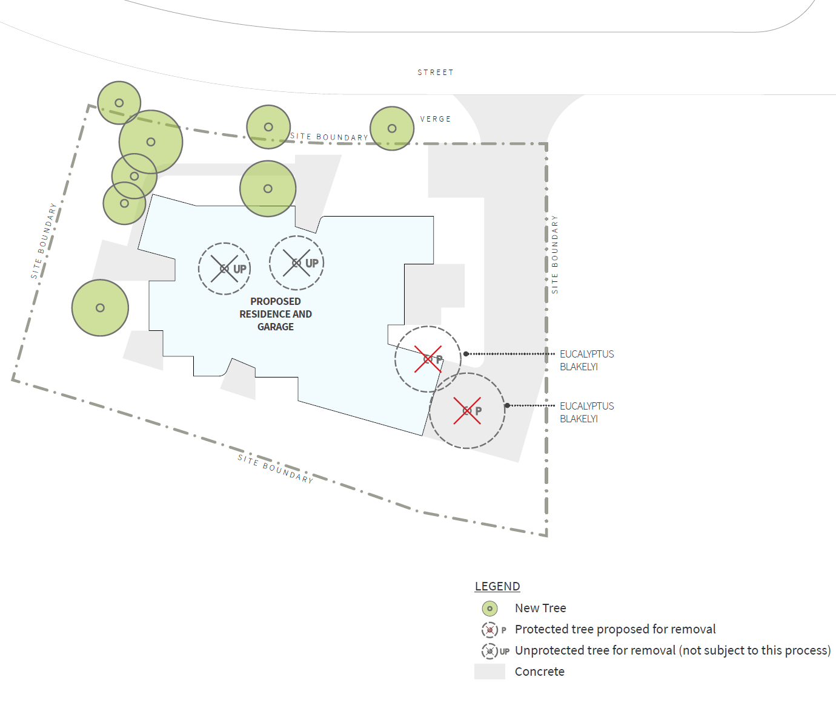

Table 5: Considerations of an example when tree removal or tree damaging activities may not be supported on design grounds
Site and development context | - Zone: CFZ Community Facility  - Site size: Approx 1,800m²  - Current land use: Vacant  - Proposed development: Residential care accommodation (approx. 717 m²).
Tree species and quality (relevant trees only) | Two Protected trees (located east of the site):  - Species name: Eucalyptus blakelyi (not remnant)  - Health and condition: Fair health, medium condition, keystone remnant tree specimen.  - No heritage or Aboriginal cultural value.
Location of tree and developable area | - While site coverage and building envelope controls do not apply to this development type, the protected trees are located generally in the south-eastern corner of the site, outside of the primary building zone that would otherwise apply to residential development on the site.
Strategic planning context | - The trees proposed for removal are not part of an ecological corridor, the blue-green network, nor is the development for important infrastructure or facilities
Planning outcomes and design impacts | - The proposal does not deliver additional dwellings.  - Retention of the two protected trees would require relocating the driveway and a small portion of the building. Noting the extent and availability of developable land on the site, this can be easily accommodated through minor design changes.  - While the design proposes a mix of medium and large trees, shrubs, and ground covers as replacement planting, and the developer has committed to supplying and installing habitat boxes within an adjacent box woodland to mitigate the loss of canopy cover and native species, these measures are not relevant in this instance, noting that the existing trees can be retained through minor design changes.

Got questions?

The DA Gateway team are also available on the following:
Email: planningenquiries@act.gov.au
Online: https://services.accesscanberra.act.gov.au/s/forms/land-planning-and-building-enquiry
Phone: 02 6205 2888

