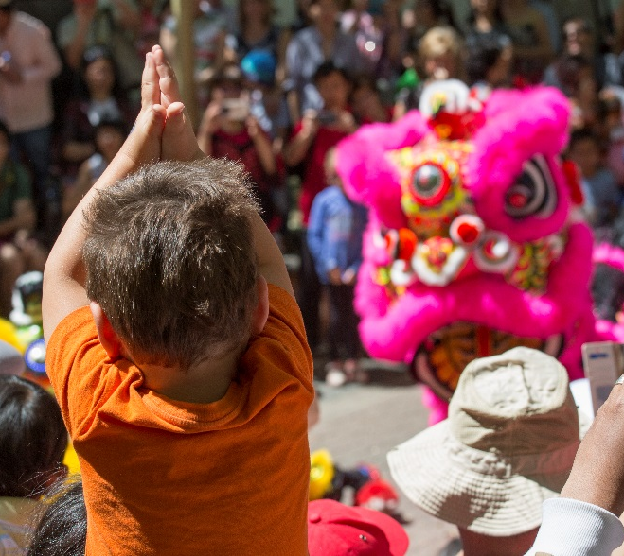

Reviewing The National Multicultural Festival
We asked the community to share their feedback and ideas to help shape the future of the National Multicultural Festival.

The National Multicultural Festival (the Festival) is a community event held over three days in February each year, providing an opportunity for Canberrans to participate in, taste and learn about other cultures and traditions.

The Festival is one of the most successful multicultural festivals in Australia and remains a community-driven ‘grassroots’ event, guided by support from Canberra’s culturally diverse communities and the broader ACT community. The Festival vision promotes equality of opportunity, maintaining social cohesion, building social capital and minimising social exclusion among culturally diverse Canberrans.

THE CONVERSATION
The YourSay online survey opened on Tuesday 26 June 2018 and closed on Friday 13 July 2018.
Further consultation was undertaken with members of the multicultural community and government by SpringGreen Consulting through face to face meetings in the same time period.
Other research and surveys are undertaken of the National Multicultural Festival that inform improvements of the Festival each year. This year IER Pty Ltd provided an Economic Impact and Research Report and the Les Winton Householder Survey Research Survey.

WHO ENGAGED
The survey was completed by 296 people. Over half were between 25 – 45 years.
The majority of respondents (86%) were attendees at the festival. The balance was made up of volunteers (6%), stallholders and performers (4% each), with women having the high representation of 58%.
59% of respondents came from Canberra’s inner north and northside suburbs, 34% from inner south & southside suburbs and 5% were from outside Canberra.

Key insights from the community
❶Overall experience of the Festival was excellent

“The Multicultural Festival is a true Canberra institution and has only gone from strength to strength in the last few years.”

“It's an excellent and fun event that brings the city alive and the community together.”

“It's an excellent and important festival for Canberra - and best when a multi-cultural and community focus and feel prevails.”

“I love it! It’s my favourite Canberran event and it makes me proud to be Australian. I love celebrating cultural diversity and the food and music!”

“All in all it was a really well planned out event.”
❷ Suggested improvements for future years

- expansion of the festival site
- spreading out the stalls
- providing more seating and shade
- keep it family friendly during day and night events

“Enhance the children’s sanctuary.”
“More seating and tables for families to sit down and enjoy food.”
❸ Local involvement

There was a strong theme related to prioritising local community involvement and limiting commercial and interstate vendors.
❹ Other feedback

Community feedback also highlighted the 2017 Festival’s alcohol policy, with both positive and negative response being received in relation to changes to the policy:
“Bring back the smaller stallholders, let the ethnic community groups sell culturally appropriate alcohol”.
“Keep the alcohol levels low.”

What’s Next?
A Review of the National Multicultural Festival has been prepared with all the feedback received through YourSay informing the Review.
The Review is now public after being announced Monday 20 August 2018.
Improved communication with stakeholders and a better defined alcohol policy are two key outcomes from the Government commissioned Review.
Key Timings
Early 2018 – 2018 National Multicultural Festival Review
26 June 2018 – YourSay survey opened
13 July 2018 – YourSay survey closes
20 August 2018 – Review of National Multicultural Festival released
15-17 February 2019 – 2019 National Multicultural Festival
Any resulting changes to Festival policy and procedures will be made widely available to community members through the Festival website and via electronic newsletter.

THANK YOU FOR YOUR FEEDBACK
534  We reached 534 people via YourSay | 296  We received 296 completed surveys | 5,438  People reached through social media

