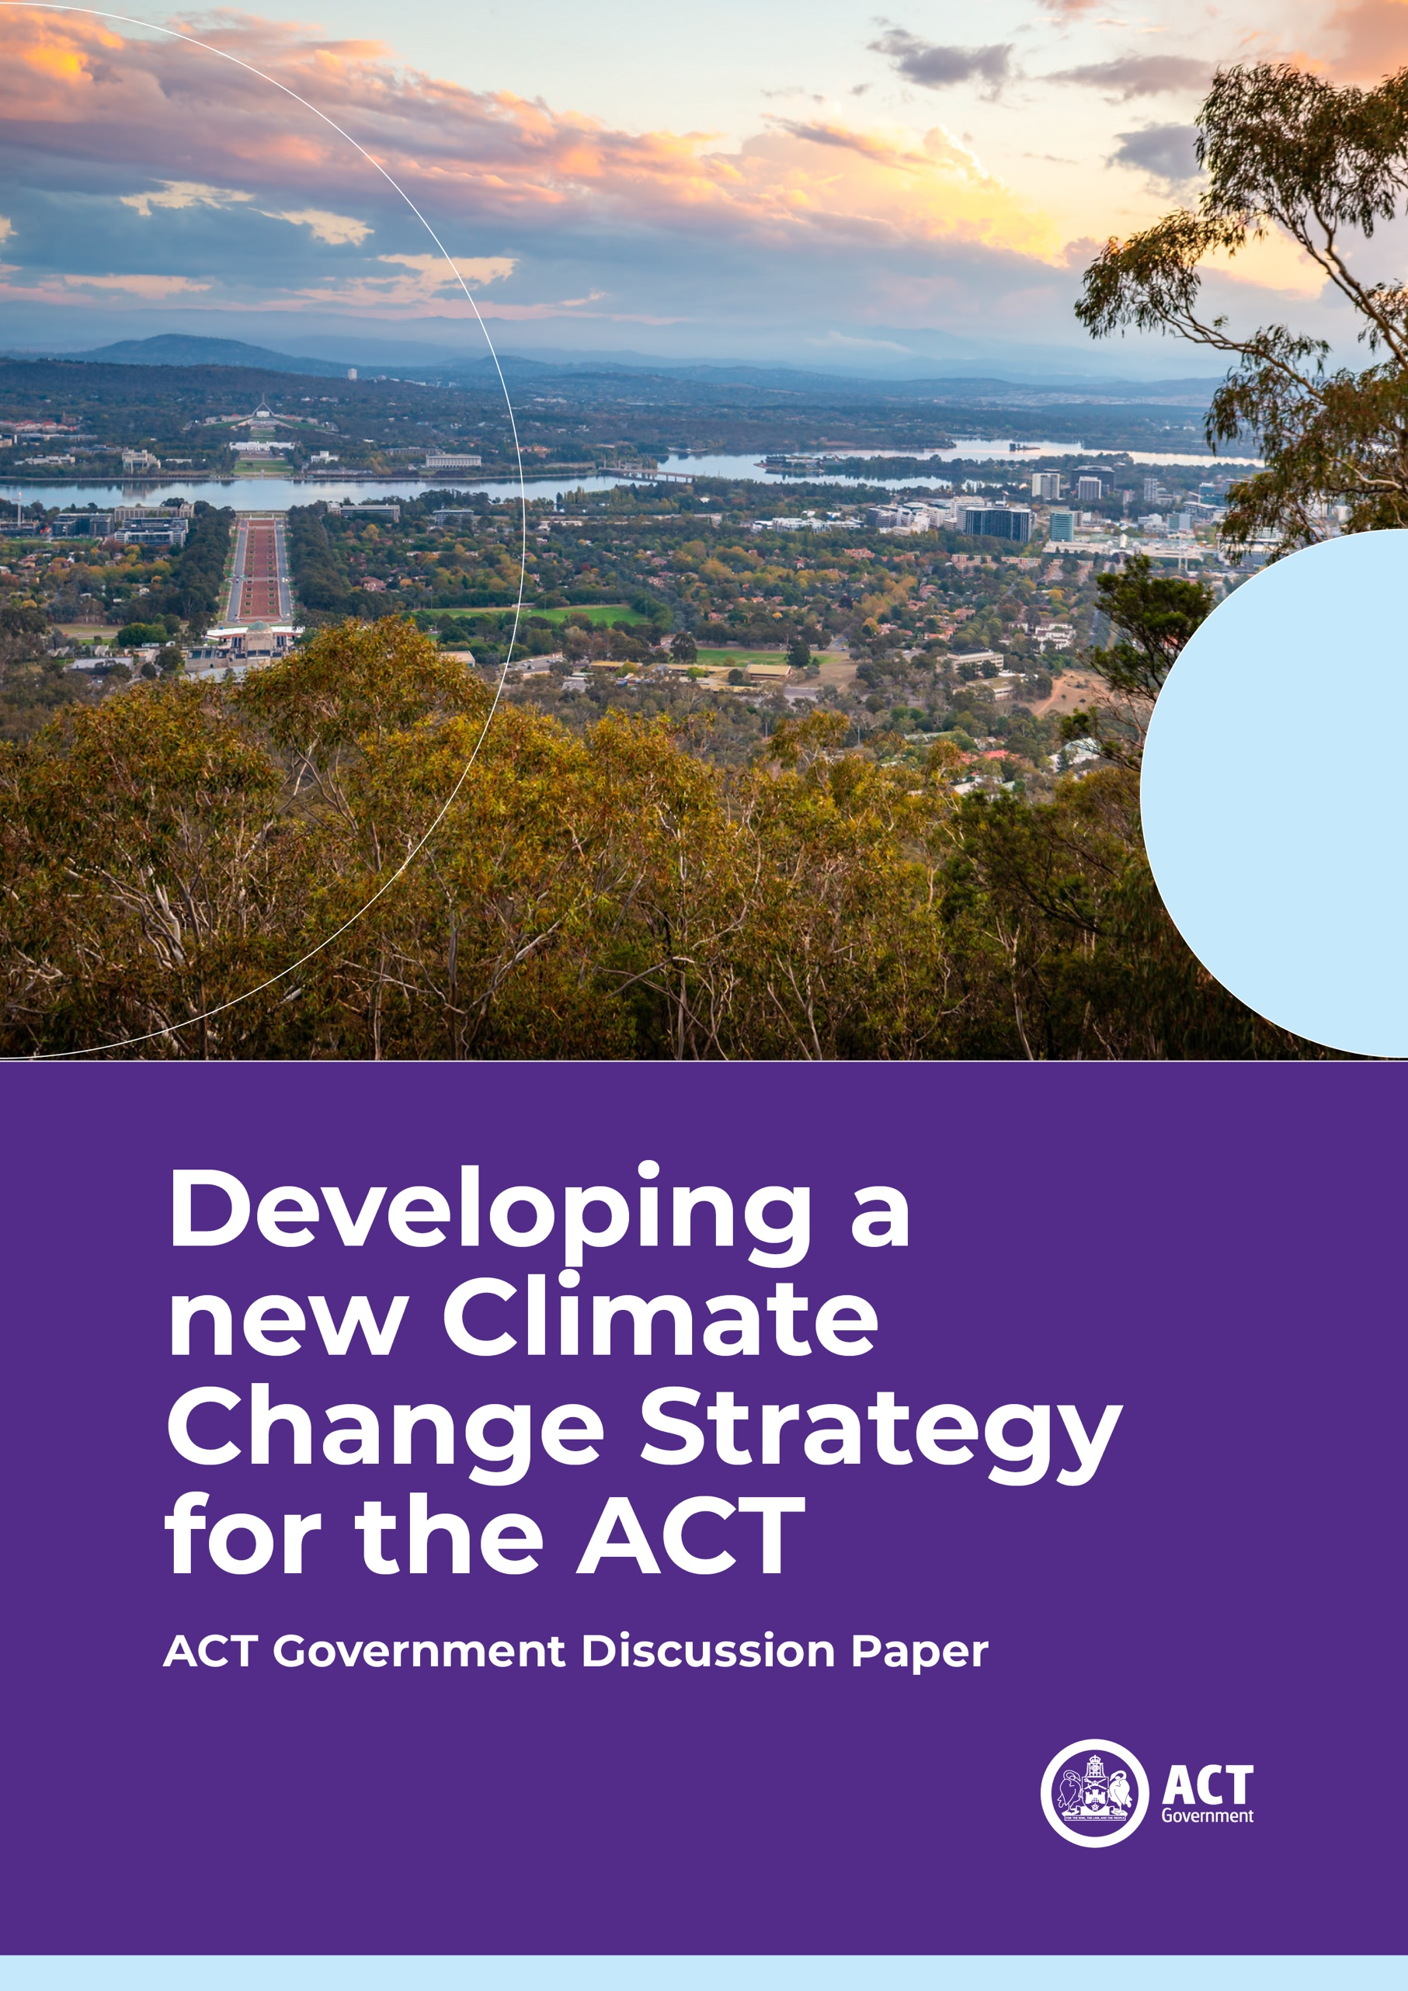

Acknowledgement of Country
The City and Environment Directorate acknowledges the Ngunnawal people as traditional custodians of the ACT and recognise any other people or families with connection to the lands of the ACT and region.
We respect the Aboriginal and Torres Strait Islander people, particularly our Aboriginal and Torres Strait Islander staff, and their continuing culture and contribution they make to the Canberra region and the life of our city.

© Australian Capital Territory, Canberra 2026
Material in this publication may be reproduced provided due acknowledgement is made.
Produced by the City and Environment Directorate. Enquiries about this publication should be directed to the City and Environment Directorate.
GPO Box 158, Canberra City 2601
act.gov.au
Telephone: Access Canberra – 13 22 81
If you are deaf, or have a hearing or speech impairment, and need the telephone typewriter (TTY) service, please phone 13 36 77 and ask for 13 22 81.
For speak and listen users, please phone 1300 555 727.
For more information on these services, contact us through the National Relay Service: www.accesshub.gov.au.
If English is not your first language and you require a translating and interpreting service, please telephone Access Canberra on 13 22 81.

Contents
Contents 3
A new Climate Change Strategy 4
The challenge: reducing our emissions 5
The challenge: Canberra in a changing climate 6
What the ACT has done so far 7
The approach for our next strategy 9
Community input on the framework 11
Embedding equity, wellbeing and resilience 12
Transport 15
Natural environment 17
Built environment 19
Energy 21
Government 23
Other emissions 25
Glossary 27

A new Climate Change Strategy

We want Canberra to…
Continue to be the nation leader and set the standard for climate action.

We will do this by…
Solving the challenges others can’t so there is no excuse for inaction locally, nationally or globally.
Showing that it is possible to reduce emissions and adapt to a changing climate in a way that empowers our whole community and protects our environment.
Development of a new Climate Change Strategy is an opportunity to underpin a bold and positive future for the ACT to protect our community, maintain existing climate actions and accelerate emissions reduction efforts.
Climate change is one of the most significant challenges we face, requiring coordinated action at local, national, and global levels.
The ACT is a climate leader. We have taken significant steps to reduce emissions and help our community adapt to the impacts of a changing climate.
The next phase of climate action will demand considerably more time, effort, and complexity, particularly in the context of a growing ACT population. Canberra’s climate is becoming increasingly hotter and more variable.
We want our new strategy to drive deep emissions reductions and get us back on track.
We want a strategy that better responds to an already changing climate because we must make real progress in protecting people, communities, organisations, and nature as our climate changes.
We need a strategy that ensures the actions we take to make real progress is fair and equitable. Adequate support must be extended to those most vulnerable to the impacts of climate change and those most impacted by the opportunities and challenges associated with the transition to net zero.
The strategy should acknowledge that ambitious climate action delivers benefits to our community such as improved health outcomes, new enterprises and jobs, and more liveable neighbourhoods.
Climate change is a challenge we all face. We want to offer the opportunity for Canberrans to share your views on our proposed approach and identified areas of focus for reducing emissions and adapting to the changing climate.

The challenge: reducing our emissions
The ACT Climate Change Strategy 2019–25 set out an ambitious program of work to lay the foundations for achieving our 2045 net-zero emissions target. Under this strategy, we reached key milestones, including achieving and maintaining a 100% renewable electricity supply. These initial measures represented relatively straightforward opportunities, yielding substantial reductions in emissions within a short timeframe.
ACT emissions have declined significantly by nearly 47% since 1990. Our per capita emissions have declined 69% per person and are generally declining year-on-year. In particular, fossil fuel gas emissions have fallen significantly, reducing by 10% compared to 2023-24. In 2024-25, total emissions were made up of ground transport (61%), fossil fuel gas (18%), and refrigerants (11%), with smaller contributions from waste (6%), agriculture (2%), and aviation (2%).
Although we have achieved a lot, we have not met our interim emissions reduction target of 50-60% by 2025. Recent projections show that we are not on track to meet our future legislated emissions reduction targets.
Our largest emissions sectors, transport and fossil fuel gas, will be key focuses over the next decade. We have already laid strong foundations to make change in these areas, including setting Canberra’s pathway to electrification and efforts to move away from fossil fuel energy (such as fossil fuel gas, petrol and diesel). We will also look to other areas where we can cut emissions, particularly from challenging sectors like waste, freight transport, construction, and land use.
Climate change is one of the greatest challenges we face, requiring coordinated action at local, national, and global levels. Development of the new Climate Change Strategy is an opportunity to accelerate emissions reduction efforts and demonstrate beyond our borders that progress can be made in a way that protects the wellbeing of our community and environment and underpins a bold and positive future for the ACT.

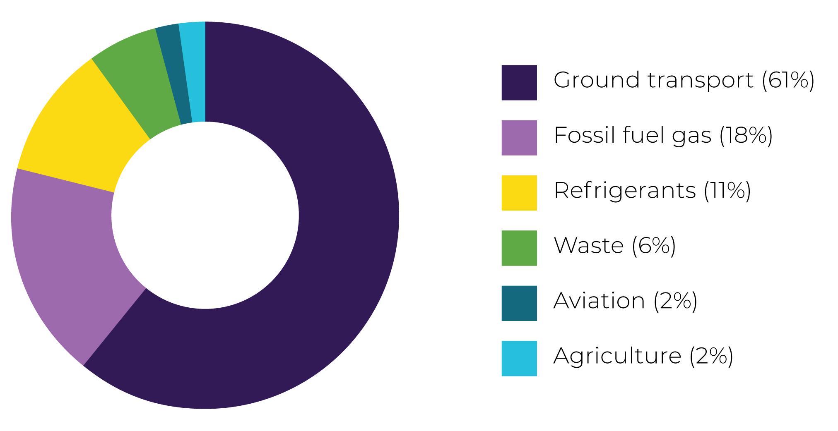

The challenge: Canberra in a changing climate
According to current climate projections, the ACT’s climate will be noticeably warmer by 2050, with average temperatures expected to rise by around 2°C compared to historical levels.
This shift will reshape daily life across the ACT. Summers will be longer and hotter, with more days exceeding 35°C, and more frequent and intense heatwaves. Warmer nights will mean less relief from daytime temperatures, especially in built-up areas.
Bushfire seasons are projected to start earlier and last longer, with increased risk across the region due to drier conditions and more frequent extreme heat events.
Rainfall patterns will also change, with a likely reduction in annual rainfall. This will lead to drier conditions overall but with more intense storms, increasing the risk of flash flooding. A heightened risk of drought and bushfires will place pressure on water supplies, agriculture, and emergency services.
Impacts of climate change on natural values and ecological systems are already being seen and are likely to be very significant going forward. This will present enormous challenges for nature conservation.
The urban heat island effect will exacerbate temperatures within built up areas of the ACT. This will impose greater heat stress on people, make our buildings less comfortable and increase the pressure on the electricity grid due to increased use of air conditioning. This makes green infrastructure and tree canopy cover, along with other methods of mitigating heat, essential to help cool our city during hot weather.
2050 is only 25 years from now. Many of us living in Canberra today will experience these impacts in our lifetimes and indeed they are already being felt.
The ACT Government acknowledges that individuals will face challenges adapting to this changing climate and meeting our emissions reduction targets. That is why we need strong Government leadership and partnerships with community to make the right structural changes that will support more resilient and sustainable choices for all over the long term, especially for those in our community who face complex barriers to change.

Caring for Ngunnawal Country
Canberra is located on Ngunnawal Country, an ancient and diverse landscape managed and cared for by the Ngunnawal people for tens of thousands of years. The Ngunnawal people have maintained tangible and intangible cultural, social, environmental, spiritual and economic connections with ACT lands and waters.
Climate change has potential to create disproportional impacts on traditional knowledge systems and the continued health and wellbeing of this community. It will be important to consider how climate change may affect cultural connections to Country and caring for Country as part of continuing climate action efforts. The ACT Government is committed to working with the Ngunnawal people and other people or families with connection to the land to support community resilience to climate change and explore opportunities to integrate traditional knowledge into ongoing land management.

What the ACT has done
so far
The ACT is recognised as a long-standing climate leader and has some of the most ambitious climate policies and targets across Australia and the world. We have made considerable progress to reduce emissions and have laid a strong foundation for future action.

The approach for our next strategy

2024 Review into Government Climate Action
An independent review of ACT Government climate action, conducted in 2024, found that the ACT has strong foundations to deliver net-zero emissions and enhance climate resilience. The review recommended a single, overarching framework to consolidate relevant visions, targets, and goals.
The new Climate Change Strategy will provide that framework, bringing together the ACT’s climate ambitions into a clear, coordinated plan until 2035. The Government will also develop underpinning Action Plans in consultation with the community to target and guide this effort.
The next Climate Change Strategy for the ACT will look a bit different to our past strategies.
The ACT has developed strong foundations to respond to the challenge of climate change, but we need a clear framework to bring all this work together and ground our next set of actions.
The new Climate Change Strategy will take the form of an overarching framework for 2026–35.
The framework will set out clear outcomes, highlight existing work already underway, and identify gaps and opportunities across key themes.
There will be regular action plan updates.
This long-term Climate Change Strategy will be supported by shorter-term action plans, spanning two to four years.
These action plans will focus on immediate priorities and will allow flexibility to respond to emerging issues and evolving community needs throughout the decade.
This approach will allow us to build on existing programs and commitments and focus on how best to support and coordinate ongoing and future climate action.
The new Climate Change Strategy will be supported by a strong monitoring and evaluation framework, including better data collection and transparency to enable both the community and decision-makers to track progress, highlight co-benefits and remain accountable as we work towards achieving our climate goals.
By providing direction for climate-related work across government and the community, we will ensure efforts are aligned, efficient, impactful and that we are working towards a shared understanding of the ACT’s climate priorities for the decade ahead.

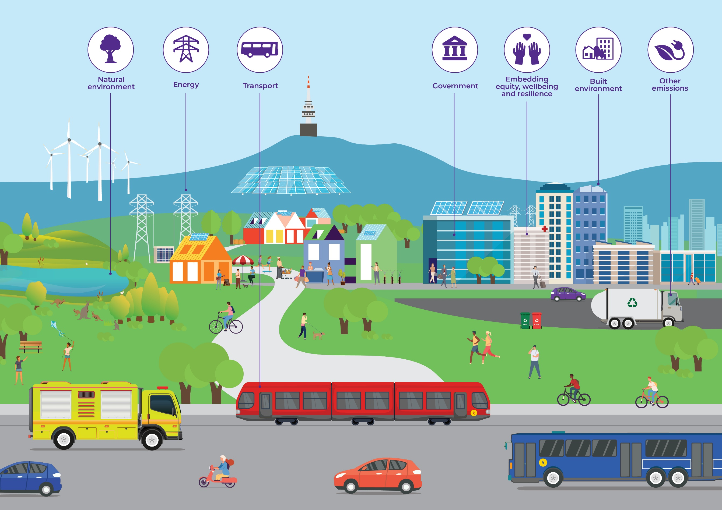

Community input on the framework
The following sections provide a broad overview of government policy and proposed next steps across each theme. The themes include guiding visions for our city and community, outlining where we want to be on our climate journey in 2035 and what success will look like, as we work towards a net-zero emissions city by 2045 and prepare our community for a warming climate.
We want to hear from the Canberra community on next steps.
We would love to hear your feedback on the vision for each of the themes, as well as the proposed next steps across each theme to inform where the ACT Government should be targeting its efforts. Your feedback will help inform development of the final strategy as well as direction for future action plans.
There are questions throughout this document to guide your response if you would like to provide a written response to this discussion paper, or you can complete a YourSay survey at www.yoursayconversations.act.gov.au.


Embedding equity, wellbeing and resilience
Vision for 2035: The ACT’s climate action efforts will empower everyone in our community including individuals, households, schools, businesses, and community groups to become more resilient, transition to net-zero, and build stronger community connections.
What success looks like for communities: Canberrans are empowered to reduce emissions, prepare and respond to the impacts of climate change, and recover from climate-related events. The health and wellbeing of Canberrans is supported by strong community connections, enabling government services, effective community education and inclusive planning.
What success looks like for businesses: Canberra businesses and organisations are world leaders in renewable energy, circularity and climate innovation, driving economic opportunities for our city. Businesses and organisations, particularly those with limited resources, are equipped to build resilience, prepare for climate risks and reduce their emissions. There are clear pathways for industries that are impacted by the transition to clean energy and affected workers are actively adapting.

Why equity, wellbeing and resilience are important
As we adapt to climate change and move towards a net-zero economy, a key element of success will be ensuring our transition is fair, equitable and doesn’t leave anyone behind. This principle applies to all planning, decisions and actions to ensure that the transition equitably benefits the wellbeing of all segments of our society.
Not everyone can afford to transition or adapt on their own, and costs must be spread equitably across consumers, government and the private sector, particularly in the context of infrastructure upgrades. Ensuring that electrification, efficiency improvements and thermal comfort upgrades are accessible across all households is key, as is ensuring that all areas of our community are becoming increasingly resilient to the impacts of climate change.
Climate change means that our community will be exposed to increased risk of climate-related hazards, such as extreme heat, bushfires, droughts, storms and flooding. It is important that we continue to plan for the impacts of climate change and continue work on improving disaster resilience and social recovery in the ACT.
The ACT workforce will be impacted by climate change, with businesses facing both challenges and opportunities from climate action. Ensuring a just and inclusive transition will be critical to the continued growth of our local industry, economic resilience and workforce stability.
A just transition involves engaging widely with the broader community on who might be at greater risk of climate change impacts or face greater barriers to transitioning. We must ensure vulnerable members of the community are heard on where supports and initiatives are best targeted for them.

What we’re doing
We’re supporting building upgrades to improve thermal comfort, energy efficiency and reduce urban heat. We have introduced a minimum standard to ensure residential rental properties have adequate ceiling insulation. We are helping communities to prepare for, respond to, and recover from climate change-related disaster events.
The ACT Government is responding to climate change as an economic opportunity. Building a net zero economy is helping to attract investment, foster innovation, grow skills, create jobs, and enhance our city’s economic resilience. We are supporting businesses to reduce operating costs and improve sustainability outcomes with technical advice and rebates. We are working with community sector organisations to strengthen their capacity to support at-risk groups and identify climate-related risks.

Proposed next steps
We want to improve, protect, and promote community health and wellbeing by preparing for the impacts of climate change and planning for future challenges on our health system. We want to explore ways to strengthen disaster resilience planning across many different sectors, including the health system, energy network and transport network. We hope to ensure that electrification, efficiency and thermal comfort upgrades are accessible to all households.
We remain committed to supporting priority groups, especially those with lower resilience to the impacts of climate change and community members with fewer financial resources or smaller community support networks, to ensure our support is effective and aligned with the challenges they face. We also want to explore ways to improve climate education and expand youth engagement to foster innovation and community-led action.
We will continue to unlock economic opportunities through climate action. We want to understand what support businesses need to manage climate risks while helping them innovate, reduce costs, and tap into emerging markets. We’re also committed to ensuring a future-ready workforce has the skills to adopt sustainable practices, respond to climate challenges, and lead emerging industries.

Feedback point
Community impact  Climate change will impact our whole community, but some will experience the impacts more than others. Older people, people with chronic health conditions or disabilities, low-income groups, renters, young people, First Nations groups, and people from culturally and linguistically diverse backgrounds (CALD) are just some groups who are anticipated to face disproportionate risk from climate change. Targeted support and adaptation measures need to be considered across all systems, such as energy, built and natural environment, transport, health, and disaster response, to ensure that disadvantaged groups are empowered to respond to climate change.  Benefits for households  Stronger community networks and social connections.  Better health and wellbeing outcomes across the Canberra community.  Improved safety and preparedness.  Faster recovery after disasters.  What you can do  Connect with your neighbours and local community networks for support and think about those in your community who may need additional help. Create a household emergency plan that considers diverse needs. | Business impact  Businesses are key to a fair and inclusive climate transition. All businesses in the ACT are likely to face challenges associated with climate-related disasters over the next decade which may impact productivity, viability, and employee health, safety and wellbeing. Many businesses will need to undertake operational changes like transitioning off gas and adjusting supply chains in response to climate risks, and in some cases transform their workforces to take advantage of new sustainable practices. Minimising disaster impacts to business operations will be best achieved by preparedness and factoring in climate-related events into risk assessments.  Benefits for businesses  Preparedness and proactive management of climate risks can reduce downtime and financial losses.  Improved safety for staff and customers.  Enhanced reputation for resilience and preparedness.  What you can do  Start thinking about how climate risks and the net-zero transition might impact your business and identify what, if any, supports you may need. Develop a business continuity and emergency response plan and train staff on disaster preparedness and evacuation procedures.

Questions
What barriers do you face in adapting your household or business to be more climate resilient?
Do you feel that all members of the community are able to participate in disaster resilience and emergency preparedness efforts?


Transport
Vision for 2035: Canberrans have multiple low-carbon transport options for moving around our city, including safe, accessible and convenient public and active transport, as well as zero-emissions vehicles.
What success looks like: Transport emissions are greatly reduced. Canberrans have access to a safe, convenient and decarbonised transport options. Zero-emission vehicles make up 100% of new passenger vehicle sales in 2035.

Why transport is important
Transport is the biggest source of emissions for the ACT, with the majority coming from private transport. Reducing emissions from this sector will be key to meeting our emissions reduction targets and will be a significant focus of the next Climate Change Strategy. Population growth presents an ongoing challenge for reducing transport emissions as more Canberrans move around the city as well as opportunities for increasing use of active travel and public transport as the city densifies.

What we’re doing
The ACT is striving for a world class transport system that supports a compact, sustainable and vibrant city. Significant work is already underway to improve public transport, with the light rail extension and the transition to 100% electric buses. Work on integrating land-use and transport is underway, such as through the Southern Gateway Corridor, which will place more value on public places that prioritise pedestrians, cycling and public transport as well as provision of social infrastructure required for sustainable communities.

Proposed next steps
Our city’s transport network must meet the needs of a growing population diverse in age, gender, location and reason for travel. That means better integrating planning, housing and the built environment to develop walkable neighbourhoods, better public transport, and safer cycling routes, while continuing to support the shift to zero-emissions vehicles. The next Climate Change Strategy is an opportunity to rethink how people and goods move to create a more connected, efficient system. By taking a holistic approach and ensuring the right infrastructure and services are in place across the Territory, we can cut emissions, ease congestion, and improve health and wellbeing.
It will be important that investment in electric vehicle charging infrastructure remains strategic, both for the public and for businesses. We will also further explore how zero emission vehicles can support the energy grid. Smart charging and vehicle-to-grid technology can help balance demand, improve reliability and help consumers save on energy costs.
While road transport is the main source of emissions, air travel still contributes around 2%. The ACT Government will continue advocating for aviation sector decarbonisation and alternatives to air travel like faster inter-city rail.

Feedback point
Community impact  Most transport emissions in Canberra come from private vehicle use. The transition to a net-zero emissions city means that we need to make it easier for all Canberrans to move sustainably around our city. This will include supporting a transport system that provides a mix of private electric vehicles, public transport, and active travel options that can meet the diverse needs and budgets of all households.  Benefits for households  EVs can help households save on fuel and maintenance costs.  Cleaner air and quieter streets.  Healthier lifestyles through active and public travel.  A more connected, accessible, rideable and walkable city.  What you can do  Consider an EV if you’re thinking of upgrading your car. EVs will not suit all budgets and lifestyles right now, but this is anticipated to change. Individuals can also make a difference by choosing public transport, walking or cycling if they are able to do so. | Business impact  Businesses are responsible for purchasing and leasing a high proportion of new vehicles in the ACT each year. This means they can play a significant role in driving the shift to zero-emissions vehicles.  Some businesses are also helping their employees to choose sustainable transport when commuting to work by providing end-of trip facilities for cyclists and supporting workers to avoid the commute altogether by working from home. These initiatives not only help the climate, they can also help create healthier workplaces.  Benefits for businesses  Lower operating costs for vehicle fleets  Enhanced sustainability credentials  Improved foot-traffic around key business hubs (e.g. shopping centres) from strategic public charging and active travel infrastructure  Healthier workforce through flexible work and support for sustainable commuting.  What you can do  Businesses with vehicle fleets can make a difference by considering transitioning to EVs. If you own your premise, you can attract customers to your business by installing an EV charger. Businesses can also help by supporting their employees to commute sustainably.

Question
What barriers do you face in decarbonising your existing transport activities?


Natural environment
Vision for 2035: Looking after nature is at the heart of our climate change action.
What success looks like: Caring for our natural environment in a changing climate underpins how we manage water, biodiversity and nature conservation. Landscapes continue to support emissions reduction, community wellbeing and our local economy, providing Canberrans with clean water, cool urban spaces, recreation, connection to nature and productive agricultural land.

Why the natural environment is important
The ACT’s natural environment, with its lands, water and unique biodiversity, gives our city a distinctive character and contributes significantly to the liveability of our city. The Ngunnawal people hold deep knowledge of the landscapes, ecosystems, catchments and waterbodies of the ACT region and these hold cultural, spiritual and ecological significance for Ngunnawal and other First Nations peoples and families.
Protecting and enhancing our natural environment supports and provides services to systems that we rely on, playing an important role in our climate response and ensuring the continued health and wellbeing of our community. The natural environment is particularly connected with continued food and water security and supporting the liveability of our urban environments.

What we’re doing
The ACT Government continues to protect and restore our natural environment, including strategic water, biodiversity and nature conservation activities, while maintaining a strong focus on adaptation. We’re providing support for sustainable agriculture and land and water management. We’re working with landholders to explore carbon abatement opportunities and supporting community-led conservation projects.
The Office of the ACT Government Landscape Architect is being established to support more effective ecological planning and connectivity and ensure landscape is integrated into the planning system for the benefit of the environment and people through the delivery of a new Landscape Plan for the ACT.

Proposed next steps
We want to explore ways to reduce our impact on the landscape and manage our water more efficiently over the coming decades. The links between our natural and built environments will need to be strengthened to connect people and nature and support healthy communities. This can include planting more trees and plants, improving our waterways, and integrating greenery and greenspaces into urban planning.
Where needed, we will build on existing measures to improve the resilience of threatened species as well as identify and prioritise action for species at risk of immediate harm from climate change.
We will investigate opportunities and challenges involved in enhancing resilience, reducing on-farm emissions, and contributing to the natural environment’s role as a carbon sink.
A key focus area for the next Climate Change Strategy will be building on work underway to support business and industry, farmers, rural landholders and the broader community in the ACT to stay resilient as extreme weather events like droughts and water shortages become more common.
Embedding Ngunnawal leadership and engaging Ngunnawal as active partners in conservation practice will be key in the management of Country. Adaptation offers a chance to integrate Ngunnawal Traditional Custodians’ knowledge into climate-adaptive land management, which must be done with full respect for their intellectual property and cultural rights. We have committed to respectfully incorporate traditional knowledge and decision-making structures into government processes, recognising the enduring value of cultural knowledge systems alongside scientific methods.

Feedback point
Community impact  While a warming climate means that we will see changes in our natural environment, nature-based solutions will also help us to adapt and respond to climate change. Trees, healthy waterways and green spaces help reduce heat in suburbs and improved access to nature in and around our city will support the overall health and wellbeing of our communities. Water will need to be managed efficiently to safeguard future supply.  Benefits for households  Cleaner waterways and healthier ecosystems.  Cooler, greener suburbs for comfort and wellbeing.  Opportunities to connect with nature and community projects.  Contributing to ACT’s climate resilience.  What you can do  Plan your garden – gardens can support biodiversity and help keep your home cool in warmer weather. Help protect and conserve established trees wherever possible. Use water wisely, especially during dry periods, and get involved in local conservation programs. | Business impact  Many businesses depend on a healthy environment to thrive. Farmers and rural landholders in particular are anticipated to experience the impacts of climate change most acutely as changes in the landscape increasingly impact productivity and present risks to our region’s food security. Sustainable farming and water management practices can potentially help improve climate resilience. Carbon abatement and nature-based solutions can also create new opportunities and revenue streams for land managers.  Benefits for businesses  Reduced climate risk and improved resilience.  Access to grants and carbon farming opportunities that can create new revenue.  Strong sustainability credentials can attract customers and investors and meet regulatory expectations.  What you can do  Start thinking about how your business can thrive in a changing climate, such as through adopting water-efficient practices and technologies. Explore carbon farming and emissions reduction opportunities. You can also consider applying for environmental grants and collaborating on conservation initiatives.

Question
What barriers would you face to reducing your water consumption?


Built environment
Vision for 2035: Our built environment is driving emissions reductions and improving liveability in a changing climate.
What success looks like: Canberra’s built environment is mitigating urban heat and providing a safe and liveable city with reduced carbon emissions.

Why the built environment is important
In 2035, the built environment will house and support 560,000+ residents, with planning and building underway for the 681,000+ Canberrans anticipated to live here by 2050. As with other sectors, this growth represents change and presents both opportunities and challenges. There are opportunities to showcase low emission building practices, particularly as Missing Middle Housing Reforms come into effect, and to encourage diverse housing in existing suburbs, helping us to meet our housing goals and promote sustainability.

What we’re doing
The ACT Government is upgrading public housing with insulation and electrification, has introduced regulation for minimum energy efficiency standards for residential rental properties, and requires energy efficiency disclosure for residential properties. We are considering how complex building types, such as apartments, might be supported to address electrification challenges.
The ACT Government is and will continue embedding climate resilience, energy efficiency and emissions reduction into planning and construction. The Planning Act 2023 promotes energy efficiency, water management, and urban heat mitigation. We’ll continue to maintain the urban forest and expand tree canopy cover to make sure our city is protected from heat wave events and to improve community health and wellbeing. We’ll also continue working with the construction and building industry to promote world-leading, low-emissions buildings throughout the Territory and ensure that development aligns with our ecological values.

Proposed Next Steps
Holistic consideration of our built and natural environments with our water, energy and transport systems will be crucial to meeting our climate goals and enhancing Canberra’s liveability. Changes to our built environment to better integrate sustainability and climate considerations will be central to driving emissions reduction and adaptation and resilience outcomes across our community.
Nature-based solutions, such as embedding trees and green spaces in developments, will be foundational to our resilience, as will ensuring adaptation measures are designed for outdoor comfort and inclusion. A considered approach to these solutions will be needed, particularly in relation to our urban forest and linkages with secondary risks like bushfires.
Further consideration of how minimum standards, disclosure requirements, and other regulatory and policy actions are influencing the housing and commercial building markets will be critical. This allows us to understand how government can encourage markets to provide energy efficient, resilient buildings that are fit for the future climate.
We will explore potential opportunities to improve how buildings communicate with and respond to the electricity grid in real time. Enhancing these capabilities could help maximise energy efficiency, reduce peak demand, and improve the reliability and resilience of the electricity network. By exploring opportunities for innovation in sustainable design and construction, we can reduce emissions, lower costs, and build a more climate-ready Canberra.
We will continue reducing embodied emissions in construction through promoting the use of low-carbon materials and adaptive reuse. We will ensure that the ACT Government leads by example to reduce embodied carbon in its own projects.

Feedback point
Community impact  Most new buildings are already required to be built all-electric and are increasingly more energy efficient and climate resilient. Canberrans looking to renovate or make upgrades to existing homes should also factor climate and energy transition considerations as part of their plans.  Renters, low-income and people who live in multi-unit apartments will face additional challenges in making upgrades to their homes. Solutions will need to be developed for these groups. The new Climate Change Strategy will prioritise a just transition to ensure that all Canberrans can experience the benefits of the transition to a net-zero emissions, climate resilient city.  Benefits for households  Lower energy costs through electrification and energy efficiency upgrades.  More comfortable homes that keep cool in summer and warm in winter.  Improved climate resilience.  What you can do  Canberrans who are thinking of making upgrades to their home can prepare for climate change and help reduce emissions by considering sustainable upgrades, including upgrading insulation, draught-proofing and making other energy efficiency upgrades, planning for all-electric, and using low-carbon building practices where possible (e.g. low-carbon concrete and using recycled materials). | Business impact  The building, construction and planning sector will play a key role in creating a future net-zero emissions, climate resilient city for the Canberra community. Climate conscious planning and building requirements will influence development. Demand will increase for low-carbon materials and innovative construction methods, particularly in the circular economy and adaptive reuse space.  An appropriately skilled workforce, including significant demand for key trades groups (e.g. electricians, builders) as well as innovative designers, planners, landscapers, and architects, will be crucial to supporting jobs and skills growth as well as better integration of sustainable design, energy efficiency, and resilience into our urban environment. Some occupations, such as gas fitters, are expected to experience a decrease in demand over time.  Benefits for businesses  Opportunities for skills growth and new jobs within the building and construction sectors.  Leadership in sustainable construction practices.  More investment in innovation and new markets.  What you can do  Canberra’s businesses have the opportunity to demonstrate nation-leading design and refurbishment practices as buildings across the ACT retrofit to be suitable for the changing climate. Businesses can consider how their premises contribute and interact with the built form around them and support their communities to feel comfortable in the built environment.

Question
What barriers do you face in taking action to make the existing built environment in your local area resilient, adaptive to a changing climate, and comfortable to move around?

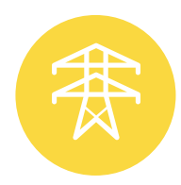
Energy
Vision for 2035: The ACT continues to be at the forefront of electrification and phasing out fossil fuel gas with a focus on a just transition supporting those who need it most.
What success looks like: The ACT has a reliable, resilient, affordable and 100% renewable energy network. The community is empowered to access the full benefits of the electrification of homes, businesses and transport.

Why energy is important
While emissions from fossil fuel gas are on a long-term decline, they are still our second-largest emissions source. The ACT is implementing a strategic pathway to reduce energy emissions across homes, businesses, and transport and electrify our city by 2045. It is critical that we maintain our 100% renewable electricity supply and progress the ACT’s energy emission reduction efforts to reach net-zero by 2045 and net-zero by 2040 for government energy emissions.

What we’re doing
We are and will continue working with the community, including renters, people living in multi-unit apartments and those in commercial buildings, to work through the challenges they face to electrify and enable them to experience the full benefits of electrification. A review into the Energy Efficiency Improvement Scheme is ongoing to ensure it can effectively support priority groups.
We’re supporting consumer energy resources such as rooftop solar, batteries, smart appliances, and electric vehicles through initiatives like the Sustainable Household Scheme. New gas network connections are already prevented in most areas of the ACT, and the government is working to upgrade public and community housing.
From a systems perspective, the Big Canberra Battery Project is supporting a 250 MW battery to be operational in 2026, whilst the mandatory rollout of smart meters will help to modernise the energy system.
The national and Territory regulatory systems that govern our energy systems are complex, and in a state of change as the energy sector decarbonises. This presents an opportunity for ACT Government to consider if there are regulatory changes that could assist a decarbonising economy, and we will work with our State, Territory, and Federal counterparts to ensure that all participants in the energy market (including networks, retailers, and consumers) are supported by the right regulatory settings to transition to the decarbonised energy system of the future.

Proposed Next Steps
We will continue to invest in transitioning away from fossil fuel gas and support uptake of consumer energy resources to help ensure a secure, renewable and affordable energy system. We will continue to help lower-income households in particular to improve efficiency, reduce energy needs, and electrify.
Ensuring grid resilience through battery storage will be essential as we manage the challenges associated with the timing of energy generation versus demand and with a distribution network vulnerable to climate-related events.
We will continue to support new technologies to accelerate the energy transition and invest in the ACT’s energy innovation sector through the Energy Innovation Fund.
An appropriately skilled workforce is crucial to supporting the energy transition. Meeting the future skills needs and working with industry to find pathways for affected workers such as gas fitters is an ongoing priority for delivering a just transition.
We will also explore possible options for managing residual emissions from harder-to-abate sources.

Feedback point
Community impact  Canberra’s energy transition means that households will increasingly need to switch to electric appliances. Households can also help manage energy demand and save on energy costs through energy efficiency measures (e.g. improved insulation) and new technologies such as batteries, solar panels and smart meters. While household upgrades will require initial investment, over time this will lead to lower energy bills, improved comfort and a continuing reliable energy system for everyone.  The ACT Government is providing support for priority groups to electrify, such as low-income, community and public housing tenants. Rebates, low-interest loans and other support is available for eligible households.  Benefits for households  Lower energy bills.  More comfortable and healthier homes.  Reliable and resilient energy supply.  What you can do  The time to go electric is when your appliances break or reach end of life. You can make a plan to go electric by using the Make Your Next Choice Electric online tool. The tool provides cost estimates for upgrades, proposed timeframes to replace appliances, and connects you with supports you may be eligible for.  You can also get free advice on how to go electric through the Sustainable Home Advice Program. | Business impact  About 40% of annual gas demand comes from ACT businesses and industrial activities. As we phase out fossil fuel gas and look to decommission the gas network, businesses will need to gradually switch to electric appliances. While the transition will be relatively similar to households for many businesses, we also know that some businesses will have challenges depending on their specific needs and situations and electrification is not always feasible for certain niche applications. Some businesses who rent their premise may face challenges in completing upgrades. The ACT Government will continue to work with businesses and industry on the best way to transition off fossil fuel gas and develop solutions for those who may face complex barriers. We will also continue investing in education and training that will support the Territory’s growing net zero economy, including through the development of the Future Energy Skills Hub at CIT.  Benefits for businesses  Opportunities for innovation, skills development and more jobs to support the transition  Electrification can improve energy efficiency and safety.  Sustainability credentials can attract customers and investors.  Greater control and predictability of energy usage for businesses; reduced reliance on fossil fuel gas protects against price volatility, and smart meters and battery storage help manage peak demand and outages.  What you can do  The time for businesses to go electric is when appliances break or reach end of life. Businesses setting up in a new premise should consider electrification as part of their fit out, so they don’t have to replace gas appliances prematurely in the future. For businesses with complex challenges when going electric, check if your premise has a gas network connection before signing a lease. Businesses operating in commercial and residential areas who do not already have access to an existing gas network connection will not be able to get a new connection.

Question
What barriers do you face in transitioning to be fully electric?


Government
Vision for 2035: The ACT Government demonstrates ambitious climate leadership.
What success looks like: The Government is successfully managing climate risks to its own services, operations and assets, and is supporting the resilience of those in the community most impacted by climate change. The ACT Government is decreasing operational emissions by 2040 and government scope 3 emissions are on a declining trajectory.

Why government is important
The ACT Government has nation-leading policies, programs and commitments, efforts to reduce operational emissions, and support for climate and sustainability innovation. This ambitious climate leadership demonstrates the pathway to others and builds industry capacity to make it easier for households and businesses to follow.
Managing climate risks are critical for the essential services government provides and for the long-lived assets that are built and managed by government.

What we’re doing
The ACT has committed to achieving zero emissions from government operations by 2040. Achieving the 100% renewable electricity target in 2020 saw government emissions cut by around 60%. Efforts to continue reducing emissions from government operations have focussed on fossil fuel gas and transport.
We’re also addressing Scope 3 emissions such as through the Low Carbon Concrete policy which outlines a phased approach to increase the use of low carbon concrete in government projects.

Proposed Next Steps
We will continue to investigate how our policy, decision-making, and regulatory and legislative systems work together with Canberrans to encourage the right actions towards a healthy and safe environment for everyone.
We must continue exploring options to strengthen emissions measurement, adaptation planning, and climate risk management. Next steps could consider how climate change impacts and risks might be more effectively evaluated in government investment and planning decisions, such as exploring expansion of training opportunities, strengthening staff capabilities to address climate risks, and improving cross-agency collaboration. This may also include exploring co-benefits, such as improved health and wellbeing, to help strengthen climate-aligned policies.
We will continue electrifying government gas assets and transitioning to zero-emissions vehicles for the government fleet to progress the ACT Government’s target of zero operational emissions by 2040.
We will seek to improve transparency and accountability and explore further opportunities to measure and report government scope 3 emissions and will consider opportunities to incorporate environmental considerations in procurement practices.
The ACT Government will also work with initiatives like the Australian Government’s Net Zero Plan to align efforts and avoid duplication.
Community impact  Government consideration of climate risk and emissions impacts in operations and services will mean better planning, more resilient infrastructure, and improved wellbeing for the community. Roads, schools, and hospitals that can withstand climate risks will help ensure that essential services are reliable during extreme weather events. Government reporting on emissions and climate actions helps build trust and confidence that the ACT is creating a climate-ready future.  Benefits for households  Safer, more resilient public infrastructure.  Improved health and wellbeing outcomes.  Reliable essential services during emergencies. | Business impact  The ACT Government is embedding climate risk and emissions considerations into decision-making and operations. This shift will influence procurement, partnerships, and compliance requirements for businesses working with or supplying to government. There will be stronger sustainability requirements for suppliers and contractors and increasing preference for low-carbon materials and climate-aligned services. This means there are opportunities for innovative solutions in electrification, energy efficiency, and climate resilience.  Benefits for businesses  Access to government contracts with sustainability criteria.  Enhanced reputation as a climate-aligned supplier.  Opportunities to improve competitive advantage and ongoing business resilience such as through localising supply chains and switching to zero-emissions vehicle fleets.

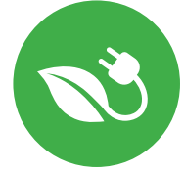
Other emissions
Vision for 2035: Territory wide scope 3 emissions are reducing. Harder to abate emissions, such as waste emissions, are being minimised and managed responsibly.
What success looks like: Responsible consumption and low carbon economic activity is reducing emissions. Food and garden organics recycling along with landfill gas capture reduces waste emissions. Residual emissions are managed through new programs such as large-scale environmental plantings.

Why other emissions are important
The ACT Government is managing and reducing waste and working towards a circular economy. Organic waste generates methane for decades when sent to landfill and work is underway to support food waste reduction and on-farm carbon abatement.
There will inevitably be residual emissions or locked in emissions that the Territory has limited influence on, including waste, refrigerant and aviation emissions. If left unaddressed, these residual emissions will make it difficult to meet legislated emissions reduction targets.

What we’re doing
Plans are underway for a new FOGO processing facility, a new Materials Recycling Facility and expansion of the ACT Container Deposit Scheme. The ACT Government also intends to introduce regulations requiring businesses to divert food and recycling from landfill.
The landfill gas capture facility in Mugga Lane has been upgraded, resulting in more methane capture, electricity generation and reduced emissions. However, methane extraction is already approaching the upper limit of what can effectively be captured.
Waste education, business support and community outreach activities are ongoing to avoid waste and increase resource recovery.
While a growing population represents a challenge to reducing net emissions generally, per capita emissions reductions continue to be realised. As the city electrifies its energy and transport sectors, per capita emissions on average will continue to fall.

Proposed next steps
We need to continue our efforts to encourage Canberrans to consume responsibly, reduce waste and divert waste from landfill while also supporting innovation and entrepreneurship in the circular economy. Encouraging practices like reducing food and textile waste, increasing use of recycled materials, and promoting a sharing and repairing culture can lower emissions and present opportunities for innovation.
We will also investigate opportunities to consider other resource recovery technologies.
As part of managing and reducing scope 3 emissions, it will be important for the ACT Government to consider how we monitor the emissions arising from consumption and construction supply chains.
We will also explore possible options for managing residual emissions from harder-to-abate sources.

Feedback point
Community impact  Consumers have significant influence on waste emissions and other consumption related emissions that result from the purchase of goods and services (scope 3 emissions). Making climate-conscious decisions when purchasing and disposing of goods will help communities be cleaner, greener and more connected.  Benefits for households  Opportunities to save money by reducing waste.  Create new and stronger community connections through a care, share, repair economy.  Reduced organic waste to landfill can protect biodiversity and water quality, improving connection to nature.  What you can do  Reduce emissions from organic waste through home composting solutions. Save money by avoiding buying new where possible; try reusing and upcycling household items, sharing and borrowing, buying second-hand, and repairing existing goods. | Business impact  While the ACT has eliminated emissions from electricity, other sources – such as waste, refrigerants, and supply chains – remain harder to abate. Businesses play a key role in reducing these emissions through waste management, circular economy practices and climate-conscious purchasing decisions. There will be increased expectations for sustainable management of waste, including future regulations for diverting food waste from landfill, as well as opportunities to reduce operational costs through better resource recovery and for innovation in recycling, repair and reuse services.  Benefits for businesses  Lower waste disposal costs.  Compliance with future-proof regulations.  Opportunities for innovation and new markets.  What you can do  Examine supply chains and identify opportunities to reduce emissions at each stage. Audit your waste streams, identify opportunities for diversion and explore partnerships for recycling and resource recovery.

Question
What barriers do you face to reducing emissions from ‘other’, or residual, emissions sources in your home or business?

Glossary
Term | Definition
Climate change adaptation | Actions taken to help communities and ecosystems adjust to changing climate conditions and their effects.
Climate change mitigation | Efforts to reduce or prevent the release of greenhouse gas emissions into the atmosphere.
Embodied Emissions | Embodied emissions are those that result from the construction, maintenance, and end-of-life disposal of an asset.
FOGO | Food Organics Garden Organics
Fossil fuel gas | The ACT Government uses to term ‘fossil fuel gas’ rather than ‘natural gas’ as it clearly identifies that we are discussing non-renewable gases. Fossil fuel gas is found in the Earth’s crust. It predominantly consists of methane, a powerful greenhouse gas; once extracted and burned, it cannot be renewed.
First Nations | For the purposes of this discussion paper, “First Nations” refers to the broader ACT Aboriginal and Torres Strait Islander community, including groups with connections to the ACT.
Greenhouse gas emissions | Any of the gases whose absorption of solar radiation is responsible for the greenhouse effect including carbon dioxide, methane, nitrous oxide, and fluorocarbons.
Net-zero emissions | When the greenhouse gas emissions released equal the amount captured from the atmosphere and stored.
Ngunnawal | The ACT Government recognises the Ngunnawal people as Traditional Custodians of the ACT and surrounding region. The Government acknowledges that other people and families also have a traditional connection to the lands of the ACT and region, and we respect this connection to Country. All reference to Traditional Custodians in this discussion paper will simply use ‘Ngunnawal’ and reference to ‘Country’ is Ngunnawal Country.
Refrigerant | Substances classified as ‘Scheduled Substances’ under the Ozone Protection and Synthetic Greenhouse Gas Management Act 1989 (OPSGG Act), commonly used in heat pump and reverse cycle air-conditioner (RCAC) equipment.
Resilience | The capacity of communities, environments and economies to cope with a hazardous event or disturbance, while maintaining their essential functions and structure.
Scope 1 emissions | Emissions released from the direct combustion of fossil fuels or fugitive emissions from activities occurring in the ACT from owned or controlled sources. This includes emissions from cars, trucks and buses travelling within a city, agriculture, and waste disposal.
Scope 2 emissions | Any emissions associated with the use of grid-supplied electricity. Electricity in the ACT is considered zero emissions due to the commitment to 100% renewable electricity.
Scope 3 emissions | This includes all other indirect emissions that are a consequence of the activity but occur at sources owned or controlled by another company.  This can include emissions generated from the production of purchased goods and services such as construction materials, and emissions associated with the transportation of goods, waste generated, business travel, employee commuting and leased assets.
ZEVs | Zero-Emissions Vehicles

